**BUSINESS ANALYSIS PROJECT 2**

Group 1:

Jeffking Sterile

[wizking5000@gmail.com](mailto:wizking5000@gmail.com)

Kesnel samuel Phillipe

[kesnelsamuel@gmail.com](mailto:kesnelsamuel@gmail.com)

Serginau Louis

[serginaulouis@gmail.com](mailto:serginaulouis@gmail.com)

Ketene Flore Thénéus

[ketteniefloretheneus@gmail.com](mailto:ketteniefloretheneus@gmail.com)

**Fraudulent Credit Card Transactions**

Introduction

Business analysis helps companies do business better, it ensures that a company is equipped to reach optimal potential. It helps managers find problems and then implement strategies or processes to solve those problems. It is like the action and result of steps taken by a person or team that delineates, orders, allocates, plans and adapts the resources available within the company so that it can operate as efficiently as possible. A good business analysis process will result in an action plan that the company can implement. It is also a disciplined approach to introducing and managing change in organizations and allows organizations to structure the way they make decisions to change their strategy to achieve their goals.

**Define the problem**

**Ⅰ．** Context

Our analysis concerns a bank that has received several complaints from its customers about credit card fraud.

The bank faces a situation where credit card information from its customers and the media regularly report that the bank's customers are losing large sums of money every time they bank and that the bank is doing nothing. This has an impact on both the customer experience and their market share.

**ⅠⅠ．** Problematic

The bank's problem is one of fraudulent credit card transactions.

credit card transactions. As a result, it is unable to provide better customer service to protect its customers' financial assets.

Background of the problem

Who identified the problem? Are there other attempts to solve it?

The media regularly reports that the bank's customers are losing large sums of money, but no attempt has been made by the bank to resolve the problem.

**ⅠⅠⅠ.** The stakeholders involved in the problem

* The bank
* The customers
* The media
* The employee

The main stakeholders are the customers because it impacts both their experience and market share and they have worked very hard to save their money.

Secondly, the bank because it is their duty as a financial institution to provide quality service to protect the financial assets of their customers and those who invest in the company i.e. the shareholders, who risk losing their investment and the bank who risk getting a bad reputation because of the media.

Measures et performance

How do customers, the company and other stakeholders measure this problem?

The bank has received several complaints from its customers about credit card fraud, which means that it has very important information, so senior management is requesting a thorough review of this problem with 6 months of data available.

**IV**. Why is the problem important for the organization?

The fraud with the bank card is a real plague for the banks, this problem is important for the company because in case of fraud the bank have to refund immediately the unduly debited sums as well as all the expenses generated by this fraud from where a loss for the bank with less profit and that could involve a defection of the customers.

**Methodology**

First, we collected data for analysis. We will use the data related to the transactions of the client, which are during 6 months (180 days). Secondly, we will use Python to manipulate the data. We will start by treating the data and use appropriate descriptive statistics such as central tendencies: mean, mode and median as well as frequencies for analysis. Figures, tables , graphs and charts were used to present the analysed data for ease of understanding-

There’s a part of the analysis that is performed only on fraudulent transactions and then, after visualizing the data with graph, table, we will determine where the most frauds come from and take different measurements to resolve the problem.

**Results**

**Highlights**

* The data are collected in 180 days, there are 112 customers concerned in 4112, 50 merchants, 15 categories of transaction based on purchase.
* We have **1.21% of transactions that are fraudulent,** and we have 37.89 average transactions per day.
* The average amount of non-fraudulent transactions is 31.8 but the average amount of Fraudulent transactions is 530.92.

**As we can see from the graph, we have more fraudulent transactions that come from women.**

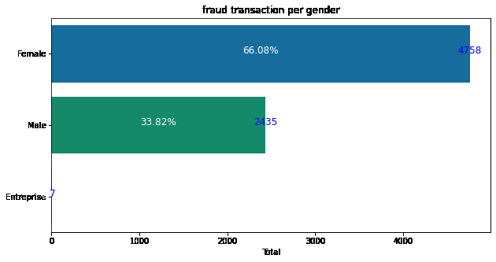

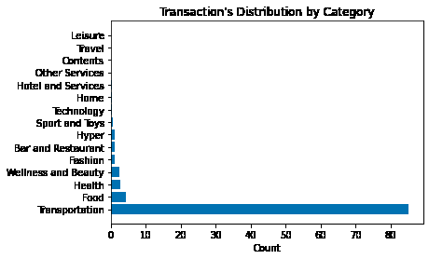 **Transportation: 84.94**

**Food: 4.41**

**Health: 2.71**

**Wellness & Beauty: 2.53**

**Fashion: 1.08**

**While overall transactions are increasing, fraud trends remain the same.**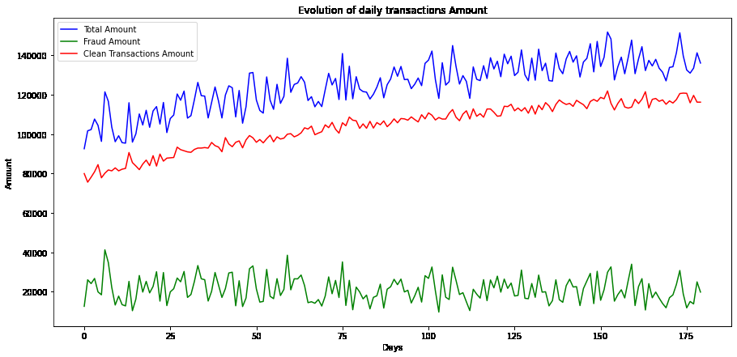

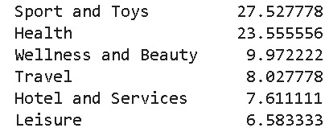

**Probability for the transaction to be in this category knowing that it is a fraud?**

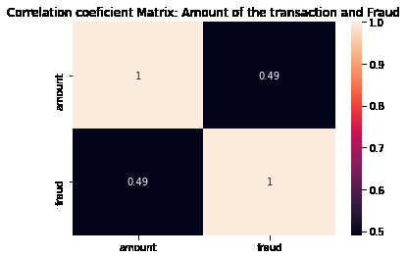

**There is a positive correlation between the amount of the transaction and the fact of the fraud.**

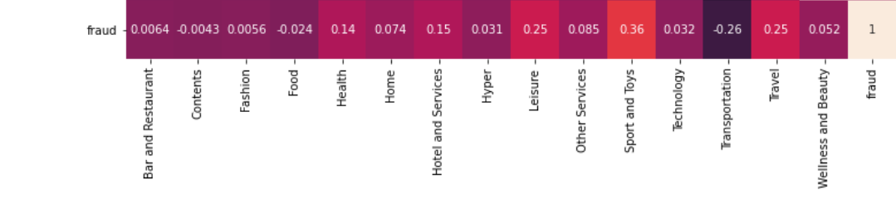

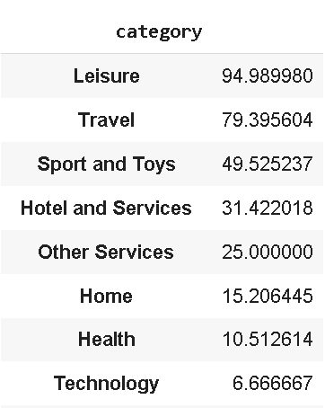

**Discussions & Proposed Solution**

SWOT Methodology

SWOT (strengths, weaknesses, opportunities, and threats) is used to assess a company's relationship with its market in order to develop strategic planning.

The SWOT analysis evaluates internal and external factors, as well as current and future potential.

**Strengths**

1.excellent customer service

2.Online customer service

**Weaknesses**

1.high level of fraudulent transactions

2.Lack of credibility on the part of clients

3.Low customer loyalty

4-Negative publicity from the media

5-Transaction level not too secure

**Opportunities**

1.Data availability

2.they can use the result of the business analysis to manage the problem of fraud

and will be able to regain the trust of the customers.

**Threats**

1. Profit at risk

2.Risk of losing shareholder confidence

3.Negative publicity from the media

4-Declining economy (loss of large sums)

5-High competitive risk compared to other banks

6-Loss of customer confidence

**Proposed solution**

* Double check on transactions about  **travel** and **leisure** if possible.
* Block transactions with a high level of amount (over 530) in the 2 categories mentioned above and more security steps from female transactions.
* Doing a model that can predict fraudulent transactions in realtime in order to block possibly fraudulent transactions.

**Alternative solution**

The bank should put in place a security system that can prevent those way of hacking:

1.1 **Phishing** (process of attempting to acquire information such as usernames or passwords by masquerading as a trustworthy online source.)

**Solution:** Advise the customer to avoid links to begus websites.

1.2 **Spoofing** ( the act of creating and using an invented story to persuade an individual to provide sensitive informations or perform an action.)

**Solution:** Advice the customer if they ever receive an email claiming to be from their card issuer, do not click any links, and call the bank for further information.

1.3 Skimming ( an illegal practice used by identity thieves to capture credit card information from a cardholder surreptitiously)

**Advantages and inconvenients**

**Advantages**

* Block high level of amount in some category will protect the client from high losses.
* Algorithm which can make the bank to react faster in case there are frauds.

Inconvenients

* Make a great algorithm can relatively take time for the unclassified transactions in some categories, we could have to collect the “unknown data”.
* Blocks some transactions ( who are not fraudulent transactions) will make the client feeling frustrated.

**Solution 1**

Our anti-fraud solution offers companies an intelligent risk analysis engine capable of detecting fraudulent electronic transactions in real time. Our solution allows you to:

Reduce financial losses related to electronic fraud

Reduce the time spent analyzing and detecting fraud

Increase the speed of interventions

**Advantages of the anti-fraud solution**

Our solution allows you to evaluate certain major losses associated with the risk of fraud.

**Solution 2**

Given the number of frauds, the bank must have an effective fraud management system to preserve their financial situation and reputation, and also find a way to restore customer confidence, improve the "customer experience" and thus differentiate themselves from the competition.

**References**

1.<https://voxeu.org/article/how-banks-affect-investment-and-growth>

2. [What is Business Analysis? | Global Standard for Business Analysis Certification | IIBA®](https://www.iiba.org/professional-development/career-centre/what-is-business-analysis/)

3.  [Strength, Weakness, Opportunity, and Threat (SWOT) Analysis Definition (investopedia.com)](https://www.investopedia.com/terms/s/swot.asp)