-----------Git Command---------------------------

1.) git --version

-> To check git version

2.) git config --global user.name ["enter a name"]

-> To configure global user name

-> Ex:-

git config --global user.name "Ketul"

3.) git config --globle user.email ["enter an email"]

-> To configure globle user email

-> Ex:-

git config --global user.email "pketul2212@gmail.com"

4.) git config --global core.editor ["enter an editor name"]

-> To configure globle esditor

-> Ex:- [For VS Code]

git config --global core.editor "code"

5.) git config --list

-> To show all configuration

6.) git init

-> To initialise git repository

7.) git status

-> To check git status

8.) git branch

-> To show all branch and also check currentlly working branch

----------------------------Git Workflow--------------------------------

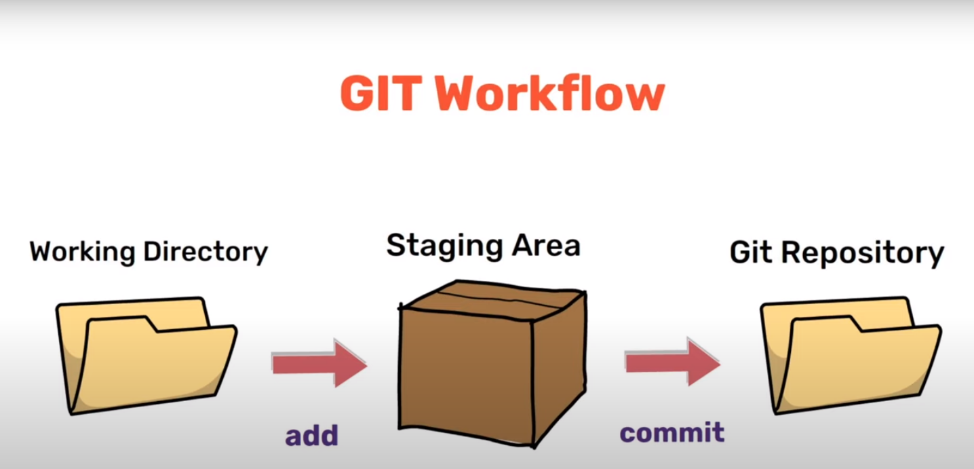

9.) git ls-files

-> To show which files are in the staging area

10.) git add [files name]

-> To add a file into a staging area

-> Ex :-

git add abc.txt xyz.txt

11.) git add .

-> To add all files into a staging area

12.) git rm –cached [files name]

-> To remove file from staging area

-> Ex:-

git rm –cached abc.txt

13.) git commit -m ["any message"]

-> To add staging area file to permanent storage

-> Ex:-

git commit -m "1st Commit"

14.) git log

-> To show history(log) of particular repository

15.) git log –oneline

-> To show history(log) of particular repository in one line

16.) git branch [enter a new branch name]

-> To create a new branch

-> Ex:-

git branch demo-branch

17.) git switch [enter a existing branch name]

-> To switch the branch

-> Ex:-

git switch test

18.) git merge [enter a existing updated branch name]

-> To mearge a branch

-> Ex:-

git merge test

19.) git reset –hard [commit id]

-> To change (HEAD -> branch) point to particular commit

-> Ex:-

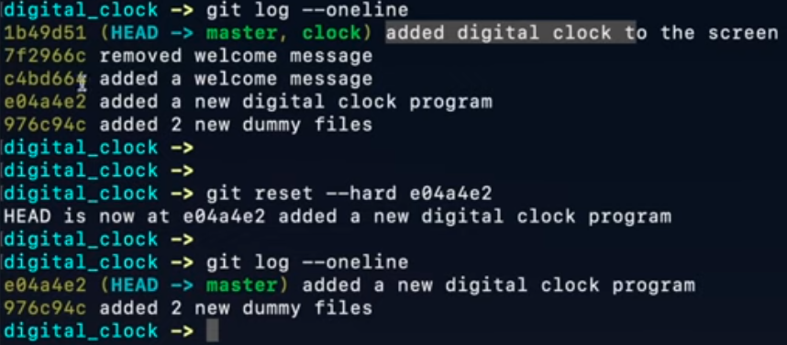

20.) git checkout [commit id]

-> To change HEAD point to direct commit

-> Ex:-

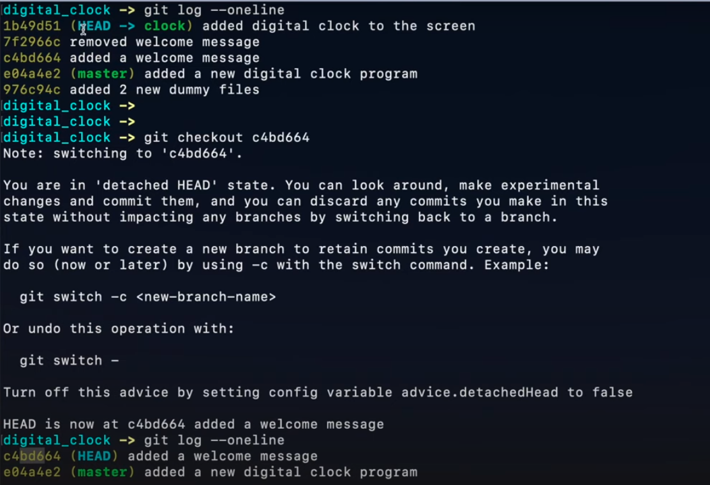

21.) git switch -c [enter a new branch name]

-> To create new branch and switch new branch

-> Ex:-

git switch -c new_test

22.) git remote -v

-> To check any remote github repository is assign or not, basically **remote** means address or url to remote repository

23.) git remote add origin [enter a remote url]

-> To add git repository to remote github repository

-> Ex:-

git remote add origin <https://github.com/ketul2212/basic-demo-SSL.git>

**NOTE:-** origin is a name and it is replaceable with any name but by default is a origin.

24.) git push -u origin [enter a existing branch name which we are push to github branch]

-> To push a git repository to github repository.

Ex:-

git push -u origin main

25.) git pull origin [enter a github repository branch name which we are pull in local]

-> All the changes done in github repository are reflected in local

Ex:-

git pull origin main

26.) git clone [enter a remote url]

-> To clone the project into local machine

Ex:-

git clone <https://github.com/ketul2212/basic-demo-SSL.git>