**Table of Contents**

Revision History ii

Document Approval ii

1. Introduction 1

1.1 Purpose 1

1.2 Scope 1

1.3 Definitions, Acronyms, and Abbreviations 1

1.4 References 1

1.5 Overview 1

2. General Description 2

2.1 Product Perspective 2

2.2 Product Functions 2

2.3 User Characteristics 2

2.4 General Constraints 2

2.5 Assumptions and Dependencies 2

3. Specific Requirements 2

3.1 External Interface Requirements 3

3.1.1 User Interfaces 3

3.1.2 Hardware Interfaces 3

3.1.3 Software Interfaces 3

3.1.4 Communications Interfaces 3

3.2 Functional Requirements 3

3.2.1 <Functional Requirement or Feature #1> 3

3.2.2 <Functional Requirement or Feature #2> 3

3.3 Use Cases 3

3.3.1 Use Case #1 3

3.3.2 Use Case #2 3

3.4 Classes / Objects 3

3.4.1 <Class / Object #1> 3

3.4.2 <Class / Object #2> 3

3.5 Non-Functional Requirements 4

3.5.1 Performance 4

3.5.2 Reliability 4

3.5.3 Availability 4

3.5.4 Security 4

3.5.5 Maintainability 4

3.5.6 Portability 4

3.6 Inverse Requirements 4

3.7 Design Constraints 4

3.8 Logical Database Requirements 4

3.9 Other Requirements 4

4. Analysis Models 4

4.1 Sequence Diagrams 5

4.3 Data Flow Diagrams (DFD) 5

4.2 State-Transition Diagrams (STD) 5

5. Change Management Process 5

A. Appendices 5

A.1 Appendix 1 5

A.2 Appendix 2 5

# 1. Introduction

The introduction of the Software Requirements Specification (SRS) provides an overview of the entire SRS with purpose, scope, definitions, acronyms, abbreviations, references and overview of the SRS. The aim of this document is to gather and analyze and give an in-depth insight of the complete **SNS: Snap and Search Application** by defining the problem statement in detail. Nevertheless, it also concentrates on the capabilities required by stakeholders and their needs while defining high-level product features. The detailed requirements of the **SNS: Snap and Search Application** are provided in this document.

The introduction to the Software Requirement Specification (SRS) document should provide an overview of the complete SRS document. While writing this document please remember that this document should contain all of the information needed by a software engineer to adequately design and implement the software product described by the requirements listed in this document. (Note: the following subsection annotates are largely taken from the IEEE Guide to SRS).

## 1.1 Purpose

The purpose of the document is to collect and analyze all assorted ideas that have come up to define the system, its requirements with respect to consumers. Also, we shall predict and sort out how we hope this product will be used in order to gain a better understanding of the project, outline concepts that may be developed later, and document ideas that are being considered, but may be discarded as the product develops.

In short, the purpose of this SRS document is to provide a detailed overview of our software product, its parameters and goals. This document describes the project's target audience and its user interface, hardware and software requirements. It defines how our client, team and audience see the product and its functionality. Nonetheless, it helps any designer and developer to assist in software delivery lifecycle (SDLC) processes.

*What is the purpose of this SRS and the (intended) audience for which it is written.*

## 1.2 Scope

The SNS: Snap and Search is the Android Application which shall allow user to search for the similar product by uploading a snap of the product taken by the user from different e-Commerce websites like Amazon.in, flipkart.com, snapdeal.com etc. The application shall also allow user to compare the products displayed in results and buy them from the third party e-Commerce website. The application should be free to download from either mobile application store or similar services.

The application can gather the information about the products including images of them from the different e-Commerce websites. This information should act as the bases for the search results displayed to user. An administrator also uses the web-portal in order to administer the system and keep the information updated and accurate. The administrator can for instance, verify the information and manage user information.

Initially, the product scope shall be limited only to the search of Watches as a product. More products can be added further.

Furthermore, the application needs Internet connection to fetch and display results. All system information is maintained in database, which is located on web-server. The software also interacts with Image Processing Algorithm executing on the web-server. By using, Image Processing Algorithm, user can get the results having similar look to the snap/picture taken by oneself. Application also shall have the capability to compare the results to help user differentiate between the product features. Application redirects user to the third party e-Commerce website when user wants to buy the product.

*This subsection should:*

*(1) Identify the software product(s) to be produced by name; for example, Host DBMS, Report Generator, etc*

*(2) Explain what the software product(s) will, and, if necessary, will not do*

*(3) Describe the application of the software being specified. As a portion of this, it should:*

*(a) Describe all relevant benefits, objectives, and goals as precisely as possible. For example, to say that one goal is to provide effective reporting capabilities is not as good as saying parameter-driven, user-definable reports with a 2 h turnaround and on-line entry of user parameters.*

*(b) Be consistent with similar statements in higher-level specifications (for example, the System Requirement Specification) , if they exist.What is the scope of this software product.*

## 1.3 Definitions, Acronyms, and Abbreviations

*This subsection should provide the definitions of all terms, acronyms, and abbreviations required to properly interpret the SRS. This information may be provided by reference to one or more appendixes in the SRS or by reference to other documents.*

## 1.4 References

*This subsection should:*

*(1) Provide a complete list of all documents referenced elsewhere in the SRS, or in a separate, specified document.*

*(2) Identify each document by title, report number - if applicable - date, and publishing organization.*

*(3) Specify the sources from which the references can be obtained.*

*This information may be provided by reference to an appendix or to another document.*

## 

## 1.5 Overview

The remainder of this document includes four chapters and appendices. The second one provides an overview of the system perspective and the underlying assumptions considered while designing the system. Furthermore, it also provides information about the product functions. It also gives information about the constraints that will limit the developer and user characteristics which affects the product requirements.

The third chapter provides the requirements specification in detailed terms and a description of the different system interfaces. Different specification techniques are used in order to specify the requirements more precisely for different audiences. It also gives information about design constraints imposed on the product.

The fourth section includes different analysis models viz. DFD, STD and sequence diagram. The fifth section contains management process to be used to update the SRS.

The Appendices in the end of the document include the further information about the terms being used in the SRS.

*This subsection should:*

*(1) Describe what the rest of the SRS contains*

*(2) Explain how the SRS is organized.*

# 2. General Description

*This section of the SRS should describe the general factors that affect 'the product and its requirements. It should be made clear that this section does not state specific requirements; it only makes those requirements easier to understand.*

## 2.1 Product Perspective

This system will consist of two parts: one mobile application and one web portal. The mobile application will be used to find similar looking products and view information about them while the web portal will be used for managing the information about the products and the system as a whole.

The mobile application with the help of the mobile camera takes the picture of the product. The taken picture is uploaded with the help of the Internet. The uploaded image will be compared with images in the database. The same you can see in the figure. Both the mobile application and web portal will communicate with database, however in different ways. Mobile application only uses database to get data while web portal also adds and modifies data. The database communication is carried out over the Internet.

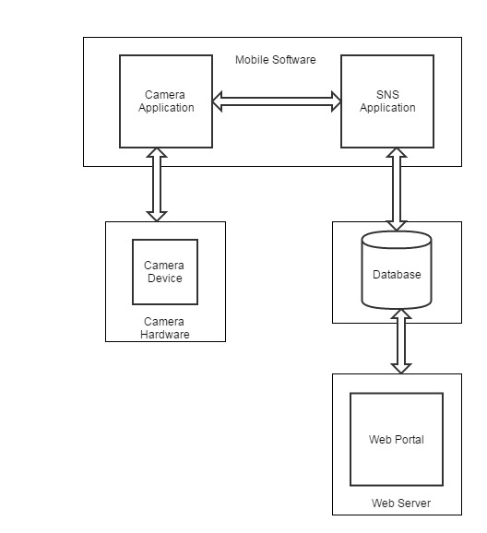

Figure 1

*This subsection of the SRS puts the product into perspective with other related products or*

*projects. (See the IEEE Guide to SRS for more details).*

## 2.2 Product Functions

With the mobile application, user will be able to search for the similar looking products. The results will be based on the image uploaded. Displayed results will be similar looking products to the image uploaded by user.

User further can filter the results based on various criteria such as vendor, price etc. User shall also be able to compare at least two and at most four results. User shall be redirected to vendor website upon clicking the “Buy” button.

The web portal will provide functionality to manage the system and the product information. It will also provide information about the system, for example show when there is a new update.

This subsection of the SRS should provide a summary of the functions that the software will perform.

## 2.3 User Characteristics

There are two types of users that interact with the system: users of the mobile application and administrators. Each of these two types of user has different use of the system so each of them has their own requirements.

The mobile application ‘users’ can use the application to find similar looking products. This means that user will be able to search for products, choose from that search and then navigate to it. Users can compare and buy products.

The ‘administrators’ interact with the web portal. They are managing the overall system in order to maintain correct and updated information. The administrator can manage the information for each product as well as the options for mobile application users. Admin also can define the time interval between the consecutive gathering of the information from the third party e-Commerce websites.

This subsection of the SRS should describe those general characteristics of the eventual users of the product that will affect the specific requirements. (See the IEEE Guide to SRS for more details).

## 2.4 General Constraints

The major constraint to be faced by our application is imposed by the third party vendors/e-Commerce websites. Since, each third party vendor has their own User Interface. There also may be navigation differences between them. Images displayed on the third party vendor websites must include different angles of the product.

The Internet connection is also a constraint for the application. Since the application fetches data from the database over the Internet, it is crucial that there is an Internet connection for the application to function.

Both the web portal and the mobile application will be constrained by the capacity of the database. Since the database is shared between both application it may be forced to queue incoming requests and therefore increase the time it takes to fetch data.

*This subsection of the SRS should provide a general description of any other items that will*

*limit the developer’s options for designing the system. (See the IEEE Guide to SRS for a partial list of possible general constraints).*

## 2.5 Assumptions and Dependencies

One assumption about the product is that it will always be used on mobile phones that have enough performance. If the phone does not have enough hardware resources available for the application, for example the users might have allocated them with other applications, there may be scenarios where the application does not work as intended or even at all.

Another assumption is about picture resolution taken by device camera. We assume that pictures taken by all devices provide similar outputs.

Results will be depended on the efficiency of image processing algorithms that will be used in application.

This subsection of the SRS should list each of the factors that affect the requirements stated in the SRS. These factors are not design constraints on the software but are, rather, any changes to them that can affect the requirements in the SRS. For example, an assumption might be that a specific operating system will be available on the hardware designated for the software product. If, in fact, the operating system is not available, the SRS would then have to change accordingly.

# 3. Specific Requirements

This will be the largest and most important section of the SRS. The customer requirements will be embodied within Section 2, but this section will give the D-requirements that are used to guide the project’s software design, implementation, and testing.

Each requirement in this section should be:

* Correct
* Traceable (both forward and backward to prior/future artifacts)
* Unambiguous
* Verifiable (i.e., testable)
* Prioritized (with respect to importance and/or stability)
* Complete
* Consistent
* Uniquely identifiable (usually via numbering like 3.4.5.6)

Attention should be paid to the carefuly organize the requirements presented in this section so that they may easily accessed and understood. Furthermore, this SRS is not the software design document, therefore one should avoid the tendency to over-constrain (and therefore design) the software project within this SRS.

## 3.1 External Interface Requirements

### 3.1.1 User Interfaces

There are two types of users in our system. They are Application Users and Administrators. Each will have different interface for the sake of simplicity for using the application.

User will have welcome screen consisting of login and registration options. Upon clicking the “Register” button, user will be redirected to registration page having registration form. Selecting the “Login” option, a login prompt will be displayed. After successful login, the user will have sight of search history. User will also see different options such as Take a Snap, Compare Results, Logout. After choosing Take a Snap option, device camera will be enabled and user will be allowed to take a snap. After taking a snap, user will be provided two options, namely Remove Snap or Upload Snap. Once the Upload Snap is chosen, Results of products from database will be displayed. Result will comprise product description, vendor information, price and option to buy product.

Administrators work on the web-portal. Administrators will be verified. After successful verification, Administrators can see three databases. Administrators will also be provided with an option to gather images along with description of products. After selecting one of the database, Administrators can update, delete and insert records.

### 3.1.2 Hardware Interfaces

Since neither the mobile application nor the web portal have any designated hardware, it does not have any direct hardware interfaces. The camera application is managed by the mobile phone and the hardware connection to the database server is managed by the underlying operating system on the mobile phone and the web server.

### 3.1.3 Software Interfaces

The mobile application communicates with the Camera in order to take snap of product, and with the database in order to get the information about the products, see Figure 1. The communication between the database and the web portal consists of operation concerning both reading and modifying the data, while the communication between the database and the mobile application consists of only reading operations.

### 3.1.4 Communications Interfaces

The communication between the different parts of the system is important since they depend on each other. However, in what way the communication is achieved is not important for the system and is therefore handled by the underlying operating systems for both the mobile application and the web portal.

## 3.2 Functional Requirements

This section describes specific features of the software project. If desired, some requirements may be specified in the use-case format and listed in the Use Cases Section.

### 3.2.1 Functional Requirement or Feature #1

ID: FR1

TITLE: Download mobile application

DESC: A user should be able to download the mobile application through either an application store or similar service on the mobile phone. The application should be free to download.

RAT: In order for a user to download the mobile application.

DEP: None

### 3.2.2 Functional Requirement or Feature #2

ID: FR2

TITLE: Download and notify users of new releases

DESC: When a new/updated version or release of the software is released, the user should check for these manually. The download of the new release should be done through the mobile phone in the same way as downloading the mobile application.

RAT: In order for a user to download a new/updated release.

DEP: FR1

### 3.2.3 Functional Requirement or Feature #3

ID: FR3

TITLE: User registration - Mobile application

DESC: Given that a user has downloaded the mobile application, then the user should be able to register through the mobile application. The user must provide user-name, password and e-mail address. The user can choose to provide a regularly used phone number.

RAT: In order for a user to register on the mobile application.

DEP: FR1

### 3.2.4 Functional Requirement or Feature #4

ID: FR4

TITLE: User log-in - Mobile application

DESC: Given that a user has registered, then the user should be able to log in to the mobile application. The log-in information will be stored on the phone and in the future the user should be logged in automatically.

RAT: In order for a user to register on the mobile application.

DEP: FR1, FR3

### 3.2.5 Functional Requirement or Feature #5

ID: FR5

TITLE: Retrieve password

DESC: Given that a user has registered, then the user should be able to retrieve his/her password by email.

RAT: In order for a user to retrieve his/her password.

DEP: FR1

### 3.2.6 Functional Requirement or Feature #6

ID: FR6

TITLE: Mobile application - Search

DESC: Given that a user is logged in to the mobile application, then the first page that is shown should be

the search page and search history. The user should be able to search for a product, after taking snap. The search options are Price, Product, and Vendor.

RAT: In order for a user to search for a product.

DEP: FR4

### 3.2.7 Functional Requirement or Feature #7

ID: FR7

TITLE: Mobile application - Search result

DESC:

* Search results can be viewed in a list. Each element in the list represents a specific product.
* Each element should include the product description, vendor name, price, according to the snap taken by user, a link to products’ web-page
* There should be maximally 20 results displayed. If the result contains more results than
* what can be displayed on the screen at one time, the user should be able to scroll through them.
* When searching by price the results should be sorted according to the following order:

1. Product price
2. Product type

RAT: The way results should be displayed in a list.

DEP: FR6

### 3.2.8 Functional Requirement or Feature #8

ID: FR8

TITLE: Mobile application - Search by price

DESC: A user should be able to input a maximum and a minimum price range. The result is displayed in a list view by default.

RAT: In order for a user to search by price.

DEP: FR8

### 3.2.9 Functional Requirement or Feature #9

ID: FR9

TITLE: Mobile application - No match found

DESC: If no match is found the user should be informed but kept on the search page in order to get the possibility to conduct a new search right away.

RAT: In order for user to conduct a new search if no match is found.

DEP: FR5

### 3.2.10 Functional Requirement or Feature #10

ID: FR10

TITLE: Mobile application - Profile page

DESC: On the mobile application, a user should have a profile page. On the profile page a user can edit his/her information, which includes the password, e-mail address and phone number. RAT: In order for a user to have a profile page on the mobile application.

DEP: FR1

### 3.2.11 Functional Requirement or Feature #11

ID: FR11

TITLE: Mobile application - Navigation to vendor website.

DESC: A user should be able to select a product and buy it. When a purchase is made, the user should then be navigated to the vendor website.

RAT: To navigate a user to a vendor website.

DEP: FR7

## 3.3 Use Cases

## Use case.jpg

## 3.4 Classes / Objects

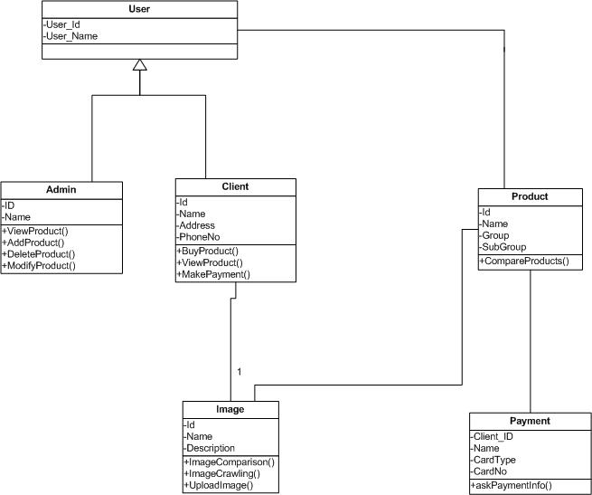

## 

## 3.5 Non-Functional Requirements

Non-functional requirements may exist for the following attributes. Often these requirements must be achieved at a system-wide level rather than at a unit level. State the requirements in the following sections in measurable terms (e.g., 95% of transaction shall be processed in less than a second, system downtime may not exceed 1 minute per day, > 30 day MTBF value, etc).

### 3.5.1 Performance

Output of the image processing algorithm will provide results having images most similar to the snap uploaded by user. Thus one will get what one is looking for.

The product shall take initial load time depending on internet connection strength which also depends on the media from which the product is run.

Results should also take minimal time to load and being displayed.

### 3.5.2 Reliability

System will give right and most relevant results to the query entered by user.

Servers will be maintained for all time access of the web portal. Database will be updated frequently to accommodate most recent information.

### 3.5.3 Availability

The system will be available for user whenever required. The database will be available to system as required.

The application should be connected to the Internet in order to communicate with database.

### 3.5.4 Security

The messages should be encrypted for log-in communications, so others cannot get user-name and password from those messages.

If an admin tries to log in to the web portal with a non-existing account then the admin should not be logged in. The admin should be notified about log-in failure.

An admin and IP address should not be able to log-in to the web portal for a certain time period after three times of failed log-in attempts.

If a user wants to create an account and the desired user name is occupied, the user should be asked to choose a different user name.

Redirection to the third party vendor for the made purchase should be secure and payment gateway should provide maximum security to the user.

### 3.5.5 Maintainability

The application should be easy to extend. The code should be written in a way that it favors implementation of new functions.

Test environments should be built for the application to allow testing of the applications different functions.

New products should be easily added in the system.

### 3.5.6 Portability

Application should be portable with most of the versions of Android OS.

## 3.6 Design Constraints

The system shall be built using a standard web page development tool that conforms to Android’s GUI standards.

Device must be equipped with standard camera. Device should be connected to Internet and running on the Android OS.

## 3.8 Logical Database Requirements

We will be using three databases viz. User DB, Product DB and Image DB. User DB will be storing information about registered users.

Product ID field of the Product database will be the Primary key for the same and will act as a foreign key in database for images.

# 4. Analysis Models

List all analysis models used in developing specific requirements previously given in this SRS. Each model should include an introduction and a narrative description. Furthermore, each model should be traceable the SRS’s requirements.

## 4.1 Sequence Diagrams

## Sequence (1).png

## 4.3 Data Flow Diagrams (DFD)

DFD Level 0:

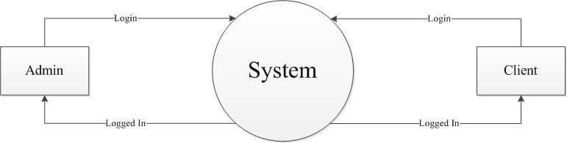

## 

## DFD Level 1:

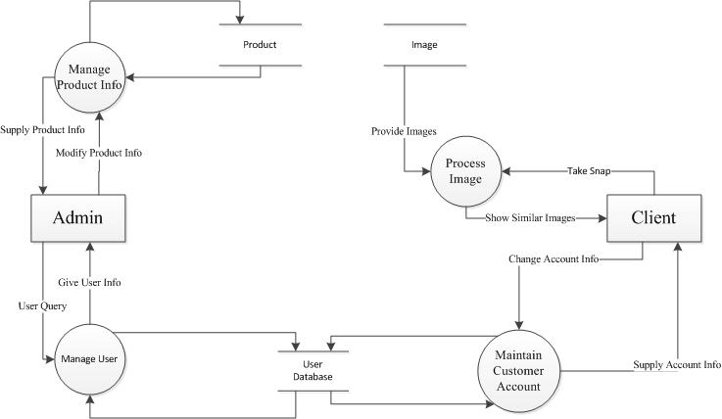

DFD Level 2:

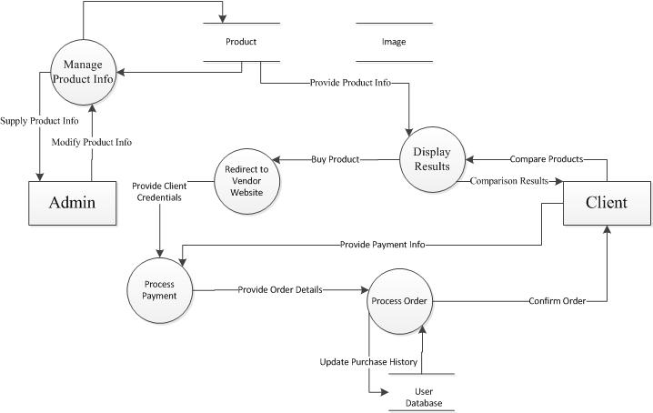

## 4.2 State-Transition Diagrams (STD)

State Diagram 1: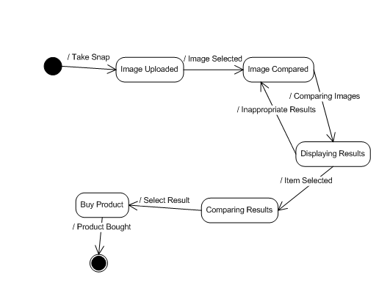

State Diagram 2: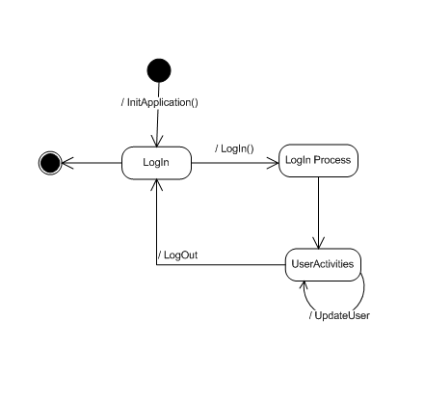

State Diagram 3:

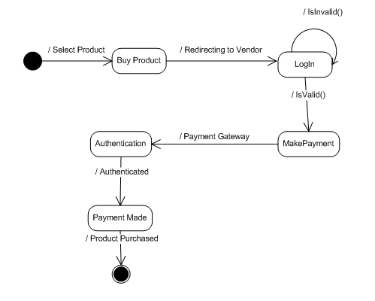

# 5. Change Management Process

The changes will be made in the Application after they have been approved by all the stakeholders. To approve the changes to be made in the System, discussion will be done and after discussion, whatever conclusion is reached, will be applied to the System.

Identify and describe the process that will be used to update the SRS, as needed, when project scope or requirements change. Who can submit changes and by what means, and how will these changes be approved.

# A. Appendices

Appendices may be used to provide additional (and hopefully helpful) information. If present, the SRS should explicitly state whether the information contained within an appendix is to be considered as a part of the SRS’s overall set of requirements.

*Example Appendices could include (initial) conceptual documents for the software project, marketing materials, minutes of meetings with the customer(s), etc.*

## A.1 Appendix 1

## A.2 Appendix 2