A7: Project Report

Kevin Sweet

12/9/2021

# Introduction

The COVID-19 pandemic has undoubtably been the most impactful event in recent history. As the virus continues to spread and adapt, researchers are working all over the world to understand what impacts this virus has had and what we can do to stop it. To properly research this topic in the scope of this class, this paper seeks to understand the impacts COVID-19 has had on Cook County Illinois, the county that Chicago is located in.

# Related Work

Prior work has been done to study the effects that COVID has had on the Cook County community. A study was conducted on hesitancy to seek emergency care during the early stages of the pandemic. The findings from this study showed that communities with lower Child Opportunity Index (COI) scores had statistically significant higher hesitancy to seek emergency care than those with lower COI scores. (Macy, Smith, Cartland, Golbeck, & Davis, 2021) Another study assessed the seropositivity rates of different Chicago neighborhoods that were geographically close together but had vastly different case counts. (Mustanski, 2021) No studies were identified that explored the effectiveness of mask mandates nor the impact on the school system in Cook County.

These studies on the differences in response to the pandemic for different demographics raised the following research questions for this paper:

1. How did masking policies change the progression of confirmed COVID-19 cases in Cook County from February 1, 2020 through October 15, 2021?
2. What impact has the COVID-19 pandemic had on education in Cook County?
3. Is there a similar impact on education regardless of how wealthy the community is?

Q1 will be addressed using the confirmed cases, mask mandates, and mask use datasets. (DS4-6 in “Data Sources”) The hypothesis (H1) is that mask mandates reduce the change in new COVID-19 cases shortly after their institution.

Q2 and Q3 will be addressed by using education data obtained by the city of Chicago and by the state of Illinois. (DS1-3) I have identified three performance indicators that directly impact the quality of education: dropout rate, student attendance rate, and teacher retention rate. The importance of these metrics is highlighted in reports made for the National Assessment of Educational Progress. (NAEP) (Ginsburg, 2014) The hypothesis for these questions is that levels for these three metrics have worsened during the pandemic (H2) and that the impact is more severe for schools that have a student body from less wealthy families. (H3)

# Methodology

## Q1 Common Analysis

The method used to address this question was to create a susceptible–infected–recovered–dead (SIRD) model to estimate the impact the pandemic would have had if a mask mandate had not been put in place. To supplement this method, a plot of the new cases over time as well as the rate of change in new cases will be created to visually identify how new case counts changed when the mask mandate was put into place.

The SIRD model used for answering this question is a time-varying Markov model. Each person in the population is modeled in one of five states: susceptible, infectious, resolving, dead, or recovered. (Figure 1)

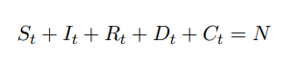

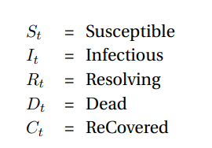

Figure 1: States in a SIRD model at time period t (Fernández-Villaverde & Jones, 2020)

The assumption of the model is that there is a single initial infection (0 = 1) that will then spread the disease to others according to two factors: number of lengthy contacts per day and number of days the contact is infectious. These factors, denoted as βt and γ respectively, are variables that when multiplied together form the basic reproduction rate . The basic reproduction rate represents the number of infections that an infected person is expected to spread the disease to. At every time step in the simulation, the values for , , , , and are updated according to the formulas in Figure 2. The assumed values for the parameters to these update equations can be found in Figure 3.

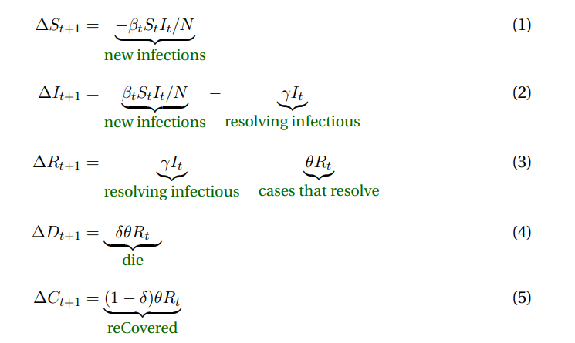

Figure 2: Population state update equations (Fernández-Villaverde & Jones, 2020)

|  |  |
| --- | --- |
| Number | Assumption |
| 1 | Masks are 67% effective at stopping transmission. This means that for the proportion of the population that wear masks, they transmit COVID-19 at a rate that is 33% of the usual transmission rate. (Peeples, 2020) |
| 2 | The base reproduction rate () values for Cook County are fixed at 1.5 (simplifying assumption) |
| 3 | The population (N) of Cook County is stable at 5,275,541 as shown in the county assignment spreadsheet (simplifying assumption) |
| 4 | Those that are infected and recover are immune (simplifying assumption) |
| 5 | Recovery period (1/θ) is on average 10 days long (Fernández-Villaverde & Jones, 2020) |
| 6 | Death rate (δ) is on average 1% of all infections (Fernández-Villaverde & Jones, 2020) |
| 7 | Infectious period (1/γ) is on average 5 days long (Fernández-Villaverde & Jones, 2020) |

Figure 3: SIRD Model Assumptions Table

Two versions of this simulation will be run, one that implements a mask mandate that reduces the reproduction rate by 67% after May 1st which is meant to reflect the real-world result. The other simulation will not introduce the effect of a mask mandate at May 1st. Each of these simulations will run from the beginning of the recorded data and project out to June 1st. The number of infected will then be compared for these two simulations to determine what impact the mask mandate had on the progression of COVID-19.

## Q2 & Q3 Analysis Extension

Q2 & Q3 both pertain to education metrics in cook county, so datasets DS1-3 were procured from online sources and cleaned. Exploratory data analysis was performed on these datasets and DS1 was identified as having the appropriate data points to effectively answer these questions. It contains yearly school-level performance metrics for every school in Illinois, most importantly, dropout rate, student attendance rate, teacher retention rate, and a Title I school indicator. Title I schools are defined as having enrolled in a title I program with the department of education. (U.S. Department of Education, 2018) To be eligible for title I, a school must have more than 40% of its students living below the poverty line. This will be used in the analysis to distinguish between wealthy and not wealthy communities, needed to answer Q3.

After data preparation, we had a processed dataset of two school years of performance metrics for every school in Cook County. The two school years, identified as “pre” and “post” pandemic, were the 2019-2020 and 2020-2021 school years respectively. These groups were further divided into “title I” and “non-title I” schools. In this dataset, there are 790 schools identified as title I and 412 schools identified as non-title I.

To answer Q2 and Q3, a dependent t-test for paired samples is performed on the title I and non-title I for the pre and post pandemic years. The results of this t-test will show whether there is a significant change in any of these metrics, thus answering Q2. A significant difference in change for title I and non-title I schools will show highlight any disparities between wealthy and poor communities, answering Q3.

# Findings

## Q1 Common Analysis

The SIRD model showed extreme sensitivity to the choice of βt that accordingly affected . The simplifying assumption that is fixed at 1.5 originated from experimentation with the model and observation that as approached approximately 2, the rate of infection was so large that by the end of the simulation every person in Cook County was infected with COVID-19. While this isn’t an impossible result due to the dormant nature of the virus in some cases, the plausibility of this is questionable. The difficulty with modeling this situation originates from the estimation of βt, the number of lengthy contacts. The simplifying assumption that this number is static throughout the duration of the simulation is the issue. In reality, this number changes drastically as people understand the dangers of the pandemic, the weather, world events, and many more reasons that cannot reasonably be modeled in the scope of this project.

That being said, the results of the SIRD model showed that the simulation in which everyone complies with the mask mandate after May 1st resulted in a drop in number of infected from 537,169 to 40,275. This is a 92% decrease in the total number of infections.

The supplementary visualization (Figure 3) contains two subplots: the top plot shows the 7-day moving average of COVID cases in Cook County Illinois. The X axis is the date at which the new confirmed cases were reported and the Y axis is the number of new cases. The bottom graph, which shares the same X axis as the top, is the rate of change in new cases i.e., the acceleration of new case growth. The grayed areas of both graphs represent the time periods in which a mask mandate was in effect and the solid yellow vertical line represents the point at which the first vaccine was introduced. There are a few instances of extreme spikes in case counts that are likely attributed to delayed reporting (1/1/2021, 9/6/2021). This could be due to those dates being holidays. An interesting finding from this graph is that shortly after the introduction of both mask mandates, the new case rate seems to drop.

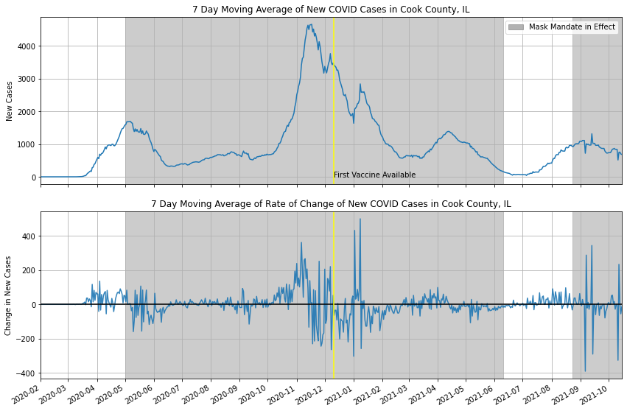

Figure 3: Changes in cases and new cases over time in Cook County

## Q2 & Q3 Analysis Extension

Figures 4 – 6 show the results of the paired sample t-tests. Starting with dropout rate, the analysis showed that in both title I and non-title I schools there was a significant decrease in the mean dropout rate. (p = 4.4E-8 and p = 1.7E-6 respectively) In non-title I schools, the mean dropout rate decreased from 1.57% to 0.96%, a 38.9% decrease. In title I schools, the mean dropout rate decreased from 5.39% to 3.32%, a 38.4% decrease.

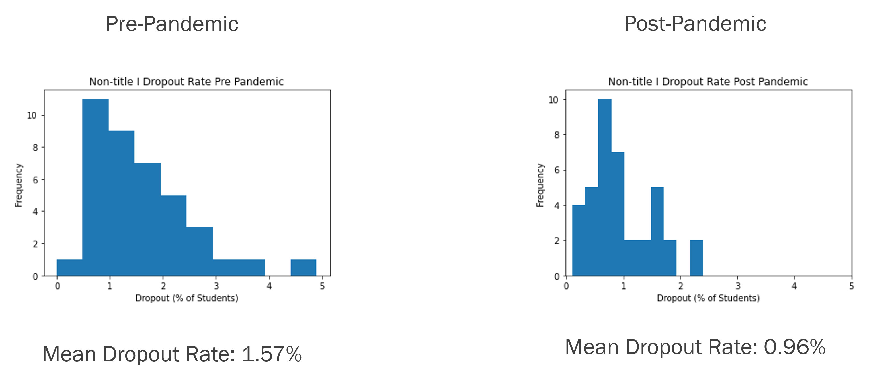

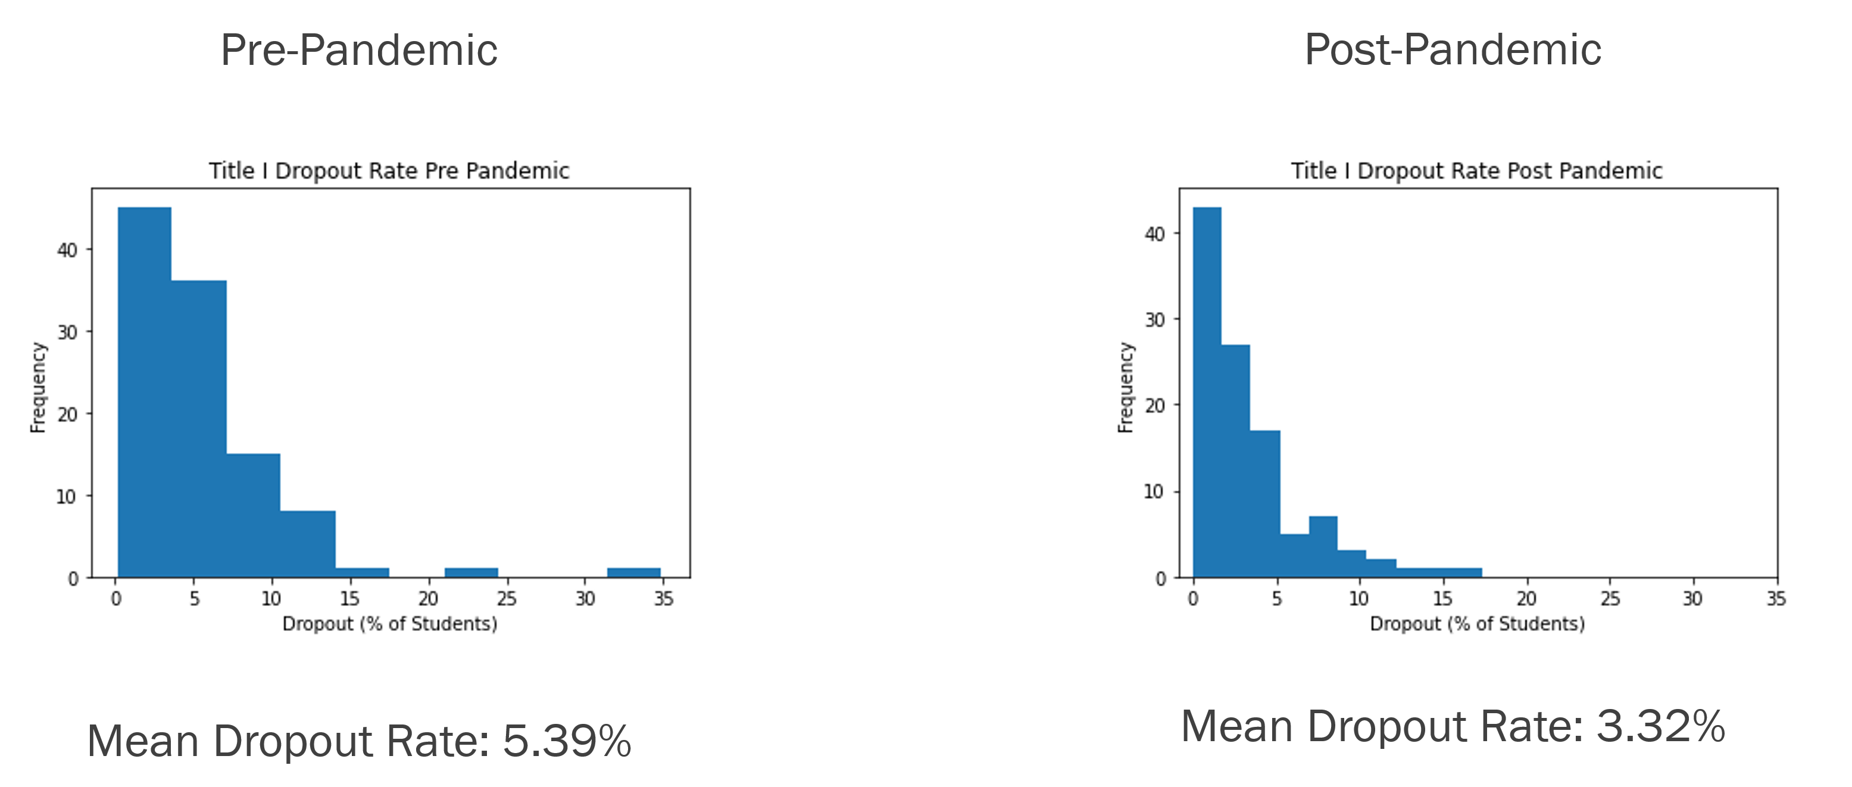

Figure 4: Dropout rate histograms for title I and non-title I schools

Similarly, a significant decrease in attendance rate was observed in both title I and non-title I schools. (p=5.2E-98 and p=2.9E-17 respectively) In non-title I schools, the mean attendance rate decreased from 95.36% to 92.54%, a 2.96% decrease. In title I schools, the mean attendance rate decreased from 95.37% to 90.69%, a 4.9% decrease.

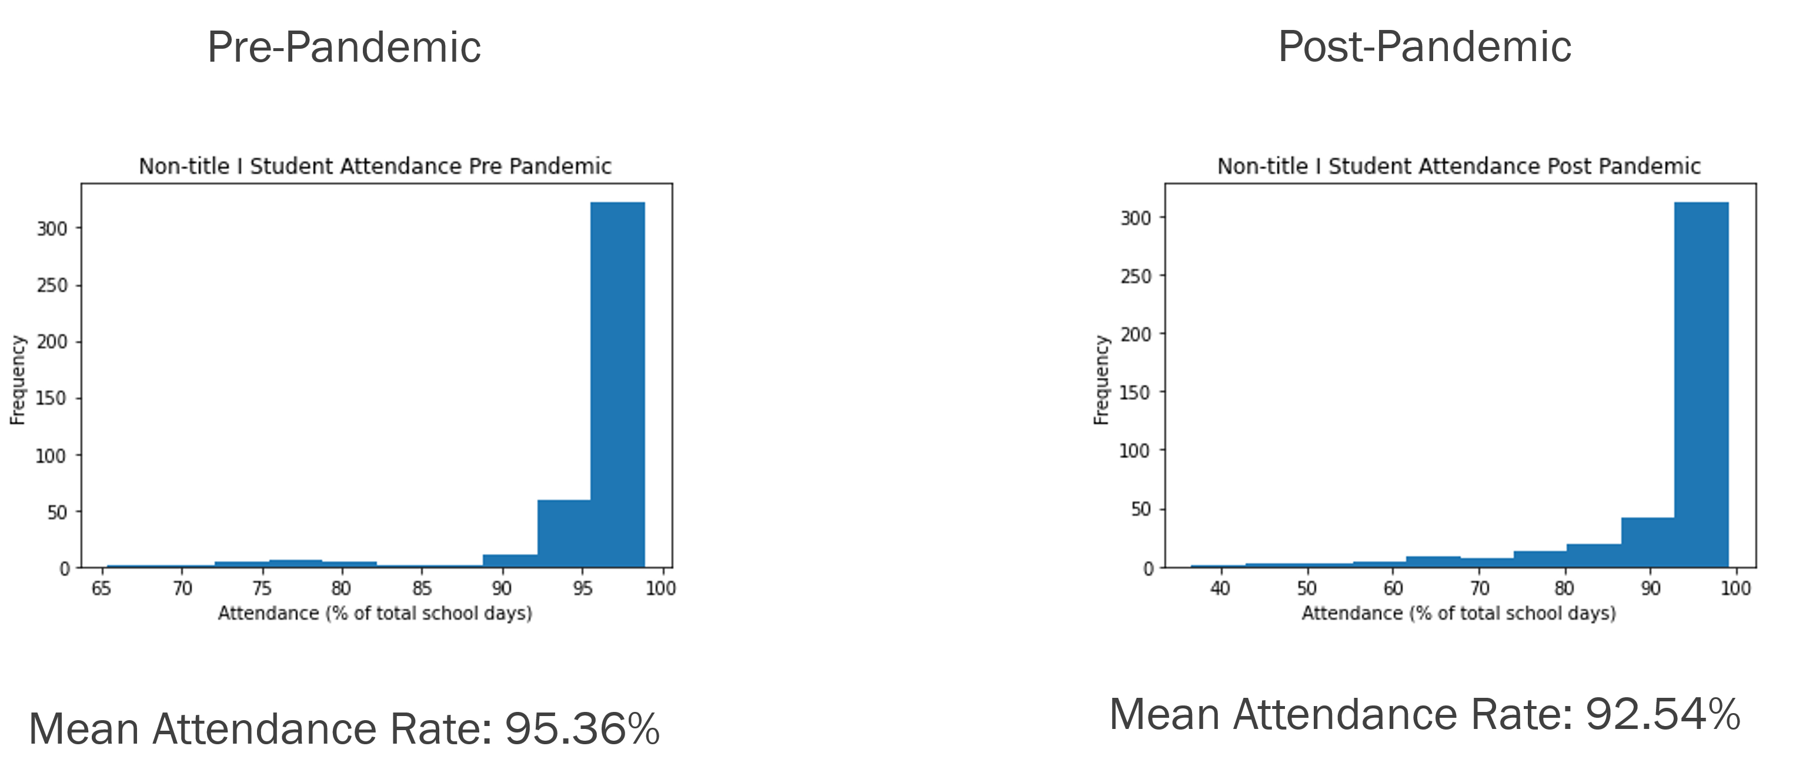

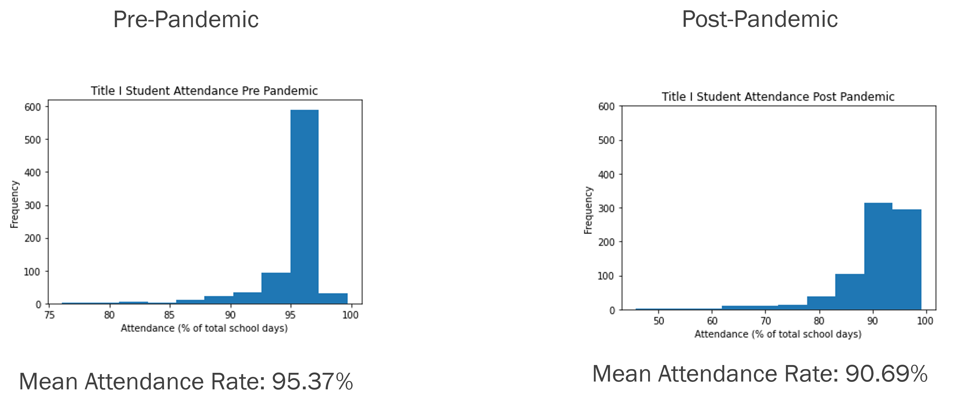

Figure 5: Attendance rate histograms for title I and non-title I schools

Finally, teacher retention rate saw a statistically significant improvement in both title I and non-title I schools. (p=4.4E-31 and p=4.1E-3 respectively) In non-title I schools, the mean retention rate increased from 80.13% to 81.01%, a 1.1% increase. In title I schools, the mean retention rate increased from 82.35% to 85.39%, a 3.69% increase.

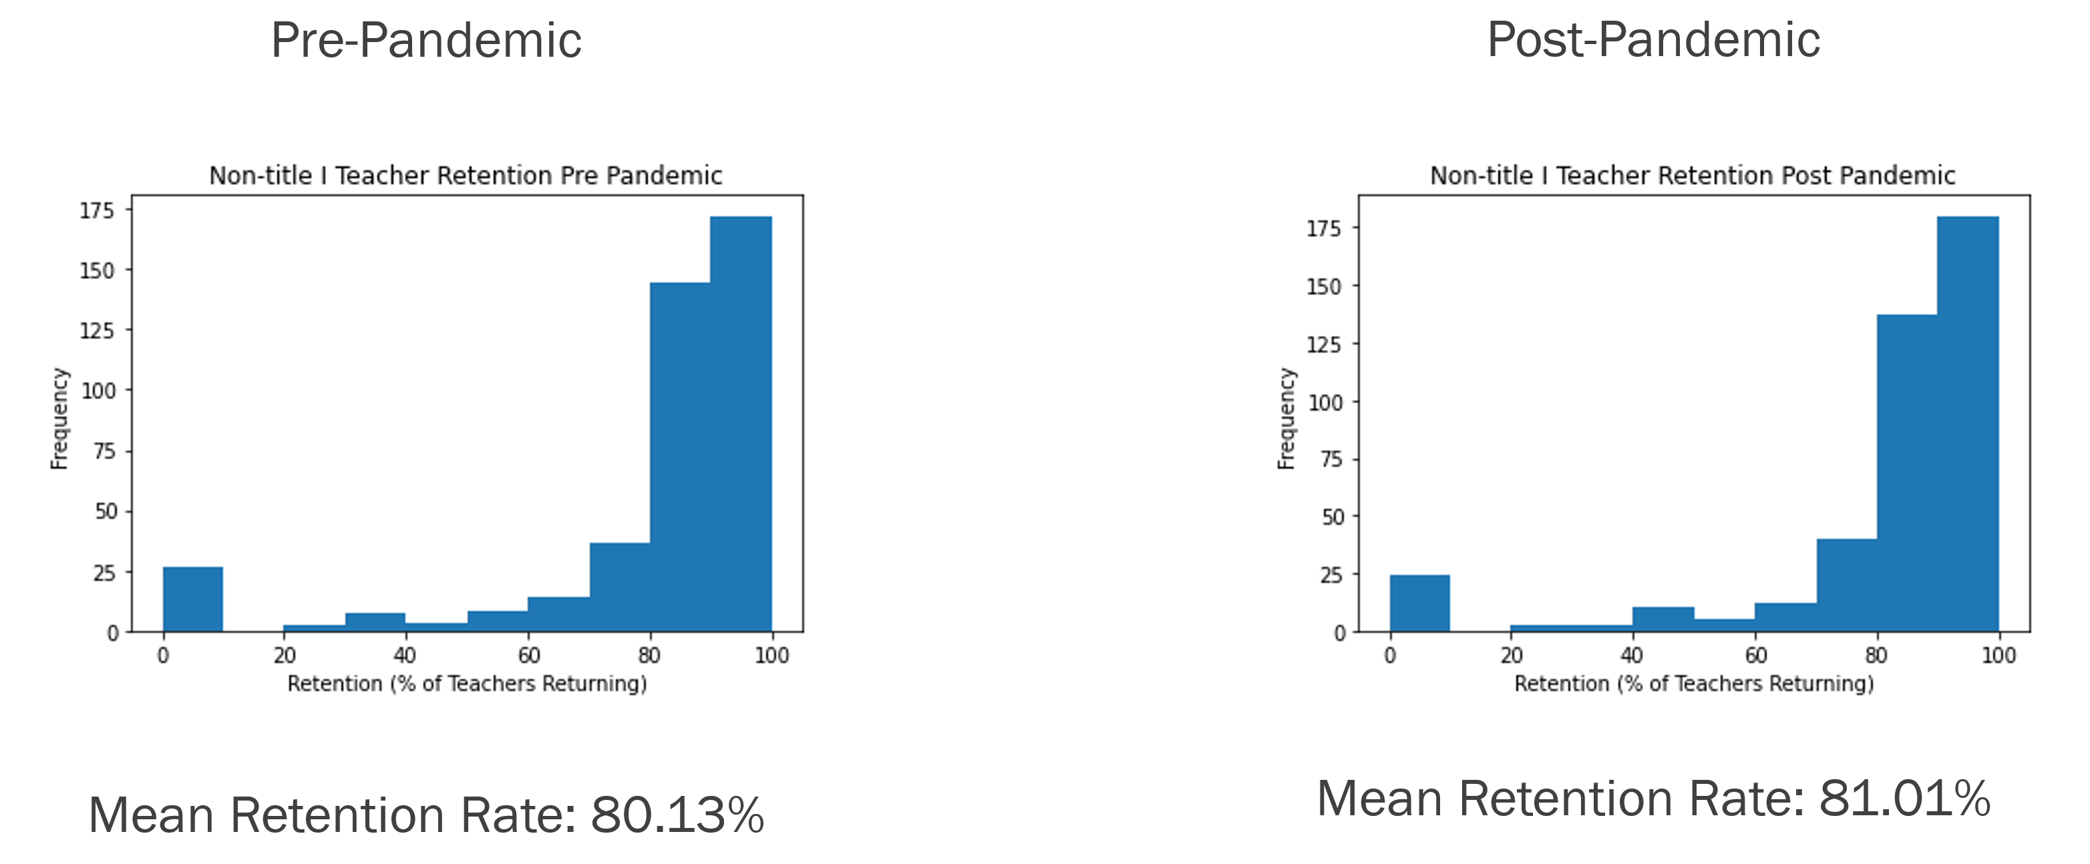

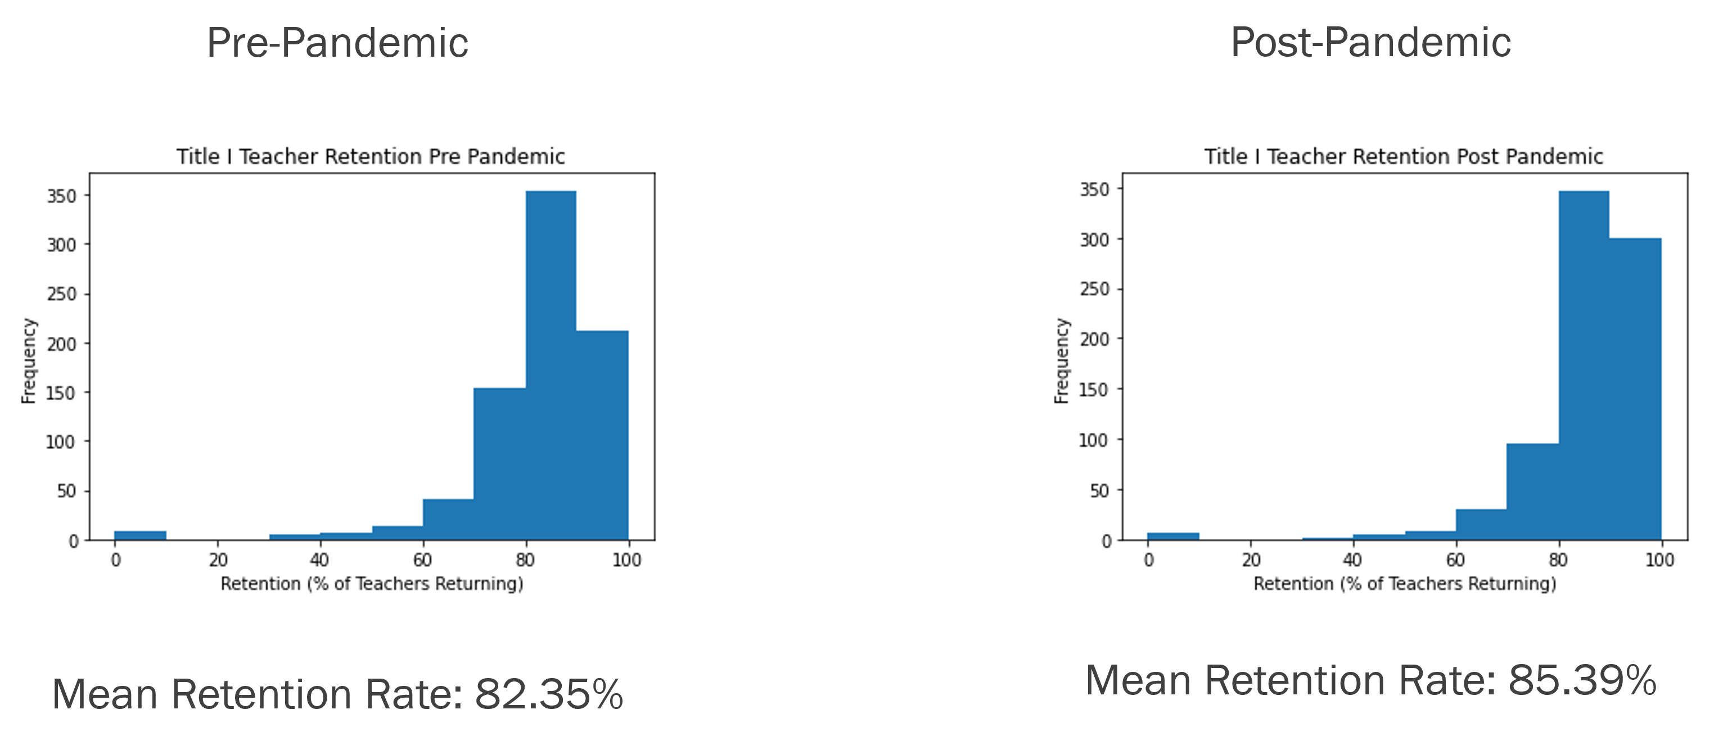

Figure 6: Teacher retention rate histograms for title I and non-title I schools

# Discussion

Answering questions adequately about the pandemic is difficult, especially while the situation is constantly developing. It is difficult to make definitive statements in a constantly changing situation, but the three hypotheses discussed in this paper, H1-3, have been tested in this analysis.

The first hypothesis tested (H1) was not adequately answered using the SIRD model, but the visualization suggests that after the two mask mandates were put into place, there was a decrease in new cases. Due to the many factors that affect the spread of the virus, we do see that regardless of the mask mandate, there was an increase in case rates during the winter time. A topic of future study can be to address why this occurs, but current theories suggest that it could be due to people staying inside more often.

The second hypothesis tested (H2) was partially confirmed. While rates of attendance worsened in schools, the dropout rate and teacher retention rate improved. It is difficult to conclude whether this finding indicates a worsening or improvement in the total quality of education. The effects of missing a few months of schooling and the low attendance rates may take time to reveal themselves. This finding shows the value in exploring digital learning as an option for schools in the future. Future longitudinal studies should be performed on children to identify what impacts this pandemic will have on the education of this generation after they finish schooling.

The third hypothesis (H3) also had partial confirmation. While dropout rates and teacher retention rates both saw improvement, disproving the hypothesis, we see that attendance in title I schools saw a much larger decrease than in non-title I schools. Future studies can look into this disparity to better understand why this happened and what can be done to ensure attendance equity in the future.

# Limitations

There are many limitations to this study. As discussed earlier, the SIRD model was inadequate to capture enough of the factors that impact the spread of COVID-19. While visually it may appear that case rates declined after the institution of a mask mandate, a broader study will have to be conducted to reach a consensus on whether it works in every scenario. In this scenario, mask compliance was at a relatively high level of 98% reporting they at least rarely wear a mask, with 72% reporting that they always wear a mask. (DS6) It would be interesting to see whether this drop in case rates appeared in areas with low levels of mask compliance.

A key limitation of the education analysis was the loosening in graduation requirements that occurred just as the pandemic was starting. (Chicago Public Schools, 2020) Given the timing of this change in policy, it is reasonable to expect that high schoolers who were planning on dropping out may have already done so prior to this change in requirements being put into place. Since there is no evidence of these graduation requirements changing for the following year, it is possible that the improvement in graduation rates can be attributed to these laxed requirements.

# Conclusion

The findings from this study are numerable:

1. There is evidence that shortly after a mask mandate was put into place, there was a drop in new cases in Cook County, IL.
2. Dropout rates declined for both title I and non-title I schools in Cook County, IL.
3. Student attendance declined for both title I and non-title I schools, with there being a larger impact on title I schools in Cook County, IL.
4. Teacher retention rates increased for both title I and non-title I schools in Cook County, IL.

This has given me an increased appreciation for the work that COVID researchers do to attempt to answer these important questions. While an extremely complex, worldwide event is developing it is very hard to come to an accurate conclusion on what impact it has had, but there is certainly value in trying.

# References

Chicago Public Schools. (2020, April 30). *Chicago Public Schools Releases Equity-Focused Guidance on Grading, Graduation Requirements and Promotion Policy*. Retrieved from Chicago Public Schools Web Site: https://www.cps.edu/press-releases/chicago-public-schools-releases-equity-focused-guidance-on-grading-graduation-requirements-and-promotion-policy/

Fernández-Villaverde, J., & Jones, C. (2020). Estimating and Simulating a SIRD Model of COVID-19 for Many Countries, States, and Cities. *National Bureau of Economic Research*.

Ginsburg. (2014). *Key Education Indicators for NAEP: A Composite Indicator Approach.* Washington, District of Columbia: National Assessment Governing Board. Retrieved from https://www.nagb.gov/focus-areas/reports/key-education-indicators-for-naep.html

Macy, M. L., Smith, T. L., Cartland, J., Golbeck, E., & Davis, M. M. (2021). Parent‐reported hesitancy to seek emergency care for children at the crest of the first wave of COVID‐19 in Chicago. *Academic emergency medicine*, 355-358.

microCOVID Project. (2021, November 4). *Research Sources*. Retrieved from microCOVID Project: https://www.microcovid.org/paper/14-research-sources

Mustanski, B. S. (2021). Geographic disparities in COVID-19 case rates are not reflected in seropositivity rates using a neighborhood survey in Chicago. *Annals of epidemiology*.

Peeples, L. (2020, 10 6). *Face masks: what the data say*. Retrieved from nature: https://www.nature.com/articles/d41586-020-02801-8

U.S. Department of Education. (2018, October 24). *Improving Basic Programs Operated by Local Educational Agencies (Title I, Part A)*. Retrieved from U.S. Department of Education Web Site: https://www2.ed.gov/programs/titleiparta/index.html

# Data Sources

[DS1: Illinois Report Card Data](https://www.isbe.net/pages/illinois-state-report-card-data.aspx)  
[DS2: Chicago Public Schools Dropout Rates](https://www.cps.edu/about/district-data/metrics/)  
[DS3: City of Chicago Progress Reports](https://data.cityofchicago.org/Education/Chicago-Public-Schools-School-Progress-Reports-SY2/ngix-dc87)  
[DS4: RAW_us_confirmed_cases](https://www.kaggle.com/antgoldbloom/covid19-data-from-john-hopkins-university?select=RAW_us_confirmed_cases.csv)  
[DS5: State and Territorial Mask Mandates](https://data.cdc.gov/Policy-Surveillance/U-S-State-and-Territorial-Public-Mask-Mandates-Fro/62d6-pm5i)  
[DS6: Mask Use Survey](https://github.com/nytimes/covid-19-data/tree/master/mask-use)