**Write up:**

Creating the random number guesser was a really interactive and hands on project. In this project I learned how to use input validation, which determined whether the guess was low or high. I also continued using my previous skills of displaying a message to direct the user. In addition, I learned how to set a range of numbers to choose from based on the user’s input, which is also apart of input validation.

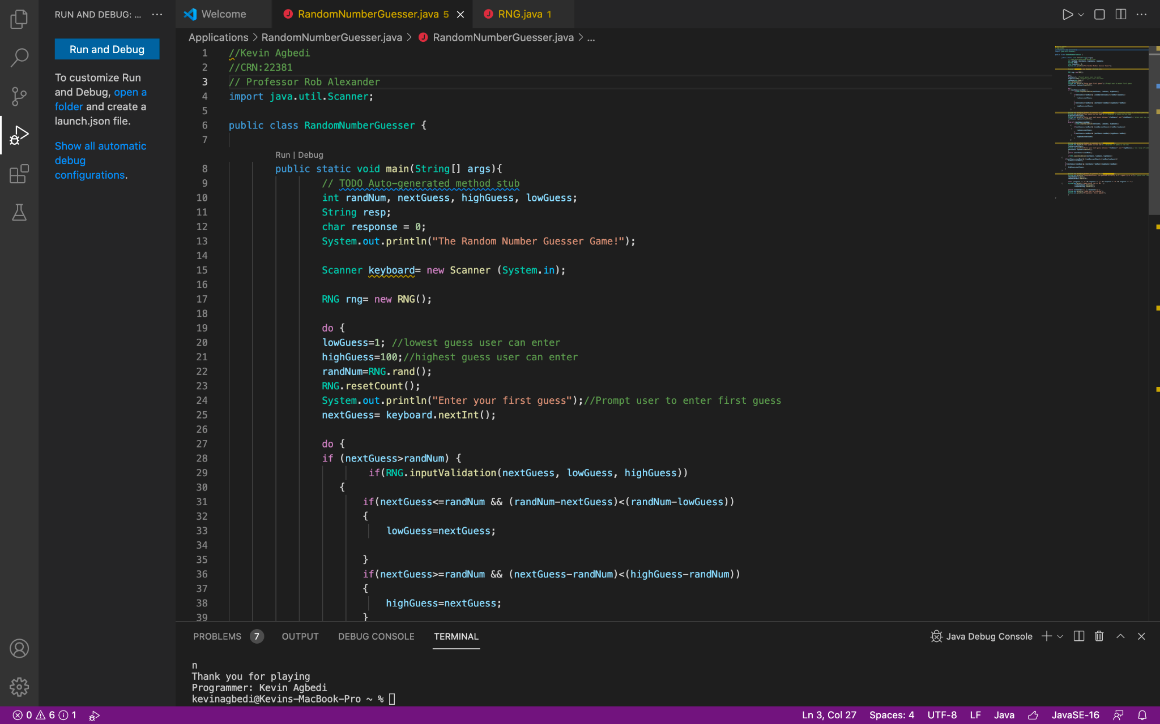**Regular Run**

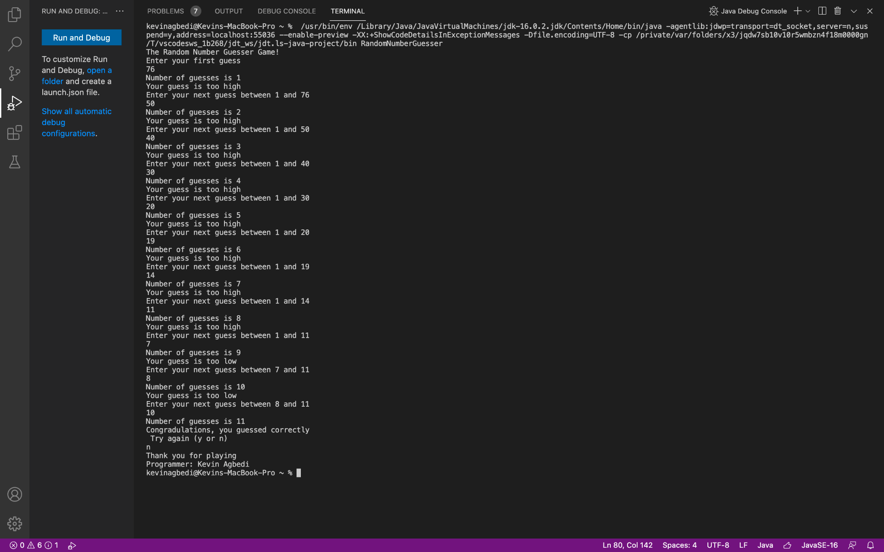

**Run when entering numbers out of the given range**

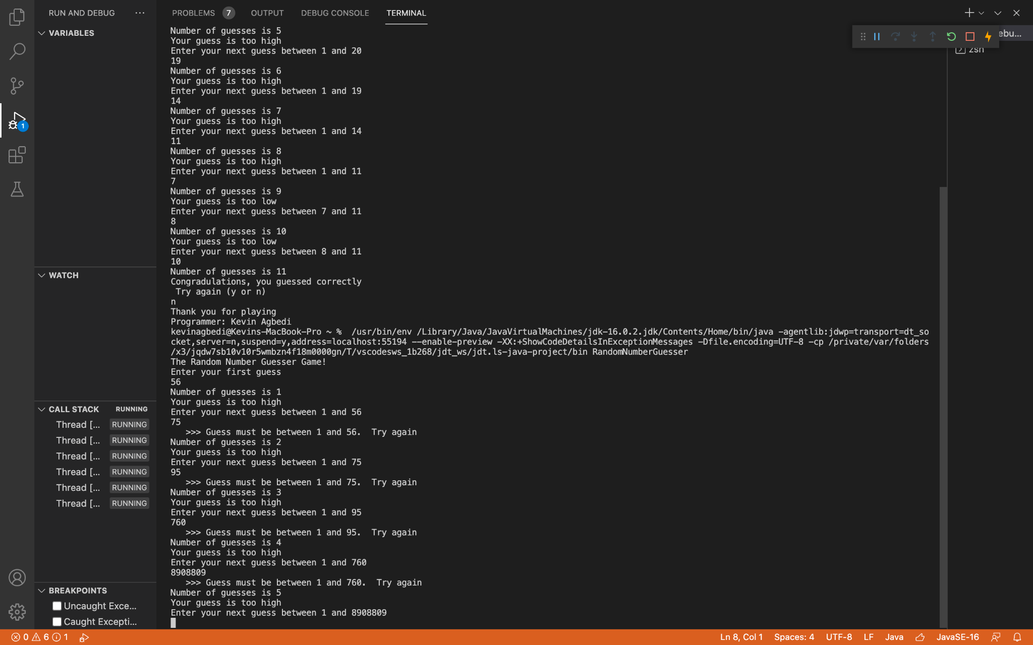

**Final PseudoCode:**

**ASSIGNMENT 2 DESIGN**

**1. Prompt user to make a guess**

**2. Display the attempt number of guess**

**3. If guess is too low display “Too low”**

**4. Prompt user to enter a new guess between the appropriate intervals**

**5. If number entered is not between the interval display “Try again”**

**6. If guess is too high display “Too high”**

**7. Prompt user to enter a new guess between a smaller interval**

**8. Once the user has enter the correct number display “Congratulation,**

**you guessed correctly”**

**9. Ask user if they would like to restart**

**10. If user enters “No” display “Thanks for playing”**