**Enterprise Software Architecture**

**Lab – 1**

Keval Sompura

IAM Credentials

URL: <https://225989365782.signin.aws.amazon.com/console>

Username: grader

Password: daJ8b1()

1. Screenshots of your AWS Console showing the instance running and the volumes  
   you have allocated on EBS.

Volume allocated

1. Output of Linux command “ fdisk -l” in the instance.

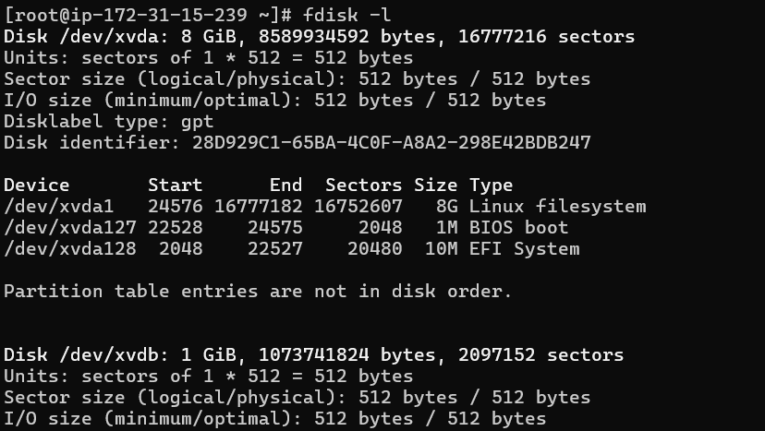

1. Output of running docker inspect on the database and application containers.

* Will be included in the video.

1. Output of Linux command “df” in instance

