**Lab Practical #03:**

Study of different types of network cables & connectors and crimping a LAN.

**Practical Assignment #03:**

1. List various networks cable. Also, write short description.
2. Difference between guided and unguided media.
3. Give cross-wired cable and straight through cable diagram (Color Code wise).
4. **List various networks cable and connectors. Also, write short description.** 
   1. **Network Cable Name: Twisted Pair Cable** o **Description**: o It is a physical media made up of a pair of cables twisted with each other. o It is cheap as compared to other transmission media.
      * Installation of the cable is easy and it is a lightweight cable. o The frequency range for cable is from 0 to 3.5KHz. o It consists of two insulated copper wire arranged in regular spiral pattern. o The degree of reduction in noise interference is determined by the number of turns per foot.
      * Increasing the number of turns per foot decreases noise interference.
      * Separately insulated. o It is widely used in different kinds of data and voice infrastructure. o The use of two wires twisted together helps to reduce crosstalk and electromagnetic induction.

o **Diagram**:

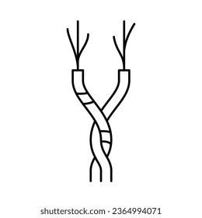

* 1. **Network Cable Name: Unshielded Twisted Pair Cable** o **Description**: o An unshielded twisted pair is widely used in telecommunication. o Ordinary telephone wires. o Weak immunity against noise & interferences. o Following are the categories of UTP: o Category 1: Used for telephone lines that have low-speed data. o Category 2 & 3: It can support up-to 4Mbps & 16Mbps. o Category 4: It can support up-to 20Mbps.
     + It can be used for long-distance communication. o Category 5: It can support up-to 200Mbps. o Advantages**:** o It is cheap. o Installation of the unshielded twisted pair is easy. o It can be used for high-speed LAN. o Disadvantage:
     + This cable can only be used for shorter distances because of attenuation o **Diagram**:

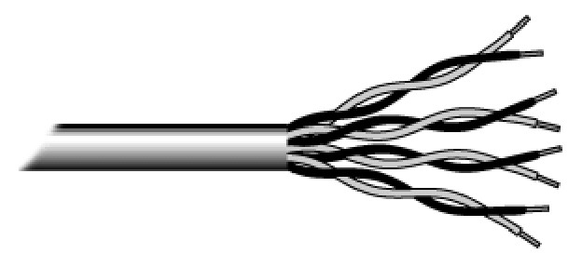

* 1. **Network Cable Name: shielded Twisted Pair Cable** o **Description**:
     + A shielded twisted pair is a cable that contains the mesh surrounding the wire that allows the higher transmission rate. o An installation of STP is easy. o It has a higher attenuation. o It is shielded that provides the higher data transmission rate. o It is more expensive as compared to UTP and coaxial cable.
     + It has higher capacity as compared to unshielded twisted pair cable. o Used in exterior network (outside of building).
     + **Diagram**:

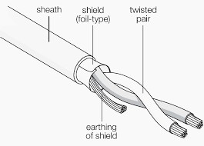

* 1. **Network Cable Name: Coaxial Cable** o **Description**: o Outer conductor is braided shield. o Inner conductor is solid metal. o Separated by insulating material, and whole cover by plastic cover. o The middle core is responsible for the data transferring whereas the copper mesh prevents from the **EMI** (Electromagnetic interference). o Used in television, long distance telephone transmission.
     + It has excellent noise immunity.
     + It has a higher frequency as compared to Twisted pair cable.

⇨ **Coaxial cable is of two types**:

* + - **Baseband transmission:**
    - It is defined as the process of transmitting a single signal at high speed.

* + - **Broadband transmission:**
    - It is defined as the process of transmitting multiple signals simultaneously.

* + - **Advantages of Coaxial cable**: o The data can be transmitted at high speed. o It has better shielding as compared to twisted pair cable.
    - It provides higher bandwidth.

* + - **Disadvantages of Coaxial cable**:
    - It is more expensive as compared to twisted pair cable.
    - If any fault occurs in the cable causes the failure in the entire network.

o **Diagram**:

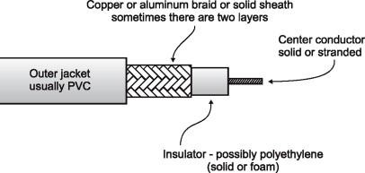

* 1. **Network Cable Name: Fiber Optic Cable** o **Description**: o A fiber-optic cable is made of glass or plastic and transmits signals in the form of light. o A glass or plastic core is surrounded by a cladding of less dense glass or plastic.
     + The difference in density of the two materials must be such that a beam of light moving through a core is reflected off the cladding instead of being refracted into it.
     + Optical fibers use reflection to guide light through a channel.
     + **Core:** The optical fibre consists of a narrow strand of glass or plastic known as a core. o **Cladding:** The concentric layer of glass is known as cladding. o **Jacket:** The protective coating consisting of plastic is known as a jacket.
     + Light travels in a straight line as long as it is moving through a single uniform substance.

* + - **Advantages :** o It provides faster data transmission than copper wires. o It carries the data at a longer distance as compared to copper cable. o Small size & weight. o Better Reliability. o Used in high bandwidth network.
    - High data rate & lower attenuation.

o **Diagram**:

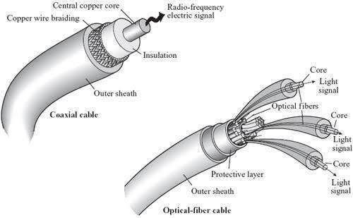

1. **Difference between guided and unguided media.**

|  |  |  |
| --- | --- | --- |
| No. | Guided Media | Unguided Media |
| 1 | The guided media is also called wired communication or bounded transmission media. | The unguided media is also called wireless communication or unbounded transmission media. |
| 2 | The signal energy propagates through wires in guided media. | The signal energy propagates through the air in unguided media. |
| 3 | Used to perform point-to-point communication. | Unguided media is generally suited for radio broadcasting in all directions. |
| 4 | It is affordable. | It is costly. |
| 5 | Discrete network topologies are formed by the guided media. | Continuous network topologies are formed by the unguided media. |
| 6 | Signals are in the form of voltage, current, or photons in the guided media. | Signals are in the form of electromagnetic waves in unguided media. |

1. **Give cross-wired cable and straight through cable diagram (Color Code wise).** 
   1. Cross-wired Cable Diagram (Color Code)

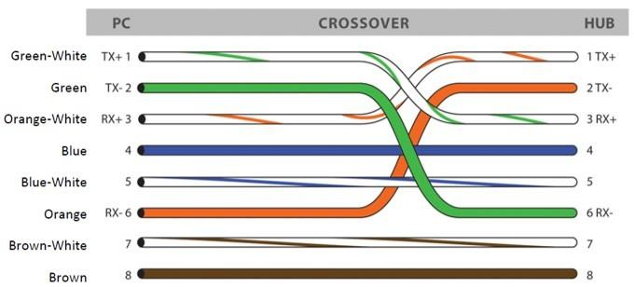

* 1. Straight Through Cable Diagram (Color Code)

