**Lab Practical #04:**

Installation of Network Simulator (Packet Tracer) and Implement different LAN topologies.

**Practical Assignment #04:**

1. **Create a simple network with switch and two or more pc. Also check connectivity between them using ping command or PDU utility.**
2. **Implement different topologies in packet tracer.** 
   1. **Bus**
   2. **Ring**
   3. **Star**
   4. **Mesh**
   5. **Tree**

1. **Simple Network**

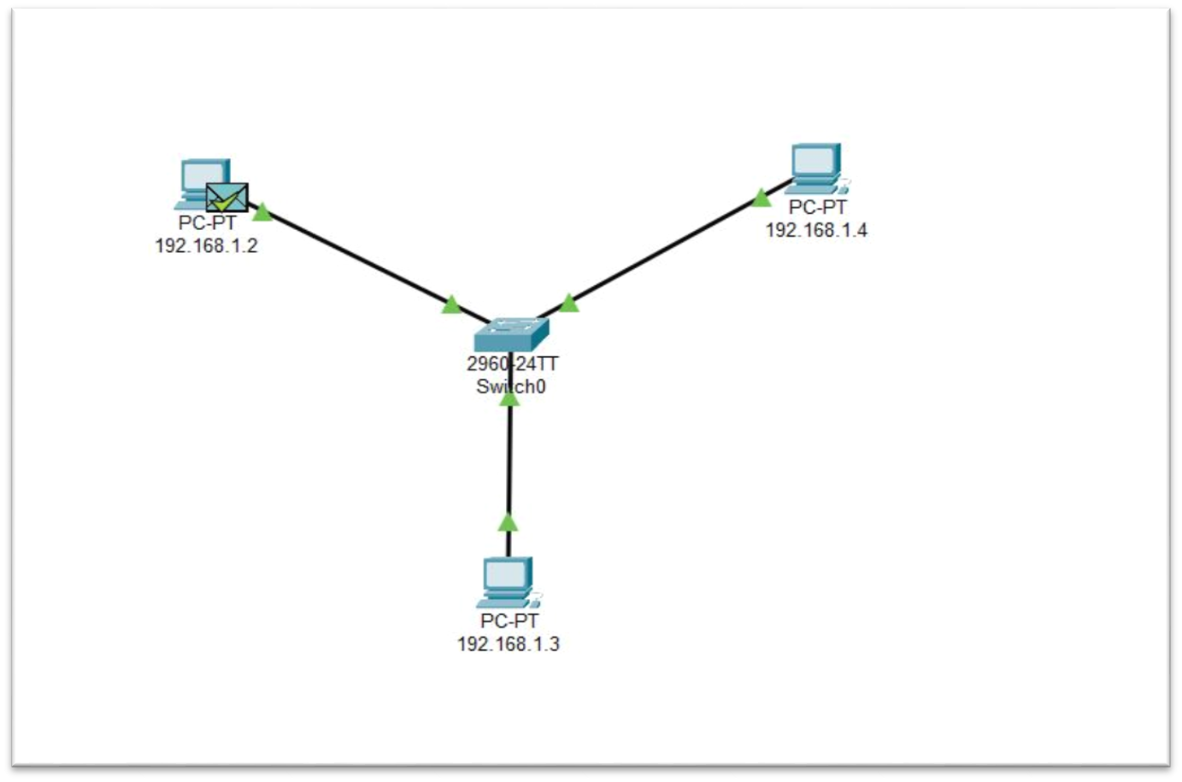

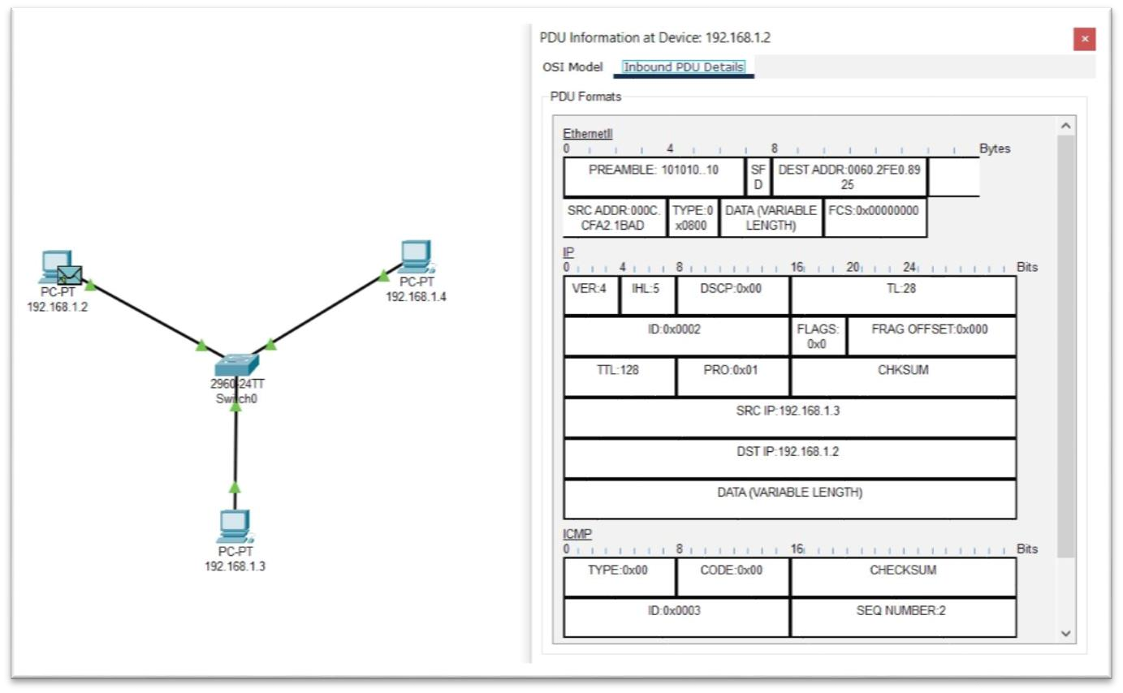

1. **Topologies**

**a. Bus Topology**

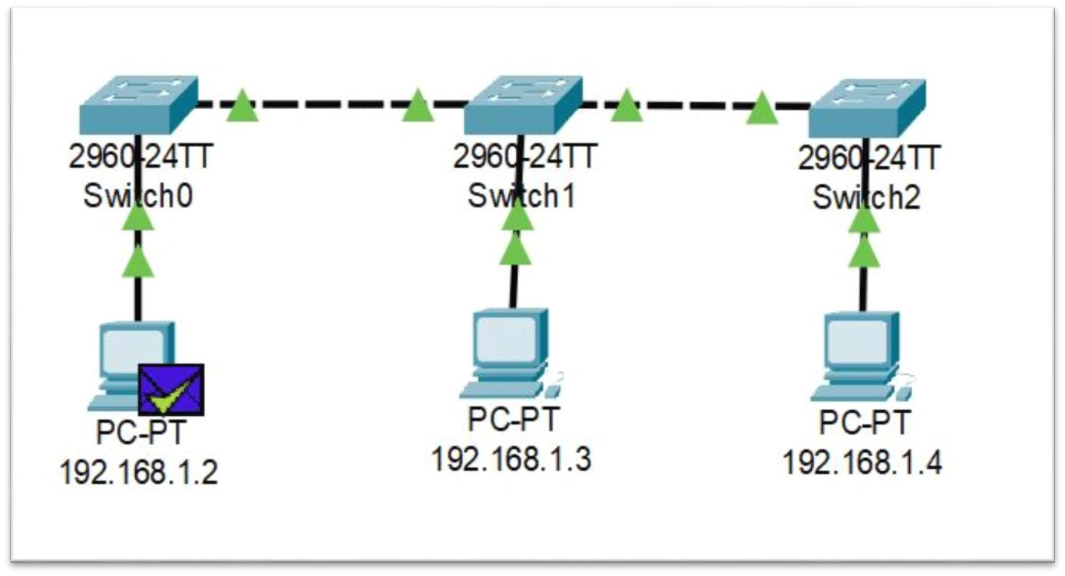

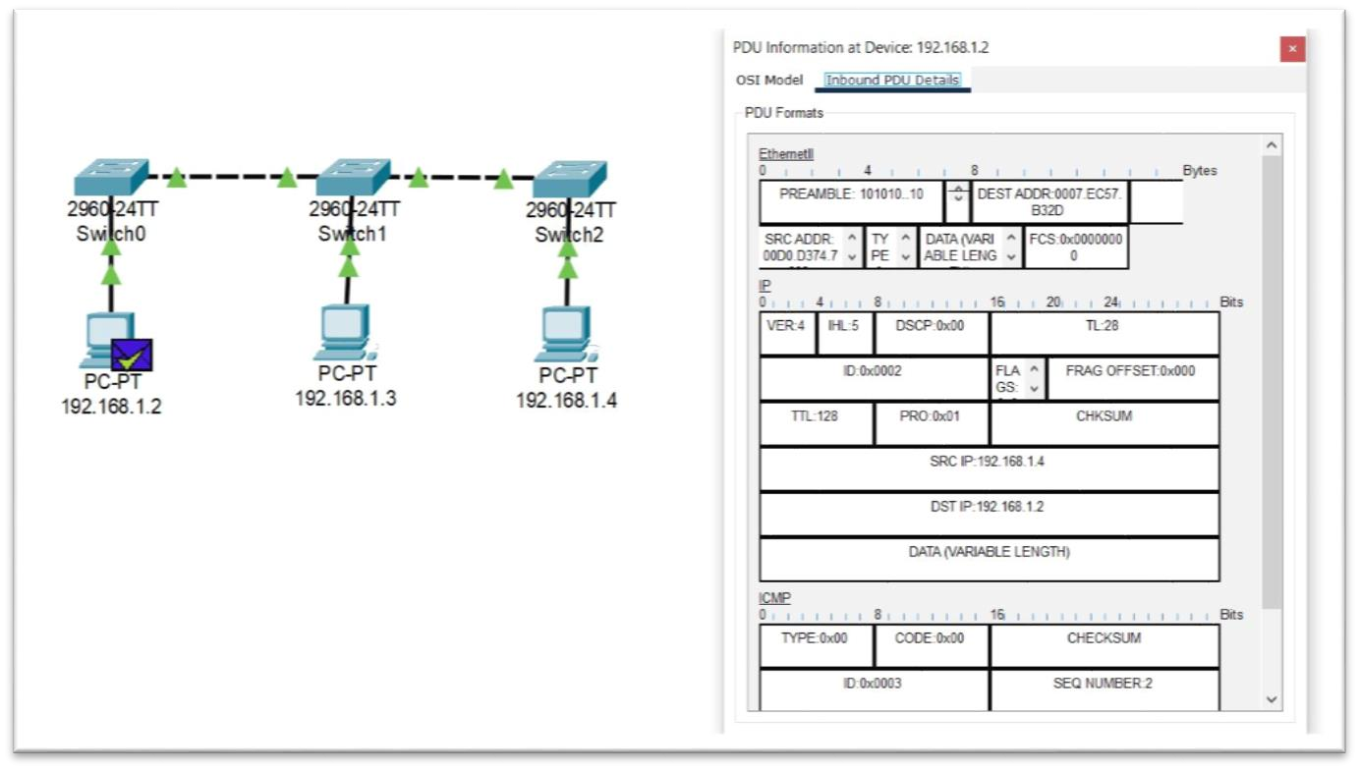

**b. Ring Topology**

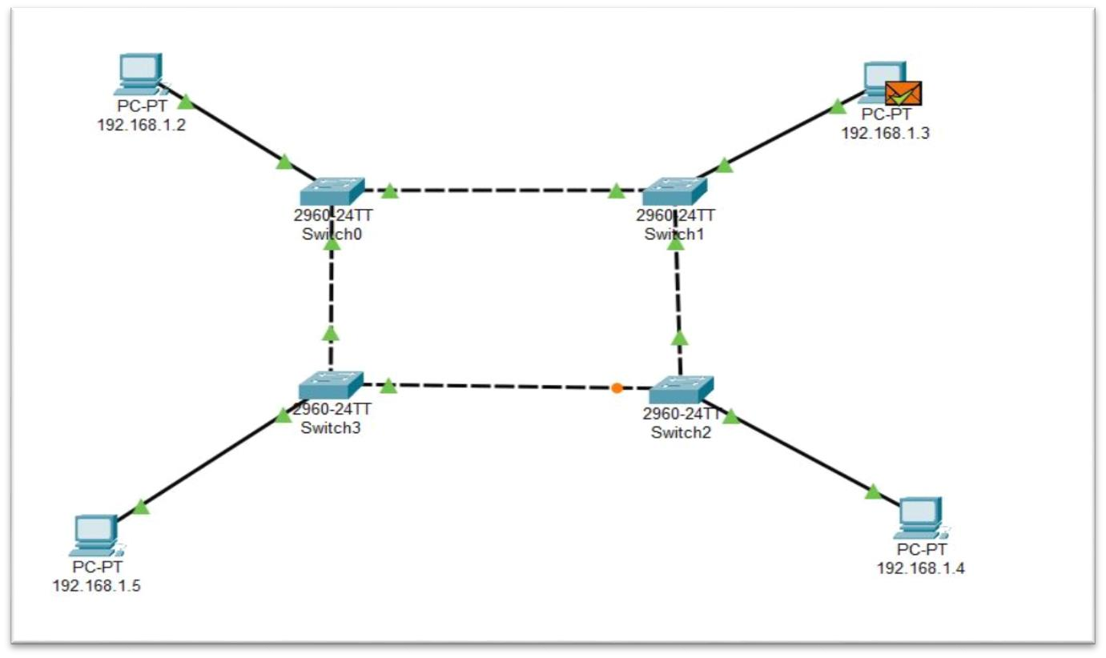

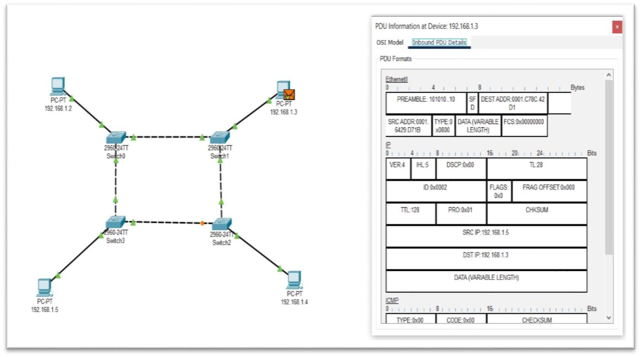 **c. Star Topology**

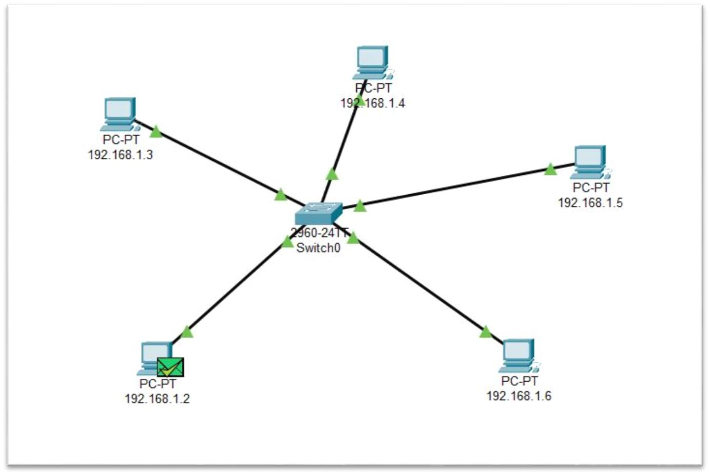

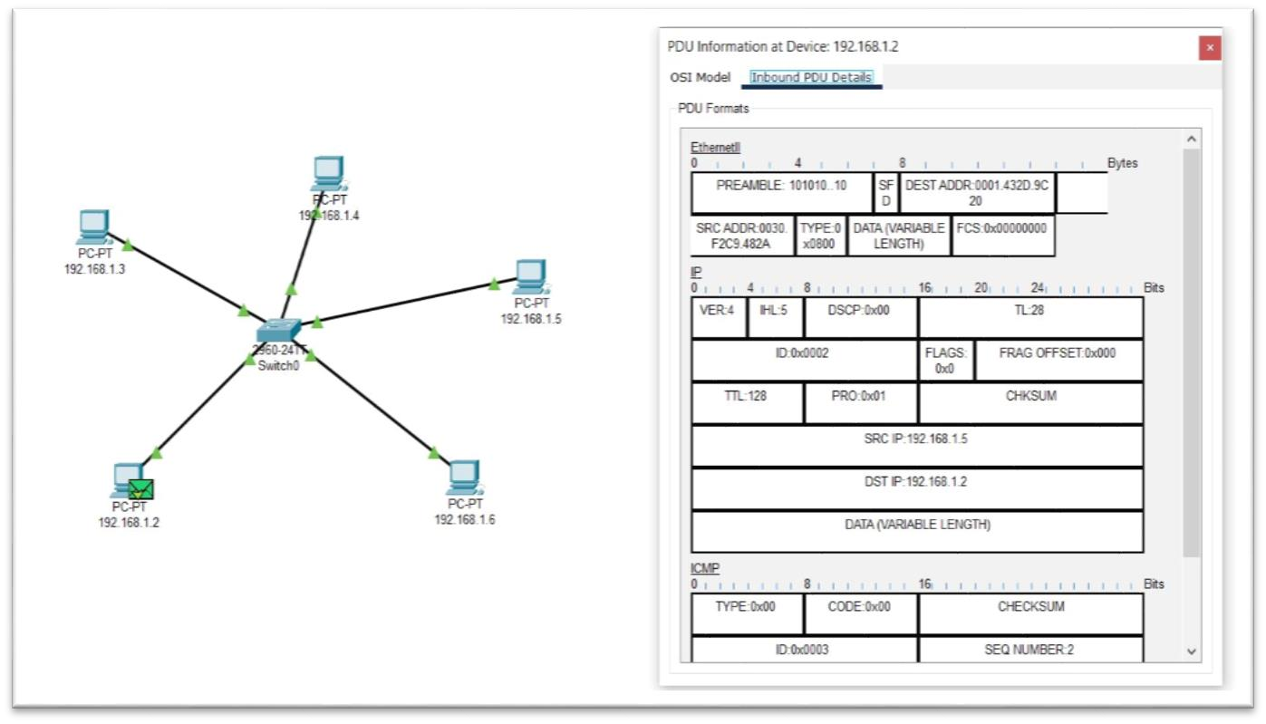

**d. Mesh Topology**

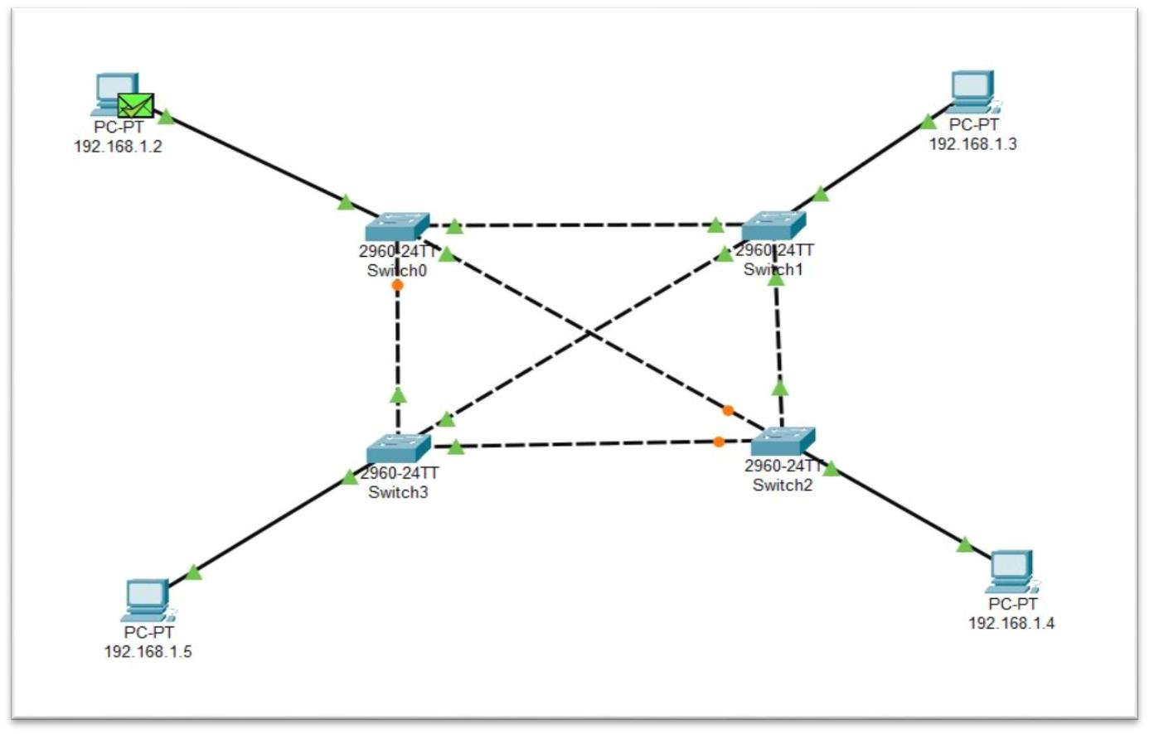

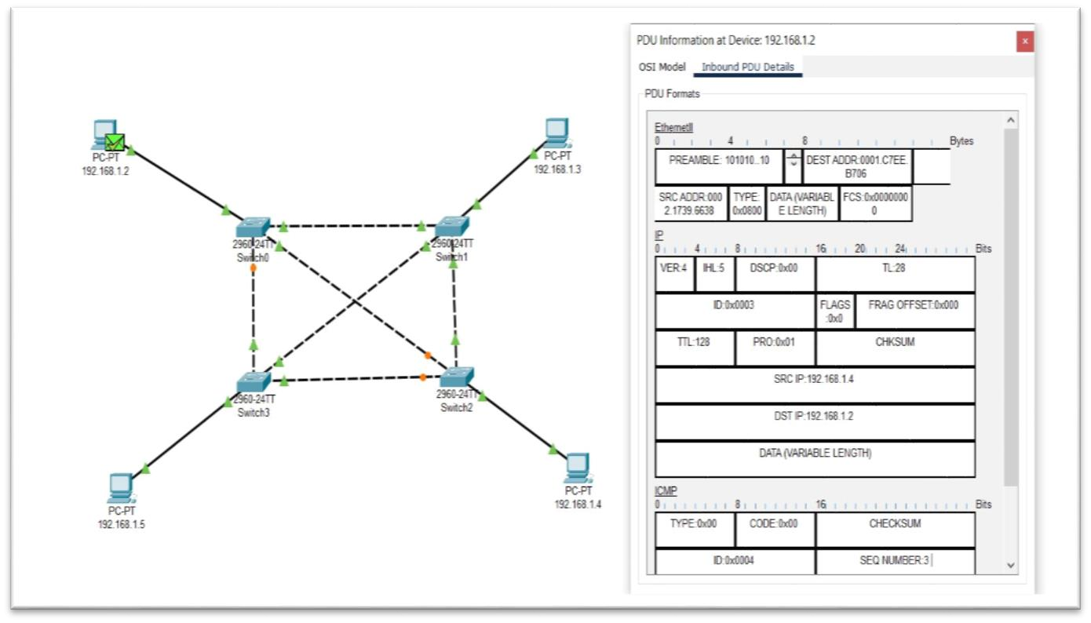

**e. Tree Topology**

