**Lab Practical #05:**

Study the concept of VLAN using packet tracer.

**Practical Assignment #05:**

**1. Implement the different network structures in VLAN and VLAN trunking. Also check connectivity between them using ping command or PDU utility.**

**Instructions:**

1. Different VLANs configuration setup screenshot. (VLAN example given by lab faculty)
2. Write steps to create VLANs in packet tracer.
3. Mention IP address of each pc as label.
4. Ping command or PDU screenshot between two VLANs.

**1.**

**VLAN_1:**

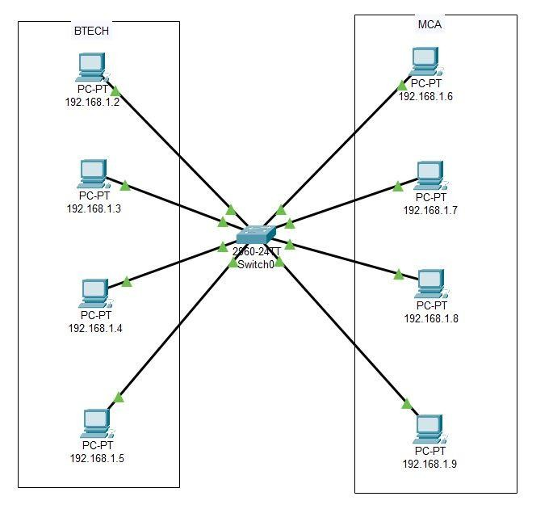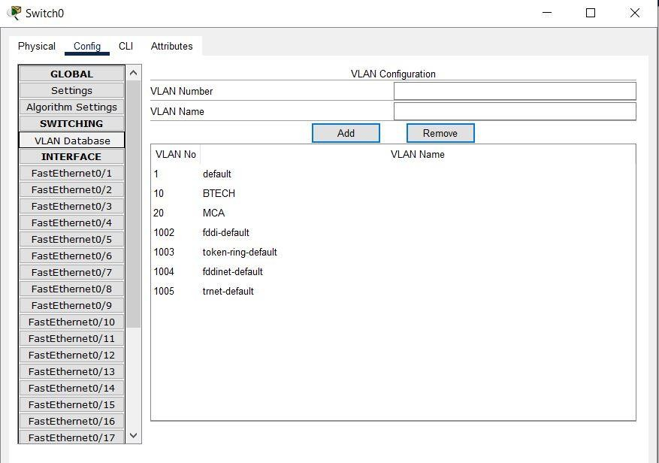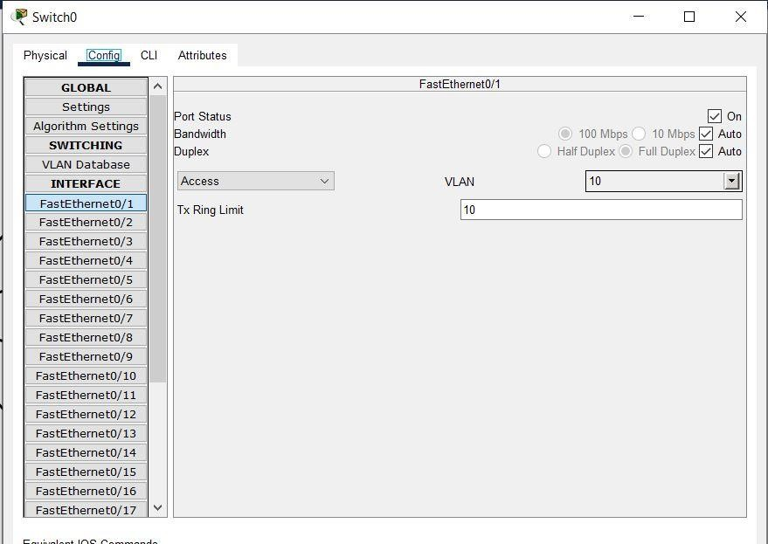

# 1.1 Steps to Create in Packet Tracer

## 1. Add Devices in Workspace

* Drag one **2960-24TT switch** into workspace.
* Add 8 PCs → split into two groups:
  + **BTECH Group (Left side)** → PC0, PC1, PC2, PC3.
  + **MCA Group (Right side)** → PC4, PC5, PC6, PC7.
* Connect each PC to the switch using **Straight-Through cables**.

## 2. Assign IP Addresses to PCs

On each PC →Desktop → IP Configuration:

* BTECH VLAN(VLAN 10) o PC0 → 192.168.1.2 / 255.255.255.0 o PC1 → 192.168.1.3 / 255.255.255.0 o PC2 → 192.168.1.4 / 255.255.255.0 o PC3 → 192.168.1.5 / 255.255.255.0
* MCA VLAN (VLAN 20) o PC4 → 192.168.1.6 / 255.255.255.0 o PC5 → 192.168.1.7 / 255.255.255.0 o PC6 → 192.168.1.8 / 255.255.255.0 o PC7 → 192.168.1.9 / 255.255.255.0

Add labels to each PC to display its **IP Address**.

## 3. Create VLANs on Switch

Click on the switch → **Config tab → VLAN Database**:

• VLAN 10 → Name: **BTECH** → Add. • VLAN 20 → Name: **MCA** → Add.

## 4. Assign Switch Ports to VLANs

Go to **Switch → Config tab → Interfaces**.

• Assign **FastEthernet 0/1 – 0/4** → VLAN 10 (BTECH). • Assign **FastEthernet 0/5 – 0/8** → VLAN 20 (MCA).

This ensures each group of PCs belongs to its own VLAN.

## 5. Test VLAN Connectivity

* Open **Command Prompt** on a PC.
* Ping another PC in the **same VLAN** → should be successful.
* Ping a PC in a **different VLAN** → will fail (unless VLAN trunking or router is configured).

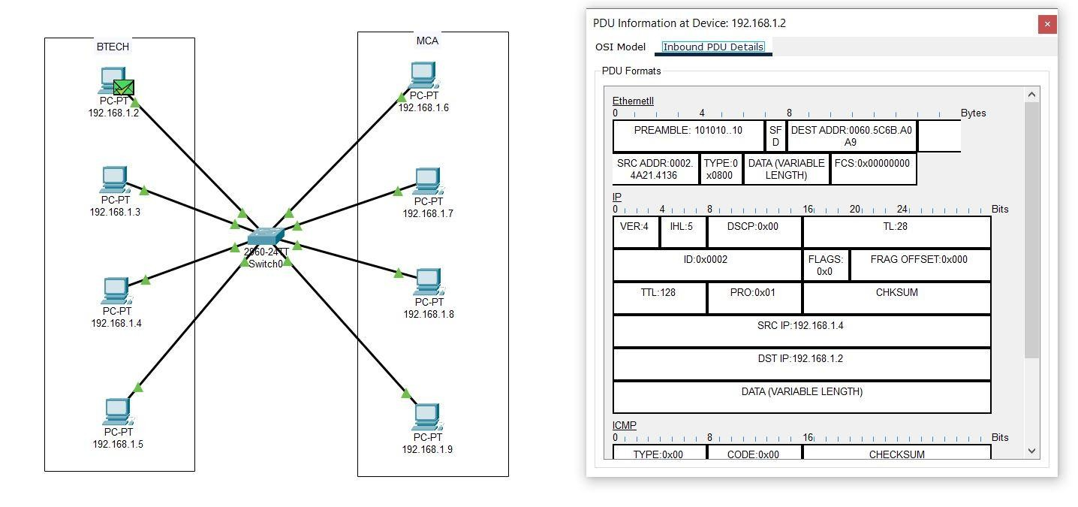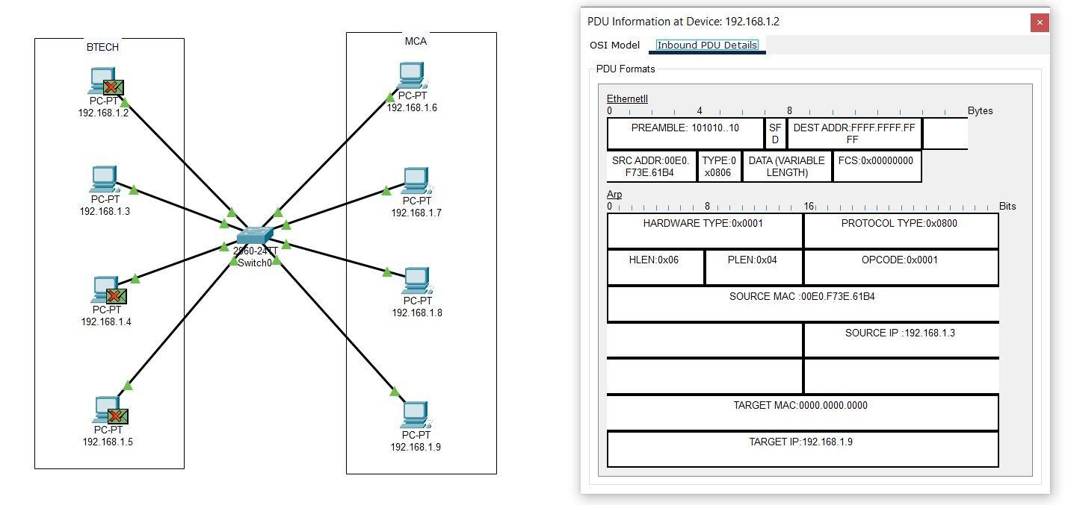

**2. VLAN_2:**

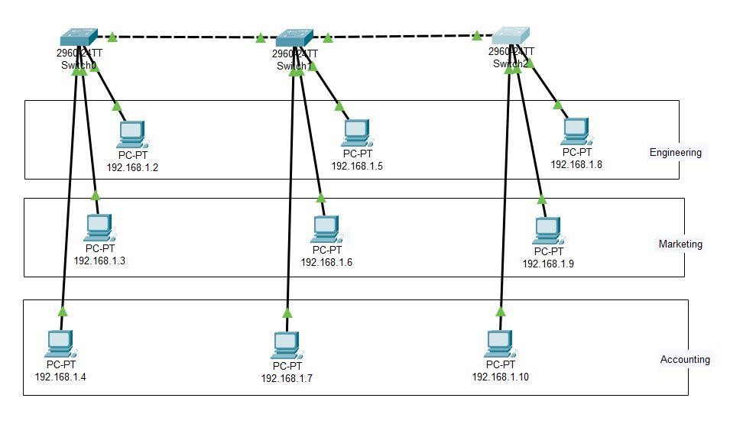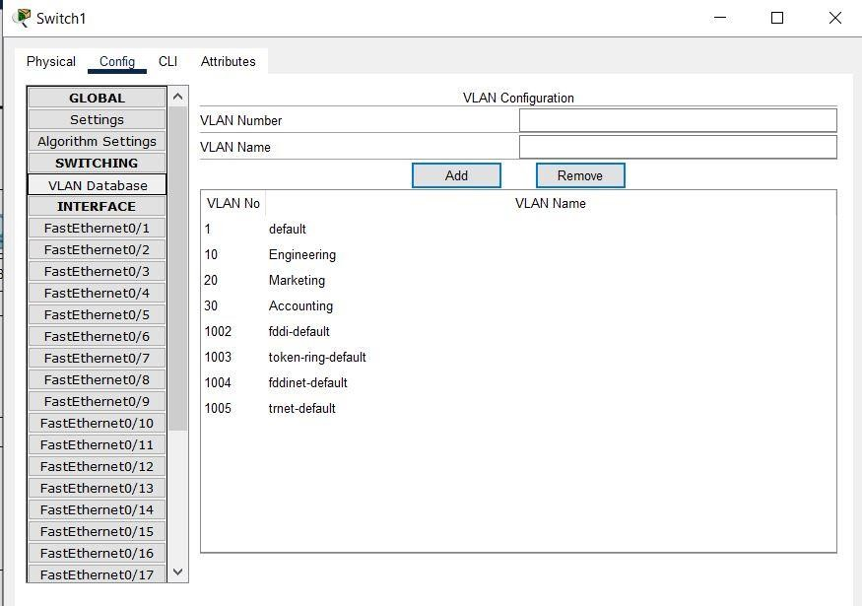

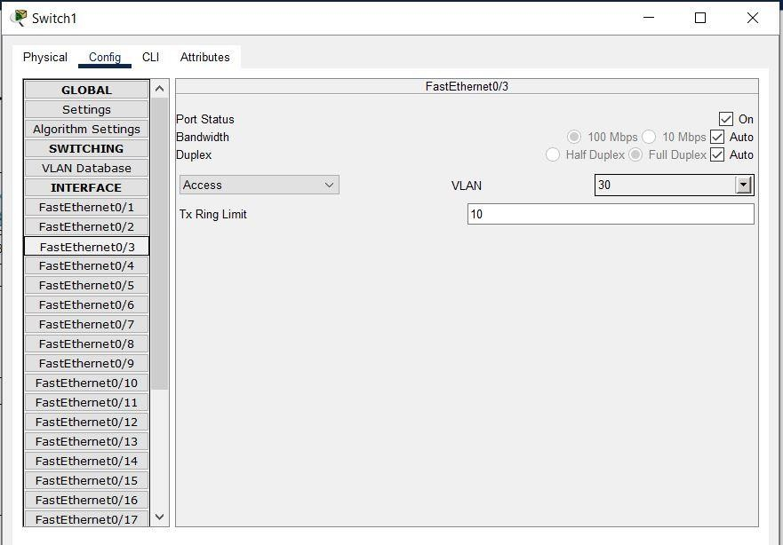

# 2.1 Steps To Create VLAN

## 1. Add Devices in Workspace

* Drag and drop **3 switches (2960-24TT)** into workspace.
* Add 9 PCs and arrange them into 3 groups:

o Engineering (3 PCs) o Marketing (3 PCs) o Accounting (3 PCs)

* Connect PCs to switches using **Straight-Through cables**.
* Connect switches together with **crossover cables**.

## 2. Assign IP Addresses to PCs

Configure each PC → Desktop → IP Configuration:

* Engineering VLAN (VLAN 10) o PC0 → 192.168.1.2 / 255.255.255.0 o PC3 → 192.168.1.5 / 255.255.255.0 o PC6 → 192.168.1.8 / 255.255.255.0

* Marketing VLAN (VLAN 20) o PC1 → 192.168.1.3 / 255.255.255.0 o PC4 → 192.168.1.6 / 255.255.255.0 o PC7 → 192.168.1.9 / 255.255.255.0
* Accounting VLAN (VLAN 30) o PC2 → 192.168.1.4 / 255.255.255.0 o PC5 → 192.168.1.7 / 255.255.255.0 o PC8 → 192.168.1.10 / 255.255.255.0

Add labels to each PC to display its **IP Address**.

## 3. Create VLANs on Each Switch

Click on each switch → **Config tab → VLAN Database**:

* VLAN 10 → Name: **Engineering** → Add.
* VLAN 20 → Name: **Marketing** → Add.
* VLAN 30 → Name: **Accounting** → Add.

Do this on **Switch0, Switch1, and Switch2**

## 4. Assign Ports to VLANs

For each switch → Config tab → select **Interface (FastEthernet)** → assign VLAN.

Example for **Switch0**:

* Port F0/1 → VLAN 10 (PC 192.168.1.2 – Engineering)
* Port F0/2 → VLAN 20 (PC 192.168.1.3 – Marketing)
* Port F0/3 → VLAN 30 (PC 192.168.1.4 – Accounting)

Similarly configure **Switch1** and **Switch2**.

## 5. Configure Trunk Links Between Switches

For switch-to-switch connections:

* Select interface where switches are connected • Set **Mode → Trunk**.
* This allows VLAN 10, 20, and 30 traffic to pass across switches.

Repeat for all inter-switch connections.

## 6. Test VLAN Connectivity

* Open **Command Prompt** on a PC.
* Ping another PC in the **same VLAN** → should be successful. • Ping a PC in a **different VLAN** → will fail.

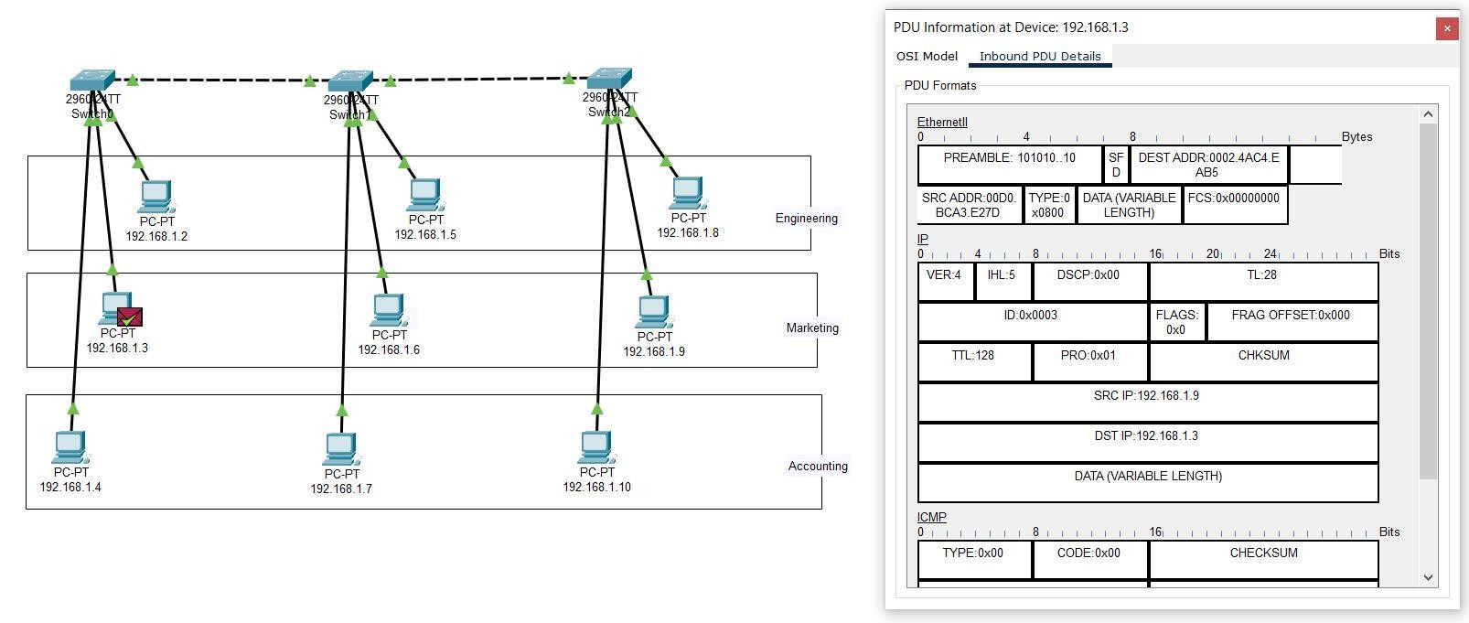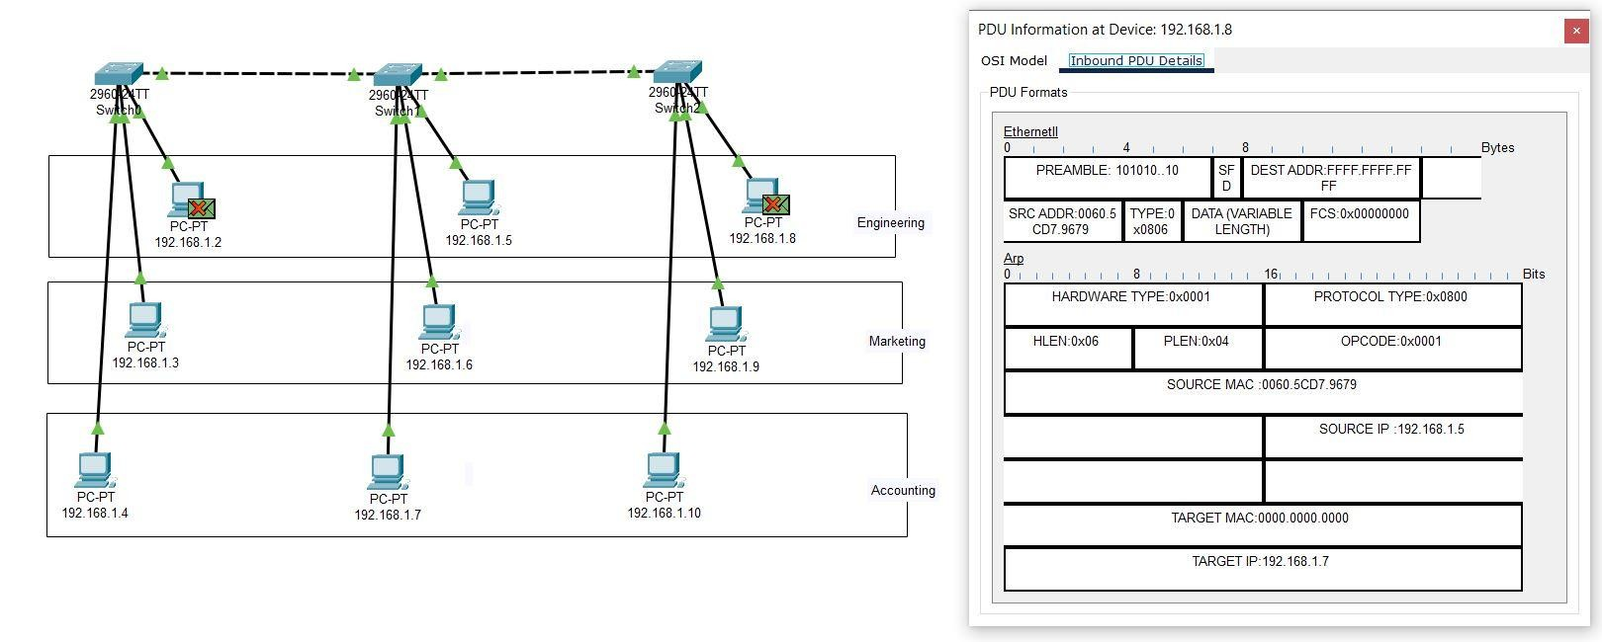

**3. VLAN_3:**

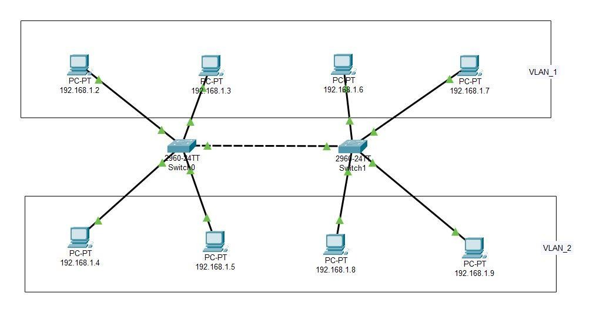

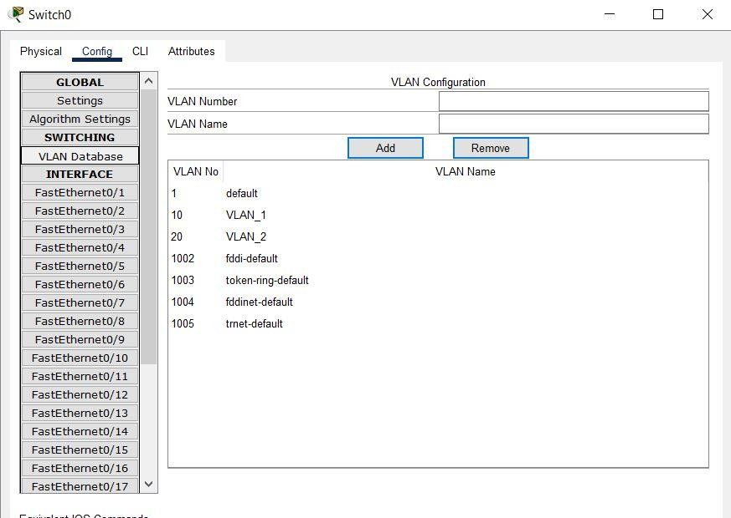

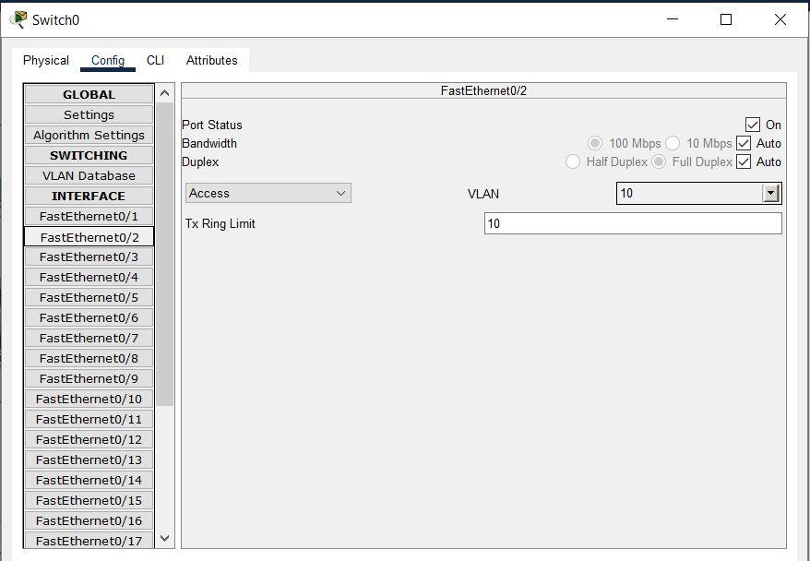

# 3.1 Steps To Create VLAN

## 1. Add Devices in Workspace

* Drag and drop **2 switches** (2960/2950) into workspace.
* Add **8 PCs** into the workspace. • Divide them into 2 groups:

o **VLAN 1** → 4 PCs o **VLAN 2** → 4 PCs

* Connect PCs to switches using **Straight-Through cables**.
* Connect the two switches together using a **Crossover cable**.

## 2. Assign IP Addresses to PCs

Go to each PC → **Desktop → IP Configuration** and assign IP addresses:

* VLAN 1 o PC0 → 192.168.1.2 / 255.255.255.0 o PC1 → 192.168.1.3 / 255.255.255.0 o PC2 → 192.168.1.6 / 255.255.255.0

o PC3 → 192.168.1.7 / 255.255.255.0

* VLAN 2 o PC4 → 192.168.1.4 / 255.255.255.0 o PC5 → 192.168.1.5 / 255.255.255.0 o PC6 → 192.168.1.8 / 255.255.255.0 o PC7 → 192.168.1.9 / 255.255.255.0

Add labels to each PC to display its IP address.

**3. Create VLANs on Each Switch** For each switch → **Config tab → VLAN Database**:

* VLAN 10 → Name: VLAN_1 → Add.
* VLAN 20 → Name: VLAN_2 → Add.

Repeat on both Switches.

## 4. Assign Ports to VLANs

For each switch → Config tab → select **Interface (FastEthernet)** → assign VLAN.

* **Switch0 Example:** 
  + Port F0/1 → VLAN 1 (PC0 – 192.168.1.2) o Port F0/2 → VLAN 1 (PC1 – 192.168.1.3) o Port F0/3 → VLAN 2 (PC4 – 192.168.1.4) o Port F0/4 → VLAN 2 (PC5 – 192.168.1.5)
* **Switch1 Example:** 
  + Port F0/1 → VLAN 1 (PC2 – 192.168.1.6) o Port F0/2 → VLAN 1 (PC3 – 192.168.1.7) o Port F0/3 → VLAN 2 (PC6 – 192.168.1.8) o Port F0/4 → VLAN 2 (PC7 – 192.168.1.9)

## 5. Configure Trunk Link Between Switches

* For the interface connecting Switch0 ↔ Switch1 → set to **Trunk mode**.
* This allows both VLAN 1 and VLAN 2 traffic to pass across switches.

## 6. Test VLAN Connectivity

* Open **Command Prompt** on a PC.
* Ping another PC in the **same VLAN** → should succeed. • Ping a PC in a **different VLAN** → should fail.

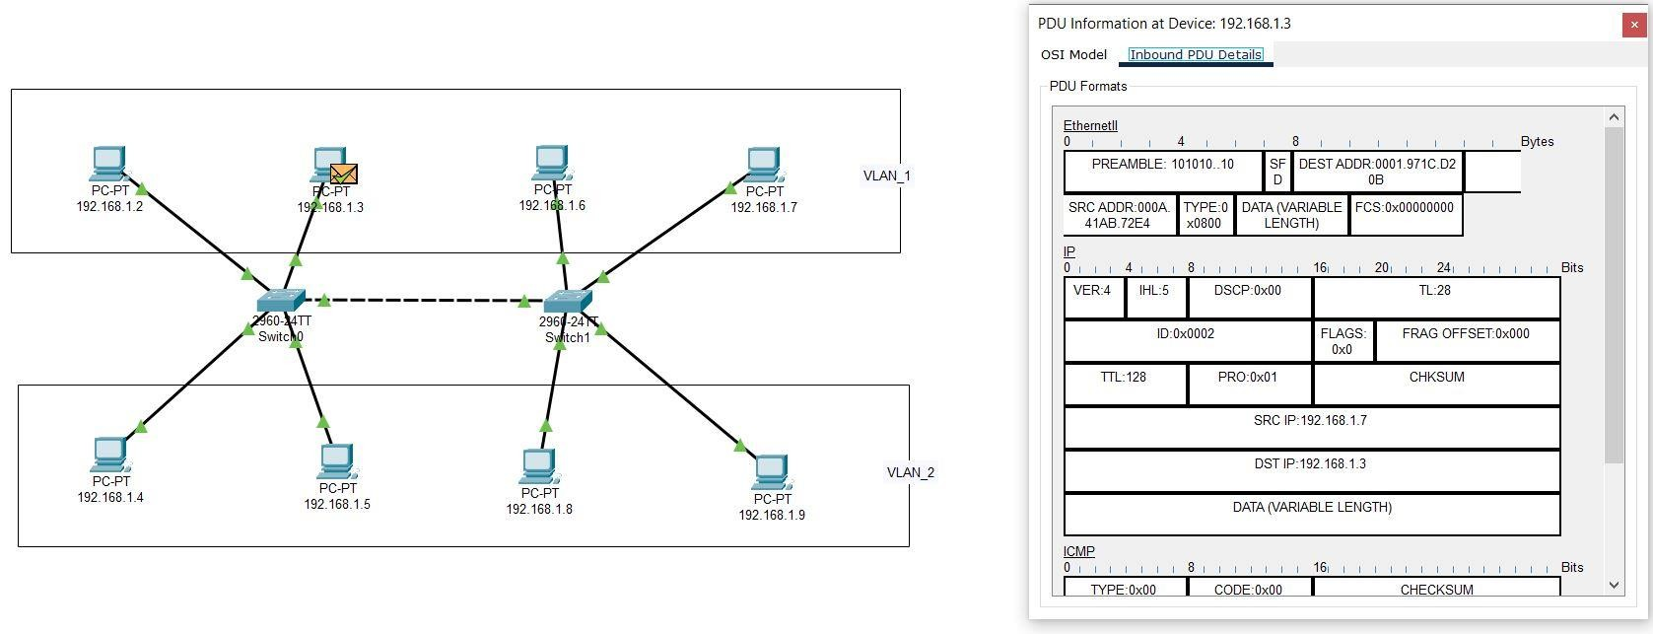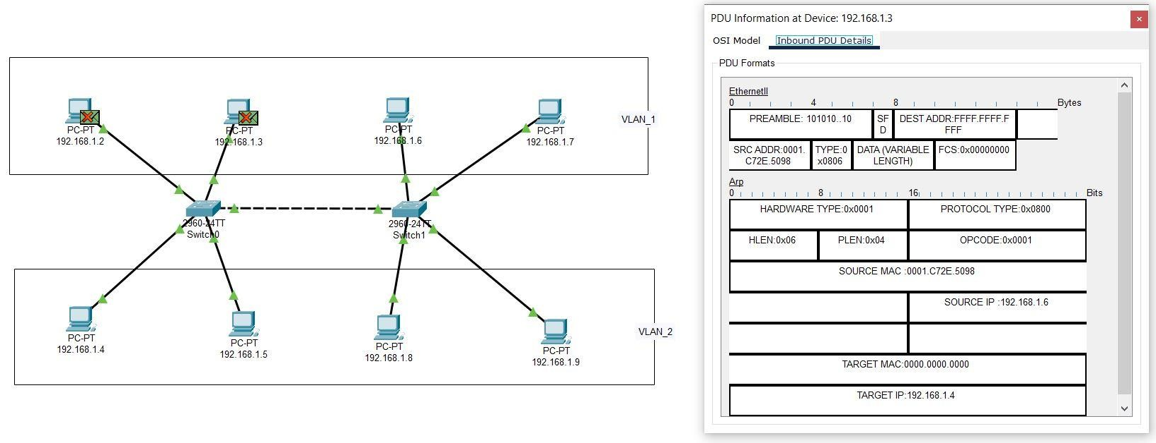

**4. VLAN_4:**

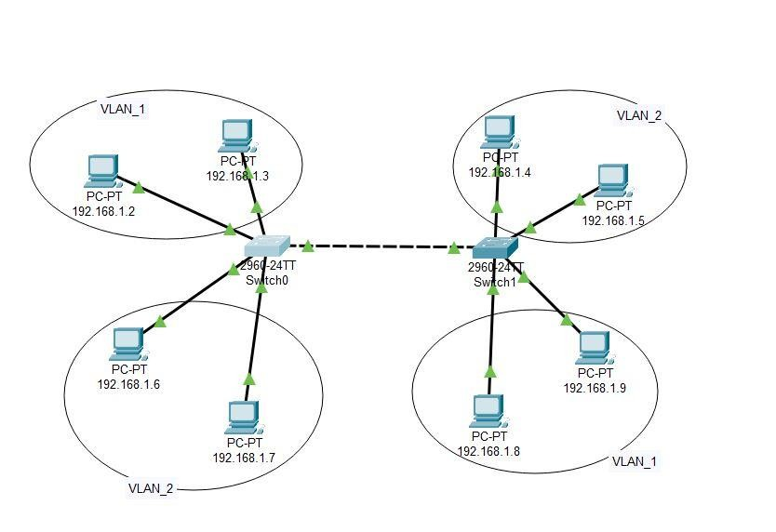

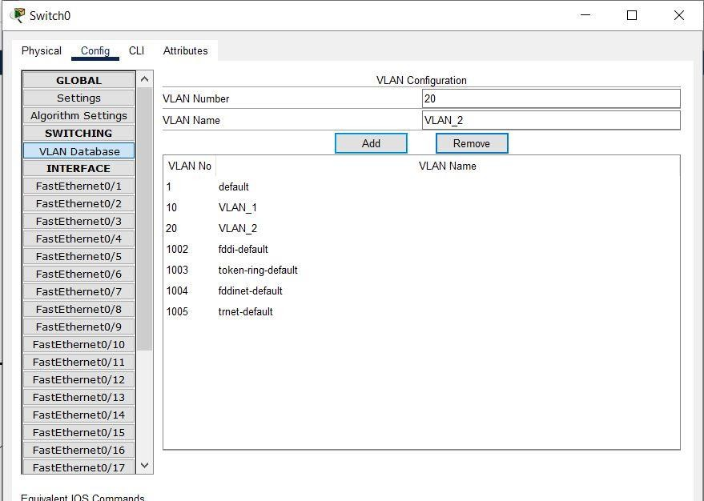

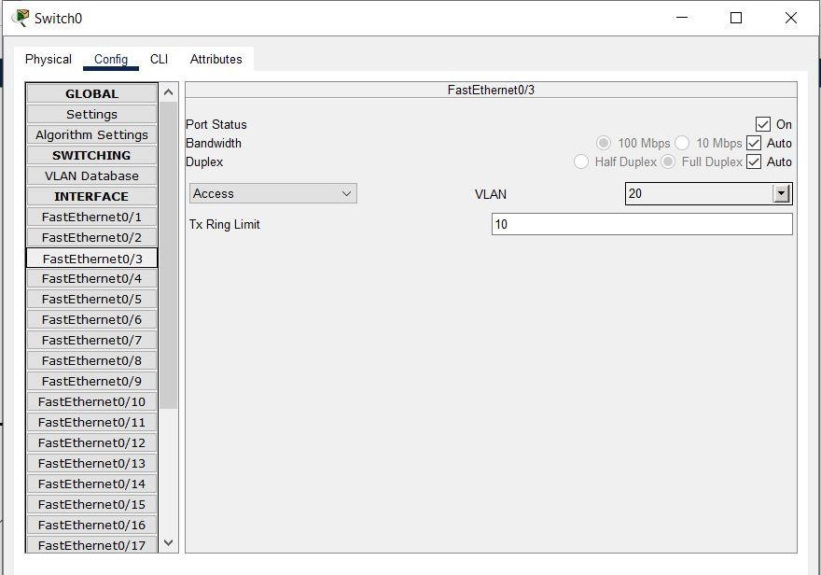

# 4.1 Steps To Create VLAN

## 1. Add Devices in Workspace

* Drag and drop **2 switches (2960-24TT)** into the workspace.
* Add **8 PCs** and arrange them into 2 groups:

o **VLAN 1** group → 4 PCs o **VLAN 2** group → 4 PCs

* Connect PCs to switches using **Straight-Through cables**.
* Connect **Switch0 ↔ Switch1** using a **Crossover cable**.

## 2. Assign IP Addresses to PCs

Configure each PC → **Desktop → IP Configuration**:

* VLAN 1 o PC0 → 192.168.1.2 / 255.255.255.0 o PC1 → 192.168.1.3 / 255.255.255.0 o PC6 → 192.168.1.8 / 255.255.255.0 o PC7 → 192.168.1.9 / 255.255.255.0
* VLAN 2 o PC2 → 192.168.1.6 / 255.255.255.0 o PC3 → 192.168.1.7 / 255.255.255.0 o PC4 → 192.168.1.4 / 255.255.255.0 o PC5 → 192.168.1.5 / 255.255.255.0

Add **labels** to each PC to display its IP Address.

**3. Create VLANs on Each Switch** Click on each switch → **Config tab → VLAN Database**:

* VLAN 1 → Name: VLAN_1 → Add.
* VLAN 2 → Name: VLAN_2 → Add.

Do this on both Switch0 and Switch1.

## 4. Assign Ports to VLANs

• **Switch0:**

* Port F0/1 → VLAN 1 (PC0 – 192.168.1.2)o Port F0/2 → VLAN 1 (PC1 – 192.168.1.3)o Port F0/3 → VLAN 2 (PC2 – 192.168.1.6)o Port F0/4 → VLAN 2 (PC3 – 192.168.1.7)• **Switch1:**
* Port F0/1 → VLAN 2 (PC4 – 192.168.1.4)o Port F0/2 → VLAN 2 (PC5 – 192.168.1.5)o Port F0/3 → VLAN 1 (PC6 – 192.168.1.8)o Port F0/4 → VLAN 1 (PC7 – 192.168.1.9)

## 5. Configure Trunk Link Between Switches

For the interface connecting **Switch0 ↔ Switch1**:

* Select the interface (e.g., FastEthernet 0/24).
* Set **Mode → Trunk**.
* This allows VLAN 1 & VLAN 2 traffic to pass across switches.

## 6. Test VLAN Connectivity

* Open **Command Prompt** on a PC.
* Ping another PC in the **same VLAN** → should be successful. • Ping a PC in a **different VLAN** → will fail.

