 | Online Blood Bank System  Technical Design Document
 | Prepared By / Last Updated By | Reviewed By | Approved By
Name | Keval
Role | GenC
Signature
Date | 01/12/2019

Table of Contents

1.0 Introduction 3
1.1 Purpose of this document 3
1.2 Project overview 3
2.0 Solution Summary 3
2.1 Scope 3
2.2 Assumptions 3
2.3 Dependencies 3
2.4 Risks 3
3.0 Schematic Diagram 3
4.0 System Design 4
4.1 Proposed design 4
4.2 Component inventory 4
5.0 Database Design 4
5.1 Data Model 4
5.2 Tables Structure 4
6.0 Appendices 4
6.1 Glossary 4
6.2 Other 5
7.0 Terms & Conditions 5
- Change Log 5

Introduction

1.1 Purpose of this document
The main purpose of this project and the document, is to serve the person in need in a better way, since there was no other best thing to do in life than saving a life. This document provides a better understanding of the technical design, component details and database design of Online Blood Bank System. The provided document also specifies the scope, assumptions, risks, and dependencies of the project.

Objectives
The goal of the project is to develop a web application for blood banks to manage information about their donors and blood Bank. The main objectives of this system development can be defined as follows:
1. To develop a system that provides functions to support donors to view and manage their information conveniently.
2. To maintain records of blood donors, blood donation information and blood stocks in a centralized database system.
3. To inform donors of their blood result after their donation.
4. To support searching, matching and requesting for blood convenient for administrators.
5. To provide a function to send an e-mail directly to the donor for their user account and the hospital, the availability of the blood bank.

1.2 Project overview
The Online Blood Bank System project, helps many people by providing the right need at the right time in a sophisticated and user friendly platform.
This project describes the user interface being implemented and have a better understanding towards the flow of the Online Blood Bank System.
This project helps us to understand the problems of a normal person and provide him/her, a better opportunity to receive and provide help to one another in a large scale.
It will provide, us a high secured environment as well as a better opportunity to serve the person in need.

Solution Summary

2.1:Scope
Online Blood Bank System has the ability to register many users and makes easier to find the blood donors and give information about the blood bank.
- User registration & credential authentication
- Posting of blood requirement by any registered user
- Fetching donor information and blood availability information according to the user’s requirement.
- Also displaying the posted blood group requirements for a user.

Assumptions
The Online blood bank system helps each person, who is need of blood at the right time, by posting the blood requirements for a particular blood group, which will be displayed in the homepage, where a normal site viewer can show interest to donate blood. The main aim of this project is to maintain the complete information of the donors, with different blood groups available at each blood bank of a particular area and to provide a sophisticated platform for their need.

Dependencies
- MySQL is needed for database operations.
- Without Tomcat server the application will not run.
- Without Eclipse software, we will not be able to run the application.

Risks
As we are using HTTP Session objects, the data is transferred using http, which is less secured than https, so there is a possibility of data corruption. As we are using HTTP Session objects, the data is transferred using http, which is less secured than https, so there is a possibility of data corruption.
.

Schematic Diagram
Below is the overall functional flow of the project including the components of interaction:
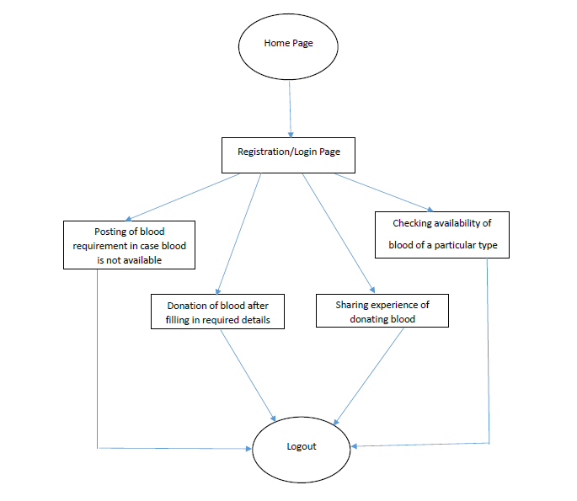
- Home Page:
This is the homepage where any visitor can view blood requirements, experience shared by donors, contact us, about us, blood donation tips.
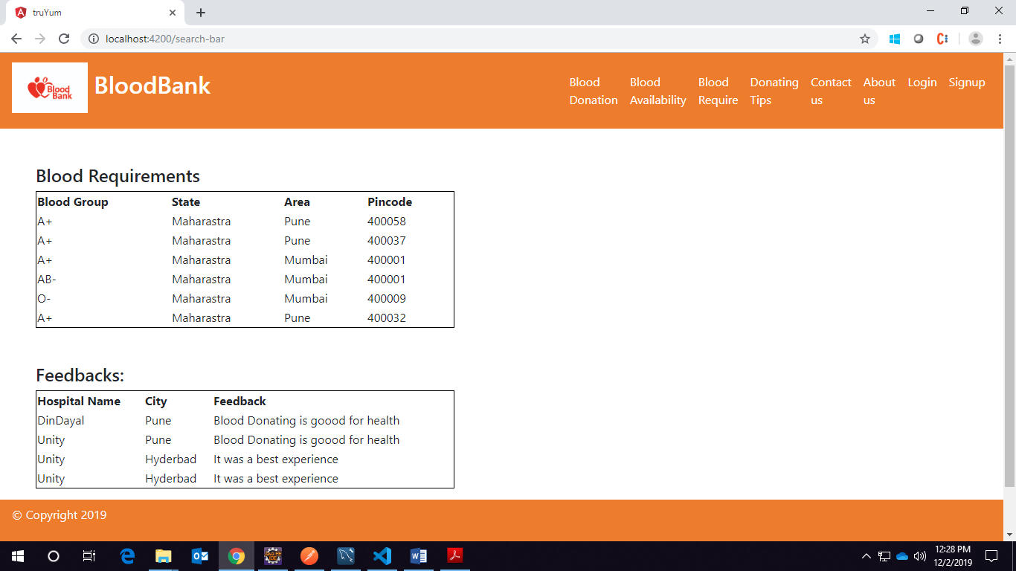
- Donating Tips:
This is blood donating tips where visitor can find do’s and don’t during blood donation.
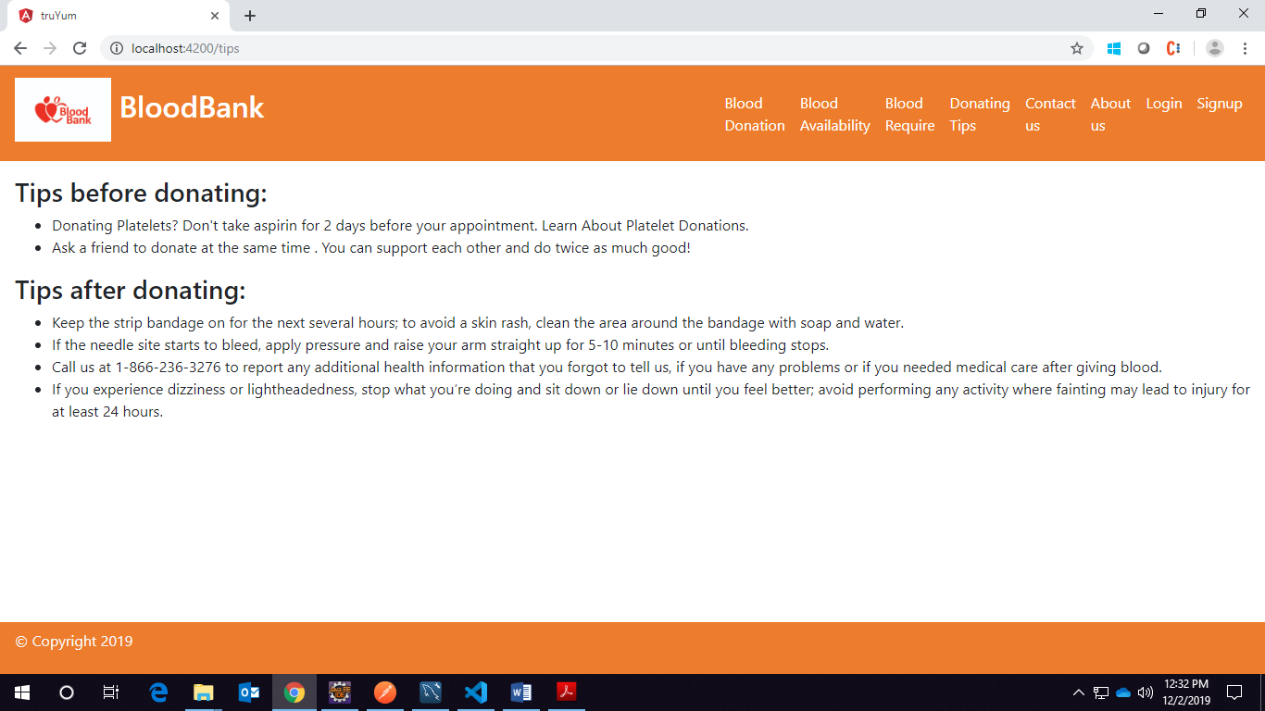
- About us:
This page includes information about the blood bank.
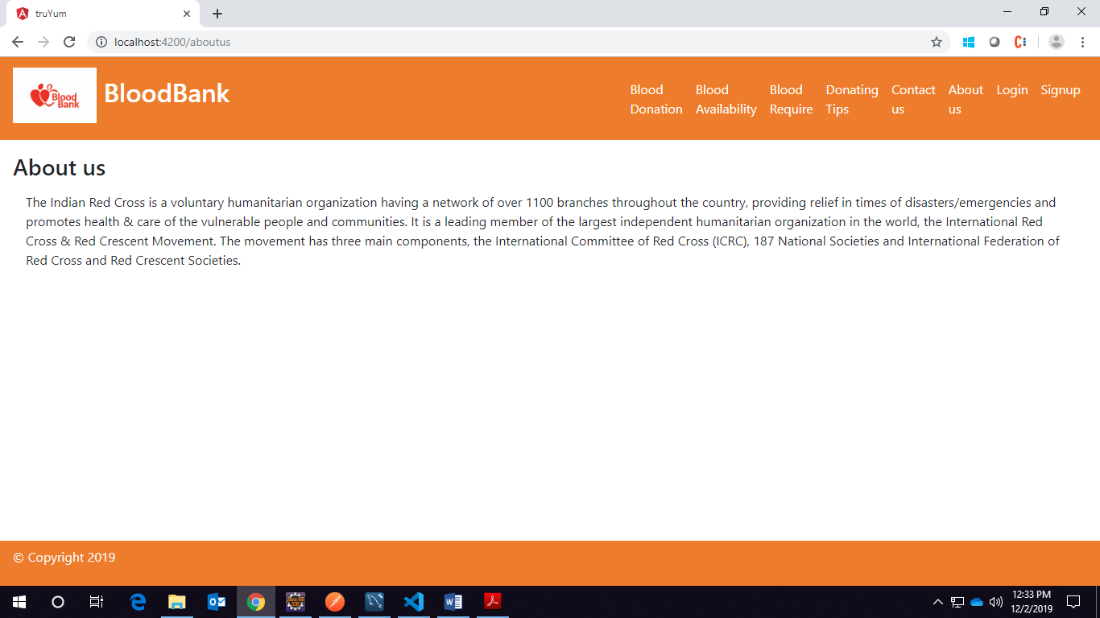
- Contact us:
This page has contact information of the organization. Any visitor can contact for any query/FAQ by submitting the form given
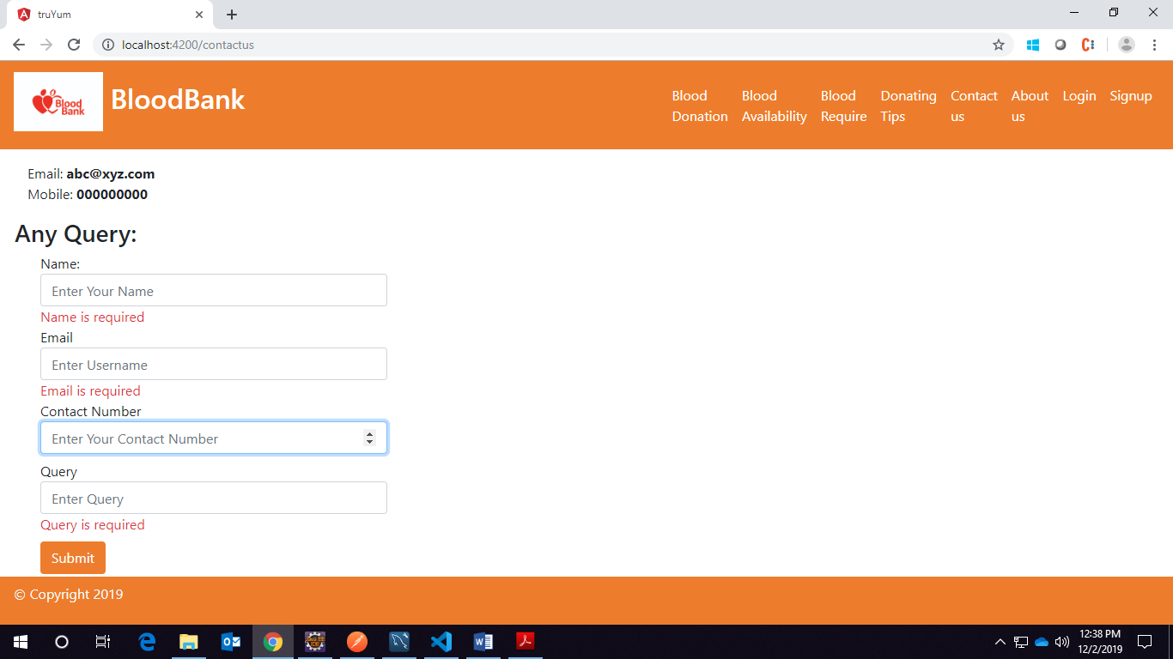
- Login:
Authorize user can login and can have access to functionality like blood donation, posting requirement, sharing experience/feedback, search for blood availability.
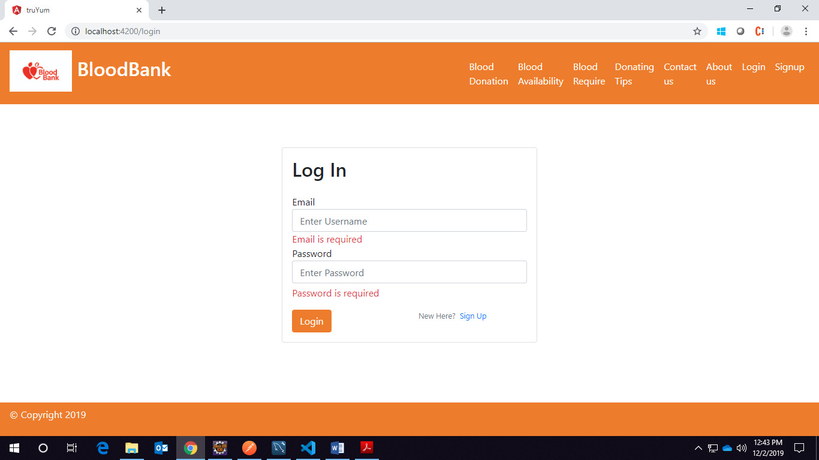
- Sign up:
This page includes validation for all fields and if email already exists in database then it should able give alert that email already exists. After validation of data, all data should be stored in database.
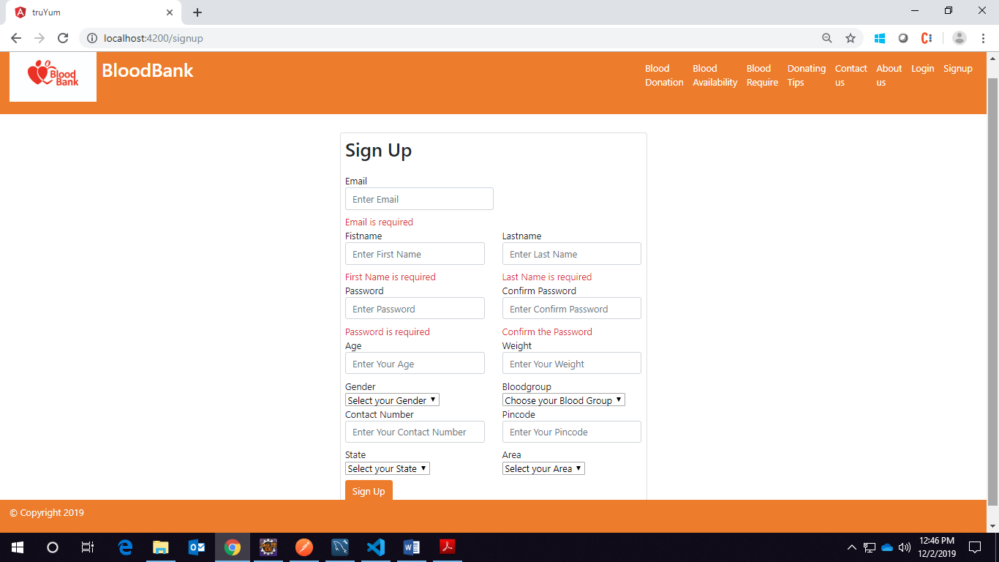
- Blood Requirement:
This should be accessed only after successful login. User should provide the require data and after successful validation data should be stored in database and should be viewed by any visitor.
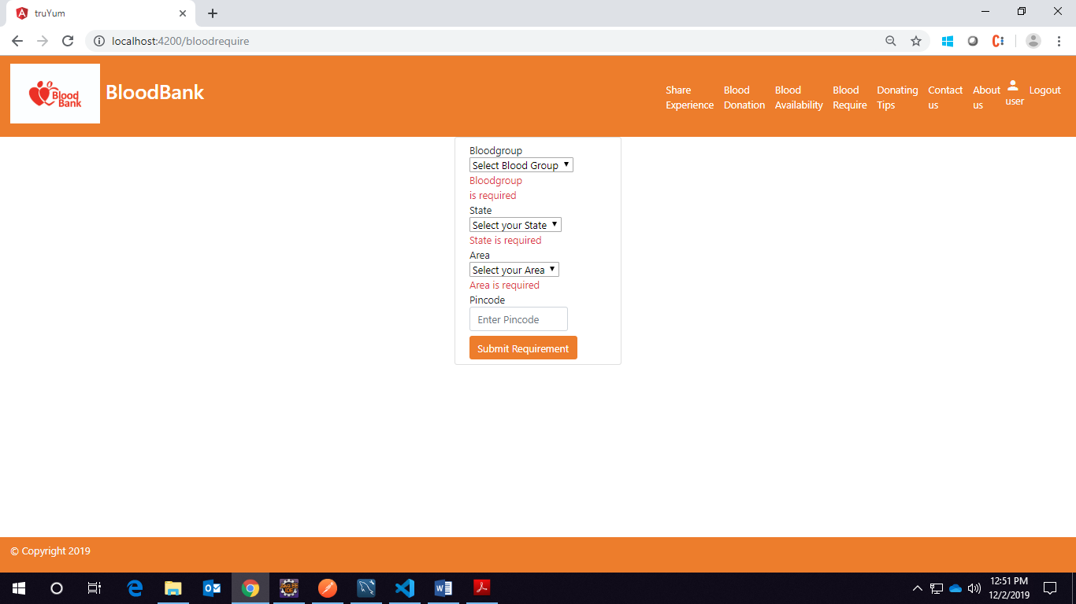
- Blood Availability:
This page should be access only after successful login. User should fill the require data and find the available. This should display the data of available donor in the provided data.
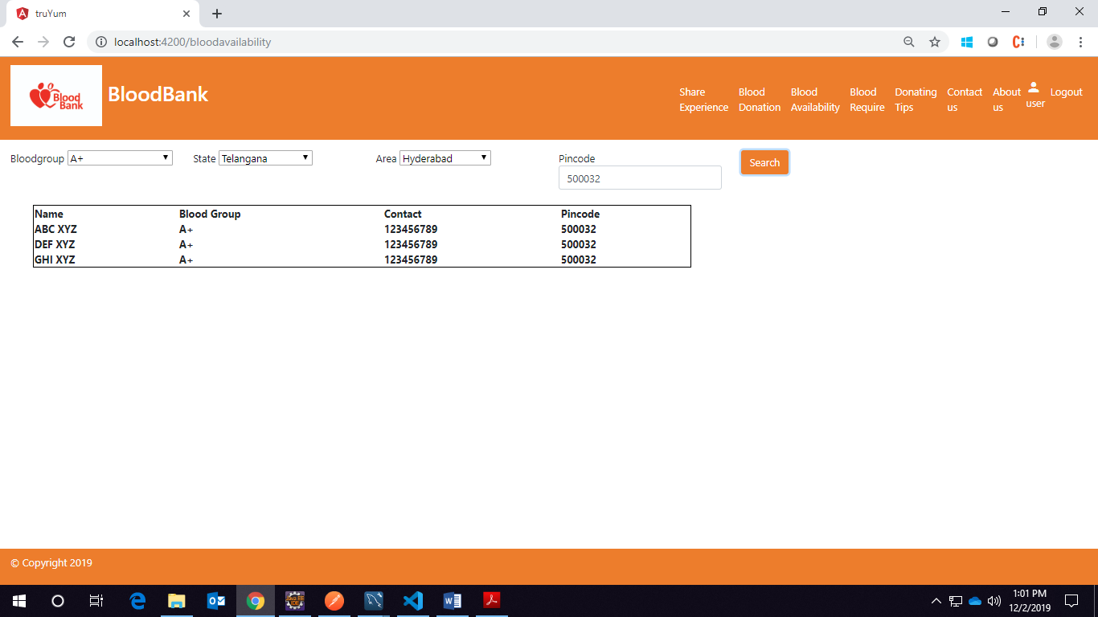
- Blood Donation:
For any available requirement if a user can donate the blood then hospital name, date and time should provide by user. After clicking on book slot, system should search if slot is booked by another user then it should print try different slot else it book the slot.
- Experience Sharing:
Any user wants to share their experience/feedback for blood donation should provide the necessary data and after successful validation it should be displayed on homepage for any visitor.
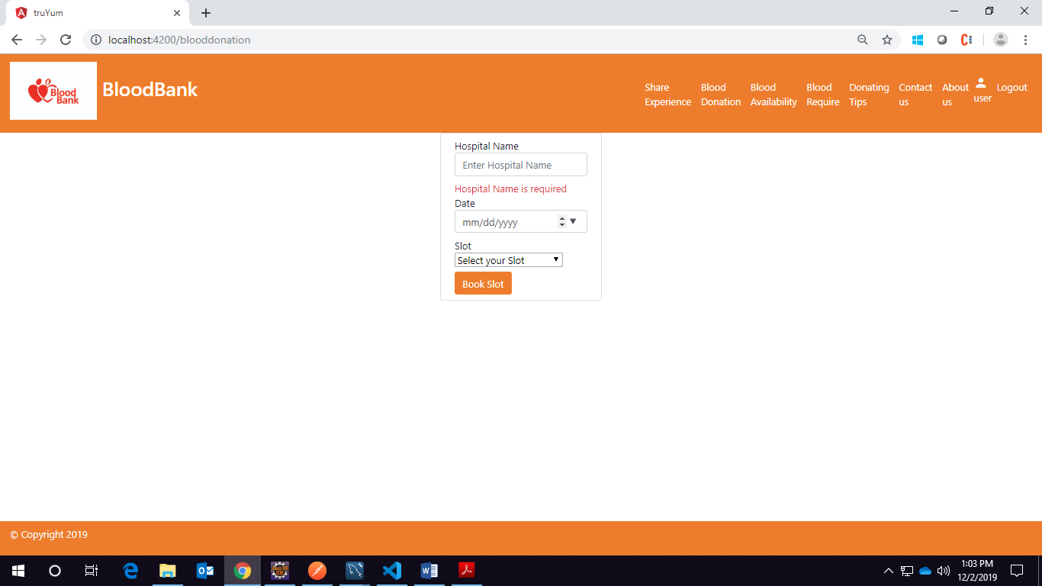

System Design

Proposed design
Considering the anomalies in the existing system computerization of the whole activity is being suggested after initial analysis. The “Online Blood Bank System” is an online blood bank management system that helps in managing various blood bank operations effectively. This is a web application allows you to access the whole information about blood bank management software, readily scalable and adaptable to meet the complex need of blood banks who are facilitator for the Healthcare Sector, it also supports all functionalities of Blood Bank Data Model

Component inventory
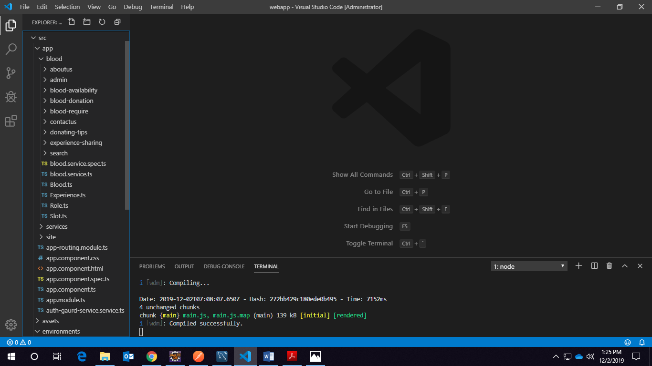
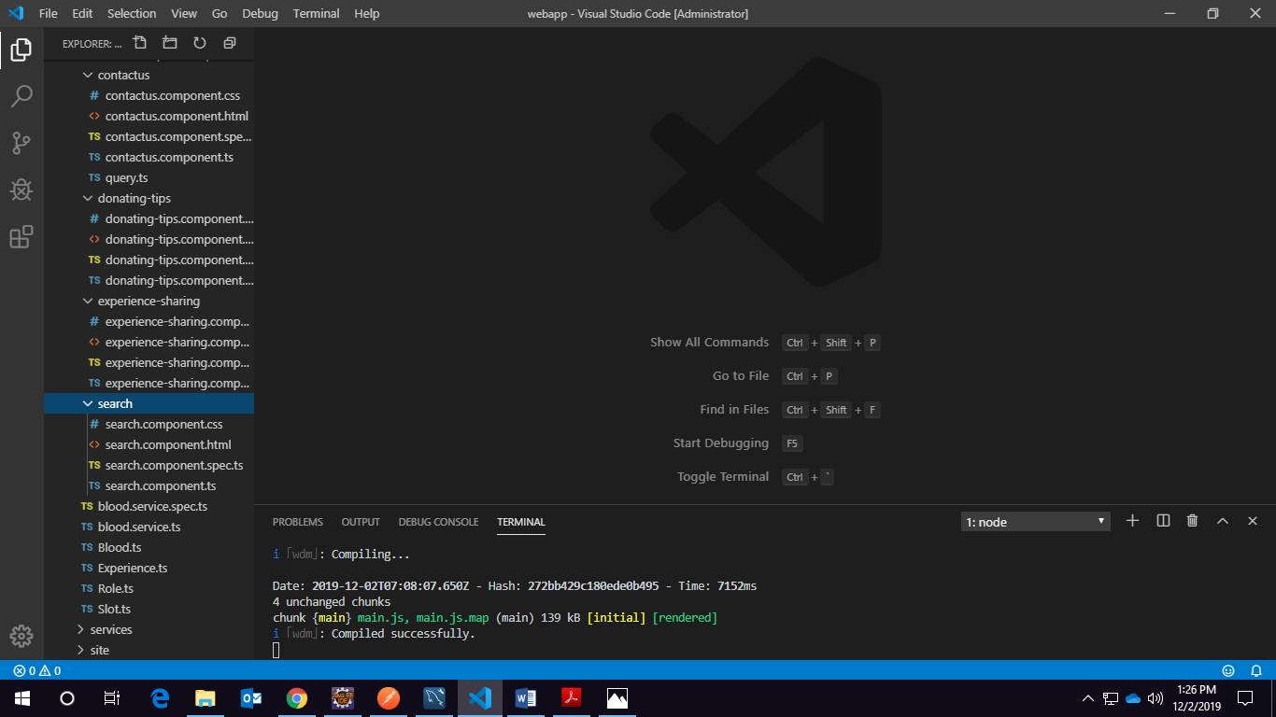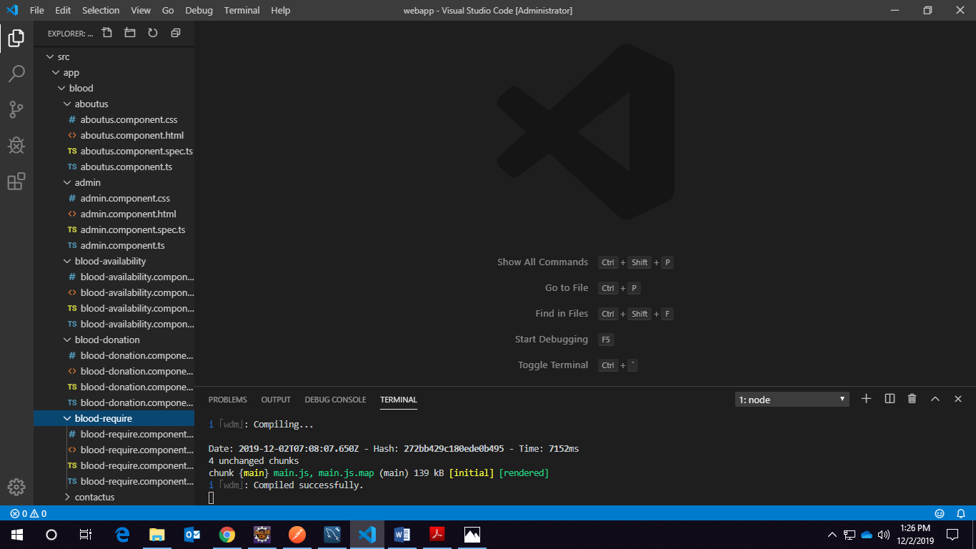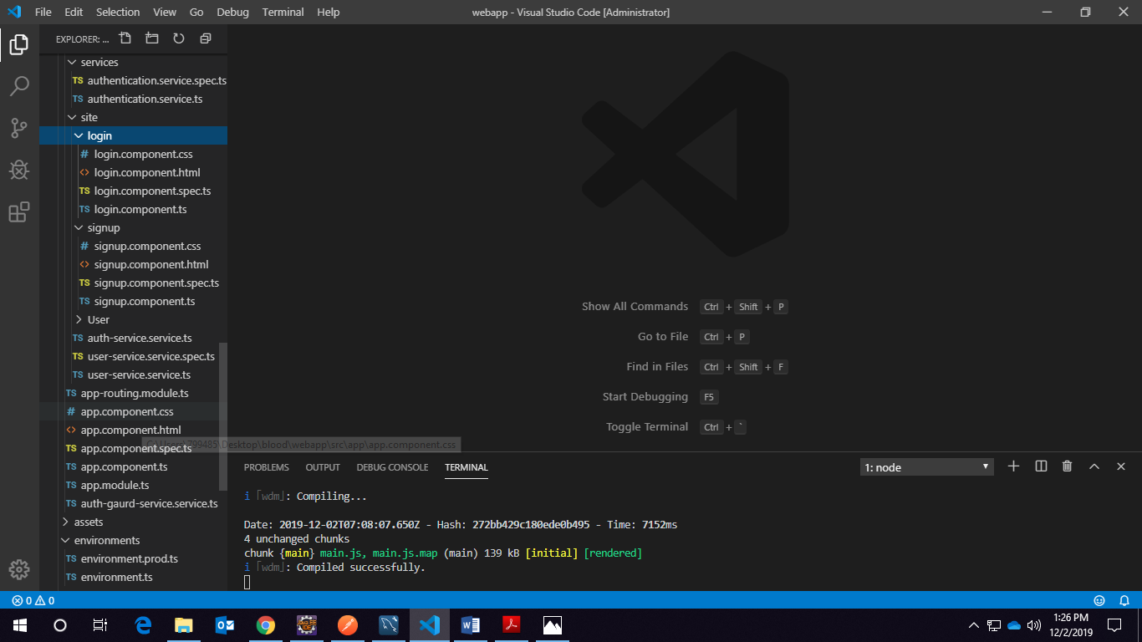

Database Design

Data Model
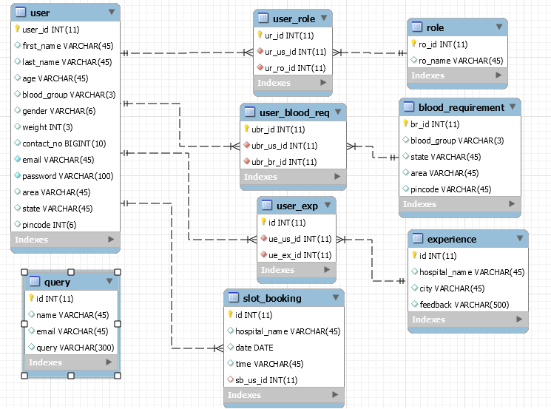

Table Structure

Tables
User
Role
User_role
Blood_requirement
User_blood_req
Experience
User_exp
Slot_booking
query

User Registration

Field Name | Field Type | Data Type | Mandatory | Possible Values
User Id | Text(10) | Alphabetic | Yes
First Name | Text(50) | Alphabetic | Yes
Last Name | Text(50) | Alphabetic | Yes
Age | Numeric(2) | Numeric | Yes
Gender | Drop Down | NA |  | Male, Female
Contact Number | Text(10) | Numeric | Yes
Email | Text(15) | Email | Yes
Password | Text(15) | Alphanumeric | Yes
Weight | Numeric(3) | Numeric | Yes
State | Drop Down | NA | Yes
Area | Drop Down | NA | Yes
Pin code | Numeric(6) | Numeric | Yes
Blood Group | Drop Down | NA | Yes | All possible blood groups

Blood Required
Field Name | Field Type | Data Type | Mandatory | Possible Values
Id | Text(10) | Alphabetic | Yes
Blood Group | Drop Down | NA | Yes | All possible blood groups
State | Drop Down | NA | Yes
Area | Drop Down | NA | Yes
Pin code | Numeric(6) | Numeric | Yes
Contact Number | Text(10) | Numeric | Yes

Donor
Field Name | Field Type | Data Type | Mandatory | Possible Values
Id | Text(10) | Alphabetic | Yes
Blood Group | Drop Down | NA | Yes | All possible blood groups
State | Drop Down | NA | Yes
Area | Drop Down | NA | Yes
Pin code | Numeric(6) | Numeric | Yes
Contact Number | Text(10) | Numeric | Yes

Hospital Location
Field Name | Field Type | Data Type | Mandatory | Possible Values
Id | Text(10) | Alphabetic | Yes
Hospital Name | Text(15) | Alphabetic | Yes
City | Text(15) | Alphabetic | Yes
Date | Drop Down | NA | Yes
Time | Drop Down | NA | Yes

Feed Back
Field Name | Field Type | Data Type | Mandatory | Possible Values
Id | Text(10) | Long
Hospital Name | Text(15) | Alphabetic | Yes
City | Text(15) | Alphabetic | Yes
Feedback Comments | Text(500) | Alphabetic | Yes

Post Details
Field Name | Field Type | Data Type | Mandatory | Possible Values
Id | Text(10) | Alphabetic | Yes
Blood Group | Drop Down | NA | Yes | All possible blood groups
State | Drop Down | NA | Yes
Area | Drop Down | NA | Yes
Pin code | Numeric(6) | Numeric | Yes
Contact Number | Text(10) | Numeric | Yes

Appendices

Glossary
Acronyms | Definitions
JDBC | Java Database Connectivity
API | application programming interface
JSP | Java Server Pages
DB | Database
Apache tomcat | Apache Tomcat is an open source Web server tool developed by the Apache Software Foundation (ASF). It is one of many Apache-related open source products used by IT professionals for various tasks and objectives.

7.0 Terms And Conditions
Interns shall be solely responsible for all its acts and omissions under this program. Interns will comply at all times with all applicable laws. Interns shall not use Cognizant’s name, logo and trademark in any promotional materials or other communications with third parties without the prior written consent of Cognizant. Any materials used by interns in relation to program will not infringe the copyrights, trademarks, patents, trade secrets or other intellectual property rights, privacy or similar rights of any person or entity. Interns agrees not to post, draw, make, display any content that is threatening, libelous, obscene, defamatory, abusive, pornographic, or advocates/encourages any conduct that could constitute a criminal offence or give rise to any civil liability. Cognizant its associates’ personal details including but not limited to name, address, contact number shall not be shared or forwarded to any third party, without prior written consent of Cognizant, its associates. All intellectual property provided by Cognizant, as part of program shall be owned exclusively by Cognizant. Intern shall indemnify, defend and indemnify Cognizant its associates, officers, directors from and against any claims, demands, loss, damage, liability, causes of action, judgments, or costs and expenses of every nature (including attorney’s fees and expenses) incurred by Cognizant based on any claim that any breach of terms and conditions of this program

Change Log
Please note that this table needs to be maintained even if a Configuration Management tool is used.
Version Number | Changes made
V<n.n> | <If the change details are not explicitly documented in the table below, reference should be provided here>
V<n.n> | Page no | Changed by | Effective date | Changes effected

