**Calculator**

**Title: Create a simple calculator component that performs basic arithmetic operations and use reusable common component for the button.**

**1. Task Description:**

The task is to create a **Calculator App** using **React.js**. The app performs basic arithmetic operations like addition, subtraction, multiplication, and division. It uses reusable components for the buttons and is styled using **Tailwind CSS** for a modern, responsive design. The app evaluates the expressions and displays the result. Additionally, it handles invalid inputs and clears the display when required.

**2. Task Output Screenshot:**

**This is how a simple calculator looks like.**

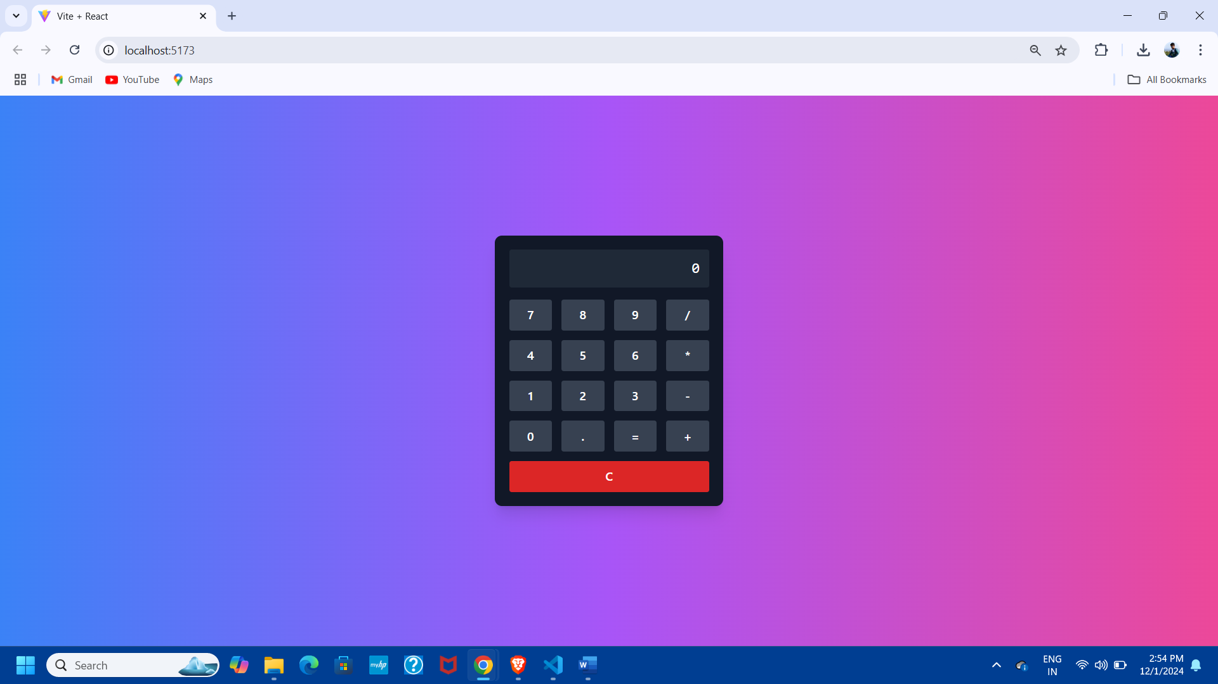

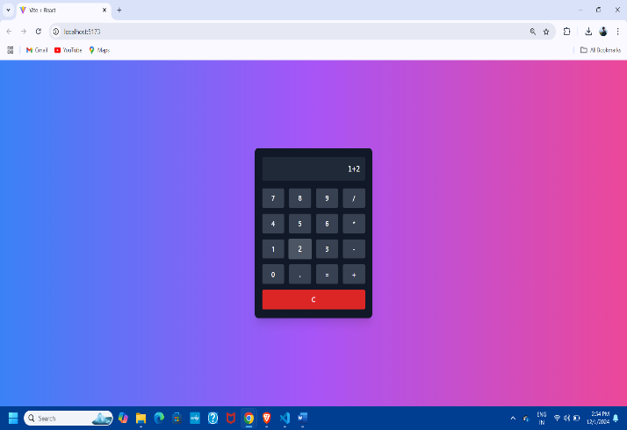**Now perform addition operation in this calculator:**

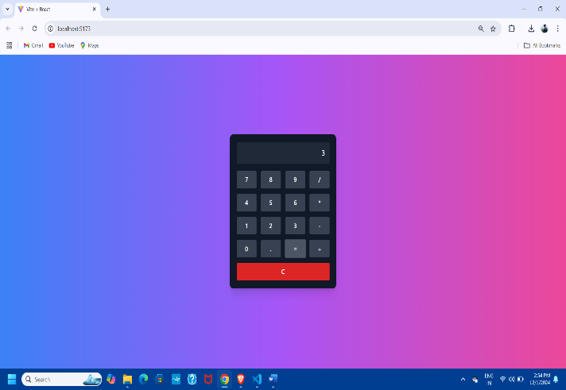

### 3. ****Widget/Algorithm Used In Task:****

* **Button Component**: A reusable button component is used for creating calculator buttons. It takes in the button's value and triggers the relevant operation when clicked.
* **Display Area**: The display area shows the ongoing expression or the result of the calculation. It updates dynamically when the user presses a button.
* **Arithmetic Operations**: The app uses JavaScript’s eval() function to evaluate arithmetic expressions entered by the user. If the input is invalid, it displays "Error".
* **Tailwind CSS**: Used for styling the app. Key utilities used include grid layout for buttons, responsive design for different screen sizes, and modern color schemes for a clean and intuitive user interface.