Input form

Title : Build a dynamic form that adds and removes input fields based on user input.

**1. Task Description**

Create an input form in React that allows users to input and submit data.

* The form collects user details such as **Name**, **Email**, and **Message**.
* Upon submission, the entered data is displayed dynamically on the same page.
* Used validation to ensure required fields are filled and email format is correct.
* Added Tailwind CSS for a responsive and visually appealing design.

#### ****2. Task Output Screenshot****

**Screenshots:**

1. **Input Form Layout:**

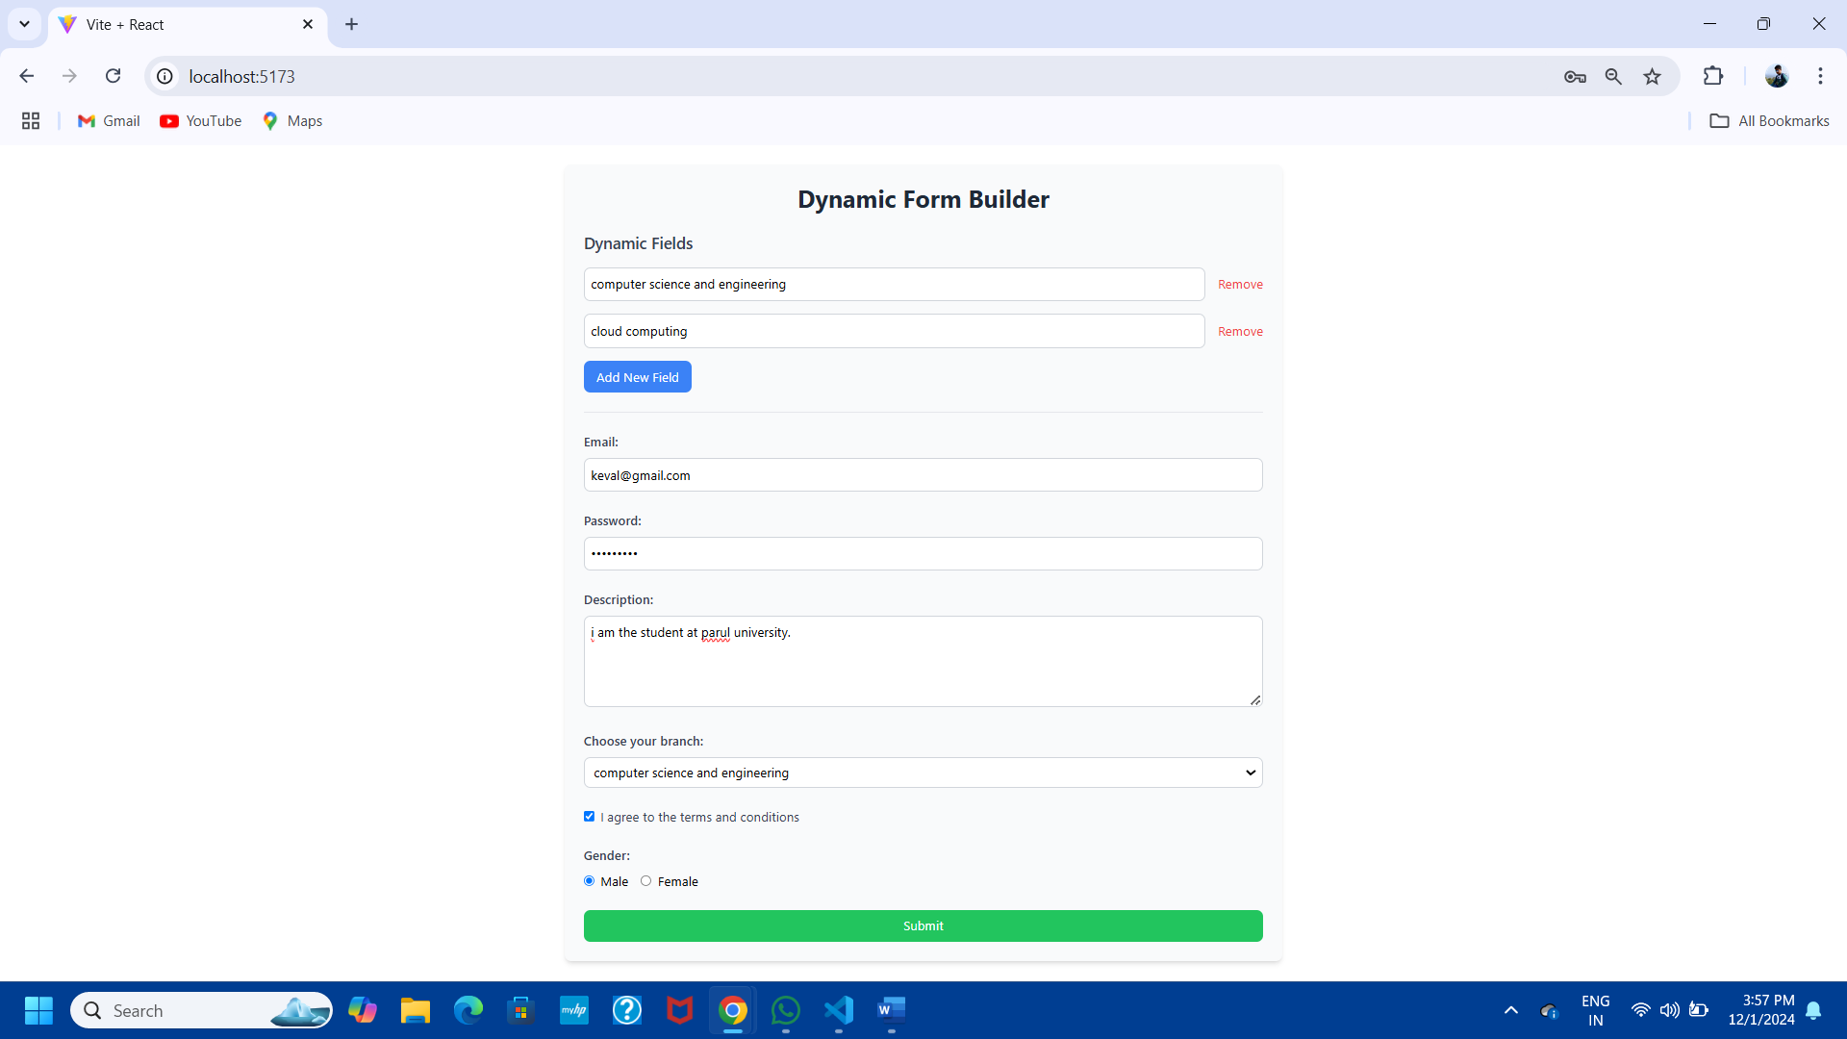

1. **Form Submission Result:**

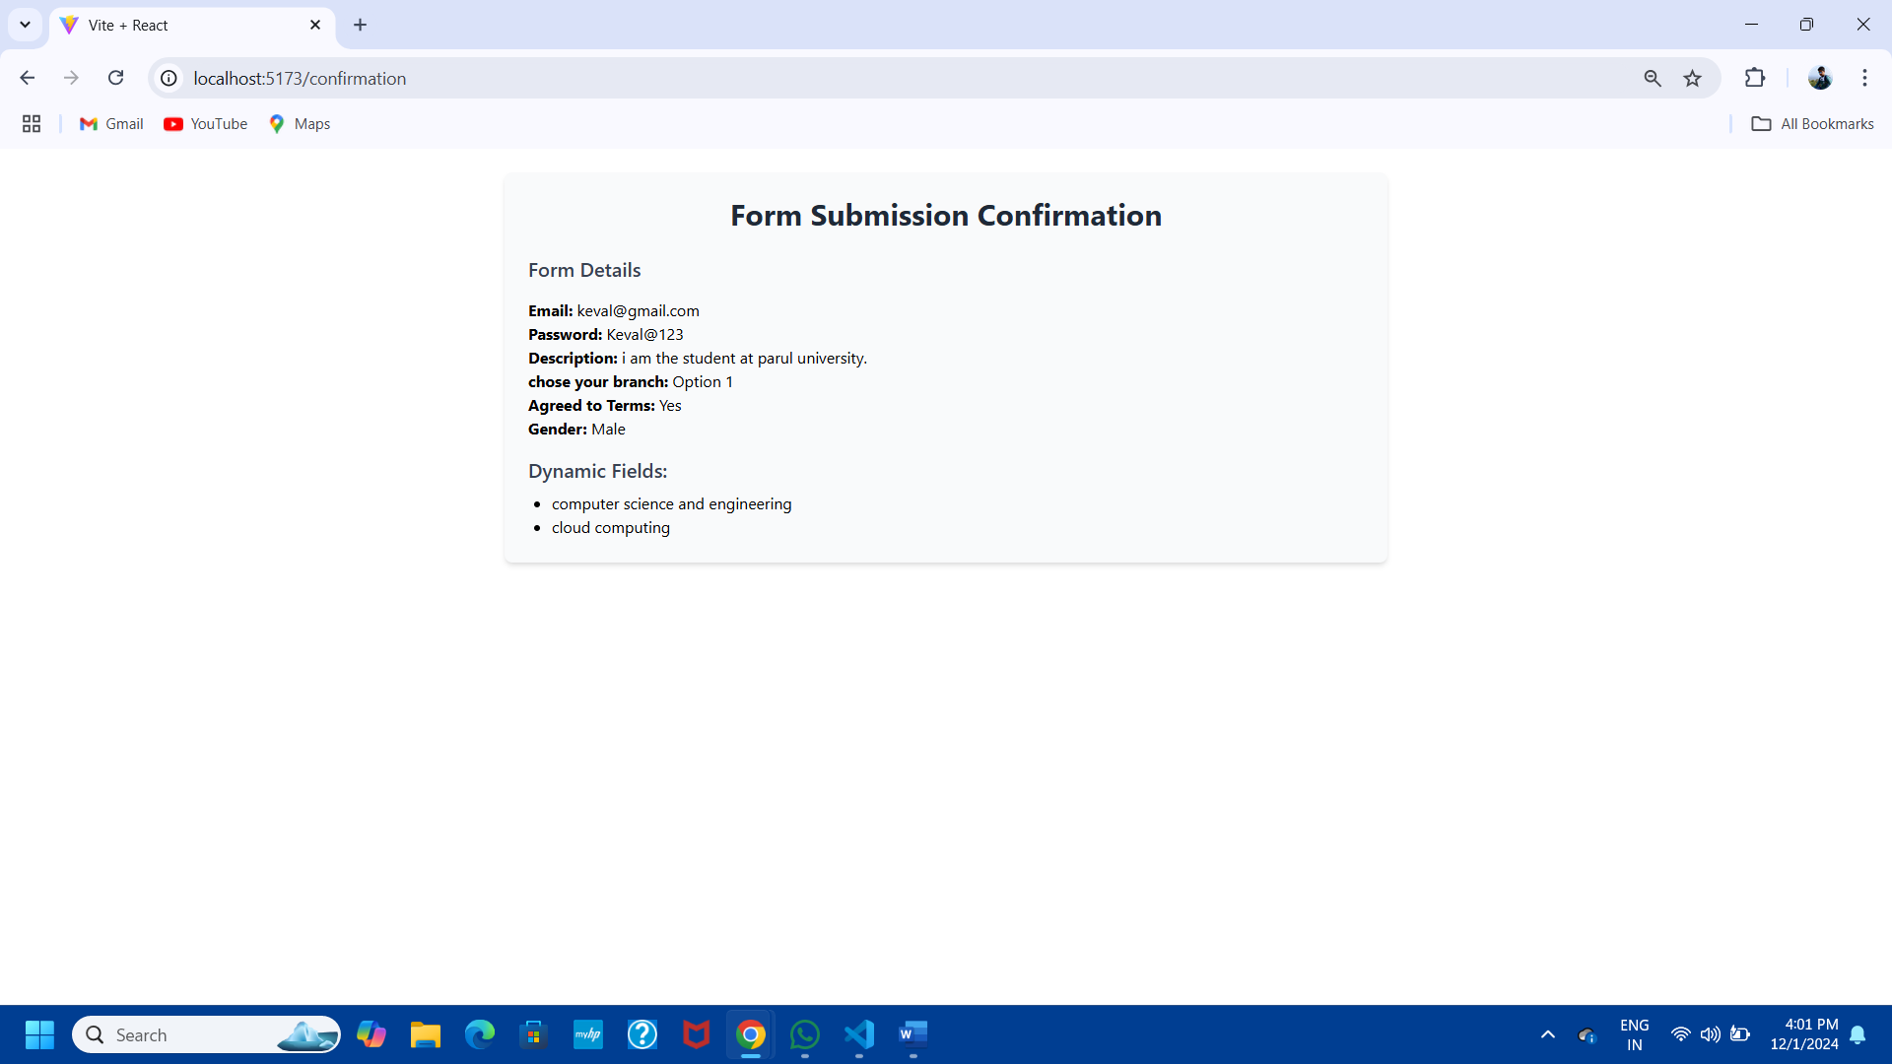

#### ****3. Widget/Algorithm Used in Task****

* **HTML Form Elements Used:**
  + **Input Fields:**
    - Collect data for Name, Email, and Message fields.
  + **Button:**
    - A Submit button to process and display the entered data.
* **React Functionalities:**
  + **State Management:**
    - Used useState hook to manage the values of form fields and submitted data.
  + **Form Validation:**
    - Ensured all fields are required.
    - Checked that the email follows a valid format using a regular expression.
* **Tailwind CSS Classes:**
  + Designed a clean, responsive layout with spacing, borders, hover effects, and transitions.
  + Used grid and flex utilities to ensure proper alignment and responsiveness.