Sept. 15, 2019 Kevan Thompson

NETINT FPGA Test

I implemented this design on an Arty board. This board has an Artix-7 XC7A35T FPGA on it. To test the design I connected each input and output to a Xilinx Virtual Input Output (VIO). (See figure below) With a system clock of 100MHz.

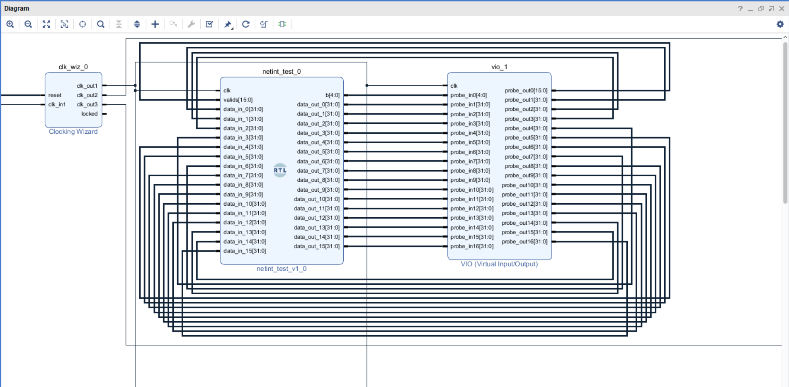
This design used 2189 LUTs, and 517 Registers. (See utilization below)

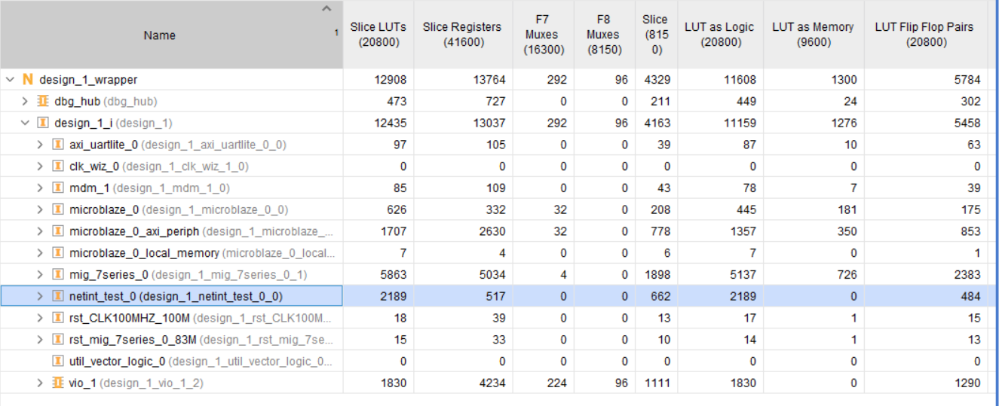

You can see in the VIO screen shot below that bits 0, 3, 4, and 7 of Valids are set. Register b is showing the value 4, and first 4 buffers have stored the data for Data_IN_0, Data_IN_3, Data_IN_4, and 7.

