Sample Test Questions [Trigonometry]

1. Basic Trigonometric Ratios
- "What is sin(30°)?"
- "Calculate cos(45°)"
- "Find tan(60°)"
- "Evaluate sin(π/6)"

2. Inverse Trigonometric Functions
- "What is arcsin(0.5)?"
- "Find arccos(√2/2)"
- "Calculate arctan(1)"

3. Trigonometric Identities & Simplification
- "Simplify sin²(x) + cos²(x)"
- "Prove that tan(x) = sin(x)/cos(x)"
- "Simplify 2sin(x)cos(x)"
- "Verify the Pythagorean identity"

4. Solving Trigonometric Equations
- "Find all solutions to cos(x) = -1"
- "Solve tan(x) = √3"
- "Find x where 2sin(x) - 1 = 0"

5. Right Triangle Applications
- "In a right triangle with angle 35° and hypotenuse 10, find the opposite side"
- "A ladder leans against a wall at 60°. If the ladder is 15 feet long, how high up the wall does it reach?"
- "From a point 50m away, the angle of elevation to a building top is 40°. Find the height"

6. Unit Circle & Angle Conversions
- "Convert 150° to radians"
- "Convert 2π/3 radians to degrees"
- "Find the reference angle for 225°"
- "What are the coordinates of the unit circle at 120°?"

7. Complex Trigonometric Problems
- "If sin(x) = 3/5 and x is in the first quadrant, find cos(x) and tan(x)"
- "Find the general solution to 3sin(2x) = 2"
- "Use the law of sines to find the missing side: a=10, A=50°, B=60°"
- "Solve sin(x) = 0.5 for x ∈ [0, 2π]"

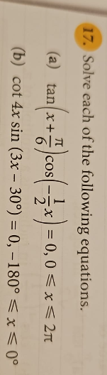

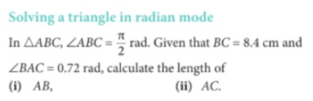

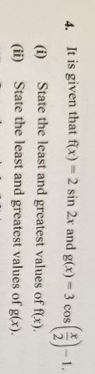

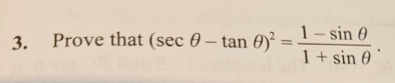

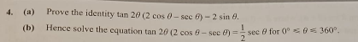

Alpha
