Team Name: DirectDesign

1. First Name _Brant________Last Name_Stannert______
Email _bss54@drexel.edu____

2. First Name _Kevin_______Last Name _Burdick_____
Email _kmb474@drexel.edu__

3. First Name _Robert______Last Name _Davis_______
Email _rjd79@drexel.edu_____

4. First Name _Stephen_____Last Name _Slaughter_____
Email _sws26@drexel.edu______

Project Name: DirectElect

Project Overview
The DirectDesign team proposes to develop a web-based electronic election voting system. We chose this project because we believe this technology is the future of political elections; as such, we seek to show a possible approach in the design of such an electronic system. Within the scope of our project is the design of a service-oriented architecture (SOA) with the flexibility to support new security policies, new technologies, and changes in the voting procedures using service components which provide the functionality needed by voters and administrators. Also within scope is the implementation of a set of services which comprise a demonstration prototype of the voting system which we will show to our class at the end of the course. The following sections of this proposal detail both the functionality and other concerns of our project.

We appreciate the security concerns that come with electronic voting systems and will address these in our design, if not in our implementation. While we would enjoy implementing security in our system, we acknowledge that we may not have enough time to incorporate this service in addition core functionality and other concerns.

Functionality
The design approach for this project will rely on UML artifacts. Although a complete implementation and demonstration of this Architecture is out of scope the intent is to architect and design a whole system. The following lists the architecture design considerations that will be addressed as part of the Design process. Through this text the work shall implies that the team is required to address it and may implies that it may be address or may not, due to design changes, and as time permits.

Communication
For an integration architecture consisting of multiple applications, the communication infrastructure connects these applications in a topology. Some of the key considerations for developing an infrastructure are the middleware, and the messaging pattern to be deployed.

The System shall transmitting messages across the network using a publish and subscribe methodology.
The System shall allow multiple services to write to same topic or queue
The messaging middleware shall be Java Messaging Services (JMS) compliant

Services
A SOA architecture is a set of methodologies for designing systems in the form of interoperable services. Services are well-defined business functionalities that are built as components that can be reused for different purposes, (Wikipedia Sept 2012). All services may be based on a predefined service contract that guarantees a minimum service level. Listed below are the key requirements of the primary Services that will be provided.
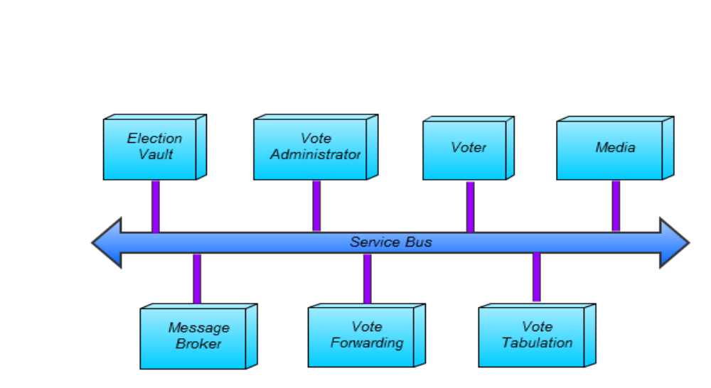

Figure 1: Service Diagram

The Voter shall register for a specific poll
The Voter shall be able to vote multiple times as long as the Poll is open
The Voter shall provide a valid password to logon to the Election Vault
The Voter may support security certificates
The Voter Administrator shall create Polls
The Voter Administrator shall create ballots
The Voter Administrator shall create list of valid voters
The Voter Administrator may support security certificates
The Election Vault shall provide information on Polls
The Election Vault will provide a continuous backup of all data
The Election Vault may include a postgres database
The Election Vault shall ensure that only one vote per individual will count towards a single election
The Media shall be able to view statistics on votes in a Poll
The Media shall be able to view when Polls are open and closed.
The Media shall be able to view statistics on voter turnout.
The Vote Forwarding Service shall establish credentials
The Vote Forwarding Service shall provide logging
The Vote Forwarding Service may provide encryption of votes and user credentials
The Vote Tabulation Service shall tabulate the votes in a Poll
The Vote Tabulation Service may provide decryption

Security
The SOA architecture provides for new flexibility and interoperability. However at times services and architecture are not secured. Some of the vulnerabilities include Injection flaws, Denial of Service Issues, Insecure Communication, Replay Attacks, and Insufficient Authentication (Service Oriented Architecture Security Vulnerabilities Web
Services – nsa.gov). A Security Model shall be created that will address security concerns at multiple levels. From here a more complete set of security requirements can be generated.

The System shall be designed to minimize security threats at multiple layers.
The System may use SSL as one capability of the Security Model

Demonstration
The following will define the overall approach to the demonstration at the end of the quarter. For the demonstration the DirectDesign team will implement a Reference Design that will provide a set of the key functionality that is a subset of the overall DirectElect System. The Reference Design will contain at a minimum the following capability.
One pub/sub server shall be provided with a pub/sub messaging pattern and support JMS. One Election Vault service shall be proved that will provide election functionality for demonstrating an election. At least two instances of a Voter services will be provided and will demonstrate registering and voting. Finally one Poll Administrator service will be provided that shows the creation of a ballot and setting up an election.

Other concerns

Agile Development
This project will be developed using a variation of Scrum development. The project will be broken down into several large features which will in turn be broken into smaller stories. Each story will be ranked using a point system depending on the amount of hours necessary to complete it. There will be release planning, a sprint 0, multiple working sprints, and some time at the end to fix remaining issues, conduct more extensive testing, and prepare for product release. A Scrum master will manage the Scrum board and ensure issues get resolved. The Scrum board itself will be located at Trello and presented as multiple boards representing the Front Burner, Back Burner, Fridge, Tested, Done, and Issues with cards on them representing stories. Each story will have at least one task to be completed by at least one team member. Trello was chosen because it is platform independent, easy to use, and is easily adapted for agile development.

Diagram Creation
UML Diagrams such as use cases and component diagrams will be creating using Gliffy. These diagrams will enhance documentation and allow different services to be easily visualized and discussed. Gliffy was chosen because it is platform independent, easy to use, and able to generate all the diagrams that are needed.

Version Control
Every file that is created will be added to a version control system to track changes, ensure build stability, and make altering existing files much easier. Github will be used for this purpose mainly because it will make the project open source. This way others can continue contributing to DirectElect after the initial release or modify the application to fit their own needs.

Web Response Design
DirectElect will support various browser sizes whether it is mobile, tablet, or desktop by using CSS3 media queries and jQuery. Pages will adapt the size of content or change it when needed to allow compatibility with all screen sizes. Using a web responsive design will allow the development of one page to display correctly on all devices instead of creating mobile specific pages or applications.

Automated Attack Prevention
CAPTCHA will be implemented to prevent automated software from logging into the system. Specifically reCAPTCHA was chosen because it is free, easy to implement, and secure. Another added bonus is that each CAPTCHA helps digitize books.

Application Server
An application server will be implemented

