**SHARK 2D - SCREENSHOT GALLERY**

COMP 4471 – COMPUTER GRAPHICS

KEVIN MACDONALD

ALEX REPEC

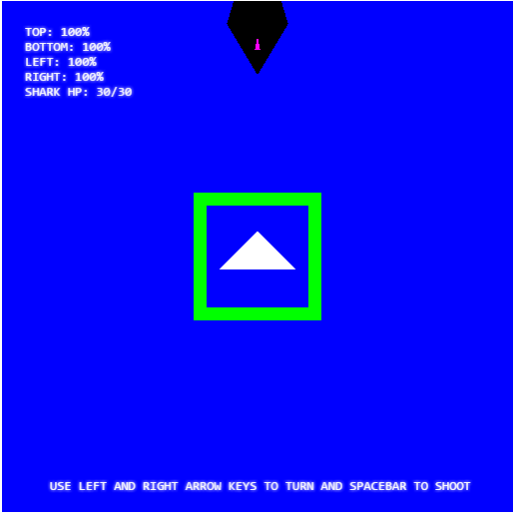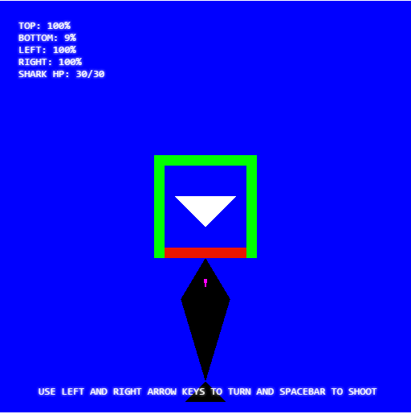

**LEFT**: This is the main screen at the beginning of the game. A shark will approach from one of the four sides of the cage at random. The strength of each side is displayed in the top right along with the shark’s health. Shark is made from 2 parts (body & top fin). Controls are displayed at the bottom of the screen.

**RIGHT:** In addition to the strength value display, the damage to the cage sides is visualized by the changing of the color of the attacked side wall from green to red. Once the wall is fully red (strength at 0%) the wall will disappear and the shark will be enter the cage and the player will lose.

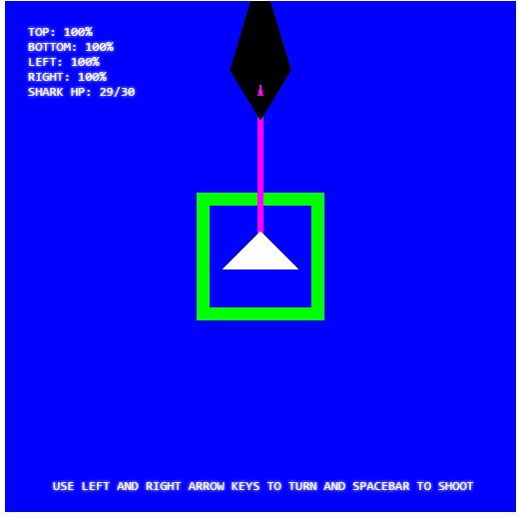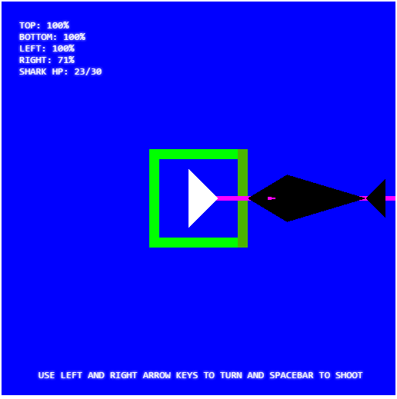

**LEFT & RIGHT:** Shooting the shark is visualized by a “laser” fired at the shark by pressing the spacebar or clicking the mouse. Once the shark has been hit by the laser 3 times, it will vanish from that side and appear at another side at random. The health of the shark can be seen decrementing in the top left corner.

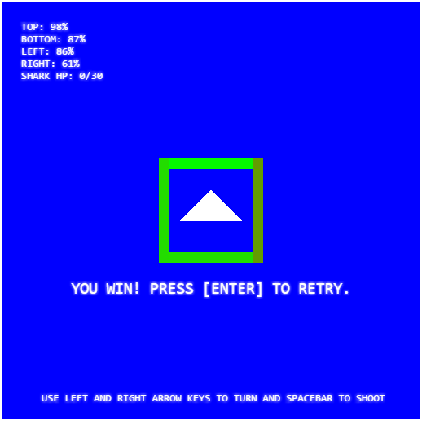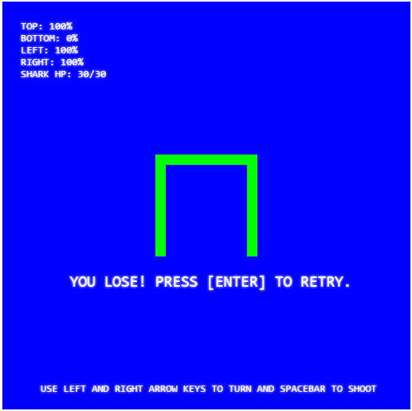

**LEFT:** Once the shark has been killed, a game over message will appear on the screen indicating that you have won the game and the player will be given the option to replay the game by pressing enter. This will refresh the page and the game will restart.

**RIGHT:** If the shark succeeds in breaking through the wall, the shark will kill the player and swim away. A message will appear on the screen indicating that you have lost the game and will be once again given the option to replay the game by pressing enter.