**SHARK 3D - SCREENSHOT GALLERY**

COMP 4471 – COMPUTER GRAPHICS

KEVIN MACDONALD

ALEX REPEC

**GAME START AND PLAY:**

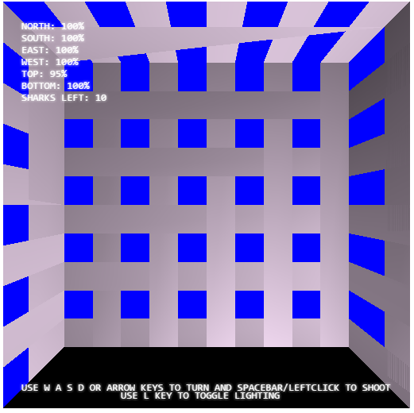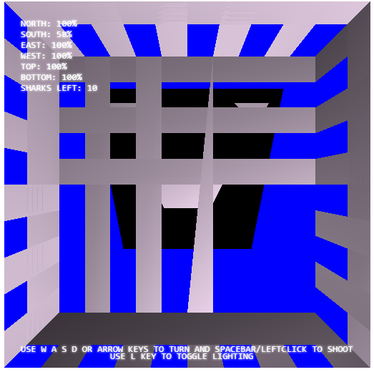

When the game is started, a shark will approach one of the six sides of the cage at random and begin to damage it. The strength of each cage is shown in the top left corner, as well as being visually represented on the cage wall itself by damage. In addition, sharks remaining are displayed as well. You align yourself with the shark as seen in the right screenshot and press spacebar to kill it.

**SHADOWS:**

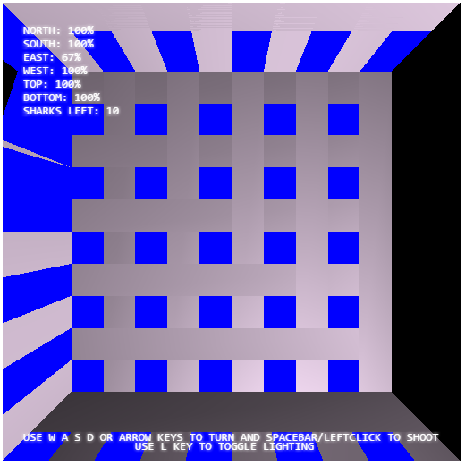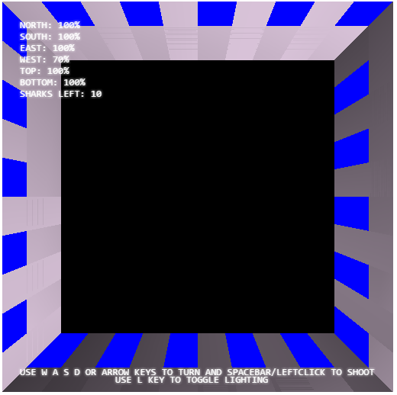

Sides you are facing can be seen and shadow of the shark is displayed on the opposite side of the cage where the shark is attacking. It is displayed as a black square and disappears once the shark is killed.

**GAME OVER:**

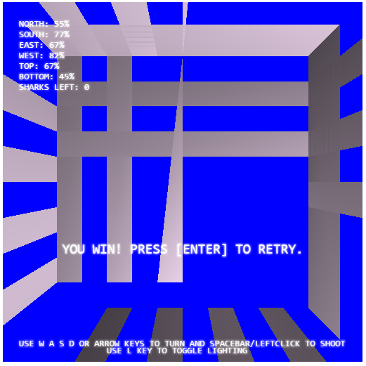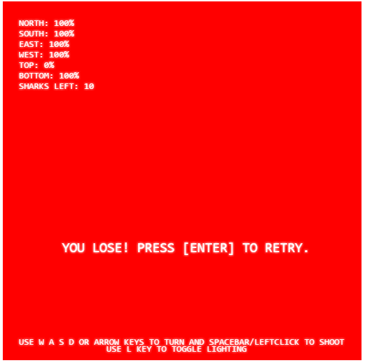

Once the sharks have all been killed or if the shark has killed you, a game over screen appears indicating that you have won or lost the game. If you wish to replay the game, simply press [Enter].

**EXTRA FEATURES – SHARK ATTACKS FROM SIX SIDES:**

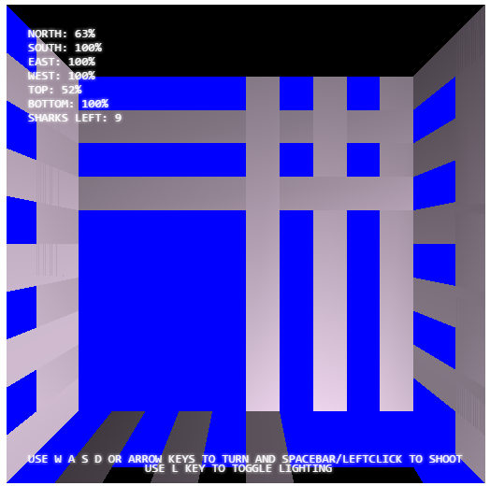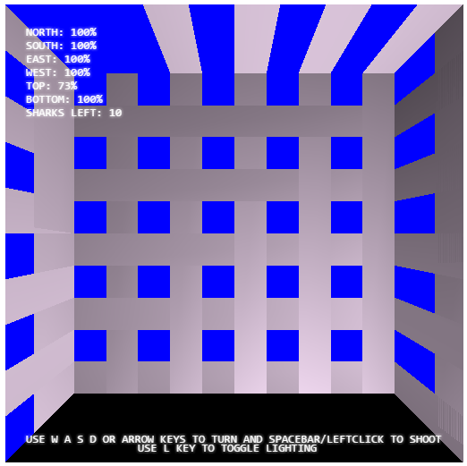

The first extra feature we have added to the game is having the shark being able to attack the cage from each of the six sides. As you can see in the left screenshot the shark is attacking from the bottom, and in the right screenshot, the shark is attacking from the top of the cage. To align yourself with the shark, press up or down accordingly.

**EXTRA FEATURES – SCREEN MESH DAMAGE**

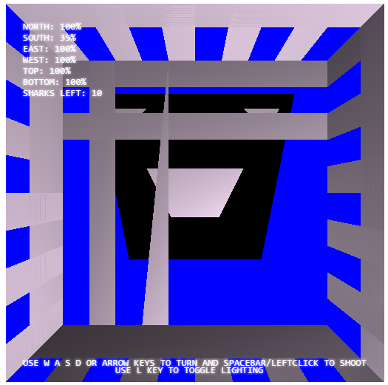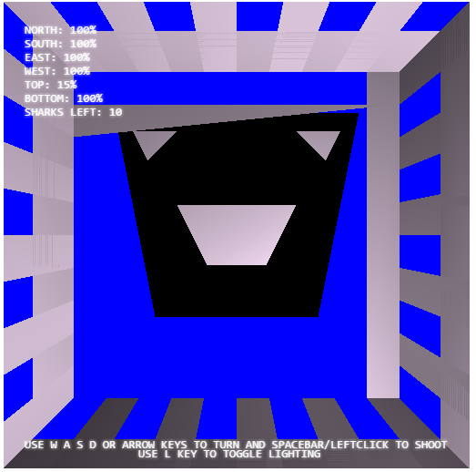

In addition to the strength of the cage being displayed in the top left corner, it is also indicated visually by the walls themselves in a screen mesh which becomes sparser as the shark is attacking it. This color and cage design is based on the actual look of a shark cage that would be used underwater.

**EXTRA FEATURES – LIGHTING TOGGLE:**

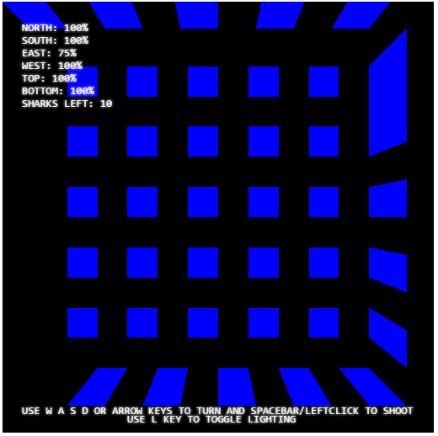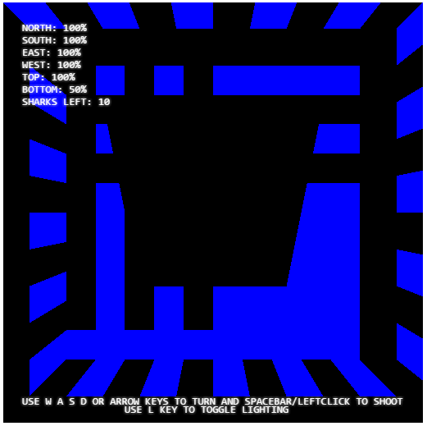

The final extra feature added is the ability to turn the lighting on or off. Lighting is on by default but if you wish to toggle the lighting simply press the L key. The cage is now dark and the shark face is not visible. This is designed to simulate the use of a flashlight by the player underwater.