

ESCUELA SUPERIOR POLITÉCNICA DEL LITORAL

FACULTY OF ELECTRICAL AND COMPUTER ENGINEERING

Software Engineering II

Intellectual Property – Report 1st Evaluation

Team #5

Members:
- Kevin Alejandro Castro Ortíz
- John Eduardo Cañarte Ormaza
- Ronny Steven Garcia Zambrano
- Bryan Jair Segovia Mariscal

GUAYAQUIL - ECUADOR
Year: 2024

Abstract
The Oficina de Transferencia de Resultados de Investigación (OTRI) of the Escuela Superior Politécnica del Litoral (ESPOL) currently lacks an automated system to assist in the registration and maintenance of intellectual property generated by its researchers. This project aims to design and implement a system to address this need. The system will enable online registration of research by ESPOL authors, review and tracking of OTRI registration processes, generation of reports and statistics, among other activities. The project seeks to develop a web platform to ensure proper protection and commercialization of the intellectual property generated at ESPOL. Additionally, it aims to integrate the system with an existing one that scans and verifies submitted papers, processes them, and submits a registration request. Apart from system development, the project seeks to integrate the completion of the pre-registration form, which will collect all the necessary information to properly manage the process legally and avoid future complications.

Index
1. Introduction 5
1. Description of the problem 5
2. Justification of the problem 5
3. Objectives 5
3.1. General Objective 5
3.2. Specific Objectives 6
3.3. User Histories 6
3.4. Use Case Diagram 9
3.5. Class Diagram 10
3.6. Component Diagram 11
3.7. Deployment Diagram 12
3.8. Prototype 12
2. Repository URL 13
3. SCRUM 13
3.1 Role definition 13
3.2 Backlogs 14
3.3 Planning 15
4. Online tool for teamwork management 16
5. Coding Standard Documentation and detecting and Enforcing Coding Standards 18
6. Preemptive Error Detection 19
7. Definition and Execution of Test Cases 21
8. System Deployment 25
9. Sprint Review 25
10. Acceptance form 26

Introduction

Description of the problem
The research process is very important in any society as it allows you to develop and seek information on a specific topic and explore it in greater depth, or perhaps innovate with new methods applied to various branches of science. It is essential to acknowledge the people who invest time and effort into these research processes, as without them, the topic might not develop, and progress that benefits society might not occur. This is why the concept of intellectual property (IP) exists, to control the material that other researchers can use, ensuring that the efforts of researchers are recognized and not in vain, and preventing anyone from using their work without giving them due credit or recognition. This also opens doors for researchers to collaborate with others and potentially secure funding for their projects, moving from mere written ideas to practical implementation.
The processes for IP registration are time-consuming and involve many follow-up meetings to complete a form that gathers all the necessary information for a successful and legal registration. Therefore, it is optimal to have a system that can manage this form-filling process more efficiently, providing immediate feedback without requiring both parties to coordinate meetings for reviews. It is important to keep a record of everything, and the options should be configurable since the world is constantly changing, and the form requirements might not be an exception. The requirements for registration might change, but the process would remain the same, aiming to simplify the lives of people with a system that performs these actions.
Intellectual property represents a significant component in the research domain, serving to recognize and protect the original contributions generated by an educational institution. Escuela Superior Politécnica del Litoral (ESPOL) is immersed in a flow of innovation and discoveries, necessitating efficient and secure management and maintenance of its research. The OTRI (Office for the Transfer of Research Results) handles these requests, and it is important to consider that each manager represents their faculty and their assigned research centers. This significantly streamlines the processes.

Justification of the problem
The project aims to design and implement an Intellectual Property Registration System adapted to meet the needs of ESPOL and OTRI. This will help streamline and automate processes associated with the management of intellectual property records, strengthening the protection and dissemination of research achievements by the author(s). Aspects such as user identification, registration, and maintenance of intellectual property will be addressed. Functional and non-functional requirements will also be implemented to ensure that the Technology Transfer Office (OTRI) has a system they can use to perform their activities at ESPOL.

Objectives

General Objective
- Develop and implement a web platform that systematizes and tracks the processes of registration and management of intellectual property generated at Escuela Superior Politécnica del Litoral.

Specific Objectives
- Provide OTRI managers at ESPOL with a tool that optimizes the review and tracking of intellectual property registrations within the institution
- Analyze the current processes of intellectual property management at ESPOL, identifying the system's functional and non-functional requirements.
- Develop and implement the system using software technologies, including the creation of reporting modules, statistics, and a dashboard for monitoring indicators.

User Histories
Here are the user stories presented to the client in the first stage of the project. It is noteworthy that the project has taken a different direction in the current stage, for example, uploading documents is no longer necessary. Instead, a single form will be used to collect all the information. The user stories are listed below:
- As a user, I need to have a username and password authentication system to validate my access to the intellectual property registration tracking system.
- As a user, I want to be able to choose the assigned role with which I will log into the system to enter with the appropriate role for the actions I want to perform in the system.
- As a user, I need to be able to select the role I want to work with without having to log out and log back into the system, to perform different tasks that require specific role permissions.
- As a user, I need to be able to read the system's terms of use to be informed about the scope of the system and the conditions involved in its use.
- As a user, I need to be able to electronically sign PDF documents within the system to facilitate the use of electronic signatures in conjunction with the system.
- As a user, I need to validate electronically signed documents when they are uploaded to the system to ensure the documents are correctly signed.
- As a user, I need to be able to upload documents to the system to submit documents related to intellectual property registration processes.
- As an administrator, I need to be able to delete documents that have been uploaded to the system to remove documents that were uploaded incorrectly.
- As a researcher, I need to receive notifications to stay informed about updates, deadlines, announcements, etc.
- As a researcher, I need access to a panel where I can view all the notifications I have received to review and manage the notifications received previously.
- As a researcher, I need to be able to independently view my intellectual property registration processes, their details, and their status to track the intellectual property registration processes in which I am involved.
- As a researcher, I need a screen where I can see the status of the intellectual property registration, whether it was accepted or rejected, and details about it to know which of my registrations have been granted or denied and keep track of them.
- As a manager, I need to receive reminders about pending steps in the intellectual property registration process to be aware that I need to complete certain activities in the registration process.
- As a manager, I need to track multiple intellectual property registration processes simultaneously to efficiently manage the various registration processes assigned to me.
- As a user, I need to have a history of the intellectual property registration processes in which I have been involved, whether successful or not, to keep a record of the registration processes for decision-making.
- As a researcher, I need to obtain my digitized certificate from the platform once a registration process is completed to obtain a document from the OTRI that supports my institutional intellectual property registration.
- As an administrator, I need to be able to create, modify, and delete roles to better manage the system.
- As an administrator, I need to assign permissions to specific roles to ensure data security and system functionality.
- As an administrator, I need to assign and remove roles from different users in the system to provide users with an experience appropriate to the activities they need to perform.
- As an administrator, I need to configure the different types of intellectual property accepted in the system, the steps to follow in each of their registration processes, and the required documents to define the necessary requirements for the various registration types.
- As an administrator, I need to view a history of all events that occurred in an intellectual property registration process to control the registration process and the activities performed during it.
- As an administrator, I need to create, modify, and delete notifications with customizable parameters to facilitate the personalization of alerts according to needs and changes in the process.
- As an administrator, I need the ability to audit user actions to ensure data integrity and compliance with policies.
- As a manager, I need to generate statistics and charts on the management of intellectual property registrations to make informed decisions based on the analyzed data from these charts.
- As an administrator, I need to configure a priority system for tasks, notifications, and other activities that require it to appropriately prioritize necessary activities.
- As a manager, I need to upload certificates to the system or generate them from the system to provide the researcher with proof of their intellectual property registration.
- As an administrator, I need to assign who will be responsible for a particular process and modify these assignments so that the researcher has a point of contact for questions or issues.
- As an administrator, I need to assign a temporary person responsible for a specific process to delegate management to an appointed person for a limited time.
- As an administrator, I need to upload a file detailing the intellectual property and providing information about the process to achieve registration and maintenance to be informed about intellectual property concepts and registration processes.
- As a manager, I need an estimate of the costs generated during the intellectual property registration process depending on the type and location where it is to be registered to properly budget the registration costs.
- As a manager, I need to enter the total cost generated by the intellectual property registration in the different countries where it is being registered to compare the cost estimation in the system with the actual cost paid to register the intellectual property.
- As a manager, I need to generate reports tracking sent notifications, including dates, recipients, and notification content to keep a record of all the information obtained from the system for backup in case of errors.
- As an administrator, I need to be able to connect with other OTRI or ESPOL systems to obtain information to integrate the registration process and manage information more effectively.
- As an administrator, I need the ability to customize and configure the views and panels for tracking intellectual property registration processes to meet the specific needs of users by roles.
- As a manager, I need to add comments to the documents I am reviewing to provide detailed feedback to researchers on corrections that need to be made to inform researchers quickly about any observations during the intellectual property registration process.
- As a researcher, I need to be able to add comments during the intellectual property registration process to resolve doubts, details, or add information to the accessed registration.
- As a visitor, I need to be able to consult information about the intellectual properties registered by ESPOL to learn about the technologies promoted by ESPOL and understand the work done by the institution.

Use Case Diagram
Figure 1: Use Case Diagram of the system

Class Diagram
Figure 2: First version of the Class Diagram for the system

Component Diagram
Figure 3: First version of the Component Diagram for the system

Deployment Diagram
Figure 4: First version of the Deployment Diagram for the system

Prototype
You can find the prototype created with the Figma tool, which meets the previous requirements demanded by the client. It also presents certain parts where the new logic of the system is managed due to the client's indication of changes in the requirements and priorities of the OTRI.
Link: https://www.figma.com/design/vLaew55B4UDi0RhI9o4k25/OTRI?node-id=0-1&t=PZ0M1MZE9f85vsB1-1

Repository URL
Repository of Software Engineering 1 and the proyect management:
https://github.com/kevcorti/SoftwareEngineering

Repository of Software Engineering 2 (frontend):
https://github.com/rsgarcia0203/SRSPI-front-end

Repository of Software Engineering 2 (backend):
https://github.com/rsgarcia0203/SRSPI-back-end

SCRUM
In this sprint, the goal is to complete the implementation of both the pre-registration form and the full registration form. These forms will require necessary user information to properly manage the process. Additionally, the sprint will focus on displaying the application's database and receiving feedback necessary for making improvements.

Role definition
CASTRO ORTIZ KEVIN ALEJANDRO | BACKEND DEVELOPER | DOCUMENTATION, IMPLEMENTATION OF BACKEND OF THE APPLICATION, TEST THE FUNCTIONALITY OF THE FORM
CAÑARTE ORMAZA JOHN EDUARDO | FRONTEND DEVELOPER | USE OF REACT TO DO THE FRONTEND IMPLEMENTATION, FOLLOW THE CODE STANDAR OF THE ESPOL
GARCIA ZAMBRANO RONNY STEVEN | SCRUM MASTER, BACKEND DEVELOPER | DATABASE IMPLEMENTATION, COORDINATION OF THE MEETINGS WITH THE CLIENT
SEGOVIA MARISCAL BRYAN JAIR | FRONTEND DEVELOPER | DESIGN OF THE FORM, COMMUNICATION WITH THE CLIENT IN MEETINGS.

Backlogs
Table 1. Backlogs
Cod | User Story for Sprint 1 | Estimation (days) | Priority | Status
HU01 | As a researcher, I must be able to accept terms and conditions. | 1 | High | Done
HU02 | As an Espol user, I must be able to view the pre-form. | 1 | High | Done
HU03 | As a researcher, I must be able to fill out the form. | 2 | High | In progress
HU04 | As a researcher, must be able to navigate between tabs. | 1 | High | Done
HU05 | As an Espol user, I must be able to log into the system. | 1 | High | In progress
HU06 | As an Espol user, I must be able to choose a role. | 1 | High | In progress
HU07 | As a researcher, I can create a PI registration request. | 1 | High | Done
HU08 | As a manager, I must have assigned faculties and research centers. | 3 | Low | Not done
HU09 | As an Espol user, I must see the showcase of PI. | 4 | Low | Not done

Planning
Table 2. Backlogs Planning
Cod | User Story for Sprint 1 | Owner | Priority | Status
HU05 |  | CASTRO ORTIZ KEVIN ALEJANDRO | High | In progress
  As an Espol user, I must be able to log into the system.
HU06 | As an Espol user, I must be able to choose a role. | CASTRO ORTIZ KEVIN ALEJANDRO | High | In progress
HU02 | As an Espol user, I must be able to view the pre-form. | CAÑARTE ORMAZA JOHN EDUARDO | High | Done
HU03 | As a researcher, I must be able to fill out the form. | CAÑARTE ORMAZA JOHN EDUARDO | High | In progress
HU07 | As a researcher, I can create a PI registration request. | GARCIA ZAMBRANO RONNY STEVEN | High | Done
HU08 | As a manager, I must have assigned faculties and research centers. | GARCIA ZAMBRANO RONNY STEVEN | Low | Not done
HU01 | As a researcher, I must be able to accept terms and conditions. | SEGOVIA MARISCAL BRYAN JAIR | High | Done
HU04 | As a researcher, must be able to navigate between tabs. | SEGOVIA MARISCAL BRYAN JAIR | High | Done
HU09 | As an Espol user, I must see the showcase of PI. | SEGOVIA MARISCAL BRYAN JAIR | Low | Not done

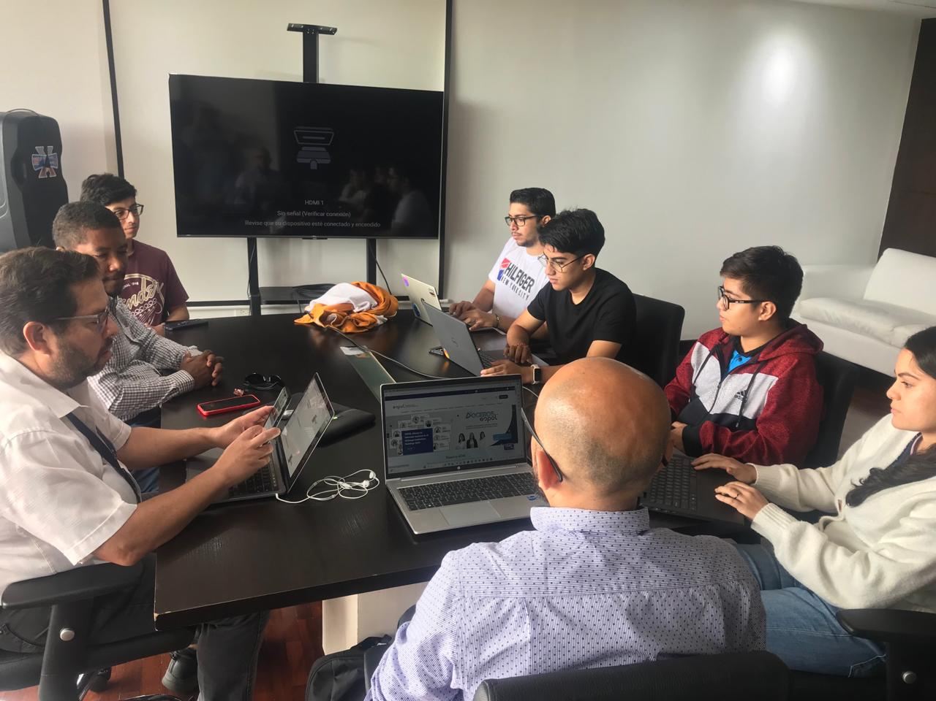
Figure 5: All meetings were held in person at the Vice-Rectorate at ESPOL.

Online tool for teamwork management
For managing the documents and code of the project, which will be developed in both React for the frontend of the application and .Net for the backend using microservices, we have two repositories on GitHub. These repositories have been divided to separate these two deliverables for better use by the developers. GitHub also allows us to manage multiple branches where each developer can work independently without affecting the changes of others. This is to prevent versioning issues. Additionally, it allows us to manage task assignments in a project as well as monitor its progress.
We work with this tool because of the ease it provides in managing options and because the development participants are also very familiar with it. Therefore, it was deemed feasible to opt for something comfortable, especially since everyone has an account on this application.
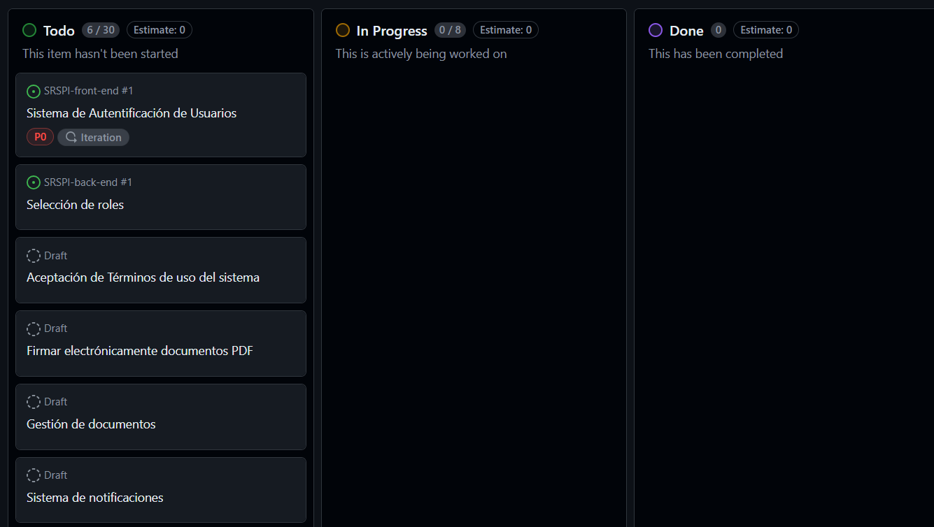
Figure 6: Task management in GitHub

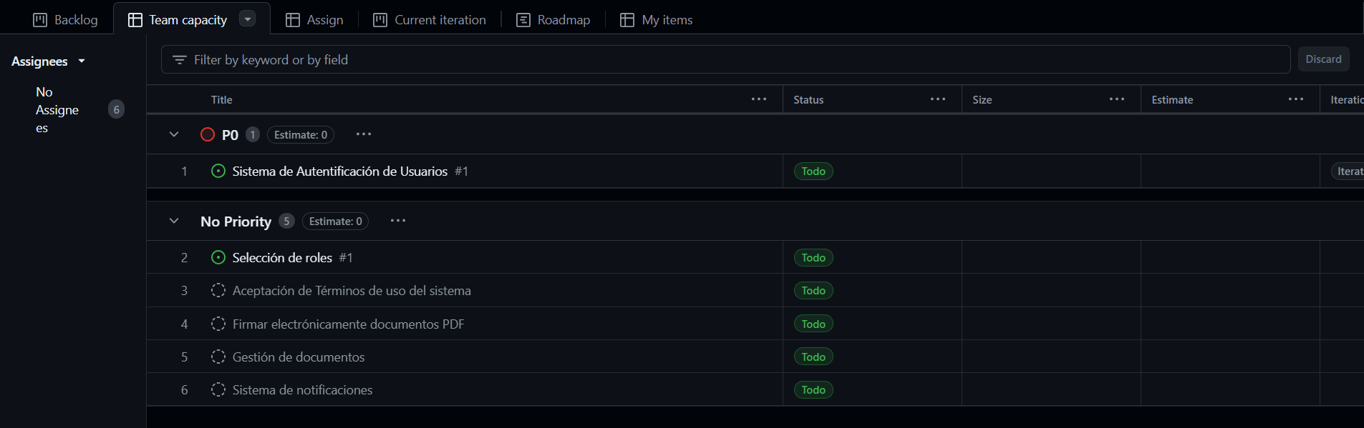
Figure 7: Another view of the GitHub tool for managing team tasks.

Coding Standard Documentation and detecting and Enforcing Coding Standards
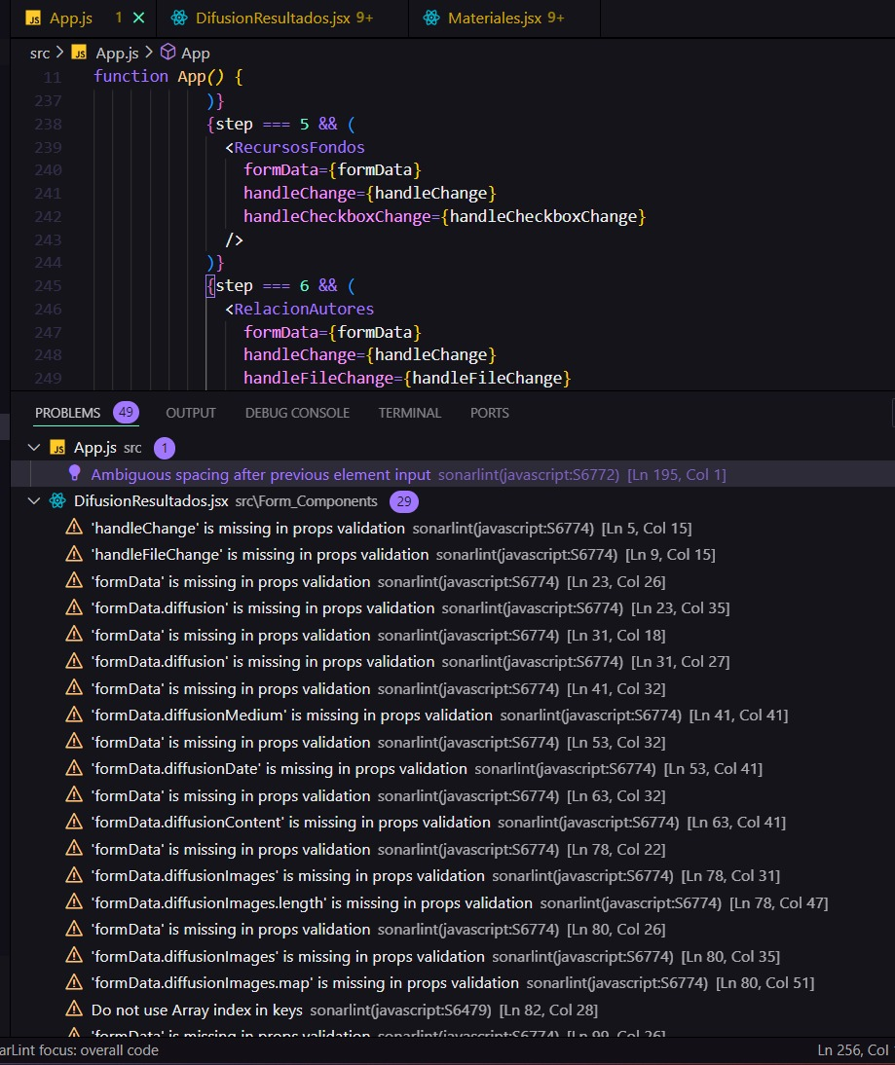
Figure 8: Proof before using the coding standard in the application, demonstrating all the problems in App.js.
Basically a large part of our code problems, if not all, were a question of Props validation in React, and SonarLint helped us keep in mind that it is important to validate the props that React components receive to ensure that they are being corrected. using it correctly and avoid possible runtime errors. In order to solve this, the prop-types library was imported.

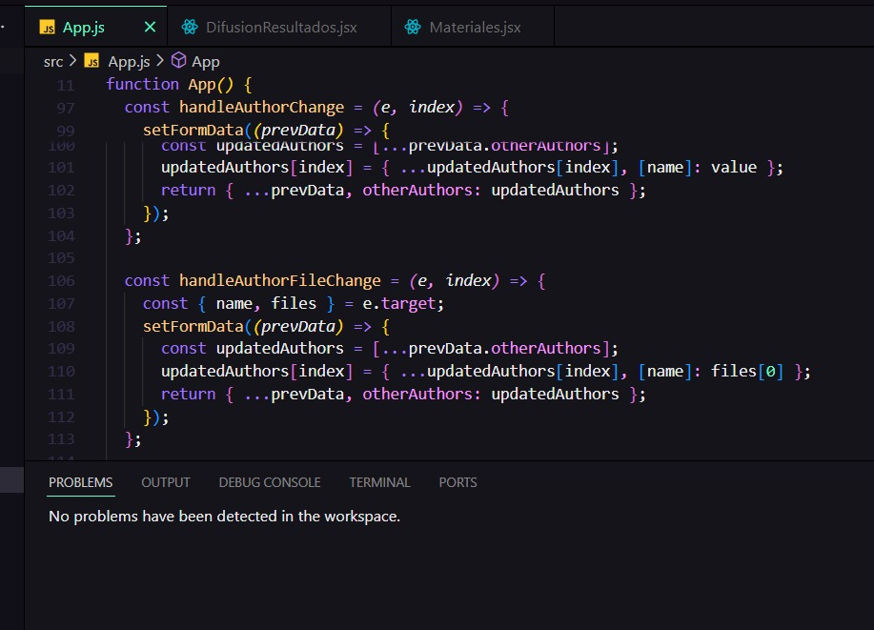
Figure 9: Proof after using the coding standard in the application, demonstrating there are no problems in App.js.

These screenshots, along with the description and code examples, demonstrate how SonarLint helps detect and fix problems in your code, ensuring compliance with coding standards.
As an addition we demonstrate that now we manage the code by components, and not as in the beginning all the code was in the App file

Preemptive Error Detection
SonarLint for JavaScript is a tool designed to improve code quality by providing real-time feedback directly within integrated development environments (IDEs) such as Visual Studio Code, IntelliJ IDEA, and Eclipse. Here's a description of what SonarLint offers for JavaScript:
- Code Quality Analysis
- Real-time Feedback
- Rules-based Analysis
- Customization
- Integration
- Continuous Improvement
We use this tool because developers found it very useful for verifying both the frontend made with React and JavaScript, and the backend developed with .NET using C#. The tool serves for both and is easy to use in Visual Studio Code.
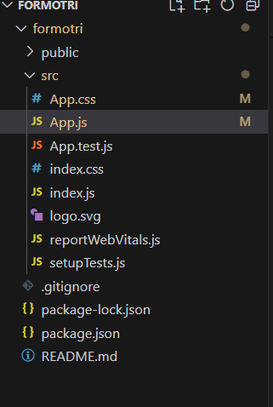
Figure 10: Management of the form in one file
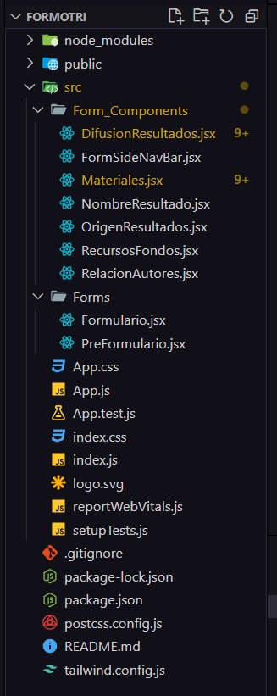
Figure 11: Structuring the project by components
This demonstrates how we have utilized components to create the form and pre-form of our application, ensuring a better structure and improved management in terms of programming.

Definition and Execution of Test Cases
The definition of the test cases are as follows.
Test case ID | TC-HU01-01
Test Priority | 2
Test title | Terms and Conditions Acceptance
Test Description | Verify that a researcher can successfully accept the terms and conditions.
Pre-condition | Researcher is presented with terms and conditions acceptance screen.
Expected output | Terms and conditions accepted successfully.
Actual output | Terms and conditions accepted successfully.
Status | Pass

Test case ID | TC-HU02-01
Test Priority | 5
Test title | Pre-Form Viewing
Test Description | Ensure that an Espol user can view the pre-form.
Pre-condition | Espol user is logged into the system.
Expected output | Pre-form is displayed correctly.
Actual output
Status | Not tested yet

Test case ID | TC-HU03-01
Test Priority | 2
Test title | Form Filling
Test Description | Verify that a researcher can fill out all required fields in the form.
Pre-condition | Researcher has accessed the form and is entering data.
Expected output | Form is completed with all required fields filled.
Actual output | Form is partially completed with all required fields filled.
Status | Partially tested

Test case ID | TC-HU04-01
Test Priority | 1
Test title | Tab Navigation
Test Description | Ensure that a researcher can navigate between different tabs/screens in the application.
Pre-condition | Researcher is logged into the system and has access to multiple tabs.
Expected output | Able to switch between tabs without issues.
Actual output | Able to switch between tabs without issues.
Status | Pass

Test case ID | TC-HU05-01
Test Priority | 5
Test title | Login Functionality
Test Description | Verify that an Espol user can log into the system using valid credentials.
Pre-condition | Espol user has valid username and password.
Expected output | User successfully logged into the system.
Actual output
Status | Not tested yet

Test case ID | TC-HU06-01
Test Priority | 2
Test title | Role Selection
Test Description | Test that an Espol user can select a role upon logging into the system.
Pre-condition | Espol user has logged into the system.
Expected output | User can choose a role from available options.
Actual output
Status | In Progress (ongoing testing)

Test case ID | TC-HU07-01
Test Priority | 4
Test title | Verify that a researcher can successfully create a PI registration request.
Test Description | Researcher has filled out all required information in the PI registration form.
Pre-condition | PI registration request created successfully.
Expected output | PI registration request created successfully.
Actual output
Status | PI registration request created successfully.

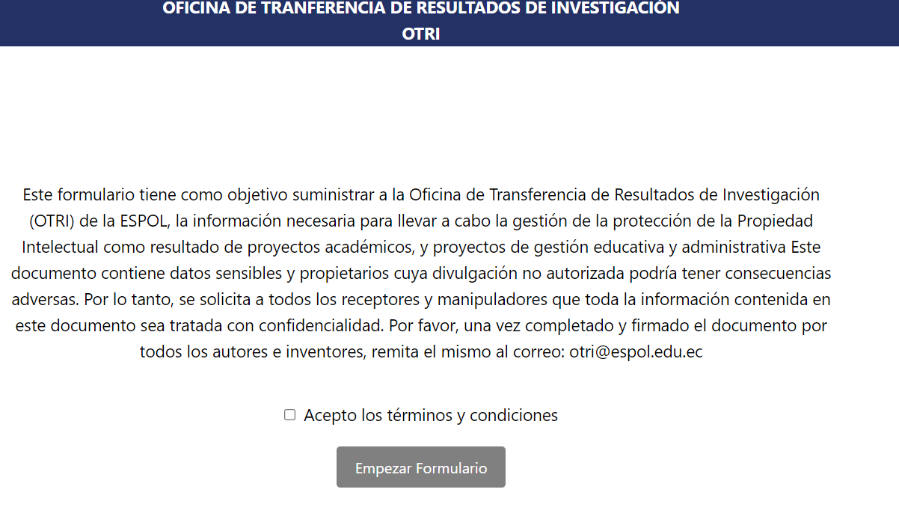

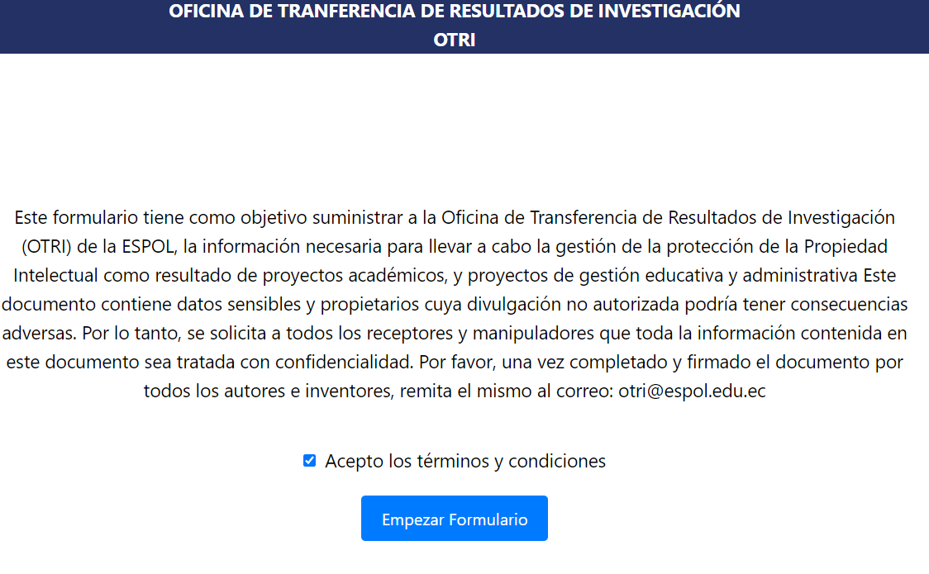
Figure 11: test (TC-HU01-01) Pass

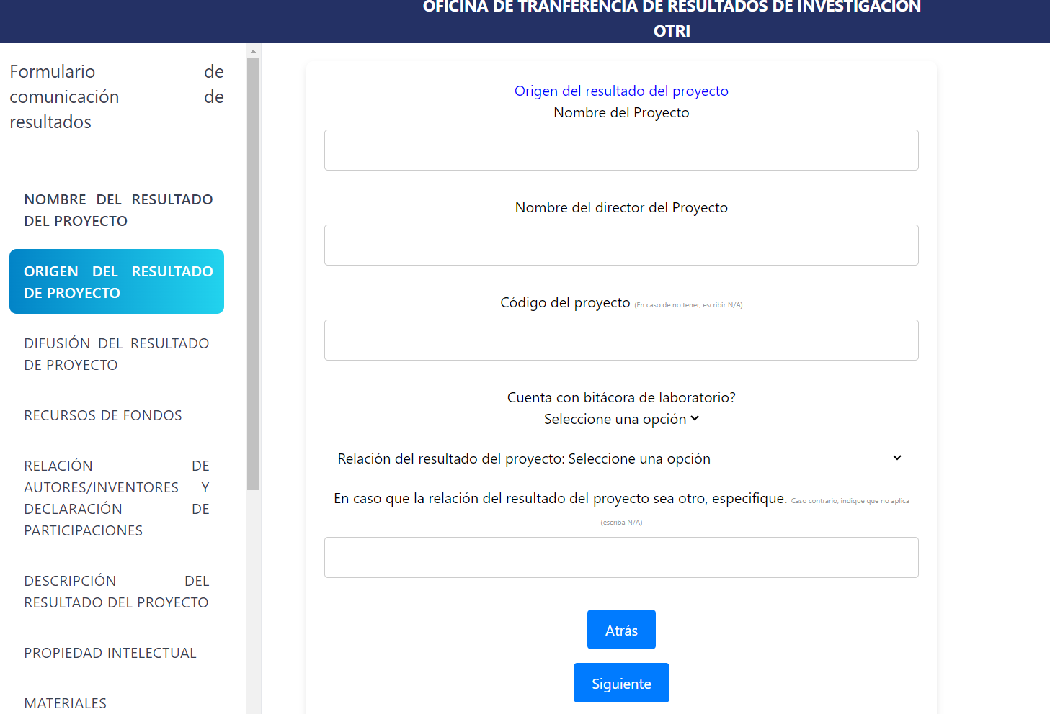
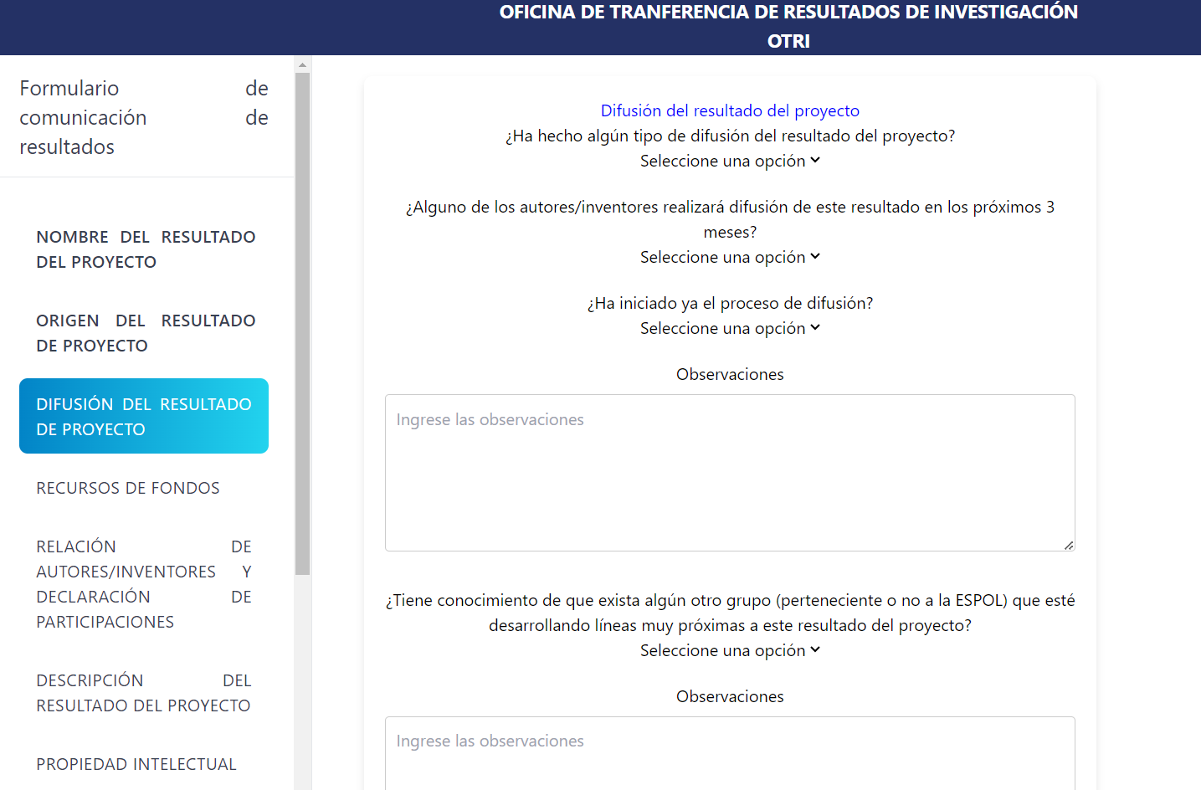
Figure 11: test (TC-HU04-01) Pass

System Deployment
The application still cannot be uploaded to production because we must adhere to Espol's guidelines. The procedures have been delayed as requirements have changed. This is because OTRI will no longer have a system for handling requests; instead, everything will be tracked, and our system will integrate that functionality. We have not yet had the meeting with GTSI to use Espol's systems and data, which is crucial for getting the application up and running. However, it's important to note that to request its deployment, it must be nearly finished. Currently, we are still in meetings defining the design, tables, and demonstrating progress as we receive the necessary information.

Sprint Review
Video of the sprint: https://youtu.be/SOQ9K0x_6_U

Acceptance form
