

FACULTY OF SCIENCE AND TECHNOLOGY  
  
ACADEMIC YEAR 2019  
SEMESTER 2  
  
 COMP3161 “Introduction to Database Management System”

Group Members:

Kevel Campbell - 620076557

Akeem Purrier – 620087903

Sania Spence – 620096421

Delano Tracey- 620109589

Date Due: May 7, 2020

**Social Networking ER-Diagram**

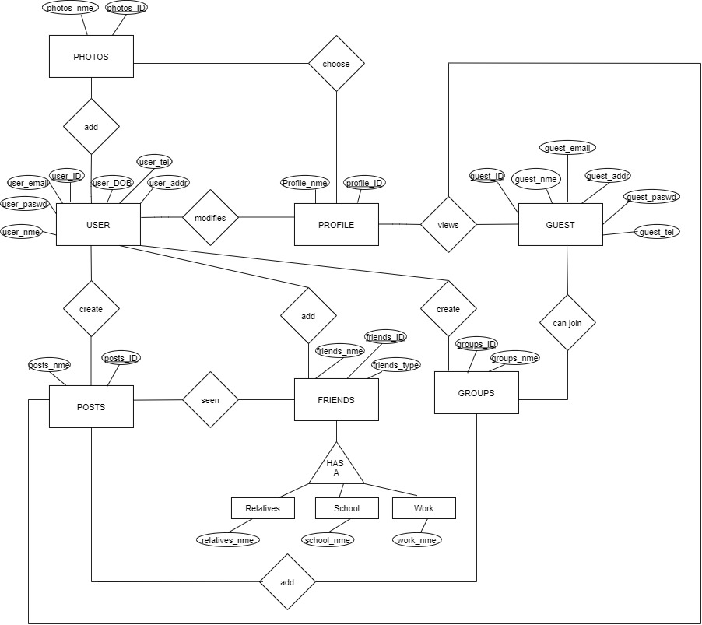

**Un – Normalised Tables**

User (user_ID, user_DOB, user_nme, user_paswd, user_email, user_addr, user_tel).

Photos (photos_ID, photo_nme).

Profile (profile_ID, profile_nme).

Guest (guest_ID, guest_nme, guest_email, guest_addr, guest_paswd, guest_tel).

Posts (posts_ID, posts_nme).

Friends (friends_ID, friends_nme, friends_type).

Relatives (friends_ID, relatives_nme).

School (friends_ID, school_nme).

Work (friends_ID, work_nme).

**Normalised Tables**

Users (user_id, user_fname, user_lname, user_dob, user_paswd, user_addr)

Emails (user_id, user_email)

Telephones (user_id, user_tel)

Profiles ( user_id, ,profile_desciption,profile_photo)

Photos (photo_id, user_id ,photo_nme, photo_image,photo_datetime)

Posts (posts_id, user_id , post_text,datetime)

Groups (group_id, user_id,group_nme,group_description) note: user_id would be the creator’s user_id

GroupMembers(group_id,user_id,member_status) note: member_type either being creator, content creator or member

GroupPosts(group_id,post_id)

Friends (user_id,friend_id,friend_type)

Comment (comment_id,user_id,post_id ,comment_text,comment_datetime)

Guest (guest_ID, guest_nme, guest_email, guest_addr, gueszt_paswd, guest_tel).

**Data Dictionary**

**User**

|  |  |  |  |  |
| --- | --- | --- | --- | --- |
| **Field Name** | **Data Type** | **Field Size** | **Description** | **Example** |
| User_id, | Number |  | Unique record of a user | 48723 |
| User_dob | Date/ Time |  | Date of birth of a user | 4/01/1980 |
| User_fnme | String |  | First name of a user | John |
| Uuser_lnme | String |  | Last name of a user | Brown |
| User_paswd | Auto Number |  | Password for a user | Jdfh834&gr |
| User_addr | String |  | Address of a user | 4 Orange Street, New Jersey |

**Email**

|  |  |  |  |  |
| --- | --- | --- | --- | --- |
| **Field Name** | **Data Type** | **Field Size** | **Description** | **Example** |
| User_id | Number |  | Unique record of a user | 78745 |
| User_email | Auto Number |  | Email address of a user | johnbrown@gmail.com |

**Telephone**

|  |  |  |  |  |
| --- | --- | --- | --- | --- |
| **Field Name** | **Data Type** | **Field Size** | **Description** | **Example** |
| User_id | Number |  | Unique record of a user | 62362 |
| User_tel | Number |  | Telephone number of a user | 87472 |

**Photos**

|  |  |  |  |  |
| --- | --- | --- | --- | --- |
| **Field Name** | **Data Type** | **Field Size** | **Description** | **Example** |
| Photo_id | Number |  | Unique record of a photo | 72363 |
| user_fname | String |  | First name of a user | John |
| user_lname | String |  | Last name of a user | Brown |
| Photo_nme | String |  | Name of the photo uploaded | Awesome |
| Photo_image | Image |  | Actual photo that was uploaded | Awesome.jpeg |
| photo_datetime | Date/ Time |  | Date of a particular photo | 2/03/2019 |
| User_id | Number |  | Unique record of a user | 62572 |

**Profile**

|  |  |  |  |  |
| --- | --- | --- | --- | --- |
| **Field Name** | **Data Type** | **Field Size** | **Description** | **Example** |
| user_id | Number |  | Unique record of a user | 8535 |
| user_fname | String |  | First name of a user | Mary |
| user_lname | String |  | Last name of a user | Jane |
| Profile_description | String |  | Information about a particular user | Hello MyBook. |
| Profile_photo | Image |  | Photo for a user’s profile | Hello.jpeg |

**Posts**

|  |  |  |  |  |
| --- | --- | --- | --- | --- |
| **Field Name** | **Data Type** | **Field Size** | **Description** | **Example** |
| Posts_id | Number |  | Unique record of a post | 46372 |
| User_id | Number |  | Unique record of a user | 48727 |
| User_fname | String |  | First name of a user | Tom |
| User_lname | String |  | Last name of a user | Henry |
| Post_text_datetime | Date/ Time |  | Date of a particular post text | 5/04/2019 |

**Guests**

|  |  |  |  |  |
| --- | --- | --- | --- | --- |
| **Field Name** | **Data Type** | **Field Size** | **Description** | **Example** |
| Guest_id | Number |  | Unique record of a guest | 362462 |
| Guest_fnme | String |  | First name of a guest | Mary |
| Guest_lnme | String |  | Last name of a guest | Jane |
| Guest_email | Auto Number |  | Email address of a guest | maryjane@yahoo.com |
| Guest_addr | String |  | Address of a guest | 58 Linton Ave, New York |
| Guest_paswd | Auto Number |  | Password for a guest | Filedb48 |
| Guest_tel | Number |  | Telephone number of a guest | 1-876-123-4567 |

**Groups**

|  |  |  |  |  |
| --- | --- | --- | --- | --- |
| **Field Name** | **Data Type** | **Field Size** | **Description** | **Example** |
| Group_id | Number |  | Unique record of a group | 8172 |
| User_id | Number |  | Unique record of a user | 47834 |
| Group_nme | String |  | Name of particular group | Database Hard talk |
| Group_description | String |  | Information about a particular group | Database Hard Talk is where we discuss pressing matter as it relates to world of database. |

**GroupMembers**

|  |  |  |  |  |
| --- | --- | --- | --- | --- |
| **Field Name** | **Data Type** | **Field Size** | **Description** | **Example** |
| Group_id | Number |  | Unique record of a group | 9274 |
| User_id | Number |  | Unique record of a user | 83452 |
| Member_status | String |  | Status of a particular member | Admin |

**GroupPosts**

|  |  |  |  |  |
| --- | --- | --- | --- | --- |
| **Field Name** | **Data Type** | **Field Size** | **Description** | **Example** |
| Group_id | Number |  | Unique record of a group | 7529 |
| Post_id | Number |  | Unique record of a post | 9356 |

**Friends**

|  |  |  |  |  |
| --- | --- | --- | --- | --- |
| **Field Name** | **Data Type** | **Field Size** | **Description** | **Example** |
| User_id | Number |  | Unique record of a user | 2945 |
| Friend_id | Number |  | Unique record of a friend | 8573 |
| Friend_type | String |  | Type of friend to the user | Relative |

**Comment**

|  |  |  |  |  |
| --- | --- | --- | --- | --- |
| **Field Name** | **Data Type** | **Field Size** | **Description** | **Example** |
| comment_id | Number |  | Unique record of a comment | 85 |
| user_id | Number |  | Unique record of a user | 7482 |
| post_id | Number |  | Unique record of a post | 8573 |
| user_fname | String |  | First name of a user | John |
| user_lname | String |  | Last name of a user | Brown |
| comment_text | String |  | The actual comment made by the user | Hey, I’m new to MyBook |
| comment_datetime | Date/ Time |  | Date and Time when a comment was made | 3/09/2019 |

User Population Script

#!/usr/bin/python

from __future__ import print_function

from flask import Flask, request

from faker import Factory

from random import randint, choice, sample

import mysql.connector

from mysql.connector import Error

import hashlib

fake = Factory.create('en_US')

cnxn = mysql.connector.connect(host='localhost',

database='comp3161finalproject',

user='root',

password='')

print ("GENERATING THE USERS FOR THE DATABASE!!")

cursor = cnxn.cursor()

count = 0

for i in range (500000):

user_fname = fake.first_name()

user_lname = fake.last_name()

user_dob = fake.date_of_birth()

user_password = fake.password(length = 12)

user_addr = fake.address()

cursor.execute("INSERT INTO Users VALUES (%s, %s, %s, %s, %s)", (user_fname, user_lname, user_dob, user_password, user_addr))

cnxn.commit()

count +=1

print ("DONE CREATING USERS")

print ("")