**Kickstarting with Excel**

Week 1 Project

**Overview of Project**

The data set provided shows how group funding was successful in terms of meeting the funding goal,

it included timing that shows what was the best time to launch the funding requests for a successful outcome.

**Purpose**

Show what the outcomes of campaigns in relation to their launch dates and their funding goals.

**Analysis and Challenges**

The main challenges faced were new or unfamiliar functions and having to look up system functions to accomplish the tasks. Documentation at time was sparce and hard to find.

**Analysis of Outcomes Based on Launch Date**

Group funding was mores successful in terms of reaching goals for campaigns with a launch date in May or June. The least successful months are December, October, January, and August. The other months were all above 60% funded.

There may be some assumptions drawn as to why the approaching summer months have the better success rates that may include outdoor theater and greater access due to the warmer weather.

**Analysis of Outcomes Based on Goals**

The success of the goal largely depended on the size of the goal. The smaller the goal amount the more likely it was to be successful.

If the goal was greater than 10,000 it has less than a 50% chance of success. While goals of less than $5,000 have more than a 60% chance of success.

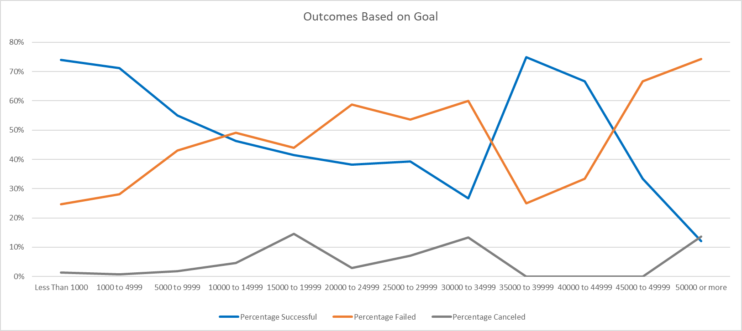

**Challenges and Difficulties Encountered**

One of the challenges is the data shows that more campaigns are successful in May and June.

A little deeper investigation was needed to determine if this was simply because there were more campaigns, or if it was a timing issue.

**Results**

The first conclusion about outcomes based on the launch date is that it is best to launch the campaign in May.

The second conclusion is that December is the month least likely to have a successful campaign launched.

If your goal is less than $10,000 you have a greater chance of success.

The data set has a very broad range of information. Some of the information is for buildings and others for project funding.

The data requires that more analysis be done for each type of campaign to adequately describe what happens in each category as well as time and goal amount.

A graph and table for each category would help better understand the effects of the size of campaign as well as the timing. For example, if technology has a lower success rate and more of these campaigns are run in December it may help explain why December has a lower success rate.

A table and graph of the percentage for each month of success in each category. This would help determine if it was category dependent as well as date and goal size dependent.