FAANG刷題LeetCode策略&要點

1. **HASH TABLE – 僅下列幾種container支援hash-function(目的是為了將傳入的參數算出唯一的hash value)**
   1. **<unordered_map>** 
      1. unordered_map - [unordered_map/hash_function/](https://cplusplus.com/reference/unordered_map/unordered_map/hash_function/)

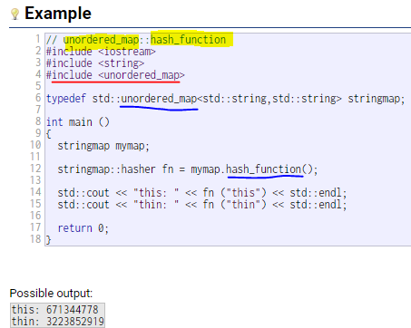

* + 1. unordered_multimap - [unordered_multimap/hash_function/](https://cplusplus.com/reference/unordered_map/unordered_multimap/hash_function/)

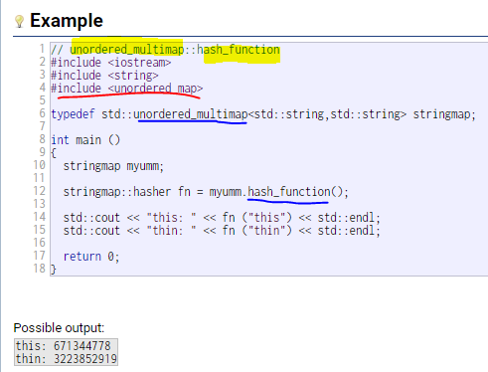

* 1. **<unordered_set>**
     1. unordered_set - [unordered_set/hash_function/](https://cplusplus.com/reference/unordered_set/unordered_set/hash_function/)

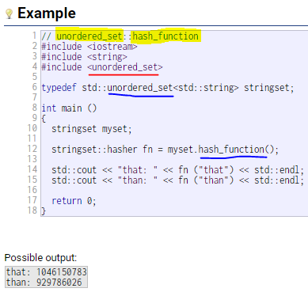

* + 1. unordered_multiset – [unordered_multiset/hash_function/](https://cplusplus.com/reference/unordered_set/unordered_multiset/hash_function/)

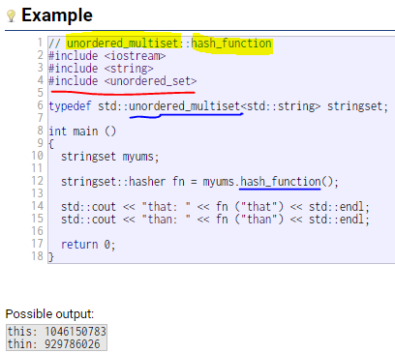

1. **Container** –

<https://hackmd.io/@AliennCheng/BydIK9q4L>

* 1. Sequence Containers(有序收納器): array, vector, list, deque, forward_list
  2. Associative Containers(關聯性收納器): map, multimap, set, multiset
     1. <map> -
        1. **map** - 每個資料的key都需不同，如果有資料是相同的key，則須改用multimap。
        2. multimap
     2. <set>
        1. **set** – 每個資料的key都需不同，如果有資料是相同的key，則須改用multiset。
        2. multiset
  3. Unordered associative Containers: 僅以下這四種class才有support hash_function的功能。
     1. <unordered_set>
        1. unordered_set
        2. unordered_multiset
     2. <unordered_map>
        1. unordered_map
        2. unordered_multimap