HPE ProLiant Windows Server ISO Automation (Root Readme)

Table of Contents
- Technical Component Overview
- Summary
- 🚀 Quick Start - Setup & Installation
  - TL;DR - One-Line Setup
  - Internal docs index
  - In this document
- Project Architecture
- Generated Audit Logs (JSON)
- Quick Links for Common Tasks
- Makefile Commands
- GitLab Pipeline Files
  - Pipeline Activation
- Contributing
- Support
- License
- HPE Doc

Technical Component Overview
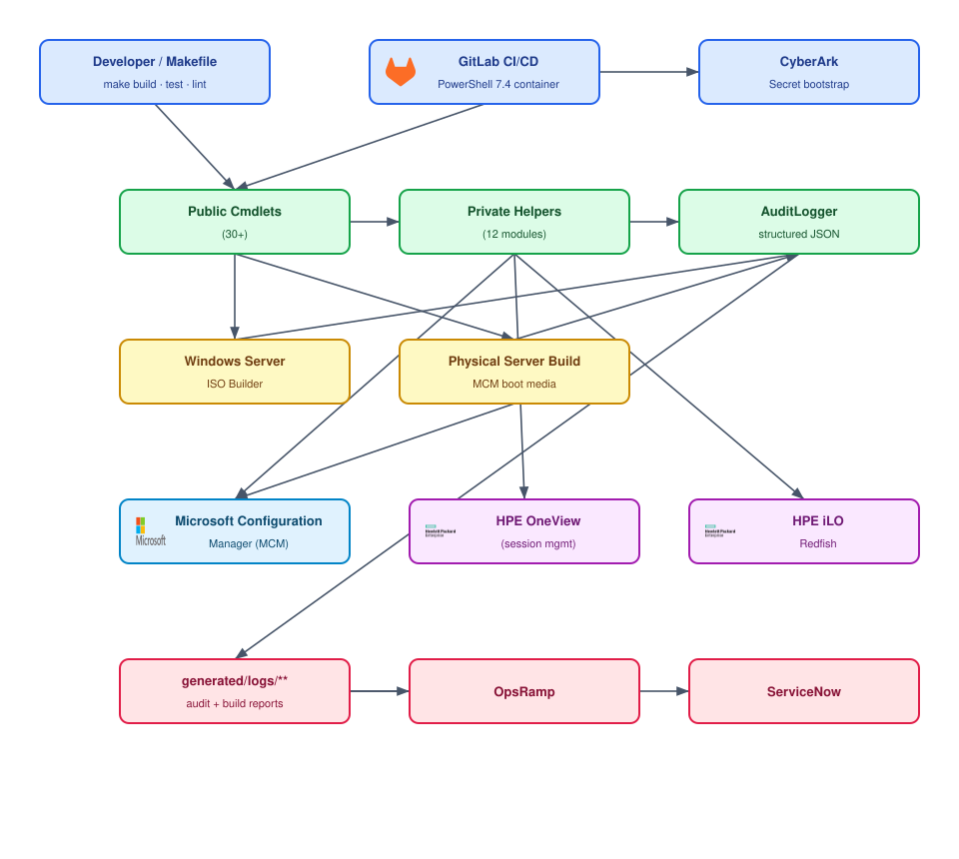
Technical Component Overview

Summary
Automated build pipelines for creating customized Windows Server installation ISOs and for orchestrating physical HPE ProLiant server deployments using Microsoft Configuration Manager bootable media, HPE OneView, and HPE iLO Redfish. Integrates firmware/driver updates, security patching, vulnerability scanning, complete audit trails, with OpsRamp monitoring and reporting.

🚀 Quick Start - Setup & Installation
New to this project? Start here:
- 📖 Setup Guide - Complete setup instructions for PowerShell profile and maintenance mode
- 🔧 Quick Client Setup - 5-minute setup for using maintenance mode commands

TL;DR - One-Line Setup
make setup && . $PROFILE
Then use:
# 1. Connect to OneView and establish a persistent session {#sec7}
Connect-OneView -ManagementHost oneview.example.com -Environment Prod
# 2. Run OneView commands while the session is active {#sec8}
# Get-OneViewServerList shows, per server: MaintMode (Yes/No), lifecycle State, {#sec9}
# State Reason, Health, Power, iLO IP, ROM, and Model (HPE model code, last column). {#sec10}
Get-OneViewServerList
Get-OneViewConnectionStatus
# 3. Disconnect from OneView when finished {#sec11}
Disconnect-OneView
# 4. Enable maintenance mode {#sec12}
Set-MaintenanceMode -Action enable -TargetId CLU-CLUSTER-01 -Mode scom -Environment Prod
Tip — short parameter aliases: the OneView commands accept short aliases so they are faster to type. For example: Get-OneViewConnectionStatus -SrvrId MXQ1234567 -IdTyp Serial is equivalent to Get-OneViewConnectionStatus -ServerIdentifier MXQ1234567 -IdentifierType Serial. The long and short forms are interchangeable (see the Automation Command Reference for the full alias table).
Built-in -Help: every main Automation command accepts a -Help switch that prints a man-like reference (synopsis, mandatory/optional parameters, types, allowed ValidateSet values, and the source-link) and returns without doing anything else — so you never need Get-Help. For example: Get-OneViewServerList -Help. See the Built-in command help (-Help) section for the full output format.
# 5. Disable maintenance mode {#sec13}
Set-MaintenanceMode -Action disable -TargetId CLU-CLUSTER-01 -Mode scom -Environment Prod

Internal docs index

Core Documentation
Document | Description
📚 Documentation Index | Complete documentation overview
🚀 Setup Guide | START HERE - Profile setup, module installation, quick start
📡 PowerShell API Reference | Module overview, cmdlet usage, orchestrator API
📗 Automation Command Reference | All automation commands with full parameter tables - functional reference linking to source
📘 PowerShell Function Reference | Complete coverage of ALL PowerShell functions and cmdlets - comprehensive parameter documentation, examples, and usage for every function in src/powershell/Automation/. Auto-generated from source code.
🔌 CI Run Requirements | Prerequisites, CyberArk bootstrap, GitLab/Jenkins examples
🧪 PowerShell Testing (Pester) | Pester v6 BDD testing guide, test commands, mocking
⚙️ Code Quality & Security | PSScriptAnalyzer, Ruff (Python), gitleaks configuration
🔗 GitLab CI/CD Integration | REST API pipeline triggers, webhook configuration

Physical Server Build & Runbooks
Document | Description
📋 Runbook Requirements | Operational runbook for physical HPE server builds via OneView + iLO Redfish
📋 Runbook Changes | Implementation plan and design decisions for the ConfigMgr bootable-media workflow
📗 Automation Command Reference | Command-level reference for the physical server build functions

Maintenance Mode & Scheduling
Document | Description
🔧 Quick Start Guide | NEW USERS - Complete setup and first steps
⚡ Maintenance Mode Shortcuts | mm command reference and examples
🔧 Maintenance Mode Architecture | Architecture, scheduling, audit, OpsRamp integration
🔧 Maintenance Mode Environment Config | Environment variable configuration
🔧 Maintenance Mode Code Map | Complete code map with links to all mm command functionality

Integration & Authentication
Document | Description
🔐 SCOM Authentication | SCOM authentication setup and configuration
🔐 OneView Authentication | HPE OneView authentication details
🔐 Authentication Overview | General authentication documentation
📊 Audit Process | Audit trail and compliance process
📊 GDPR Compliance | GDPR compliance documentation

Developer Resources
Document | Description
📖 DevOps Guide to HPE Terms | HPE terminology guide

In this document
- HPE ProLiant Windows Server ISO Automation (Root Readme)
  - Table of Contents
  - Summary
  - 🚀 Quick Start - Setup & Installation
    - TL;DR - One-Line Setup
    - Internal docs index
      - Core Documentation
      - Physical Server Build & Runbooks
      - Maintenance Mode & Scheduling
      - Integration & Authentication
      - Developer Resources
    - In this document
  - Project Architecture
  - Generated Audit Logs (JSON)
  - Quick Links for Common Tasks
  - Makefile Commands
  - GitLab Pipeline Files
    - Pipeline Activation
  - Contributing
  - Support
  - License
- HPE Doc

Project Architecture
image-build-automation/
├── bin/ # Bundled binaries (checkmake, make, oh-my-posh)
├── configs/ # Server/cluster/patch JSON configs
├── docs/ # Documentation (see Documentation Index above)
├── generated/ # Generated output (gitignored)
│ └── logs/ # Audit trails and build reports
├── scripts/ # CI runner provisioning and helpers
├── src/powershell/Automation/ # PowerShell module
│ ├── Public/ # Exported cmdlets (30+)
│ ├── Private/ # Internal helpers (12 modules)
│ └── Automation.psd1 # Module manifest
├── tests/powershell/ # Pester v6 test suite (47 test files)
├── vendor/ # Vendored PowerShell modules
├── .gitlab-ci.yml # GitLab CI/CD pipeline
├── docker-compose.yml # Containerised build environment
├── Dockerfile # Docker image for build agents
├── Makefile # Build automation targets
└── README.md # This file

Generated Audit Logs (JSON)
During both normal operations and unit testing (e.g. make test), you will notice a significant number of structured .json log files generated in the generated/logs/ subdirectories (such as generated/logs/testing/enable_UNIT-TEST-CLUSTER_...json).
These files are the definitive, machine-readable execution records generated by the AuditLogger. They are designed to be ingested programmatically by external monitoring and compliance systems (like OpsRamp and ServiceNow) to confirm state changes, durations, and metadata without parsing plain text logs.
Important Note on Testing: During test execution, these JSON logs are intentionally written to generated/logs/testing/ to validate that the audit mechanics work end-to-end without polluting the production audit trails. Do not change their filenames or suppress their generation in the test runner, as doing so breaks the execution record structure required for GDPR compliance and external system integrations. A log pruning script (scripts/prune-logs.ps1) automatically manages retention to prevent these from bloating the repository.

Quick Links for Common Tasks
Task | Manual Command | Pipeline Stage
Run all tests locally | pwsh -File scripts/run-tests.ps1 | Unit Tests
Run maintenance mode tests | make maint-mode-tests | Unit Tests
Generate test coverage | make coverage | Test
Test OneView connectivity | Connect-OneView -ManagementHost oneview-appliance (or Test-ServerConnectivity for diagnostics) | Connectivity Check
Disconnect from OneView | Disconnect-OneView | Session Cleanup
Enable maintenance mode | Set-MaintenanceMode -Action enable -TargetId CLUSTER -Mode scom -Environment Prod -Start now -End +2hours | Maintenance Mode
Build physical server | Start-PhysicalServerBuild -ServerIdentifier SERVER -OneViewHost ... -SiteCode P01 ... -DryRun | Physical Server Build
Validate configuration | pwsh -Command "Get-Content configs/clusters_catalogue.json \| ConvertFrom-Json" | Setup

Makefile Commands
This project is Makefile-driven. The canonical way to run day-to-day tasks is:
Target | Description
make help | List all Makefile targets with descriptions
make list-commands | List all available Automation module commands (28) with synopses
make setup | Provision the PowerShell environment, profiles, and CI runner (module install, oh-my-posh, checkmake, make)
make lint | Run the full lint suite: PowerShell (PSScriptAnalyzer), Makefile (checkmake), and Python (Ruff)
make lint-python | Lint and autofix Python scripts with Ruff (resolved via uv run ruff)
make test | Run the full Pester v6 test suite (verbose)
make test-unit | Run only unit tests
make test-integration | Run only integration tests
make coverage | Run tests with code coverage → generated/coverage/
make docs | Generate the PowerShell API docs (docs/dynamic-code-docs/), fix links, and add anchors/TOC
make fix-docs | Repair broken markdown links and regenerate anchors/TOC across configs/, docs/, and root markdown
make gen-docs | Regenerate docs/dynamic-code-docs/ from src/ and scripts/ source
make add-anchors | Add Bitbucket/GitStash-compatible anchors + TOC to all markdown files
make fix-docs-dryrun | Preview link/anchor/TOC fixes without writing
make word-docs | Convert Markdown docs to Word DOCX with clickable bookmarks/links
make rtf-docs | Convert Markdown docs to RTF
make prune-logs | Prune log files older than 30 days
make clean | Remove build artifacts and temp files
make ci | Full pipeline: lint + coverage
make all | Run linting and tests
Note — Python linting: make lint-python requires Ruff, which is resolved automatically via uv run ruff if uv is on PATH, otherwise via python -m ruff, or a one-shot pip install --user ruff. Configuration lives in ruff.toml at the repository root.

GitLab Pipeline Files
The GitLab CI pipeline lives in .gitlab-ci.yml at the repository root using PowerShell 7.4 containers.

Pipeline Activation
The pipeline is currently disabled via a workflow rule to prevent execution on the development GitLab instance. Before deploying to the Bank’s GitLab:
- Remove the workflow block from .gitlab-ci.yml:
yaml # Remove lines 9-13: # workflow: # rules: # - when: never
- Ensure MAINTENANCE_API_KEY is configured as a masked variable in GitLab CI/CD settings
- Verify all required secrets are configured in CyberArk for the bootstrap stage

Contributing
All changes should include: 1. Unit tests mirroring the module structure in tests/powershell/ 2. Documentation updated in docs/

Support
- Create an issue or pull request in the repository
- Contact Kev Everall
- Reference build ID from generated/logs/build_reports/ or generated/logs/audit/maintenance_audit.log

License
MIT License - see LICENSE file for details.

HPE Doc
oneview-powershell-samples
community.hpe.com
HPE OneView PowerShell Library
HPE OneView Support Centre links
HPE OneView Powershell Library Guide and Versions
HPE OneView PS releases

