Homework #1

1a.) $f\left(n\right)= Ω(g\left(n\right))$ because 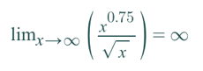

1b.) $f\left(n\right)=Θ(g\left(n\right))$ because 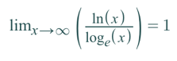

1c.) $f\left(n\right)=O\left(g\left(n\right)\right)$ because 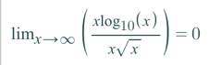

1d.) $f\left(n\right)=O\left(g\left(n\right)\right)$ because 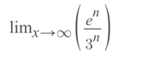= 0

1e.) $f\left(n\right)= Θ(g\left(n\right))$ because 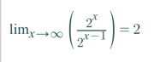

1f.) $f\left(n\right)=O(g\left(n\right))$ because 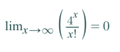

2a.) If f1(n) = Ω(g(n)) and f2(n) = O(g(n)) then f1(n)= Θ (f2(n) )

Prove false with counter-example:

Let $f_{1}(n)=n^{3}$, $f_{2}(n)=n$, and $g\left(n\right)=n^{2}$

$f_{1}\left(n\right)=Ω\left(g\left(n\right)\right)$ and $f_{2}(n)=O(g\left(n\right))$

BUT, $f_{1}\left(n\right)≠{Θf}_{2}(n)$

Because 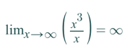

2b.)