Homework #1

1a.) because 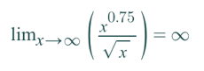

1b.) because 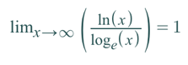

1c.) because 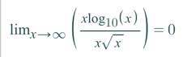

1d.) because 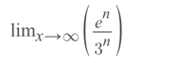= 0

1e.) because 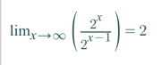

1f.) because 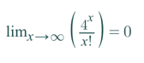

2a.) If f1(n) = Ω(g(n)) and f2(n) = O(g(n)) then f1(n)= Θ (f2(n) )

Prove false with counter-example:

Let , , and

and

BUT,

Because 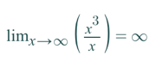

2b.) If f1(n) = O(g1(n)) and f2(n) = O(g2(n)) then f1(n)+ f2(n)= O(g1(n) + g2(n) )

Prove true:

If , then there exists constants such that  
 I. for all and

since , there exists constants such that  
 II. for all

Let

III. for all

IV. for all

By adding III & IV,

for all

Therefore,

and

or

4b.)

|  |  |
| --- | --- |
| Insertion Sort | |
| n | T(n) |
| 625 | 0.04333333 |
| 1250 | 0.49 |
| 2500 | 0.57333333 |
| 5000 | 1.79333333 |
| 7500 | 3.23333333 |
| 10000 | 6.22 |
| 12500 | 7.72666667 |
| 15000 | 13.45 |
| 20000 | 24.6166667 |
| 25000 | 39.97 |

|  |  |
| --- | --- |
| Merge Sort | |
| n | T(n) |
| 20000 | 0.19666667 |
| 40000 | 0.44333333 |
| 60000 | 0.61666667 |
| 80000 | 0.84 |
| 100000 | 0.81333333 |
| 120000 | 0.99666667 |
| 140000 | 1.08 |
| 160000 | 1.14333333 |
| 180000 | 1.67333333 |
| 200000 | 2.09 |

4c.) As expected, a quadratic regression best fit the insertion sort data. The equation for the regression line is featured below on the graph with an R^2 value.

Unexpectedly, a power regression best fit the merge sort data. The equation for the regression line is featured below on the graph with an R^2 value. I attribute this unexpected outcome to flip server irregularities. In a perfect world, my server would not be used by many other students. Even though I took several tests and averaged the results, the data did not fit a logarithmic regression the best as I would expect theoretically.

4d.)

4e.) I am struggling to compare experimental running times to theoretical running times because for my experimental running times, there is a known computer processing speed whereas theoretically, there is no known computer processing speed.

In theory, insertion sort would have a worst-case scenario of O(n^2). If I were to take n=625, where experimentally I got T(n) = 0.04, and put it theoretically into f(n) = n^2, that would yield f(n) = 390625. I am not sure how to compare 0.04 with 390625. 390625 would in theory be multiplied by some constant based on the processing speed of the theoretical computer.

I have similar confusion for merge sort which would have a worst-case scenario of O(nlogn). Similarly, if I were to take n=20000, where experimentally I got T(n)=0.20, and put it theoretically into f(n)=nlgn, that would yield f(n) = 285754. Again, I am not sure how to compare 0.20 with 285754. 285754 would in theory be multiplied by some constant based on the processing speed of the theoretical computer.