**About Me**

I am from DFW. I decided to attend OSU on the recommendation of an alumnus friend of mine. He currently works for a big bank making $110k before he even graduated this program. I am currently a programming/IT teacher and love teaching but it just does not pay enough. My coding interests are primarily in web development, but I am enjoying learning more about other languages. My general interests are Nintendo, stock trading, and most geek culture topics. I also like to be outside hiking, camping, backpacking, etc. I have previously graduated with two degrees in Child Development and Psychology. After graduation, I would love to become a software developer. In 5 or 10 years, I would like to move up to a management position. I have zero interest in research. I have experienced a computer science perception problem as a teacher daily. Often, girls are discouraged from computer science because they think it is “just for boys” or “it’s too hard”. I will say that there are boys that say CS is too hard also, but it is a much smaller proportion. One of my personal missions as a teacher has been to cultivate a love for CS, in particular targeting girls. It is my personal belief that every industry benefits from more diversity, and so I strive to build students’ confidence in CS. I actually had one of my girl students come in 2nd at our school’s hackathon! It made me feel good.

**Programming Experience**

I have been a high school programming teacher for 2 years now. We focus primarily on HTML/CSS/JavaScript/JQuery. It is mostly the basics, and thus I consider myself an amateur at best. We typically just use any text editor such as Sublime to code our websites. This CS program has been humbling because I realize now just how much I didn’t know. It has been very enjoyable to sharpen my saw through learning about the various topics in 161/162/225. I think coding is cool, and so far the classes have been fun, although stressful at times.

First Program Screenshots:

IDE Output:  
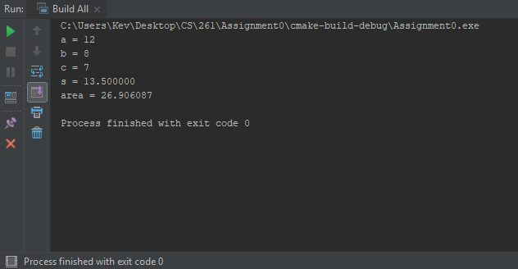

OSU Engineering Server Output:  
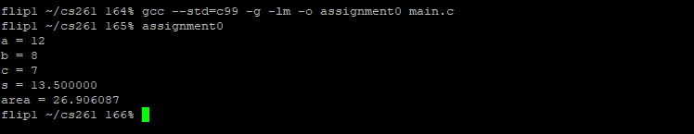

Source code:  
