Worksheet 18: Linked List Queue, pointer to Tail

In Preparation: Read Chapters 6 and 7 to learn more about the Stack and Queue data types. If you have not done so already, you should do Worksheet 17 to learn about the basic features of a linked list.

One problem with the linked list stack is that it only permits rapid access to the front of the collection. This was no problem for the stack operations described in Worksheet 17, but would present a difficulty if we tried to implement a queue, where elements were inserted at one end and removed from the other.

A solution to this problem is to maintain two references into the collection of links. As before, the data field firstLink refers to the first link in the sequence. But now a second data field named lastLink will refer to the final link in the sequence:

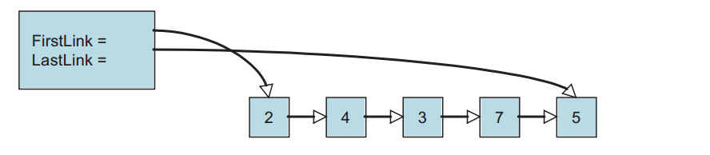

To reduce the size of the image the fields in the links have been omitted, replaced with the graphic arrow. Both the firstLink and lastLink fields can be null if a list is empty. Removing a data field from the front is the same as before, with the additional requirement that when the last value is removed and the list becomes empty the variable lastLink must also be set to null.

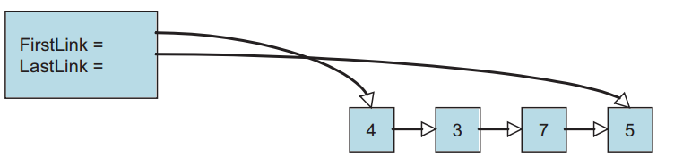
Because we have a link to the back, it is easy to add a new value to the end of the list.

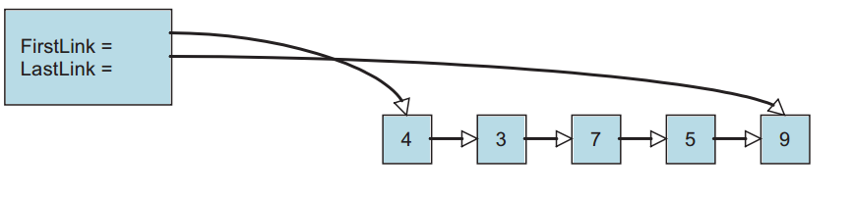
We will add another variation to our container. A sentinel is a special link, one that does not contain a value. The sentinel is used to mark either the beginning or end of a chain of links. In our case we will use a sentinel at the front. This is sometimes termed a list header. The presence of the sentinel makes it easier to address special cases. For example, the list of links is never actually empty, even when it is logically empty, since there is always at least one link. A new value is inserted after the end.
Sentinel
3
7
4
2

Values are removed from the front, as with the stack. But because of the sentinel, the element removed will be the element right after the sentinel. Make sure that when you remove a value from the collection you free the memory for the associated link.

You should complete the following skeleton code for the ListQueue. The structures have been written for you, as well as the initialization routine. The function isEmpty must determine whether or not the collection has any elements. What property characterizes an empty queue?

(You need to submit the answers of the following questions)

- Draw a picture showing the values of the various data fields in an instance of ListQueue when it is first created.
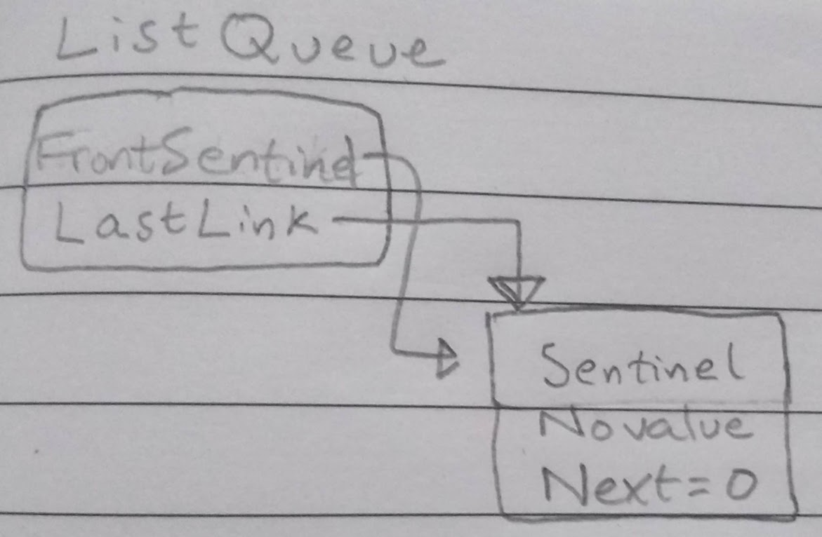

- Draw a picture showing what it looks like after one element has been inserted.
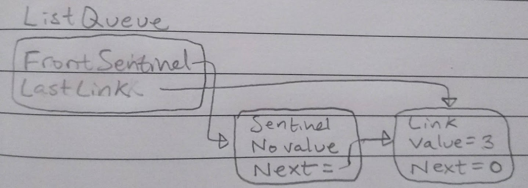

- Based on the previous two drawings, can you determine what feature you can use to tell if a list is empty?
Yes, the sentinel’s next pointer being null or not would indicate whether the list is empty or not respectively.

- Draw a picture showing what it looks like after two elements have been inserted.
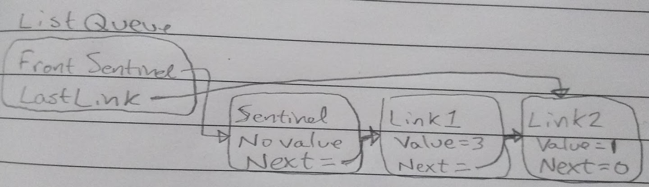

- What is the algorithmic complexity of each of the queue operations?
O(1)

- How difficult would it be to write the method addFront(newValue) that inserts a new element into the front of the collection? A container that supports adding values at either and, but removal from only one side, is sometimes termed a scroll.
Not difficult to add at front.

- Explain why removing the value from the back would be difficult for this container. What would be the algorithmic complexity of the removeLast operation?
It would be difficult to remove the value from the back of the container because it is only a single list. Basically, there is not prev pointer. So, if we were to remove from the back, we would have to scroll over all the links in order to get to the new last link so that we could update the lastLink pointer and have the next pointer pointing to null. Because we are looping through the linked list, the algorithmic complexity would be O(n).

struct link {
TYPE value;
struct link * next;
};

struct listQueue {
struct link *firstLink;
struct link *lastLink;
};

void listQueueInit (struct listQueue *q) {
struct link *lnk = (struct link *) malloc(sizeof(struct link));
assert(lnk != 0); /* lnk is the sentinel */
lnk->next = 0;
q->firstLink = q->lastLink = lnk;
}

void listQueueAddBack (struct listQueue *q, TYPE e) {
struct link * newLink = (struct link *) malloc(sizeof(struct link));
assert (newLink != 0);
newLink->value = e;
newLink->next = 0;
q->lastLink->next = newLink;
q->lastLink = newLink;
}

TYPE listQueueFront (struct listQueue *q) {
assert(!listQueueIsEmpty(q));
return q->firstLink->next->value ;
}

void listQueueRemoveFront (struct listQueue *q) {
assert(!listQueueIsEmpty(q));
struct link * temp = q->firstLink->next;
// Check to see if there is more than one element
if(q->firstLink->next->next != 0)
q->firstLink->next = q->firstLink->next->next;
// There is only one element, thus when it is removed, sentinel’s next // must be 0
else
q->firstLink->next = 0;
free(temp);
}

int listQueueIsEmpty (struct listQueue *q) {
return q->firstLink->next == 0 ;
}

