实验3 MapReduce编程实践

学号 | 2022313065 | 姓名 | 周龑翔 | 专业年级 | 数据22

【实验目的】
1、理解MapReduce在Hadoop体系结构中的角色。
2、掌握基本的MapReduce编程方法。
3、掌握用MapReduce解决一些常见数据处理问题的方法，包括数据合并、数据去重和倒排索引。
【实验内容】
- 编写MapReduce程序对数据文件data1.txt、data2.txt和data3.txt合并后的数据进行去重操作。
- 假设有数据文件num1.txt、num2.txt和num3.txt，编写MapReduce程序实现如下功能：以降序的方式获取文件内容中最大的10个数据，并将这10个数据保存到一个文件中。
- 假设有四个数据文件file1.txt、file2.txt、file3.txt和file4.txt，编写MapReduce程序使用倒排索引的方式对文件内容实现倒排索引。
要求：输入输出文件夹以个人学号命名，例如“D:/XXX/input”（XXX替换成个人学号），HDFS中创建的文件夹也是以学号命名，例如“/XXX/output/”（XXX替换成个人学号）。
【实验要求】
请参照教材按以上实验内容完成相关实验，将实验代码和实验结果粘贴在下方（注意：标清题号，实验结果以截图的方式给出），并分析在实验过程中遇到的问题及解决方案。实验1和实验2以本地方式运行，实验3以集群的方式运行（给出运行Jar包的Shell代码）。

实验1、
package cn.itcast.dedup;
//Mapper
public class DedupMapper extends Mapper<LongWritable, Text, Text, NullWritable> {
private static Text field = new Text();
@Override
protected void map(LongWritable key, Text value, Context context)throws IOException, InterruptedException {
field = value;
context.write(field, NullWritable.get());
}
}
//Reducer
public class DedupReducer extends Reducer<Text, NullWritable, Text, NullWritable> {
@Override
protected void reduce(Text key, Iterable<NullWritable>values, Context context)throws IOException,InterruptedException{
context.write(key, NullWritable.get());
}
}
//Driver
public class DedupDriver {
public static void main(String[] args) throws
IOException,ClassNotFoundException,InterruptedException {
Configuration conf = new Configuration();
Job job = Job.getInstance(conf);
job.setJarByClass(DedupDriver.class);
job.setMapperClass(DedupMapper.class);
job.setReducerClass(DedupReducer.class);
job.setOutputKeyClass(Text.class);
job.setOutputValueClass(NullWritable.class);
FileInputFormat.setInputPaths(job, new
Path("D:\\2022313065\\Dedup\\input"));
FileOutputFormat.setOutputPath(job, new
Path("D:\\2022313065\\Dedup\\output"));
boolean res = job.waitForCompletion(true);
System.exit(res ? 0 : 1);
}
}
运行结果：
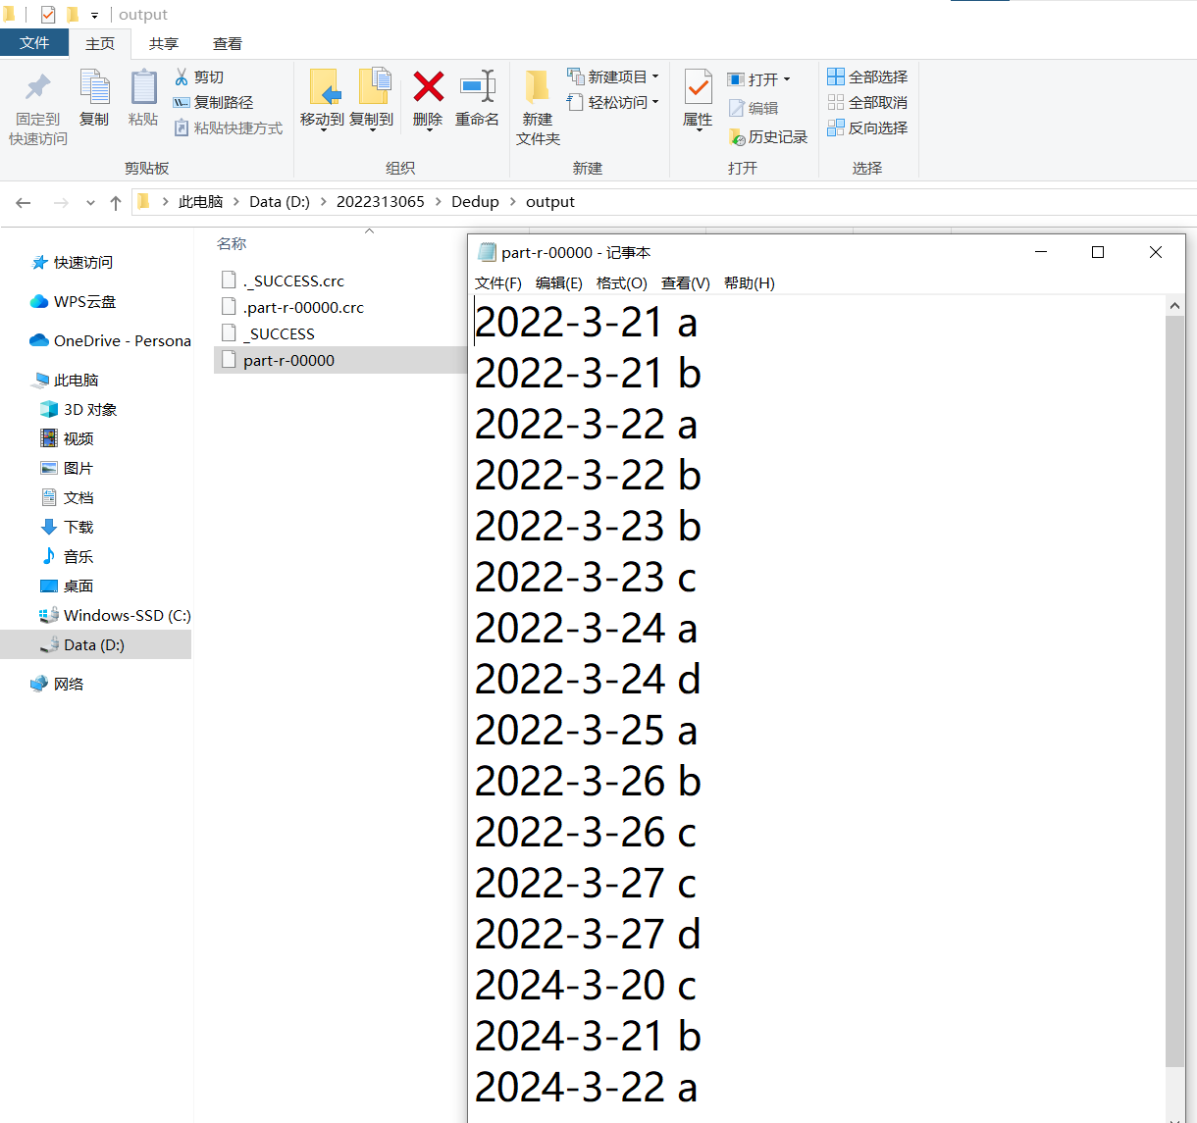
实验2、
package cn.itcast.TopN;
//Mapper
public class TopNMapper extends Mapper<LongWritable, Text, NullWritable, IntWritable> {
private TreeMap<Integer, String>repToRecordMap =
new TreeMap<Integer,String>();
@Override
public void map(LongWritable key, Text value, Context context) {
String line = value.toString();
String[] nums = line.split(" ");
for (String num : nums) {
repToRecordMap.put(Integer.parseInt(num), " ");
if (repToRecordMap.size() > 10) {
repToRecordMap.remove(repToRecordMap.firstKey());
}
}
}
@Override
protected void cleanup(Context context) {
for (Integer i : repToRecordMap.keySet()) {
try {
context.write(NullWritable.get(), new IntWritable(i));
}catch (Exception e) {
e.printStackTrace();
}
}
}
}
//Reducer
public class TopNReducer extends Reducer<NullWritable, IntWritable, NullWritable, IntWritable> {
private TreeMap<Integer, String>repToRecordMap = new TreeMap<Integer,String>(new Comparator<Integer>() {
public int compare(Integer o1, Integer o2) {
return o2 - o1;
}
});
public void reduce(NullWritable key, Iterable<IntWritable>values, Context context)throws IOException, InterruptedException{
for (IntWritable value : values) {
repToRecordMap.put(value.get(), " ");
if (repToRecordMap.size() > 10) {
repToRecordMap.remove(repToRecordMap.lastKey());
}
}
for (Integer i : repToRecordMap.keySet()) {
context.write(NullWritable.get(), new IntWritable(i));
}
}
}
//Driver
public class TopNDriver {
public static void main(String[] args) throws Exception{
Configuration conf = new Configuration();
Job job = Job.getInstance(conf);
job.setJarByClass(TopNDriver.class);
job.setMapperClass(TopNMapper.class);
job.setReducerClass(TopNReducer.class);
job.setNumReduceTasks(1);
job.setMapOutputKeyClass(NullWritable.class);
job.setMapOutputValueClass(IntWritable.class);
job.setOutputKeyClass(NullWritable.class);
job.setOutputValueClass(IntWritable.class);
FileInputFormat.setInputPaths(job, new
Path("D:\\2022313065\\TopN\\input"));
FileOutputFormat.setOutputPath(job, new
Path("D:\\2022313065\\TopN\\output"));
boolean res = job.waitForCompletion(true);
System.exit(res ? 0 : 1);
}
}
运行结果：
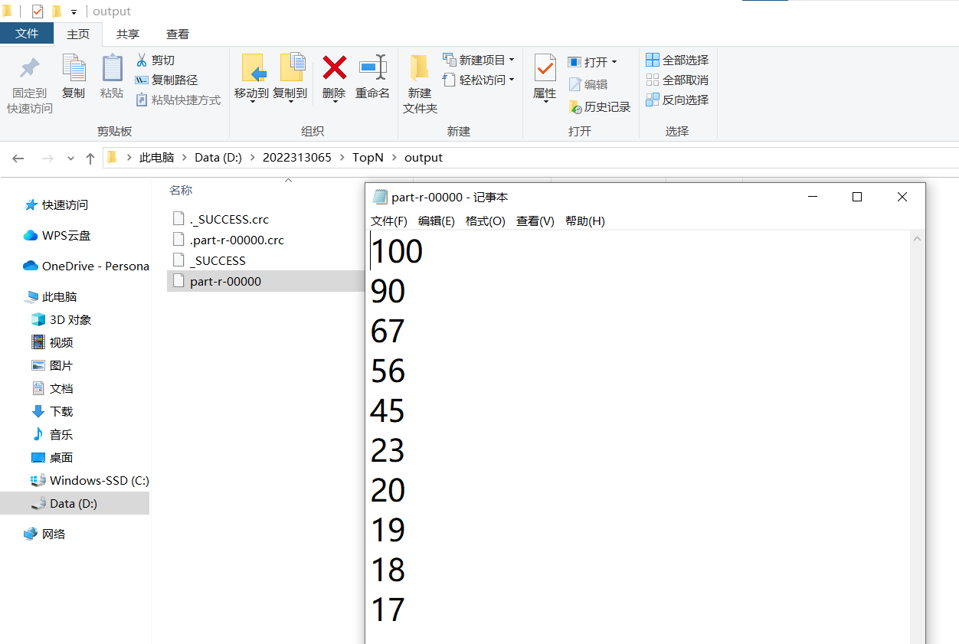

实验3、
package cn.itcast.invertedIndex;
//Mapper
public class InvertedIndexMapper extends Mapper<LongWritable, Text, Text,Text> {
private static Text keyInfo = new Text();
private static final Text valueInfo = new Text("1");
@Override
protected void map(LongWritable key, Text value, Context context)throws IOException, InterruptedException{
String line = value.toString();
String[] fields = StringUtils.split(line," ");
FileSplit fileSplit = (FileSplit) context.getInputSplit();
String fileName = fileSplit.getPath().getName();
for (String field : fields) {
keyInfo.set(field + ":" + fileName);
context.write(keyInfo, valueInfo);
}
}
}
//Combiner
public class InvertedIndexCombiner extends Reducer<Text, Text, Text, Text> {
private static Text info = new Text();
@Override
protected void reduce(Text key, Iterable<Text>values, Context context) throws IOException, InterruptedException{
int sum = 0;
for (Text value : values) {
sum += Integer.parseInt(value.toString());
}
int splitIndex = key.toString().indexOf(":");
info.set(key.toString().substring(splitIndex + 1) + ":" + sum);
key.set(key.toString().substring(0,splitIndex));
context.write(key,info);
}
}
//Reducer
public class InvertedIndexReducer extends Reducer<Text, Text, Text, Text> {
private static Text result = new Text();
@Override
protected void reduce(Text key, Iterable<Text>values, Context context) throws IOException, InterruptedException{
String fileList = new String();
for (Text value : values) {
fileList += value.toString() + ";";
}
result.set(fileList);
context.write(key,result);
}
}
//Driver
public class InvertedIndexDriver {
public static void main(String[] args) throws IOException, ClassNotFoundException, InterruptedException {
Configuration conf = new Configuration();
conf.set("mapreduce.framework.name","yarn");
Job job = Job.getInstance(conf);
job.setJarByClass(InvertedIndexDriver.class);
job.setMapperClass(InvertedIndexMapper.class);
job.setCombinerClass(InvertedIndexCombiner.class);
job.setReducerClass(InvertedIndexReducer.class);
job.setOutputKeyClass(Text.class);
job.setOutputValueClass(Text.class);
FileInputFormat.setInputPaths(job,new Path(args[0]));
FileOutputFormat.setOutputPath(job,new Path(args[1]));
boolean res = job.waitForCompletion(true);
System.exit(res ? 0 : 1);
}
}
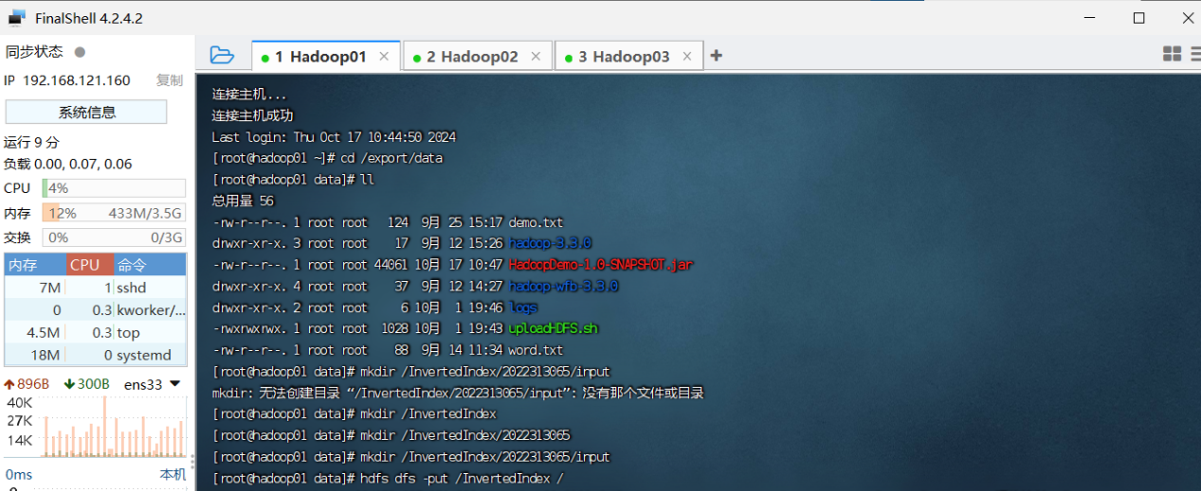

运行结果：
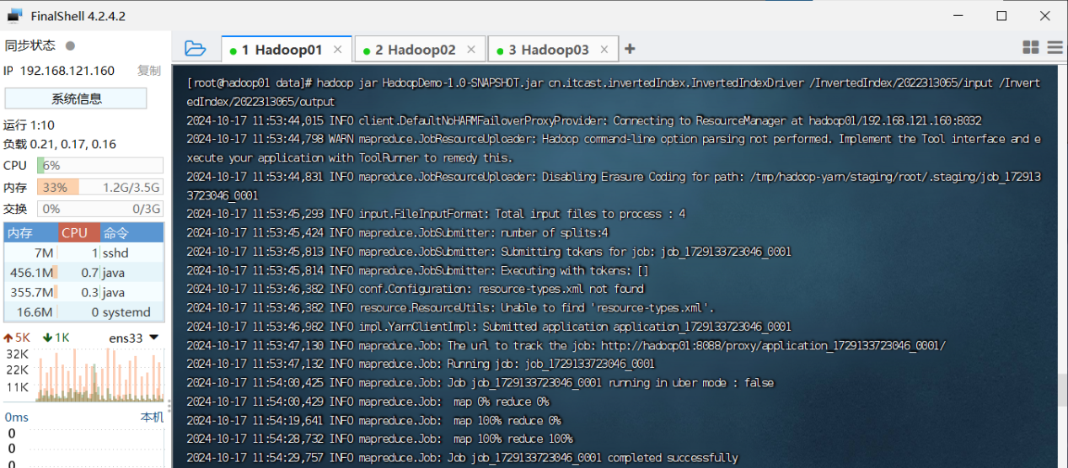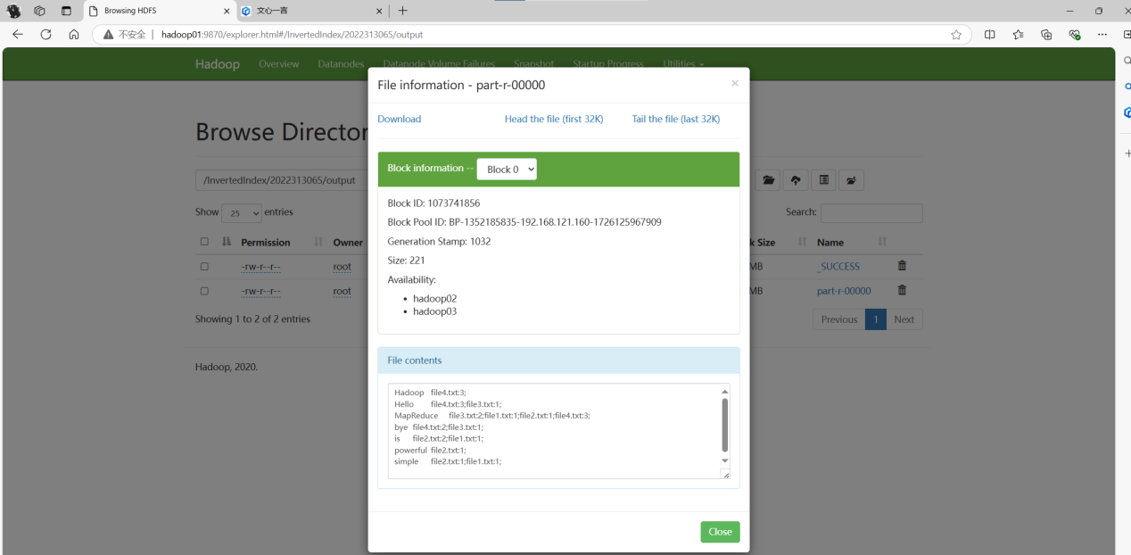

问题1：
运行实验2报错：Exception in thread "main" java.lang.UnsatisfiedLinkError: org.apache.hadoop.io.nativeio.NativeIO$POSIX.stat(Ljava/lang/String;)Lorg/apache/hadoop/io/nativeio/NativeIO$POSIX$Stat;在调用一个本地方法时未能找到相应的本地库，尝试访问底层文件系统失败。
解决方案：把对应的Hadoop版本的hadoop.dll文件复制到C:\Windows\System32目录下。

问题2：
在集群中执行如下命令时hadoop jar HadoopDemo-1.0-SNAPSHOT.jar \
cn.itcast.invertedIndex.InvertedIndexDriver \
/InvertedIndex/2022313065/input /InvertedIndex/2022313065/output
报错：Exception in thread "main" java.lang.ClassNotFoundException: cn.itcast.invertedIndex.InvertedIndexDriver
解决方案：使用jar tf HadoopDemo-1.0-SNAPSHOT.jar命令查看jar文件内容，发现需要执行的Driver程序InvertedIndexDriver.class不存在，原因是在打包为jar文件时，invertedIndex这个包的java程序没有编译。在IDEA中选择Build Project编译整个项目。

