NORTHWIND INTERACTIVE SALES DASHBOARD
Using Microsoft Power BI
Project Report
Submitted By
Name: Kevidya
Tool Used: Microsoft Power BI Desktop

1. Introduction
This report documents an interactive Northwind sales dashboard developed in Power BI. The report brings together order activity, customer coverage, product performance and category sales so that the underlying sales information can be reviewed from several angles.
The dashboard contains summary cards, monthly order movement, employee-level order comparison, category sales, customer-by-country analysis and filter-driven pages.

2. Objectives
- Measure the overall number of orders and customers.
- Summarize quantity sold and freight-related measures.
- Observe the monthly pattern in order volume.
- Compare order counts across employees.
- Examine sales contribution by product category.
- Review the geographic distribution of customers.
- Allow the report to be explored through Year, Region and Category selections.

3. Dataset Description
The Northwind model used for this dashboard contains product, category, customer, employee and order-related information. The visible report fields include ProductName, CategoryName, Country, EmployeeName, orders, quantity sold, sales and freight measures.

4. Data Preparation
The Power BI model was arranged so that the product and category fields could support detailed tables and category comparisons, while employee and country fields could be used for grouped analysis. Month and Year information was prepared for time-based visuals and filtering.
- Prepared product and category fields for product-level analysis.
- Prepared employee information for order comparison.
- Prepared country information for customer distribution.
- Prepared month and year fields for the time visuals.
- Created measures for order, customer, quantity and freight KPIs.

5. KPI Measures
The latest supplied Northwind dashboard screenshot displays these KPI values:
- Total Orders – 830
- Number of Customers – 91
- Total Quantity Sold – 51K
- Total Freight – 64.94K
- Average Freight – 78.24
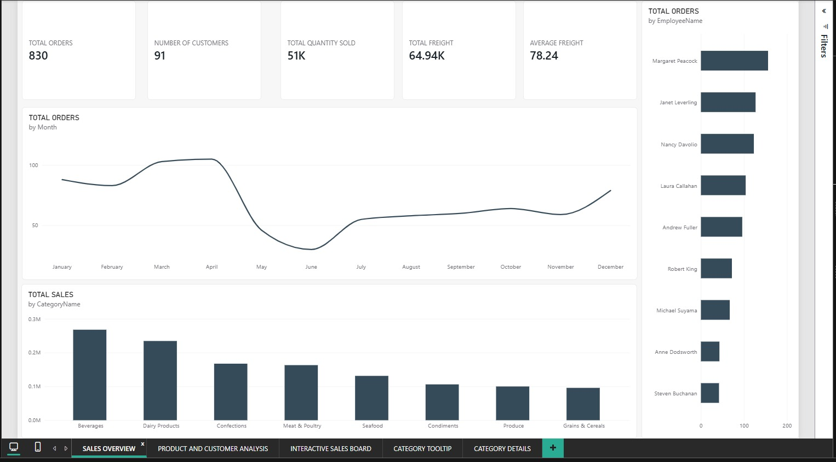
Figure 1: Sales Overview with KPI cards and core visuals

6. Sales Overview
The SALES OVERVIEW page combines the five KPI cards with three main analytical visuals. The monthly line chart shows order volume by month, the employee chart compares total orders, and the category chart compares total sales.
In the displayed monthly pattern, orders rise into March and April, fall sharply during May and June, and then recover through the later months, ending higher in December than in November.

7. Orders by Employee
The employee visual provides a direct comparison of total orders. In the supplied view, Margaret Peacock has the longest displayed bar, followed by Janet Leverling and Nancy Davolio. Andrew Fuller is also visible in the updated dashboard.

8. Sales by Category
The category chart contains Beverages, Dairy Products, Confections, Meat & Poultry, Seafood, Condiments, Produce and Grains & Cereals. Beverages is the largest displayed category, while Grains & Cereals is the smallest displayed category in this view.

9. Product and Customer Analysis
The PRODUCT AND CUSTOMER ANALYSIS page places a detailed product table beside a customer-by-country chart. The table includes ProductName, CategoryName, Total Sales and Total Quantity Sold.
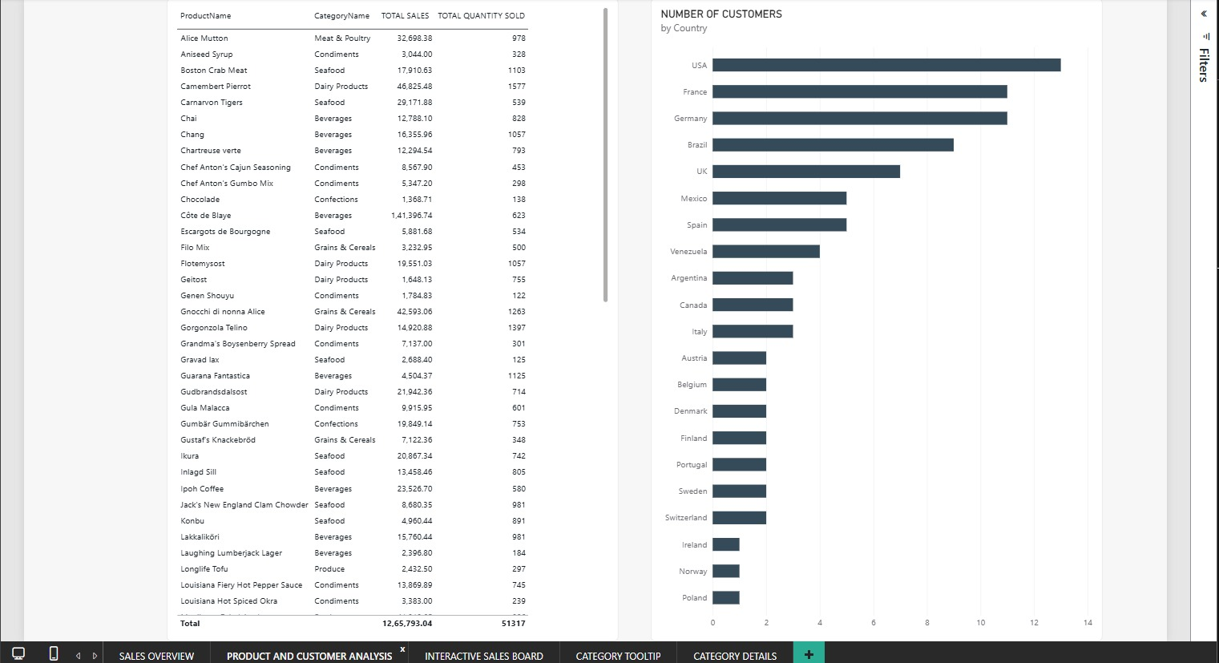
Figure 2: Product and Customer Analysis
The visible table total is 12,65,793.04 for Total Sales and 51,317 for Total Quantity Sold. The country chart shows the number of customers by country, with the USA having the longest displayed bar.

10. Interactive Sales Board
The INTERACTIVE SALES BOARD provides a more compact dashboard layout. It repeats the monthly order and employee comparisons, adds category sales, and places the main filters and KPI cards on the right side.
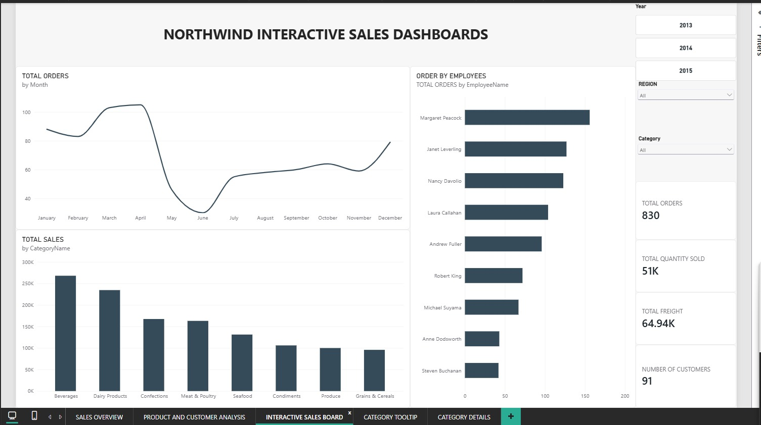
Figure 3: Interactive Sales Board
The visible filter controls are:
- Year – 2013, 2014 and 2015 are displayed.
- Region – available as a dropdown filter.
- Category – available as a dropdown filter.
The right-side KPI cards show 830 total orders, 51K total quantity sold, 64.94K total freight and 91 customers.

11. Category Tooltip
The CATEGORY TOOLTIP page presents a small group of KPI cards designed to appear when category-level information is inspected.
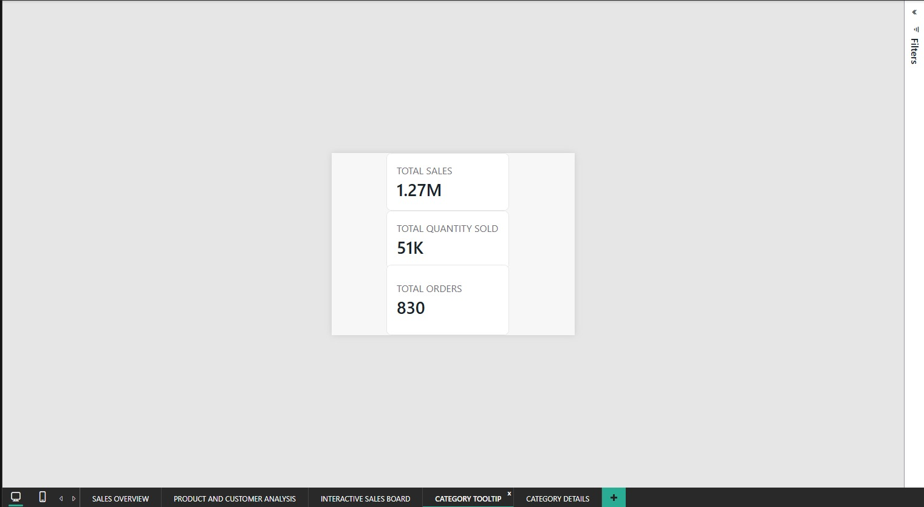
Figure 4: Category Tooltip
The supplied tooltip view displays Total Sales of 1.27M, Total Quantity Sold of 51K and Total Orders of 830.

12. Category Details
The CATEGORY DETAILS page changes according to the selected category. In the supplied screenshot, Meat & Poultry is selected. The cards show Total Sales of 163.02K, Total Quantity Sold of 4K and Total Orders of 830.
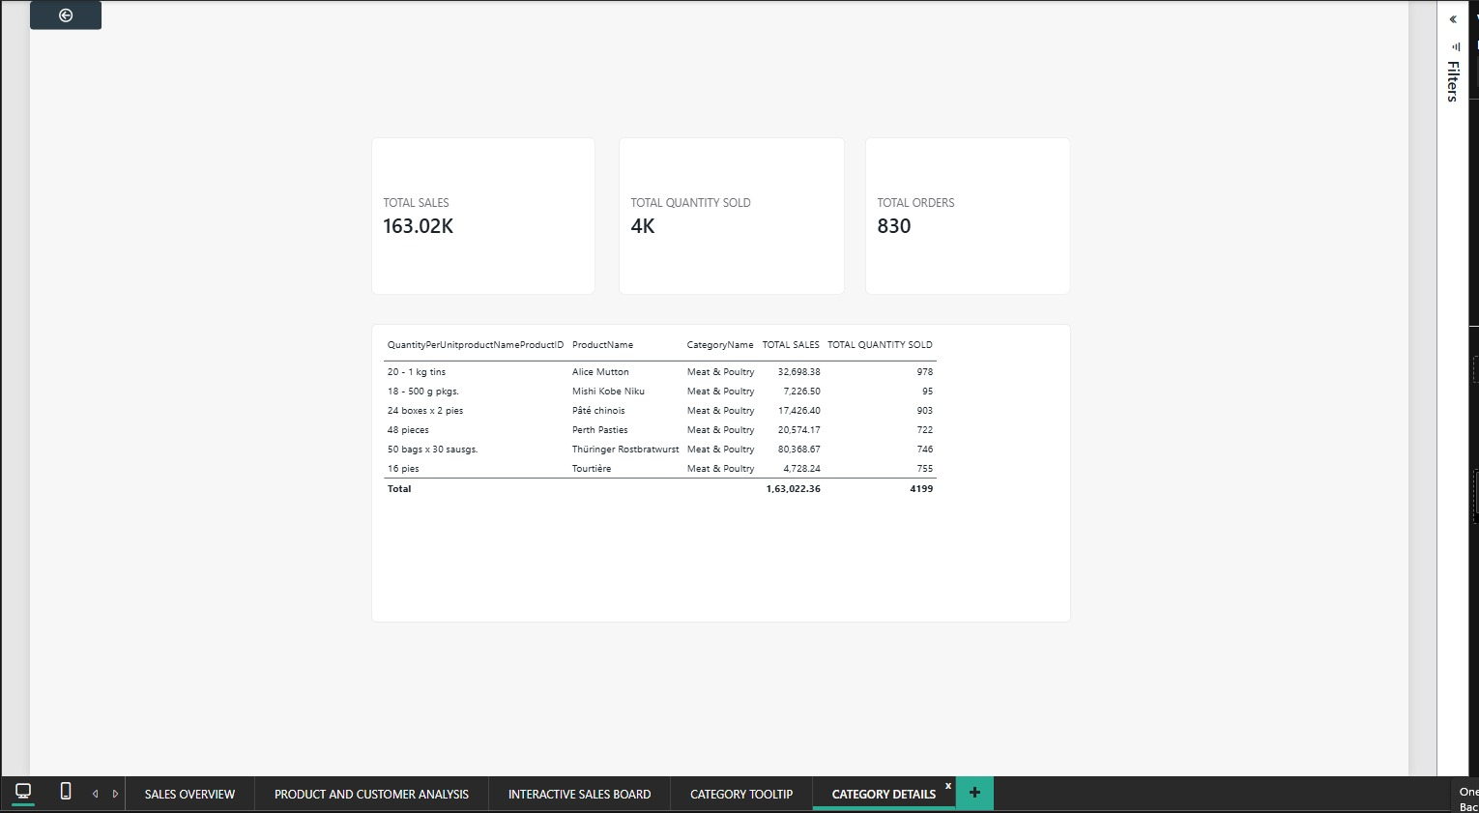
Figure 5: Category Details – displayed selection
The detailed table lists quantity per unit, ProductName, CategoryName, Total Sales and Total Quantity Sold. For the displayed selection, the table total is 163,022.36 in Total Sales and 4,199 in Total Quantity Sold.

13. Key Findings
- The latest overview shows 830 total orders and 91 customers.
- Total quantity sold is displayed as 51K.
- Total freight is displayed as 64.94K and average freight as 78.24.
- Order volume reaches its highest displayed area around March and April before dropping in May and June.
- Beverages is the largest category in the displayed sales chart.
- The USA has the largest displayed customer count.
- The dashboard supports year, region and category filtering.
- The category-details example shows Meat & Poultry at 163,022.36 in sales.

14. Conclusion
The Northwind report combines high-level KPIs with product, employee, category and customer analysis. Its separate overview, interactive board, tooltip and category-detail pages make it possible to move from summary figures to a selected category and then inspect the underlying products.

15. References
- Microsoft Power BI Desktop
- Northwind Sales Dataset
- Microsoft Power BI Documentation

