**Individual Assignment Weightage : 80%, 100 marks**

**Question 1**

1. Convert the 4275 octal number to (6 marks)
   1. Binary

Conversion Table for Octal to Binary

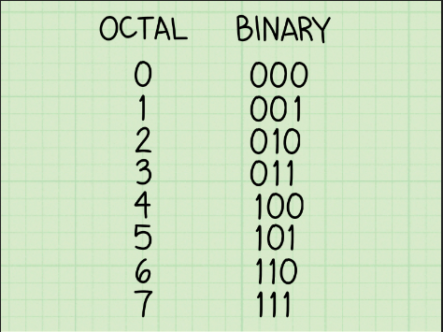

Refering to the table above, we can convert each digit to its respective binary number.

Final Answer:

4275 = 100 010 111 101

* 1. Decimal

We can use the expansion method here.

Final Answer: 2237

* 1. Hexadecimal

We can use the final answer in the binary and use 4 bits to convert it to to hexadecimal by using the table below.

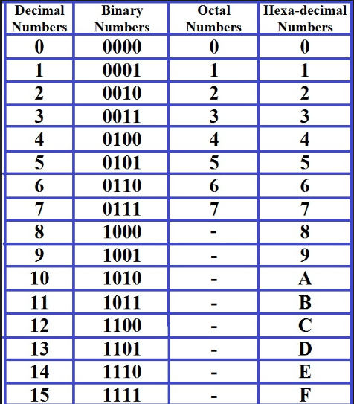

4275 converted to binary is 100 010 111 101.

Convert to 4 bits is 1000 1011 1101.

Using the table as a reference,

Hexadecimal is 8BD.

Final Answer: 8BD

1. Calculate the following: (6 marks)

(i) 10268 + 53258

Convert Octal to Decimal.

1026 in Decimal

534

5325 in Decimal

2773

Add normally.

534 + 2773 = 3307

Convert back to Octal using long division method

3307 / 8 | Remainder 3

413 / 8 | Remainder 5

51 / 8 | Remainder 3

6 / 8

Final Answer: 6353

(ii) 11112 * 1012

1111

X 0101

-----------------------

1111

1111

+ 1111

-----------------------

0100 1011

Final Answer: 0100 1011

(iii) FECA16 + 87B616

Convert to Decimal first by using the table below as reference

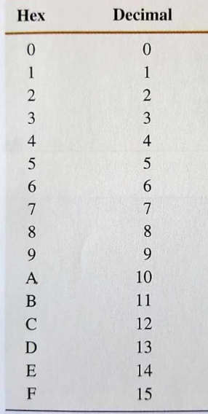

FECA in Decimal

Expansion Method

65226

87B6 in Decimal

Expansion Method

34742

Multiply normally.

34742 * 65226 = 2 266 081 692

Convert back to hexa using Long Division method.

2 266 081 692 / 16 | Remainder 12

141 630 105 / 16 | Remainder 9

8 851 881 / 16 | Remainder 9

553 242 / 16 | Remainder 10

34 577 / 16 | Remainder 1

2161 / 16 | Remainder 1

135 / 16 | Remainder 7

8 / 16

Final Answer: 8711A99C

# Question 2

## Given that

## 

* 1. Construct a logic circuit diagram for the above Boolean expression.

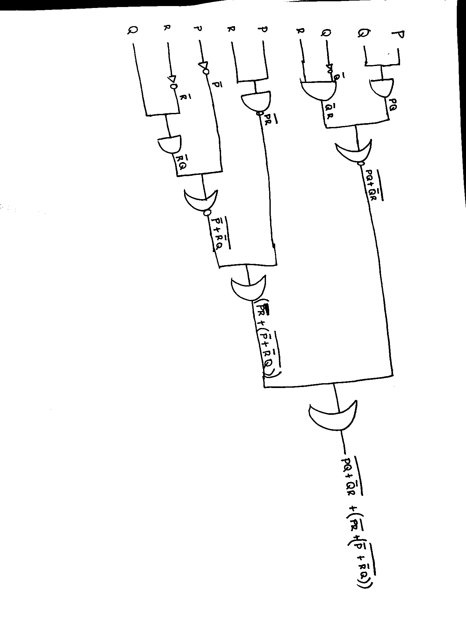

* 1. Construct a truth table for the above Boolean expression.

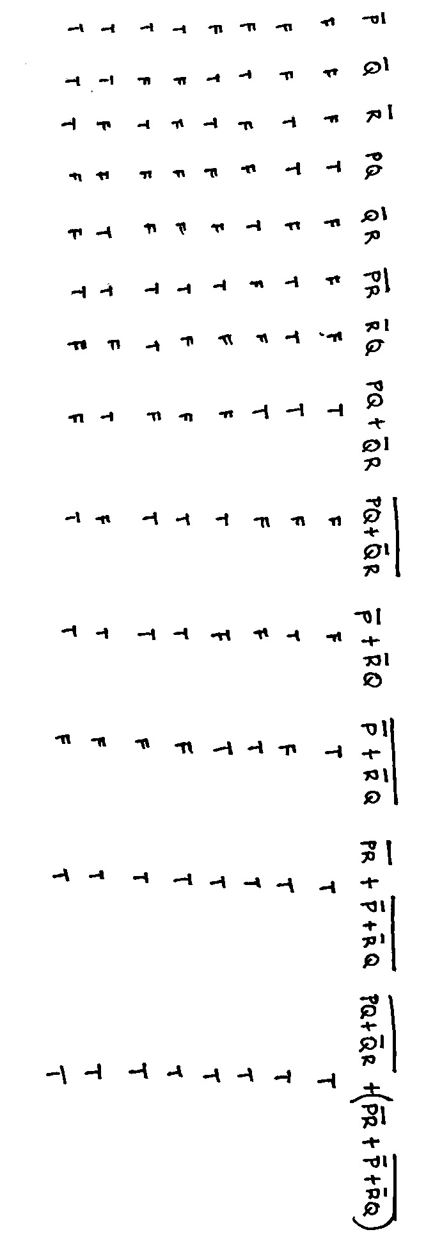

* 1. Simplify the Boolean expression of part (i).

Using the laws as reference, we can simplify this expression.

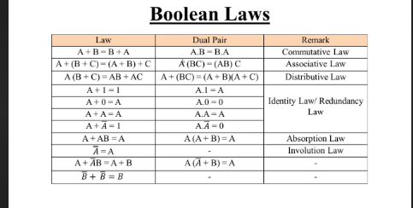

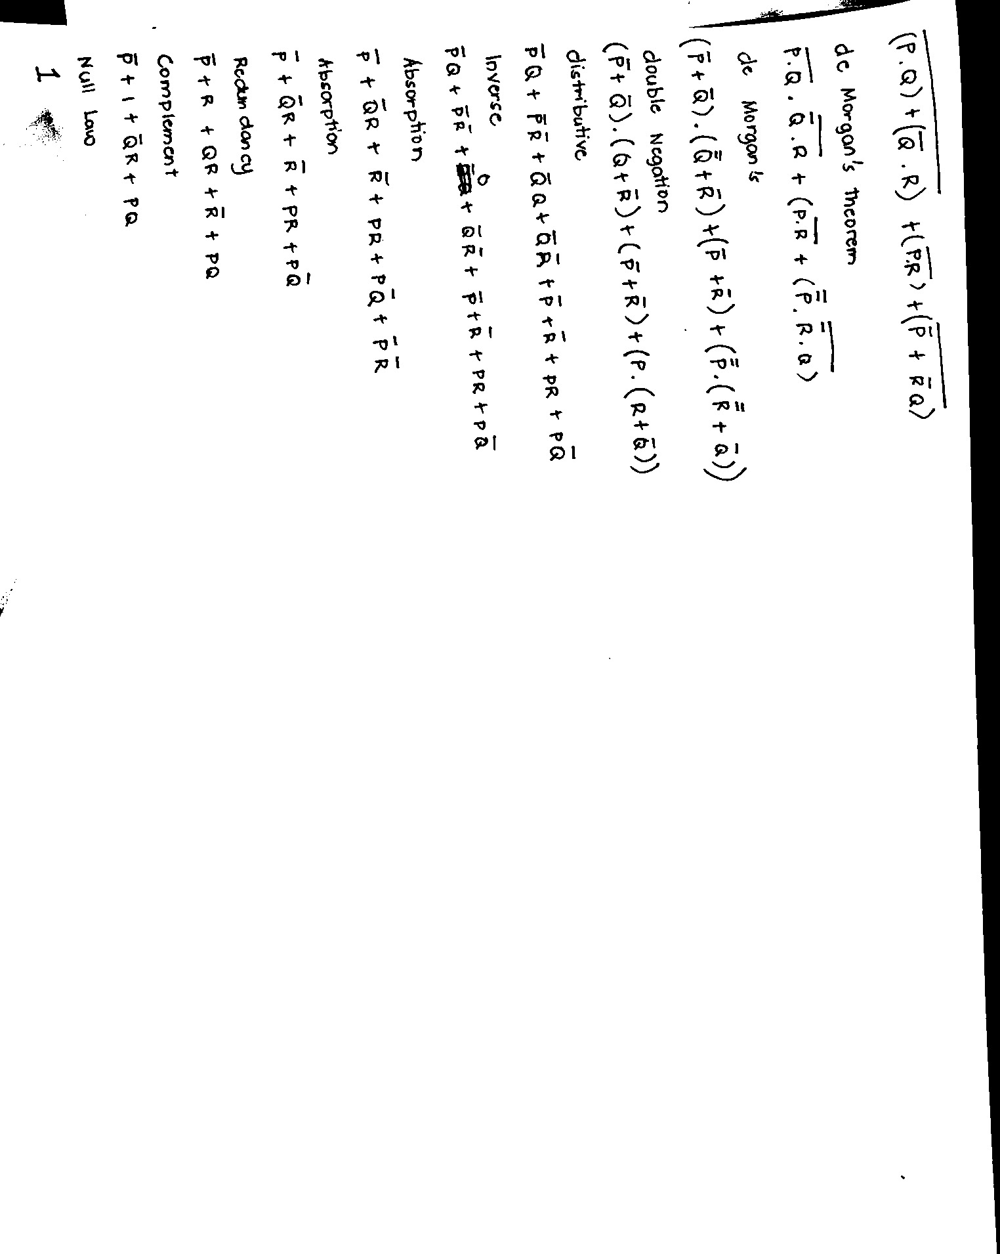

**Question 3**

1. A can of soda at temperature (Ti) 25◦ C is placed in a refrigerator, where the ambient temperature F is 10◦ C. We want to determine how the temperature of the soda changes over a period of time t from 0 to 100 minutes. A standard way of approaching this type of problem is to subdivide the time interval into a number of small steps, each of duration ***dt***. If Ti is the temperature at the beginning of step i, the following model can be used to determine Ti+1:

Ti+1 = Ti + K ***dt*** (F − Ti)

where K is the conduction coefficient, a parameter that depends on the insulating properties of the can and the thermal properties of the soda. Assume that units are chosen so that time is in minutes and that an interval ***dt***

= 1 minute provides sufficient accuracy. Write MATLAB script to compute, display, and plot this update process for K = 0.05.

(8 marks)

time = 0:dt:t_max;

temperature = zeros(size(time));

K = 0.05;

Ti = 25;

F = 10;

t_max = 100;

dt = 1;

temperature(1) = Ti;

for i = 1:length(time)-1

Ti = Ti + K * dt * (F - Ti);

temperature(i+1) = Ti;

end

figure;

plot(time, temperature, 'b', 'LineWidth', 2);

xlabel('Time in Minutes');

ylabel('Temp');

title('Change of Soda Temperature Over Time');

grid on;

final_temperature = temperature(end);

fprintf('Final temperature: %.2f°C\n', final_temperature);

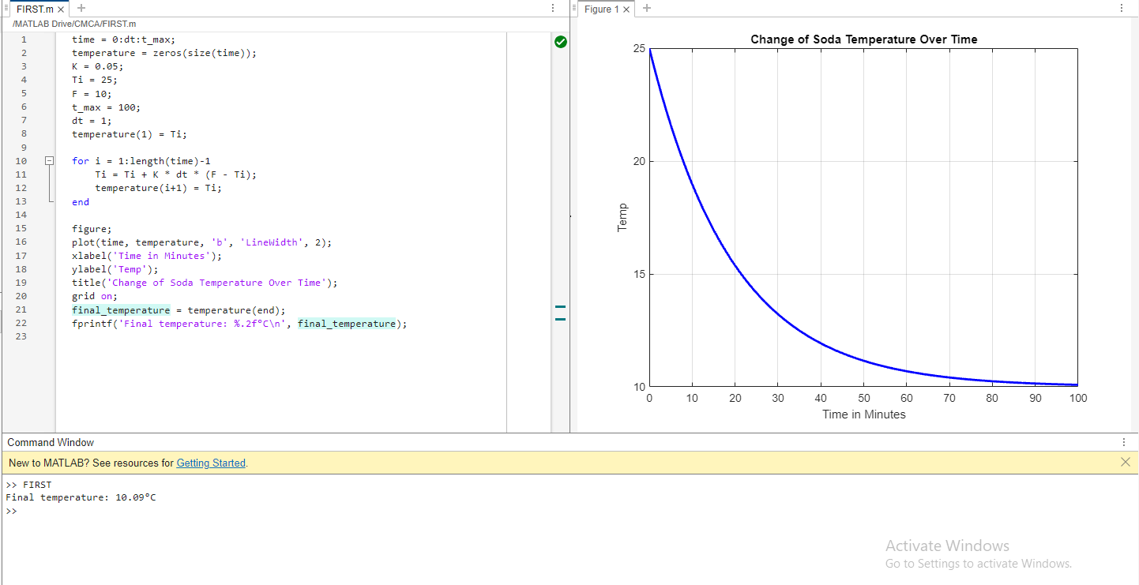

1. Write a MATLAB program to compute the sum of the first 15 terms in the series

5𝑘2 − 2𝑘 , where k is from 1 to 15 (8 marks)

sum = 0;

for k = 1:15

currentNum = 5*k^2-2*k;

sum = sum + currentNum;

end

fprintf('The total sum of first 15 terms is %d\n', sum);

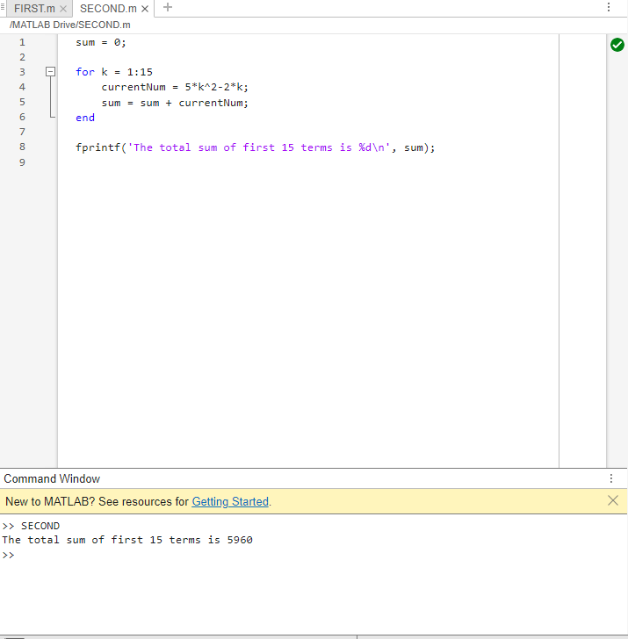

# Question 4

Smart Plotter Program - Design an application that displays a menu to ask the user to choose whether to: (20 marks)

1. Plot the relationship between the temperature and time using bar chart using the following instructions
   * Load a file that contain an array of 10 temperatures
   * Load a file that contain an array of 10 corresponding time values at which the temperatures were taken.
   * Determine the mean temperature and print the output.
2. The variable t represents time in seconds, and the dimensionless variable y represents the pressure difference across the aortic valve, normalised by a constant reference pressure.

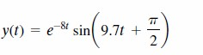

Write Matlab command to plot this function y(t) for from 𝟎 ≤ 𝒕 ≤ 𝟐𝟎.

1. Quit the Smart Plotter

The user can choose then proceed to plot a simple 2D line, a scatter plot or bar chart. The program will continue displaying the menu to allow the user to choose until the user chooses to quit the application.

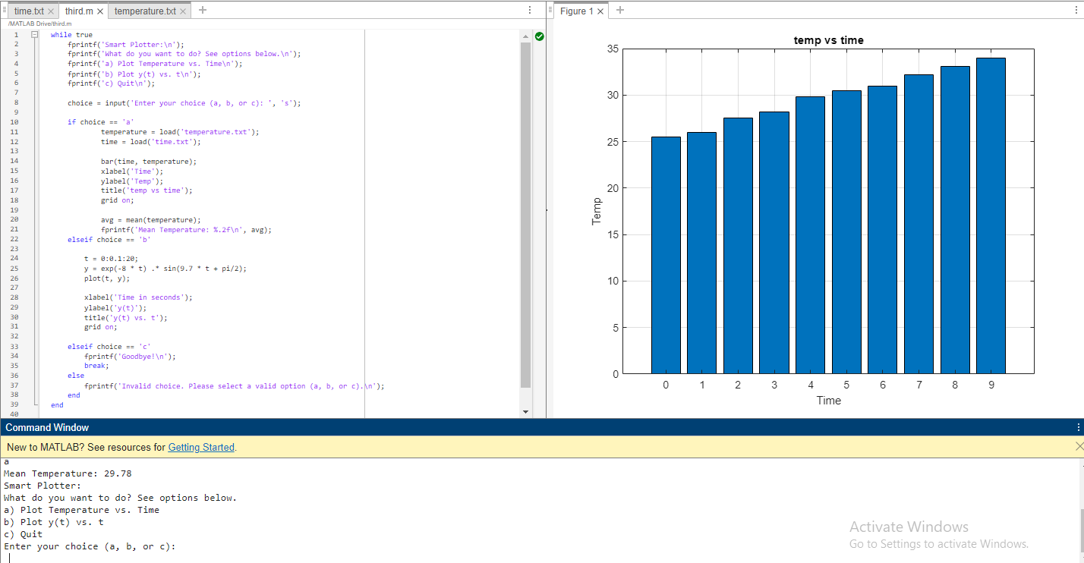

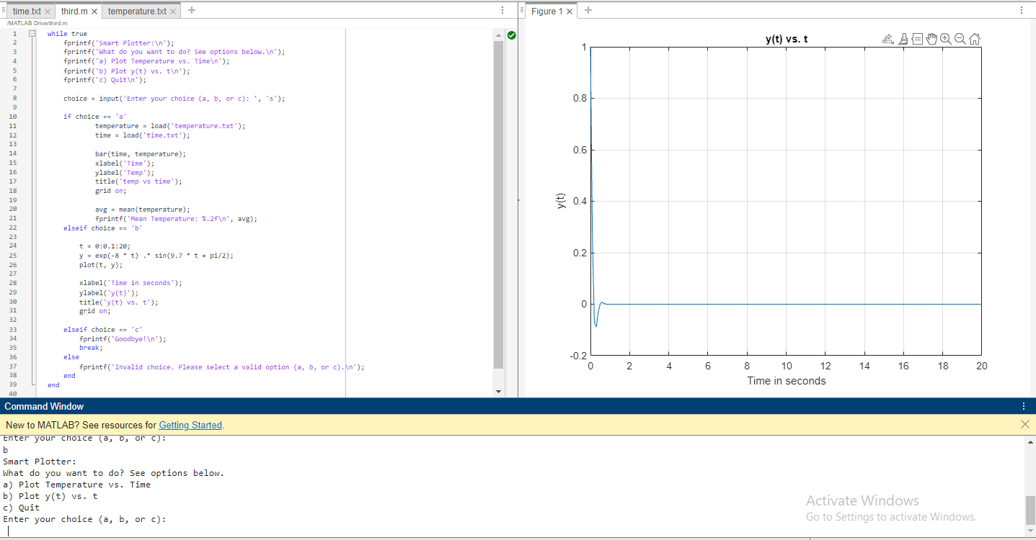

while true

fprintf('Smart Plotter:\n');

fprintf('What do you want to do? See options below.\n');

fprintf('a) Plot Temperature vs. Time\n');

fprintf('b) Plot y(t) vs. t\n');

fprintf('c) Quit\n');

choice = input('Enter your choice in small letters only! (a, b, or c): ', 's');

if choice == 'a'

temperature = load('temperature.txt');

time = load('time.txt');

bar(time, temperature);

xlabel('Time');

ylabel('Temp');

title('temp vs time');

grid on;

avg = mean(temperature);

fprintf('Mean Temperature: %.2f\n', avg);

elseif choice == 'b'

t = 0:0.1:20;

y = exp(-8 * t) .* sin(9.7 * t + pi/2);

plot(t, y);

xlabel('Time in seconds');

ylabel('y(t)');

title('y(t) vs. t');

grid on;

elseif choice == 'c'

fprintf('Goodbye!\n');

break;

else

fprintf('Invalid choice. Please select a valid option (a, b, or c).\n');

end

end

# Question 5

1. Using these matrices

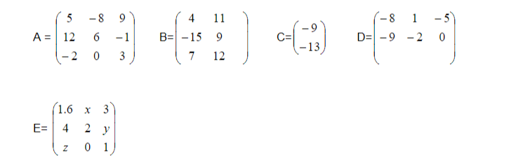

Calculate each of the followings:

* 1. AB (2 marks)

5*4 + -8*-15 + 9*7 5*11+-8*9+9*12

12*4 + 6*-15 + -1*7 12*11+-6*9+-1*12

-2*4 + 0*-15 + 3*7 -2*11+0*9+3*12

203 91

-49 174

13 14

* 1. B*C (2 marks)

½C is Equal to

-9/2

-13/2

B*1/2C is equal to

4*-9/2 + 11*-(13/2)

-15*-9/2 + 9*-(13/2)

7*-9/2 + 12*-(13/2)

-89.5

9

109.5

* 1. 5B D (2 marks)

5*B

5*4 5*11

5*-15 5*9

5*7 5*12

Equals

20 55

-75 45

35 60

5b * D

20*-8 + 55*-9 20*1 + 55*-2 20*-5 + 55*0

-75-8 + 45*-9 -75*1 + -45*-2 -75*-5 + -45*0

35-8 + 60*-9 -35*1 + 60*-2 -35*-5 + 60*0

-655 -90 -100

195 -165 375

-820 -85 -175

* 1. Find the values of x, y and z in E, if 1/3A = E

1/3A is the matrix below.

1/3*5 1/3*-8 1/3*9

1/3*12 1/3*6 1/3*-1

1/3*-2 1/3*0 1/3*3

Is equal to below

5/3 -8/3 3

4 2 -1/3

-2/3 0 1

With reference to the equivalence above,

X = -8/3 or -2.67

Y = -1/3 or –0.33

Z = -2/3 or –0.67

* 1. A+2E (2 marks)

**2E**

2*5/3 2*-8/3 2*3

2*4 2*2 2*-1/3

2*-2/3 2*0 2*1

10/3 16/3 6

8 4 -2/3

-4/3 0 2

**A**

5 -8 9

12 6 -1

-2 0 3

10/3+5 16/3+(-8) 6+9

12+8 4+6 -2/3+-1

-10/3 0 5

25/3 -40/3 15

20 10 -5/3

-10/3 0 5

OR

8.33 -13.33 15

20 10 -1.67

-3.33 0 5

# Question 6

1. Write down the MATLAB conversion program that prompts user to input number as any integer and units as string. (8 marks)
   * If the user input units as inch, then the given number is converted to centimetres using the formula centimetres = number * 2.54.
   * If the user input units as metre, then the given number is converted to centimetres using the formula centimetres = number * 100.
   * If the user input units as any other string, then display unit is unknown.

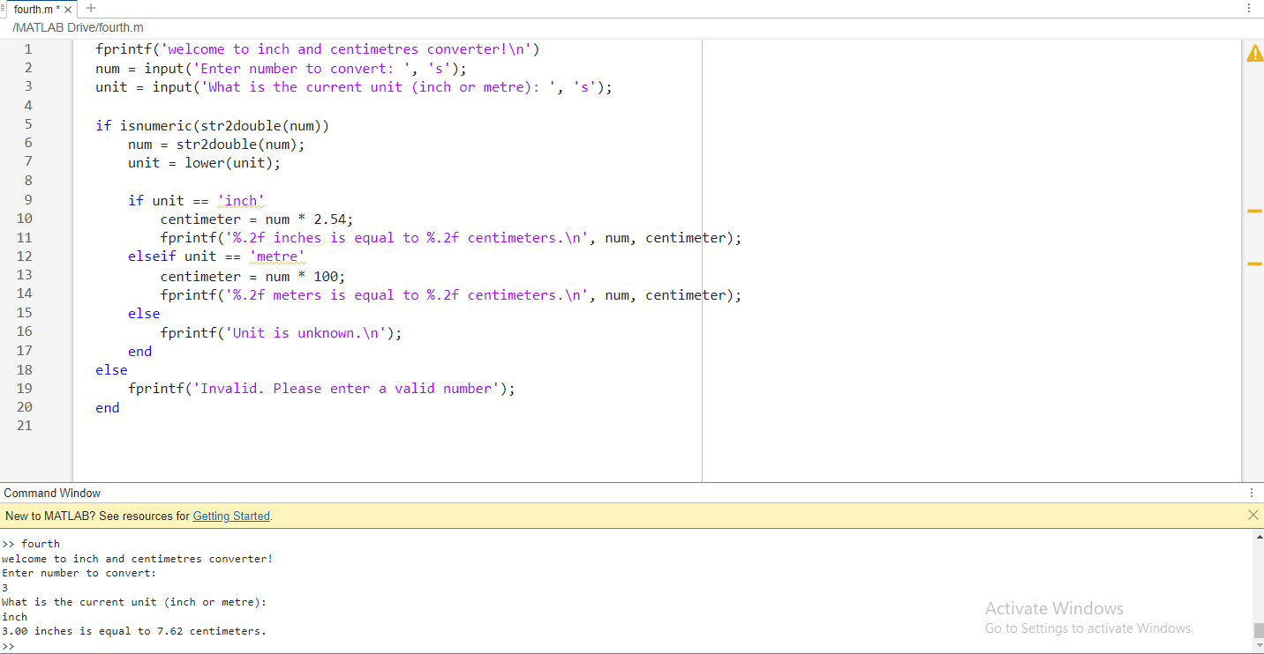

fprintf('welcome to inch and centimetres converter!\n')

num = input('Enter number to convert: ', 's');

unit = input('What is the current unit (inch or metre): ', 's');

if isnumeric(str2double(num))

num = str2double(num);

unit = lower(unit);

if unit == 'inch'

centimeter = num * 2.54;

fprintf('%.2f inches is equal to %.2f centimeters.\n', num, centimeter);

elseif unit == 'metre'

centimeter = num * 100;

fprintf('%.2f meters is equal to %.2f centimeters.\n', num, centimeter);

else

fprintf('Unit is unknown.\n');

end

else

fprintf('Invalid. Please enter a valid number');

end

1. Write a MATLAB program to calculate the taxi fare for the following:

(10 marks)

There are two types of taxis:

* Online taxi: It can be booked by using an online app from phones
* Classic taxi: It can be booked anywhere on the road

The online taxis cost Oc for the first km and Od for every km afterward. The classic taxis travel at a speed of Cs km per minute. The costs of classic taxis are Cb, Cm, and Cd that represents the base fare, cost for every minute that is spent in the taxi, and cost for each kilo meter that you ride.

You are going to the school from your home. Your task is to minimize the cost that you are required to pay. The distance from your home to the school is D. You are required to select whether you want to use online or classic taxis to go to your school. If both the taxis cost the same, then you must use an online taxi.

**Input**

* Single integer D that denotes the distance from your house to the school
* Three integers Oc***,*** Of***,*** and Od
* Four integers Cs, Cb, Cm, and Cd

If you select an online taxi to travel, then print a string '**Online Taxi**'. Otherwise, select '**Classic Taxi**'. You can print this string in a new, single line.

Formula:

online taxi cost = Oc + (D – Of) *Od

classic taxi cost = Cb + (D/Cs) *Cm + D *Cd

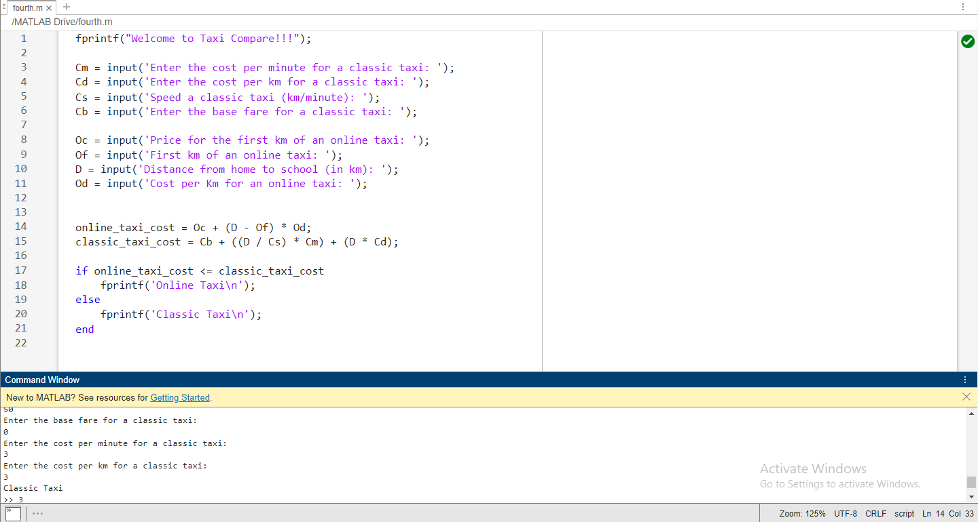

fprintf("Welcome to Taxi Compare!!!");

Cm = input('Enter the cost per minute for a classic taxi: ');

Cd = input('Enter the cost per km for a classic taxi: ');

Cs = input('Speed a classic taxi (km/minute): ');

Cb = input('Enter the base fare for a classic taxi: ');

Oc = input('Price for the first km of an online taxi: ');

Of = input('First km of an online taxi: ');

D = input('Distance from home to school (in km): ');

Od = input('Cost per Km for an online taxi: ');

online_taxi_cost = Oc + (D - Of) * Od;

classic_taxi_cost = Cb + ((D / Cs) * Cm) + (D * Cd);

if online_taxi_cost <= classic_taxi_cost

fprintf('Online Taxi\n');

else

fprintf('Classic Taxi\n');

end