**Vanier College**

**Computer Science Department**

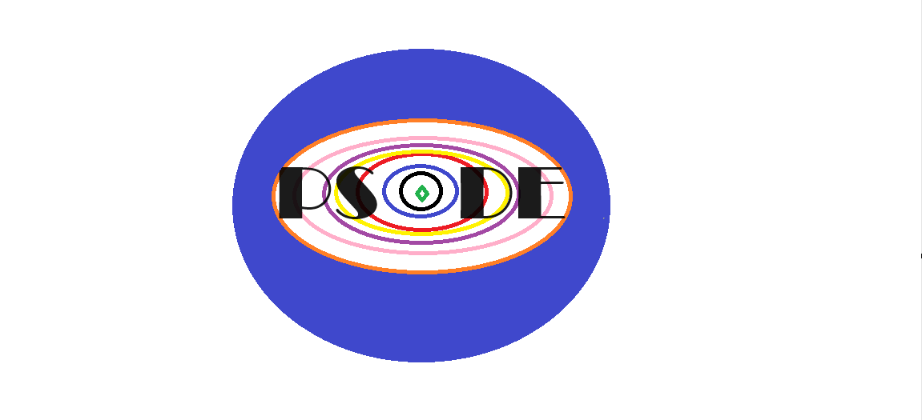

**User Manual**

Chrisjan Tadeo Alejandro

David Bidi

Kevin Saliba

420-203-RE: Program Development In A Graphical Environment (Sec-02)

Teacher: Syed Naseem Afzal

Monday, December 4, 2023

**Table of Contents**

Introduction…………………………………………………………………………………..3

Interactive Features…………………………………………………………………………3

Interactive Features…………………………………………………………………………4

Interactive Features…………………………………………………………………………5

Graphical User Interface……………………………………………………………………6

Basic UI……………………………………………………………………………………….7

Application Features…………………………………………………………………….…..7

Menu Home Features……………………………………………………………………….7

System at Rest……………………………………………………………………………....8

Moving System…………………………………………………………………..…………..9

1 at Rest, 1 Moving…………………………………………………………………...……10

Beta Version……………………………………..……………………………………...….11

Release Version……………………………………………………………………………12

Release Version……………………………………………………………………………13

**Introduction:**

The **Physics Simulator On Doppler Effect** is an application designed to simulate a real-world Doppler Effect animation. This program provides real physics Doppler Effect features such as a visualized system of an observer at rest, a source at rest, and finally the whole system moving closer and away from each other. This user manual will help students and teachers, providing them with a detailed explanation of all the features included in the physics simulation of the Doppler Effect.

**Interactive Features:**

For many centuries, The Doppler Effect has been a phenomenon observed in wave physics, where the frequency or wavelength of a wave appears to change relative to an observer's motion. This effect is experienced with sound waves, where the pitch of a sound shifts as a source or observer moves. The **Physics Simulator On Doppler Effect** is an educational tool designed to help students and teachers visualize and understand the Doppler Effect phenomenon. This application offers a user-friendly interface for simulating various scenarios, allowing users to control the motion of both the source and observer in a virtual environment. Some of the major features of this application include:

* The **home window** displays the date and time, a custom logo, and an interactive button to go to the simulation.
* The **scene switch feature** is used so that the user can switch back and forth between the actual animation and calculation part of the application, with a back-to-home button, to the home page with the start button.
* The **custom logo icon** is used to make the application belong to the group that developed it. It also adds a better and more professional look to the application.
* The **date and time** were used and added to the opening page and the animation page for the user’s benefit.
* The **slider modifiers** are used so that the user can pick the speed of the observer and the source or simply choose to leave either at rest. It is also used to set the frequency of the source.
* The **speed of sound options** are given by two radioButtons and the option for the user to choose to select the version of the speed of sound that fits the problem he is working with. Using a toggle group only one can be selected.
* The **media sound controller** is used to demonstrate the sample noise of the animation.
* The **animation display** shows the result of the simulation, demonstrating the function.
* The **graph feature** is used for a better look and a clearer and more accurate way to show the animation. A canvas is used and the animation is placed on the graph to improve it.
* The **Frequency calculator** is used to take the values picked by the user and use them to calculate the frequency heard by the observer in any different scenario and return it immediately.
* The **ComboBox for the characters** is used so that the user has the option to change from a pair of two different characters, basically changing the scenario and the sound.
* The **start and stop animation buttons** are simply used to start and stop the animation to either change values or restart.
* The **reset animation button** resets all values to zero, returns the observer and source to their initial place, and stops all waves or sounds.
* The **clear waves button** is used to clear all waves that start to leave the source and restart again.
* The **moving background** of the home page is a feature used for a better-looking application and makes it more attractive for a user to want to use it.

**Graphical User Interface:**

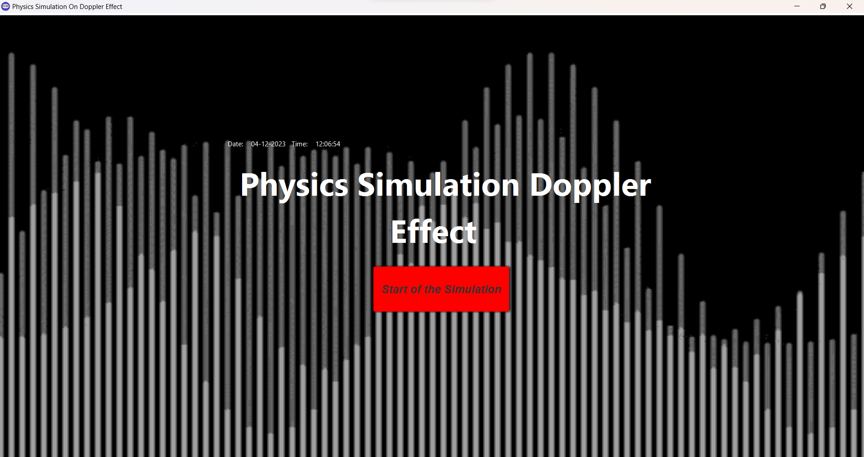

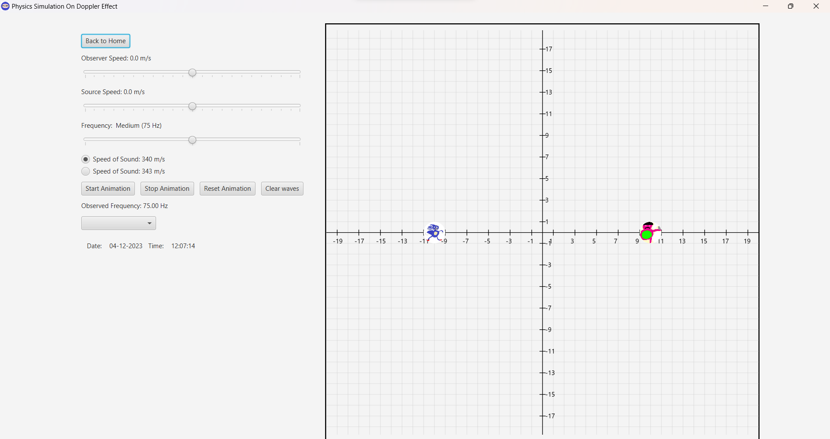

**Basic UI :**

This application is programmed using the JavaFX language, utilizing nodes, and comes with a simple user interface, for a user-friendly experience.

The main window presents the menu of the Doppler Effect Simulation, giving the user the option to select which situation they want to visualize in order to understand the material they are being taught in class. Clicking an option brings the user to another scene, with a specific simulation they will modify.

**Application Features:**

Menu Home Window

In the Menu **home window**, a custom logo has been set to remove any default Java application looks, making the window and taskbar icon cleaner. The **date and time** feature is introduced, which allows users to have real-time information within the application, and tracks the chronological order of events making it easier for users to understand when an event took place. Once again, the **scenario controls** open specific Doppler Effect simulations, which are feature-limited to the simulation you chose.

Animation 1: System at Rest

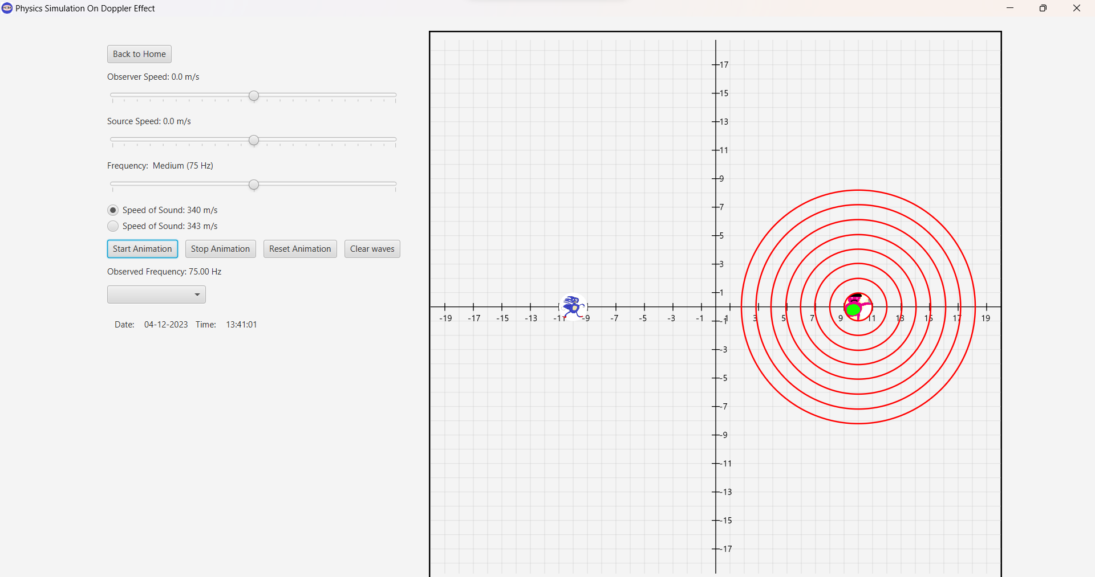

In a **system at rest**, both the observer and source will first appear in the application set to a certain position and the speed set at zero, therefore they will not be moving. Then when we press the “Start Animation” button, the sound waves will start appearing from the source accompanied by a sound. Also, the calculator will immediately display the frequency heard by the observer. You can also change the characters and do the same again.

Animation 2: Moving System

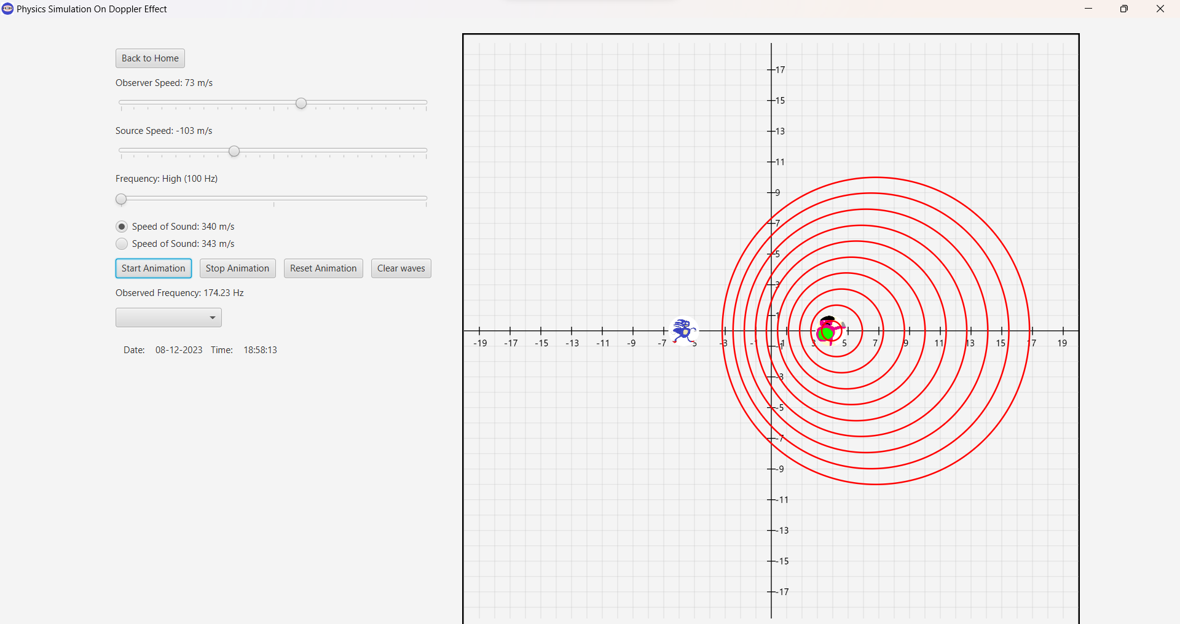

In a **moving system**, both the observer and source can move either to get close to each other, move far from each other, or move close while the other moves away. These cases are important in a Doppler effect problem and bring different outcomes. So that the observer and the source move, the user will have to use the slider to set the speed at which they will move, and dragging it left or right will determine the direction they will move. Then, once the speeds of each are chosen and the frequency as well, the calculator will automatically give the resulting frequency. The animation is then ready to start, showing how the wave and sound act in these different situations. The other characters shown in the comboBox can also be used for the same system but with a different scenario and sound to go with it.

Animation 3: 1 at Rest and 1 moving

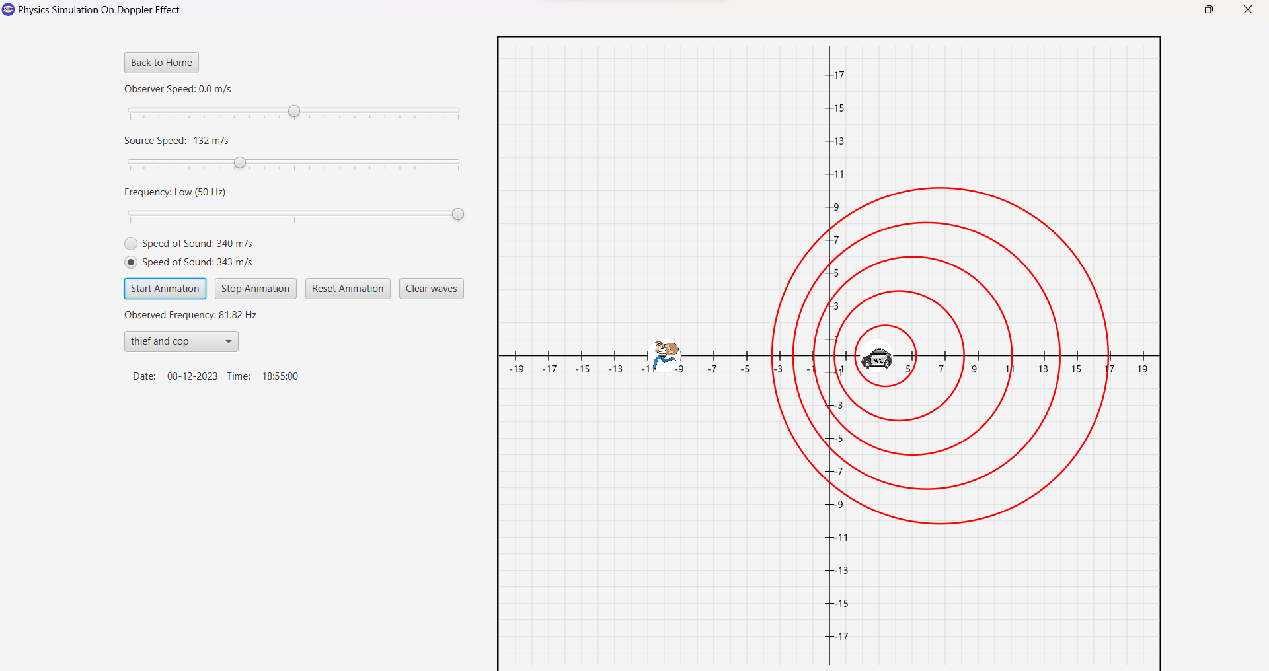

In a **system where 1 is moving, and 1 at rest**, the user can interact with the slider to move either the source or the observer, keeping the other stationary. This is another important case in the Doppler effect world. The source can either move away or towards the observer and the calculation will display the correct resulting frequency for that case. Also, the observer can move closer or away to the source when the source is at rest and we’ll get the right frequency heard at that moment. Using the comboBox the other characters can do the same but with a different scenario and sound to go with it.

**Previous Version:**

**Beta**

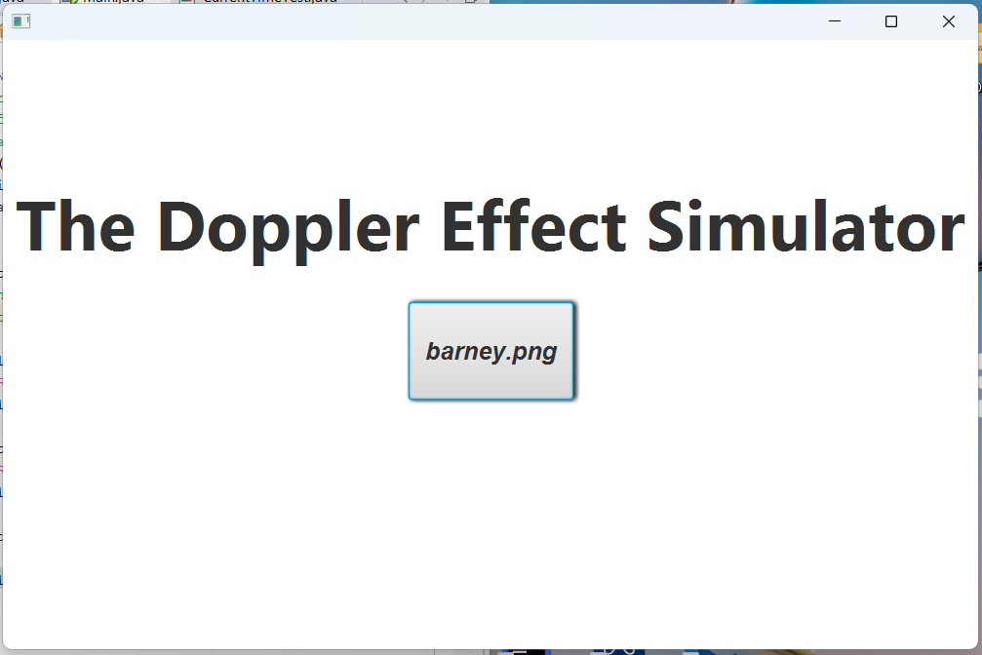

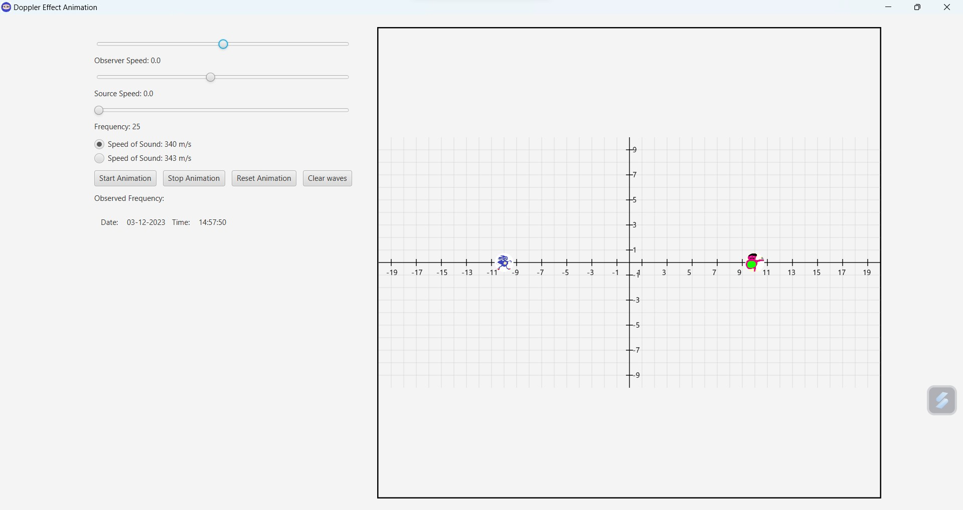

**Release Version:**

**Version 1.0.0**





