# BUILDING A SMARTER AI- POWERED SPAM CALSSIFIER

# BATCH MEMBER

**211121104032 : KEVIN . B**

**Phase 3 Submission Document**

**Phase 3 : Development Part 1**

**Topic : Start building the spam classifier model by loading and preprocessing the dataset .**

**INTRODUCTION :**

**A spam classifier model is a machine learning model or algorithm designed to automatically distinguish between spam and non-spam (legitimate) messages or content. It plays a crucial role in filtering out unwanted or potentially harmful content from various forms of communication, such as emails, text messages, comments, and more. Here's an introduction to the key aspects of a spam classifier model:**

**1. Purpose and Importance:**

**-** Spam is unwanted and often deceptive or malicious content that can clog up communication channels and pose security risks. Spam classifiers help protect users from these nuisances.

- They are essential for email providers, social media platforms, and other online services to maintain the quality of user experience and security.

**2. Types of Spam Classifier Models**

**-** Rule-Based Models: These models use predefined rules to identify spam based on specific keywords, patterns, or heuristics. While simple, they can be less effective in handling evolving spam techniques.

- Machine Learning Models These models leverage machine learning algorithms to automatically learn and adapt to different spam patterns. Common algorithms used include Naive Bayes, Support Vector Machines, Decision Trees, and Neural Networks**.**

**3. Data Preprocessing:**

**-** Text data is preprocessed to prepare it for analysis. This may include lowercasing, removing special characters, tokenization (breaking text into words or tokens), stemming or lemmatization, and removing stop words**.**

**4. Feature Extraction:**

**-** Features are extracted from the preprocessed text data. Common approaches include using term frequency-inverse document frequency (TF-IDF) or word embeddings like Word2Vec, GloVe, or BERT.

**5. Training and Testing: -** The model is trained on labeled data, typically consisting of a large dataset of both spam and non-spam examples. This dataset is divided into training and testing subsets to evaluate the model's performance.

**6. Model Evaluation:**

**-** The model's performance is assessed using various metrics like accuracy, precision, recall, F1-score, and the confusion matrix**.**

In summary, a spam classifier model is a critical tool for protecting users from unwanted,

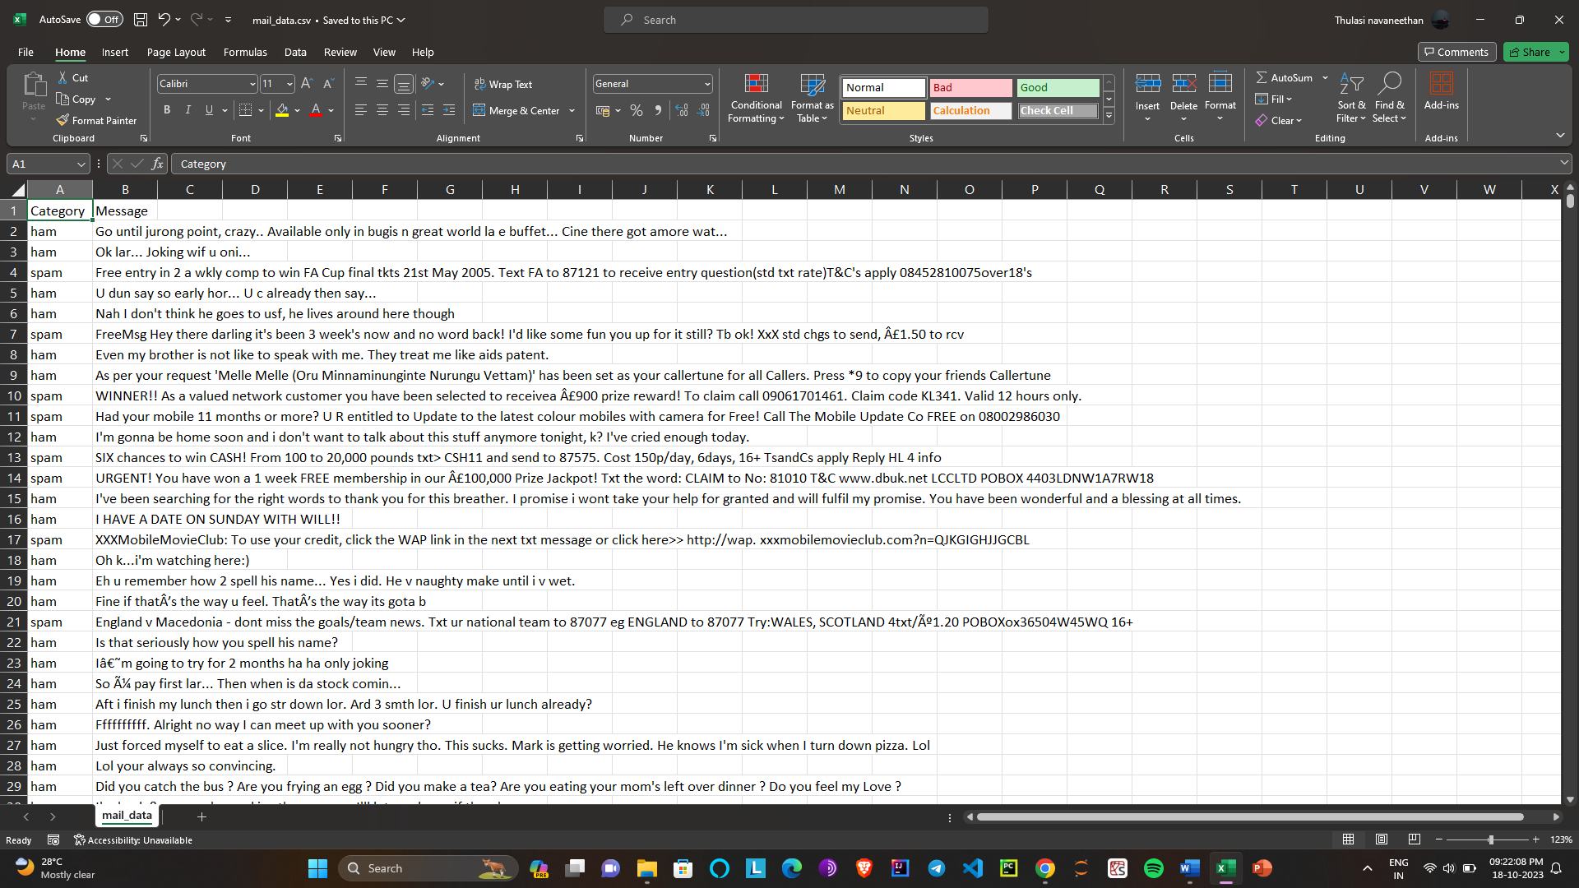**Given Dataset :**

Importing the Dependencies

import numpy as np  
import pandas as pd  
from sklearn.model_selection import train_test_split  
from sklearn.feature_extraction.text import TfidfVectorizer  
from sklearn.linear_model import LogisticRegression  
from sklearn.metrics import accuracy_score

Data Collection & Pre-Processing

# loading the data from csv file to a pandas Dataframe  
raw_mail_data = pd.read_csv('/content/mail_data.csv')

print(raw_mail_data)

Category Message  
0 ham Go until jurong point, crazy.. Available only ...  
1 ham Ok lar... Joking wif u oni...  
2 spam Free entry in 2 a wkly comp to win FA Cup fina...  
3 ham U dun say so early hor... U c already then say...  
4 ham Nah I don't think he goes to usf, he lives aro...  
... ... ...  
5567 spam This is the 2nd time we have tried 2 contact u...  
5568 ham Will ü b going to esplanade fr home?  
5569 ham Pity, * was in mood for that. So...any other s...  
5570 ham The guy did some bitching but I acted like i'd...  
5571 ham Rofl. Its true to its name  
  
[5572 rows x 2 columns]

# replace the null values with a null string  
mail_data = raw_mail_data.where((pd.notnull(raw_mail_data)),'')

# printing the first 5 rows of the dataframe  
mail_data.head()

Category Message  
0 ham Go until jurong point, crazy.. Available only ...  
1 ham Ok lar... Joking wif u oni...  
2 spam Free entry in 2 a wkly comp to win FA Cup fina...  
3 ham U dun say so early hor... U c already then say...  
4 ham Nah I don't think he goes to usf, he lives aro...

# checking the number of rows and columns in the dataframe  
mail_data.shape

(5572, 2)

Label Encoding

# label spam mail as 0; ham mail as 1;  
  
mail_data.loc[mail_data['Category'] == 'spam', 'Category',] = 0  
mail_data.loc[mail_data['Category'] == 'ham', 'Category',] = 1

spam - 0

ham - 1

# separating the data as texts and label  
  
X = mail_data['Message']  
  
Y = mail_data['Category']

print(X)

0 Go until jurong point, crazy.. Available only ...  
1 Ok lar... Joking wif u oni...  
2 Free entry in 2 a wkly comp to win FA Cup fina...  
3 U dun say so early hor... U c already then say...  
4 Nah I don't think he goes to usf, he lives aro...  
 ...   
5567 This is the 2nd time we have tried 2 contact u...  
5568 Will ü b going to esplanade fr home?  
5569 Pity, * was in mood for that. So...any other s...  
5570 The guy did some bitching but I acted like i'd...  
5571 Rofl. Its true to its name  
Name: Message, Length: 5572, dtype: object

print(Y)

0 1  
1 1  
2 0  
3 1  
4 1  
 ..  
5567 0  
5568 1  
5569 1  
5570 1  
5571 1  
Name: Category, Length: 5572, dtype: object

import seaborn as sns  
import matplotlib.pyplot as plt  
from wordcloud import WordCloud  
from wordcloud import STOPWORDS  
import string  
from sklearn.metrics import accuracy_score, confusion_matrix , classification_report

print(raw_mail_data.columns)

Index(['Category', 'Message'], dtype='object')

plt.hist('Category')

(array([0., 0., 0., 0., 0., 1., 0., 0., 0., 0.]),  
 array([-0.5, -0.4, -0.3, -0.2, -0.1, 0. , 0.1, 0.2, 0.3, 0.4, 0.5]),  
 <BarContainer object of 10 artists>)

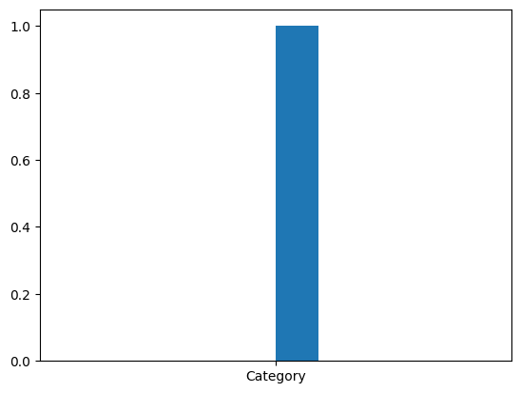

**Some common data preprocessing tasks include:**

➢ **Data cleaning**: This involves identifying and correcting errors and

inconsistencies in the data. For example, this may involve

removing duplicate records, correcting typos, and filling in missing

values.

➢ **Data transformation**: This involves converting the data into a

format that is suitable for the analysis task. For example, this may

involve converting categorical data to numerical data, or scaling

the data to a suitable range.

➢ **Feature engineering**: This involves creating new features from

the existing data. For example, this may involve creating features

that represent interactions between variables, or features that

represent summary statistics of the data.

➢ **Data integration**: This involves combining data from multiple

sources into a single dataset. This may involve resolving

inconsistencies in the data, such as different data formats or

different variable names.

Data preprocessing is an essential step in many data

science projects. By carefully preprocessing the data, data scientists can

improve the accuracy and reliability of their results.

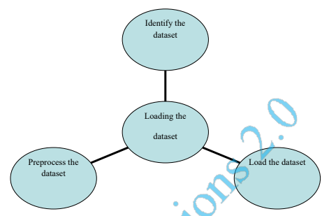

**Conclusion :**

In conclusion, data preprocessing is a crucial initial step in building an effective spam classifier model. It involves cleaning and transforming the raw text data to make it suitable for machine learning. This preparation ensures that the model can accurately distinguish between spam and legitimate content, ultimately enhancing the quality of communication channels and user experience.