Propuestas para el paper:

Submit to Optical Network Systems (ONS)

Brainstorming:
- Que el paper tenga un detalle de Control Automatico. Por ejemplo control de los motores del nuevo sistema de posicionamiento
- Debe ser experimental
- Debe de usar ML
- Debe ser de 1 LED
- Añadir el filtro Kalman

Aplicación:
Pensar en la aplicación que se hará con el paper y q sea de interés

- Pienso que se debería usar el Robot en una tarea
- Robot con tarea de pick-and-place
- Robot con el receptor y que se sepa su trayectoria.

Micro-avances o ideas anteriores:
- Estudio de estimación 3D model-based empleando 2PD.
- Seguimiento del UE con gradiant ascent
- Propuesta con 02 Tx.

Tendencia:
- Transferencia de power a los dispositivos
- Optical IRS
- VSLED
- Beamstearing

Propuesta 1:

Posibles nombres:
- Plug-and-Play Nodes for Visible Light Positioning and LiFi: Toward Scalable and Maintainable Deployments
- Node-Level Cooperation for Visible Light Positioning and Communication: Design and Testbed Evaluation
- Beyond Monolithic ISAC: A Modular and Upgradeable Node Architecture for VLP and VLC

A Novel Modular Node Architecture for Cooperative Visible Light Positioning and Communication

Abstract— Visible light positioning (VLP) and visible light communication (VLC) deployments remain predominantly non-modular and site-specific, often requiring room-dependent calibration (luminaire coordinates, fingerprinting, and LED/photodiode tilt), which increases cost and hinders scalability. This paper presents a modular node architecture that enables cooperative VLP–VLC operation while preserving plug-and-play installation. The architecture defines three interoperable roles: (i) VLP nodes dedicated to localization service, (ii) VLC nodes dedicated to communication service, and (iii) hybrid nodes combining both functions. A lightweight control plane supports self-discovery and exchange of positioning estimates (with uncertainty) and QoS requirements, allowing independent hardware/firmware evolution across heterogeneous room geometries and mounting heights. This modularity enables flexible deployments—ranging from positioning-only (e.g., robotics), communication-only (e.g., static LiFi hotspots), or cooperative operation where VLP assists VLC in serving mobile users.

To validate the concept, we implement a two-node testbed comprising a beam-steered single-VLP transmitter and a beam-steered VLC transmitter. A photodiode mounted on a robotic arm traces the workspace; the VLP node provides real-time position estimates that the VLC node uses to steer its beam and adapt power/modulation. We compare against a baseline with a downward-fixed VLC beam and evaluate throughput, BER/SNR, link continuity, and positioning error. The proposed architecture is designed to reduce calibration overhead and to improve operational efficiency by aligning link formation with user position, offering a scalable and maintainable alternative to bespoke deployments and monolithic ISAC designs.

Index Terms— visible light positioning (VLP), visible light communication (VLC), LiFi, modular node architecture, node cooperation, beam steering, single-LED, testbed, indoor robotics.

Steering a Single-LED Optical Wireless Positioning System with Two Photodiodes for Calibration-Free 3D Localization

Optical Wireless Positioning (OWP) systems typically rely on dense infrastructures or careful radiometric/extrinsic calibration to achieve accurate three-dimensional localization. This paper shows that centimeter-scale 3D accuracy is attainable with minimal hardware and no per-session calibration by electronically steering a single LED transmitter and measuring received signal strength (RSS) with just two upward-facing photodiodes (2PD). We drive the LED through a known sequence of beam orientations while maintaining constant radiant power. From the resulting RSS traces, we form orientation-wise power ratios that cancel unknown gains, LED intensity, and slow ambient drift. Under a Lambertian optical channel, these ratios become linear in the direction cosines of the receiver relative to the steered beam, enabling a closed-form estimate of bearing and range, followed by a lightweight nonlinear refinement. We analyze identifiability and noise sensitivity, showing that three or more non-coplanar steering orientations suffice for unique recovery and that adding orientations improves robustness to sensor mismatch. A prototype implementation validates the approach across typical indoor distances, demonstrating accurate, repeatable 3D localization without radiometric calibration, inter-device alignment, or auxiliary sensors. This work reduces infrastructure and setup costs for OWP while preserving accuracy, and it provides a practical path to calibration-free optical localization with commodity components.

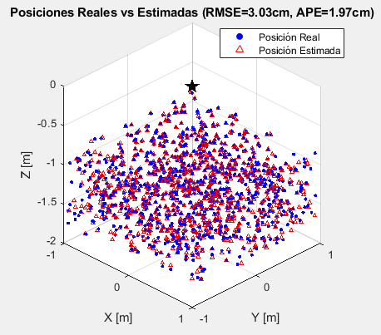

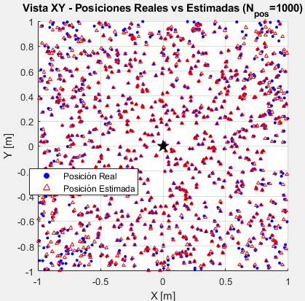

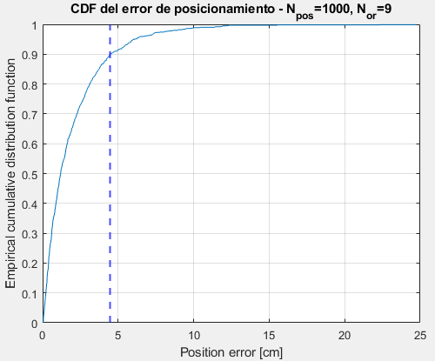

Figuras de referencia:
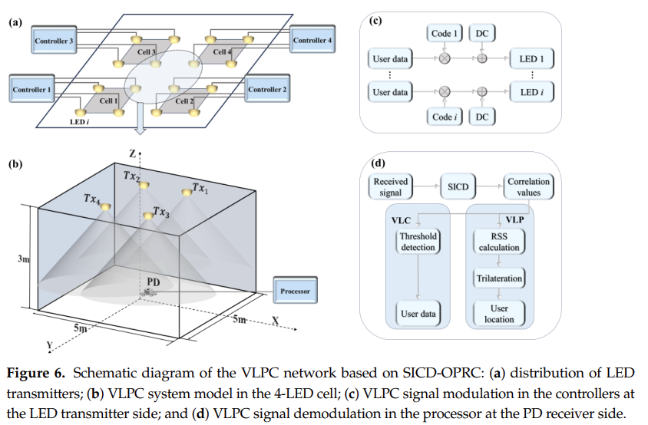
[Asynchronous Code Division Multiplexing-Based Visible Light Positioning and Communication Network Using Successive Interference Cancellation Decoding]

