DroidSecAnalytica
Technical Documentation

By Kevin Day

College of Management
Metropolitan State University
St. Paul, MN
January 25, 2024

Overview
DroidSecAnalytica is a comprehensive tool designed for the dynamic and static analysis of Android applications, particularly focusing on security aspects such as permission usage, file system analysis, and malware detection. This tool is tailored for cybersecurity experts, researchers, and developers, aiming to provide a robust platform for both static and dynamic analysis of Android APK files. DroidSecAnalytica boasts a range of features, making it a versatile tool in the cybersecurity toolkit:
- Static Analysis: Deconstructs APK files to analyze components like permissions and intent filters, providing a static security overview.
- Dynamic Analysis: Connects to real-time Android environments to assess application behavior, highlighting potential runtime vulnerabilities.
- Database Management: Maintains a comprehensive database of Android malware hashes, enabling quick identification of known threats.
- Reporting: Generates detailed reports, offering both summaries and in-depth analysis, suitable for various stakeholders.

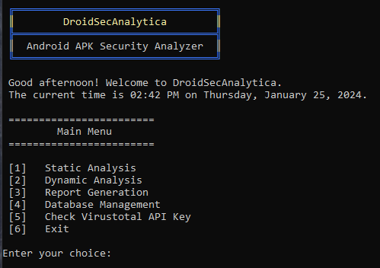
Objectives
DroidSecAnalytica's primary objective is to equip users with a detailed insight into Android applications' security aspects. It aims to:
- Identify potential security vulnerabilities in Android applications.
- Provide a thorough analysis of Android permissions and their usage.
- Detect and analyze malware signatures within Android APK files.
- Offer a user-friendly interface for conducting complex security assessments.

Technology Stack
DroidSecAnalytica is built on Python, leveraging its powerful libraries for efficient processing and analysis. The integration of ADB (Android Debug Bridge) allows for seamless interaction with Android devices or emulators for real-time analysis.

System Requirements
- Python 3.12
- ADB (Android Debug Bridge) for dynamic analysis
- Access to Android devices or emulators

Installation Guide
- Clone the repository from GitHub: git clone https://github.com/username/DroidSecAnalytica.git
- Install required Python libraries: pip install -r requirements.txt
- Set up ADB and ensure it's in the system PATH.

Module Descriptions
1. Static Analysis (static_analysis package)
- Performs static analysis of APK files.
- Extracts and analyzes permissions, intent filters, and other manifest components.
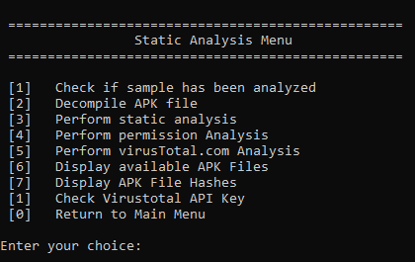

2. Dynamic Analysis (dynamic_analysis package)
- Connects to Android devices for real-time analysis.
- Includes modules such as device_manager, app_manager, and file_system_analysis.
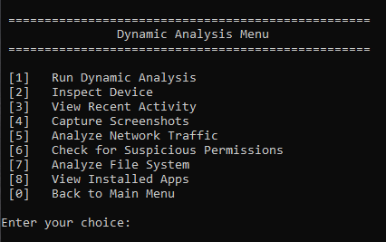

3. Database Management (database package)
- Handles interactions with the project's database.
- Includes modules for managing Android malware hashes and other relevant data.

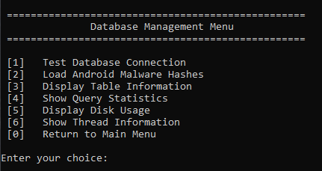

4. Reporting (reporting package)
- Generates comprehensive reports based on analysis results.
- Supports various output formats for easy interpretation.

5. Utilities (utils package)
- Includes helper modules like logging_utils for logging and app_display for UI components.

Usage Instructions
- Run main.py to start the application.
- Use the main menu to navigate between different functionalities.
- Follow on-screen prompts for specific actions like analyzing an APK or viewing database information.

Troubleshooting and Support
- Ensure all dependencies are correctly installed.
- Check the logs directory for error logs and troubleshooting information.
- For additional support, contact [Support Email].

Future Work and Enhancements
- Integration with external malware databases for enhanced analysis.
- Implementing machine learning for predictive analysis of APKs.

Contributing
We welcome contributions to DroidSecAnalytica from the community. Whether you're a seasoned developer or just starting out, your contributions are valuable in making DroidSecAnalytica a more robust and effective tool for Android security analysis.

How to Contribute
- Familiarize with the Project: Start by reading the documentation, understanding the codebase, and setting up the development environment on your local machine.
- Find an Issue: Look through the open issues on our GitHub repository. If you're new to the project, you might want to start with an issue labeled "good first issue".
- Fork and Clone: Fork the DroidSecAnalytica repository and clone your fork to your local machine.
- Create a Branch: Create a new branch in your fork for your contribution. Use a clear and descriptive name for your branch.
- Make Changes: Work on the issue in your branch. Make sure you adhere to the coding standards and write clean, maintainable code.
- Test Your Changes: Before submitting your changes, thoroughly test them to ensure they work correctly and don’t introduce new issues.
- Commit Your Changes: Commit your changes with a clear and concise commit message, following any commit message guidelines specified in the project.
- Submit a Pull Request: Push your changes to your fork and submit a pull request to the main DroidSecAnalytica repository. In your pull request description, explain your changes and link to the issue you're addressing.

Review Process
Once you submit your pull request, maintainers will review your contribution. They might suggest changes or improvements. Be receptive to feedback and make necessary updates to your pull request if requested.

Questions and Support
If you have questions or need help with your contribution, feel free to reach out to the community through our GitHub Discussions or contact the project maintainers directly.

