ECPS204 Project2-Multi-threading canny edge

CHENG-CHIH, LEE, 29329351
JONATHAN KIM, 42411903

Project Description (2 pts)
- The purpose of this project is to implement multithreading on the canny application. OpenMP and pthread are explored and implemented.
- The improvement of performance is expected to be measured and discussed.

- Experimental Setup (4 pts)
- For this project, we set up a Git repository to exchange files between the RPi and laptop. Following the instructions, we get each step done and recorded.
- The local canny file is used to study multithreading method. And the developed canny.cpp in proj1 is also modified to implement multithreading.
- Results (6 pts)
Step 2 – Understanding the modifications on canny_local.c with OpenMP
Parameter Sets  <sigma>/<tlow>/<thigh> | Results | Comment and observation
1.0/0.2/0.6 | 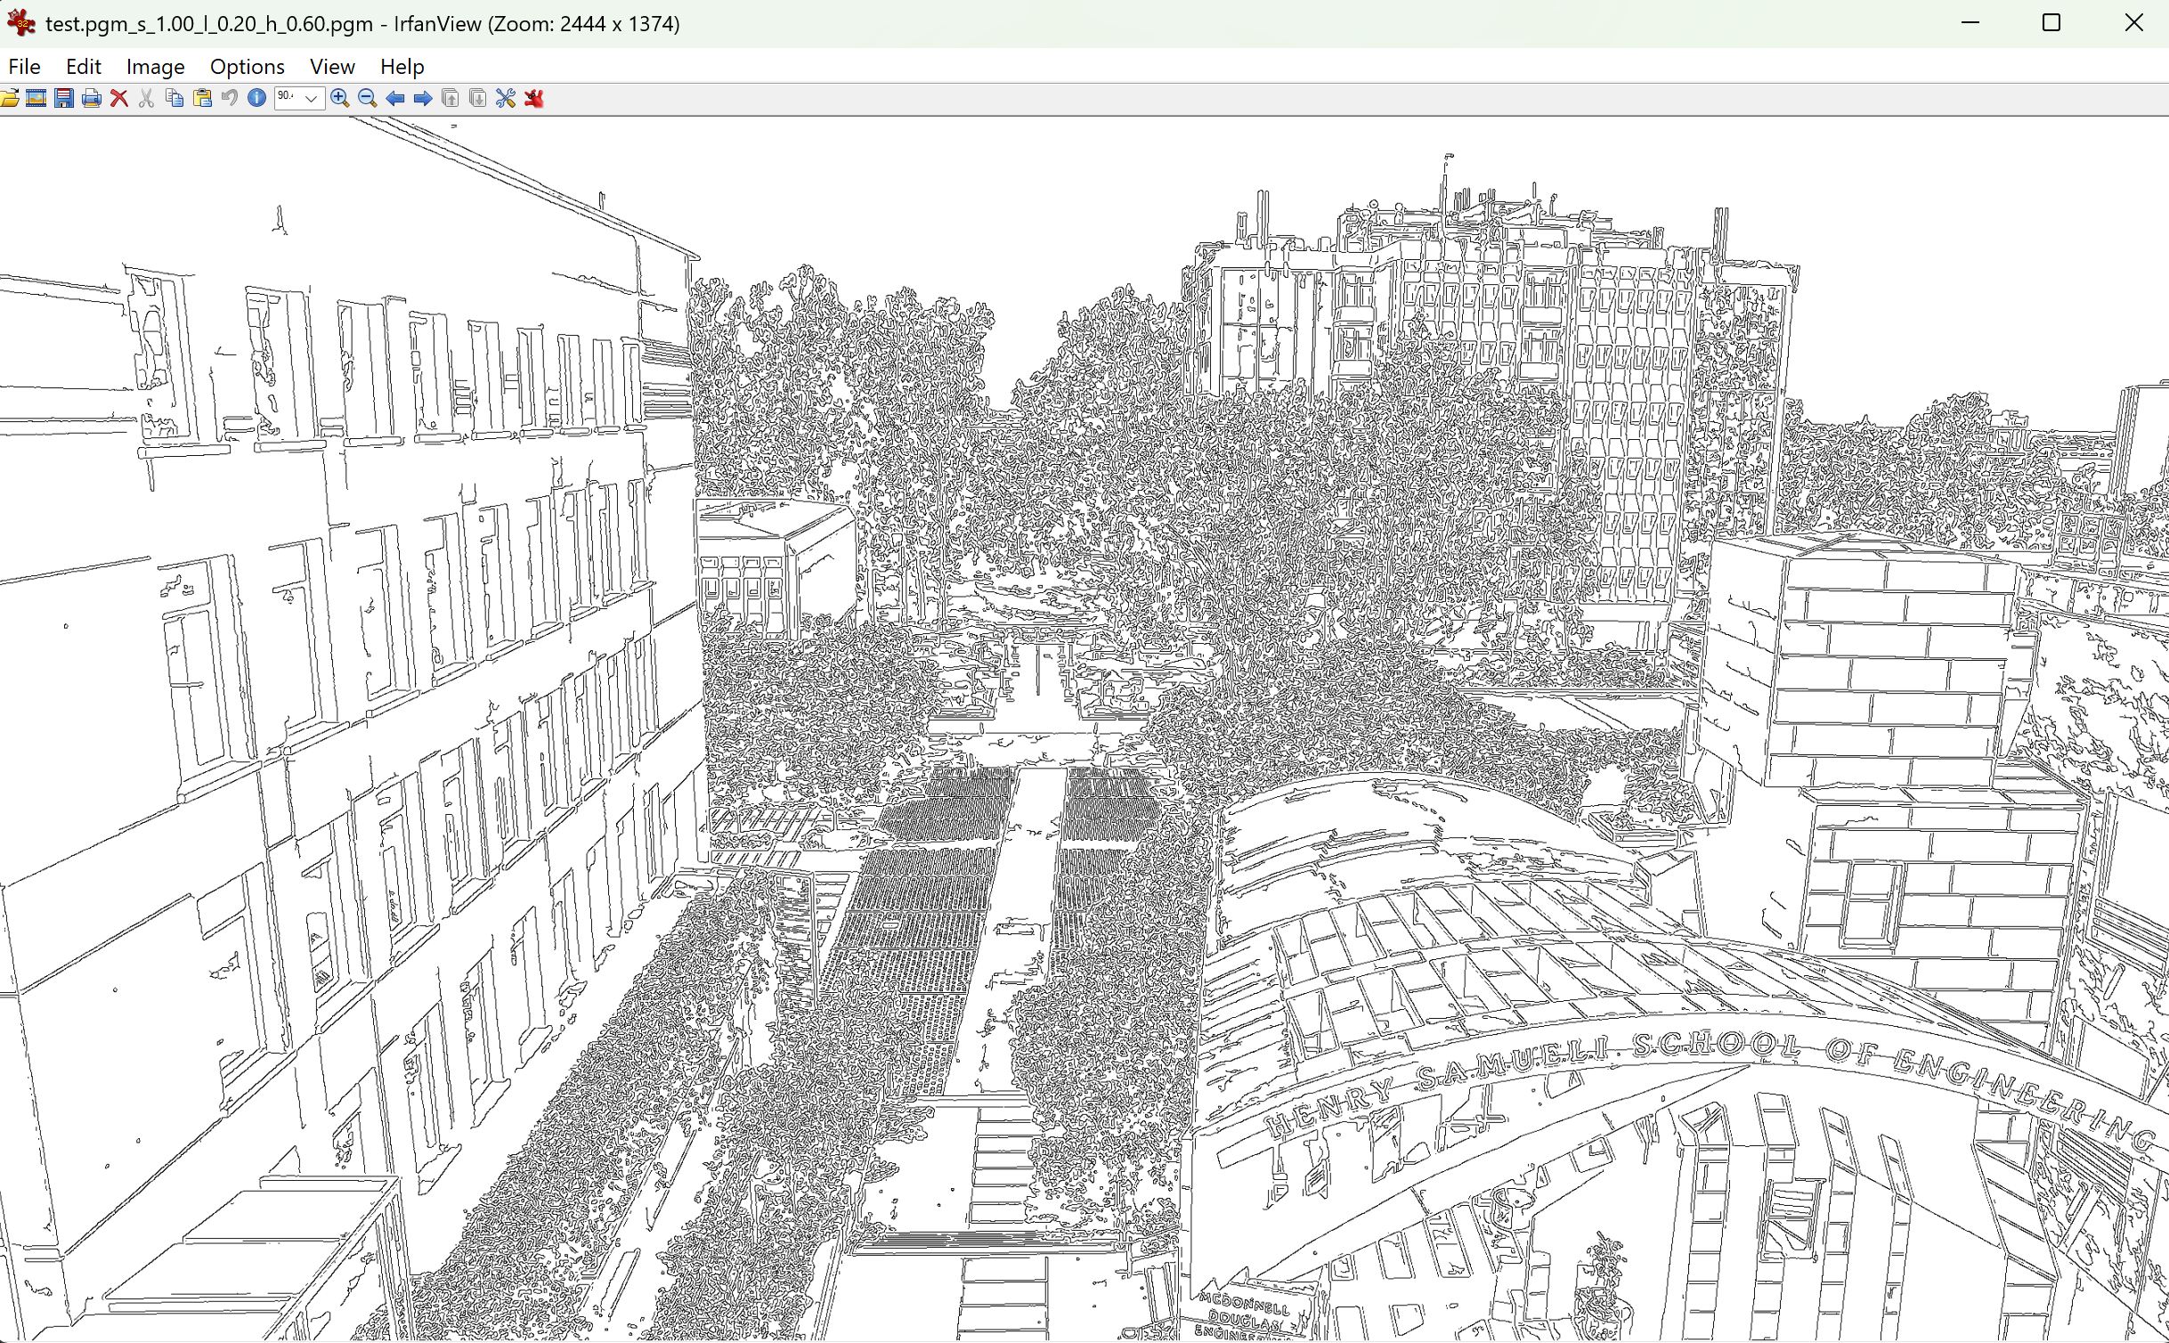 | Example Command
1.0/0.2/0.2 | 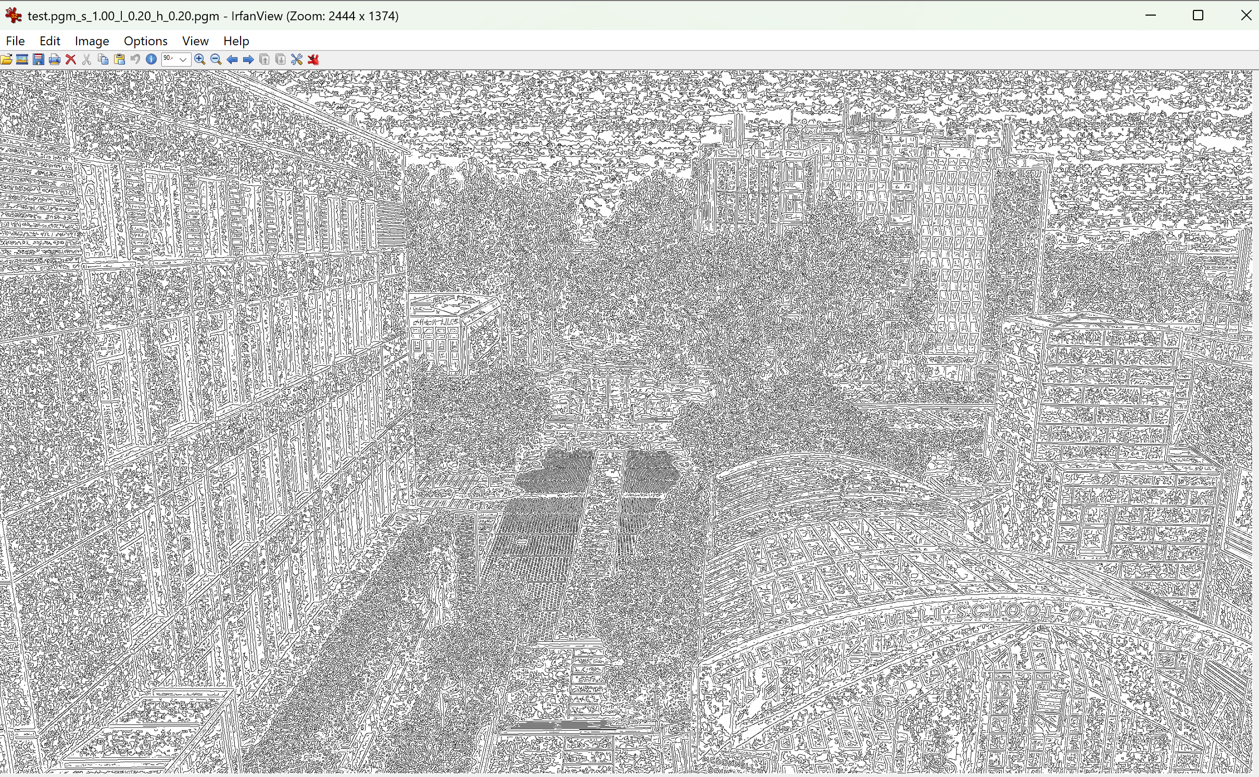 | By tuning <thigh> down to 0.2, there are too much noise kept.
1.0/0.2/0.9 | 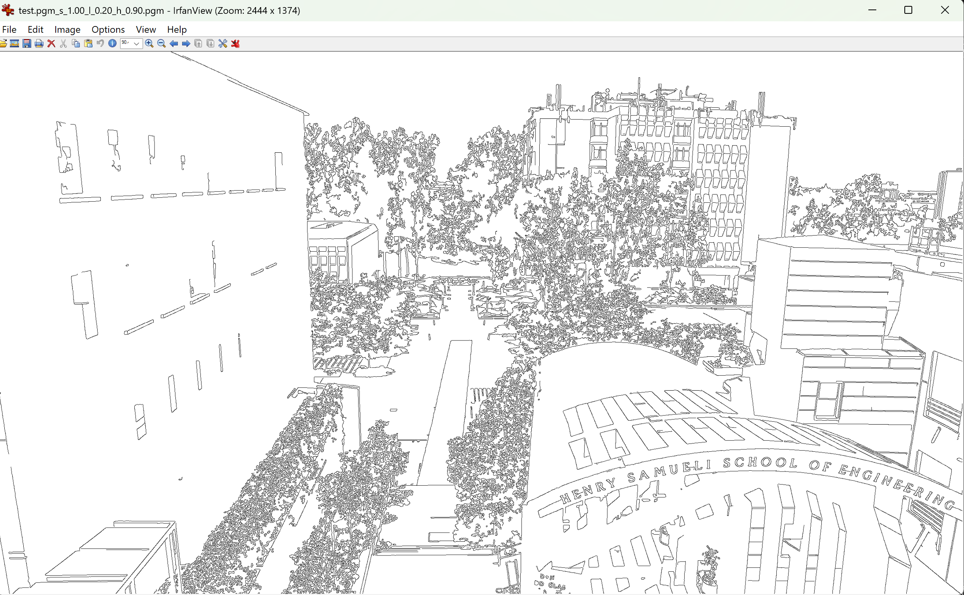 | By tuning <thigh> up to 0.9, there are way less noise kept.
1.0/0.8/0.6 | 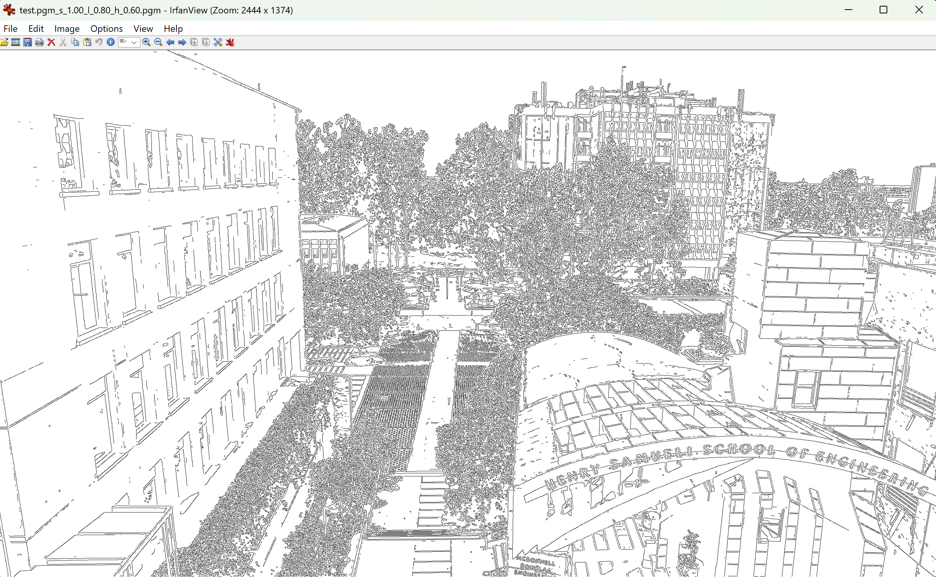 | By tuning <tlow> up to 0.8, this set is probably not making sense. Since the lower threshold is now higher than higher threshold.
2.0/0.2/0.6 | 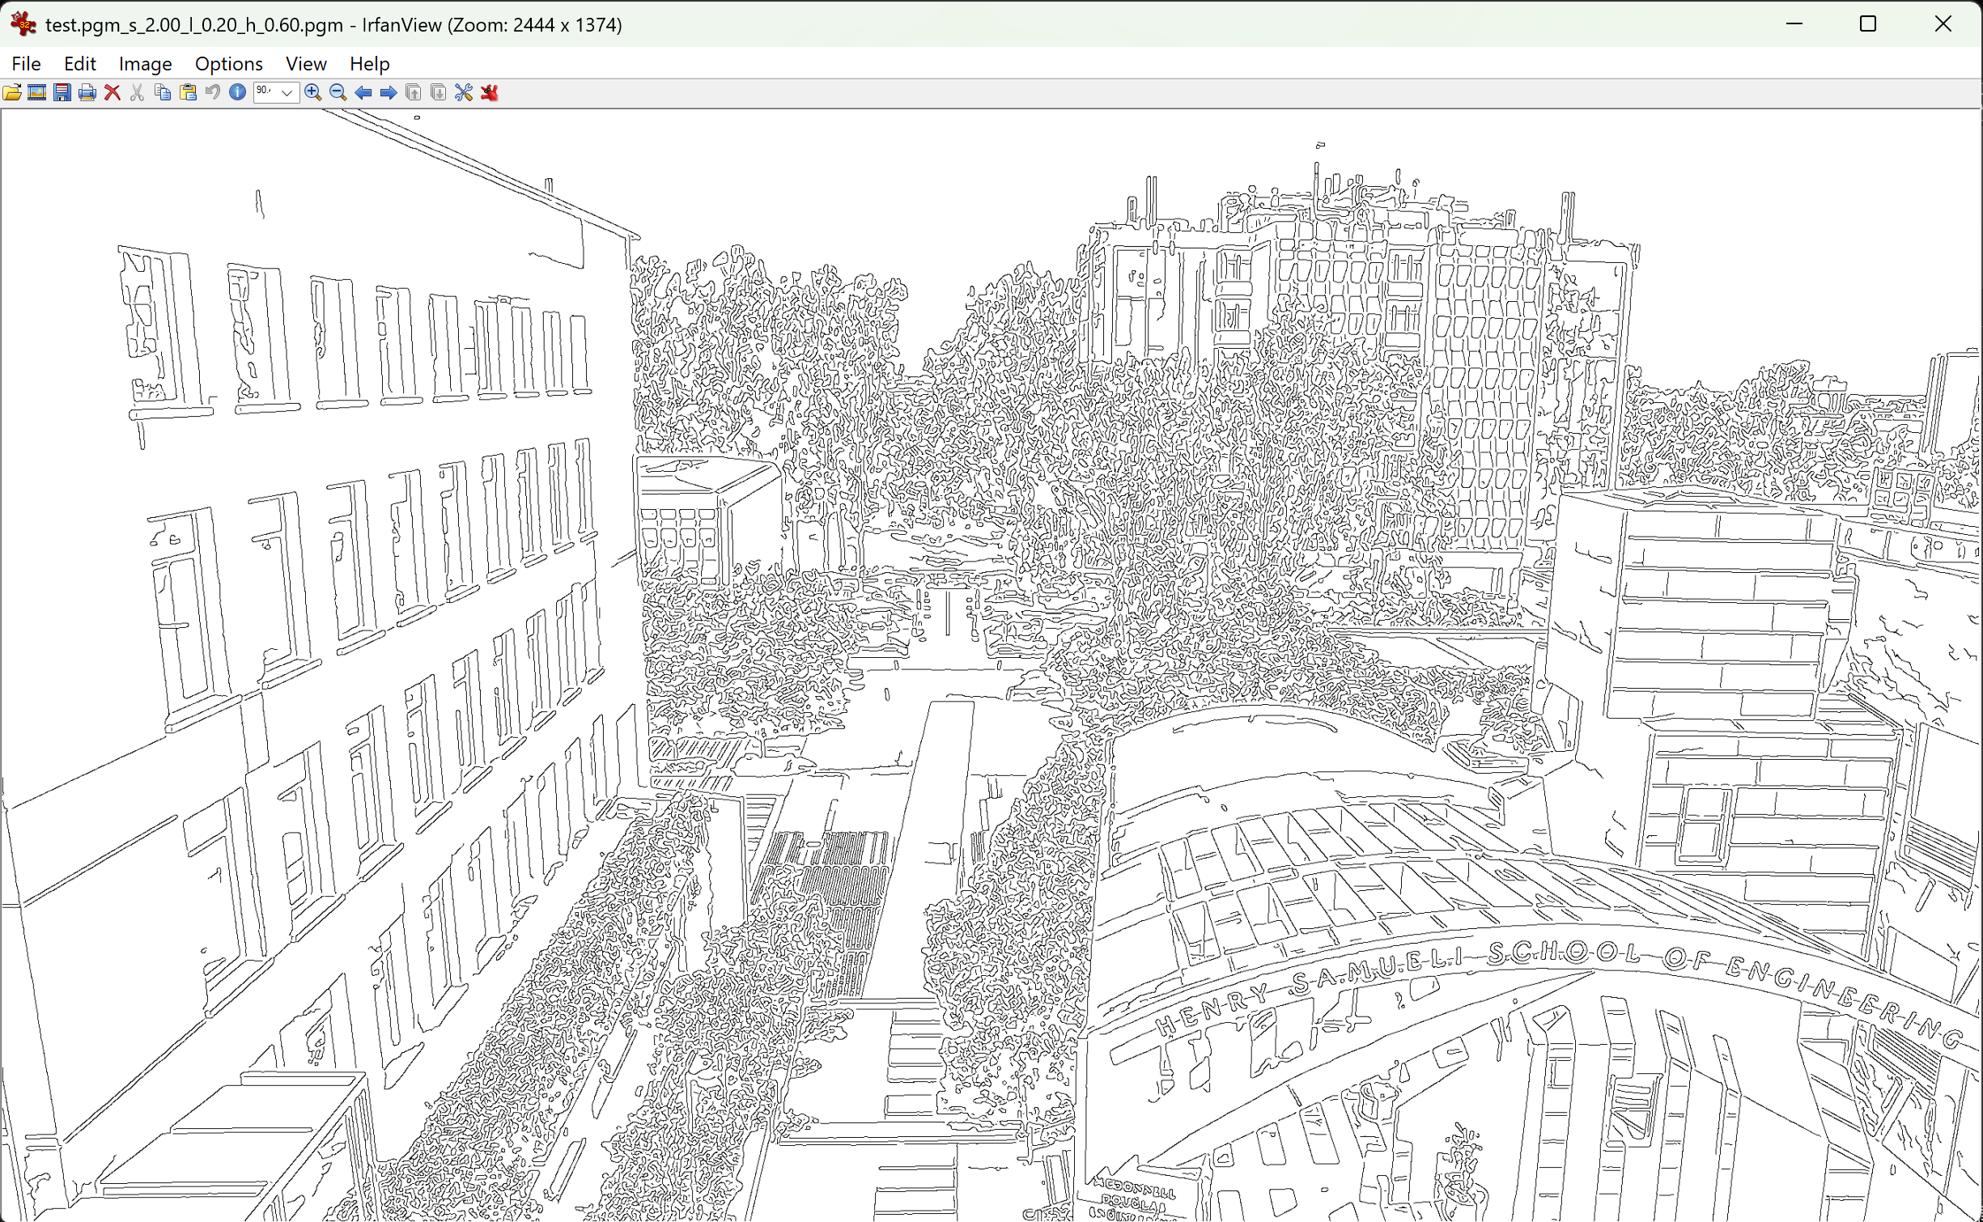 | By tuning <sigma> up to 2, edges become clearer and simpler (strong edges).
Canny application with different parameters and comparison.

- Problems and Discussion (6 pts)
- First, we were a little stuck by the camera library but that was an easy fix by switching to libcamera.
- Setting up the repository took us a little bit of time since we would need the passkey to operate git access on the RPi.
- Other parts are fine and clear.
- Conclusion (2 pts)
- After setting up the environment and RPi, the camera functioned as expected.
- After testing canny with different parameters, we came up with the conclusion that the <sigma> defines the magnitude of smoothing; <tlow> defines the lower threshold to remove an edge; <thigh> defines the higher threshold to keep an edge.

