CHENG-CHIH LEE

LightSwarm

CHENG-CHIH LEE

2025/11/02

#Summary
This project is built upon the previous lab and creates a swarm to connect at most three ESP32's and a Raspberry Pi (as a data logger). The RPi will have a button and four LEDs (Red, Green, Yellow, White). The ESP will have an analog light sensor (photoresistor in the package).

The following links show the reference code for lightswarm logic.
- ESP 8266 LightSwarm.ino Download LightSwarm.ino(obtained from Prof. Shovic's github)
- Raspberry Pi LightSwarm.py Download LightSwarm.py(obtained from Prof. Shovic's github)
  - Python 3 version: github.com/switchdoclabs/SDL_Pi_LightSwarmLinks to an external site.
Each of the three ESP32's in the swarm is identical. There are no software differences and no hardware differences. They can communicate with each other by broadcasting messages to exchange sensor readings. One of them, the ESP32 with the highest reading, will become the "Master" and will forward the readings to the RPi for data logging.

*I teared down the legacy code and fit it into FreeRTOS architecture.

(key words: ESP32, Raspberry Pi 5, UDP, Photocell Sensor, GPIO, FreeRTOS, threading)

>>>>Demo Video Link<<<<
https://drive.google.com/file/d/1dnlHyrJOuUTgEx_KMW08Rm2C5fZBNJ4Z/view?usp=sharing

#OUTLINE

-Version History
-Components used / Pin Definition / Schematics
-Overall Flow-chart
-Protocol
-State Machine
-Part 1-1 Raspberry Pi WiFi setup and packet delivery
-Part 1-2 Rpi correctly reacts to received packets and error condition
-Part 2-1 ESP WiFi setup and packet delivery
-Part 2-2 ESP correctly reacts to received packets

# Version History

Version | Date | Comment | Known Issue/Fix
v01_Beta | 11/04/2025 | Beta version

#Components used
- Photocell with a 10k pull-down resistor.
- External LEDs. Need resistors (330 Ohm).
- A button. Need a pull-down resistor (10k Ohm), digital input and with interrupt mode set to that pin.
#Pin Definition for ESP32
Pin Name | Definition | Usage and comments
LED_BUILTIN | GPIO 2 | Built in onboard LED (fixed)
PHOTO_CELL | GPIO 34 | ADC Sampling pin for Photocell sensor
Table.1 Pin Definition

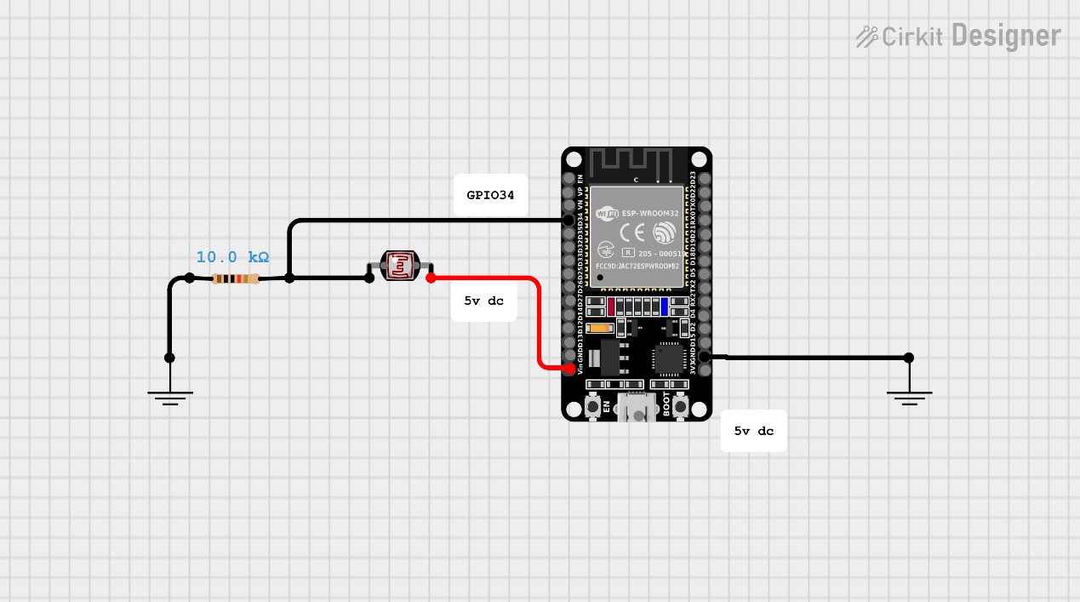

Fig.1 Schematics
#Pin Definition for Raspberry Pi
Pin Name | Definition | Usage and comments
LED_R | GPIO 26 | Pin for Red External LED
LED_Y | GPIO 13 | Pin for Red External YELLOW
LED_G | GPIO 6 | Pin for Red External GREEN
LED_W | GPIO 5 | Pin for Red External WHITE
BTN | GPIO 16 | Pin for External Push Button
Table.2 Pin Definition

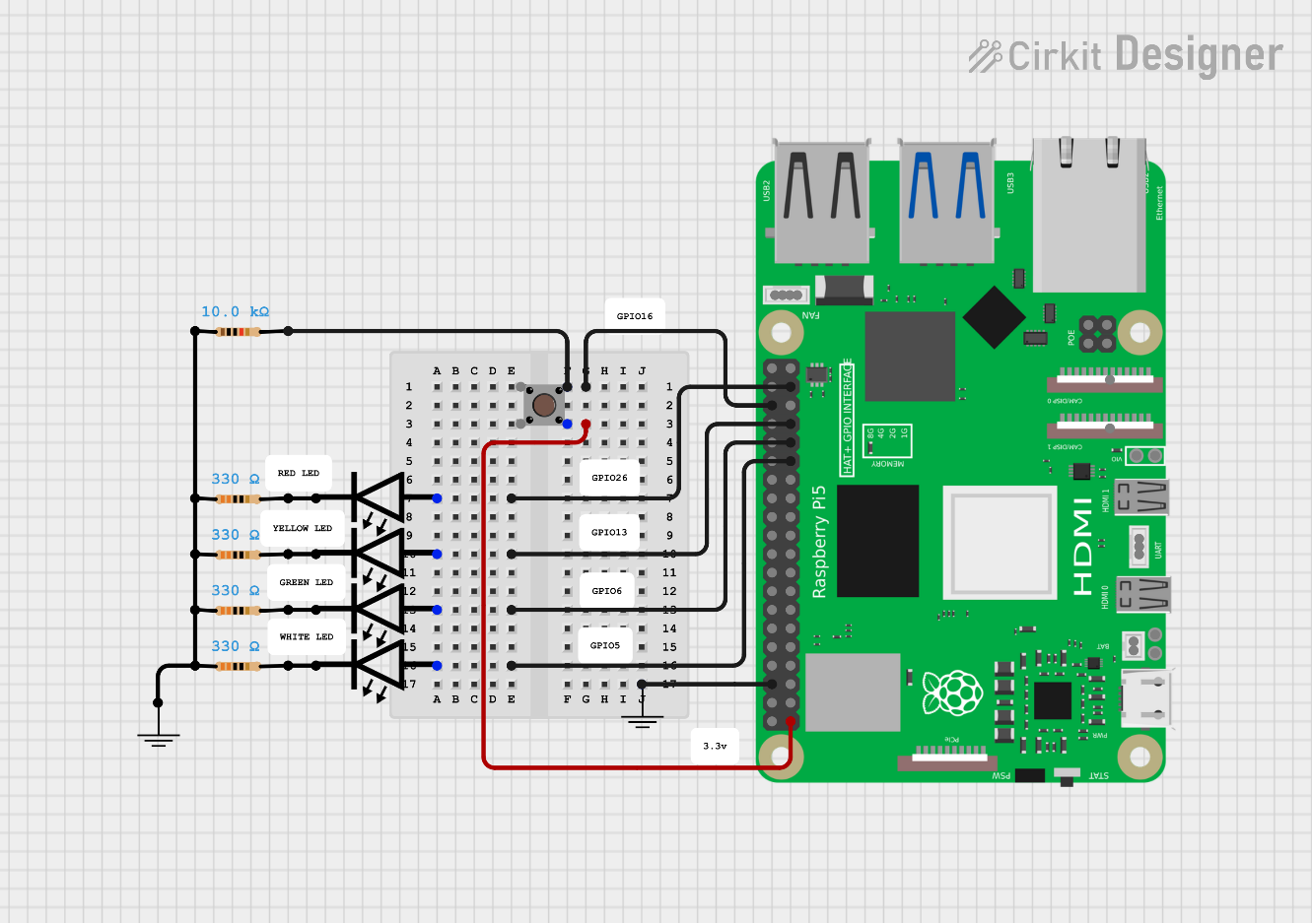
Fig.2 Schematics

#Overall Flow-chart
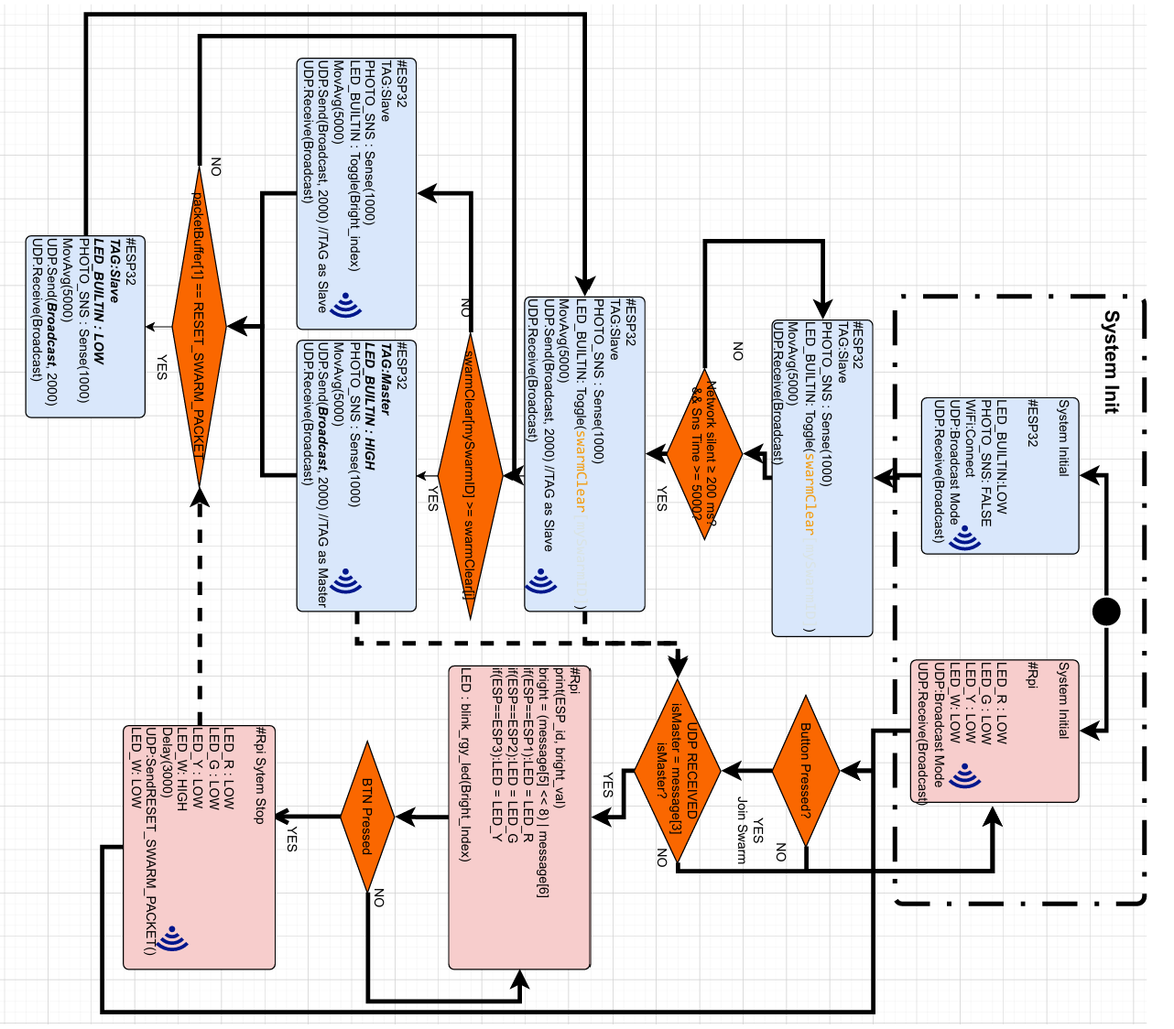

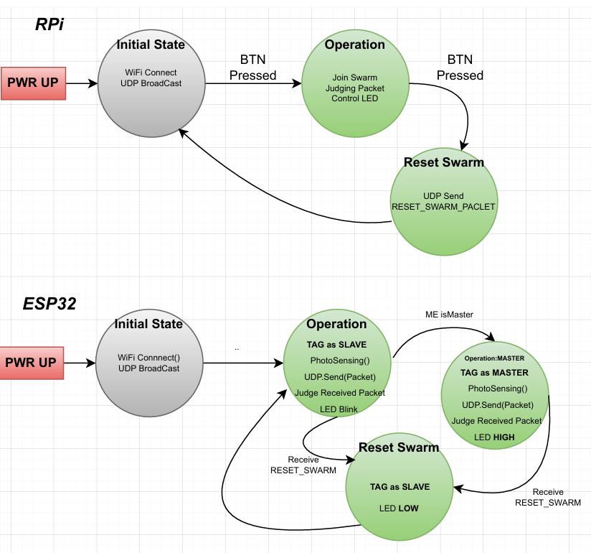
#State Machine

#Protocols
During my development, UDP broadcasting is configured. That means all devices in the network should be able to receive all packets sent. No IP is hardcoded in any device. Port is set as 1996.
Laptop：IP ----, Port 1996
RPi ：IP ----, Port 1996
ESP32：IP ----, Port 1996

Byte | Field | Value | Description
0 | 0xF0 | Constant | Start-of-frame marker. Helps receivers validate the packet type.
1 | LIGHT_UPDATE_PACKET (=0) | 0 | Packet type ID — distinguishes from reset, blink, etc.
2 | localIP[3] | e.g., 123 | Node ID — the last octet of its IP (unique in local subnet). Used as swarm identifier.
3 | masterState | 0 or 1 | Role flag: 1 = master, 0 = slave.
4 | VERSIONNUMBER | e.g., 28 | Firmware version for compatibility tracking.
5–6 | clearColor (high, low) | sensor value | Clear (luminance) 16-bit reading from the photocell (moving average).
7–8 | redColor (high, low) | Not used | Placeholder for red channel intensity. (Unused here since no color sensor.)
9–10 | greenColor (high, low) | Not used | Placeholder for green.
11–12 | blueColor (high, low) | Not used | Placeholder for blue.
13 | 0x0F | 0x0F | End-of-frame marker (symmetrical with start marker).

Part 1-1 Raspberry Pi WiFi setup and packet delivery
Files: talk_v03.py, UDP_v03.py, state_machine_v03.py, LightSwarm.py

In this project, the LightSwarm functionality is modified/integrated into the previous “we_need_to_talk” project. talk_v03 works as the main file, initializing some threads. UDP_v03 works as the UDP rx/tx library module. The state machine module is modified to keep only two states, including operation and reset Swarm. And the RPi is connected to my personal hotspot named IPhoneKL. WiFi related functionalities are developed in the “UDP_ v03.py” module.

#WiFi Setup and UDP
For the UDP setup, it’s set to broadcast mode, thus sending to 255.255.255.255. port is 1996.
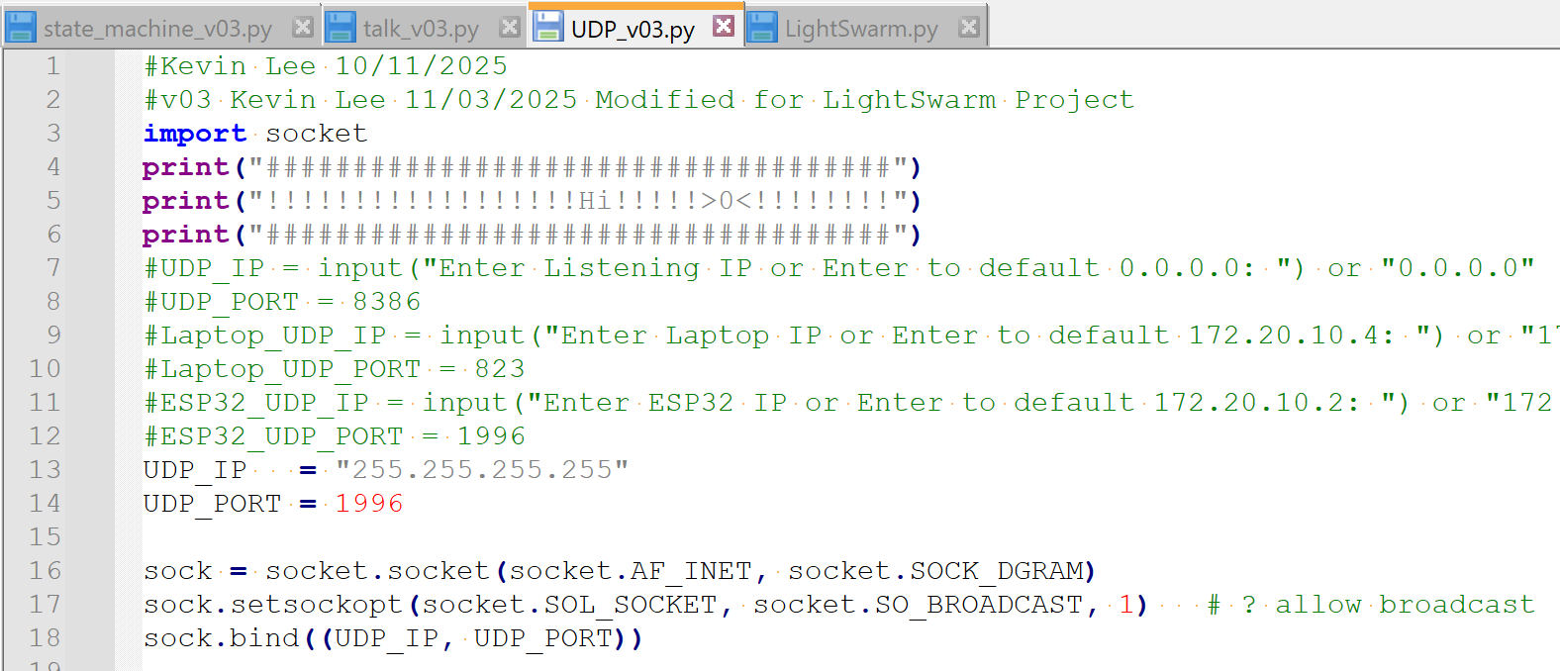
In the main file (talk_ v03.py), I put UDP_Receive() and processPacket() to thread to make sure it keeps listening.
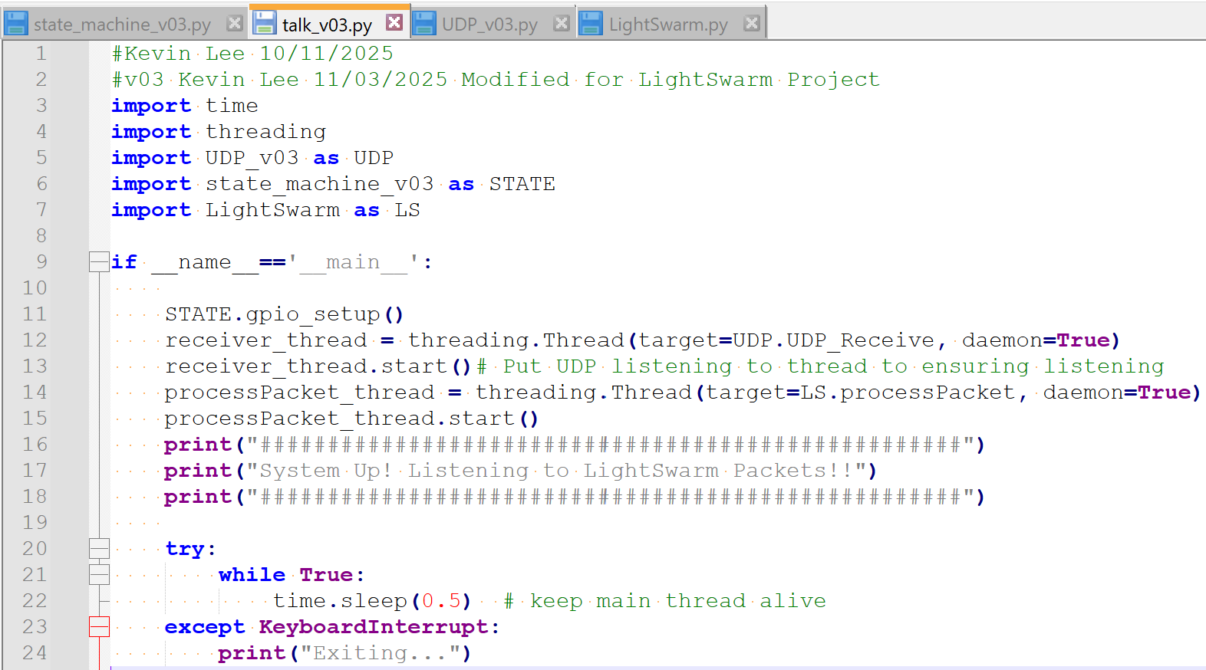

This UDP module also works as a layer for state_machine and LightSwarm to exchange the LSCommand. The set functionset LSCommand(cmd) is for writing to this layer; get functions are for accessing values.

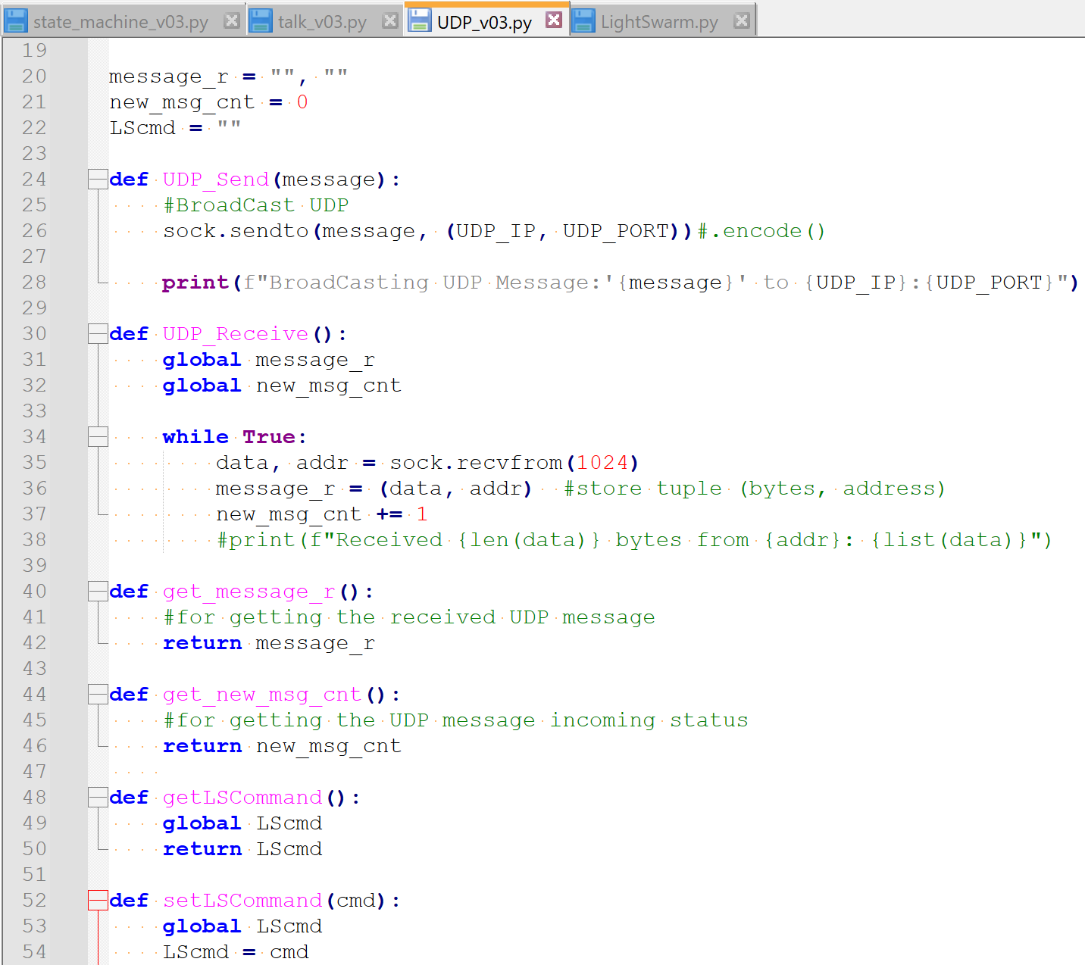

For UDP sending, I developed UDP_Send() method to send messages to both my laptop and ESP32 for the beta version. This method will later be called by the state_maching module.

For UDP receiving, I developed UDP_Receive() method to receive messages. Now RPi is listening to all UDPs with this method put to thread. Upon receiving UPDs, it also updated the new_msg_cnt for checking message incoming status.

Part 1-2 Rpi reacts to received packets
#State Machine
In the State machine, 4 state transitions are developed. The button_callback() is attached to external push button input interrupt for triggering state change.
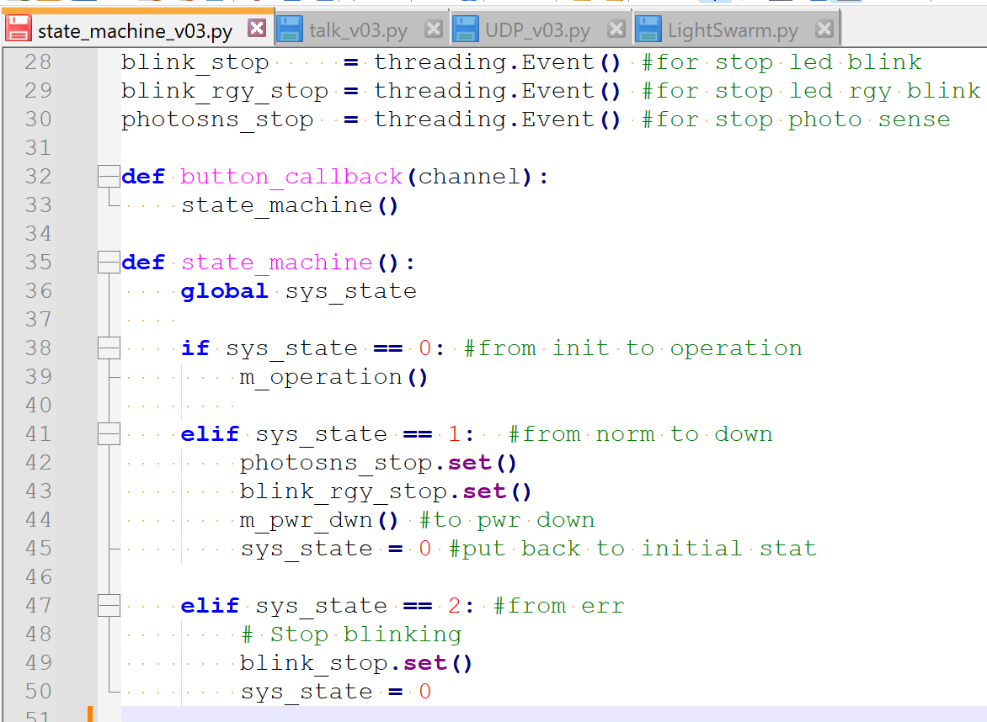

#Operation Mode m_operation()
This state is triggered when status flag sys_state == 0 and the button is pressed.
The sys_state is then set to 1 indicating it’s in operation mode. The phototsensing and RGY led indicating tasks will be put to threading.

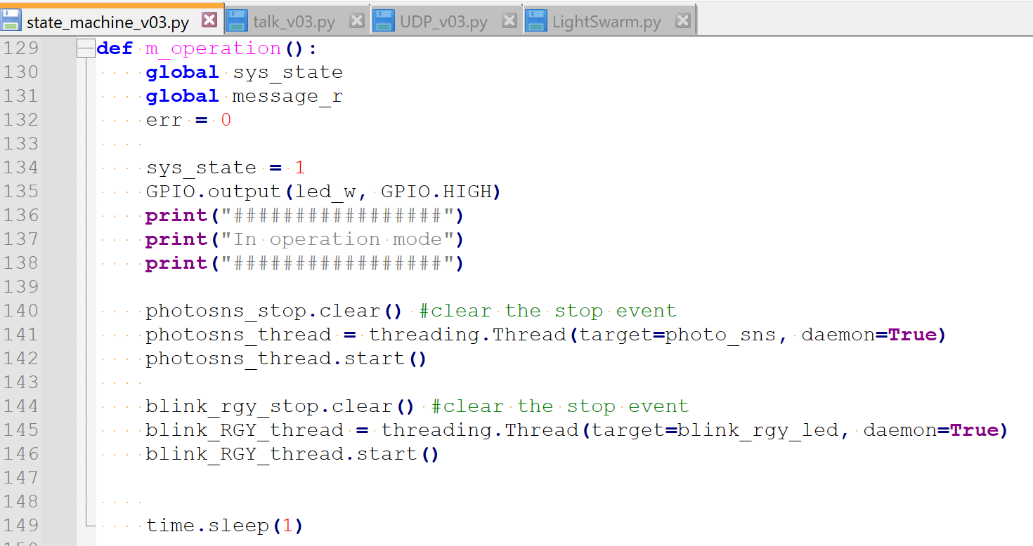

#Photocell value process photo_sns()
When photo_sns() is put to thread, with sys_state==1 and the thread is not stopped. This method checks if the packet is from a master device or not, clear led indicator thread stop flag and it also shuts down leds accordingly.

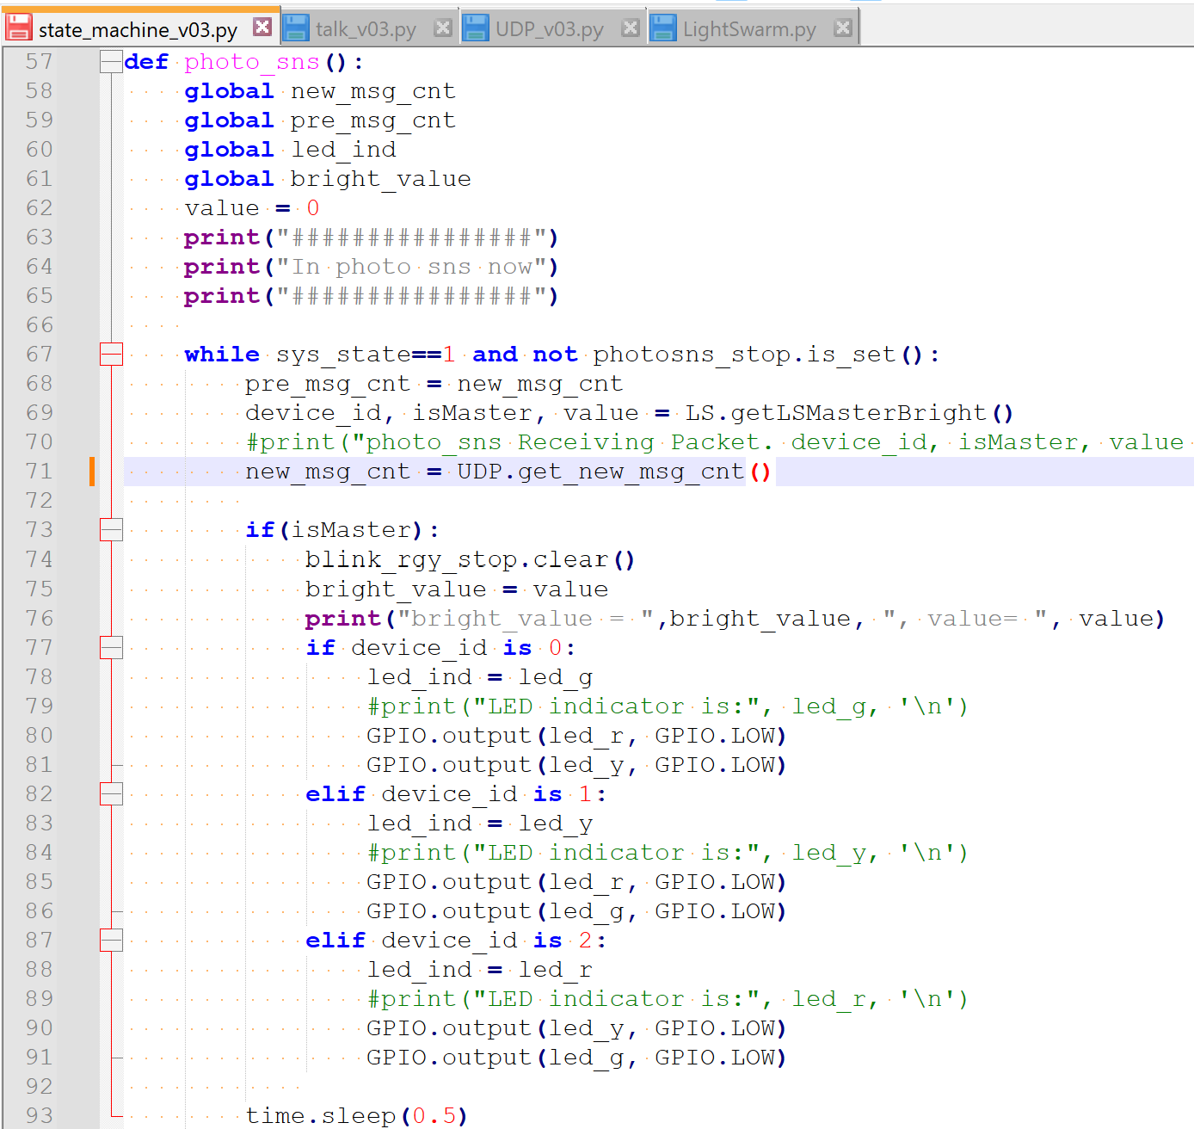

#Power Down mode m_pwr_dwn()
Works as reset Swarm task
During normal operation, when the external button is pressed, the state machine will generate the photo_sns() and blink_rgy_stop() thread stopping event and sent UDP.setLSCommand("RESETSWARM").

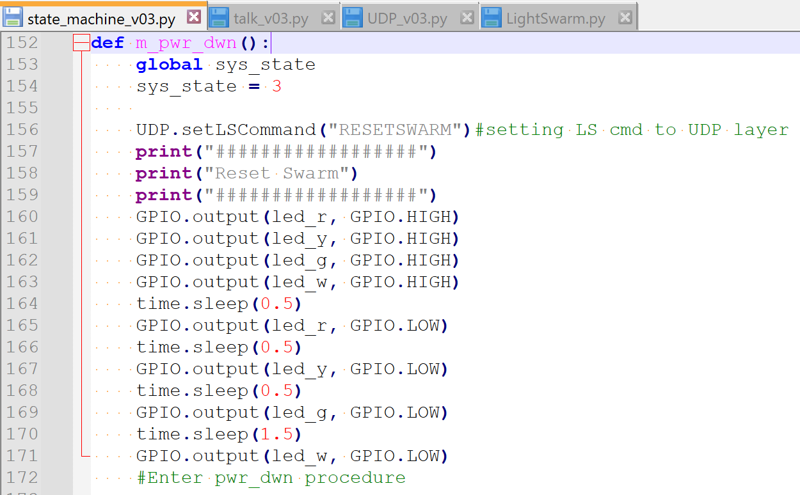

The operation method will then put RPi back to initial state to wait for the button pressed to join the Swarm again.

Part 2-1 ESP WiFi setup and packet delivery

ESP is connected to my hotspot. It is also developed to UDP broadcasting.
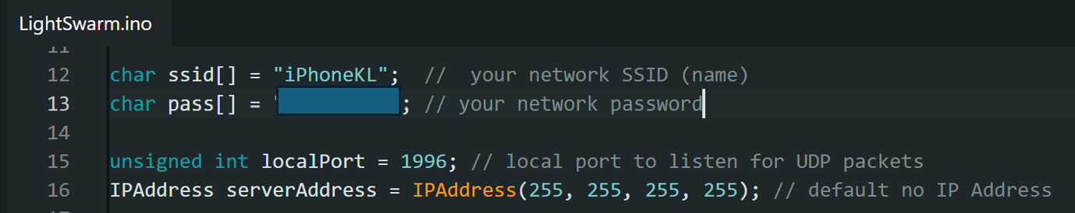
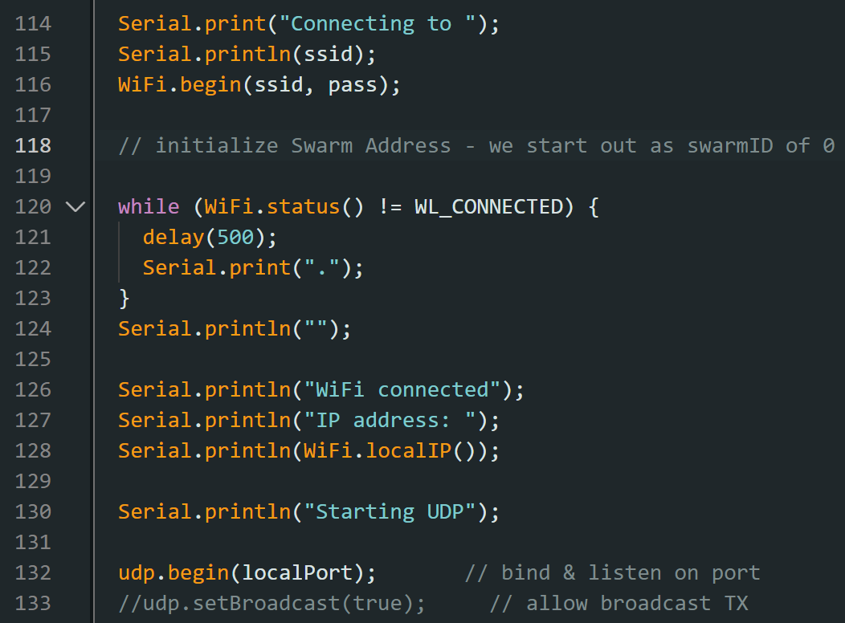
Swarm data array is initialized here.
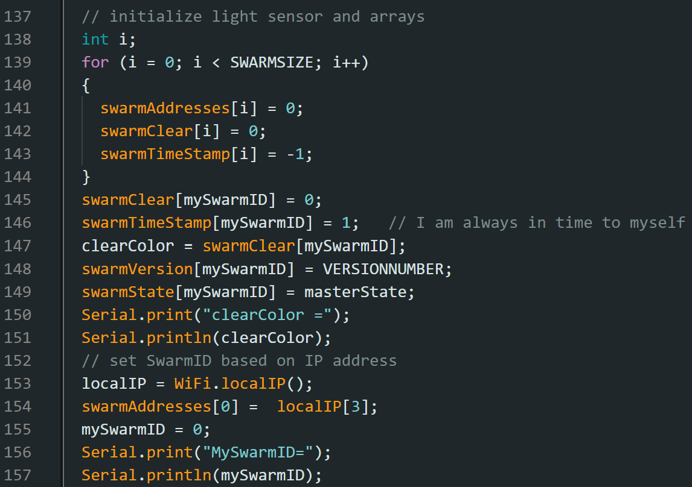

#Tasks
After WiFi connection, six tasks are created. UDP receiving Task for UDP receiving, Task_PhotoSns for Photocell sensing, Task_UDP_Send for sending UDP packet. Task_Swarm for Swarm logic implementation. Task_LED_Blink for controlling Built-In led blinking behavior. Task_Monitor for checking stack watermark.
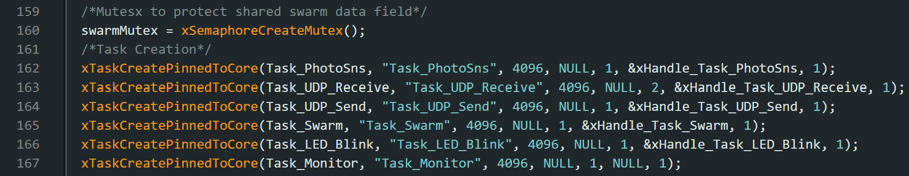

#UDP Receiving UDP_Receive(void)
In the UDP_Receive() function, UDP incoming messages are processed by calling the Packet_Helper function. There’s a mutex set to protect the incoming packet.
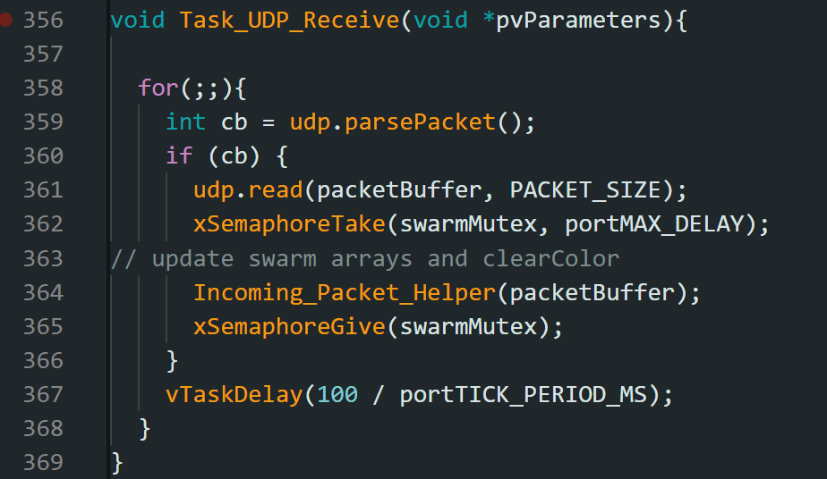
#UDP Sending UDP_Send(const char* msg)
In the UDP_Send() function, broadcastARandomUpdatePacket() is called and sendLightUpdatePacket() is called accordingly.
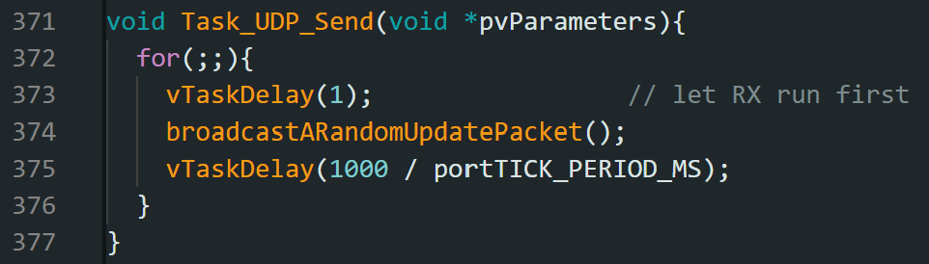
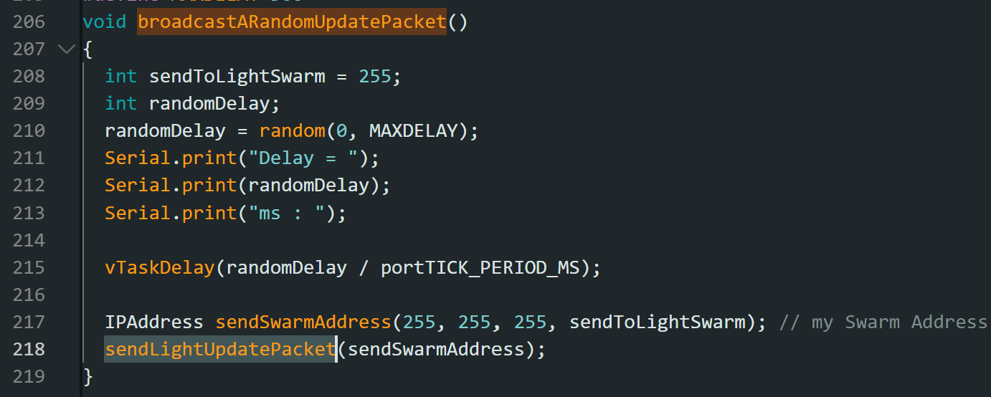

Part 2-2 ESP correctly reacts to received packets

#Task_Swarm
The Task_Swarm is for checking the main logic for Light Swarm by calling checkAndSetIfMaster().
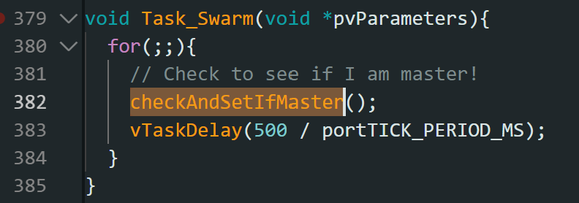
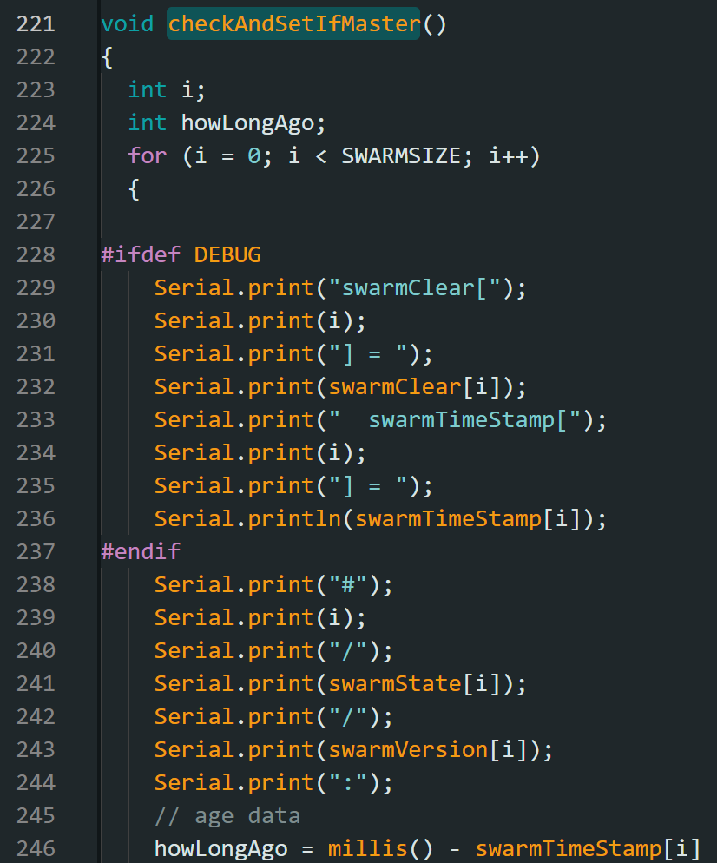

#Photocell sensing function
The Photo_Sns(void) function is developed to execute sensing with analog reading. A moving average function MovAvg(uint16_t input, uint16_t *buffer) is used to derive 5 sec sliding window average.
