2020.5.8

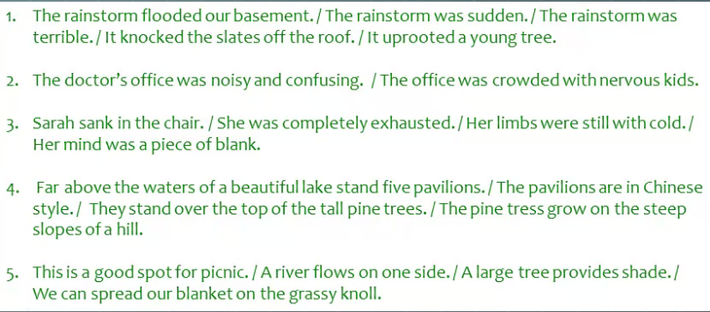

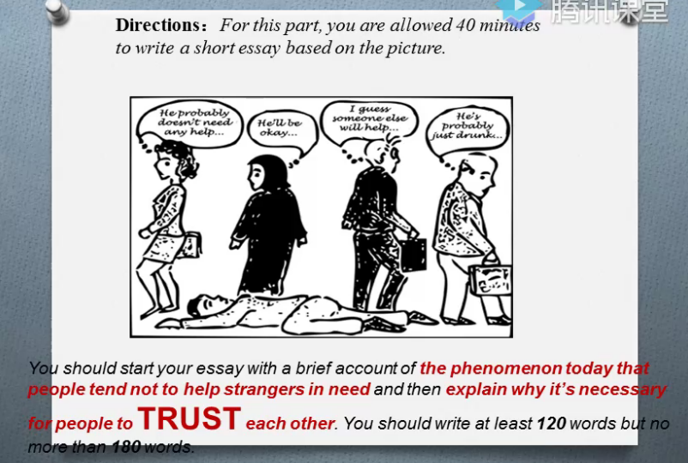

As is shown above, this picture shows a ridiculous scene, in which a man lying on the road but others offered no help. Strangers have their own ideas, either think it's none of their business, or think others will help, do not need their own. This carton really reflects a thought-provoking social phenomenon: why people tend not to help strangers in need?

From my personal perspective, it is not hard to imagine that if the current state of affairs

concerning the losing of trust is to continue, we would pay the high price. With credit, no matter in the study, work or life, we can feel the intimacy of being trusted. People are social animals. Only with trust can we unite and make progress together.

Li Ming

Room 301, building 5, xiangxieli garden

Jianggan, hangzhou, zhejiang, 310018

China

John Smith

900 Chesapeake Avenue N.W.

Washington D.C.20010

U.S.A

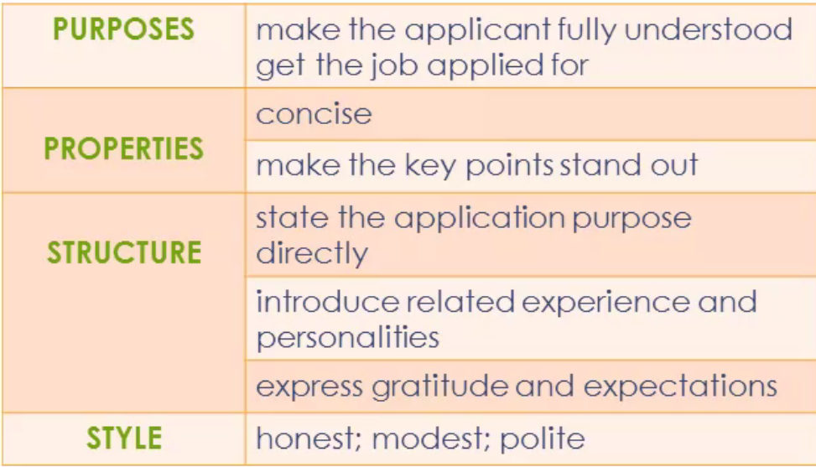 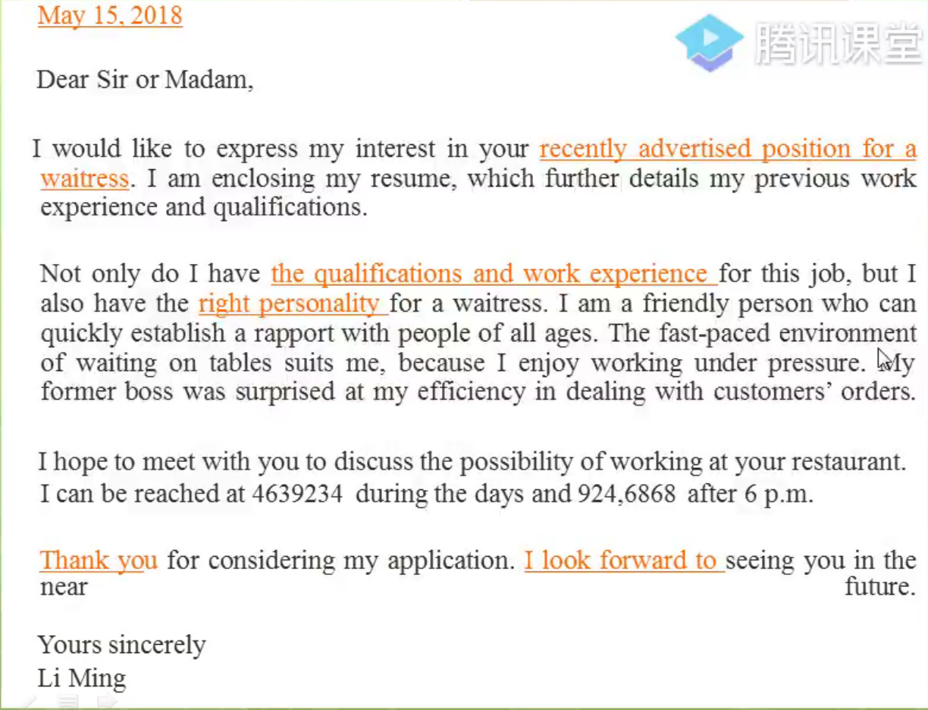

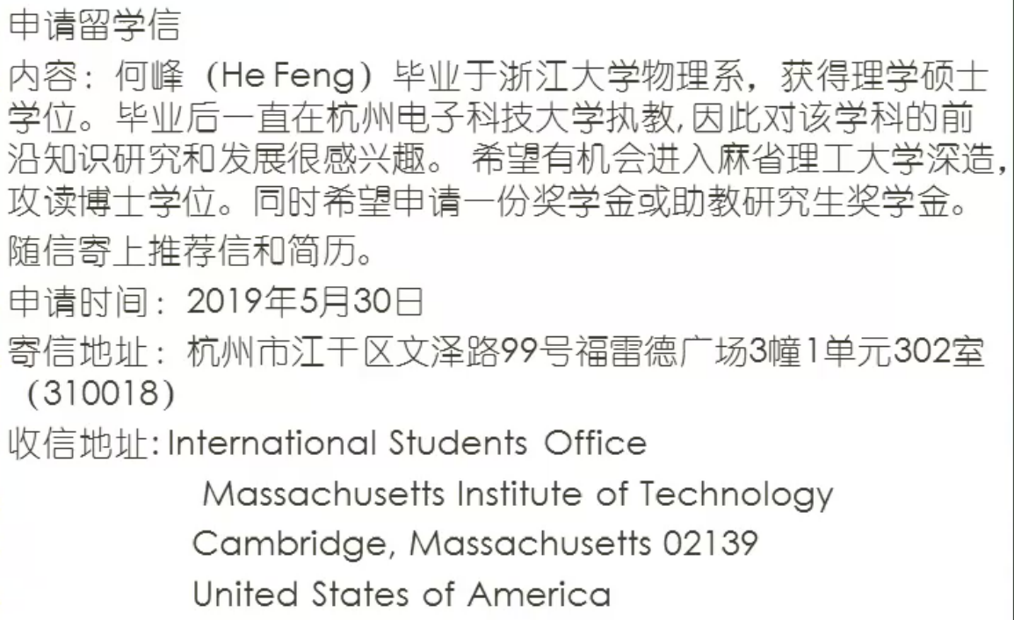

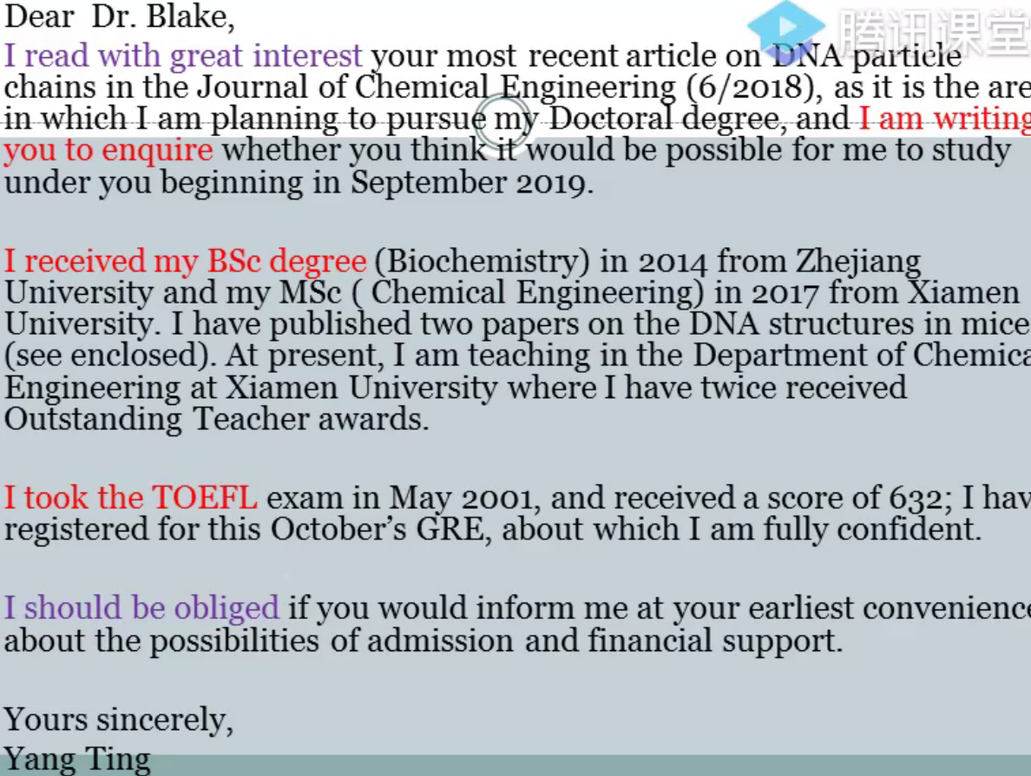

He Feng

Room 302, Unit 1, Building 3, Frid Plaza, 99 Wenze Road

Jianggan, Hangzhou, Zhejiang, 310018

China

May 30, 2019

International Students Office

Massachusetts Institute of Technology

Cambridge, Massachusetts 02139

U.S.A

Dear Sir or Madam,

I would like to study in the physics department of your university for a doctor's degree in physics. I am enclosing my resume and a letter of recommendation, which further details my previous study and work experience.

My name is He Feng, and I graduated from Zhejiang university with a master of science degree in physics. Since graduation, I have been teaching in Hangzhou Dianzi university. Due to my keen interest in this discipline, I have published three SCI papers during my master's and teaching years. In order to further improve my academic ability, I hope to have the opportunity to further my study in your university and pursue a doctoral degree. In addition, I would like to apply for a scholarship or assistantship to relieve the pressure of my life.

Yours sincerely,

He Feng

Lost and Found

On April 16, We found a bunch of keys in classroom 409. Please go to 7-building 107 office to collect it.