In this document we can collaborate to add important points of different sections of the paper.

1. **Introduction:**

* Kuramoto model (1975)
* Crawford (1990s) methodical approach to study Kuramoto model
* This paper: reinterpret Crawford’s approach to Kuramoto model

1. **Background**

Kuramoto model: motivated by the phenomenon of collective synchronization, in which an enormous system of oscillators spontaneously locks to a common frequency (despite differences in the frequencies of the individual oscillators).

Biological examples:

* Networks of pacemaker cells in the heart
* Circadian pacemaker cells in the suprachiasmatic nucleus of the brain
* Metabolic synchrony in yeast cell suspensions
* Congregations of synchronously flashing fireflies
* Crickets that chirp in unison

Physics & engineering examples:

* Arrays of lasers
* Microwave oscillators
* Superconducting Josephson junctions

Collective synchronization was studied before. For example Winfree (1967).

Winfree assumptions:

* The coupling is weak and the oscillators nearly identical. Then we can consider a separation of timescales:
  + Fast timescale: oscillators relax to their limit cycles (lecture #20 AM214) and can be characterized solely by their phases
  + Long timescale: the phases evolve due to
    - Weak coupling
    - Slight frequency differences among oscillators.
* Further simplification:
  + Each oscillator is coupled to the collective rhythm generated by the whole population. Then the model becomes:

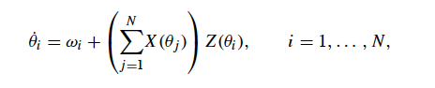

$θ_{i}$: phase of oscillator i

$ω_{i}$: natural frequency of oscillator i

$X(θ_{j})$: influence oscillator j exerts in all others

$Z(θ_{i})$: sensitivity function on how oscillator i responds to influence of oscillator j

Discovery: such a system can exhibit a temporal analog of phase transition. If the spread of natural frequencies is (compared to the coupling):

* Large: the system behaves incoherently, each oscillator runs at its own frequency.
* Small: incoherence persists until a certain threshold is reached. Then a small cluster of oscillators synchronize.

1. Kuramoto model
   1. Governing equations

Kuramoto modified the Winfree’s model by using the perturbative method of averaging to show:

For any system of weakly coupled, nearly identical limit-cycle oscillators, the long term dynamics are given by phase equations of the following universal form

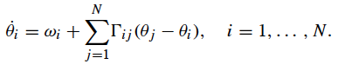

$θ_{i}$: phase of oscillator i

$ω_{i}$: natural frequency of oscillator i

$Γ_{ij}$: interaction functions

The Kuramoto model corresponds to the simplest possible case of equally weighted, all-to-all, purely sinusoidal coupling:

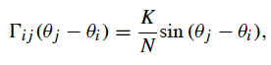

* 1. Order parameter
  2. Simulations
  3. Puzzles

1. Kuramoto’s analysis
2. Two unsolved problems:
   1. Finite N-fluctuations
   2. Stability
3. Stability theories of Kuramoto and Nishikawa
   1. First theory
   2. Second theory
4. Continuum limit of Kuramoto model
5. Stability of the incoherent state
6. Landau damping
   1. The long-sought integral equation
   2. A lesson for Rowlands
7. A lunch with Crawford
8. Crawford's work on coupled oscillators