AC Cycling Program Evaluation

Prepared by:

Kevin Gries

AAE 776: REDA Practicum

Submitted on:

06/29/2018

Advisory Committee:

Bill Provencher • Bethany Glinsmann • Irene Jacqz

Illume Advising



**Table of Contents**

1 Executive Summary 3

1.1 Research Objective 3

1.2 Program Description 3

1.3 Key Findings 3

1.3.1 Program’s Energy and Load Impacts 3

1.3.2 Significant Snapback Period 4

1.3.3 Larger Treatment Effect for Metro Customers 5

1.4 Recommendations 5

1.4.1 Definition of the Snapback Period 5

1.4.2 Target Metro Customers in Future Program Design 5

1.4.3 Investigation of Non-Functioning DCUs 5

2 Research Purpose 6

2.1 Research Objective 6

2.2 Program Description 6

3 Research Methodology 7

3.1 Data Description 7

3.2 Data Cleaning 14

3.3 Modelling Approach 16

3.3.1 Simple Difference Model 17

3.3.2 Two-Way Fixed Effects Model 17

4 Results 19

4.1 Extended Snapback Period: 23

4.2 Heterogeneous Treatment Effect for Metro and Non-Metro Participants 27

5 Conclusions & Recommendations 31

5.1 Key Findings 31

5.1.1 Energy and Load Impacts of Program 32

5.1.2 Significant Extended Snapback Period 33

5.1.3 Larger Treatment Effect for Metro Customers 33

5.2 Recommendations: 33

5.2.1 Definition of the Snapback Period 33

5.2.2 Target Metro Customers in Future Program Design 33

5.2.3 Investigation of Non-Functioning DCUs 34

6 References 34

7 Appendix 34

# Executive Summary

## Research Objective

This analysis evaluated an Air Conditioning (AC) Cycling Demand Response (DR) Program conducted in the state of Georgia. Utilities conduct AC cycling programs to reduce electricity load during costly peak consumption periods. The purpose of this evaluation was two-fold: 1) to measure the program’s impact on hourly electricity load and net electricity consumption; and 2) to provide recommendations for improved program design and evaluation methods.

Participating customers were divided into treatment and control groups through a randomized control trial (RCT). A two-way fixed effects regression model estimated the hourly load and net electricity impacts of the program on each event day. Additional analysis measured the snapback effect and heterogeneous treatment effect for metro and non-metro participants.

## Program Description

Program participants permitted the utility to cycle their central air conditioners (CACs) during demand response events, which were called on days with high forecasted electricity demand. All participants were required to have CACs with attached digital cycling units (DCUs) that utilized radio signal to control AC units during demand response events. Cycling reduced AC runtime by, at most, 67% for each treated participant. All participants were compensated with a bill credit at sign-up and received a small incentive for each demand response event.

The AC Cycling Demand Response Program included a total of 6 event days during 2017. This analysis was limited to the July 13th and August 16th event days. A total of 8,969 customers opted in to the program. Through an RCT, 4,519 customers were assigned to the treatment group and 4,448 customers were assigned to the control group. In this program, the treatment group experienced AC cycling and the control group did not.

A field study of the program showed that 55% of metro customers, 37% of non-metro customers, and 42% of total customers had functioning DCUs.

## Key Findings

### Program’s Energy and Load Impacts

On the July 13th and August 16th event days, electricity load was reduced by 6.5% and 5.2% respectively during the AC cycling period.

The program’s net electricity savings, which included a 3-hour snapback period, were 2,567 kWh and 2,032 kWh for the July and August event days, respectively.

Table 1 summarizes the program’s load and net electricity impact for each event day. The results represent lower bounds of potential electricity savings because non-functioning DCU’s likely reduced the magnitude of the treatment effect.

Table 1. Program Net Energy and Load Impacts

|  | July Event Day | | | August Event Day | | | |
| --- | --- | --- | --- | --- | --- | --- | --- |
|  | Customer Electricity Impact[1]  (kW/hr) | Percent Load Reduction | Total Electricity Impact[2]  (kWh) | Customer Electricity Impact  (kW/hr) | | Percent Load Reduction | Total Electricity Impact  (kWh) |
| Event Period | -0.098  (.022) | -2.8% | -2,567  (95) | -0.078  (.020) | | -2.3% | -2,032  (88) |
| **AC Cycling Period** | **-0.228**  **(.025)** | **-6.5%** | **-2,972**  **(109)** | **-0.182**  **(.025)** | | **-5.2%** | **-2,372**  **(108)** |
| Snapback Period | 0.037  (-.025) | 0.1% | 478  (107) | 0.030  (.023) | | 0.1% | 393  (100) |
| Extended Snapback Period | 0.052  (.015) | 1.4% | 2,267  (63) | 0.039  (.015) | | 1.1% | 1,711  (63) |

### Significant Snapback Period

After Snapback Hour 1, the snapback effect was positive and significant at the 10% level for 8 hours on the July event and 4 hours on the August event. When all hours with significant snapback effect were included, the net electricity savings were 705 kWh on the July event and 661 kWh on the August event. The net electricity impacts of the program changed significantly when the snapback effect was included.

### Larger Treatment Effect for Metro Customers

The magnitude of the treatment effect for metro customers was 38% larger than non-metro customers for all hours of the AC cycling period. After adjusting for metro customer’s higher proportion of functioning DCUs, their estimated treatment effect was still 25% higher than non-metro customers.

The relationship between snapback effect and metro status was ambiguous with the two event days provided. Further analysis with more event days will be required to determine the effect of metro status on net electricity consumption.

## Recommendations

### Definition of the Snapback Period

The initial assumption that a 3-hour snapback period accounted for the snapback effect proved to be insufficient. In future evaluations, the extent of the snapback period can be defined by estimating the treatment effect for several hours after the AC cycling period and extending the snapback period until the last hour that shows a statistically significant snapback effect. This will provide a more comprehensive estimation of the program’s net electricity impact.

### Target Metro Customers in Future Program Design

On average, customers with metro status had a 38% larger treatment effect than non-metro customers. In future program design, it will be more economical to invest in participants living in the metro area than the non-metro area because they will likely yield higher demand reductions.

### Investigation of Non-Functioning DCUs

The presence of non-functioning DCUs caused uncertainty on the program’s electricity impacts when a DCU is functioning. Electricity reductions through AC cycling programs rely on functioning DCUs, and the program may have achieved larger electricity impacts if a higher percentage of customers had functioning DCUs. It is recommended to analyze the potential mechanical or behavioral causes of non-functioning DCUs before subsequent iterations of this program.

# Research Purpose

## Research Objective

This analysis evaluated an Air Conditioning (AC) Cycling Demand Response (DR) Program conducted in Georgia of the Southeastern United States. The program was designed to reduce electricity load during high demand periods by reducing runtime of treated customer’s AC units by, at most, 67%. This analysis evaluated two demand response event days with AC cycling periods at the following times:

1. Thursday, July 13th, 2017 from 2 PM to 5 PM
2. Wednesday, August 16th, 2017 from 4 PM to 7 PM

The primary objective was to estimate the load and electricity impacts of AC cycling on treatment customers. The electricity impacts of an event are defined by a 3-hour AC cycling period and a 3-hour snapback period. The snapback period was included to measure the snapback effect, which is the tendency for treatment customers to increase electricity consumption during the hours following the AC cycling period.

An important design feature of this program is that participating customers were divided into treatment and control groups through a randomized control trial (RCT). A two-way fixed effects model was used to estimate the net electricity impact of the program on each event day.

Secondary analysis investigated the extent and magnitude of the snapback effect. The primary analysis assumed the snapback effect only occurred during the three hours following the AC cycling period. A more flexible two-way fixed effects model estimated the snapback effect 10 hours after the AC cycling period for a more comprehensive analysis of net electricity consumption.

In addition, the heterogeneous treatment effect was estimated for customers inside and outside of the designated metro zone to inform future program design.

## Program Description

In this program, customers permitted the utility to cycle their central air conditioners (CACs) during demand response events, which are called on days with high forecasted electricity demand. All participants were required to have CACs with digital cycling unit (DCU). DCUs allowed the utility to reduce AC runtime via radio signal during demand response events. Cycling reduced AC runtime by, at most, 67% for each treated customer. All participants were compensated with a bill credit at sign-up and received a small incentive for each demand response event.

The AC Cycling Demand Response Program included a total of 6 event days during 2017. This analysis was limited to the July 13th and August 16th event days. The data will be defined in five time periods:

1. **AC cycling period:** the three-hour period when the utility reduces treatment customer AC runtime via DCUs on event days.
2. **Snapback period:** the three-hour period immediately after the AC cycling period on event days.
3. **6-hour event period:** The six-hour period that includes the AC cycling period and the snapback period.
4. **Non-event period:** All hours in the analysis that are not included in the 6-hour event period.
5. **Extended snapback period:** the ten-hour period immediately after the AC cycling period on event days.

A total of 8,969 customers opted-in to program participation with 4,519 customers randomly assigned to the treatment group and 4448 customers to the control group[3].

The program included field tests that determined that only 42% of customers had functioning DCUs. Non-functioning DCUs could not cycle treatment customer’s AC runtime during demand response events. Information on when field tests were conducted was not provided and it is possible that the number of functioning DCUs changed throughout the program. The field test results were used as an approximation of the proportion of functioning DCUs during the event days studied in this analysis.

# Research Methodology

## Data Description

The utility provided two types of data for this analysis. The first was customer-level hourly meter data from program participants, which comprised of meter readings 114 hours before and after the 6-hour event periods on the July 13th and August 16th event days. The sample size, distribution of customers, and electricity consumption statistics after data cleaning are reported in Table 2.

Table 2. Program Summary Statistics

|  | July Event | August Event | |
| --- | --- | --- | --- |
| Number of Participants | 8,642 | | 8,609 |
| Number of Participants - Treatment | 4,283 | | 4,267 |
| Number of Participants - Control | 4,359 | | 4,342 |
| Number of Hours in Study Period | 119 | | 119 |
| Number of Event Hours | 6 | | 6 |
| Participant Hourly Electricity Consumption Range | 0-28 | | 0-30 |
| Average Hourly Electricity Consumption | 2.11 | | 2.23 |
| Average Hourly Electricity Consumption Range | 1.08 - 3.27 | | 1.22 – 3.39 |

The second dataset included the customer demographic data of zip code, new tenant status, metro status, and climate zone. New tenant status was an indicator variable that took the value of 1 if the current participant was not the same person who opted into program participation. Over both event days, 10.8% of participants were new tenants.

Metro status was an indicator variable that took the value of 1 if the participant belonged to a metro area and 0 otherwise. The characteristics that defined the metro area were not provided for this analysis. Figure 1 presents the geographic distribution of metro customers over the service territory. The customer distribution suggests that metro customers live exclusively in the Atlanta metropolitan area. Over both event days, 35.2% of participants live in a metro area.

Figure 1. Distribution of the Metro Variable by Zip Code

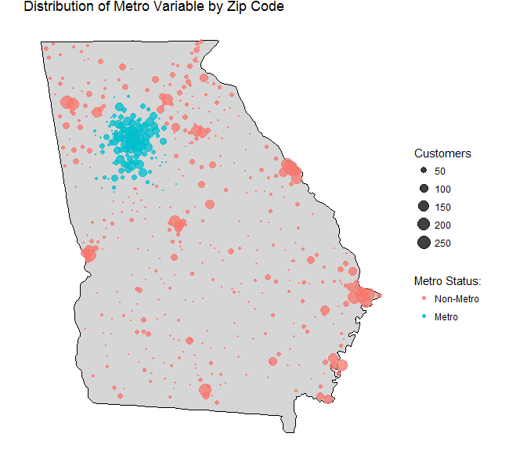

The US Department of Energy defines the geographic location of climate zones. The climate zone variable grouped participants into climate zone 2, 3, and 4, which represented 21.0%, 66.0% and 13.0% of participants respectively. Figure 4 shows the frequency of customers in each climate zone.

Figure 2. Distribution of Zip Codes in Climate Zones

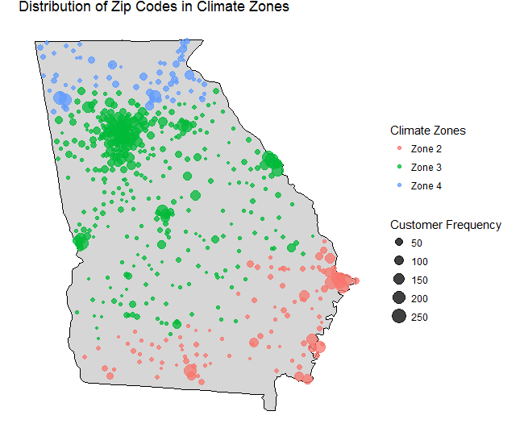

The distribution of customers in climate zones informed weather station selection. Weather data was obtained from the National Oceanic and Atmospheric Administration (NOAA). For each climate zone, one weather station was selected based on data sufficiency[4] and their proximity to the program participants.

The RCT assumption was fundamental to this evaluation’s empirical approach and, therefore, various tests were conducted to verify the randomization of control and treatment customers. In table 2, the hourly electricity consumption and distribution of demographic variables are compared between treatment and control groups. In figures 5 and 6, the electricity consumption of treatment and control groups across all non-event days are compared. The results in table 2 and figures 5 and 6 are consistent with randomization.

Table 3. Summary Statistics for Treatment and Control Groups

|  | July DR Event | | | August DR Event | |
| --- | --- | --- | --- | --- | --- |
|  | **Treatment** | **Control** | **Treatment** | | **Control** |
| Hourly Electricity Consumption (kWh) | 2.04 | 2.05 | 2.20 | | 2.19 |
| Percent Metropolitan | 35.1% | 35.5% | 35.5% | | 35.0% |
| Percent New Tenant | 11.6% | 10.1% | 11.6% | | 10.1% |
| Percent Climate Zone 2 | 10.6% | 10.5% | 10.6% | | 10.5% |
| Percent Climate Zone 3 | 33.1% | 32.9% | 33.0% | | 32.9% |
| Percent Climate Zone 4 | 6.8% | 6.2% | 6.8% | | 6.2% |

Figure 3. Hourly Electricity Consumption on July Non-Event Days

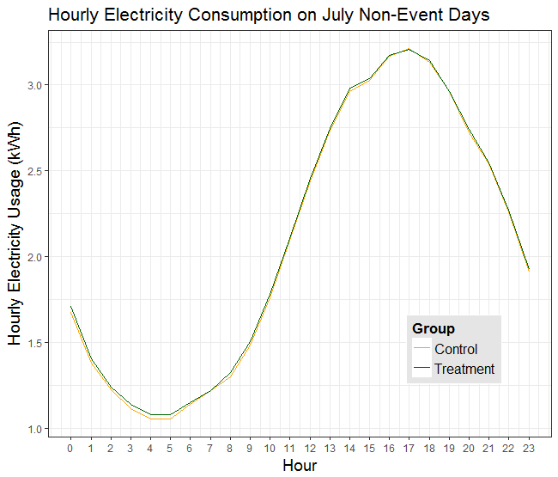

Figure 4. Hourly Electricity Consumption on August Non-Event Days

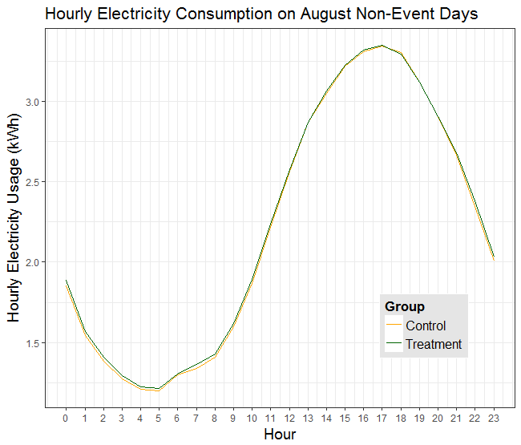

In an RCT, the geographic distribution of treatment and control customers should also be randomly allocated. In figures 6 and 7, the frequency of treatment and control customers is visualized over the service territory. The customer distribution in these figures is also consistent with randomization. [5]

Figure 5. Frequency of Treatment Customers by Zip Code

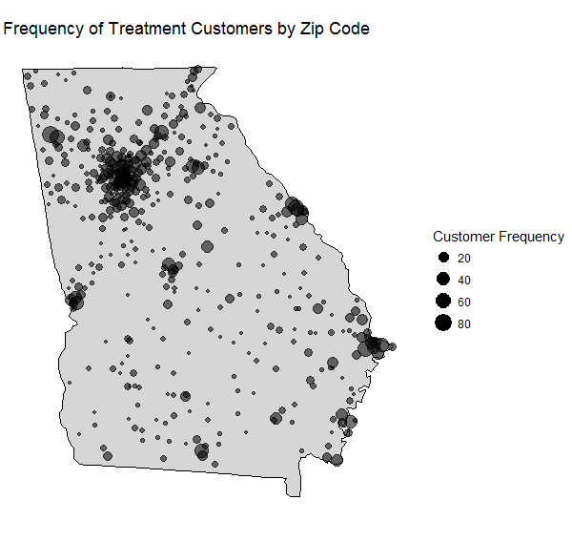

Figure 6. Frequency of Control Customers by Zip Code

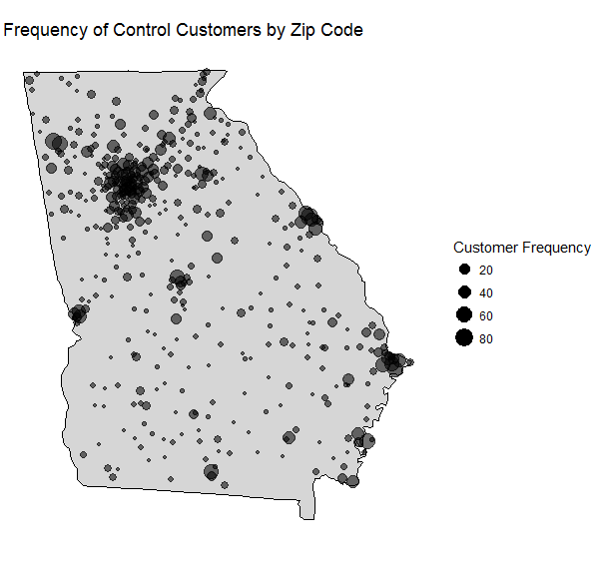

## Data Cleaning

The data were combined and cleaned before analysis. The original dataset included 2,247,397 observations with 8969 unique participants.

The data cleaning steps are described and justified below.

1. **Multiple observations with the same timestamp on a unique customer id:**

Almost 8% of observations provided had more than one meter reading per customer at the same timestamped period. These observations occurred when multiple meters were assigned to the same customer ID. Customers that had two or more observations at the same timestamp were eliminated from the data.

1. **Observations with non-hourly intervals:**

Approximately 0.34% of our observations had meter readings at sub-hourly time intervals. This analysis was conducted at the hourly level, which makes data of finer granularity irrelevant. Consequentially, observations containing non-zero minute and second data were eliminated from the analysis.[6]

1. **Missing meter reading values:**

The data contained 13,722 observations without meter readings. These were likely due to meter malfunctions. Observations with no meter reading values were eliminated from the data because they did not provide relevant information for the analysis.

1. **Participants with missing observations during event hours on any day in the study period:**

The removal of hourly observations from a customer’s time series of meter readings resulted in subsequent meter readings accounting for more than one hour of time. To mitigate the effect of this problem on analysis, all customers with missing values during the 6-hour event period hours across all days of the study period were removed.

1. **The first hour of the study period:**

The calculation of hourly electricity consumption from meter data required meter readings at the beginning and end of the hour of interest. There was no information for electricity consumption preceding the first hour of study. Meter readings for the first hour were used to calculate electricity consumption during the second hour of the study and then removed because hourly electricity consumption cannot be calculated for this hour.

1. **Remaining negative values:**

Large, negative electricity consumption values remained for 32 observations after the first two steps of data cleaning. These observations had multiple meter readings that did not occur at the same timestamp. To be consistent with step 1, these observations were dropped from the analysis.

1. **Outliers:**

As a final step, outliers in the data were removed. An outlier was defined as five times larger than the 99th percentile of hourly electricity consumption.

Table 3. Data Cleaning Summary

|  | **Observations** | | **Customers** | | |
| --- | --- | --- | --- | --- | --- |
| Data Cleaning Step | Number Excluded | Percent Excluded | | Number Excluded | Percent Excluded |
| Observations with Same Timestamps | 177,087 | 7.9 % | | 389 | 3.3% |
| Non-hourly Intervals | 6,450 | 0.34% | | 172 | 2.0 % |
| Missing Meter Readings | 13,722 | 0.66% | | 118 | 1.4% |
| Missing Observations During Event Hours | 66,900 | 3.2% | | 710 | 9.1% |
| First Hour of Study Period | 17,283 | .87% | | 0 | 0% |
| Negative kWh Values | 33 | 0% | | 0 | 0% |
| Removing Outliers | 120 | 0% | | 1 | .01% |
| Total | 281,595 | 13.1% | | 1,390 | 15.8% |

## Modelling Approach

The load and net electricity impacts of the program were estimated through two modelling approaches:

1) Simple Difference (SD) model

2) Two-Way Fixed Effects (TWFE) model.

The preferred specification was the TWFE model, but both models generate unbiased or consistent estimators for the treatment effect. The SD model was included as a robustness check for the TWFE model’s results.

### Simple Difference Model

In an RCT, a simple difference (SD) model generates an unbiased estimator of the average treatment effect. Hourly treatment effects were estimated by applying the SD model to each hour of the 6-hour event period for the July and August event days.

The RCT does not imply the errors in the SD model are independent and identically distributed. The errors in the SD model were clustered at the zip code level to account for error correlation within zip codes. The SD model is described in equation 1.

Equation 1

$${UPH}_{i}= α+ β_{1}{treat}_{i}+ E_{i}$$

**Where:**

**UPHi :** Hourly electricity consumption for participant i.

**α**: Regression intercept.

${treat}_{i}$***:*** An indicator variable that takes the value of 1 for a treatment customer and 0 otherwise.

**β1**: Estimate of the average treatment effect.

$E_{i}$: The error term for participant i.

### Two-Way Fixed Effects Model

The TWFE model utilized panel data with customer cross-sections at hourly time intervals. The TWFE specification included a fixed effect at the customer level and a fixed effect for each hour in the study period. The customer fixed effect controlled for observable and unobservable customer-specific factors that affected electricity consumption and did not change over time. Examples of customer-specific factors include school district or house size. The hourly fixed effect controlled for observable or unobservable characteristics of each hour of the study period that affected electricity consumption and did not vary across customers. Examples of hour-specific characteristics include a popular sporting event increasing TV usage or a storm decreasing air conditioning usage for a given hour in the study period.

In addition, the TWFE model included a covariate for temperature-humidity index (THI), which combines temperature and relative humidity to measure physical discomfort due to heat. This covariate was included to control for the effect of changing weather conditions on electricity consumption.

The TWFE model was the preferred specification because the inclusion of fixed effects and THI controlled for observable and unobservable factors that are correlated with electricity consumption. Their inclusion should reduce the model variance and generate more precise parameter estimates than the SD model.

A consequence of making structural assumptions about the model specification, such as adding covariates and fixed effects, is that parameter estimates will rely on consistency instead of unbiasedness. This was not problematic in our TWFE specification because our data had large sample properties.

To account for the possibility of correlation in the error term, the errors were clustered at the customer level. This resulted in consistent standard errors, which were sufficient with the data’s large sample properties. The TWFE model is described in equation 2.

Equation 2

$${UPH}_{it}= ϕ_{t}+ λ_{i}+ β_{1}{THI}_{it}+ \sum_{j=1}^{6}{σ_{j}{event_hour_j}_{t}*{treat}_{i}}+ E_{it}$$

${UPH}_{it}$: Hourly electricity consumption for each participant at each hour of the study period.

$ϕ_{t}$: Afixed effect for each hour in the study period.

: Afixed effect for each participant in the study period.

: Avariable for temperature-humidity index (THI) for each participant at each hour of the study period.

${event_hour_j}_{t}$: A variable that takes the value of 1 if hour t is the jth hour of the event period and 0 otherwise.

${treat}_{i}$: An indicator variable that takes the value of 1 for treatment participant and 0 otherwise.

$σ_{j}$: Anestimate of the average treatment effect at each hour of the event period.

$E_{it}$:The error term for each participant at each hour of the study period

# Results

The primary objective of this analysis was to estimate the load and net electricity impacts of the July 13th and August 16th demand response events. Electricity load and consumption was expected to decrease during the AC cycling period and increase during the snapback period.

Figures 7 and 8 presents the electricity consumption of treatment and control customers for each hour of each event day. As expected, treatment customers experienced reduced electricity consumption during the AC cycling period and increased consumption during the snapback period.

Figure 7. Hourly Electricity Consumption on July 13th Event Day

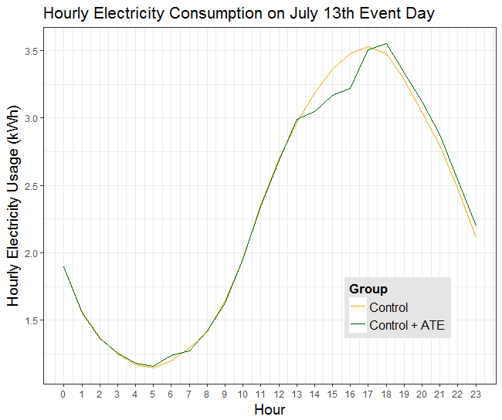

Figure 8. Hourly Electricity Conusmption on August 16th Event Day

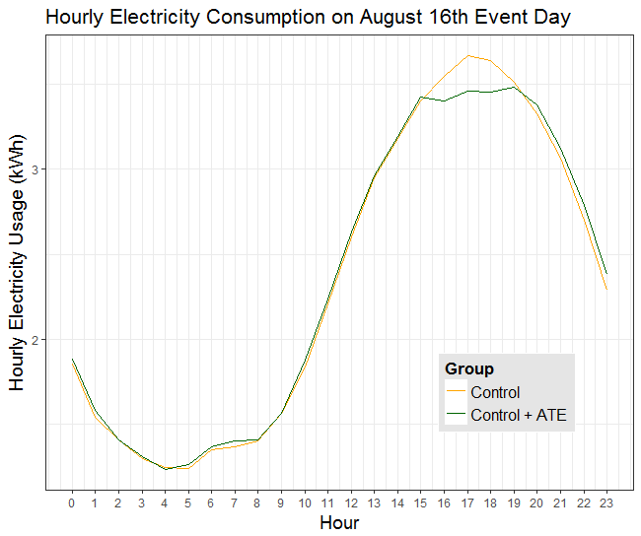

Table 5 shows results from the TWFE and SD regressions, which generated similar estimates of the average treatment effect. The TWFE consistently had lower standard errors on the treatment effect parameter, which supports the theory that including covariates and fixed effects reduces standard errors of parameter estimates. The similarity of the SD and TWFE model parameter estimates suggests that estimates of the treatment effect are robust to specification choice. These results from these two model specifications are visually represented in figure 9, which shows that the two models have similar treatment effect estimates, but the TWFE model estimates are more precise.

Table 4. Primary Regression Results

|  | July 13th (2-8 PM) | | August 16th (4-10 PM) | |
| --- | --- | --- | --- | --- |
|  | SD Model | TWFE Model | SD Model | TWFE Model |
| ATE AC Cycling Hour 1 | -.184  (.041)*** | -.140  (.029)*** | -.132  (.042)*** | -.148  (.029)*** |
| ATE AC Cycling Hour 2 | -.246  (.041)*** | -.198  (.030)*** | -.193  (.043)*** | -.210  (.030)*** |
| ATE AC Cycling Hour 3 | -.209  (.041)*** | -.258  (.030)*** | -.169  (.043)*** | -.185  (.030)*** |
| ATE Snapback Hour 1 | -.021  (.041) | -.0223  (.030) | -.015  (.043) | -.033  (.029) |
| ATE Snapback Hour 2 | .093  (.045)* | 0.075  (.023)* | .072  (.048) | .054  (.028) **.** |
| ATE Snapback Hour 3 | .070  (.040) **.** | .051  (.028) **.** | .077  (.044) **.** | .055  (.028) **.** |
| Significance Codes: ‘**.**’p< .1 , * p < .05 , ** p < .01 , *** p < .001 | | | | |

Figure 9. Model Comparison Over Both Event Days

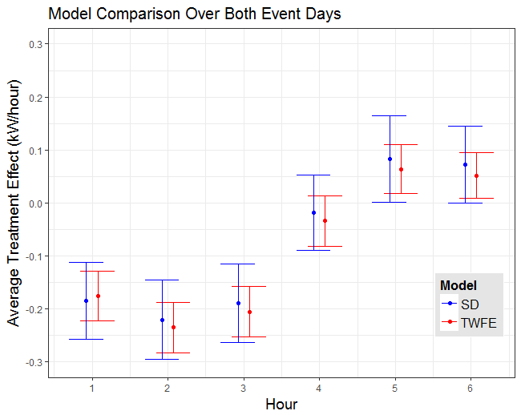

In the preferred TWFE model, the treatment effect during the AC cycling period was negative and statistically significant during both event days. These results align with the intuition that reduced AC runtime causes a reduction in electricity consumption. The magnitude of the treatment effect during the AC cycling period on the July event was larger than the August event.

During the snapback period, treatment customers were expected to increase AC usage to overcome higher relative indoor air temperatures than control customers. The estimates for the first hour of the snapback period had an insignificant magnitude and were not statistically different from zero. However, the snapback effect was positive and significant at the 10% level during the second and third hours of the snapback period on both event days.

It is important to note that the reported estimates represent the lower bound for the average treatment effect. Treatment customers with non-functioning DCUs were included in the treatment group but did not receive treatment. Approximately 42% of participant’s AC units had non-functioning DCUs, which likely reduced the magnitude of electricity savings estimates.

## Extended Snapback Period:

The primary analysis was conducted under the assumption that the three hours that followed the AC cycling period would account for the snapback effect. Figures 10 and 11 show the treatment group had higher electricity consumption than the control group for many hours after the AC cycling period.

Figure 10. July 13th Event Extended Snapback Period (5 PM – 2 AM)

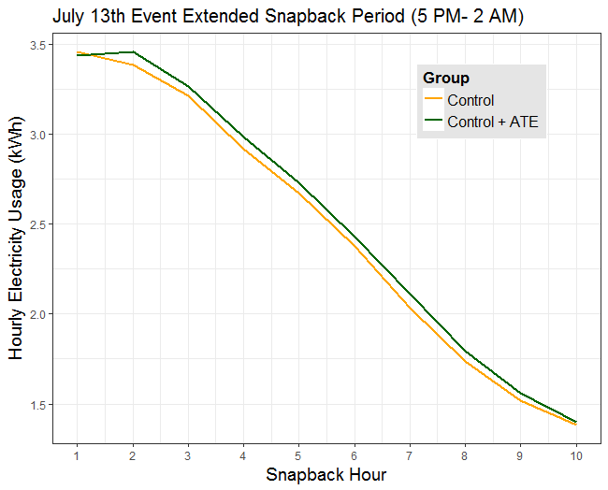

Figure 11. August 16th Event Extended Snapback Period (7 PM – 4 AM)

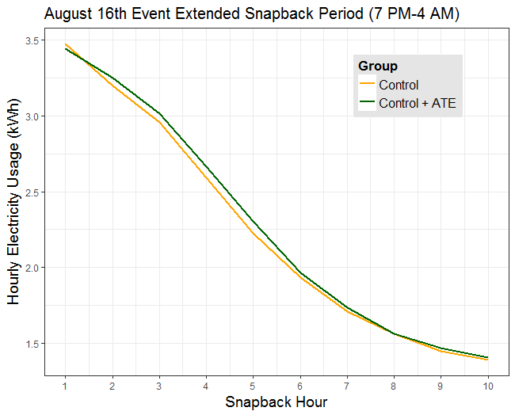

The snapback effect was estimated with a TWFE model that increased the length of the event period from 6 hours to 13 hours[7]. The results in table 5 indicate that the snapback effect extended beyond the 3-hour period originally specified on both event days. After Snapback Hour 1, the snapback effect was significant at the 10% level for 4 snapback hours on the August event day and 8 snapback hours on the July event day.

Table 5. Regression Results for Extended Snapback Period

|  | July 13th Event | August 16th Event |
| --- | --- | --- |
| ATE Snapback Hour 1 | -0.02  (0.03) | -0.03  (0.03) |
| ATE Snapback Hour 2 | 0.08  (0.02)* | 0.05  (.03)**.** |
| ATE Snapback Hour 3 | 0.05  (0.03)**.** | 0.06  (0.03)**.** |
| ATE Snapback Hour 4 | 0.07  (0.03)* | 0.07  (0.03)** |
| ATE Snapback Hour 5 | 0.06  (0.03)* | 0.08  (0.03)** |
| ATE Snapback Hour 6 | 0.05  (0.03)**.** | 0.03  (0.03) |
| ATE Snapback Hour 7 | 0.07  (0.03)** | 0.03  (0.02) |
| ATE Snapback Hour 8 | 0.05  (0.03)* | 0.00  (0.02) |
| ATE Snapback Hour 9 | 0.04  (0.02)**.** | 0.02  (0.02) |
| ATE Snapback Hour 10 | 0.02  (0.02) | 0.02  (0.02) |

*\*Variables included in the regression not present in the table are THI and Event Hours in AC Cycling Period*

Prior to analysis, the snapback effect was expected to be larger on the July event day because it had an earlier call time, which would result in higher THI values during the snapback hours because temperatures tend to reduce at night. Higher THI values were expected to increase the snapback effect because a treatment customer’s burden of regulating their indoor air temperatures after the AC cycling period would be increased by high outdoor air temperatures. Figure 12 shows that THI values decrease during later hours in the day.

Figure 12. Average Hourly THI on Each Event Day

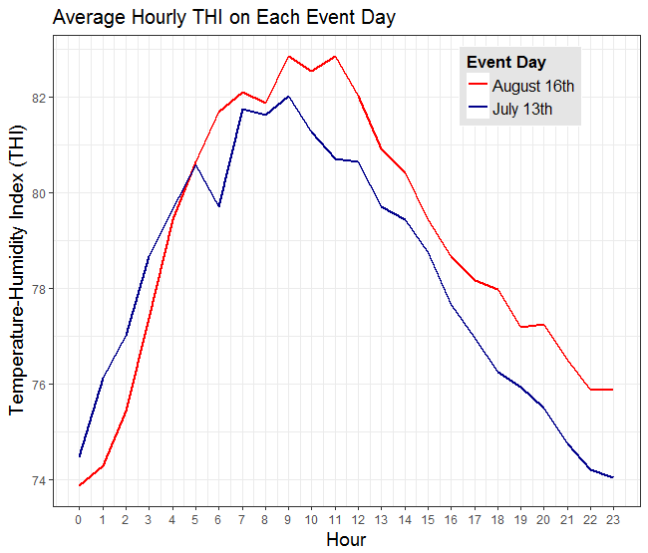

The regression results in Table 5 show a larger snapback effect during the July event day, which was called earlier in the day. However, the higher THI values do not appear to be driving the increased snapback effect. In figure 13, the THI values during snapback hours are compared on each event day. The August event has consistently higher THI values after the AC cycling period than the July event despite its later call-time, which suggests that higher THI values are not causing the extended snapback period on the July event day.

Further analysis with more event days will be necessary to determine if the timing of the demand response event is correlated with the snapback effect.

Figure 13. Average Hourly THI During Extended Snapback Period

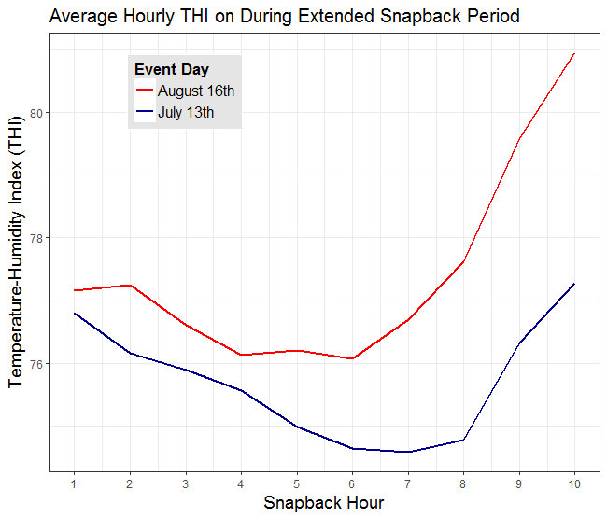

## Heterogeneous Treatment Effect for Metro and Non-Metro Participants

The heterogeneous treatment effect for metro and non-metro customers is relevant information in future program design. Figure 1 showed that participants with metro status were clustered around the Atlanta metropolitan area and non-metro participants were distributed elsewhere in the state. Prior to analysis, a larger treatment effect was expected for non-metro participants because urban dwellers tend to live in smaller houses that require less consumption of AC to maintain comfortable indoor air temperatures, which would result in smaller treatment effects.

The two-way fixed effects model in equation 3 estimated the heterogeneous treatment effect of metro status.

Equation 3

$${UPH}_{it}= ϕ_{t}+ λ_{i}+ β_{1}{THI}_{it}+ \sum_{j=1}^{6}{σ_{j}{event_hour_j}_{t}*{treat}_{i}}+ \sum_{j=1}^{6}{γ_{j}{event_hour_j}_{t}*{treat}_{i}}*{metro}_{i}+ E_{it}$$

${UPH}_{it}$: Electricity consumption for each customer at each hour of the study period.

$ϕ_{t}$: Afixed effect for each hour in the study period.

$λ_{i}$: Afixed effect for each customer in the study period.

${THI}_{it}$: Atemperature-humidity index (THI) variable for each customer at each hour of the study period.

${event_hour_j}_{t}$: A variable that takes the value of 1 if the hour is the jth hour of the event period and 0 otherwise.

${treat}_{i}$: An indicator variable that takes the value of 1 for treatment customers and 0 otherwise.

${metro}_{i}$**:** An indicator variable that takes the value of 1 for a participant with metro status and 0 otherwise.

$σ_{j}$: Anestimate of the average treatment effect for non-metro customers at each hour of the event period.

$γ_{j}$: Anestimate of the marginal change in average treatment effect for metro customers relative to non-metro customers at each hour of the event period.

$E_{it}$:The error term for each customer at each hour of the study period.

The model in equation 3 estimated the treatment effect for non-metro customers and the marginal change in the average treatment effect for metro customers. The average treatment effect for metro customers was calculated by adding estimates and standard errors of the non-metro treatment effect with the metro group’s marginal change in average treatment effect. Table 6 presents the average treatment effect for metro and non-metro customers over the July 13th and August 16th event periods. These results are visually represented in figures 14-17.

Table 6. Average Treatment Effect for Metro and Non-Metro Customers

|  | July Event | | | August Event | |
| --- | --- | --- | --- | --- | --- |
|  | Metro | Non-Metro | Metro | | Non-Metro |
| ATE AC Cycling Hour 1 | -.244  (.041) *** | -.173  (.033)*** | -.159  (.040)*** | | -.088  (.033)** |
| ATE AC Cycling Hour 2 | -.314  (.042)*** | -.229  (.033)*** | -.315  (.041)*** | | -.153  (.034)*** |
| ATE AC Cycling Hour 3 | -.298  (.041)*** | -.183  (.034)*** | -.253  (.041)*** | | -.149  (.033)*** |
| ATE Snapback Hour 1 | -.125  (.041)** | -.013  (.035) | .083  (.040)* | | -.095  (.032)** |
| ATE Snapback Hour 2 | .027  (.044)* | .101  (.034)** | .209  (.043)*** | | -.029  (.032) |
| ATE Snapback Hour 3 | -.033  (.041) | .096  (.033)** | .194  (.040)*** | | -.020  (.031) |
| Significance Codes: ‘**.**’p< .1 , * p < .05 , ** p < .01 , *** p < .001 | | | | | |

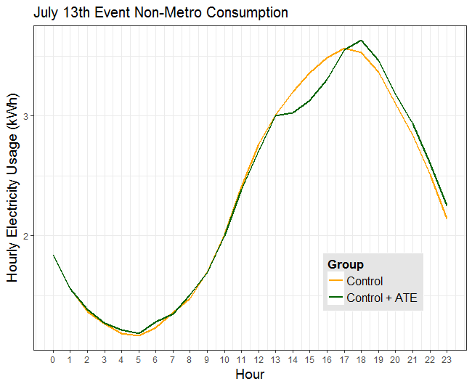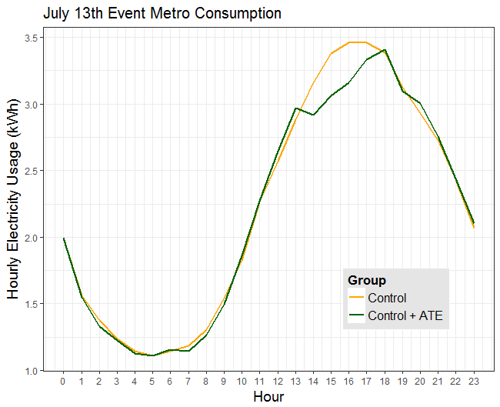

Figure 15. July 13th Event Non-Metro Consumption

Figure 14. July 13th Event Metro Consumption

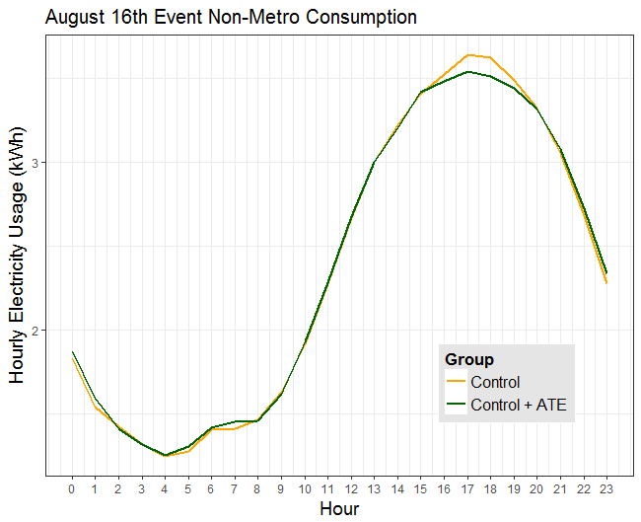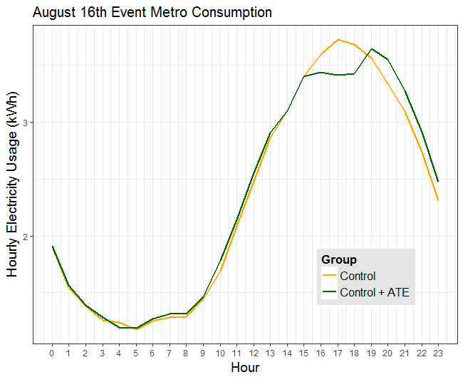

Figure 17. August 16th Non-Metro Consumption

Figure 16. August 16th Metro Consumption

The results in Table 6 indicate that the treatment effect was, on average, 38% larger for metro participants than non-metro participants during the AC cycling period across both event days.

During the July event, the snapback effect for the first hour of the snapback was significant and had an unexpected negative direction. The second snapback hour had positive and significant snapback effect followed by an insignificant third snapback hour.

During the August event, the snapback effect is positive and significant for all three hours of the snapback period. Due to their higher number of functioning DCUs, larger snapback effect was expected for metro customers. The results were not consistent and further analysis with more event days will be required to understand the relationship between metro status and the snapback effect.

On average, customers with metro status had a 38% larger treatment effect than non-metro customers. The higher proportion of functioning DCUs in metro areas explains 33% of metro customer’s larger treatment effect. Despite the difference in functioning DCUs, metro customer’s average treatment effect is still 25% larger than non-metro customers. In future program design, it will be more economical to invest in participants living in metro areas than non-metro areas because they will yield higher demand reductions. In future studies, a better estimation of the treatment effect of metro status can be achieved by comparing metro and non-metro groups that have equal proportions of functioning DCUs.

# Conclusions & Recommendations

## Key Findings

The net electricity consumption and load impacts of the AC Cycling Program are summarized in table 7, which includes the estimated impact of the 6-hour event period, the AC cycling period, the 3-hour snapback period, and a 10-hour extended snapback period for both event days.

Table 7 Load and Net Electricity Impact

|  | July Event Day | | | August Event Day | | |
| --- | --- | --- | --- | --- | --- | --- |
|  | Customer Electricity Impact[8]  (kW/hr) | Percent Load Reduction | Total Electricity Impact[9]  (kWh) | Customer Electricity Impact  (kW/hr) | Percent Load Reduction | Total Electricity Impact  (kWh) |
| Event Period | -0.098  (.022) | -2.8% | -2,567  (95) | -0.078  (.020) | -2.3% | -2,032  (88) |
| **AC Cycling Period** | **-0.228**  **(.025)** | **-6.5%** | **-2,972**  **(109)** | **-0.182**  **(.025)** | **-5.2%** | **-2,372**  **(108)** |
| Snapback Period | 0.037  (-.025) | 0.1% | 478  (107) | 0.030  (.023) | 0.1% | 393  (100) |
| Extended Snapback Period | 0.052  (.015) | 1.4% | 2,267  (63) | 0.039  (.015) | 1.1% | 1,711  (63) |

### Energy and Load Impacts of Program

On the July 13th and August 16th event days, electricity load was reduced during the AC cycling period by 6.5% and 5.2% respectively. Reduced electricity load during the AC cycling period is an estimate for the program’s load shifting benefits during the high demand period.

The program’s kWh savings were lower than the load shifting benefits because of the snapback effect. With a three-hour snapback period, electricity savings for the July and August event days are 2,567 kW and 2,032 kWh respectively.

The energy and load impacts of the program during the July event were larger than the July event by approximately 25%. Further analysis with more event days will be required to determine the cause of this discrepancy.

### Significant Extended Snapback Period

After snapback hour 1, the snapback effect was positive and significant at the 10% level after the AC cycling period for 8 hours on the July event and 4 hours on the August event. The 3-hour snapback period only accounted for 21% of the snapback effect on the July event day and 23%[10] on the August event. If the extended snapback period is included, the net kWh savings is 705 kW on the July event and 661 kW on the August event. The energy impacts of the program changed significantly when the extended snapback period was considered.

### Larger Treatment Effect for Metro Customers

The magnitude of the treatment effect for metro customers was larger than non-metro customers for all hours of the AC cycling period. Across both event days, the treatment effect was larger for metro customers by an average of 38% in the AC cycling period.

Metro customers had approximately 33% more functioning DCUs than non-metro customers. After considering the differences in DCU functionality, metro customer’s treatment effect was still 25% larger than non-metro customers.

## Recommendations:

### Definition of the Snapback Period

The initial assumption that a 3-hour snapback period accounted for the event’s snapback effect proved to be insufficient. In future evaluations, the snapback period should be extended beyond three hours. The extent of the snapback period can be defined by estimating the treatment effect for several hours after the AC cycling period and extending the snapback period until the last hour that shows a statistically significant snapback effect.[11] This will provide a more comprehensive estimation of the program’s electricity impacts.

### Target Metro Customers in Future Program Design

Customers with metro status had a much higher treatment effect than non-metro customers. In future program design, it will be more economical to invest in participants living in metro areas than non-metro areas because they will yield higher demand reductions.

Additionally, providing more demographic data to future program evaluations will allow for improved customer segmentation, which can further inform program design.

### Investigation of Non-Functioning DCUs

The presence of non-functioning DCUs caused uncertainty on the program’s electricity impacts. Electricity reductions through AC cycling programs are reliant on functioning DCUs and the program may have achieved larger electricity impacts if a higher percentage of customers had functioning DCUs. It is recommended to analyze the potential mechanical or behavioral causes of non-functioning DCUs before subsequent iterations of this program.

# References

# Appendix

Equation 4

$${UPH}_{it}= ϕ_{t}+ λ_{i}+ β_{1}{THI}_{it}+ \sum_{j=1}^{13}{σ_{j}{event_hour_j}_{t}*{treat}_{i}}+ E_{it}$$

${UPH}_{it}$: Hourly electricity consumption for each participant at each hour of the study period.

$ϕ_{t}$: Afixed effect for each hour in the study period.

: Afixed effect for each participant in the study period.

: Avariable for temperature-humidity index (THI) for each participant at each hour of the study period.

${event_hour_j}_{t}$: A variable that takes the value of 1 if the hour is the jth hour of the event period and 0 otherwise.

${treat}_{i}$: An indicator variable that takes the value of 1 for treatment participant and 0 otherwise.

$σ_{j}$: Anestimate of the average treatment effect at each hour of the event period.

$E_{it}$:The error term for an each participant at each hour of the study period

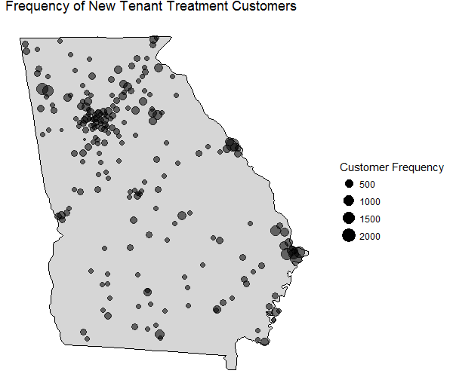

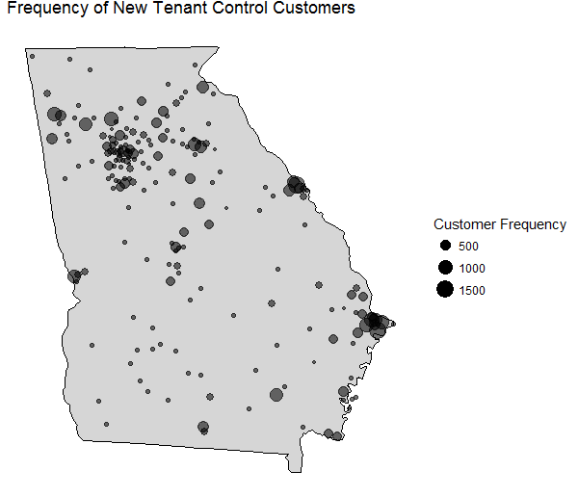

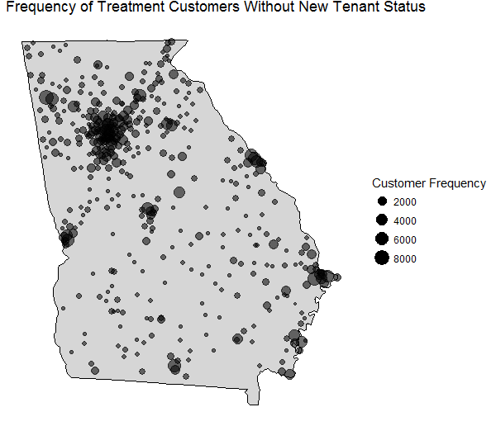

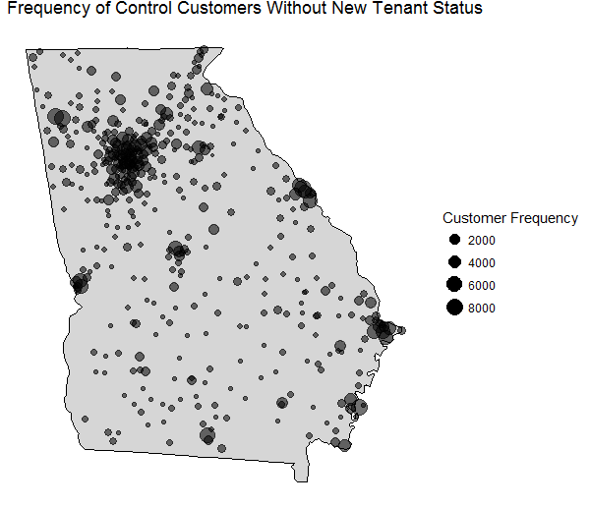

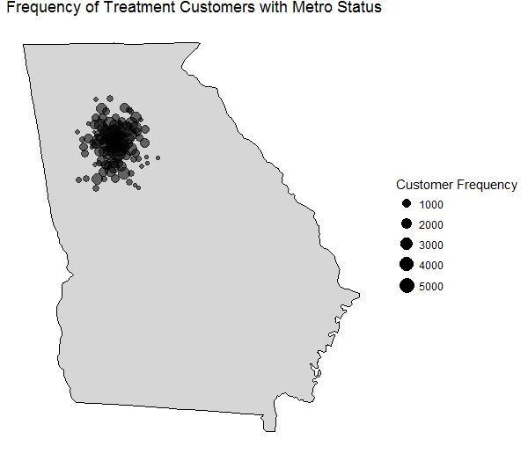

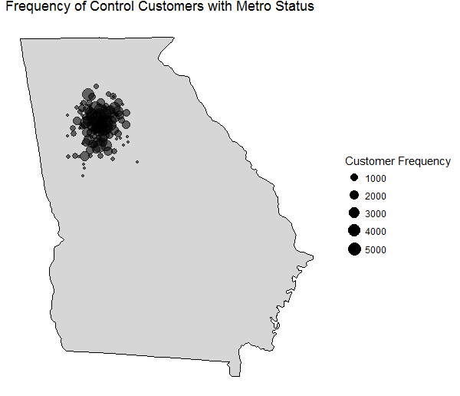

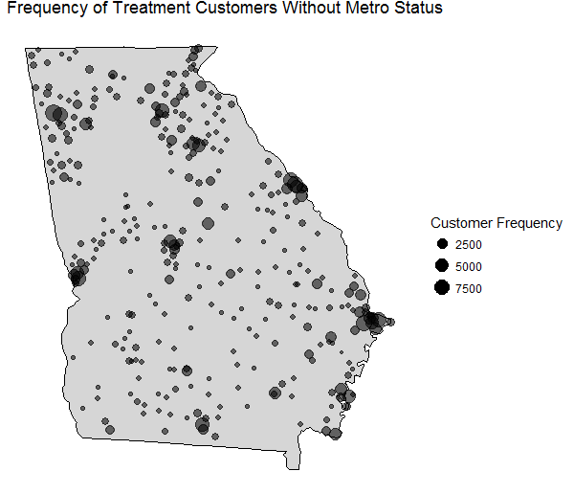

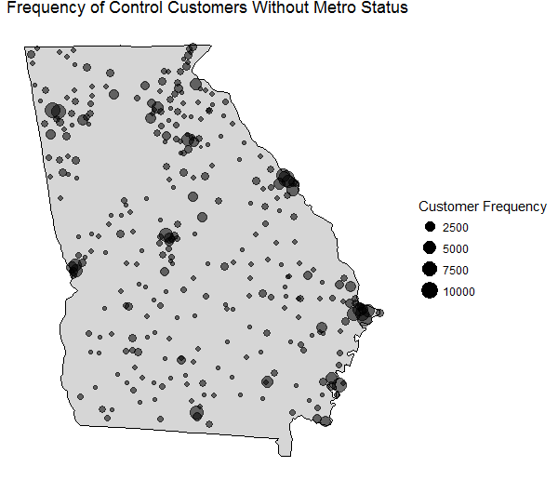

1. Customer level savings and standard errors were calculated by running 3 separate regressions with the full event, AC Cycling Period, and Snapback periods independent, indicator variables. The estimates and standard errors in Table 6 are taken from these regression results
2. Total savings were estimated by multiplying the regression coefficients from the customer level savings by the number of treatment customers and the number of hours in the period of interest. The standard error was calculated with the variance formula.
3. Other than the drop-outs, the same customers were in treatment and control groups on both event days.
4. The data sufficiency requirement was that the data had no missing values during the hours of the 6-hour event period on any day in the study period.
5. The geographic distribution of treatment and control customers for the new tenant and metro variables were also analyzed. The results were also consistent with randomization. The figures can be found in the appendix.
6. All of the customers dropped removing non-hourly observations had their regular hourly observation removed in the “Observations with the Same Timestamp” step. This was verified by removing non-hourly as the first data cleaning step. Results showed 0 dropped customers and 8777 dropped observations.
7. A detailed specification is labelled as Equation 4 in the appendix.
8. Customer level savings and standard errors were calculated by running 3 separate regressions with the full event, AC Cycling Period, and Snapback periods independent, indicator variables. The estimates and standard errors in Table 6 are taken from these regression results
9. Total savings were estimated by multiplying the regression coefficients from the customer level savings by the number of treatment customers and the number of hours in the period of interest. The standard error was calculated with the variance formula.
10. These percentages were calculated by dividing the kWh savings from the 3-hour Snapback Period by the kWh savings from the Extended Snapback Period.
11. Snapback Hour 1 was insignificant in our primary TWFE model estimation. This is likely due to a transition period between the AC Cycling and Snapback Periods. When defining the Extended Snapback Period, hours can be defined after Snapback Hour 1.