|  |
| --- |
| … |
| **E-paper Display Unit Design Definition** |
| … |

|  |
| --- |
| KL  12-15-2015 |

Document history

|  |  |  |  |
| --- | --- | --- | --- |
| **Date** | **Revision** | **By whom** | **Note** |
| 21st Nov 2015 | Draft A | KL | Creation |
| 15th Dec 2015 | Draft B | KL |  |

Contents

1 Introduction 4

1.1 System Architecture 4

2 Hardware Design Definition 4

2.1 E-paper display development board 4

2.1.1 Suggested platform 4

2.1.2 Other platform 5

2.2 Bluetooth development board 6

2.3 Android plat form 6

3 Software design definition 7

3.1 Software architecture 7

3.2 Software components 7

3.2.1 Bluetooth Stack 7

3.3 E-paper display driver 7

# Introduction

This project is to create a simple E-paper display system which consists of an e-paper display unit (EDU) embedded in a mobile phone cover case that can be attached to an Android mobile device via Bluetooth for leisure reading.

## System Architecture

The architecture of the EDU consists of the following main components:

* E-paper display and associated circuit
* Bluetooth system on chip nRF51
* Host Android/iOS mobile device

The E-paper display and associated circuit will be supplied with existing software API. The Bluetooth SoC will use this API to control and send data to the E-paper display. Figure 1 shows the simplified system block of the E-paper display system.

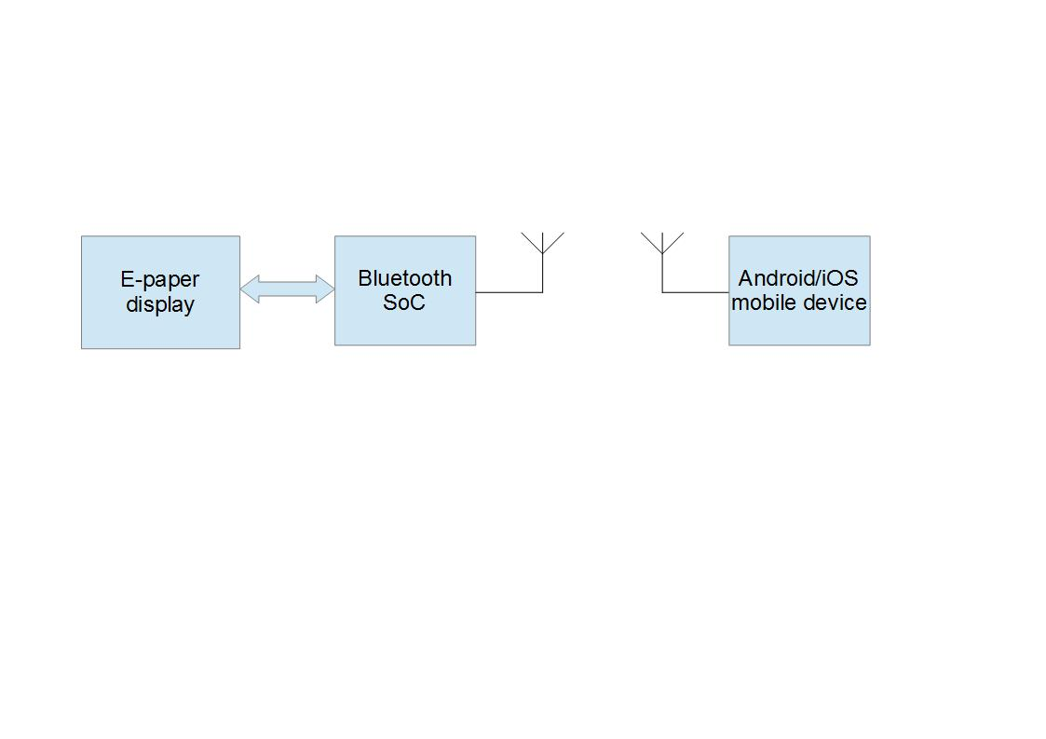

Figure : Simplified system diagram

# Hardware Design Definition

## E-paper display development board

### Suggested platform

The suggested platform is the Pervasive 4.41” E-paper display (link <http://www.pervasivedisplays.com/kits/mpicosys441>). It is recommended because of low power consumption: 7mA for best quality update and less than 1µA in idle state.

For the Pervasive platform, an edp file has to be generated on the Android phone and transmitted to the display via Bluetooth. This provides flexibility to create graphics from mobile platform, and transfer directly to the e-paper display.

Pricing for the development platform is $54.

Pricing for the display and the timing controller IC:

* 10 pcs - USD 66/set (samples only)
* 100 pcs - USD 52.40/set
* 1k pcs - USD 45.75/set

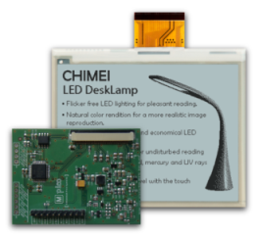

Figure : Pervasive 4.41" E-paper display and timing controller board

### Other platform

Information available at: <http://www.waveshare.com/4.3inch-e-paper.htm>

Support information available at: <http://www.waveshare.com/wiki/4.3inch_e-Paper>

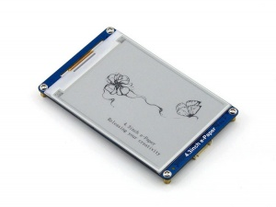

## Bluetooth development board

The Nordic development board is chosen because it offers low power operation which is essential for Bluetooth operations. This platform also receives good support from Nordic community. Price of the development board is £75.85.

Bluetooth IC unit price: £3.123 @ 10 off, £2.5449 @ 100 off

<https://developer.mbed.org/platforms/Nordic-nRF51-DK/>

<https://www.nordicsemi.com/eng/Products/nRF51-DK>

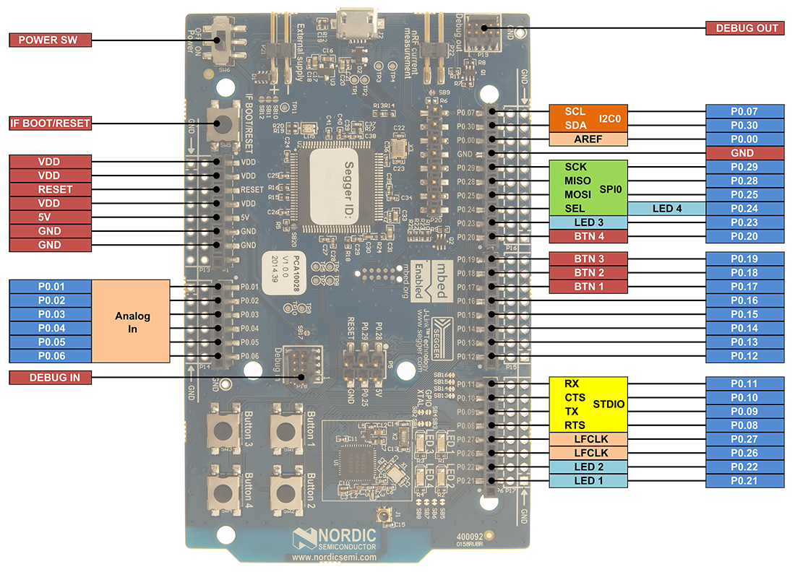

## Android plat form

Recommended android platform must have Bluetooth Low Energy v4.1 capability.

# Software design definition

## Software architecture

## Software components

### Bluetooth Stack

This accommodate communications to Android phone, handles button interrupt, and UART

## E-paper display driver

This component will reside in the nRF51 and take care of displaying text on the EDU. This driver will be ported from other platform. Source code is available at: <http://www.waveshare.com/wiki/4.3inch_e-Paper#Resources>