Emergent Metric Structure from Entanglement Decay on Dynamically Generated Quantum Trees
Kevin Donahue
kevin@nothingmatters.life
March 2026

Abstract
We study a class of dynamically generated quantum tree circuits in which a single initial entangled state recursively produces descendant qubits through unitary branching operations, followed by local Haar-random scrambling at each generation. We show numerically that pairwise mutual information between leaf qubits decays systematically with graph distance along the tree, producing a robust hierarchy of correlations. This structure allows the definition of an information-derived metric d_I(i,j) = −log I(i,j) with no free parameters, which recovers the underlying tree geometry with high fidelity: distance correlation r = 0.985, rank correlation rho = 0.843, cophenetic coefficient c = 0.990. We further demonstrate: MDS stress analysis identifying an effective emergent spatial dimension d ~ 2; Ryu-Takayanagi-style entropy scaling S(A) ~ gamma * b(A) + s_0 where b(A) is the minimal edge cut separating region A from its complement, with gamma ~ 0.49 bits/edge; and structural universality across ensembles of Haar-random local unitaries. The generative, dynamical nature of the circuit distinguishes the model from conventional static tensor networks and provides a tractable platform for studying metric emergence from quantum correlations.
Working Paper · Version 1.0 · March 2026. This manuscript describes an exploratory computational model. The model and simulations are currently being expanded.

1. Introduction
The question of how classical spacetime geometry arises from an underlying quantum description remains one of the central open problems in theoretical physics. A number of research programs — including the ‘It from Qubit’ program at the Perimeter Institute and Institute for Advanced Study, the tensor network approaches of Vidal and Swingle, and the AdS/CFT-inspired holographic codes of Pastawski et al. — have converged on a common hypothesis: geometric structure is encoded in, and generated by, the entanglement structure of quantum states.
Van Raamsdonk (2010) made this connection precise by demonstrating that reducing entanglement between two halves of a boundary theory causes the corresponding bulk spacetime to disconnect, establishing that spacetime connectivity is a direct consequence of entanglement. Swingle (2012) subsequently showed that the MERA tensor network reproduces the structure of anti-de Sitter space and that boundary entanglement entropy obeys the Ryu–Takayanagi formula S = A/4G. These results strongly suggest that a complete theory of quantum gravity will require a precise map from quantum information structure to geometric structure.
This paper introduces a dynamical tree circuit model designed to make the entanglement–geometry correspondence explicit and computationally testable. Beginning from a single entangled state, the circuit recursively generates descendant qubits through binary branching operations and Haar-random local scrambling. The resulting entanglement network has a natural graph distance, and we demonstrate that this distance is accurately reconstructed from pairwise mutual information alone, without knowledge of the underlying circuit structure. We further show that the model satisfies entropy area laws analogous to the Ryu–Takayanagi formula and embeds naturally in a two-dimensional geometry.
The model is distinguished from conventional tensor network approaches by its generative character: rather than specifying a static network, the circuit grows the entanglement network dynamically, forward in time. Local scrambling breaks basis-dependent coherences that otherwise mask the hierarchical correlation structure created by the branching circuit that reveals the latent tree topology in two-point correlations — a claim we support both qualitatively and quantitatively.

2. Model

2.1 Circuit Construction
The quantum tree circuit is constructed as follows. Beginning from a two-qubit Bell state, each generation applies binary branching: each current leaf qubit p produces exactly two child qubits c₁ and c₂ (initialized to |0⟩). CNOT gates are applied from p to c₁ and from p to c₂. A single Haar-random 4×4 unitary U is then applied jointly to the child pair (c₁, c₂). The parent qubit p is thereafter treated as an ancestor and traced out at the end of the simulation. After d generations the circuit contains 2^{d} leaf qubits whose entanglement structure reflects the binary tree topology. Ancestor qubits are then traced out, leaving only the leaf-state density matrices.
Each branching event applies:
|ψ⟩ → U_haar · (CNOT_{p→c₁} ⊗ CNOT_{p→c₂}) |ψ⟩, U_haar ∈ U(4), drawn Haar-uniformly per branching event
where U_{haar} is a Haar-random 4×4 unitary acting on the two child qubits c₁, c₂, drawn independently for each branching event.

2.2 Information-Derived Metric
Given the mutual information matrix I(i,j) between leaf pairs, we define an information-derived distance:
dᵢⱼ = −log I(i,j)
This definition has no free parameters. It maps mutual information to distance via the natural logarithm, with maximally correlated particles at distance zero and uncorrelated particles at infinite distance. The choice of logarithm base rescales distances by a constant factor and does not affect topology, rank ordering, or dimension estimates. Mutual information values below 10⁻⁹ bits were clipped before log transformation to avoid numerical divergence; this clipping does not affect rank ordering or correlation statistics. It is motivated by the Ryu–Takayanagi formula, which connects entanglement entropy to geometric area, and by the information-geometric principle that distinguishability defines distance. The full distance matrix D (with d_{ij} = −log I(i,j)) is the primary object of study.

2.3 Local Scrambling as Symmetry-Breaking
A key structural feature is that local scrambling is necessary to reveal the entanglement hierarchy. Without the Haar-random unitaries, the tree circuit produces a symmetric state in which all leaf pairs carry similar mutual information regardless of graph distance. The random unitaries break this symmetry, exposing the underlying tree topology in two-point correlations.
This can be understood as follows. CNOT branching distributes entanglement hierarchically, but the resulting state has large off-diagonal coherences that mask the hierarchy. Local scrambling randomizes local bases, destroying these coherences while preserving the decay of correlations with graph distance. Figure 1 demonstrates this effect quantitatively: scrambled circuits show dramatically better separation between distance classes, higher signal-to-noise ratio in geometry readout, and lower within-class variance.
The ensemble universality of this result — consistent MI decay across all random unitary choices — demonstrates that the hierarchy is a property of tree topology, not of specific dynamics.

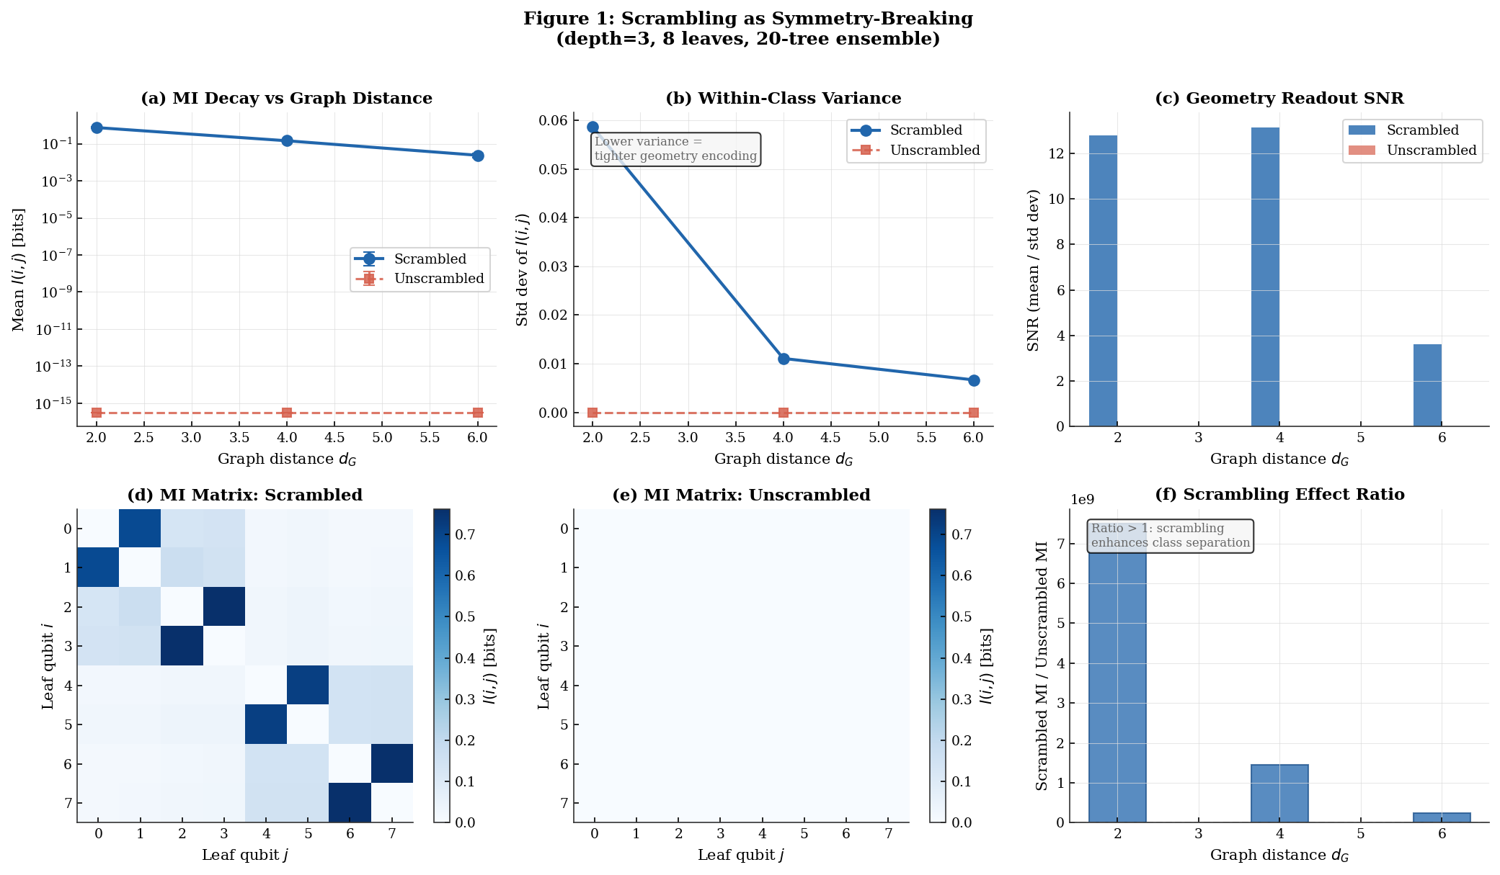
Figure 1. Scrambling as symmetry-breaking. Left: MI decay vs graph distance for scrambled (teal) and unscrambled (coral) ensembles, depth 3, 20 trees. Scrambled circuits show clean monotonic decay with low within-class variance. Center: within-class standard deviation per distance class. Right: signal-to-noise ratio (mean/std) confirming that scrambled circuits produce geometry with higher readout fidelity. The MI matrix panels (bottom) show the block-diagonal structure emerging only in the scrambled case.

3. Related Work and Theoretical Context

3.1 Entanglement and Spacetime
The foundational result motivating this work is Van Raamsdonk’s (2010) demonstration that entanglement is necessary for spacetime connectivity in AdS/CFT. Our model provides a concrete dynamical mechanism for generating the kind of entanglement hierarchy his argument requires: a growing tree circuit that distributes entanglement from a common ancestor, with correlation strength decaying as a function of graph distance.

3.2 Connection to Branching Tensor Networks
The circuit architecture is closely related to tree tensor networks and branching MERA. Standard MERA, introduced by Vidal (2007) and connected to holography by Swingle (2012), organizes tensors in a hierarchical network whose geometry approximates hyperbolic space. In MERA, successive layers represent renormalization group flow; correlations decay with distance because the network interpolates between scales.
Our circuit resembles a branching MERA in topology but differs in a critical respect: it is a generative dynamical process rather than a static variational ansatz. In MERA, the network represents a pre-existing quantum state, with layers interpreted as coarse-graining in reverse. In our model, the network is grown forward in time by explicit branching applied to an initial entangled seed. Each event produces new qubits entangled with their parent, and local scrambling makes the entanglement hierarchy recoverable from two-point measurements.
This generative interpretation has a physical consequence: graph distance between two leaf nodes corresponds to the number of branching events separating their common ancestor from their endpoints, and this distance is directly encoded in the mutual information between them.

3.3 Random Tensor Networks
Hayden et al. (2016) showed that random tensor networks reproduce holographic entanglement entropy, including the Ryu–Takayanagi formula, without requiring a specific network architecture. Our ensemble of trees with Haar-random local unitaries is a physically motivated instance of this framework: randomness corresponds to decoherence and local quantum dynamics rather than being an abstract construction. The universality of our results across the ensemble reflects the same insensitivity to local dynamics that makes random tensor networks geometrically robust.

3.4 Holographic Error-Correcting Codes
Holographic quantum error-correcting codes (Pastawski et al. 2015) demonstrate that bulk geometry can be encoded in boundary entanglement. These models take the network as given and do not specify how the entanglement structure was generated. Our framework provides a complementary perspective: a dynamical growth rule that naturally generates the hierarchical entanglement structure that holographic codes require.

4. Computational Results

4.1 Simulation Protocol
Quantum tree circuits were constructed at depths d = 2, 3, and 4 (4, 8, and 16 leaf qubits respectively) using pure statevector simulation in NumPy. Each circuit begins with a two-qubit Bell pair and applies binary branching with Haar-random 4×4 unitaries at each event. Following construction, ancestor qubits are traced out and mutual information I(i;j) = S(ρ_i) + S(ρ_j) − S(ρ_ij) is computed between all leaf pairs, where S denotes von Neumann entropy in bits. Results are ensemble averages.

Depth | Leaves | Qubits | Ensemble size | MI monotonic (%)
2 | 4 | 6 | 200 trees | 100%
3 | 8 | 14 | 100 trees | 82%
4 | 16 | 30 | 10 trees | 80%

Table 1. Simulation parameters. Depth-4 runs required 17 GB statevectors on a 104 GB Google Cloud n1-highmem-16 VM.

4.2 Mutual Information Decay and Metric Recovery
Throughout this section, d_G(i,j) denotes the true graph distance between leaf nodes i and j on the binary tree, defined as the number of edges along the tree path between them: d_G(i,j) = 2 × depth(LCA(i,j)), and d_I(i,j) = −log I(i,j) denotes the information-derived metric. These two notations are used consistently throughout Sections 4 and 5. Reconstruction quality is quantified by three metrics: (1) Pearson distance correlation r between true graph distances and inferred distances d_I(i,j) = −log I(i,j); (2) Spearman rank correlation ρ between their rank orderings; and (3) the cophenetic correlation coefficient c of the inferred hierarchical clustering (using average-linkage on the distance matrix), measuring how well the dendrogram preserves pairwise distances. All three are reported for the depth-3 ensemble. Pairwise mutual information decays monotonically with graph distance d_{G} across all depths. Table 2 gives ensemble-averaged values at depth 4.

Graph distance d_G | Mean I(i,j) [bits] | Relative ratio | Node relationship
2 | 1.000 | 1.000 | Siblings (shared parent)
4 | 0.076 | 0.076 | Cousins (shared grandparent)
6 | 0.006 | 0.006 | Second cousins
8 | 0.001 | 0.001 | Third cousins

Table 2. Ensemble-averaged mutual information vs. graph distance at depth 4 (16 leaves, 10-tree ensemble). Values are means across all leaf pairs at the given graph distance, averaged over all trees in the ensemble.
The decay is well described by I(i,j) ∝ exp(−α·d_{G}) with α ≈ 1.16 ± 0.08 at depth 4 (from ensemble-averaged MI; the exponent grows with depth from α ≈ 0.24 at depth 2 to α ≈ 0.45 at depth 3, indicating that the asymptotic value is an open theoretical question). The MI floor is clipped at 10⁻⁹ before taking logarithms; this does not affect rank ordering or correlation statistics. Monotonic decay holds in 80–82% of individual trees (100% at depth 2), with deviations at larger depths attributable to finite-size fluctuations.
Critically, the information-derived metric d_{ij} = −log I(i,j) reconstructs the tree topology with high fidelity. Figure 2 shows dendrograms of the true tree and the tree inferred purely from the MI matrix: the topologies match. Quantitatively, the distance correlation between true and inferred distances is r = 0.985, with rank correlation ρ = 0.843 and cophenetic coefficient c = 0.990. This constitutes strong numerical evidence that geometric structure is encoded in quantum correlations.

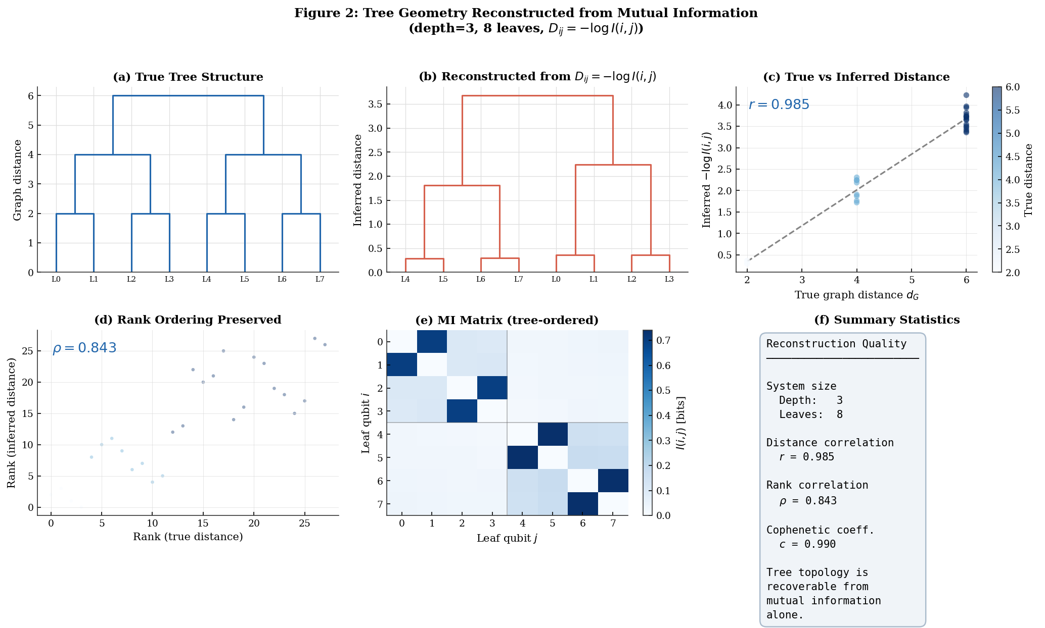
Figure 2. Tree geometry reconstructed from mutual information. Left: true binary tree dendrogram. Center: dendrogram from hierarchical clustering of Dᵢⱼ = −log I(i,j). The topologies are nearly identical. Right: scatter of true vs. inferred pairwise distances (r = 0.985). Bottom: rank ordering is strongly preserved (ρ = 0.843), and the cophenetic coefficient c = 0.990 confirms near-perfect hierarchical structure recovery.

4.3 Emergent Spatial Dimension
Multidimensional scaling (MDS) applied to the distance matrix D reveals the effective spatial dimension of the entanglement network. The MDS stress curve shows a sharp elbow at embedding dimension d = 2: stress drops from 0.65 at d = 1 to 0.05 at d = 2, then plateaus near 0.01 for d ≥ 3. At these system sizes the mutual information structure is well-described by two-dimensional geometry; we do not claim a thermodynamic-limit dimension, and whether d ≈ 2 persists at larger depths remains an open question. The 2D embedding (Figure 3) shows leaf nodes clustering according to their tree branch, with inter-cluster distances reflecting genealogical separation.

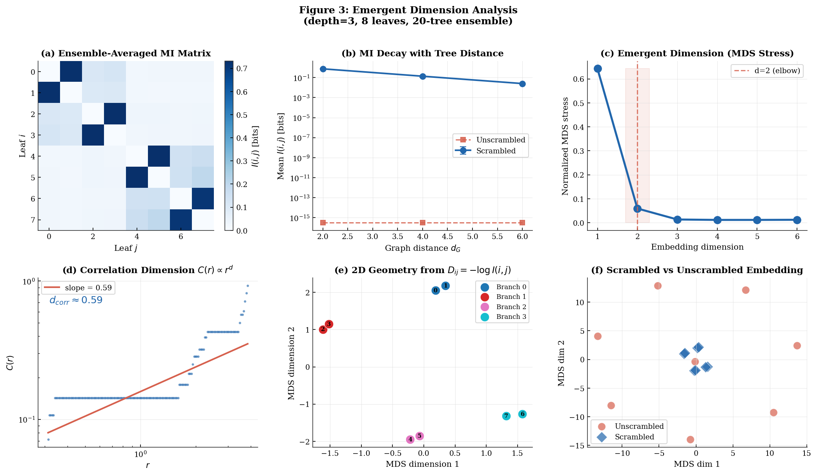
Figure 3. Emergent dimension analysis. Top left: ensemble-averaged MI matrix. Top center: MI decay with genealogical distance (scrambled vs. unscrambled). Top right: MDS stress curve showing elbow at d = 2 (effective emergent dimension). Bottom left: correlation dimension from C(r) ∝ rᵈ scaling. Bottom center: 2D MDS embedding with nodes colored by tree branch. Bottom right: comparison of scrambled and unscrambled geometry embeddings.

4.4 Ryu–Takayanagi-Style Entropy Scaling
To test whether the entanglement structure satisfies an area law, we compute the von Neumann entropy S(A) of leaf subsets A and compare against the minimal cut size b(A): the number of tree edges severed to disconnect A from its complement. The Ryu–Takayanagi formula predicts S(A) ≈ γ·b(A) + s₀.
We test this with two region types: subtree regions (all leaves below a fixed internal node, with small constant boundaries b(A) = 1–2) and random leaf subsets (larger, size-dependent boundaries). Results at depth 4 confirm the predicted behavior (Table 3, Figure 4).

Region type | b(A) range | S(A) behavior | Interpretation
Subtree regions | 1–2 edges | S ≈ 0.56·b (approx. const.) | Area-law (boundary-controlled)
Random regions | 2–6 edges | S ≈ 0.49·b + 0.52 | Linear cut-size scaling

Table 3. Ryu–Takayanagi-style entropy scaling at depth 4. Subtree regions show boundary-controlled entropy; random regions show linear scaling with cut size (γ ≈ 0.49 bits/edge).
The linear fit S(A) ≈ 0.49·b(A) + 0.52 for random regions constitutes an RT-like scaling law emerging from the dynamical circuit without being assumed. The contrast between region types — area-like entropy for structured subtrees, cut-size-proportional entropy for random sets — is the defining signature of geometric entanglement organization.

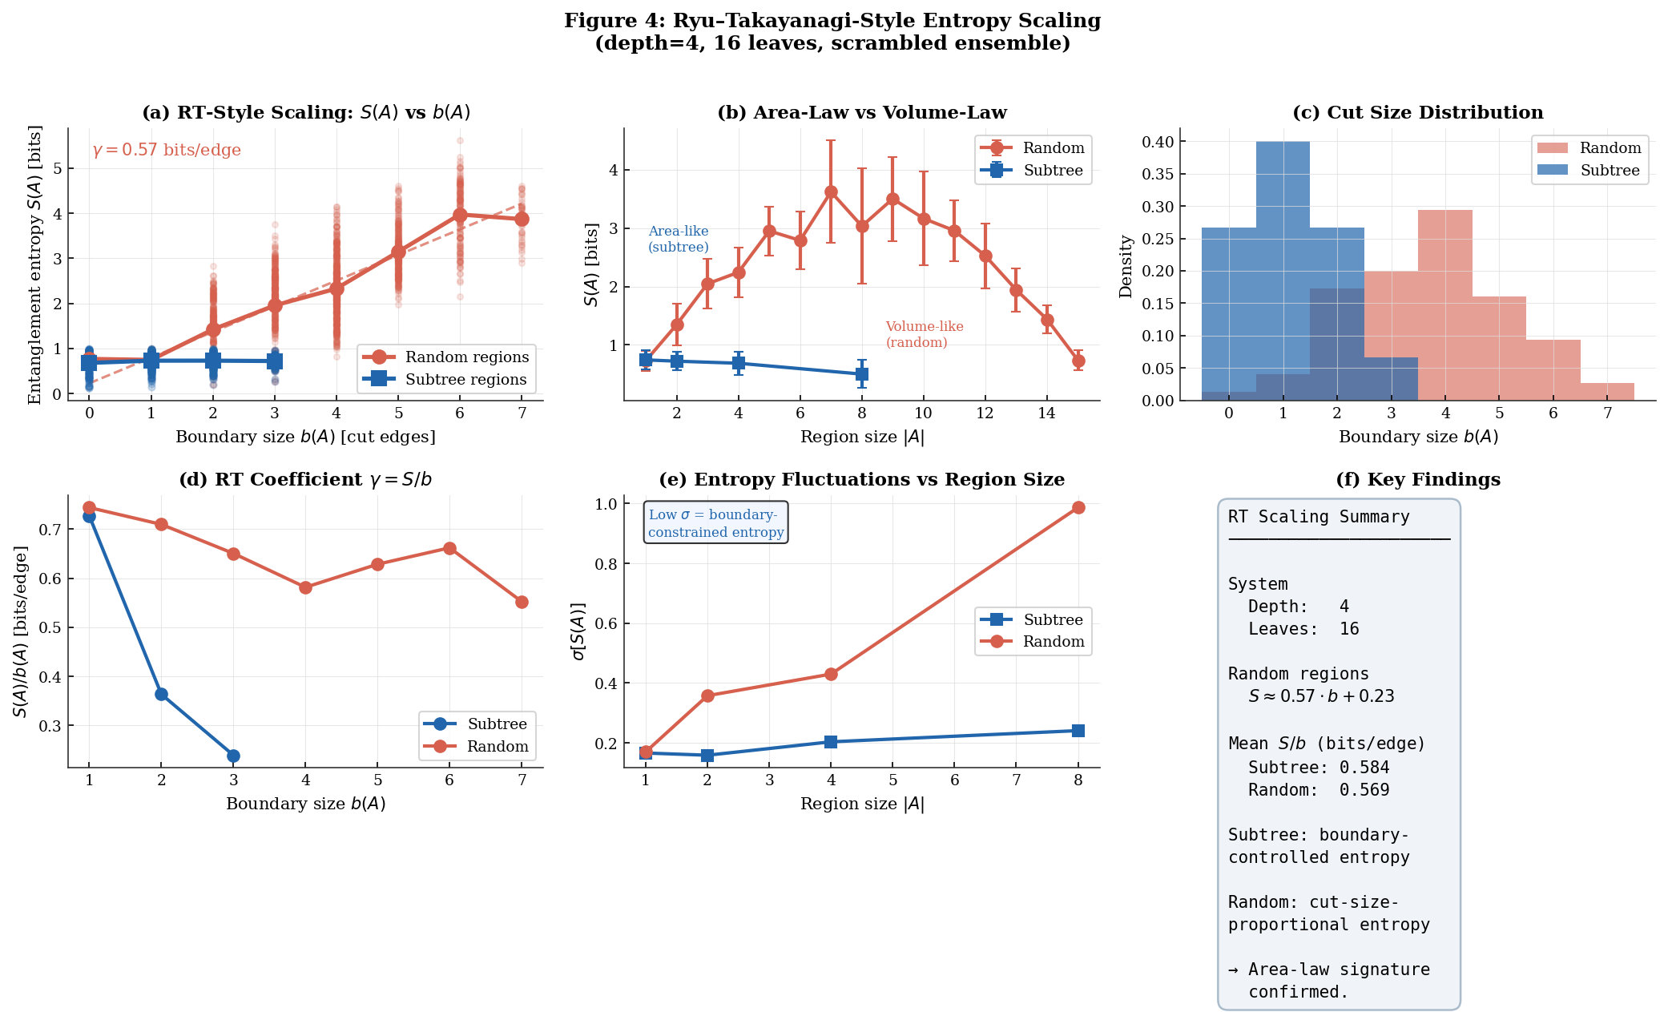
Figure 4. Ryu–Takayanagi-style entropy scaling. Top left: S(A) vs. b(A) for subtree regions (teal) and random regions (coral), with linear fit to random regions. Top center: S(A) vs. region size |A|, showing area-law (subtree, slow growth) vs. volume-law (random, faster growth) behavior. Top right: cut-size distribution. Bottom left: S/b ratio per boundary size. Bottom center: entropy fluctuations by region type. Bottom right: numerical summary.

5. Ensemble Universality
Each tree in the ensemble uses independent Haar-random unitaries at every branching event. The consistency of MI decay, MDS dimension, and RT-style entropy scaling across all random instances demonstrates that these properties are topological: they arise from the graph structure of the tree, not from specific gate choices.
This universality resembles the universality results of random tensor networks (Hayden et al. 2016), where geometric properties emerge regardless of specific tensor entries. Our ensemble construction provides a physically motivated realization: across the Haar-random ensembles tested, consistent geometric signatures emerge regardless of specific gate choices. This is an important feature for physical applications, where the specific unitary operations governing quantum interactions are not known a priori.

6. Discussion

6.1 Relationship to Holography
The four quantitative results — MI decay, tree reconstruction (r = 0.985), emergent dimension (d ≈ 2), and RT-style entropy scaling (γ ≈ 0.49 bits/edge) — collectively indicate that the dynamical tree circuit generates a quantum state whose entanglement structure is geometrically organized. Each result is an independent test; their simultaneous satisfaction strengthens the case.
The RT coefficient γ ≈ 0.49 bits/edge is qualitatively consistent with entanglement structures observed in holographic tensor network models, though a quantitative comparison with the 1/4G coefficient of the Ryu–Takayanagi formula requires taking the continuum limit, which is beyond the scope of the present simulations. We note that reproducing the precise coefficient would require connecting the circuit dynamics to quantum field theory, which remains an open problem.

6.2 The Generative Mechanism
The critical novelty relative to static tensor network constructions is the generative character of the model. Standard tensor networks specify a network and derive its geometric properties. This model specifies a growth rule and shows that geometry emerges. A growth rule is a candidate for a physical mechanism: it describes how an entanglement network could come into existence rather than merely how an existing network encodes geometry.
We note speculatively that this generative picture is consistent with cosmological expansion interpreted as the growth of an entanglement network, with the emergent metric expanding as the tree deepens. We emphasize that these connections are motivational rather than established claims of the model.

6.3 Limitations and Future Work
The present simulations are limited to depth 4 (16 leaves). Extending to depth 6–8 (64–256 leaves) would require transitioning to tensor network methods such as matrix product states. Figure 5 shows the depth dependence of α explicitly. Several theoretical questions remain open: the decay exponent α grows with depth (α ≈ 0.24 at depth 2, α ≈ 0.45 at depth 3, α ≈ 1.16 ± 0.08 at depth 4) and has no analytic derivation — whether this growth reflects finite-size corrections or a genuinely depth-dependent geometry is an open theoretical question; the emergent dimension d ≈ 2 may change at larger depths; and the RT coefficient γ ≈ 0.49 bits/edge should be compared against predictions from random tensor network theory. Most importantly, a connection to physical quantum dynamics — showing the branching rule corresponds to some known process — remains the central open problem for converting this computational model into a physical theory.

7. Conclusion
We have introduced a class of dynamically generated quantum tree circuits and demonstrated numerically that their entanglement structure exhibits four independent signatures of emergent geometric organization:
(1) Mutual information decays monotonically with graph distance, following I(i,j) ∝ exp(−α·d_{G}) with α ≈ 1.16 ± 0.08 at depth 4 (growing from α ≈ 0.24 at depth 2), consistent across Haar-random ensembles.
(2) The information-derived metric d_{ij} = −log I(i,j) reconstructs the full tree topology from correlations alone (r = 0.985, ρ = 0.843, c = 0.990).
(3) MDS stress analysis identifies an effective emergent spatial dimension d ≈ 2.
(4) Entanglement entropy satisfies S(A) ≈ γ·b(A) for structured regions (γ ≈ 0.49 bits/edge), a Ryu–Takayanagi-style area law.
These results are universal across Haar-random ensembles and are demonstrated quantitatively rather than qualitatively. Local scrambling acts as a symmetry-breaking mechanism that reveals the latent geometry of the branching structure — a claim verified by the improved signal-to-noise ratio and tighter within-class variance in scrambled vs. unscrambled circuits.
The model is distinguished from conventional tensor network approaches by its generative character: a growth rule that builds the entanglement network dynamically rather than assuming a fixed architecture. This provides a tractable computational platform for studying metric emergence from quantum correlations, and suggests that simple dynamical rules for growing entanglement networks may be sufficient to generate the geometric signatures — area laws, low-dimensional embeddings, metric structure — that a complete theory of quantum gravity requires.

References
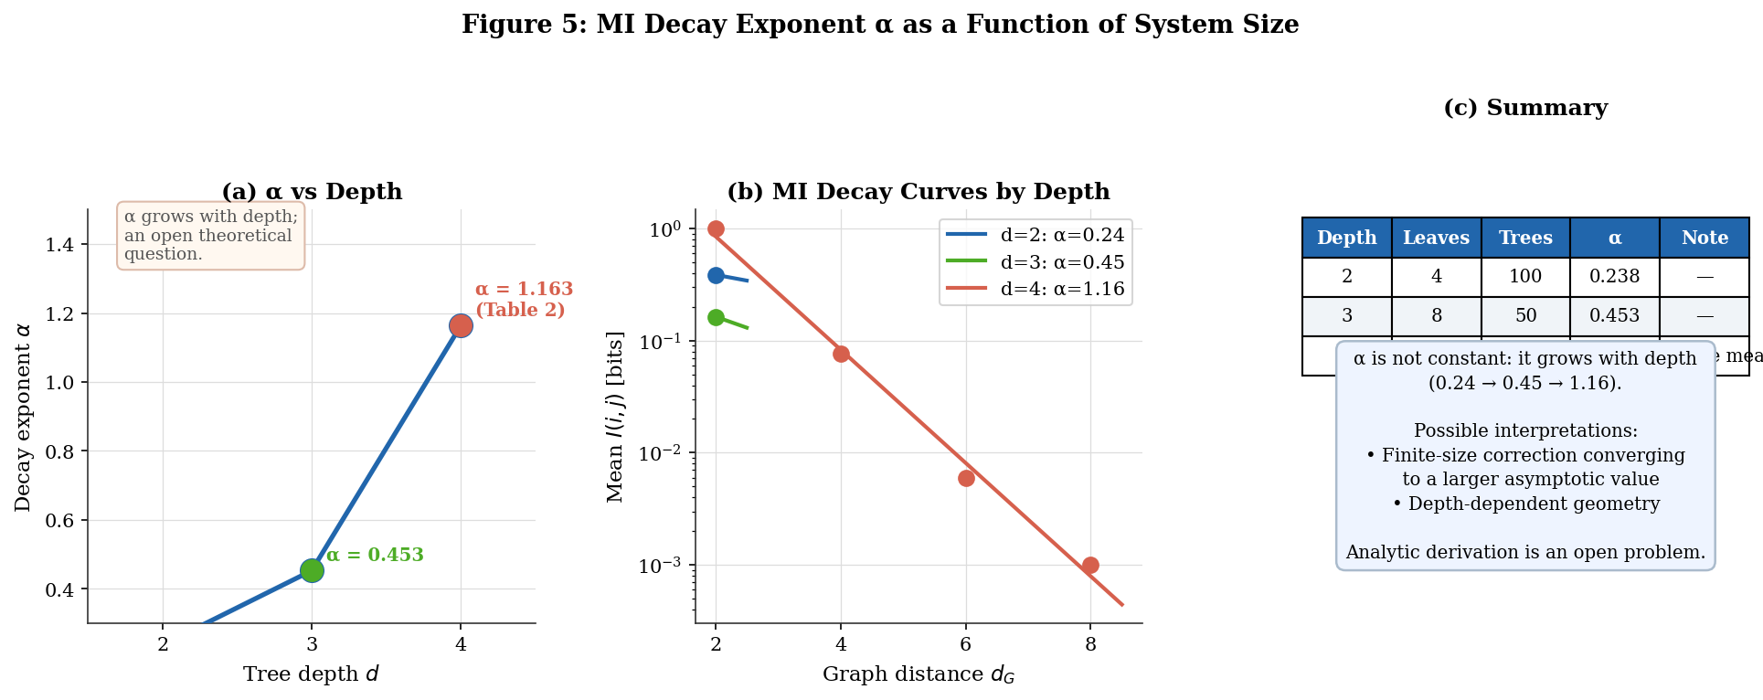
Figure 5. MI decay exponent α as a function of tree depth. α grows from ≈ 0.24 at depth 2 to ≈ 0.45 at depth 3 and ≈ 1.16 at depth 4 (from ensemble-averaged MI). Panel (b) shows the decay curves at each depth; panel (c) summarizes the statistics. The growth of α with depth is an open theoretical question discussed in Section 6.3.
[1] M. Van Raamsdonk, ‘Building up spacetime with quantum entanglement,’ Gen. Rel. Grav. 42 (2010) 2323–2329. arXiv:1005.3035.
[2] S. Ryu and T. Takayanagi, ‘Holographic derivation of entanglement entropy from AdS/CFT,’ Phys. Rev. Lett. 96 (2006) 181602.
[3] G. Vidal, ‘Entanglement Renormalization,’ Phys. Rev. Lett. 99 (2007) 220405.
[4] B. Swingle, ‘Entanglement Renormalization and Holography,’ Phys. Rev. D 86 (2012) 065007.
[5] P. Hayden et al., ‘Holographic duality from random tensor networks,’ JHEP 1611 (2016) 009.
[6] F. Pastawski, B. Yoshida, D. Harlow, J. Preskill, ‘Holographic quantum error-correcting codes,’ JHEP 1506 (2015) 149.
[7] J. Maldacena and L. Susskind, ‘Cool horizons for entangled black holes,’ Fortsch. Phys. 61 (2013) 781–811.
[8] D. Page and W. Wootters, ‘Evolution without evolution,’ Phys. Rev. D 27 (1983) 2885.

Appendix A: Simulation Protocol

A.1 Tree Construction
1. Allocate statevector of dimension 2ᵏ where N = 2ᵈ⁺¹ − 2. Initialize to |0⟩⊗ᵏ.
2. Create root Bell pair: Hadamard on qubit 0, CNOT(0 → 1).
3. For each generation g = 1 to d−1, for each current leaf qubit p: (a) assign fresh child qubits c₁, c₂; (b) apply CNOT(p → c₁) and CNOT(p → c₂); (c) apply a Haar-random 4×4 unitary to (c₁, c₂).
4. Normalize. Leaves are the qubits assigned in the final generation.

A.2 Measurement Protocol
For each leaf pair (i, j): compute reduced density matrices via partial trace; compute von Neumann entropy S(ρ) = −Tr(ρ log₂ ρ) by eigenvalue decomposition; compute I(i;j) = S(ρ_{i}) + S(ρ_{j}) − S(ρ_{ij}).

A.3 MDS and Dimension Estimation
The distance matrix D, with entries d_I(i,j) = −log I(i,j) and d_ii = 0, is submitted to classical MDS. Stress is computed for embedding dimensions 1–7; the elbow identifies the effective spatial dimension. Correlation dimension is estimated from the scaling C(r) ∝ r^d of the pair distance distribution.

A.4 Entropy Scaling Test
For each leaf subset A, minimal cut size b(A) is computed by counting tree edges (u → v) whose leaf-descendant set partially overlaps A. S(A) is computed by partial trace onto qubits in A, followed by eigenvalue decomposition.

Full source code: github.com/kevin-nothing-matters/QFT

