Tutorial: Using the RGB LED

The RGB LED is actually three LEDs in one package. In order to manipulate each of the LEDs into turning on or off, we will need to setup some basic information below.

1. Open a new Arduino file. File > New
2. We need to define the RGB LEDs. The code should go at the beginning of the file.
   1. To define the RGB LED, add the following lines of code. Red is on pin 8, Blue is on pin 7, and Green is on pin 6.

#define RED 8

#define BLUE 7

#define GREEN 6

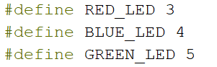

1. We need to setup the RGB LEDs are outputs. The code should be written in the setup() section.
   1. For each LED, you need to use the LED name and write the following line.

pinMode(RED, OUTPUT); // RED is connected to pin 8. It is now configured as output.

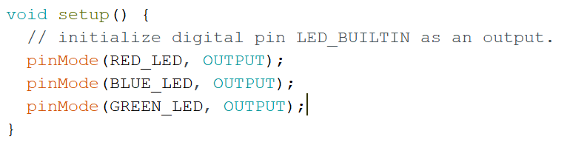

1. Now, we need to run code in the loop(). Code placed in this section will run over and over.
   1. Use the digitalWrite function.

digitalWrite(GREEN, HIGH); //Turn GREEN LED off

digitalWrite(GREEN,LOW);//Turn GREEN LED off

**digitalWrite(NAME , MODE)**

**NAME – We defined it as RED, GREEN, or BLUE.**

**MODE – This can be HIGH or LOW.**

* 1. Use the delay function.

delay(500); //Delay for half a second.

**delay(TIME)**

**TIME – This is the time. 1000 = 1 second.**

* 1. Look for the loop() section of code.

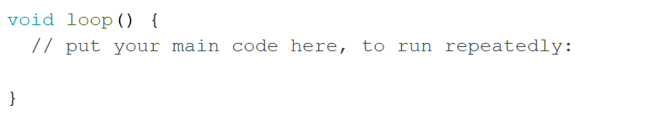

1. Let’s try to turn the RED led on and off every half second. Use the following code.

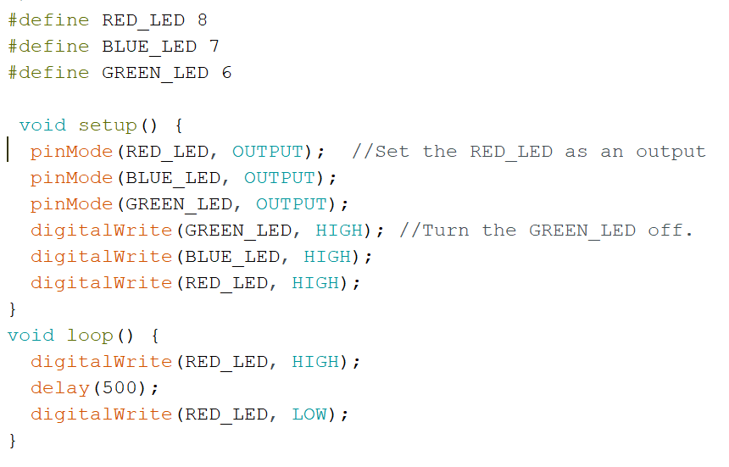

1. Use the regular programming procedure.
   1. Unplug the board and hit the arrow circled in red. Make sure that the owlBoard shows up under the lower right corner.
   2. Press the right arrow boxed in red below.

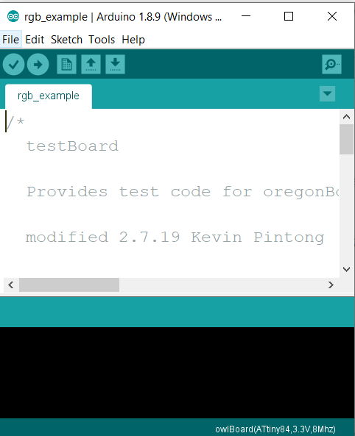

Challenge 1: Make sure you can blink the RED led.

Challenge 2: Try blinking the GREEN led or BLUE led.

Challenge 3: Make the RGB led blink in order: Red, Green and then Blue.