
Development of jatropha seed oil extraction machine
By
ARINAITWE RODGERS
Student Registration Number: 2022/A/KME/0957/G/F
An individual project report/dissertation submitted in fulfillment of the requirements for the Degree of

Bachelor of Mechanical Engineering
at
Faculty of Engineering, Technology, Applied Design, and Fine Art
Kabale University
Supervisor: Isaac Ndawula Co-supervisor: Rutaraka Gideon
Course Lecturer: Isaac Ndawula
June 2026

Declaration
I, Arinaitwe Rodgers (Registration Number: 2022/A/KME/0957/G/F), hereby declare that this bachelor’s research project entitled “Development of Jatropha Seed Oil Extraction Machine” is whilly my own original work and has not been submitted anywhere else for academic credit, either by another person or by myself.
I understand what plagiarism implies and confirm that this dissertation is my own work in terms of words, phrases, arguments, graphics, figures, results and organization except where reference is explicitly made to another’s work.
I further understand that any unethical academic behaviour, which includes plagiarism and unethical use of artificial intelligence tools is viewed seriously by kabale university and is punishable by disciplinary action.

Signed:……………………….
Date: 14th June 2026

Approval

This bachelor’s degree project report entitled “Development of Jatropha Seed Oil Extraction Machine” by Arinaitwe Rodgers (Registration Number: 2022/A/KME/0957/G/F) has been submitted with my approval as the university supervisor.
Main supervisor: Isaac Ndawula
Date:…………………………..

Acknowledgement
I wish to express my sincere gratitude and appreciation to the following individuals and organisations whose contributions made this project successful.
First and foremost, I thank the Almighty God for His endless grace, wisdom and good health throughout my studies at Kabale University.
I extend my deepest gratitude to my main supervisor, Mr.Isaac Ndawula for his professional guidance, constructive criticism, patience and valuable insights from the conceptualization stage to the completion of this project. His expertise in mechanical engineering design greatly shaped the quality of this work.
I am profoundly grateful to the Department of Mechanical Engineering at kabale university for providing academic environment, workshop facilities and technical support necessary for this reseach. Special thanks go to workshop technicians who assisted me with material sourcing and fabrication advice.
My heartfelt appreciation go to my family-my parents, siblings, relatives, fellow mwchanical engineering students, classmates and friends for their moral support during challenging phases, financial assistance and constant encouragement throughout my academic journey. Your belief in me has been my greatest motivation.
Finally, I thank the authors whose work I have cited in this report. Their previous research laid the foundation upon which this project was built.
May God bless you all abundantly.
Arinaitwe Rodgers
Kabale University
June 2026

Dedication

This project is dedicated to my beloved family for their unwavering support, encouragement and prayers throughout my academic journey. Their sacrifices have been the foundation upon which this achievement stands.
I also dedicate this work to all small scale farmers in rural Uganda and across all developing countries who strive daily to improve their livelihoods through sustainable agriculture and local innovation. May this work contribute, in whatever small way, to easing their access to affordable and efficient oil extraction technology.

Abstract
Jatropha curcas is a perennial, non-edible, drought resistant plant that grows on marginal land with minimal agricultural inputs, making it an ideal potential for biodiesel production and rural development in developing countries. Despite its promising benefits, commercialization of jatropha oil in rural Uganda remains a challenge due to absence of an efficient, locally fabricated oil extraction machine. The exising technologies are either expensive with high initial investment costs, complex in design or yielding low oil quantities, rendering them inaccessible to low income small-scale farmers.
The main objective of this project was to develop a jatropha seed oil extraction machine customized for rural areas in developing countries. The specific objectives were to conceptualise the idea, design and analyse the machine analytically and numerically through detailed design culculations and simimulations and lastly to fabricate a prototype using locally available materials and workshop facilities.
Three conceptual designs were generated that is a screw press with straight screw shaft, a screw press with tapered helical shaft, a tapered shaft vith variable screw pitch.using a weighted decision matrix based on cost-effectiveness, design complexity, extraction time and efficiency, the tapered shaft with variable screw pitch was selected as the optimal design, scoring 7.2 out of 10.
Detailed designs were performed for kinematic and kinetic analysis, load analysis, fatigue analysis, safety factor, thermal analysis, component sizing and ANSYS simulation confirmed the analytical results with discrepancies attributed to differences in boundary conditions and stress concentration modelling. Materials for the different components were selected basing on their mechanical properties and local availability in Uganda. Prototype procedures were developed after analytical and numerical results being in reasonable agreement to ensure the designed jatropha seed oil extraction machine is structurally safe, mechanically feasible and locally manufacturable, providing a practical solution for small scale farmers in rural Uganda and other developing countries by creating opportunities for local innovation, employment and sustainable biodiesel production.

Table of Contents

Declaration ii
Approval iii
Acknowledgement iv
Dedication v
Abstract vi
Table of Contents vii
List of tables xii
List of figures xiii
List of abbreviations xiv
List of symbols xv
1 Introduction 1
1.1 Background 1
1.2 Problem statement 1
1.3 Objectives 2
1.3.1 Main objective 2
1.3.2 Specific objectives 2
1.4 Justification 2
1.5 Delimitations and Limitations 3
2 Literature Review 4
2.1 Introduction 4
2.2 Solvent Extraction Method. 4
2.3 Mechanical Extraction (Press) 4
2.3.1 Hydraulic Press 5
2.3.2 Screw Press 5
2.3.2.1 Komet Presses 6
2.3.2.2 Rose Down Press 6
2.3.2.3 Strainer-Type Presses 7
2.4 Factors Influencing Oil Press Machine Operation 7
3 Methodology 8
3.1 User requirements 8
3.2 Design specifications/Design requirements 8
3.3 Concept generation 9
3.3.1 Concept One: Screw Press Oil Extraction Machine Using a Straight Screw Shaft 9
3.3.2 Concept Two: Screw Press Oil Extraction Machine Using Tapered Helical Shaft 10
3.3.3 Concept Three: Oil Extraction Machine with Tapered Shaft and Variable Pitch screw 11
3.4 Concept evaluation and selection 12
3.4.1 Evaluation criteria 12
3.4.2 Weights, Values and Total Values 13
3.4.3 Evaluation and selection approach 13
3.4.4 Selected Concept Justification 14
3.4.5 3D Modelling of the Selected Concept. 14
3.4.6 Assembly Process 15
3.5 Kinematic analysis 16
3.6 Dynamic analysis 18
3.7 Load analysis 21
3.8 Material selection 27
3.8.1 The Hopper 27
3.8.2 Screw Shaft 27
3.8.3 The Barrel 29
3.8.4 The Bearings 29
3.8.5 The Frame 30
3.8.6 The Belt and Pulley System 30
3.8.7 The Bolts 31
3.8.8 Summary 32
3.9 Component sizing/design 32
3.9.1 Hopper Design 32
3.9.2 Belt and Pulley System Design 33
3.9.3 Screw Shaft Design 35
3.9.4 Screw Flight Design 40
3.9.5 Barrel Design 42
3.9.6 Bearing Design 43
3.9.7 Frame Design 43
3.9.8 Bolt Design 45
3.9.9 Choke Mechanism Design 46
3.9.10 Oil Drainage System Design 46
3.10 Simulation 47
3.10.1 Simulation Process 47
3.10.2 Static Structural Load Application 47
3.10.3 Meshing 48
3.10.4 Static Structural Safety Factor 48
3.10.5 Static Structural Shear Stress Distribution 49
3.10.6 Static Structural Total Deformation 50
3.10.7 Static Structural Equivalent Stress on the Barrel 51
3.10.8 Static Structural Safety Factor on the Barrel 51
3.10.9 Static Structural Total Deformation on the Barrel 52
3.11 Manufacturing/prototyping procedures 53
3.11.1 Material sourcing 53
3.11.2 Screw shaft fabrication 53
3.11.3 Barrel fabrication 53
3.11.4 Hopper fabrication 53
3.11.5 Frame fabrication 53
3.11.6 Belt and Pulley system preparation 53
3.11.7 Choke mechanism fabrication 53
3.11.8 Assembly 54
3.11.9 Inspection and testing 54
3.11.10 Painting and finishing 54
3.11.11 Final documentation 54
4 Results and discussion 55
4.1 Kinematic Analysis Results 55
4.2 Kinetic/Dynamic Analysis Results 56
4.3 Load Analysis Results 57
4.4 Fatigue Analysis Results 60
4.5 Thermal Analysis Results 61
4.6 Component Sizing Results 61
4.6.1 Hopper Sizing 61
4.6.2 Belt and Pulley System Sizing 62
4.6.3 Screw Shaft Sizing 63
4.6.4 Screw Flight Sizing 65
4.6.5 Barrel Sizing 65
4.6.6 Bearing Sizing 66
4.6.7 Frame Sizing 66
4.6.8 Bolt Sizing 67
4.7 Simulation Results 68
4.7.1 Meshing on the shaft 68
4.7.2 Static Structural Safety Factor on the shaft 68
4.7.3 Static Structural Shear Stress Distribution on the shaft 69
4.7.4 Static Structural Total Deformation 69
4.7.5 Static Structural Equivalent Stress on the Barrel 69
4.7.6 Static Structural Safety Factor on the Barrel 70
4.7.7 Static Structural Total Deformation on the Barrel 70
5 Conclusion and future work 71
5.1 Conclusion 71
5.2 Future work 71
5.2.1 Optimization of operating parameters 71
5.2.2 Oil yield analysis 71
5.2.3 Durability and Fatigue testing 72
5.2.4 Design improvements 72
5.2.5 Economic and social feasibility studies 72
5.2.6 Quality standards and certification 72
5.2.7 Application diversification 72
References 74

List of tables
Table 3.1: Design specifications 8
Table 3.2: Ranking Table. 13
Table 3.3: Concept scoring matrix table. 13
Table 3.4: Bending Moments Table 24
Table 3.5: Material Selection Summary Table. 32
Table 3.6: Belt and Pulley Design Specifications 33

List of figures
Figure 2.1: A diagram of komet screw press (Murthy et al., 2019). 6
Figure 2.2: A diagram of rose down screw press (Murthy et al., 2019). 7
Figure 2.3: A diagram of strainer-type screw press (Murthy et al., 2019). 7
Figure3.5: Exploded View of the 3D Model. 15
Figure 3.4: 3D Model of the Selected Concept. 16
Figure 3.6: Free Body Diagram 24
Figure 3.7: Load Application on the Shaft 48
Figure3.8: Meshing on the shaft 48
Figure 3.9: Safety Factor on the Shaft. 49
Figure 3.10: Shear Stress on the Shaft 50
Figure 3.11: Total Deformation on the Shaft 51
Figure 3.12: Equivalent Stress on the Barrel 51
Figure 3.13: Safety Factor on the Barrel 52
Figure 3.14: Total Deformation on the Barrel 52

List of abbreviations
ANSYS: Analysis Systems (engineering simulation software)
ASTM: American Society for Testing and Materials.
CAD: Computer Aided Design
FEA: Finite Element Analysis
FOS: Factor of Safety
HRC: Hardness Rockwell C

List of symbols
α: Angle of twist (radians) or thermal coefficient
δ: Static deflrction (m)
η: Efficiency
λ: Helix angle (degrees) or slenderness ratio
µ: coefficient of friction
ρ: Density
σ: Normal Stress
τ: Shear stress
ω: Angular velocity
≈: Approximately
>: Greater than
<: Less than

Introduction

Background
In industry, oil extraction machines are used to expel oil out of oil containing material such as plant seeds. A jatropha seed oil extraction machine is a mechanical equipment used to squeeze jatropha oil out of jatropha seeds by either cold or hot pressing. In operation, oil seeds are fed into the machine through the hopper, the machine then conveys, crushes and presses the oil seeds in a cylindrical barrel with worm shaft and plates until oil is squeezed out of the seed. The extracted oil is drained through the oil outlet and residual cake is discharged at cake outlet.
Jatropha curcas is a perennial, non-edible, drought and pest resistant plant that grows on all types of land with minimal agricultural inputs and easy to harvest that serves various purposes such as making living fences, controlling soil erosion, firewood and others (Patel et al., 2016). Its bark can be used to make dyes, leaves to rear silkworms and other parts can be turned into bio-oil, insecticide, soap and medicine with its oil particularly being used for cooking, lubrication, lighting lamps, paint binders as well as raw material for biodiesel production(Tambunan et al., 2012). Jatropha seed oil extraction involves various activities such as cleaning, dehulling, drying and grinding though oil yield depends on particle size, extraction time and temperature, moisture content, nature and type of solvent used(Gutiérrez et al., 2008). Jatropha seed oil can be extracted by either solvent extraction, mechanical extraction or a combination of the two.
In Developing Countries, oil extraction from jatropha seeds remains a major challenge with the most available methods being manual, time consuming and yielding low oil quantities. Commercial oil expellers, though efficient, are costly and complex to operate and maintain which gives a blueprint to the need for a simple, efficient and locally fabricated oil extraction machine to process jatropha seeds effectively for rural applications in order to maximize benefits of small-scale farmers such as increasing labor productivity while minimizing production costs (Mašín and Petrů, 2016). Such a machine would encourage jatropha seed oil extraction, biodiesel production, create employment opportunities and promote sustainable development in rural communities.

Problem statement
With all the promising benefits of jatropha, the absence of an efficient locally fabricated oil extraction machine to extract oil from jatropha seeds remains a potential hinderance to its commercialization especially for small scale farmers and potential entrepreneurs in rural areas of developing countries. The fact that existing technologies are expensive with high initial investment cost, complex component designs, yielding low oil quantities, high energy consumption rates, make them inaccessible to low-income users. Also, the fact that many rural farmers rely on manual oil extraction methods, or costly imported presses, this results into high labor inputs, time delays and high costs of purchasing which limit jatropha seed oil extraction, employment opportunities and rural development.

Objectives

Main objective
To develop a jatropha seed oil extraction machine.

Specific objectives
- To conceptualize the idea of developing a jatropha seed oil extraction machine customized for rural areas in developing countries.
- To design and analyze the machine numerically and analytically to ensure strength and efficiency through detailed design calculations and simulations.
- To prototype the designed machine using the locally available materials and available workshop facilities.

1.4 Justification
The significancy of the study lies in integrating biomechanical properties of jatropha seeds with robust engineering principles to extract jatropha seed oil by designing and prototyping a machine that is cost-effective, Eco-friendly and locally adaptable for small-scale jatropha oil extraction in rural areas of developing countries and reducing capital outflow on imported equipment. The project supports rural development by creating opportunities for rural innovation and manufacturing, job employment and simplicity in jatropha seed oil extraction while utilizing the locally available materials.

1.5 Delimitations and Limitations
The project focuses on mechanical oil extraction mechanism involving idea conceptualization, machine design and analysis as well as prototype fabrication. However, the study does not cover large-scale industrial extraction or solvent-based methods of oil extraction, transesterification process and economic feasibility. Analysis and testing will be conducted under controlled workshop conditions as a detailed model requires further study that time and financial limitations can’t allow.

Literature Review

2.1 Introduction
Jatropha oil can be extracted from jatropha seeds using mainly two conventional methods that is; solvent extraction method and mechanical extraction method sometimes called pressing. Many oils can be extracted from various seeds by one of the two methods or a combination of the two(K Yusuf, 2018). However, mechanical oil extraction method is the commonly used method because it’s easier, cheaper and requires low maintenance although it requires further treatments such as filtering and degumming(Siregar et al., 2015).

2.2 Solvent Extraction Method.
Solvent extraction is a chemical method of oil extraction where the raw material is treated with a solvent such as hexane, petroleum ether, diethyl ether and ethanol while putting into consideration the particle size, solvent-solute ratio, solvent-oil relative volatility, oil viscosity and polarity, costs and market available(Shittu et al., 2018). Solvents such as hexane easily dissolve vegetable oils due its suitable boiling temperature with relatively low latent heat of evaporation hence conserving energy during distillation. In addition, hexane is non corrosive to metals, chemically resistant under process conditions, neutral to extracted oil and readily available at reasonable price. Because of ecological factors, instead of hexane, low risk solvents like ethanol, isopropanol and hydrocarbons are sometimes used. With this method, the disadvantages are that the extraction method is lengthy, high solvent consumption, high investment, high energy requirement, emission of volatile organic compounds into the atmosphere, high operation costs, poor product quality and damage to heat-sensitive compounds due to high flammability of solvents(Khalaf et al., 2023).

2.3 Mechanical Extraction (Press)
Mechanical extraction is the application of pressure to bring oil out of the material by either screw or hydraulic pressing. Mechanical pressing can be done by either cold-pressing or hot-pressing. Cold pressing, sometimes called scarification is carried out at low temperature of less than 500℃ and pressure whereas hot pressing is carried out at high temperatures and pressure(K Yusuf, 2018). With cold-pressed oils, valuable nutraceuticals like phytosterols and tocopherols in the oil are retained but hot-pressed oils have reduced viscosity at high temperatures which enhances oil flow and efficiency during extraction(Patel et al., 2016). The advantage of hot-pressing over cold-pressing is higher oil extraction efficiency but due to the heat involved, the overall oil quality is lower. Hence, Cold-pressed oils are safer than hot pressed ones reason being that cold-pressing low temperatures prevent unfavorable effects of deterioration of valuable oil components, decline in oxidative stability and overall reduction in oil quality due to factors like press pressure, process, spiral press rotational speed, process temperature, grain moisture, location, variety and environment (Bakhshabadi et al., 2025). The various types of extraction machines include; screw presses, hydraulic presses, roll presses and mills, disc mills, interlocking finger extractors, reamers, collapsible plate, frame-filter presses, sayari expellers, komet expellers, ram presses, strainer presses and cylinder-hole presses.

2.3.1 Hydraulic Press
A typical hydraulic press consists of a pump that aids transmission power for the fluid, the medium of power transmission through hydraulic pipes and connectors, control devices and then hydraulic motor to convert hydraulic energy into useful work at the point of load resistance(Kumar and Sharma, 2008). Hydraulic presses have three main parts that is to say; piston base, circular slats and the cylinder where the seeds are placed for squeezing. Circular slats are placed between the seeds to uniformly distribute the acting force and enhance oil yield. Hydraulic presses are more advanced, easy to control, efficient and expensive with higher oil yields less compared to other methods as some of the oil is absorbed in the seed cake after extraction(Khalaf et al., 2023).

2.3.2 Screw Press
These operate by pressing the seed to extract oil by feeding the oil seeds into the barrel through the hopper where a screw press rotates within the barrel to crush and squeeze the oil out of the seeds. The resultant friction leads to increase in temperature adding to the high pressure setting hence squeezing out the oil that seeps through the screens as the residual material continues. The extracted oil is collected in separate vessel and the residual seed cake is used as animal feed or fertilizer. The metal frame connects all these components together with the bearings to provide support for the high pressure and temperature conditions generated within the system. If the cake still has high oil content, solvent method may be used to extract it and then the clear extracted oil taken for refinery where it may be bleached, deodorized and so forth.
Screw presses have three main parts namely; base, housing and the screw whereby the screw is inserted into housing that is supported by the base. An electric motor is attached to the gear box to minimize the screw’s r.p.m. that is regulated by the frequency inverter while the motor speed is controlled by the direction switch and the temperature of the preheated seeds is controlled by wireless thermostat(Khalaf et al., 2023). The advantage of screw press over the hydraulic press is that they have a continuous mode of operation and oil yields are higher. The science is not just in squeezing, but in the mechanics of oil expression and materials science that breaks down the jatropha seed into hull, kernel and cellular matrix with oil being stored in the intracellular organelles while extraction requires breaking the cell walls by compressive stress, shear strain and often thermal energy(Singh et al., 2008).

2.3.2.1 Komet Presses
These use cylindrical vessel with drilled oil drainage holes and tapered screw shaft. Oil and cake drainage zones prevent clogging as heating jacket reduces oil viscosity thus improving flow. They are excellent for excellent large-scale centralized operations using induction heating jackets to boost yield but at a power cost(≥3kW) which is untenable for many rural areas in developing countries.
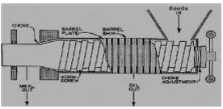
Figure 2.1: A diagram of komet screw press (Murthy et al., 2019).

2.3.2.2 Rose Down Press
These comprise a gearbox-driven screw shaft, horizontal feeder, vertical feeder and interchangeable cage liners. The screw shaft uses multi-stage compressions to gradually increase pressure, lower power peaks and wear.
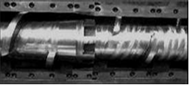
Figure 2.2: A diagram of rose down screw press (Murthy et al., 2019).

2.3.2.3 Strainer-Type Presses
These use perforated plates for oil drainage and adjustable choke cones to control cake thickness. They are simpler and easier to fabricate.
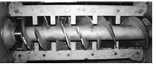
Figure 2.3: A diagram of strainer-type screw press (Murthy et al., 2019).

2.4 Factors Influencing Oil Press Machine Operation
The oil yield depends on seed type, seed quality depending on whether seeds were harvested too early or too late, proper seed harvest and storage, moisture content as too moist seeds give gummy residual cake, pressing temperature, pressure settings such as distance between press head and screw end, press speed, diameter of residual cake exit hole and type of screw used.

Methodology

User requirements
The fact that existing technologies are expensive with high initial investment cost, complex component designs, yielding low oil quantities, high energy consumption rates, make them inaccessible to low-income small-scale rural farmers. Also, the fact that many rural farmers rely on manual oil extraction methods, or costly imported presses, this results into high labor inputs, time delays and high costs of purchasing which limit jatropha seed oil extraction, opportunities for rural innovation and manufacturing, job employment, biodiesel production as well as utilization of local materials and resources thus limiting rural development. In this project, the core design philosophy lies in the buildability, repairability and adaptability of the oil extraction machine design for components to be repairable and adjustable not only to seeds, but to people such as the left-handed users and shorter operators while preserving oil quality and meeting the needs of small-scale farmers in rural areas of developing countries. The machine design intends to be cost-effective, Eco-friendly and locally adaptable for small-scale jatropha oil extraction in rural areas of developing countries in order to reduce capital outflow on imported equipment as well as supporting rural development by creating opportunities for rural innovation and manufacturing, job employment, biodiesel production as well as utilizing local materials and resources.

Design specifications/Design requirements
The design specifications are summarized and presented in TABLE
Table 3.1: Design specifications
Specification | Description
Cost-effectiveness | Machine design should be cost-effective in its design and prototyping as well as to low-income small-scale users in rural areas of developing countries.
Design complexity | Machine design should be easy to build, repair and adopt for small-scale jatropha oil extraction in rural areas of developing countries while using the locally available materials and resources.
Oil yield quantity and quality | Machine design should be able to maximize oil yield in terms of both quantity and quality.
Energy consumption rate | The machine design should be able to minimize the rate of energy consumption while effectively and efficiently functioning.
Extraction time and efficiency | Machine design should be able to minimize extraction time while maximizing efficiency.
Usability and safety | Machine design should be user-friendly to all people such as the left-handed users and shorter operators as well as Eco-friendly in terms of safety.
Automation | The machine design should be semi-automatic so that it is easier and simpler to operate.
Engineering standards | The machine design should be able to meet engineering standards so as to be competitive on international market.

Concept generation
Having identified customer requirements and generated the design specifications, the next critical stage in the design process is the generation of diverse mechanical concepts customized to meet and solve customers’ needs or requirements. The following are the concepts that can be approached, developed and evaluated to develop a jatropha seed oil extraction machine.

Concept One: Screw Press Oil Extraction Machine Using a Straight Screw Shaft
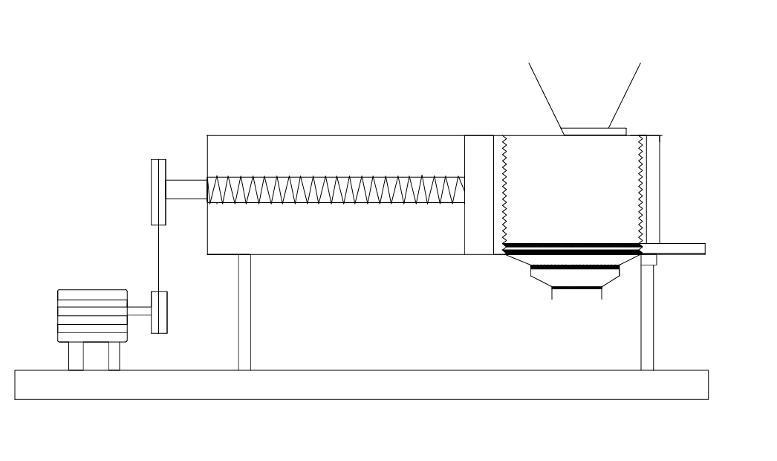
screws
Sieve system
Screw shaft
piston
hopper
motor
Figure 3.1: Screw Press Oil Extraction Machine using a Straight Screw Shaft.
This is a modified screw oil press with a vertical pressing and filtration chamber. The screw is uniformly tapered and compression takes place in the vertical chamber where seeds are fed into the machine through the hopper. The horizontal screw rotates, presses and crushes the seeds in the chamber and due to continuous feeding by the screw and restricted outlet below, pressure builds within the chamber and creates bulk compression. Due to this bulk compression, oil is squeezed out through the screens and the residual cake is discharged out. The advantage of this type of machine design is better control of filtration and separation, reduced wear on the screw with relatively more uniform oil drainage though its slightly more complex with possibility of clogging in vertical chamber.

Concept Two: Screw Press Oil Extraction Machine Using Tapered Helical Shaft
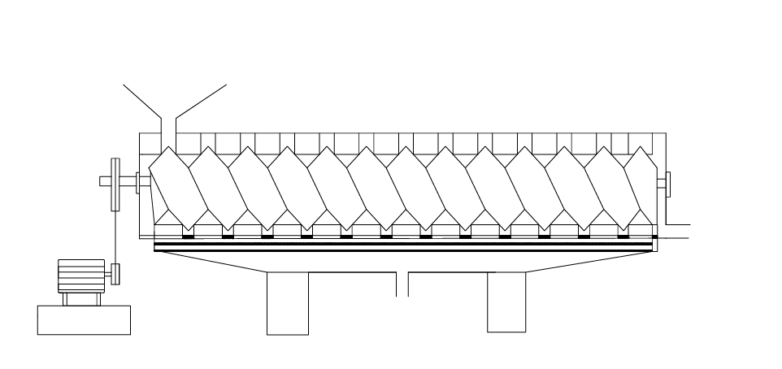
Sieve system
Screw shaft
Driving shaft
motor
hopper
Figure 3.2: Screw Press Oil Extraction Machine using a Tapered Helical Shaft
Jatropha oil seeds are fed into the machine through the hopper and the rotating screw conveys the seeds forward inside the barrel. As the seeds move forward, the space reduces due to the tapered screw of reducing pitch which increases the pressure that is controlled by choke mechanism and friction hence crushing the seeds and rupturing the oil cells. Through the small gaps in the barrel, oil is squeezed out into the collection tray and the residual oil cake becomes compact and discharges through the end outlet. The advantage with this machine design is that its simple to design, easy to maintain and repair but with higher power consumption due to friction, wear and tear of the barrel. The differently hatched sieves along the barrel make up the screen grades with coarse ones at inlet and finer ones at oil outlet in order to prevent solid particles from escaping along as oil flows out.

Concept Three: Oil Extraction Machine with Tapered Shaft and Variable Pitch screw
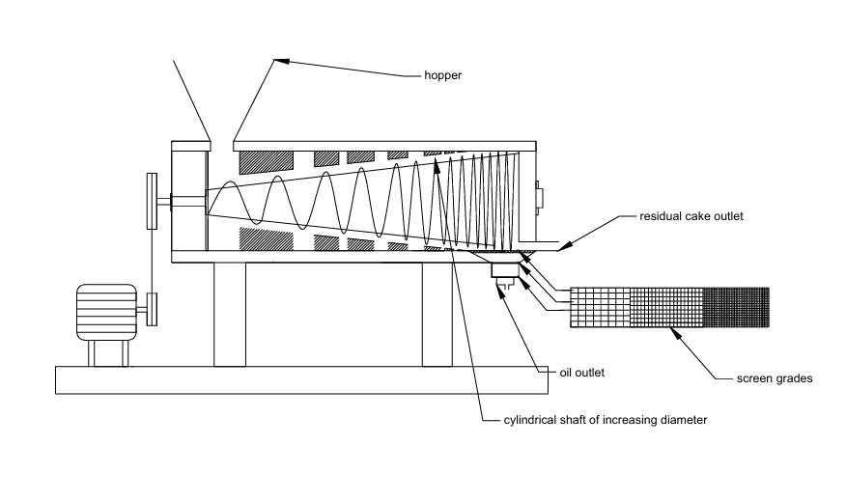
motor
Figure 3.3: Screw Press Oil Extraction Machine Using Screw with Tapered Shaft and Variable Pitch.
This machine design combines screw types with tapered shaft and screws with decreasing pitch with shaft diameter increasing towards the discharge end. Oil seeds are fed into the machine through the hopper and the screw within the barrel rotates and convey the seeds forward. The cylindrical shaft of increasing diameter creates the pressure due to very small clearances by reducing volume and the rate of pressure increase in this type of screw is higher compared to other types of screw. As the seeds are being crushed oil is being released out through the screens to outlet as the solid residual cake is being compressed and discharged at outlet. The screw through which the seeds are fed has the maximum pitch in order to increase seed capacity. The volume is decreased by an amount in each single turn while distance and pressure are constant through each thread but increase at the transitions. The advantage with this machine design is that its simple and more efficient but with higher power consumption, wear of screw and barrel and requires pretreatment of seeds.

Concept evaluation and selection
This involves the steps taken into consideration for coming up with the decision on what concept best suits the intended objectives.

Evaluation criteria
The set criteria for concept evaluation includes cost-effectiveness, design complexity, oil yield quantity and quality, energy consumption rate, extraction time and efficiency, usability and safety.

Weights, Values and Total Values
According to the relative importance of the overall success of the machine design, appropriate weight values are assigned to various evaluation criteria. The sum of the weight is equal to one and is defined by;
𝑊₁ +𝑊₂+𝑊₃+……….………………………. +𝑊_{𝑛} $=\sum_{i=1}^{n}{W}$_{𝑖}=1
Where n is the number of evaluation criteria.
Each concept is assigned a value between 0 to 10 according to how well it satisfies the evaluation in consideration. For various concepts, the product of weight and value obtained is noted and the total value (TV) is compared. Total value (TV) is given by
TV = 𝑊₁ ×𝑉₁ +𝑊₂×𝑉₂+𝑊₃×𝑉₃+….…………………………. + 𝑊_{𝑛}×𝑉_{𝑛}

Evaluation and selection approach
Design specifications were narrowed down to a smaller number by eliminating those that cut across all concepts so that a selection matrix can be used to easily identify the most suitable concept that can fulfil customer and performance requirements.
Table 3.2: Ranking Table.
Ranking of Weights | 0 | 0.25 | 0.5 | 0.75 | 1
Description | Poor | Fair | Average | Good | Very Good
Table 3.3: Concept scoring matrix table.
Evaluation Criteria | Weights | Concept One |  | Concept Two |  | Concept Three
 | W | V₁ | W×V₁ | V₂ | W×V₂ | V₃ | W×V₃
Cost-Effectiveness | 0.25 | 6 | 1.50 | 8 | 2.00 | 7 | 1.75
Design Complexity | 0.25 | 5 | 1.25 | 6 | 1.50 | 7 | 1.75
Extraction Time | 0.20 | 6 | 1.20 | 7 | 1.40 | 8 | 1.60
Efficiency | 0.30 | 5 | 1.50 | 6 | 1.80 | 7 | 2.10
Total Values |  |  | 5.45 |  | 6.70 |  | 7.20
Concept three is selected as the best concept for this particular machine design of development of jatropha seed oil extraction machine with a score of 7.20 because it offers a feasible balance of shorter extraction time and higher efficiency, relatively cost effective and acceptable design complexity in relation to other concepts.

Selected Concept Justification
Basing on the progressive compression principle, increasing the shaft diameter and reducing pitch along the screw increases the internal pressure due to reduction in volume as increase in pressure increases cell rapture and higher oil extraction. On extraction time, highest rank (8) indicates high mass flow rate and throughput due to minimal dead zones, backflow and material clogging because of the continuous screw system and thus processing time is reduced. Considering complexity, the score (7) suggests better stress distribution along the shaft which is strength as tapered shafts reduce shock loading. The gradual compression prevents sudden torque spikes that cause energy losses and structural failure due to vibrations thus improving durability and reliability. The design of Screw Press Oil Extraction Machine that uses a Tapered Shaft and Variable Screw Pitch is the optimal machine design with superior mechanical performance such as pressure development, material flow efficiency and energy utilization. The tapered compression mechanism ensures progressive load application, enhanced oil extraction efficiency with minimal mechanical losses. Although this machine design is slightly more complex, its design remains manufacturable and offers better economic returns in the long run which makes it the most suitable design for the development of jatropha seed oil extraction machine.

3D Modelling of the Selected Concept.
The development of a 3D model for jatropha oil seed extraction machine was done in SolidWorks CAD software. Modelling started by creating a new assembly file, defining units in mm and sketching 2D profiles of each component on a selected reference plane. The different sketch tools were used to constructs the geometry that represents the outline of the part. The sketches were then dimensioned and constrained using geometric relations to ensure that their shape and size are fully defined. They were then transformed into 3D objects using feature tools such as swept boss/ base and lofted cut for variable pitch extruder screw, extrude boss for barrel top cover and pulleys, shell and fillet for hopper, hole wizard for bolts, trim/extend for support stands, revolved boss for nozzles of oil and residual cake seed outlets and toolbox from SolidWorks built-in library to insert bearings. Pulleys and belts were designed using design library. Additional features like Fillets and chamfers were applied to edges of objects to reduce stress concentrations. Mirroring features were employed to replicate repetitive elements efficiently. After that, different material properties were assigned to each component, preparing the model for later simulation studies. Each component was then saved as an individual part file to ensure that it can be independently modified and reused when necessary.
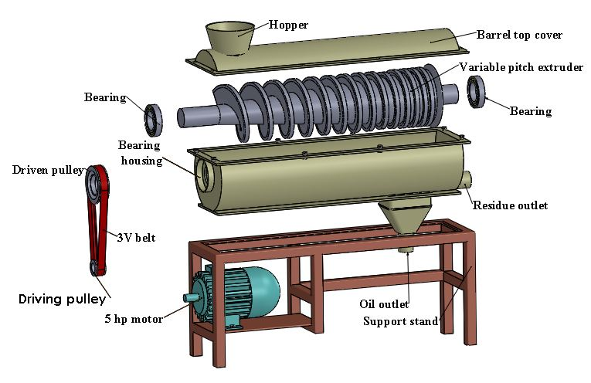
Figure3.5: Exploded View of the 3D Model.

Assembly Process
The assembly modelling was then done by bringing together all individual components to a new assembly file. Mates were applied to define how they fit and move relative to one another while simulating real mechanical relationships. The assembly process started by fixing support stands by mating motor face to stand plate using coincident and bolt holes. Pulleys were added concentric and coincident to extruder shaft. The motor was then connected to the pulleys using the belt/chain feature. Bearings were mounted using concentric mates with extruder shaft axis. Extruder screw was inserted by mating inside bearing bores and defining rotational degrees of freedom. The barrel cover was added to the barrel coincident with the stand top and cutouts for the extruder. The hopper was attached coincident and offset to barrel inlet. The oil and residual cake outlets were mated to the barrel bottom.
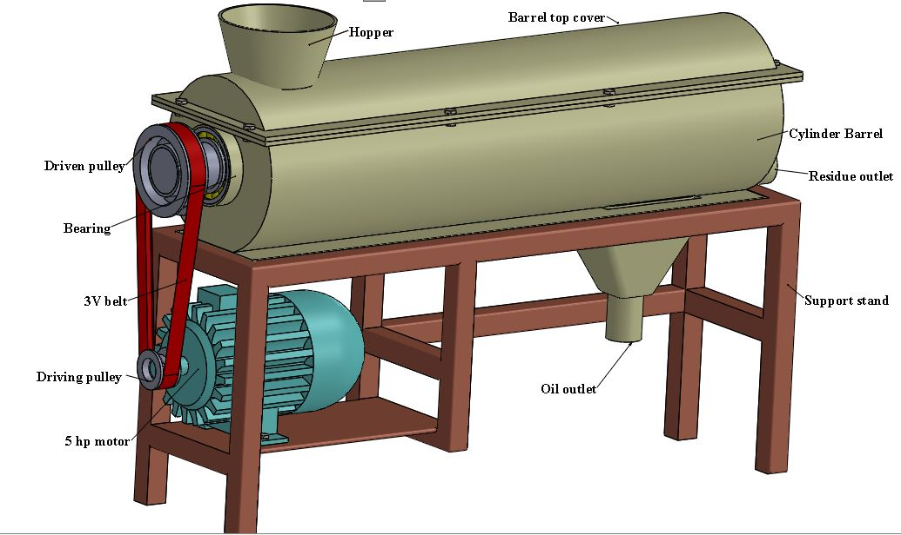
Figure 3.4: 3D Model of the Selected Concept.

Kinematic analysis
Kinematic analysis focuses on the motion characteristics of machine components without considering the forces causing the motion.
The angular velocity of the shaft was calculated using the equation;
$$\begin{aligned}ω=\frac{2πN}{60}\#3.8\end{aligned}$$
where N=screw speed(rpm).
The screw flight forms a helical surface which conveys and compresses the seeds causing axial thrust. The helix angle of the screw flight was calculated using the equation;
$\begin{aligned}\tan{λ}=\frac{p}{πD}\#3.9\end{aligned}$
where p=pitch of the screw(mm) and D=screw diameter (mm) at feed and compression zones. The reduction in helix angle along the screw increases compression and oil extraction efficiency.
To increases residence time and improve compression, the axial velocity of seeds along the screw was calculated using the equation;
$\begin{aligned}V_{a}=\frac{pN}{60}\#3.10\end{aligned}$
where p= pitch(m) and N=screw speed (rpm) at feed and compression zones.
The cross-sectional conveying areas for flow at both feed and compression zones were calculated using the equation;
$\begin{aligned}A=\frac{π}{4}{(D}^{2}-d^{2})\#3.11\end{aligned}$
where D=internal diameter of the barrel (m) and d=screw diameter at feed zone(m).
The volumetric flow rate of jatropha seeds in the barrel was calculated using the equation;
$$\begin{aligned}Q_{V }=AV_{a}η_{f}\#3.12\end{aligned}$$
where η_{f=} oil seed fill factor, A and V_{a} are average values for feed and compression zones.
The mass flow rate was calculated using the equation;
$$\begin{aligned}ṁ=ρQ_{V}\#3.13\end{aligned}$$
where ρ=bulk density of jatropha seeds(kg/m³).
The velocity of the belt was calculated using the equation;
$\begin{aligned}V=\frac{πDN}{60} \#3.14\end{aligned}$
where D=diameter of the driver motor pulley(m) and N=motor speed(rpm).
The critical speed of the shaft was calculated using the Rayleigh – Ritz equation;
$\begin{aligned}U_{sc}=\frac{60}{2π}\sqrt{\frac{g}{δ}} \#3.15\end{aligned}$
where g=acceleration due to gravity and δ=static deflection at mid-point of the simply supported shaft(m).
As screw shaft conveys seeds along the screw, heat is generated due to friction. This frictional heat helps oil to flow by reducing viscosity and the velocity at which this frictional heat moves was calculated using the equation;
$$\begin{aligned}U=\frac{πdN}{60}\#3.16\end{aligned}$$
where d=screw diameter (m) and N=screw speed(rpm).

Dynamic analysis
Dynamic analysis focuses on the forces, torques, stresses, pressures and power acting on the machine. As seeds move along the screw, forces such as axial Compression Force, Friction Force and Radial Pressure from the barrel develop due to volume reduction.
Oil expression follows Darcy’s law for flow through porous media. Using the screw press theory, the pressure developed along the screw shaft was calculated using the equation;
$$\begin{aligned}P_{c}=\int_{0}^{l}{\frac{2µωR}{h\left(x\right)}}dx \# 3.17\end{aligned}$$
where l=length of the screw, μ=coefficient of friction, R=reaction on the screw, the clearance, $h\left(x\right)=\frac{D-d}{2}$ where D=feed pitch, d=compression pitch.
For oil to be extracted out of jatropha seeds, they must undergo compression along the screw shaft. The axial compression force acting on the seeds between the screw and the barrel was calculated using the equation;
$\begin{aligned}F_{a}=P_{c}A\#3.18\end{aligned}$
where A=cross section area at compression zone(m²).
The torque required to drive the screw shaft was calculated using the equation;
$$\begin{aligned}T=F_{a}×r\#3.19\end{aligned}$$
where F_{a} =axial compression force(N) and r=radius of the screw(m).
The amount of power required to move and rotate the shaft was calculated using the equation;
$\begin{aligned}P=\frac{2πNT}{60} \# 3.20\end{aligned}$
where N=screw speed(rpm) and T= torque required to drive the screw (Nm)
The required power of the motor was calculated using the equation;
$\begin{aligned}P_{m}=\frac{P}{η} \# 3.21\end{aligned}$
Where η=efficiency of the motor hence the appropriate motor size suitable for operation was selected.
The belt design power was calculated using the equation;
$$\begin{aligned}P_{d}=K_{s}P_{m} \#3.22\end{aligned}$$
where K_{s}=pulley service factor and P=motor power.
The frictional force due to contact between the screw, seeds and the barrel generate heat and contribute to power loss. Although this frictional force affects the distribution of torque along the shaft, it enhances oil flow by reducing viscosity. The frictional force acting on the shaft was calculated using the equation;
$$\begin{aligned}F_{f}=μF_{a }\# 3.23\end{aligned}$$
where µ=coefficient of friction.
The total effective force on the shaft was calculated using the equation;
$$\begin{aligned}F_{total}=F_{a}+F_{f} \# 3.24\end{aligned}$$
The heat generated due to friction should be moderate and controlled to aid oil flow without overheating the screw shaft. The frictional power loss due to frictional heat was calculated using the equation;
$$\begin{aligned}P_{f}=F_{f}U \# 3.25\end{aligned}$$
The equivalent dynamic load for tapered roller bearings was calculated using the equation;
$$\begin{aligned}P=XF_{r}+YF_{a} \# 3.26\end{aligned}$$
Where F_{r}=radial load on the shaft, X=radial load factor and Y=axial load factor for tapered roller bearings hence a bearing with the resulting dynamic rating can be selected for the design.
The shaft experiences bending due to belt tensions, screw weight and seed compression loads. The resultant load on the pulley was calculated using the equation;
$$\begin{aligned}F_{p}=T_{1}+T_{2} \# 3.27\end{aligned}$$
where T₁ and T₂ are belt tensions in newtons at tight and slack sides of the pulley respectively.
For a simply supported shaft, the maximum bending moment on the shaft due to pulley load was calculated using the equation;
$$\begin{aligned}M_{b}=F_{P}×l \# 3.28\end{aligned}$$
Where l=length of the shaft.
To predict failure of the shaft, the maximum shear stress theory (Tresca theory) of failure was used to determine the equivalent twisting moment on the shaft using the equation;
$\begin{aligned}T_{e}=\sqrt{{\left(K_{b}M_{b}\right)}^{2}+({K_{t}T)}^{2}} \# 3.29\end{aligned}$
where K_{b}=combined shock and fatigue factors applied to Bending Moment and K_{t}=combined shock and fatigue factors applied to Torsional Moment.
The allowable shear stress on the shaft was calculated using the equation;
$\begin{aligned}τ_{a}=\frac{{0.3S}_{y}}{f} \# 3.30\end{aligned}$
where S_{y}=yield strength of shaft material and f=factor of safety of the material.
The screw is subjected to torsional and axial compressive stresses. The torsional shear stress acting on the shaft was calculated using the equation;
$\begin{aligned}τ=\frac{{16T}_{e}}{πd^{3}} \# 3.31\end{aligned}$
where d=diameter of the shaft.
To prevent buckling (bursting) of the barrel, Lame’s thick cylinder theory was used to design an appropriate thick cylindrical barrel. The tangential stress on the barrel was calculated using the equation;
$\begin{aligned}σ_{t}=\frac{P_{c}\left({r_{o}}^{2}+{r_{i}}^{2}\right)}{\left({r_{o}}^{2}-{r_{i}}^{2}\right)} \# 3.4\end{aligned}$
where P_{c}=compression pressure, r_{o}=external diameter of the barrel, and r_{i}=internal diameter of the barrel.

Load analysis
Load analysis was conducted to determine the magnitude, direction and distribution of all forces, moments and torques acting on a component throughout its operating cycle to aid in predicting stress, deflection, fatigue life for safe and reliable design. For this machine design, the screw shaft is the most critical loaded component. The screw shaft transmits power while simultaneously subjecting material to high compressive forces.
The cross-sectional conveying areas for flow at both feed and compression zones were calculated using the equation;
$\begin{aligned}A=\frac{π}{4}{(D}^{2}-d^{2})\#3.11\end{aligned}$
where D=internal diameter of the barrel (m) and d=screw diameter at feed zone(m).
The torque transmitted on the screw shaft was calculated using the equation;
$$\begin{aligned}T=\frac{9594P}{N}\#3.32\end{aligned}$$
where P=motor power (kW) and N=screw shaft speed (rpm).
Due to the torque being transmitted along the screws on the shaft, the reaction on the screw thread was calculated using the equation;
$$\begin{aligned}R=\frac{2T}{d} \#3.33\end{aligned}$$
where d=diameter of the screws (m).
As screw shaft rotates in the barrel, seeds are conveyed, crushed and compressed to extract oil. The angular velocity of the screw shaft was calculated using the equation;
$$\begin{aligned}ω=\frac{2πN}{60}\#3.8\end{aligned}$$
where N=screw speed(rpm).
The radial clearance between the screws and the barrel was calculated using the formular;
$\begin{aligned}h\left(x\right)=\frac{D-d}{2} \#3.34\end{aligned}$
where D=internal diameter of the barrel (m) and d=screw diameter (m).
Using the screw press theory, the pressure developed along the screw shaft can be calculated using the equation;
$$\begin{aligned}P_{c}=\int_{0}^{l}{\frac{2µωR}{h\left(x\right)}}dx \# 3.17\end{aligned}$$
where l=length of the screw (m) and μ=coefficient of friction.
The axial compression force is developed from backpressure as volume between the screw flights decreases due to reducing pitch and seeds being forced against the barrel and discharge choke. This axial force contributes to torque requirement and influences bearing selection. The axial compression force acting on the seeds between the screw and the barrel was calculated using the equation;
$$\begin{aligned}F_{a}=P_{c}A\#3.18\end{aligned}$$
Where Pc=compression pressure (N/m) and A=axial compression area (m).
The torsional moment (torque) is generated by the electric motor and transmitted via the belt and pulley system at the overhung and is applied at the pulley, transmitted along the shaft to screw and gradually absorbed by the seeds as they are compressed along the screw length. The torque required to drive the shaft was calculated using the formula;
$$\begin{aligned}T=F_{a}×r \#3.19\end{aligned}$$
Where r=radius of the screw shaft (m). This torque must overcome seed resistance during conveying, crushing and compressing along the screw length.
The distributed resisting torque along the screw length is due to axial compression force of seeds and is converted to torque via thread helix angle. The helix angle of the screw flight was calculated using the equation;
$\begin{aligned}\tan{λ}=\frac{p}{πD}\#3.9\end{aligned}$
where p=pitch of the screw (mm) and D=screw diameter (mm). The smaller the helix angle, the higher the torque for the same axial force which implies more torque is absorbed per meter.
The mass of the shaft was calculated using the formula;
$$\begin{aligned}m_{1}=\frac{π}{4}d^{2}lρ\#3.35\end{aligned}$$
Where d=average diameter of the shaft (m), l=length of the shaft covered with screws (m) and ρ=density of steel material.
The mass of the shaft not covered with screws (overhang +plain end) was calculated using the formula;
$$\begin{aligned}m_{2}=\frac{π}{4}d^{2}lρ \#3.36\end{aligned}$$
Where d=average diameter of the shaft (m), l=overhang length between the pulley and the bearing (m) +plain end length at discharge end (m) and ρ=density of steel material.
Total mass of the whole shaft length was calculated using the equation;
$$\begin{aligned}m={(m}_{1}+m_{2})f\#3.37\end{aligned}$$
Where f=factor of safety
The weight of the whole shaft length was calculated using the equation;
$$\begin{aligned}W=mg\#3.38\end{aligned}$$
Where g=acceleration due to gravity.
The uniform load distribution along the entire length of the shaft was calculated using the formula;
$$\begin{aligned}UDL=\frac{W}{l}\#3.39\end{aligned}$$
Where l=length of the entire shaft.
The shaft experiences bending due to belt tensions, screw weight and seed compression loads. The resultant load on the pulley was calculated using the equation;
$$\begin{aligned}F_{p}=T_{1}+T_{2} \# 3.27\end{aligned}$$
where T₁ and T₂ are belt tensions in newtons at tight and slack sides of the pulley respectively.

R_{D}
R_{B}
F_{p}
W
Figure 3.6: Free Body Diagram
Two bearing arrangement provides adequate support while allowing for thermal expansion and minor misalignments during assembly. To obtain the reactions at the bearings, the sum of vertical forces was considered whereby sum of upward forces is equal to sum of downward forces and the results can be obtained using the equation;
$$\begin{aligned}R_{B}+R_{D}=F_{p}+W\#3.40\end{aligned}$$
where R_{B}=reaction at feed bearing and R_{D}=reaction at discharge bearing. Taking moments at the discharge end bearing (point D), the reaction at the feed bearing (R_{B}) can be obtained hence R_{D} was obtained.
Bending moment is caused by transverse loads acting on the shaft due to self-weight of the shaft, weight of screw flights and overhung pulley load resulting from belt tensions. Unlike torque, bending moment varies significantly along the shaft length and depends on support conditions of the bearings. To obtain the bending moment at each point of force application, the whole beam was sectioned and the following bending moment equations were obtained at different points on the shaft as shown in the table below.
Table 3.4: Bending Moments Table
At point A (pulley): | $$M=1246.5X$$
At point B (feed bearing): | $$M=1246.5X-1588.7(X-0.1)$$
At point C (centroid weight): | $$M=1246.5X-1588.7\left(X-0.1\right)+287.4(X-0.4)$$
Where M=bending moment and X=distance from point of application of moments so the maximum bending moment was obtained.
As the shaft rotates to convey, crush and compress jatropha seeds, it experiences thermal load due to friction. The frictional force acting on the shaft was calculated using the equation;
$$\begin{aligned}F_{f}=μF_{a }\# 3.23\end{aligned}$$
where µ=coefficient of friction.
The frictional power loss in form of heat was calculated using the equation;
$$\begin{aligned}P_{f}=F_{f}U \# 3.25\end{aligned}$$
The heat generated due to friction should be moderate and controlled to aid oil flow without overheating the screw shaft. The temperature rise in one hour due to frictional heating of the shaft was calculated using the equation;
$$\begin{aligned}T_{o}=\frac{P_{f}×t}{m×c} \#3.54\end{aligned}$$
where t=operating time, m=mass of the barrel and c=specific heat of steel.
The thermal stress analysis on the shaft was determined by first calculating the thermal expansion of the shaft using the equation;
$$\begin{aligned}∆L=αLT_{o} \#3.87\end{aligned}$$
Where α=coefficient of thermal expansion for steel, l=entire length of the shaft (m) and T_{o}=temperature rise.
The thermal stress in the shaft if fully constrained was calculated using the equation;
$$\begin{aligned}σ=EαT_{o} \#3.88\end{aligned}$$
Where E=modulus of elasticity for steel.
Using the maximum shear stress theory (Tresca theory) of failure, the equivalent twisting moment on the shaft was calculated using the equation;
$\begin{aligned}T_{e}=\sqrt{{\left(K_{b}M_{b}\right)}^{2}+({K_{t}T)}^{2}} \# 3.29\end{aligned}$
where K_{b}=combined shock and fatigue factors applied to Bending Moment and K_{t}=combined shock and fatigue factors applied to Torsional Moment
The screw is subjected to torsional and axial compressive stresses. The torsional shear stress acting on the shaft was calculated using the equation;
$\begin{aligned}τ=\frac{{16T}_{e}}{πd^{3}} \# 3.31\end{aligned}$
where T_{e}= equivalent twisting moment on the shaft and d=selected design diameter of the shaft.
The moment of inertia on the shaft was calculated using the equation;
$$\begin{aligned}I=\frac{{πd}^{4}}{64} \#3.56\end{aligned}$$
Due to self-weight and seed load on the shaft, the static deflection at mid-point of the simply supported shaft was calculated using the equation;
$$\begin{aligned}δ=\frac{{WL}^{3}}{48EI} \#3.57\end{aligned}$$
where W=load applied on the shaft (weight of shaft + weight of screw), L=length between bearings (m) and E= Modulus of elasticity.
The screw shaft rotates continuously at a given rpm, experiencing reverse bending stress from tension to compression back to tension for each revolution causing high-cycle fatigue. The estimated modified endurance limit of the shaft was calculated using the equation;
$$\begin{aligned}{S_{e}}^{'}=0.5S_{u} (for S_{u}<1400 MPa)\#3.58\end{aligned}$$
where S_{u}=ultimate strength of the material.
The fatigue strength of the shaft at 10⁴ cycles was calculated using the equation;
$$\begin{aligned}f=1.6-\left(4.1×{10}^{-4}S_{u}\right)+\left(1.5×{10}^{-7}{S_{u}}^{2}\right) for 500<S_{u}<1400 MPa \#3.59\end{aligned}$$
The surface finish factor of the shaft was calculated using the equation;
$\begin{aligned}C_{f}=aN^{b} where a=\frac{{\left(fS_{u}\right)}^{2}}{{S_{e}}^{'}} and b=\frac{-1}{3}log\frac{fS_{u}}{{S_{e}}^{'}} \#3.60\end{aligned}$e temperature factor of the shaft was calculated using the equation;
$$\begin{aligned}C_{t}=1-0.0058\left(T_{o}-450\right)\#3.61\end{aligned}$$
where T_{o}=maximum operating temperature (⁰C).
The actual endurance limit of the shaft was calculated using the equation;
$$\begin{aligned}S_{e}=C_{f}×C_{r}×C_{s}×C_{t}×\frac{1}{K_{f}}×{S_{e}}^{'} \#3.62\end{aligned}$$
where C_{r}=reliability factor, C_{s}=size factor, K_{f}=fatigue stress concentration factor.
Due to rotation of the shaft, the screw shaft experiences alternating bending stress which was calculated using the equation;
$$\begin{aligned}σ_{a}=\frac{32M_{b}}{πd^{3}} \#3.63\end{aligned}$$
where M_{b}=bending moment on the shaft (Nm) and d=diameter of the screw shaft (m)

Material selection
The different materials for the different design components were selected basing on yield strength, wear resistance, safety, machinability, durability, anti-corrosion characteristics and cost among others.

The Hopper
This is a circular truncated conical unit through which jatropha seeds are fed into the machine by gravity with a control feed gate to regulate seed input. It is positioned directly above the screw shaft at feed zone. ASTM A36 steel material was selected due to its yield strength of 250 MPa that withstand static loading of seeds without permanent deformation, good ductility due its ability to slightly bulge under overload without brittle fracture, good weldability and relatively low cost.

Screw Shaft
This is a component responsible for conveying, crushing and compressing the oil-bearing jatropha seeds. The shaft rotates inside a fixed barrel and as seeds move along the screw flights, the available volume decreases generating high pressures necessary for oil extraction. The screw shaft experiences bending from the weight of the seeds, axial compression and torsion from the motor torque to compress jatropha oilseeds hence causing shear. The maximum shear stress acting on the solid circular shaft is denoted by the equation;
$$\begin{aligned}τ_{max}=\frac{16T}{πd^{3}} \#3.1\end{aligned}$$
where T=applied torque (Nm) and d=diameter of the shaft (mm). Due to bending moment on the shaft, the shaft experiences deflection due to self-weight and seed load but excessive shaft deflection causes uneven wear between the screw and the barrel, premature bearing failure and increased vibration. The maximum deflection for a simply supported shaft is denoted by the equation;
$$\begin{aligned}δ=\frac{{WL}^{3}}{48EI} \#3.2\end{aligned}$$
where W=load applied on the shaft (weight of shaft + weight of screw), L=span length, E= Modulus of elasticity and I=area moment of inertia. The screw shaft rotates continuously at a given rpm, experiencing reverse bending stress from tension to compression back to tension for each revolution causing high-cycle fatigue. To determine the endurance limit of the shaft, the following equation can be used;
$$\begin{aligned}S_{e}=C_{f}×C_{r}×C_{s}×C_{t}×\frac{1}{K_{f}}×{S_{e}}^{'} \#3.3\end{aligned}$$
where C_{f}=surface finish factor, C_{s}=size factor, C_{r}=reliability factor, C_{t}=temperature factor, K_{f}=fatigue stress concentration factor and S_{e}’=estimated modified endurance limit. Therefore, the screw shaft material was selected as Alloy Steel AISI 4140 (Chromoly) for power transmission due to its high shear yield strength of 415 MPa that allows the shaft to handle starting torque, its fatigue strength that provides high endurance limit resisting crack propagation from the cyclical torsional stress, its high strength-weight ratio that prevents deflection and resonance in long spans. Its high ultimate strength of 655 MPa optimizes the endurance limit of the screw shaft.

The Barrel
The barrel acts as a thick pressure cylinder subjected to internal pressure. As the screw shaft rotates, the friction between the seeds and the barrel increases by reducing the degree of slippage and rotation of pressed seed cake with the shaft. In so doing, the barrel experiences internal pressure, tangential stress, thermal loading and wear. To prevent bursting, Lame’s thick cylinder theory can be used to design an appropriate thick cylindrical barrel. The tangential (hoop) stress experienced by the barrel can be calculated using the equation;
$\begin{aligned}σ_{t}=\frac{P_{c}\left({r_{o}}^{2}+{r_{i}}^{2}\right)}{\left({r_{o}}^{2}-{r_{i}}^{2}\right)} \# 3.4\end{aligned}$
where P_{c}=compression pressure (MPa), r_{o}=external diameter of the barrel(mm), and r_{i}=internal diameter of the barrel(mm). The barrel also experiences sliding contact from the rotating screw with abrasive jatropha seed particles. Considering Archard’s wear law, the volume of the material worn away can be calculated using the equation;
$$\begin{aligned}V=K\frac{FL}{H}\#3.5\end{aligned}$$
Where K=wear coefficient, F=normal contact force (N), L=sliding distance (m) and H=hardness of the softer material. From Archard’s equation, the volume of material worn away due rolling or sliding contact between two surfaces is inversely proportional to the hardness of the material meaning that maximizing hardness is the only mathematical way to reduce material loss from the internal surface of the barrel. The barrel design material was selected as Hardened Steel AISI 4340 due to its high yield strength of 470 MPa to handle internal pressures generated by compacted material, high abrasion resistance and toughness to withstand impacts without shattering.

The Bearings
Bearings can be used to support rotating shafts, constrain relative motion with precise alignment and transmit loads from the shaft to the frame while allowing smooth and low-friction rotation. Unlike radial bearings, screw shaft bearings must handle a unique combination of high axial load due to seed compression backpressure and moderate radial loads due to pulley belt tensions and shaft self-weight. For rolling contact bearings, wear occurs via rolling not sliding. Considering Archard’s wear equation;
$$\begin{aligned}L_{10}∝\frac{1}{H}\#3.6\end{aligned}$$
Where L₁₀=bearing life and H=hardness of the softer material. Increasing hardness reduces rolling contact wear and fatigue life. Under repeated high localized pressures, materials fail from sub-surface fatigue meaning that ordinary steel would yield plastically very fast. Tapered roller ball bearings 52100 of hardness 62 HRC were selected for the design because of their high carbon content that helps to resist the alternating shear stresses. The chromium in 52100 bearing forms stable carbides to aid the necessary wear resistance and high rolling contact fatigue life.

The Frame
The frame acts as a support for the barrel and the system at large. It requires to be designed in a way that vibration modes need to stay below the operating frequency. The frame requires complex welding of fillets and butt joints so Mild steel ASTM A36 with yield strength of 250 MPa and modulus of elasticity (E=207GPa) was selected for the design of the frame due to its excellent weldability, high rigidity, its high corrosion resistance and specific carbon equivalent that prevents hydrogen induced cracking post-weld and relatively low cost. In addition, its high stiffness minimizes deflection and caters for unexpected overloads under motor vibration. Short or fat columns yield in compression while slender or long columns buckle so in order to determine the maximum axial load before buckling occurs, the critical buckling load of the frame can be calculated using Euler’s buckling formula;
$$\begin{aligned}P_{cr}=\frac{π^{2}EI}{{\left(Kl\right)}^{2}} \#3.7\end{aligned}$$
where E=modulus of elasticity, I=area moment of inertia, K=effective length factor and l=unsupported length of the column. To prevent buckling of the frame, hollow sections were selected for the design in order to maximize buckling resistance due to their higher area moment of inertia.

The Belt and Pulley System
The belt and pulley system performs two major functions of power transmission and speed reduction. A motor with in-built speed reducing gearbox was selected for this design due to its higher efficiency. Grooved reinforced rubber cord composite material (Nylon) of tensile strength 923 (N/mm²) was selected for belt design due to its ability to absorb shock and ease to transmit high power per belt without slipping due to the V-groove wedges that maximize the friction coefficient. The cord reinforcement carries the tensile load at the tight side of the belt thereby preventing elongation.
The choice of pulley material is critical in this design because it directly affects the efficiency, longevity and cost of the entire power transmission system. Design Pulleys should have sufficient strength to handle transmitted torque, good frictional characteristics to prevent belt-slip, durability against wear and resistance to factors such as premature wear, dust, heat and oil. To minimize vibration and bearing loads, a uniform pulley material is required for proper dynamic balancing. For this design, cast iron GG25 material was selected due to its high yield strength of 250 MPa, high vibration damping capacity thus protects the belt, bearings and shaft from fatigue. Its ideal coefficient of friction with rubber v-belts, hardness to resist groove wear without being so hard to cause aggressive abrasion of the belt and its relatively low cost compared to Aluminum and steel for same duty cycle are crucial property requirements for this design.

The Bolts
The screw shaft rotates at a given rpm basing on the torque acting on it. Since the pulley is mounted on the same side just above the motor running at a different rpm, a lower torque is experienced by the motor. This torque due to the motor exerts a force onto the bolts. The force acting on bolts due to this torque can be calculated using the equation;
$$\begin{aligned}F=\frac{T}{R}\#3.80\end{aligned}$$
Where R=radius of the motor pulley. For a given number of bolts used, there is a force acting on each bolt. For bolt frictional grip (tightening) to occur, there is a preload required to prevent joint separation. The preload required for frictional grip can be calculated using the equation;
$$\begin{aligned}F_{g}=\frac{F_{b}×f}{μ}\#3.82\end{aligned}$$
Where f=safety factor and μ=coefficient of friction. Due to high vibration application on the bolts by the motor, Grade 8.8 Carbon Steel was selected for the design due to its high yield strength that prevents joint relaxation under cyclic motor vibrations.

Summary
The different material selections for the different components are summarized in the table below.
Table 3.5: Material Selection Summary Table.
Component | Material | Property Value | Justification
Hopper | mild steel  ASTM A36 | Yield strength: Sy = 250MPa | Easily machined, locally available, good ductility
Screw shaft | Alloy steel  AISI 4140 | Yield strength: Sy = 415 MPa  Ultimate strength: Su=655 MPa | High torsional strength, high strength-weight ratio
Barrel | Hardened steel  AISI 4340 | Yield strength: Sy = 470MPa | Wear resistance, toughness, fatigue strength
Bearings | Chrome steel  AISI 52100 | Hardness: 62 HRC | Rolling contact fatigue life, high hardness
Frame | Mild steel  ASTM A36 | Yield strength: Sy = 250 MPa | Excellent weldability, rigidity, low cost
Belt | Reinforced rubber cord composite | V-section belt type | Shock absorption, ease of power transmission
Pulleys | Cast iron  GG25 | Yield strength: Sy = 165MPa  Ultimate strength: Su = 250MPa | High vibration damping, good frictional characteristics, cost-effectiveness

Component sizing/design
This involves determining the design parameters of each component while incorporating in the guiding mechanical engineering knowledge, theories and principles.

Hopper Design
The angle of repose for jatropha seeds was calculated from the formular;
$$\begin{aligned}\tan{θ=}\frac{h}{H} \#3.41\end{aligned}$$
Where h=vertical drop (300 mm) and H=horizontal run (100 mm).
The volume of the circular truncated conical hopper was calculated using the equation;
$$\begin{aligned}V=\frac{πh}{3}\left({r_{1}}^{2}+r_{1}r_{2}+{r_{2}}^{2}\right)\#3.42\end{aligned}$$
where h=vertical height from r₁ to r₂ (0.3m), r₁=smaller radius (0.05m) and r₂=bigger radius (0.15m).
The mass of jatropha seeds the hopper can contain was calculated using the equation;
$\begin{aligned}m=ρ×V \#3.43\end{aligned}$
where $ρ$=bulk density of jatropha seeds (650 kg/m³).

Belt and Pulley System Design
The belt and pulley system is a power transmission system between the motor and the shaft. It was designed using the Fenner industrial belt drive standard. The belt and pulley system design specifications chosen are identified in the table below.
Table 3.6: Belt and Pulley Design Specifications
Design parameter | Symbol and value
Motor speed | N₁=1440 rpm
Driver motor pulley diameter | D₁=100 mm
Driven pulley diameter | D₂=400 mm
The speed of the driven pulley was calculated using the equation;
$$\begin{aligned}N_{2}=\frac{D_{1}}{D_{2}}N_{1} \# 3.44\end{aligned}$$
The velocity ratio was calculated using the equation;
$$\begin{aligned}VR=\frac{N_{1}}{N_{2}} \#3.45\end{aligned}$$
The design power accounting for shock and continuous loading was calculated using the equation;
$$\begin{aligned}P_{d}=K_{s}P_{m}\#3.46\end{aligned}$$
where P_{m}=motor power (3.73 kW) and K_{s}=pulley service factor (1.2 for heavy starting load for 8-10 hr/day service).
The Actual power transmitted per belt was calculated using the equation;
$$\begin{aligned}P_{b}=\frac{P_{d}}{K_{c}}\#3.47\end{aligned}$$
Where K_{c}=correction factor (0.9)
The number of belts required was calculated using the equation;
$$\begin{aligned}n=\frac{P_{d}}{P_{b}}\#3.48\end{aligned}$$
The velocity of the belt was calculated using the equation;
$$\begin{aligned}V=\frac{{{πD}_{1}N}_{1}}{60}\#3.14\end{aligned}$$
The difference in the belt tensions was calculated using the equation;
$$\begin{aligned}T_{1}-T_{2}=\frac{P}{V} \#3.49\end{aligned}$$
where P=Power of the motor (3.73kW), T₁ and T₂ are belt tensions in newtons at tight and slack sides of the pulley respectively.
Using Euler’s belt equation, the belt tension ratio, $\frac{T_{1}}{T_{2}}$=$e^{µɵ}$ where µ=0.3 and ɵ=2.8;
$\begin{aligned}T_{1}=2.316T_{2} \#3.50\end{aligned}$
Substituting equation 3.50 into equation 3.49, the belt tensions T₂ and T₁ were obtained.
The resultant load on the pulley system was calculated using equation;
$$\begin{aligned}F_{p}=T_{1}+T_{2} \# 3.27\end{aligned}$$
The torque transmitted by the motor was calculated using the equation;
$$\begin{aligned}T=\frac{9549P}{N} \#3.32\end{aligned}$$
where N=motor speed (1440rpm).
The power required to drive the shaft was calculated using the equation;
$$\begin{aligned}P=\frac{2πNT}{60} \#3.20\end{aligned}$$
where N=motor speed (45rpm).
The Centre distance between pulleys was calculated using the formula;
$$\begin{aligned}C=2\sqrt{\left(D_{2}-D_{1}\right)D_{1}}\#3.51\end{aligned}$$
The length of the belt was calculated using the equation;
$$\begin{aligned}l=2C+\frac{π}{2}\left(D_{2}+D_{1}\right)+\frac{{\left(D_{2}-D_{1}\right)}^{2}}{4C}\#3.52\end{aligned}$$
The angle of contact on the pulleys was calculated using the equation;
$$\begin{aligned}π-2\sin^{-1}\left(\frac{D_{2}-D_{1}}{2C}\right)\#3.53\end{aligned}$$
Where C= Centre distance between pulleys.

Screw Shaft Design
Due to the torque being transmitted along the screw shaft, the reaction on the screw thread;
$$\begin{aligned}R=\frac{2T}{d} \#3.33\end{aligned}$$
where T=torque transmitted (N) and d=diameter of the screws (0.085m).
The angular velocity of the shaft was calculated using the equation;
$$\begin{aligned}ω=\frac{2πN}{60}\#3.8\end{aligned}$$
where N=screw speed (45rpm).
The radial clearance between the screws and the barrel was calculated using the formular;
$\begin{aligned}h\left(x\right)=\frac{D-d}{2} \#3.34\end{aligned}$
where D=internal diameter of the barrel (0.09m) and d=screw diameter (0.085m).
Oil expression follows Darcy’s law for flow through porous media. Using the screw press theory, the pressure developed along the screw was calculated using the equation;
$$\begin{aligned}P_{c}=\int_{0}^{l}{\frac{2µωR}{h\left(x\right)}}dx \# 3.17\end{aligned}$$
where l=length of the shaft covered with screws (0.66m), μ=coefficient of friction (0.3) and R=reaction on the screws (N).
The axial compression area was calculated using the equation;
$$\begin{aligned}A=\frac{π}{4}(D-d)\#3.11\end{aligned}$$
where D=internal diameter of the barrel (0.09m) and d=screw diameter (0.085m) at feed and compression zones.
For oil to be extracted out of jatropha seeds along the screw shaft, they must undergo compression. So, the axial compression force acting on the seeds between the screw and the barrel was calculated using the equation;
$\begin{aligned}F_{a}=P_{c}A\#3.18\end{aligned}$ The torque required to drive the screw was calculated using the equation;
$$\begin{aligned}T=F_{a}×r\#3.19\end{aligned}$$
where F_{a} =axial compression force(N) and r=radius of the screw (0.0425m).
The amount of power required to move and rotate the shaft was calculated using the equation;
$\begin{aligned}P=\frac{2πNT}{60} \# 3.20\end{aligned}$
where N=screw speed (45 rpm) and T= torque required to drive the screw (Nm)
The required power of the motor was calculated using the equation;
$\begin{aligned}P_{motor}=\frac{P}{η} \# 3.21\end{aligned}$
where η=motor efficiency (0.75), hence the appropriate motor size suitable for operation can be selected.
The frictional force acting on the shaft was calculated using the equation;
$$\begin{aligned}F_{f}=μF_{a }\# 3.23\end{aligned}$$
where µ=coefficient of friction (0.3).
The total effective force on the shaft was calculated using the equation;
$$\begin{aligned}F_{total}=F_{a}+F_{f} \# 3.24\end{aligned}$$
As screw shaft conveys seeds along the screw, heat is generated due to friction. This heat helps oil to flow by reducing viscosity and the velocity at which this frictional heat moves was calculated using the equation;
$$\begin{aligned}U=\frac{πdN}{60}\#3.16\end{aligned}$$
Where d=screw diameter (0.085m) and N=screw speed (45rpm).
The frictional power loss in form of heat was calculated using the equation;
$$\begin{aligned}P_{f}=F_{f}U \# 3.25\end{aligned}$$
The heat generated due to friction should be moderate and controlled to aid oil flow without overheating the screw shaft. The temperature rise in one hour due to frictional heating of the shaft was calculated using the equation;
$$\begin{aligned}T_{o}=\frac{P_{f}×t}{m×c} \#3.54\end{aligned}$$
where t=operating time (3600s), m=mass of the barrel (40kg) and c=specific heat of steel (500J/kg. K).
The thermal stress analysis on the shaft was determined by first calculating the thermal expansion of the shaft using the equation;
$$\begin{aligned}∆L=αLT_{o} \#3.87\end{aligned}$$
Where α=coefficient of thermal expansion for steel (12×10⁻⁶ C⁻¹), l=entire length of the shaft (0.8m) and T_{o}=temperature rise.
The thermal stress in the shaft if fully constrained was calculated using the equation;
$$\begin{aligned}σ=EαT_{o} \#3.88\end{aligned}$$
Where E=modulus of elasticity for steel (207 GPa).
Using the maximum shear stress theory (Tresca theory) of failure, the equivalent twisting moment on the shaft was calculated using the equation;
$\begin{aligned}T_{e}=\sqrt{{\left(K_{b}M_{b}\right)}^{2}+({K_{t}T)}^{2}} \# 3.29\end{aligned}$
where K_{b}=combined shock and fatigue factors applied to Bending Moment (1.0) and K_{t}=combined shock and fatigue factors applied to Torsional Moment (1.5).
The allowable shear stress on the shaft was calculated using the equation;
$\begin{aligned}τ_{a}=\frac{{0.3S}_{y}}{f} \# 3.30\end{aligned}$
where S_{y}=yield strength of shaft material (415 MPa) and f=factor of safety of the material (f=4).
Using the maximum shear stress theory, the minimum diameter of the shaft was calculated using the equation;
$$\begin{aligned}d=(\frac{16}{{πτ}_{a}}T_{e}{) }^{\frac{1}{3}} \#3.55\end{aligned}$$
where τ_{a}=allowable shear stress on the shaft and T_{e}=equivalent twisting moment on the shaft.
The screw is subjected to torsional and axial compressive stresses. The torsional shear stress acting on the shaft was calculated using the equation;
$\begin{aligned}τ=\frac{{16T}_{e}}{πd^{3}} \# 3.31\end{aligned}$
where T_{e}= equivalent twisting moment on the shaft and d=selected design diameter of the shaft.
The moment of inertia on the shaft was calculated using the equation;
$$\begin{aligned}I=\frac{{πd}^{4}}{64} \#3.56\end{aligned}$$
Due to self-weight and seed load on the shaft, the static deflection at mid-point of the simply supported shaft was calculated using the equation;
$$\begin{aligned}δ=\frac{{WL}^{3}}{48EI} \#3.57\end{aligned}$$
where W=load applied on the shaft (weight of shaft + weight of screw), L=length between bearings (0.7m) and E= Modulus of elasticity (207x10⁹ N/m)
To avoid resonance, the natural frequency of the shaft must be far from the operating speed. The critical speed of the shaft was calculated using the Rayleigh – Ritz equation;
$\begin{aligned}U_{sc}=\frac{60}{2π}\sqrt{\frac{g}{δ}} \#3.15\end{aligned}$
where g=acceleration due to gravity (9.81m/s²) and δ=static deflection at mid-point of the simply supported shaft(m).
The screw shaft rotates continuously at 45 rpm, experiencing reverse bending stress from tension to compression back to tension for each revolution causing high-cycle fatigue. The estimated modified endurance limit of the shaft was calculated using the equation;
$$\begin{aligned}{S_{e}}^{'}=0.5S_{u} (for S_{u}<1400 MPa)\#3.58\end{aligned}$$
where S_{u}=ultimate strength of the material (655 MPa).
The fatigue strength of the shaft at 10⁴ cycles was calculated using the equation;
$$\begin{aligned}f=1.6-\left(4.1×{10}^{-4}S_{u}\right)+\left(1.5×{10}^{-7}{S_{u}}^{2}\right) for 500<S_{u}<1400 MPa \#3.59\end{aligned}$$
The surface finish factor of the shaft was calculated using the equation;
$\begin{aligned}C_{f}=aN^{b} where a=\frac{{\left(fS_{u}\right)}^{2}}{{S_{e}}^{'}} and b=\frac{-1}{3}log\frac{fS_{u}}{{S_{e}}^{'}} \#3.60\end{aligned}$e temperature factor of the shaft was calculated using the equation;
$$\begin{aligned}C_{t}=1-0.0058\left(T_{o}-450\right)\#3.61\end{aligned}$$
where T_{o}=maximum operating temperature (⁰C).
The actual endurance limit of the shaft was calculated using the equation;
$$\begin{aligned}S_{e}=C_{f}×C_{r}×C_{s}×C_{t}×\frac{1}{K_{f}}×{S_{e}}^{'} \#3.62\end{aligned}$$
where C_{r}=reliability factor (0.897 for 90%), C_{s}=size factor (0.7 for d>50 mm), K_{f}=fatigue stress concentration factor (1.2).
Due to rotation of the shaft, the screw shaft experiences alternating bending stress which was calculated using the equation;
$$\begin{aligned}σ_{a}=\frac{32M_{b}}{πd^{3}} \#3.63\end{aligned}$$
where M_{b}=bending moment on the shaft (Nm) and d=diameter of the screw shaft (0.085m)
For safety of the shaft design, the fatigue safety factor was calculated using the equation;
$$\begin{aligned}FOS=\frac{S_{e}}{σ_{a}} \#3.64\end{aligned}$$

Screw Flight Design
The screw flights act as an inclined helical conveyor inside the fixed barrel. The screw flights experience major loads of compression and shear. For progressive pressure build up, it is designed in a way that decreasing the helix angle increases compression. The screw flight forms a helical surface which conveys and compresses the seeds causing axial thrust. The helix angle of the screw flight was calculated using the equation;
$\begin{aligned}\tan{λ}=\frac{p}{πD}\#3.9\end{aligned}$
where p=pitch of the screw (10mm at feed zone and 2mm at compression zone) and D=screw diameter (85mm).
The axial velocity of seeds along the screw was calculated using the equation;
$\begin{aligned}V_{a}=\frac{pN}{60}\#3.10\end{aligned}$
where p= pitch (0.01m at feed zone and 0.002m at compression zone) and N=screw speed(45rpm).
The cross-sectional conveying areas for flow at both feed and compression zones were calculated using the equation;
$\begin{aligned}A=\frac{π}{4}{(D}^{2}-d^{2})\#3.11\end{aligned}$
where D=internal diameter of the barrel (0.09m) and d=screw shaft diameter (0.01m at feed zone and 0.002m at compression zone).
At feed zones, the volumetric flow rate was calculated using the equation;
$$\begin{aligned}Q_{V }=AV_{a}η_{f}\#3.12\end{aligned}$$
where η_{f=} oil seed fill factor (0.75).
The mass flow rate of jatropha seeds was calculated using the equation;
$$\begin{aligned}ṁ=ρQ_{V}\#3.13\end{aligned}$$
where ρ=bulk density of jatropha seeds (650 kg/m³).
The compression ratio was calculated using the equation;
$$\begin{aligned}CR=\frac{A_{1}}{A_{2}} \#3.65\end{aligned}$$
where A₁=cross-section conveying area at feed zone and A₂=cross-section conveying area at compression zone.
The screw flight experiences compressive loading, torsional shear and abrasive wear causing shear stress. The shear stress in the screw flight was calculated using the equation;
$$\begin{aligned}τ=\frac{{16T}_{e}}{{πd}^{3}} \#3.31\end{aligned}$$
where d=diameter of the screw (0.085m).
The polar moment of inertia on the shaft was calculated using the equation;
$\begin{aligned}J=\frac{{πd}^{4}}{32}\#3.66\end{aligned}$
where d=diameter of the screw (0.085m).
To obtain the angle of twist per meter, the angle of twist was calculated using the equation;
$$\begin{aligned}α= \frac{T_{e}l}{JG} \#3.67\end{aligned}$$
where l= length of the screw shaft (0.8m) and G= Modulus of rigidity (80x10⁹ N/m²).

Barrel Design
The allowable stress in the barrel was calculated using the equation;
$$\begin{aligned}σ_{all}=\frac{S_{y}}{f} \#3.68\end{aligned}$$
where S_{y}= yield strength of the material (470 MPa) and f=factor of safety (4 for stationary industrial machine).
During compression, internal pressures are generated by the compacted material. Using the pressure vessel theory, the wall thickness of the barrel was calculated using Barlow’s formula;
$$\begin{aligned}t_{b}=\frac{P_{c}d}{{2σ}_{all}}+C \#3.69\end{aligned}$$
where d=screw diameter (0.085m) and C=corrosion allowance (0.003m).
The external diameter of the barrel was calculated using the equation;
$$\begin{aligned}d_{o}=d_{i}+2t_{b} \#3.70\end{aligned}$$
Where di=internal diameter of the barrel (90mm).
As the screw shaft rotates in the barrel, the barrel experiences perpendicular stress or loop stress or tangential stress. The tangential stress experienced by the barrel was calculated using Lame’s equation;
$$\begin{aligned}σ_{b}=\frac{P_{c}\left({r_{o}}^{2}+{r_{i}}^{2}\right)}{\left({r_{o}}^{2}-{r_{i}}^{2}\right)} \#3.4\end{aligned}$$
where r_{o}=the external diameter of the barrel (mm) and r_{i}=internal diameter of the barrel (mm).

Bearing Design
Bearings are used to provide coupling to the rotating shaft. Basing on the radial nature and size of the loads on the shaft by the coupling, tapered roller bearings bore diameter of 60mm were selected. The radial load (F_{r}) acting on the bearing due to crushing and screw shaft action ≈ pulley load (F_{P}) and the axial force (F_{a}) ≈ compressive load from backpressure. The equivalent dynamic load on the bearings was calculated using the equation;
$$\begin{aligned}P=XF_{r}+YF_{a} \# 3.26\end{aligned}$$
Where X=radial load factor (0.4) and Y=axial load factor (1.5) for tapered roller ball bearings hence a bearing with the resulting dynamic rating was selected for the design.
Basic rating life is a critical calculation for bearing design that determines how many hours the bearing should operate before fatigue develops. The basic rating life of the bearing was calculated using the equation;
$$\begin{aligned}L_{10}={\left(\frac{C}{P}\right)}^{\frac{10}{3}}×{10}^{6} revolutions\#3.71\end{aligned}$$
Where C=dynamic load rating (85 kN for tapered roller bearings)
To convert to operating hours, the following equation was used;
$$\begin{aligned}L_{h}=\frac{L_{10}}{60N} \#3.72\end{aligned}$$
where N=screw speed (45 rpm).
The maximum pressure at ball contact was calculated using the Hertzian contact stress formula;
$$\begin{aligned}σ_{max}=\frac{4P}{πd^{2}} \#3.73\end{aligned}$$
where d=diameter of the bearing (60 mm)

Frame Design
The frame acts as a support for the barrel and the system at large. For hollow square section (outer 50×50 and inner 44×44 mm), the area moment of inertia was calculated using the formula;
$$\begin{aligned}I=\frac{b_{o}{h_{o}}^{3}-b_{i}{h_{i}}^{3}}{12} \#3.74\end{aligned}$$
Where b=base length (mm) and h=height (mm) for outer and inner sections.
To determine the maximum axial load before buckling occurs, the critical buckling load of the frame was calculated using Euler’s buckling formula;
$$\begin{aligned}P_{cr}=\frac{π^{2}EI}{{\left(Kl\right)}^{2}} \#3.7\end{aligned}$$
where E=modulus of elasticity (200 GPa), I=area moment of inertia, K=effective length factor (0.5 for fixed end non rotational joints) and l=unsupported length of the column (1.2m).
The maximum allowable buckling load was calculated using the equation;
$$\begin{aligned}P_{all}=\frac{P_{cr}}{f} \#3.75\end{aligned}$$
Where f=factor of safety (4)
The cross-section area was calculated using the equation;
$$\begin{aligned}A={b_{o}}^{2}-{b_{i}}^{2}\#3.76\end{aligned}$$
Where b_{o}=outer base length (50mm) and b_{i}=inner base length (44mm)
The radius of gyration refers to the minimum value if the frame axes differ due to vibrations and was calculated using the formula;
$$\begin{aligned}r=\sqrt{\frac{I}{A}}\#3.77\end{aligned}$$
To determine if yielding occurs before buckling, the slenderness ratio was calculated using the equation;
$$\begin{aligned}λ=\frac{Kl}{r} \#3.78\end{aligned}$$
where K=effective length factor (0.5 for fixed end non rotational joints) and l=unsupported length of the column (1.2m). The smaller the r, the higher the λ and the more likely buckling occurs.

Bolt Design
The screw shaft rotates at a given rpm basing on the torque acting on it. Since the pulley is on the same side just above the motor running at a different rpm, a lower torque is experienced by the motor. The torque experienced by the bolts due to the motor was calculated using the equation;
$$\begin{aligned}T=\frac{9549P}{N}\#3.79\end{aligned}$$
Where P=motor power(3.73kW) and N=motor speed(1440rpm).
This torque due to the motor exerts a force onto the bolts. The force acting on bolts due to this torque were calculated using the equation;
$$\begin{aligned}F=\frac{T}{R}\#3.80\end{aligned}$$
Where R=radius of the motor pulley (0.05m).
For a given number of bolts used, there is a force acting on each bolt. The force per bolt was calculated using the equation;
$$\begin{aligned}F_{b}=\frac{F}{n}\#3.81\end{aligned}$$
Where n=number of bolts used (4).
For frictional grip (tightening) to occur, there is a preload required to prevent joint separation. The preload required for frictional grip was calculated using the equation;
$$\begin{aligned}F_{g}=\frac{F_{b}×f}{μ}\#3.82\end{aligned}$$
Where f=safety factor (4 for bolt design in vibrating machinery) and μ=coefficient of friction (0.3).
For bolt material grade 8.8, the allowable shear stress on the bolts was calculated using the equation;
$$\begin{aligned}σ=\frac{S_{y}}{f} \#3.83\end{aligned}$$
where S_{y}= yield strength of the material (640 MPa).
Bolts experience tensile stress per unit area. The tensile stress area was calculated using the equation;
$$\begin{aligned}A=\frac{F_{g}}{σ_{all}}\#3.84\end{aligned}$$
The suitable bolt size was calculated using the equation;
$$\begin{aligned}d=\sqrt{\frac{4A}{π}}\#3.85\end{aligned}$$
The torsional stress on the bolts was calculated using the equation;
$$\begin{aligned}τ=\frac{16T}{{πd}^{3}}\#\#\#3.31\end{aligned}$$
where d=root diameter of the bolts (4.13mm).
For safety of the design, the Von-misses stress theory of failure was used to determine the safety of the design using the equation;
$$\begin{aligned}σ_{v}=\sqrt{σ^{2}+3τ^{2}}\#3.86\end{aligned}$$

Choke Mechanism Design
The choke refers to a deliberate narrowing located at discharge end of the screw press barrel that opposes the forward movement of compressed seed cake thereby creating backpressure within the barrel, increasing shear and improving material compaction. This restriction or narrowing forces the screw to work harder to push material through, thereby increasing the internal pressure within the barrel. Choking and jamming mostly depend on the vessel geometry so the vessel canalizes the compressed cake, thereby allowing oil to flow back and flow out of the vessel through the oil outlet to prevent any choking or jamming.

Oil Drainage System Design
The oil drainage system is located at the final compression zone where screws become smallest to collect and direct the expressed oil out of the barrel to the collection vessel through holes that are machined onto the vessel wall before the residual cake exits while retaining the pressed seed cake within the extraction camber or barrel. The radial clearance between the screw flights and the barrel (2.5mm) provides a continuous annular passage for oil to flow axially and radially towards the drainage openings.

Simulation

Simulation Process
Simulation was done by launching the ANSYS Workbench 2025 R1 student version. The static structural was then dragged into project schematic from the analysis systems toolbox. The different engineering parameters were defined such as material, modulus of elasticity, poisons ratio, material density and yield strength among others. The next was to import geometry of the component model from SolidWorks and assigning material to that model.
Meshing was the done by clicking on “mesh” in tree and setting element size basing on image scale. Different mechanical preferences were set and meshing was obtained by right-clicking “Generate”. The results were then obtained from the meshing such as number of nodes and elements from the fine mesh with tetrahedral elements.
Boundary conditions were set for the different actions such as fixed support, remote displacement and moment load then right-clicking “solve” to obtain the results of total deformation, shear stress and safety factor.

Static Structural Load Application
The load application diagram shows the boundary conditions and the loads applied to the screw shaft assembly. A remote displacement constraint was applied at the feed bearing location (point B) to allow rotational freedom while constraining radial movement, correctly simulating the function of a bearing support. A moment of 791Nm was applied at the pulley end (point A) to simulate the torque transmitted from the motor via the belt and pulley system. A fixed support was applied at the discharge end bearing (point C) to fully constrain all translational degrees of freedom while allowing rotation.
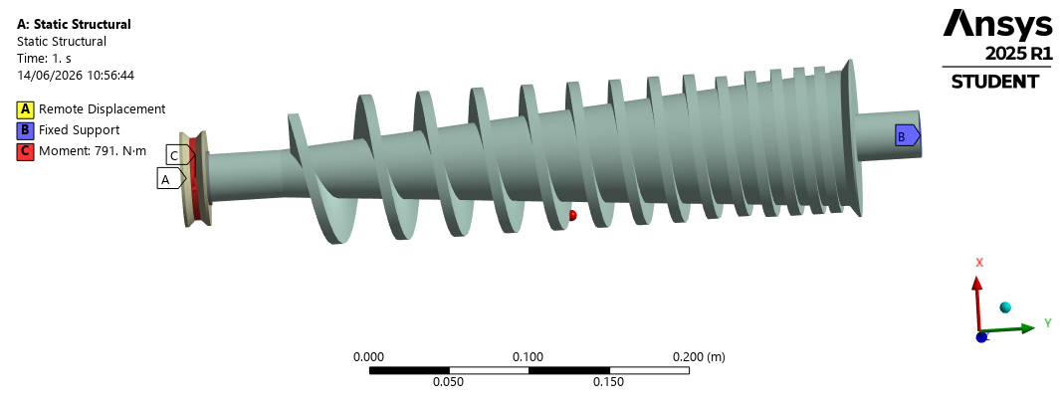
Figure 3.7: Load Application on the Shaft

Meshing
The meshing configuration employed tetrahedral elements with a uniform element size of approximately 5-10mm. the mesh was refined near bearing supports and load application points to capture stress gradients accurately.
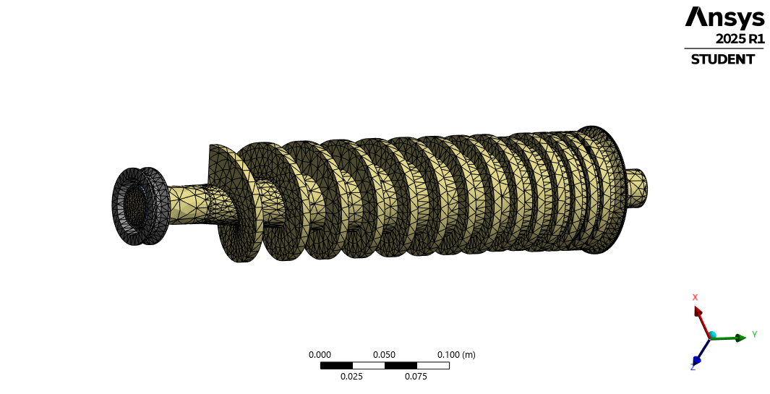
Figure3.8: Meshing on the shaft

Static Structural Safety Factor
The safety factor contour plot shows that a maximum safety factor of 15 in the lightly stressed regions (blue) such as keyway for pulley mounting, screw flights thread root and bearing shoulder fillet. A minimum safety factor 0f 1.4713 at the localized region (red), likely at stress concentration point such as diameter step change or bearing shoulder. To reduce stress concentration, these locations should be redesigned with larger radii.
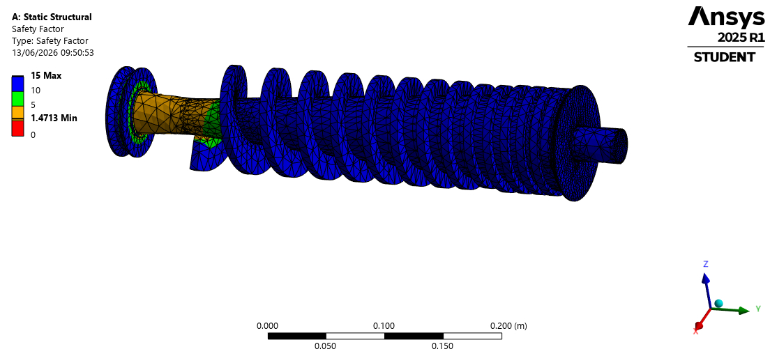
Figure 3.9: Safety Factor on the Shaft.

Static Structural Shear Stress Distribution
The shear stress contour plot on the XY Component shows a maximum shear stress of 20.54MPa and a minimum of -21.13MPa. the positive and negative values indicate that shear stress is acting in the opposite directions. The discrepancy between ANSYS result (20.54MPa) and the hand calculation (6.56MPa) is attributed to ANSYS including bending stress contributions from the overhung pulley load (1246.5N) and stress concentrations that are not captured by the simple torsion formula or hand calculation considering pure torsion only yet the shaft experiences combined torsion and bending.
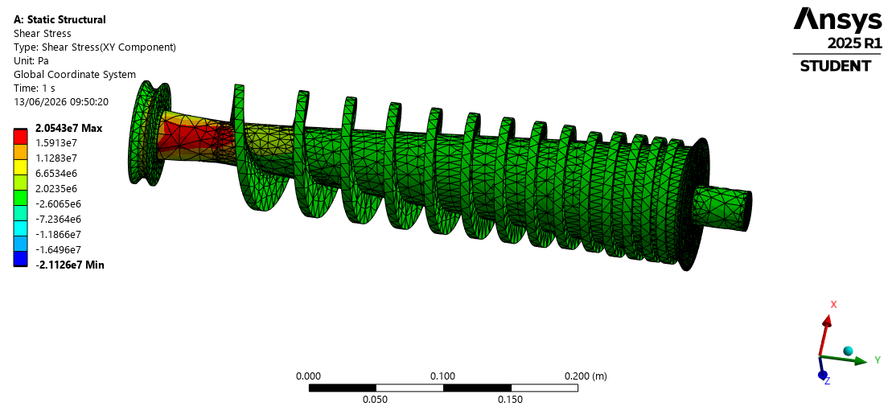
Figure 3.10: Shear Stress on the Shaft

Static Structural Total Deformation
The total deformation contour plots show a maximum deformation of 3.6789×10⁻⁵ m at the overhung pulley end (point A) with zero deformation at the fixed support (point C). The discrepancy in the ANSYS result (0.0368mm) and the hand calculation (0.016mm) is acceptable and can be attributed to geometry complexity, load distribution and support conditions. The maximum deformation of 0.0368mm is extremely small compared to the radial clearance between the screw flights and the barrel.

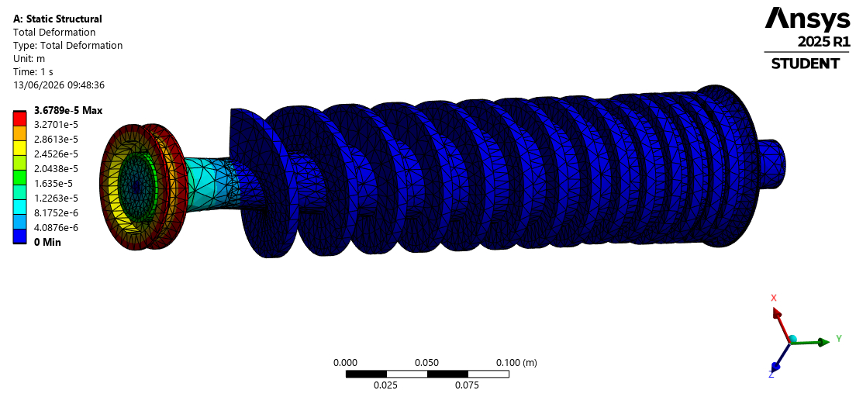
Figure 3.11: Total Deformation on the Shaft

Static Structural Equivalent Stress on the Barrel
The equivalent stress distribution on the barrel from ANSYS simulation with a maximum value of 1.91MPa which is significantly lower than the hand calculated tangential stress of 132.4MPa (from lame’s thick cylinder theory using compression pressure of 13.9MPa). the discrepancy is attributed to application of a torsional moment of 791Nm to the screw shaft not the internal compression pressure directly to the inner wall of the barrel.
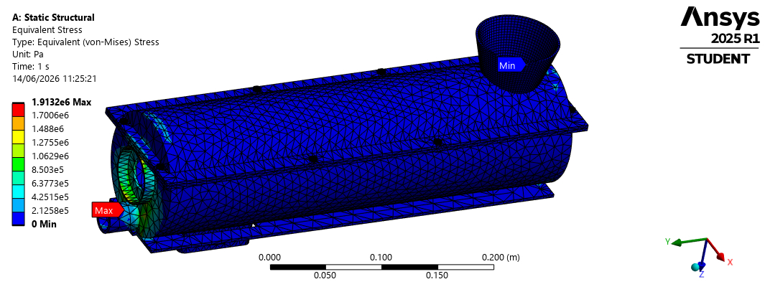
Figure 3.12: Equivalent Stress on the Barrel

Static Structural Safety Factor on the Barrel
The minimum safety factor of 15 is uniform across the model which deviates from the 3.55 from the hand calculations. The safety factor of 15 is extremely conservative implying that the barrel can withstand applied loads 15 times before yielding.
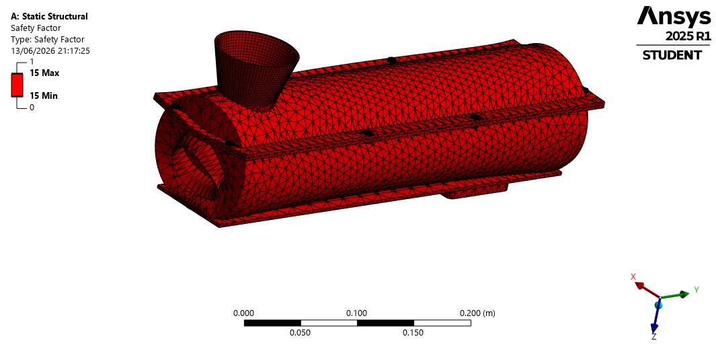
Figure 3.13: Safety Factor on the Barrel

Static Structural Total Deformation on the Barrel
The ANSYS simulation results show that the maximum deformation of 7.31×10⁻⁷ m≈0.000731mm and hand calculations show that the thermal expansion of the shaft of 0.99mm was safe against the 2.5mm clearance.
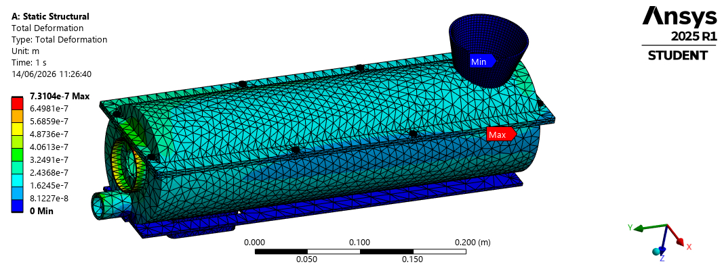
Figure 3.14: Total Deformation on the Barrel

Manufacturing/prototyping procedures

Material sourcing
The following materials are required for the manufacturing/ prototyping of the machine design. Mild steel rod (∅85mm), steel plate (6mm, 2mm), seamless pipe (ID 90mm), hollow swction (50×50×3mm), bearings, pulleys, motor and bolts.

Screw shaft fabrication
Turn the shaft on the lathe to ∅60mm (bearing seats) and ∅85mm (screw section). Cut screw flights from 6mm plate (pitch: 10mm-2mm), weld flights onto the shaft maintaining a helix angle (2.15⁰-0.43⁰), machine keyway at pulley end then grind and finish all surfaces.

Barrel fabrication
Cut seamless pipe to 700mm length, drill oil drainage holes (∅6-8mm staggered pattern), weld flanges at both ends, weld oil collection trays under holes and surface grind the internal bore to smooth finish.

Hopper fabrication
Cut 2mm sheet into truncated cone pattern (top ∅300mm, bottom∅100mm, height 300mm), roll and weld seam, weld flanges at bottom and install the slide gate.

Frame fabrication
Cut hollow square sections (50×50×3mm) to lengths: horizontal rails (2×1000mm), vertical legs (4×600mm) and cross braces as needed. Weld them into rigid rectangular frame, weld bearing support brackets at calculated positions (bearing spacing 700mm), weld the motor mounting plate and grind all welds smooth.

Belt and Pulley system preparation
Machine or source driver pulley (∅100mm) and driven pulley (∅400mm), cut keyways in both pulleys and obtain V-belt (length 2000mm).

Choke mechanism fabrication
Machine tapered conical plug from 10mm plate and attach M16 threaded rod with hand wheel.

Assembly
Mount bearings onto the shaft ends, insert the screw shaft into the barrel and check for the 2.5mm radial clearance. Bolt the barrel onto the flame and mount the motor on the flame plate. Install the belt and pulley system ,bolt the hopper onto the barrel inlet. Attach the choke mechanism at the discharge end and install the oil collection tray-pipe to container. Connect the motor to power source using the thermal overload protection.

Inspection and testing
For no-load test, run the motor without seeds for 10 minutes and check for vibration, noise, bearing temperature and belt tracking. For load test, feed dried jatropha seeds of about 1-2kg and measure oil yield, extraction time, motor current and cake consistency.

Painting and finishing
Clean all surfaces, apply anti-rust primer and then apply top coat or oil resistant paint.

Final documentation
Record test results, update drawings with any modifications made and prepare user manual.

Results and discussion
This involves obtaining the results of all the project design parameters including analytical analysis and numerical analysis results as well as providing a mechanical engineering backed discussion about the obtained results.

Kinematic Analysis Results
The angular velocity of the shaft was calculated as 4.7 rad/s using the equation 3.8. This is a very low angular velocity that ensures sufficient residence time for oil to drain from the seeds and keeps bearing temperatures low thus longer life.
The helix angle of the screw flight was calculated as 2.15⁰ at feed zone and 0.43⁰ at compression zone using the equation 3.9. The reduction in helix angle increases compression as seeds advance less distance each revolution due to decreasing pitch from 10mm at feed zone to 2mm at compression zone.
The axial velocity of seeds along the screw was calculated as 0.0075 m/s at feed zone and 0.0015 m/s at compression zone using the equation 3.10. The reduction in axial velocity increases residence time as seeds spend more time in compression zone which gives pressure enough time to build up so that oil can drain before residual seed cake is discharged thereby improving compression. The average axial velocity is 0.0045 m/s.
The cross-sectional conveying areas for flow were calculated as 3.534×10⁻³ m² at feed zone and 6.87×10⁻⁴ m² at compression zone using equation 3.11. The average channel area is 2.1×10⁻³ m².
The volumetric flow rate of jatropha seeds was calculated as 1.193×10⁻⁵ m³/s using the equation 3.12 where 0.75 is oil seed fill factor.
The mass flow rate was calculated as 7.753×10⁻³ kg/s ≈27.9 kg/hr using the equation 3.13 where 650 kg/m³ is the bulk density of jatropha seeds.
The velocity of the belt was calculated as 7.54 m/s using the equation 3.14 which is efficient for power transmission without excessive centrifugal tension.
The critical speed of the shaft was calculated as 2731 rpm using the Rayleigh – Ritz equation 3.15 where 0.016mm was the static deflection of the shaft. The operating speed (45rpm) is less than 2731rpm hence there is no resonance risk.
As screw shaft conveys seeds along the screw, heat is generated due to friction. This frictional heat helps oil to flow by reducing viscosity and the velocity at which this frictional heat moves was calculated as 0.2 m/s using the equation 3.16.

Kinetic/Dynamic Analysis Results
Dynamic analysis focuses on the forces, torques, stresses, pressures and power acting on the machine. As seeds move along the screw, forces such as axial Compression Force, Friction Force and Radial Pressure from the barrel develop due to volume reduction.
Due to the torque being transmitted along the screw shaft, the reaction on the screw thread was calculated as 18611.8N using the equation 3.33.
The angular velocity of the shaft was calculated as 4.7 rad/s using the equation 3.8. The radial clearance between the screws and the barrel was calculated as 0.0025m using the formular 3.34. The pressure developed along the screw was calculated as 13.9 MPa using the equation 3.17.
For oil to be extracted out of jatropha seeds, they must undergo compression along the screw shaft. The axial compression force acting on the seeds between the screw and the barrel was calculated as 9549.3N using the equation 3.18.
The torque required to drive the screw shaft was calculated as 405.8Nm using the equation 3.19 which is the torque the motor must deliver at the screw shaft.
The amount of power required to move and rotate the shaft was calculated as 1.9kW using the equation 3.20.
The required power of the motor was calculated as 2.53kW using the equation 3.21 considering 75% efficiency of the motor hence a motor size of 3.73 kW (5hp) was selected for the design.
The belt design power was calculated as 3.04 kW using the equation 3.22. At 1440rpm and 3.04kW, the intersection of the two falls under 3V belt-type cross-section hence a 3V belt type was selected for the design.
The frictional force due to contact between the screw, seeds and the barrel generate heat and contribute to power loss. Although this frictional force affects the distribution of torque along the shaft, it enhances oil flow by reducing viscosity. The frictional force acting on the shaft was calculated as 2864.8N using the equation 3.23.
The total effective force on the shaft was calculated as 12414.1N using the equation 3.24.
The heat generated due to friction should be moderate and controlled to aid oil flow without overheating the screw shaft as some of motor power is lost as heat. The frictional power loss due to frictional heat was calculated as 573J using the equation 3.25.
The pulley load on the shaft ≈ the radial load on the bearing (F_{r}) thus F_{r} =1246.5N. The equivalent dynamic load for tapered roller bearings was calculated as 21.1kN using the equation 3.26 where 0.4 is the radial load factor and 1.5 is the axial load factor for tapered roller bearings.
The shaft experiences bending due to belt tensions, screw weight and seed compression loads. The resultant load on the pulley due to belt tensions was calculated as 1246.5N using the equation3.27 where 870.6N is the belt tension at tight and slack sides of the pulley and 375.9N is the belt tension at the slack sides of the pulley.
For a simply supported shaft, the maximum bending moment on the shaft due to pulley load was calculated as 125N using the equation 3.28.
To predict failure of the shaft, the maximum shear stress theory (Tresca theory) of failure was used to determine the equivalent twisting moment on the shaft. The equivalent twisting moment on the shaft was calculated as 1193N using the equation 3.29.
The allowable shear stress on the shaft was calculated as 31.125MPa using the equation 3.30.
The screw is subjected to torsional and axial compressive stresses. The torsional shear stress acting on the shaft was calculated as 6.56MPa using the equation 3.31.
To prevent buckling (bursting) of the barrel, Lame’s thick cylinder theory was used to design an appropriate thick cylindrical barrel. The tangential stress on the barrel was calculated as 132.4MPa using the equation 3.4. Since 304>132.4MPa, the barrel is safe for the design.

Load Analysis Results
Load analysis was conducted to determine the magnitude, direction and distribution of all forces, moments and torques acting on a component throughout its operating cycle to aid in predicting stress, deflection, fatigue life for safe and reliable design. For this machine design, the screw shaft is the most critical loaded component. The screw shaft transmits power while simultaneously subjecting material to high compressive forces.
The cross-sectional conveying areas for flow at both feed and compression zones were calculated as 3.534×10⁻³ m² at feed zone and 6.87×10⁻⁴ m² at compression zone using the equation 3.11
The torque transmitted on the screw shaft was calculated as 791Nm using the equation 3.32.
Due to the torque being transmitted along the screws on the shaft, the reaction on the screw thread was calculated as 18611.8N using the equation 3.33.
As screw shaft rotates in the barrel, seeds are conveyed, crushed and compressed to extract oil. The angular velocity of the screw shaft was calculated as 4.7rad/s using the equation 3.8.
The radial clearance between the screws and the barrel was calculated as 0.0025m² using the equation 3.34.
Using the screw press theory, the pressure developed along the screw shaft was calculated as 13.9MPa using the equation 3.17.
The axial compression force is developed from backpressure as volume between the screw flights decreases due to reducing pitch and seeds being forced against the barrel and discharge choke. This axial force contributes to torque requirement and influences bearing selection. The axial compression force acting on the seeds between the screw and the barrel was calculated as 9549.3N using the equation 3.18.
The torsional moment (torque) is generated by the electric motor and transmitted via the belt and pulley system at the overhung and is applied at the pulley, transmitted along the shaft to screw and gradually absorbed by the seeds as they are compressed along the screw length. The torque required to drive the shaft was calculated as 405.8Nm using the formula 3.19. This torque must overcome seed resistance during conveying, crushing and compressing along the screw length.
The distributed resisting torque along the screw length is due to axial compression force of seeds and is converted to torque via thread helix angle. The helix angle of the screw flight was calculated as 2.15⁰ at feed zone and 0.43⁰ at compression zone using the equation 3.9. the reduction in helix angle implies more torque is absorbed per meter thus increasing compression.
Using the average diameter of the shaft (0.0725m) and the length of the shaft covered with screws (0.66m) and 7800 kg/m³ as the density of steel material, the mass of the shaft was calculated as 21.3kg using the equation 3.35. The mass of the shaft not covered with screws (overhang length between the pulley and the bearing (0.1m) +plain end length at discharge end (0.4m)) was calculated as 3.1kg using the equation 3.36 and the total mass of the whole shaft length (0.8m) was calculated as 29.3kg using the equation 3.37 where a safety factor of 1.2 was used.
The weight of the whole shaft length was calculated using as 287.4N using the equation 3.38 and the uniform load distribution along the entire length of the shaft was calculated as 359.3N/m using the equation 3.39.
The weight of the shaft was calculated as 287.3N using the equation 3.38 and the uniform load distribution along the shaft along the entire length of the shaft was calculated as 359.3 N/m using the equation 3.39
To obtain the reactions at the bearings, the sum of vertical forces was considered whereby sum of upward forces is equal to sum of downward forces and was obtained using the equation
Taking moments at the discharge end bearing, the reaction at the feed bearing (R_{B}) was obtained as 1588.7N hence R_{D} was obtained as -54.9N. The negative means that the discharge bearing exerts a downward force on the shaft.
The torque transmitted on the shaft is maximum at the pulley (791Nm) due to motor input, between the screw length (0.66m) torque decreases to 21Nm at feed bearing as energy is being transferred to the seeds due to increasing compression pressure from volume reduction and decreasing pitch from 10mm at feed zone to 2 mm at compression zone and at discharge end where no more compression occurs, the torque is zero.
The driver pulley is positioned 0.1m beyond the feed bearing, creating a cantilever effect that induces a significant negative (hogging) at feed bearing. The maximum bending moment was calculated as 125Nm at the feed bearing using the bending moment equations table 2 as shown below.
Table 4.1: Bending Moments Result Table
At point A  (pulley): | $$M=1246.5X$$ | X=0  X=0.1m | M=0  M=125Nm
At point B:  (feed bearing) | $$M=1246.5X-1588.7(X-0.1)$$ | X=0.1m  X=0.4m | M=125Nm  M=22Nm
At point C:  (discharge end bearing) | $$M=1246.5X-1588.7\left(X-0.1\right)+287.4(X-0.4)$$ | X=0.4m  X=0 | M=22Nm  M=0
Where M=bending moment and X=distance from point of application of moments so the maximum bending moment was obtained.
The shaft core diameter increases from 60mm at feed zone to 85mm along the screw length then returns to 60mm at the discharge end. This affects stress concentration and fatigue resistance but does not alter the bending moment or torque diagrams.
Pitch decreases progressively from 10mm at feed zone to 2mm at compression zone over a length of 0.66m. This variation causes non uniform torque absorption with higher energy transfer at points where the pitch is smallest.

Fatigue Analysis Results
The screw shaft rotates continuously at 45 rpm, experiencing reverse bending stress from tension to compression back to tension for each revolution causing high-cycle fatigue. The estimated modified endurance limit of the shaft was calculated as 327.5MPa using the equation3.58 where 655 MPa is the ultimate strength of the material.
The fatigue strength of the shaft at 10⁴ cycles was calculated as 0.349 using the equation 3.59.
The surface finish factor of the shaft was calculated as 290.4 using the equation 3.60 where constants a and b are 159.6 and 0.052 respectively.
The temperature factor of the shaft was calculated as 3 using the equation 3.61.
The actual endurance limit of the shaft was calculated as 446.7MPa using the equation 3.62.
Due to rotation of the shaft, the screw shaft experiences alternating bending stress which was calculated as 2073N/m² using the equation 3.63.
For safety of the shaft design, the fatigue safety factor was calculated as 0.2 using the equation 3.64.

Thermal Analysis Results
Due to friction between the rotating shaft, jatropha seeds and the fixed barrel. Frictional heat is generated to aid in reducing oil viscosity thereby improving oil flow and extraction efficiency. However, excessive heat damages oil quality and may damage machine components as well as power loss. The power loss due to frictional heating was calculated as 573W using equation 3.25. The frictional rise in temperature was calculated as 103⁰ using equation 3.54.
The fatigue endurance limit with thermal factor was calculated as 1.0 using the equation 3.61. Since the tangential stress in the barrel is 132.4MPa and the yield strength of the barrel is 470MPa, the barrel design is safe against bursting with a 3.55 factor of safety.
The thermal expansion of the shaft of length (0.8m) and temperature rise of 103⁰ was calculated as 0.00099m≈0.99mm where the thermal coefficient of expansion for steel is 12×10⁻⁶ C⁻¹. The radial clearance between the screw shaft and the barrel is 2.5mm and the thermal expansion is 0.99mm meaning that the design is safe since there is no seizure.
The thermal stress in the shaft was calculated as 255.8MPa which is less than the yield strength of the material (415MPa) hence the design is safe with a safety factor of 1.62.

Component Sizing Results
This involves obtaining the different size parameters for each component design.

Hopper Sizing
The angle of repose for jatropha seeds was calculated as 72⁰ using the equation 3.41.
The volume of the circular truncated conical hopper was calculated as 0.0102m³ using the equation 3.42.
The mass of jatropha seeds the hopper can contain was calculated as 6.6kg using the equation 3.43 where 650 kg/m³ is the bulk density of jatropha seeds. The weight the seeds exert on the hopper was calculated as 64.7N.

Belt and Pulley System Sizing
The belt and pulley system is a power transmission system between the motor and the shaft. It was designed using the Fenner industrial belt drive standard. The belt and pulley system design specifications chosen are identified in the table below.
Table 4.2: Belt and Pulley Design Specifications
Design parameter | Symbol and value
Motor speed | N₁=1440 rpm
Driver motor pulley diameter | D₁=100 mm
Driven pulley diameter | D₂=400 mm
The speed of the driven pulley was calculated as 45rpm using the equation3.44.
The velocity ratio was calculated as 32:1 using the equation 3.45.
The design power accounting for shock and continuous loading was calculated as 3.04kW using the equation 3.46 where pulley service factor was 1.2 (for heavy starting load for 8-10 hr/day service).
The Actual power transmitted per belt was calculated as 3.4kW using the equation 3.47 where 0.9 was the power correction factor.
The number of belts required was calculated as 1belt using the equation 3.48.
The velocity of the belt was calculated as 7.54m/s using the equation 3.14.
The difference in the belt tensions was calculated 494.7N using the equation 3.49 and the belt tension ratio as 2.316 using equation 3.50. Substituting equation 3.50 into equation 3.49, the belt tensions T₂ and T₁ were obtained as 375.9N and 870.6N respectively. The resultant load on the pulley system was calculated as 1246.5N using equation 3.27.
The torque required to drive the shaft was calculated as 405.8Nm using the equation3.19.
The power required to drive the shaft was calculated as 1.9kW using the equation 3.20
The Centre distance between pulleys was calculated as 447mm using the equation 3.51.
The length of the belt was calculated as 1730mm using the equation 3.52 hence a standard belt length of 2000mm was selected for the design.
The angle of contact on the pulleys was calculated as 140.8⁰ using the equation 3.53.

Screw Shaft Sizing
Due to the torque being transmitted along the screw shaft, the reaction on the screw thread was calculated as 18611.8N using the equation 3.33.
The angular velocity of the shaft was calculated as 4.7 rad/s using the equation 3.8.
The radial clearance between the screws and the barrel was calculated as 0.0025m using the equation 3.34.
Oil expression follows Darcy’s law for flow through porous media. Using the screw press theory, the pressure developed along the screw was calculated as 13.9MPa using the equation 3.17.
The axial compression areas for flow at both feed and compression zones were calculated as 3.534×10⁻³ m² at feed zone and 6.87×10⁻⁴ m² at compression zone using the equation 3.11
For oil to be extracted out of jatropha seeds along the screw shaft, they must undergo compression. So, the axial compression force acting on the seeds between the screw and the barrel was calculated as 9549.3N using the equation 3.18.
The torque required transmitted by the shaft was calculated as 791Nm using the equation 3.19.
The amount of power transmitted by the shaft was calculated as 3727.5W using the equation 3.20.
The frictional force acting on the shaft was calculated as 2864.8N using the equation 3.23 where 0.3 is the coefficient of friction between the seeds and the shaft.
The total effective force on the shaft was calculated as 12414.1N using the equation 3.24.
As screw shaft conveys seeds along the screw, heat is generated due to friction. This heat helps oil to flow by reducing viscosity and the velocity at which this frictional heat moves was calculated as 0.2m/s using the equation 3.16.
The frictional power loss in form of heat was calculated as 573W using the equation 3.25.
The heat generated due to friction should be moderate and controlled to aid oil flow without overheating the screw shaft. The temperature rise in one hour due to frictional heating of the shaft was calculated as 103⁰ using the equation 3.54 whereby 3600s is the operating time for one hour in seconds, 40kg is the assumed mass of the barrel with seeds since mass of the shaft with screws is 29.3kg and 500J/kg. K is the specific heat of steel.
Using the maximum shear stress theory (Tresca theory) of failure, the equivalent twisting moment on the shaft was calculated as 1193Nm using the equation 3.29 where 1.0 is the combined shock and fatigue factors applied to Bending Moment (1.0) and 1.5 is the combined shock and fatigue factors applied to Torsional Moment.
The allowable shear stress on the shaft was calculated as 31.125MPa using the equation 3.30 where 415 MPa is the yield strength of shaft material and 4 is the factor of safety of the material.
The minimum diameter of the shaft was calculated as 0.0588m ≈58.8 mm using the equation 3.55. Considering standard shaft diameters, a shaft diameter of 60mm was selected for the design.
The screw is subjected to torsional and axial compressive stresses. The torsional shear stress acting on the shaft was calculated as 6.56MPa using the equation 3.31. since 304>31.125MPa, the shaft is safe for the design.
The moment of inertia on the shaft was calculated as 6.36×10⁻⁷ m⁴ using the equation 3.56.
Due to self-weight and seed load on the shaft, the static deflection at mid-point of the simply supported shaft was calculated as 0.016mm using the equation 3.57.
To avoid resonance, the natural frequency of the shaft must be far from the operating speed. The critical speed of the shaft was calculated 239.5m/s using the Rayleigh – Ritz equation 3.15.
The screw shaft rotates continuously at 45 rpm, experiencing reverse bending stress from tension to compression back to tension for each revolution causing high-cycle fatigue. The estimated modified endurance limit of the shaft was calculated as 327.5MPa using the equation3.58 where 655 MPa is the ultimate strength of the material.
The fatigue strength of the shaft at 10⁴ cycles was calculated as 0.349 using the equation 3.59.
The surface finish factor of the shaft was calculated as 290.4 using the equation 3.60 where constants a and b are 159.6 and 0.052 respectively.
The temperature factor of the shaft was calculated as 3 using the equation 3.61.
The actual endurance limit of the shaft was calculated as 446.7MPa using the equation 3.62.
Due to rotation of the shaft, the screw shaft experiences alternating bending stress which was calculated as 2.07MPa using the equation 3.63.
For safety of the shaft design, the fatigue safety factor was calculated as 216 using the equation 3.64 hence the shaft is extremely safe against fatigue failure.

Screw Flight Sizing
The screw flights act as an inclined helical conveyor inside the fixed barrel. The screw flights experience major loads of compression and shear. For progressive pressure build up, it is designed in a way that decreasing the helix angle increases compression. The screw flight forms a helical surface which conveys and compresses the seeds causing axial thrust. The helix angle of the screw flight was calculated as 2.15⁰ at feed zone and 0.43⁰ at compression zone using the equation 3.9.
The axial velocity of seeds along the screw was calculated as 0.0075m/s at feed zone and 0.0015m/s at compression zone using the equation 3.10.
The cross-sectional conveying area for flow of jatropha seeds at feed zone was calculated as 3.534×10⁻³ m² using the equation 3.11.
The volumetric flow rate of jatropha seeds was calculated as 1.193×10⁻⁵ m³/s using the equation 3.12 where 0.75 is oil seed fill factor.
The mass flow rate was calculated as 7.753×10⁻³ kg/s ≈27.9 kg/hr using the equation 3.13 where 650 kg/m³ is the bulk density of jatropha seeds.
The compression ratio was calculated as 5:1 using the equation 3.65.
The screw flight experiences compressive loading, torsional shear and abrasive wear causing shear stress. The shear stress in the screw flight was calculated as 6.56MPa using the equation 3.31.
The polar moment of inertia on the shaft was calculated as 6.03×10⁻⁵ m³ using the equation 3.36.
To obtain the angle of twist per meter, the angle of twist was calculated as 0.0002⁰ using the equation 3.67. The angle of twist per meter was calculated as 0.0002⁰/m.

Barrel Sizing
The allowable stress in the barrel was calculated as 117.5MPa using the equation 68.
During compression, internal pressures are generated by the compacted material. Using the pressure vessel theory, the wall thickness of the barrel was calculated as 5mm using Barlow’s equation 3.69.
The external diameter of the barrel was calculated as 100mm using the equation 3.70.
As the screw shaft rotates in the barrel, the barrel experiences perpendicular stress or loop stress or tangential stress. The tangential stress experienced by the barrel was calculated as 132.4MPa using Lame’s equation 3.4.

Bearing Sizing
The oil extruder (expeller shaft) is subjected to combined radial and axial loads from the screw shaft and seed resistance.
The actual force from screw weight/ the radial load (F_{r}) acting on the bearing due to crushing and screw action ≈ pulley load (F_{P}) thus F_{r}=1246.5N as earlier calculated from equation 3.27
The axial force (F_{a}) ≈ compressive load from backpressure due to seed pressing so F_{a}=9549.3N as earlier calculated from equation 3.18
The equivalent dynamic load on the bearing was calculated as 14890N from the equation
The basic rating life of the bearing was calculated as 332.5×10⁶ revolutions using the equation 3.71
To convert to hours, the bearing life in terms of operating hours was calculated as 123148 hours using the equation 3.72
The maximum pressure at ball contact was calculated as 3.16×10⁵ N/m² using the Hertzian contact stress formula in the equation 3.73.

Frame Sizing
To prevent buckling of the frame, hollow square sections (outer 50×50 mm and inner 44×44 mm) were used to maximize buckling resistance and members have to be oriented in a way that the area moment of inertia is largest in the direction of potential buckling.
Euler’s formula in equation 3.7 was used to determine which failure would occur first between buckling and yielding. Welded joints were found to be better for this design because the effective length factor (K=0.5 for fixed ends with no rotation) maximizes the buckling load (the maximum load before buckling) than the pinned joints (K=1.0 for pinned ends free to rotate) hence providing fixed-end restraint. Long or slender columns were used because short or fat columns would yield in compression.
The area moment of inertia was calculated as 208492 mm⁴ using the equation 3.74 to aid in determining the critical buckling load of the frame.
The area of the hollow square section (outer 50×50 mm and inner 44×44 mm) was calculated as 564 mm² using the equation 3.76 to aid in determining the radius of gyration.
The radius of gyration was calculated as 19.23 mm from the equation 3.77 to aid in determining the slenderness ratio.
Short or fat columns yield in compression and long or slender columns buckle so to determine which failure mode occurs first, the slender ratio was calculated as 32 using the equation 3.78 implying that yielding occurs before buckling since the slenderness ratio, 32<50.
Buckling load depends on stiffness of the geometry not yield strength of the material thus upgrading from A36 to high-strength steel would not improve buckling resistance since the modulus of elasticity (E=200GPa) is still the same so the area moment of inertia must be increased to improve buckling resistance. The critical buckling load of the frame was calculated as 1143 kN using the equation 3.4
Applying the factor of safety (f=4), the maximum allowable buckling load was calculated as 286 kN using the equation 3.75. Since 286 >64.7N the actual load from the hopper, the frame is safe against buckling.

Bolt Sizing
The screw shaft rotates at a given rpm basing on the torque acting on it. Since the pulley is on the same side just above the motor running at a different rpm, a lower torque is experienced by the motor. The torque experienced by the bolts due to the motor was calculated as 24.73Nm using the equation 3.79. This torque due to the motor exerts a force onto the bolts. The force acting on bolts due to this torque was calculated as 494.6N using the equation 3.80.
The number of bolts used to fix the motor onto the frame was 4. The force per bolt was calculated as 123.65N using the equation 3.81. For frictional grip (tightening) to occur, there is a preload required to prevent joint separation. The preload required for frictional grip was calculated as 1648.7N using the equation 3.82.
For bolt material grade 8.8 Carbon steel, the allowable shear stress on the bolts was calculated as 160MPa using the equation 3.83. Bolts experience tensile stress per unit area and that tensile stress area was calculated as 10.3mm² using the equation 3.84 and the suitable bolt size diameter was calculated as 3.62mm using the equation 3.85. For standard bolt selection, a root diameter of 4.13mm was selected for the design leading to the selection of M5×0.8 bolt. Using the selected root diameter, the actual tensile area is 13.4mm².
The torsional stress on the bolt was calculated as 1788MPa using the equation 3.31 and the actual tensile stress from preload was calculated as 123MPa using the equation 3.84. For safety of the design, the Von-misses stress theory of failure was used to determine the equivalent stress as 266.5MPa using the equation 3.86. Since σ_{v} <S_{y}, the design is safe with a 2.4 factor of safety.

Simulation Results

Meshing on the shaft
The meshing configuration employed tetrahedral elements with a uniform element size of approximately 5-10mm. the mesh was refined near bearing supports and load application points to capture stress gradients accurately.
Results show that the tetrahedral mesh is appropriate for the complex geometry of the screw shaft of increasing diameter with screw flights of reducing pitch. Adaptive meshing was used with a resolution of 3 and fine span angle Centre. The total nodes and elements obtained were 67089 and 38249 respectively.

Static Structural Safety Factor on the shaft
The minimum safety factor of 1.4713 indicates that the design is safe but marginal for static loading. Typical engineering practice recommends a safety factor of 1.5-2.0 for static loads in well-characterized applications and 2.5-4.0 for dynamic or fatigue prone applications. The 9% difference between ANSYS result (1.47) and the hand calculation (1.62) is acceptable and is attributed to difference in load representation, boundary conditions and stress concentration modelling. This means that the shaft will withstand 47% more load than the design load before yielding.

Static Structural Shear Stress Distribution on the shaft
The shear stress contour plot on the XY Component shows a maximum shear stress of 20.54MPa and a minimum of -21.13MPa. the positive and negative values indicate that shear stress is acting in the opposite directions. The discrepancy between ANSYS result (20.54MPa) and the hand calculation (6.56MPa) is attributed to ANSYS including bending stress contributions from the overhung pulley load (1246.5N) and stress concentrations that are not captured by the simple torsion formula or hand calculation considering pure torsion only yet the shaft experiences combined torsion and bending. Results show that the maximum shear stress of 20.54MPa is well below the allowable shear stress of 31.125MPa (from equation 3.30) implying that the shaft is therefore safe against torsional failure.

Static Structural Total Deformation
Results show that the shaft deflection (0.016mm) represents only 1.47% of the available clearance which indicates that there is no risk of rubbing or contact between the rotating screw and the stationary barrel. Furthermore, the operating speed of the shaft (45rpm) is far less than the critical speed (4930rpm) implying that there is no risk of resonance or vibration-induced failure.

Static Structural Equivalent Stress on the Barrel
Results show that the maximum stress is experienced at the residual seed cake outlet and the minimum stress is experienced at the hopper. The simulation also represents the barrel’s response to shaft-induced loads only not to the primary oilseed compression pressure. The hand calculation indicates a safety factor of approximately 3.55 which is acceptable for static loading in agricultural machinery.

Static Structural Safety Factor on the Barrel
The minimum safety factor of 15 is uniform across the model which deviates from the 3.55 from the hand calculations. The safety factor of 15 is extremely conservative implying that the barrel can withstand applied loads 15 times before yielding. Results show that the safety factor would be much lower as the internal compression pressure (13.9MPa) due to jatropha seeds is applied on the barrel.

Static Structural Total Deformation on the Barrel
The ANSYS simulation results show that the maximum deformation of 7.31×10⁻⁷ m≈0.000731mm and hand calculations show that the thermal expansion of the shaft of 0.99mm was safe against the 2.5mm clearance. Results show that the maximum deformation along the entire barrel takes place at the pulley end of the barrel particularly at the bearings where shaft loads are being applied with the minimum deformation of zero taking place at the hopper.

Conclusion and future work

Conclusion
This project successfully achieved the general objective of developing a jatropha seed oil extraction machine customized for rural areas in developing countries and the three specific objectives were fully achieved through systematic design, analysis and prototype procedures. The designed jatropha seed oil extraction machine is structurally safe, mechanically feasible and locally manufacturable. All the calculated stresses are below material yield strengths, all safety factors exceed minimum engineering requirements and all components can be fabricated using standard workshop equipments available. The machine addresses the critical gap between expensive imported equipment and inefficient manual extraction methods, providing a practical solution for small-scale farmers in rural developing countries. The project contributes to rural development by creating opportunities for local innovation and manufacturing, enhancing small-scale biodiesel production, reducing capital outflow on imported equipment, promoting sustainable utilization of jatropha as an energy crop as well as generating potential employment in rural communities.

Future work
To enhance machine design performance, the following areas are recommended for further development.

Optimization of operating parameters
For moisture content, test seeds with moisture levels ranging from 6-12% to determine the optimal moisture for maximum oil yield. For screw speed, vary the screw speed from 30-60rpm using a variable frequency drive to identify the speed that balances oil yield, extraction time and energy consumption. Adjust the discharge choke from 1-5mm to determine the optimal backpressure for oil expression. For seed preheating temperature, compare cold pressing at ambient temperature with hot pressing at 40, 60 and 80⁰C to evaluate the trade-off between oil yield and oil quality.

Oil yield analysis
Conduct laboratory tests for free fatty acid (FFA) content, viscosity, density, oxidative stability and phytosterol/tocopherol retention to compare cold pressed versus hot pressed jatropha oil.

Durability and Fatigue testing
Run the machine continuously foor extended periods of 100hours to monitor wear patterns on screw flights and barrel inner surface. Measure the reduction in oil yield over time to predict maintenance intervals and component replacement schedules.

Design improvements
For energy wated due to frictional heating could be recovered by designing a heat exchanger so that this heat can be used to pre-dry seeds before extraction thus improving the overall efficiency. Additionally, a low-cost electrical heating jacket could be added to allow controlled hot pressing while maintaining the ability to cold press when higher oil quality is desired. Install low-cost microcontroller system with sensors for barrel temperatre monitoring , motor current sensing to detect overloads, automatic choke adjustment as well as digital display of oil yield.

Economic and social feasibility studies
To ensure successful adoption of the machine in rural Uganda and other developing countries, conduct a detailed economic analysis comparing the machine design to imported expellers in terms of initial investment,operating costs, payback period for small-scale farmers as well as break-even analysis. Survey local workshops and facilities to asses their capability to fabricate components without specialized tooling then conduct field trials with 10-15 small-scale farmers in rural Uganda to gather feedback information on ease of operation, ease of maintenance and repairability, safety and demand. Create training programs for local technicians on screw press maintenance and troubleshooting.

Quality standards and certification
Work with Uganda national bureau of standards (UNBS) to develop a draft standard for locally manufactured oil expellers and obtain certification to facilitate government procurement programs and donor-funded rural development projects.

Application diversification
Adopt same machine design for other oil seeds such as sunflower, groundnuts, shea nuts,castor seeds and sesame seeds. Establish partnerships with different oil dealing bodies such as ministry of energy and mineral development for policy support, national agricultural research organization (NARO) for agronomic expertise and local fabrication cooperatives for distributed manufacturin

References
Bakhshabadi, H., Ganje, M., Gharekhani, M., Mohammadi-Moghaddam, T., Aulestia, C., Morshedi, A., 2025. A Review of New Methods for Extracting Oil from Plants to Enhance the Efficiency and Physicochemical Properties of the Extracted Oils. Processes 13, 1124. https://doi.org/10.3390/pr13041124
Gutiérrez, L.-F., Ratti, C., Belkacemi, K., 2008. Effects of drying method on the extraction yields and quality of oils from quebec sea buckthorn (Hippophaë rhamnoides L.) seeds and pulp. Food Chem. 106, 896–904. https://doi.org/10.1016/j.foodchem.2007.06.058
K Yusuf, A., 2018. A Review of Methods Used for Seed Oil Extraction. Int. J. Sci. Res. IJSR 7, 233–238. https://doi.org/10.21275/1121804
Khalaf, M., Abdel-Fadeel, W., Hashish, H.M.A., Wapet, D.E.M., Mahmoud, M.M., Elhady, S.A., Esmail, M.F.C., 2023. Experimental Investigation of Different Extraction Methods for Producing Biofuel from Jatropha Seeds and Castor Seeds. Int. J. Energy Res. 2023, 1–15. https://doi.org/10.1155/2023/1780536
Kumar, A., Sharma, S., 2008. An evaluation of multipurpose oil seed crop for industrial uses (Jatropha curcas L.): A review. Ind. Crops Prod. 28, 1–10. https://doi.org/10.1016/j.indcrop.2008.01.001
Mašín, I., Petrů, M., 2016. Complex Approach to Conceptual Design of Machine Mechanically Extracting Oil from Jatropha curcas L. Seeds for Biomass-Based Fuel Production. BioMed Res. Int. 2016, 1–12. https://doi.org/10.1155/2016/7631458
Patel, V.R., Dumancas, G.G., Viswanath, L.C.K., Maples, R., Subong, B.J.J., 2016. Castor Oil: Properties, Uses, and Optimization of Processing Parameters in Commercial Production. Lipid Insights 9, LPI.S40233. https://doi.org/10.4137/LPI.S40233
Shittu, S.K., Mari, H.H., Dangora, N.D., 2018. Statistical model for solvent oil extraction from soybean (Glycine max (L.)). Food Res. 3, 182–187. https://doi.org/10.26656/fr.2017.3(2).111
Singh, R.N., Vyas, D.K., Srivastava, N.S.L., Narra, M., 2008. SPRERI experience on holistic approach to utilize all parts of Jatropha curcas fruit for energy. Renew. Energy 33, 1868–1873. https://doi.org/10.1016/j.renene.2007.10.007
Siregar, A.N., Ghani, J.A., Haron, C.H.C., Rizal, M., Yaakob, Z., Kamarudin, S.K., 2015. Comparison of oil press for jatropha oil - a review. Res. Agric. Eng. 61, 1–13. https://doi.org/10.17221/22/2013-RAE
Tambunan, A.H., Situmorang, J.P., Silip, J.J., Joelianingsih, A., Araki, T., 2012. Yield and physicochemical properties of mechanically extracted crude Jatropha curcas L oil. Biomass Bioenergy 43, 12–17. https://doi.org/10.1016/j.biombioe.2012.04.004

