Kevin Quizhpi

Kdq2

11/30/17

Homework 7

# Problem 3:

Output of classifier:

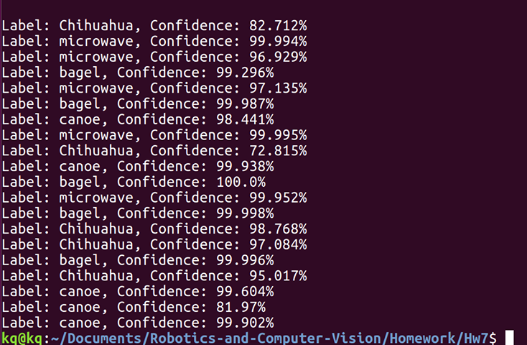

Confusion matrix and classifier metrics:

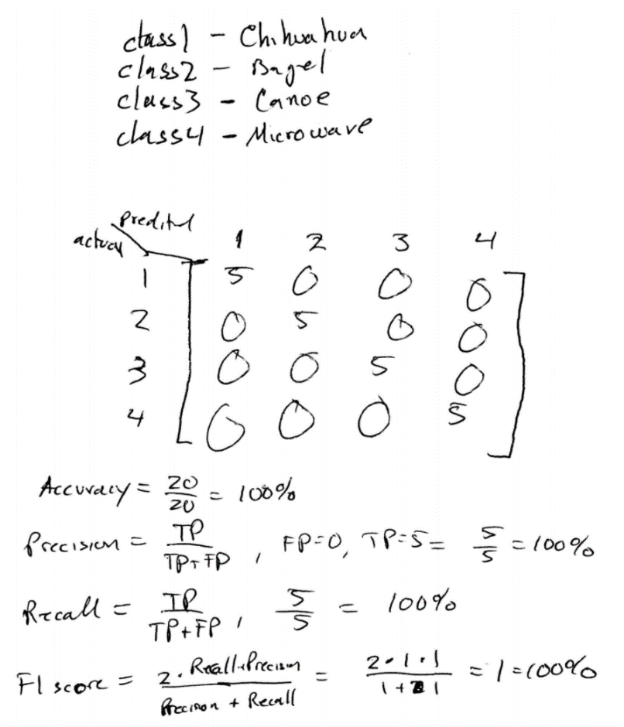

Resnet is a deep learning architecture that emulates a deeper network than it appears to be if it didn’t have its characteristic skip connections. Deeper networks are more difficult to train and so with the Resnet architecture, we can emulate a deeper network with fewer weights and avoid degradation. ResNet is a Residual Network, which focuses on learning the residual of each layer rather than each layer learning a feature. It’s significance was that it managed to achieve a depth of 152 layers with a 3.57 percent error while computationally competitive.