**Company**

**TENG LAY IMPORT EXPORT & TRANSPORT CO., LTD**

Branching out from our biggest Teng Lay Group, “Teng Lay Import Export & Transport” is the very first established company among the other five companies owned by us nowadays. 1996 marked our first office set up in Phnom Penh/Sihanoukville Sea Port and gradually expanding branches, depots and warehouses in both Phnom Penh and Sihanoukville to meet the increasing demands.

Our core business is focusing on Custom Brokerage Services, providing solutions for all logistics needs and specializing in import and export laws and regulations to facilitate all the difficulties in custom clearance. Having been operating for many years with a group of experts who have 80 years experiences in customs clearance, we have built a very strong connection with Custom House and gained trust from our clients because of our premium quality of service. By committing to deliver a prompt, time-saving and cost-saving service, we have been recognized as the leading company in the industry, locating our eight offices throughout Cambodia.

**Services**

Teng Lay Import and Export has the expertise and advanced equipment to faster the speed of delivering and custom clearance services throughout Kingdom of Cambodia. Our specialization lies in overland trucking and legal document preparation for custom clearance. Teng Lay offers a fast and convenience service in import and export with both officials and Cam-Control personnel based in our ICD port. We, nowadays, have a total number of 371 professionals and experts.

**Customs Clearances & Brokerage**

In order to avoiding delays and securing your cargo is crucially important for your business whether it is import or export shipment. We provide you full Customs Brokerage Service that cover all legal documents preparation to make sure your cargo is available as planned. With both Customs officials and Cam-Control personnel based in our ICD port, TENG LAY provides fast and convenient import and export service.

**International Freight**

Whether by Ocean or Air, FCL or LCL, Teng Lay could offer you a premium service with competitive price. With our strong connection with multi-international companies as partners and our advanced technological tracking system, we are able to provide you up-to-date and accurate information about your cargo throughout the delivery cycle.

Our existing Ocean and Air Freight services are:

* Full Container Load (FCL and Less than Container Load (LCL) Consolidations
* Sea-Land, Land-Sea, and Land-Air
* Door-Port, Port-Door and Port-Port

**TENG TRANSPORTATION CO., LTD**

Teng Lay Transportation Company, a Cambodia based inland transportation service provider, is a subsidiary of Teng Lay Group. Establishing in 2014, our company provides all the services for every aspect of your daily inland transportation serving of all borders whether in or out of Cambodia. Working closely with Teng Lay Import and Export Company, our prime goals is to deliver a fast and lower cost premium service to our customers. To do so, we are extremely confident in our group of professionals including certified and experienced specialists to handle your inland transportation and trucking partner locally and internationally.

In addition to our trucking needs, we offer a door to door service for cargo for more convenience. By providing high quality of service, we have gained a reputation for expertise and innovation. We hold the leading position in inland transportation service provider with our sophisticated technologies.

**Inland Transportation**

Teng Lay is able to offer our clients for all the local and international trucking needs since we know how to get your goods delivered in a time and within your budge. With GPS tracking devices to all trucks plus our group of professionals including certified and experienced specialists, we confident that your cargo is secured and arrive your destination on time that give you greater peace of mind.

Our local transport networks have been accommodated to offer clients express delivery of their goods including our special lockup mini trucks designed to secure your cargo and it is accessible everywhere in and around Phnom Penh City without any restriction of traffic.

Additionally, Teng Lay has already operated a door to door service for cargo from China, Hong Kong and Taiwan to Phnom Penh via Ho Chi Minh City. On the other hand, we also carry freight from Thailand to Cambodia, as also from Thailand to Vietnam via Cambodia, which gives a faster transit at a lower cost.

Cross border clearance and trucking to and from Thailand, Laos, and Vietnam is streamlined when using Teng Lay, thanks to our dedicated teams located at each border.

UNIQUE FEATURES

* All trucks are equipped with GPS tracking devices.
* C-TPAT is approved and ready
* Driver screening and background checks
* Random drug screening for drivers
* Random Breath Alcohol Screening for drivers
* Ongoing safety inspection
* Driver training program by TUV

**TENG LAY DRY PORT CO., LTD**

Established in 2008, Teng Lay Dry port is among the first privately owned Dry Port in Cambodia, owning the size of 98,000 square meters (24 acres) used as an independent bulk transfer and storage port terminal. We are committed to provide affordable, reliable and quality services to our clients.

To find secure and standardize to store your cargo is extremely important. Our Dry Port would provide you peace of mind of your cargo storage. We has service as below:

* Open container yard
* Dedicated container Freight station and depot empty storage
* Warehouse management and stock inventory control

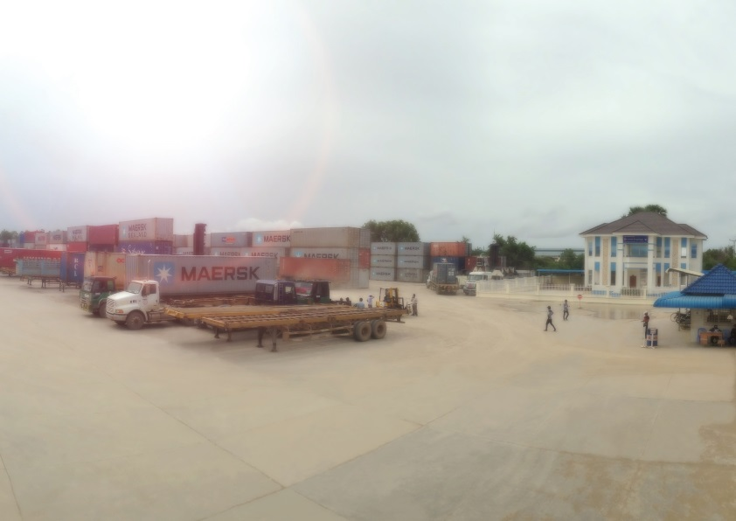

**Open Container Yard**

We have storage available for short, medium or long term purposes. Store your own containers, or rent one of our secure location.

**Dedicated Container Freight Station and Depot Empty Storage**

With Customs, Cam-Control and Police Officers based at our Dry Port, we are able to give you utmost convenience and swift inspections of your cargo. We also provide CY to shipping companies including Hanjin, APL, MGC, RGL, MITSUI and many more. We have heavy equipment for lift-on/lift-off vessels to increase the efficiency of importing and exporting your cargo.

**Warehouse Management & Stock Inventory Control**

Secure your stock at our high security facilities. Both the TENG LAY Depot and Dry Port can receive and inventory your cargo for short or long term storage in our private warehouse. We offer daily, weekly, and monthly inventory reports. We itemize your goods in Stock Keeping Units (SKU), and catch any cargo shortage upon arrival.

**TENG LAY ENGINEERING CO., LTD**

Teng Lay Engineering Co., Ltd was established in 2013. We created due to the demand from the customers for container modifications. Garment On Hanger (GOH) container serves high-end producers of the garment industry. High quality products such as Suites and Dresses demand the quality storage of hanging instead of folding into boxes. These products go straight from factory to retail and reduce transportation time and provide a better way of transportation.

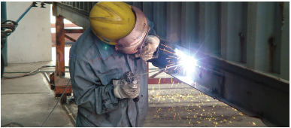**Maintenance and Repair of Container**

Our team is one of our comprehensive maintenance programs to ensure that the repair of the container is in the best condition. Our materials are used to repair tank container manufacturing approved products, to ensure that container shipping companies, the recognition of our repair, and we can provide all kinds of special GOH Container production and the transformation of services.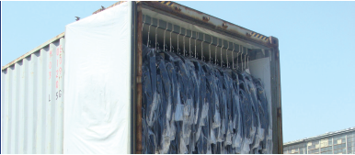

**Garments on Hanger (GOH)**

GOH container production and the transformation of services. Revised case of carbon dioxide gas welding, to ensure the welding quality and beauty. All use manual welding structural elements, to ensure that the welding strength. Hanging instead of folding into boxes.

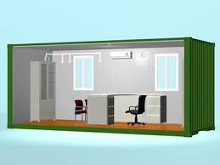**Container offices/housing**

We are engaged in offering Container Site-Offices that are highly appreciated for compact size, high structural strength and eye-catching designs. These offices are available in different colors, sizes and designs as per requirement of the clients. We make sure that the Container Offices are checked by Quality Controllers to ensure their flawlessness.

**TENG LAY DEVELOPMENT CO., LTD**

Teng Lay Development Co., Ltd creates a unique and affordable opportunity for the Cambodian housing market and provide quality resident with ideal location. We started the first project in 2012 which was completed in 2015. We build all kinds of residents including flats, town houses, and villas with beautiful gardens and parks. Currently, we add new project with 25 hectares master plan community on National Road 6A, it is condominiums along the Mekong River.

Our Project Summary:

1. Borey River Town (completed)
2. Borey Mekong Royal (on-going on National Road 6A along the Mekong River)
3. Borey Orkide Villa (on-going on Road 2004)
4. Borey Orkide Villa (on-going on National Road 6A along the Mekong River)

**BOREY RIVER TOWN**

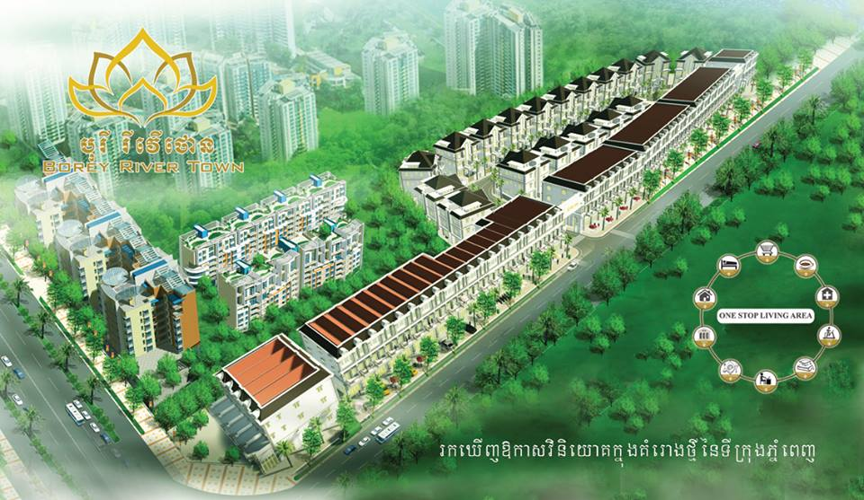

Borey River Town was established since 2012. The development location is in Phum Chroy Changva, Sangkat Chroy Changva, Khan Russey keo, Phnom Penh. Since then, we are always leading in quality, beauty, and innovation.

Borey River Town is one of the Domestic Investment Companies that build and sell modern, quality and harmonious houses and residence with a combination of Western and Khmer styles in form so-call “Borey or City’’ to our valued customers. We currently serve Flat house, Link Houses, Twin Houses, Queen Villas, and King Villas.

**BOREY MEKONG ROYAL**

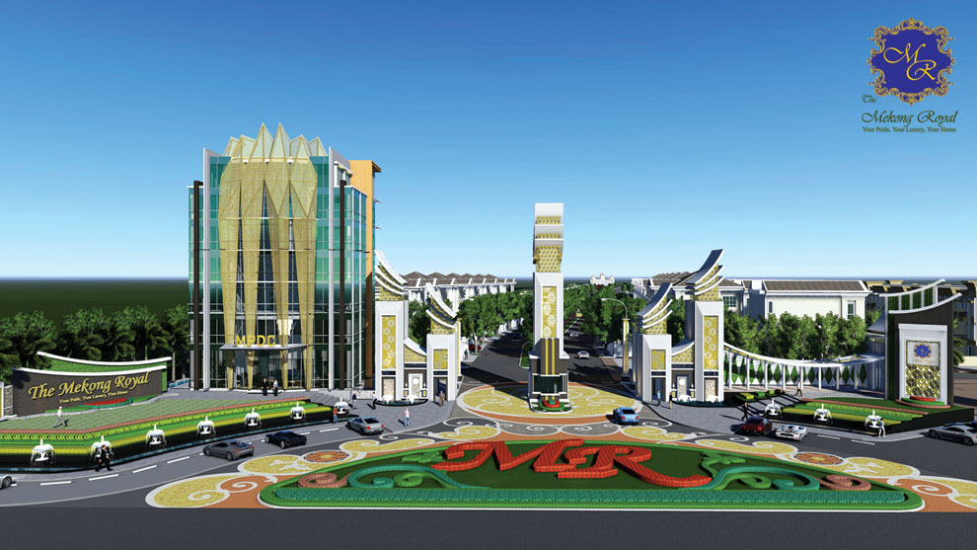

Mekong Phnom Penh Development Corporation Ltd is one of the local real estate investment as the management of Borey The Mekong Royal, I am delighted and wish to express my heartfelt thanks to all clients who have trust in and supporting our projects.

Borey The Mekong Royal supplies the actual needs of all levels of clients in the Kingdom of Cambodia with the residential building construction in Borey in form of the latest modernization which combines the Khmer and European style together, aiming to provide the classic, quality and harmony to people who live in each residence, as Single Villa (King Villa, Queen Villa, Twin Villa) Link House, Modern Flat and Shop House.

**Click here to access to borey Mekong Royal website.**

**BOREY ORKIDE VILLA**

**Project 1 (ORKIDE VILLA THE ROYAL)**

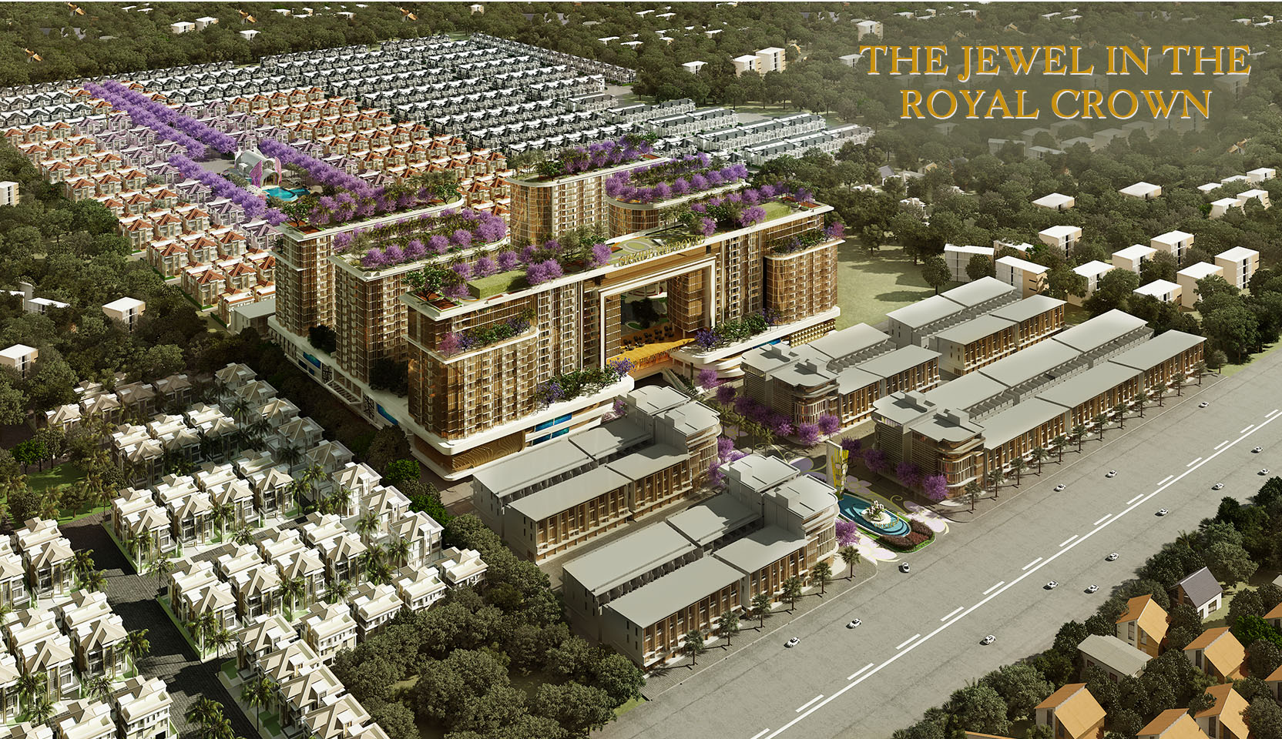

Location: Street 2004, Sangkat Tuek Thla, Khan Sen Sok, Phnom Penh, Cambodia

It is not only for “good …life”, but for “beautiful …life” at Orkidé Villa. We develop our project in order to become a real Exclusive Residence. Integrate a concept of modern architecture with Sustainable Nature oriented architecture. Let the nature and a modern life style stay close to you in every touch with privacy of Great Community.

Life fulfilled with perfection, because the perfection of life is when we have rested with members of our family at Orkidé Villa. We fully equip all areas in the project, to accommodate members in the family with happy activities, including natural park, clubhouse, swimming pool, children playground and fitness. Let a moment of relaxation full of an exquisite pleasure.

The spectacular living… there is an exclusive value of Orkidé Villa, the unique luxurious and most private home with modern style, situated in TUEK THLA District. We design all homes with most usable functions-completeness in every square inch, Together with three styles of home for choosing, accommodating all sizes happiness of each family.

Project 2: (ORKIDE VILLA BOTANIC CITY)

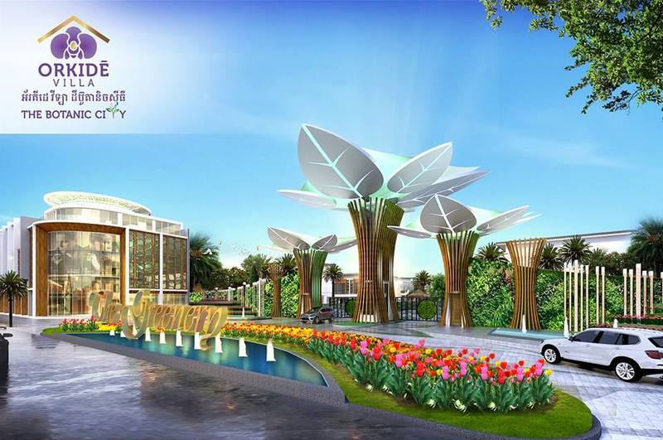

Location: Phum Chroy Changva, Sangkat Chroy Changva, Khan Russey keo, Phnom Penh

**Click here to access to Borey Orkide Villa website**

