KubeEdge Graduation Due Diligence

Authors: Fei Xu, Yue Bao, Yin Ding, Kevin Wang

TOC Sponsor: Cathy Zhang, Lin Sun

TAG input: TAG Runtime

**Table of contents**

Backgrounds

Project Goal

Current Status

1. Continuous Community Momentum

2. Development & Stability & Security

3. Community

4. Wider adoption across industries

1) End Users

2) Integrators

Future Plans (CY2024)

Project Scope

Project definition

Value-add to the CNCF ecosystem

Alignment with other CNCF projects

Alignment with TAG Runtime Reference Model

Formal Requirements

1. Have committers from at least two organizations.

2. Have achieved and maintained a Core Infrastructure Initiative Best Practices Badge

3. Have completed an independent and third party security audit

4. Explicitly define a project governance and committer process

5. Explicitly define the criteria, process and offboarding or emeritus conditions for project maintainers; or those who may interact with the CNCF on behalf of the project

6. Have a public list of project adopters for at least the primary repo

Other Considerations

Cloud Native

Project and Code Quality

Security

Security Audit - Ada Logics

KubeEdge Security Policy

OSS - Fuzzing

CNCF Security TAG Engagement

Self assessment

Joint assessment

Open Governance

TAG Runtime Review Comments for Graduation

# 

# Backgrounds

[Link to TOC PR](https://github.com/cncf/toc/pull/1165)

[Link to GitHub project](https://github.com/kubeedge)

KubeEdge is an open source system for extending native containerized application orchestration capabilities to hosts at the edge. It's built upon Kubernetes and provides fundamental infrastructure support for networking, application deployment, and metadata synchronization between cloud and edge. In addition, KubeEdge supports MQTT, allowing developers to design logic and enable resource constraints for device communications at the edge. KubeEdge decouples and simplifies Kubernetes modules.

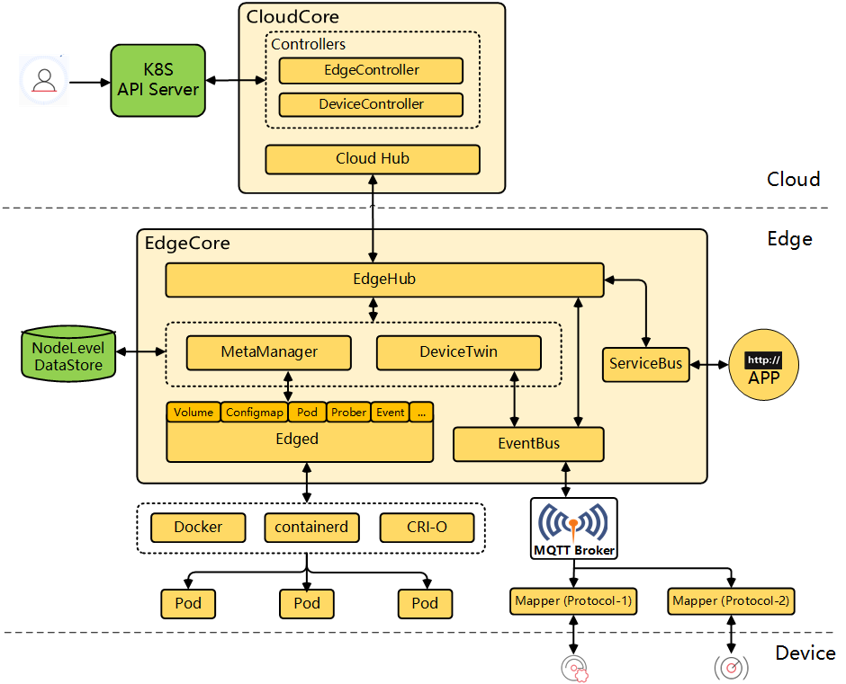

## Project Goal

KubeEdge aims to resolve three major challenges for edge computing: 1) network reliability and bandwidth limit between cloud and edge, 2) resource constraint at edge, and 3) highly distributed and heterogeneous device management.

KubeEdge provides:

1. **Seamless Cloud-Edge Communication** for both metadata and data
2. **Edge Autonomy**: Autonomous operation of Edge even when disconnected from cloud.
3. **Low Resource Requirement**: KubeEdge can work in constrained resource situations (low memory, low bandwidth, low compute)
4. **Simplified Device Communication**: Easy communication between applications and devices for IoT and Industrial Internet of Things (*IIoT*)
5. **Service discovery and traffic proxy** for edge application

In addition to these basic capabilities, the community is constantly exploring new directions for edge scenarios, including:

1. **Edge-cloud synergy AI**, Sedna subproject implements edge-cloud collaborative training and collaborative inference capabilities, such as joint inference, incremental learning, federated learning, and lifelong learning. Sedna supports popular AI frameworks, such as TensorFlow, Pytorch, PaddlePaddle, MindSpore.
2. **Edge-Cloud synergy robots**, based on KubeEdge, to implement cloud robot platform, to integrate cloud computing technologies(cloud native, AI, storage etc) with robots, to support heterogeneous robots, including mobile robots, robotics arm, and many other robot platforms.

Link to GitHub repos:

* The KubeEdge Main project: <https://github.com/kubeedge/kubeedge>
* Subsidiary projects:
  + EdgeMesh: <https://github.com/kubeedge/edgemesh>
  + Mappers-go: <https://github.com/kubeedge/mappers-go>
  + Sedna: <https://github.com/kubeedge/sedna>

## Current Status

#### **1. Continuous Community Momentum**

* Num of Contributors: 300 => **1500+**
* Github Starts: 2500 => **7100+**
* Github Forks: 600 => **2000+**
* Contributing member organizations: 25 => **100+**

#### **2. Development & Stability & Security**

Since 2018, the community has witnessed more than 60 releases. With excellent capabilities, KubeEdge has made technological breakthroughs along the way:

* Support for **100,000 edge nodes** in a Single Cluster
* **DMI**: cloud native edge device management framework
* **EdgeMesh**: HA edge computing architecture
* **Sedna**: edge-cloud synergy AI framework
* **Ianvs**: distributed collaborative AI benchmarking platform
* Support KubeEdge on **Android**
* White Paper on Cloud Native Edge Computing Threat Model and Security Protection Technical
* CNCF's first batch of integrated fuzzing projects
* CNCF's first SLSA L3 project

The figure below shows the key nodes in the evolution of the KubeEdge project：

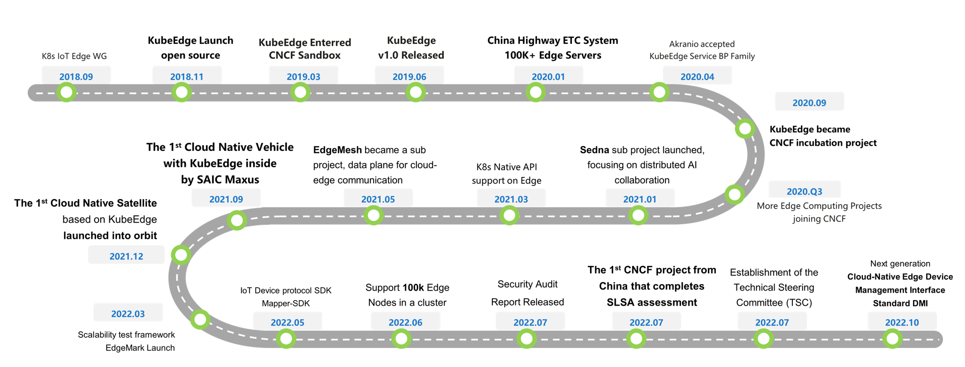

#### **3. Community**

* Open Governance:
  + Governance doc
    - <https://github.com/kubeedge/community/blob/master/GOVERNANCE.md>
  + Established **Technical Steering Committee**:
    - 7 members from 6 companies, 1 Arm, 1 Google, 2 Huawei, 1 DaoCloud, 1 HarmonyCloud, 1 KubeShpere
    - <https://github.com/kubeedge/community/tree/master/committee-technical-steering>
  + Multiple **SIG**s established:
    - SIG AI
    - SIG Robotics
    - SIG Device IoT
    - SIG Node
    - SIG Networking
    - SIG Security
    - SIG Testing
    - SIG Release
    - SIG MEC
    - WG Wireless
  + Multiple Special Teams established:
    - Security Team
      * <https://github.com/kubeedge/community/tree/master/team-security>
    - WIP: PM Team
* Community Events:
  + KubeEdge Summit 2022
    - 2-day event, 1,000+ registrations, 51,800 all-platform viewers
    - 50 speakers from 35 orgs (24 enterprises, 5 non-profits, 6 collages)
    - 28 community supporters
  + KubeEdge Academic Workshop 2022 (KEAW '22)
    - 2-days event, 800+ registrations,41,000+ all-platform viewers
    - 35 speakers from 20 colleges
  + KubeEdge Online Courses
    - 4 stages with 22 lessons, 30+ instructors
    - 1600+ learners have joined
    - 1.2k+ viewers per class, 140+ viewers per broadcast
* Remarkable Presentations at KubeCon
  + KubeCon NA 2022
    - KubeEdge: From Fixed Location To Movable Edge, Latest Updates And Future
  + KubeCon EU 2022 Keynote
    - Incremental Deep Learning For Satellite with KubeEdge and MindSpore
    - <https://sched.co/yuEH>
  + KubeCon China 2021 Keynote
    - Break Through Gravity! Cloud Native Towards Space With KubeEdge
    - <https://sched.co/qx5s>
  + KubeCon China 2020 Keynote
    - Managing One Hundred Thousand Edge Nodes With Kubernetes in China's Highway
    - <https://sched.co/cp8l>

#### **4. Wider adoption across industries**

##### **1) End Users**

KubeEdge has been widely used in industries such as intelligent transportation, smart campus, manufacturing, finance, aerospace, logistics, energy, and smart CDN, providing an integrated edge-device-cloud collaboration solution for users. The community has reached ongoing completions like the industry's largest cloud native highway project powered by edge-cloud synergy (100,000 edge nodes and 500,000 edge applications are centrally managed. Traffic at provincial borders is 13% smoother, and tolling efficiency is 10 times higher.) Other examples include the industry's first cloud native satellites, vehicles, and oilfields.

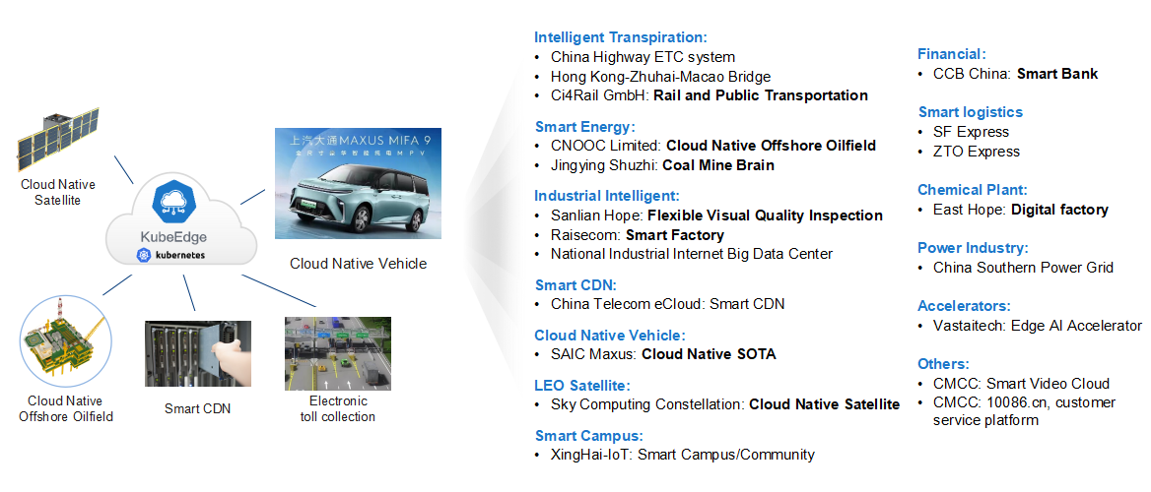

1. [**Cloud Native Vehicles (SAIC MAXUS)**](https://www.bilibili.com/video/av771524351/): KubeEdge is used to connect vehicles to the cloud as nodes, implementing unified management of more than 100,000 vehicles. A single cluster manages millions of devices, facilitating unified device upgrades.
2. [**Smart Campus (XingHai IoT)**](https://github.com/kubeedge/kubeedge/blob/master/ADOPTERS.md#xinghai-iot): Xinghai IoT is an IoT company that provides comprehensive smart building solutions by leveraging a construction IoT platform, intelligent hardware, and AI. Xinghai IoT now offers services in a wide range of areas. Therefore, its solutions should be portable and replicable and need to ensure real-time data processing and secure data storage. KubeEdge, with services designed for cloud native development and edge-cloud synergy, has become an indispensable part of Xinghai IoT for building smart campuses.
3. [**China's highways ETC system**](https://vmblog.com/archive/2021/04/16/managing-100-000-edge-nodes-on-china-s-highways-using-kubeedge.aspx): Connected ETC systems and the removal of toll gates at provincial borders give rise to the deployment of a large number of toll gantries and controllers to collect vehicle information. Currently, the KubeEdge-based edge management system manages nearly 100,000 edge nodes and more than 500,000 edge applications in 29 provinces, municipalities, and autonomous regions. It supports the continuous adjustment and update of the highway gantry services and collects more than 300 million data records every day.
4. **Smart Customer Service System (China Mobile)**: Branches of China Mobile had headaches such as slow service response, low O&M efficiency, and low resource utilization. KubeEdge helps improve O&M efficiency by over 35%, and the service continuity of their 10086 customer service system reaches 99.999%.
5. [**Cloud Native Satellites**](https://vmblog.com/archive/2022/05/06/incremental-deep-learning-for-satellite-with-kubeedge-and-mindspore.aspx) ("Sky Computing Constellation" jointly developed with Beijing University of Posts and Telecommunications): Integrates KubeEdge with satellite computing to enable satellites to use resources of edge and central clouds simultaneously in space and have AI and multitasking capabilities. By means of collaborative inference between satellites and ground stations, the calculation precision is improved by more than 50%, and the amount of data sent back by satellites to the ground is reduced by 90%. The distributed AI provided by Sedna improves the on-orbit image inference and image recognition accuracy.
6. [**Smart factory (Raisecom)**](https://github.com/kubeedge/kubeedge/blob/master/ADOPTERS.md#raisecom-technology-coltd): Ensuring industrial production safety is an important requirement of Raisecom. With KubeEdge as the edge computing platform, factory safety is under perfect control using AI, reducing the occurrence of accidents and improving production efficiency.
7. [**Mine Brain (Jingying Shuzhi)**](https://github.com/kubeedge/kubeedge/blob/master/ADOPTERS.md#jingying-shuzhi-technology-co-ltd): "Mine Brain" has helped many mining enterprises in Shanxi to realize smart mining in more than 1,000 mines: unified management, batch delivery from the center, and remote upgrade; AI analysis algorithms to deliver instructions from the cloud to the mines and provide real-time risk warning. The identification rate has reached 98%. Centralized monitoring of the IT infrastructure of sub-mining sites reduces O&M costs by 65%. Integrated full-stack IT devices in a cabinet reduce deployment costs by 75%.
8. [**IoT System (SF Express)**](https://www.bilibili.com/video/BV1Gg41117d8/?spm_id_from=333.999.0.0): Industrial IoT is seeing explosive device connections and data volume. Based on KubeEdge, SF Express built ubiquitous IoT applications for their logistics and supply chain systems and connected heterogeneous devices from multiple sources by direct connection or cross-level connection through edge nodes. The company effectively streamlined onsite OT production systems. Digital monitoring and intelligent management help improve business operations.
9. [**FinTech Smart Bank (China Construction Bank)**](https://www.bilibili.com/video/BV17V4y1E7bZ/?spm_id_from=333.999.0.0): Banks have high demands on service consistency, system stability, and security. Their IT systems must be scalable and agile on the basis of being highly available and reliable. KubeEdge helps CCB Fintech realize platform-based and cloud-based edge computing to make everything intelligent.
10. [**Large-scale CDN (China Telecom eCloud)**](https://mp.weixin.qq.com/s/bPq9NpR6dO8wBvHCoj5RA): As a typical product with cloud-network synergy, CDN needs to manage a large number of widely distributed edge nodes. Its core components are complex to be reconstructed, associated components need to be deployed in collaboration, and applications need to be managed in a unified manner to reduce costs and improve efficiency. By June 22, all new and legacy nodes of eCloud have been moved to cloud-based on KubeEdge, and they now have a full CDN product line that supports multiple acceleration services for live streaming, VOD, downloads, security, services outside Chinese mainland, as well as whole site and static acceleration, backed by industry-leading precise scheduling.

##### **2) Integrators**

* [**HuaweiCloud Intelligent EdgeFabric (IEF)**](https://www.huaweicloud.com/product/ief.html): provides you a complete edge computing solution based on KubeEdge, in which cloud applications are extended to the edge. By leveraging edge-cloud synergy, you can manage edge nodes and applications remotely and process data nearby, to meet your requirements for remote control, data processing, analysis, decision-making, and intelligence of edge computing resources. In addition, you can perform O&M in the cloud, including edge node monitoring, application monitoring, and log collection.
* [**DaoCloud Edge Computing (DEC)**](https://www.daocloud.io/en/dec): based on KubeEdge, extends the boundary of cloud native capability to the edge. It integrates the end, edge, and cloud to help enterprises quickly build a safe, flexible, efficient, and reliable edge cloud native platform. DEC is widely applicable to industrial Internet, IoT, smart factories, smart parks, smart retailing, and other fields. The cloud side registers, manages edge nodes, and deploys relevant applications and configurations. The edge side runs edge applications and implements edge autonomy. The end side integrates terminals with multiple protocols and provides standard interface docking equipment capabilities.
* [**HarmonyCloud - EdgeStack**](https://harmonycloud.cn/product/2): builds a cloud-edge collaboration system based on KubeEdge, supports access to multiple edge nodes, provides capabilities such as computing power sinking, access to multiple device protocols, and nearby data processing, and accelerates the implementation of edge intelligence for users.
* [**BoCloud - BeyondEdge**](https://www.bocloud.com.cn/product/BeyondEdge/): realizes the bilateral collaboration among cloud, edge, and device end with open architecture. The cloud is responsible for edge system registration and management, application, and configuration distribution; the edge for edge application running and access device management; the device end for edge devices running. They work independently or jointly for different scenarios.
* [**KubeSphere**](https://www.kubesphere.io/docs/v3.4/installing-on-linux/cluster-operation/add-edge-nodes/): KubeSphere leverages KubeEdge, to extend native containerized application orchestration capabilities to hosts at edge. With separate cloud and edge core modules, KubeEdge provides complete edge computing solutions.
* [**EMQ - Analytic Engine**](https://ekuiper.org/docs/en/latest/integrations/kubeedge/overview.html) based on KubeEdge, eKuiper can ingest device data from MQTT and provides versatile analytic capabilities for the KubeEdge components to achieve low latency calculation on edge.
* [**Orange Cloud Intelligent EdgeFabric (IEF)**](https://cloud.orange-business.com/en/offers/infrastructure-iaas/public-cloud/features/intelligent-edge-fabric/): provides users with a complete edge computing solution where cloud applications are extended to the edge. By leveraging edge-cloud synergy, users can manage edge nodes and applications remotely while still processing data nearby.
* [**Envision Digital - ENOS Edge**](https://www.envisioniot.com/docs/enos-edge/en/2.2.0/howto/console_configuration/containerized_service.html): Based on Kubernetes and KubeEdge, EnOS Edge Container System can manage massive Edge nodes in batches.
* [**Ci4Rail GmbH - EdgeFarm IoT Platform**](https://www.ci4rail.com/edgefarm-iot-platform/): EdgeFarm focuses on the lossless and high-quality acquisition, transmission, and processing of all types of field data and thus provides the basis for intelligent maintenance or fleet optimization, regardless of the vehicle type and manufacturer. In addition, EdgeFarm enables the convenient management of users' devices and applications and thus creates transparency for users' fleets.

## Future Plans (CY2024)

* Add new innovations and incremental features across the KubeEdge main project and all sub-projects.
* Continue to grow the community by focusing on expanding community events and engagement.

Roadmaps:

<https://github.com/kubeedge/community/blob/master/roadmap.md>

# Project Scope

## Project definition

KubeEdge falls in the scope of [CNCF Runtime TAG](https://github.com/cncf/sig-runtime) and is also well-aligned with the CNCF's mission to **make cloud native computing ubiquitous**.

## Value-add to the CNCF ecosystem

As the CNCF's first cloud-native edge computing framework and incubation project, KubeEdge has helped **expanding cloud native ecosystem to more industries outside the data center**, including Smart CDN, Smart Campus, Intelligent Transpiration, Vehicle, Aerospace, Smart logistics, Financial, Blockchain and other fields.

* Building an open edge computing platform with cloud native technologies to extend the boundary of cloud native
* Helping users extend their business architecture, applications, services, etc. from cloud to edge in the same experience
* Implementing extensible cloud-edge architecture based on Kubernetes
* Seamless development, deployment, and execution of complex workloads at edge with optimized resources

## Alignment with other CNCF projects

As a CNCF project, KubeEdge integrates with the CNCF landscape and is built on top of the following CNCF projects and brings them to edge computing.

* Kubernetes: KubeEdge is built on Kubernetes, compatible with native Kubernetes APIs, and allows calls to these native APIs to manage edge nodes and devices.
* containerd, cri-o: KubeEdge supports running containers in edge nodes with containerd, cri-o through CRI.
* Prometheus: KubeEdge provides Prometheus metrics to monitor edge nodes and edge applications.
* WasmEdge: KubeEdge supports running lightweight wasm applications on edge nodes with WasmEdge.
* KubeFlow: KubeEdge integrates with Kubeflow to run AI Jobs on edge nodes.
* ArgoCD: KubeEdge integrates with ArgoCD to provide GitOps on the edge.

## Alignment with TAG Runtime

The KubeEdge Project aligns with the CNCF reference model as shown below. KubeEdge capabilities are primarily in the edge nodes and applications management area.

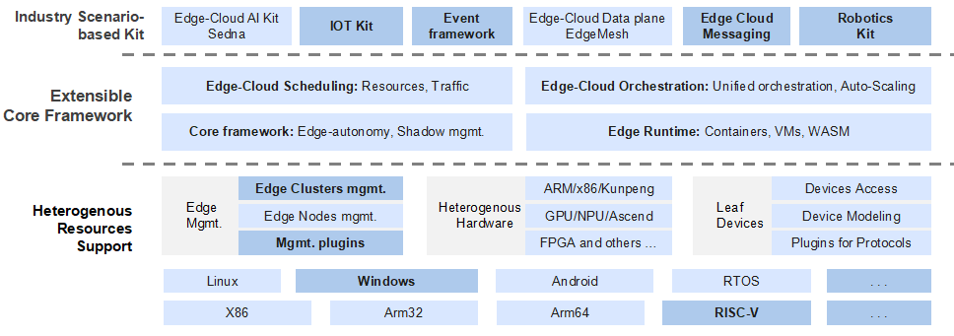

# Formal Requirements

### **1. Have committers from at least two organizations.**

KubeEdge community has 7 Technical Steering Committees from 6 companies, who are the governing body for the KubeEdge project, providing decision-making and oversight pertaining to the KubeEdge project bylaws. The Technical Steering Committee also defines the project values and structure.

KubeEdge has 12 core maintainers from 7 companies, who are responsible for maintaining code development for overall projects. KubeEdge also has 15+ SIG maintainers who Focus on maintaining corresponding modules.

Maintainers list: <https://github.com/kubeedge/kubeedge/blob/master/MAINTAINERS.md>

### **2. Have achieved and maintained a Core Infrastructure Initiative** [**Best Practices Badge**](https://bestpractices.coreinfrastructure.org/)

Yes. See the links below for Core Infrastructure Initiative Best Practices Badge.

Ref:<https://bestpractices.coreinfrastructure.org/en/projects/3018>

### **3. Have completed an independent and third party security audit**

KubeEdge community in 2022 cooperates with Ada Logics Ltd. and The Open Source Technology Improvement Fund performed a holistic security audit of KubeEdge and output a security auditing report, including the security threat model and security issues related to the KubeEdge project, which has important guiding significance for the security protection of the KubeEdge project.

The discovered security issues have been fixed and patched to the releases(v1.11.1, v1.10.2, v1.9.4) by KubeEdge maintainers according to the [KubeEdge Security Policy](https://github.com/kubeedge/kubeedge/security/policy).

KubeEdge Security Audit report: <https://github.com/kubeedge/community/blob/master/sig-security/sig-security-audit/KubeEdge-security-audit-2022.pdf>

KubeEdge Threat Model and Security Protection Analysis: <https://github.com/kubeedge/community/blob/master/sig-security/sig-security-audit/KubeEdge-threat-model-and-security-protection-analysis.md>

KubeEdge Security Policy: <https://github.com/kubeedge/community/blob/master/team-security/SECURITY.md>

### **4. Explicitly define a project governance and committer process**

This is documented in our governance documentation available here as well as our contribution guide for making contributions.

Community Governance doc: <https://github.com/kubeedge/community/blob/master/GOVERNANCE.md>

Contribution Guide doc: <https://github.com/kubeedge/community/blob/master/contribute.md>

### **5. Explicitly define the criteria, process and offboarding or emeritus conditions for project maintainers; or those who may interact with the CNCF on behalf of the project**

This is documented in our community membership documentation available here for roles with the requirements and responsibilities associated with them.

Community Membership doc: <https://github.com/kubeedge/community/blob/master/community-membership.md>

### **6. Have a public list of project adopters for at least the primary repo**

KubeEdge provides a full overview of publicly listed end-users on the website, but there are others that are not yet published or in the application process to list but can be interviewed.

**KubeEdge Supporters**: <https://kubeedge.io/#supporters>

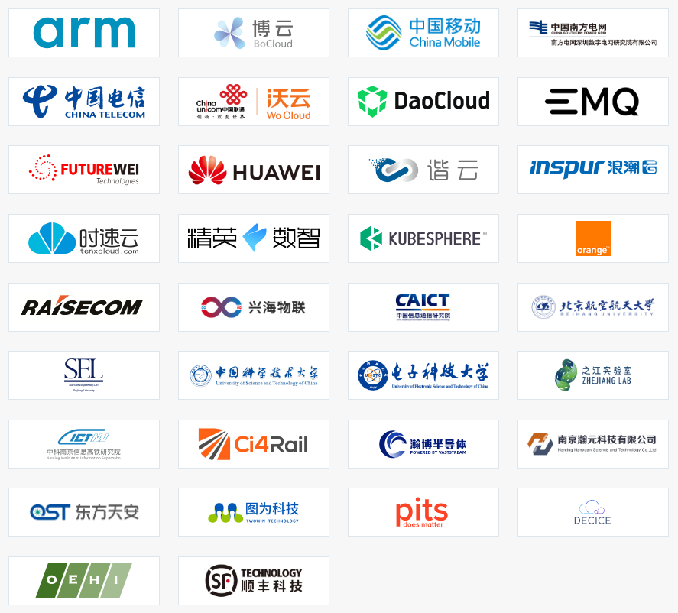

KubeEdge CaseStudies: <https://kubeedge.io/case-studies>

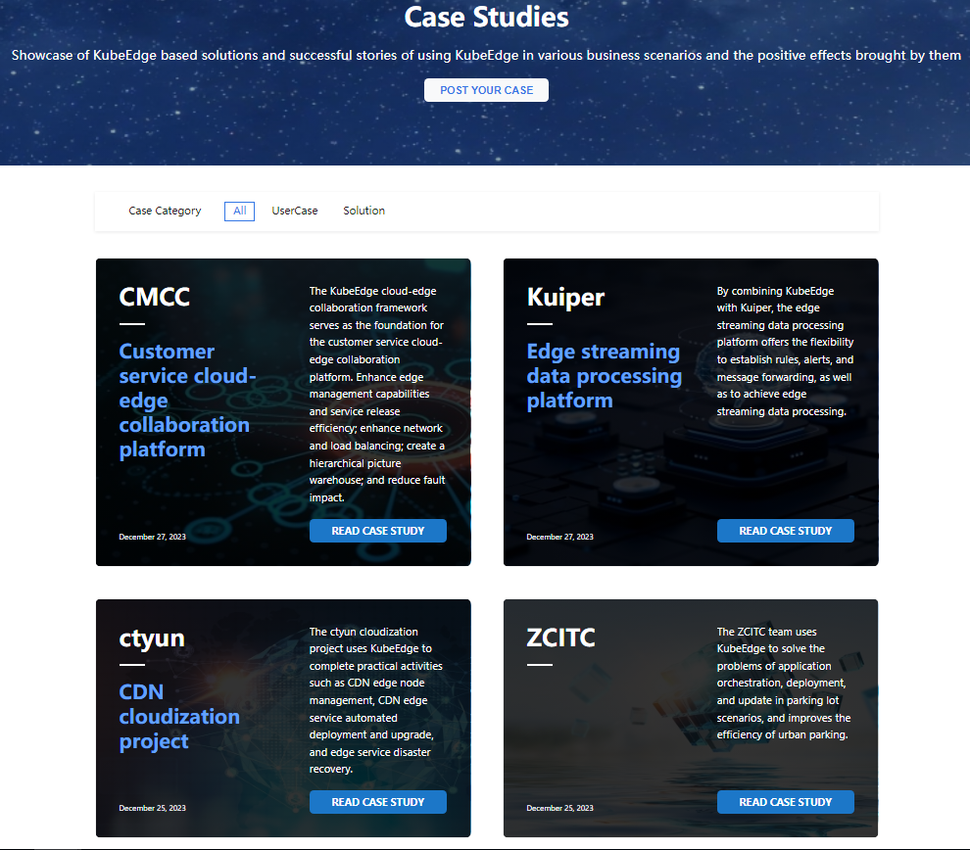

# Other Considerations

## Cloud Native

***Does the project meet the definition of Cloud Native? The CNCF charter states:***

*“Cloud native technologies empower organizations to build and run scalable applications in modern, dynamic environments such as public, private, and hybrid clouds. Containers, service meshes, microservices, immutable infrastructure, and declarative APIs exemplify this approach.*

*“These techniques enable loosely coupled systems that are resilient, manageable, and observable. Combined with robust automation, they allow engineers to make high-impact changes frequently and predictably with minimal toil.”*

KubeEdge falls in the scope of CNCF Runtime TAG and is also well-aligned with CNCF's mission to **make cloud native computing ubiquitous**.

## Project and Code Quality

KubeEdge has documentation to help developer through the process of contribution, code quality, DCO (and how to fix), etc

Contributing docs: <https://github.com/kubeedge/kubeedge/blob/master/CONTRIBUTING.md>

KubeEdge follows the community release management to ensure the stability, compatibility, and quality of releases:

<https://kubeedge.io/docs/community/release>

Each contribution(PR) needs to **pass several automated checks**, including [golangci-linter](https://github.com/golangci/golangci-lint) to ensure code quality, e2e tests to ensure code capability. Each contribution (PR) needs to get **at least two approver/reviewer** based on a code review.

Code review examples

* <https://github.com/kubeedge/kubeedge/pull/4013>
* <https://github.com/kubeedge/kubeedge/pull/5330>
* <https://github.com/kubeedge/kubeedge/pull/5331>

Coding standard

* <https://github.com/golangci/golangci-lint/>
* <https://github.com/kubernetes/community/blob/master/contributors/devel/sig-architecture/api-conventions.md>

Performance Goals and Standards

* <https://kubeedge.io/blog/scalability-test-report>

Code Quality

* CI/CD:
  + <https://github.com/kubeedge/kubeedge/tree/master/.github/workflows>
  + <https://github.com/kubeedge/edgemesh/blob/main/.github/workflows/main.yaml>
  + <https://github.com/kubeedge/sedna/tree/main/.github/workflows>
* Unit and e2e tests:
  + <https://github.com/kubeedge/kubeedge/tree/master/tests>
  + <https://github.com/kubeedge/edgemesh/tree/main/tests>
  + <https://github.com/kubeedge/sedna/tree/main/test>
* Conformance and node conformance:
  + <https://github.com/kubeedge/kubeedge/tree/master/build/conformance>

## Security

The KubeEdge project is already in production use in many industries that rely on KubeEdge for critical edge infrastructure and application needs. All projects attach great importance to security to ensure that users can trust KubeEdge's systems.

### Security Audit - Ada Logics

KubeEdge community in 2022 cooperates with Ada Logics Ltd. and The Open Source Technology Improvement Fund performed a holistic security audit of KubeEdge and output a security auditing report, including the security threat model and security issues related to the KubeEdge project, which has important guiding significance for the security protection of the KubeEdge project.

The discovered security issues have been fixed and patched to the releases(v1.11.1, v1.10.2, v1.9.4) by KubeEdge maintainers according to the [KubeEdge Security Policy](https://github.com/kubeedge/kubeedge/security/policy).

KubeEdge Security Audit report: <https://github.com/kubeedge/community/blob/master/sig-security/sig-security-audit/KubeEdge-security-audit-2022.pdf>

KubeEdge Threat Model and Security Protection Analysis: <https://github.com/kubeedge/community/blob/master/sig-security/sig-security-audit/KubeEdge-threat-model-and-security-protection-analysis.md>

### KubeEdge Security Policy

KubeEdge Security Policy：

<https://github.com/kubeedge/community/blob/master/team-security/SECURITY.md>

The KubeEdge community also strictly handles the reporting vulnerability according to the [Security Release Process](https://github.com/kubeedge/community/blob/master/team-security/security-release-process.md). The following flowchart shows the vulnerability handling process.

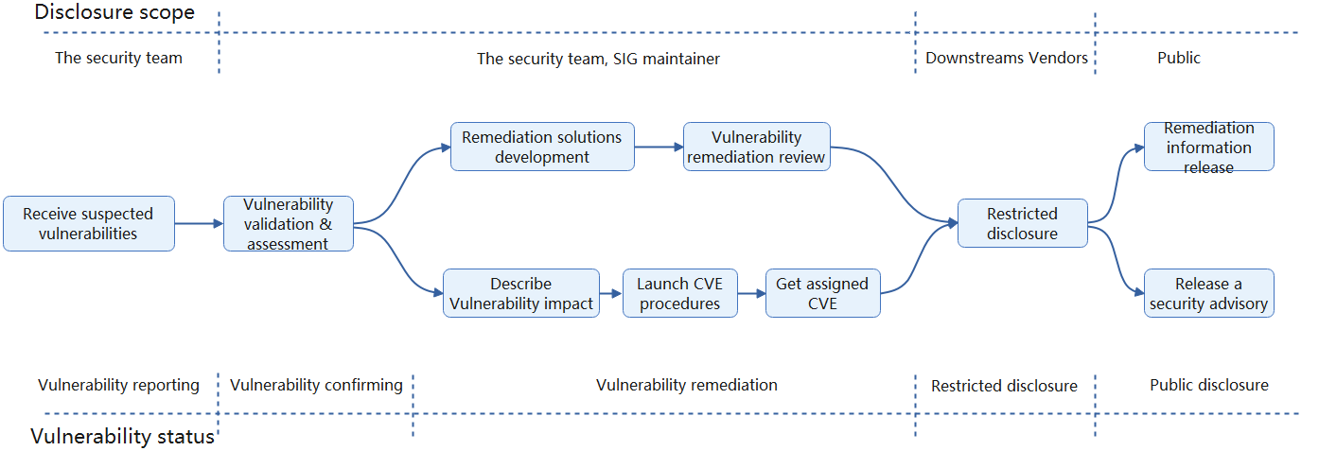

### OSS - Fuzzing

Fuzzing is a common technique to automate the process of identifying reliability and security issues. It is commonly used by security researchers to find vulnerabilities in systems and the technique has been successfully used on various [CNCF projects](https://github.com/cncf/cncf-fuzzing#cncf-projects-and-fuzzing), such as Kubernetes, Envoy, Helm, Linkerd2-proxy, and Fluent-bit. The general approach of fuzzing is to use genetic algorithms in combination with sophisticated program analysis and software instrumentation techniques to generate inputs that achieve a high level of code coverage in the target software.

Ada Logics developed a total of 41 fuzzers as part of this engagement. The KubeEdge project is one of the first CNCF Projects integrating with Fuzzing. The fuzzers were set up to run continuously by way of OSS-fuzz and 10+ bugs were reported and have been addressed.

Improving Security by Fuzzing the CNCF Landscape：

<https://www.cncf.io/blog/2022/06/28/improving-security-by-fuzzing-the-cncf-landscape/>

### CNCF Security TAG Engagement

KubeEdge submitted an issue to do a Security TAG review in Sep 2022, which is still ongoing. The current state of the engagement including work that has been completed is described below.

#### Self-assessment

The self-assessments were completed and are available here:

<https://github.com/kubeedge/community/blob/master/sig-security/self-assessment.md>

#### Joint assessment

KubeEdge is currently next in line and target completion is in the Q1/Q2 CY24 timeframe.

* Joint Review Draft: <https://github.com/kubeedge/community/blob/master/sig-security/joint-review.md>

## Performance and scalability

Users in the KubeEdge community from Cities, transportation, healthcare, manufacturing, and many other fields are expecting large-scale edge deployment. Now, KubeEdge community has fully tested, can stably support **100,000** concurrent edge nodes, and manage more than **one million** pods.

Test Report: <https://kubeedge.io/blog/scalability-test-report>

### Architecture

In the KubeEdge architecture, the cloud is a unified control plane, which includes native Kubernetes management components and KubeEdge-developed CloudCore components. It listens to cloud resource changes and provides reliable, efficient cloud-edge messaging. At the edge side lie the EdgeCore components, including Edged, MetaManager, and EdgeHub.

## 

KubeEdge allows nodes to be deployed more remotely and thereby extends edge-cloud collaboration. To help users cost less and manage more in an easier way, KubeEdge, fully compatible with Kubernetes, optimizes the cloud-edge messaging and provides access support for mass edge nodes.

### Test tools - EdgeMark

Edgemark is a performance test tool similar to Kubemark. It simulates deploying KubeEdge edge nodes in the KubeEdge cluster scalability test to build ultra-large Kubernetes clusters, powered by KubeEdge, with limited resources.

## 

### High Availability Mode of Cluster Deployment Scheme for the Test

The KubeEdge control plane is deployed with five CloudCore instances and connects to the kube-apiserver through the IP address of the master node. Hollow EdgeNodes are exposed by a load balancer and randomly connect to a CloudCore instance based on the round-robin policy of the load balancer.

## 

## Open Governance

The KubeEdge community has **7** **Technical Steering Committee members** from 6 companies, who are the governing body for the KubeEdge project, providing decision-making and oversight pertaining to the KubeEdge project bylaws. The Technical Steering Committee also defines the project values and structure.

Technical Steering Committee: [https://github.com/kubeedge/community/tree/master/committee-technical-steering](https://github.com/kubeedge/community/tree/master/committee-technical-steering#members)

KubeEdge has 12 core maintainers from 7 companies, who are responsible for maintaining code development for overall projects.

Maintainers list: <https://github.com/kubeedge/kubeedge/blob/master/MAINTAINERS.md>

KubeEdge now has 10 SIGs, and each SIG has at least one or two Chairs and Tech leaders, who focus on maintaining corresponding modules, now KubeEdge also has 15+ SIG Chair/Tech-leader.

SIGs: <https://github.com/kubeedge/community/tree/master>

**Community and Governance Docs:**

<https://github.com/kubeedge/community/blob/master/GOVERNANCE.md>

**Community Membership Process:**  
<https://github.com/kubeedge/community/blob/master/community-membership.md>

## TAG Runtime Review Comments for Graduation

TAG-Runtime recommends KubeEdge as a candidate for graduation within the Cloud Native Computing Foundation (CNCF) due to its continued maturity growth and significant contributions. KubeEdge seamlessly bridges the gap between edge computing and cloud native environments, offering a robust platform for deploying, managing, and orchestrating cloud and edge native applications.

The project fosters collaboration and innovation, making it a valuable asset for organizations seeking to leverage edge computing technologies. Its robustness, scalability, and reliability make it a standout solution for efficiently managing edge devices and applications.

By promoting KubeEdge to a graduated project in the CNCF, we can further solidify its position as a trusted and mature cloud and edge computing solution, bringing confidence and benefiting the entire cloud native ecosystem.