2021 VCE Chemistry external assessment report

General comments
Use of the study design when preparing for the examination is essential, as emphasised in this report. A significant number of questions related directly to details given in the study design. Familiarity with, and the use of key knowledge and skills found in the study design is strongly recommended.
It is crucial that students read the stem of each question carefully, and if they are asked to calculate a number, the final response they give must be in the units specified in the stem. If no units are specified in the stem, the final response must include correct units.
When calculating equilibrium constants, units for this constant must be quoted correctly.
Students should ensure that all key aspects of a question are addressed in their responses; this is particularly pertinent to descriptive responses. For example, in Question 10 a. the glycaemic indexes of both amylopectin and amylose must be referred to; reference to only one of these in a response will not gain full marks.

Specific information
This report provides sample answers, or an indication of what answers may have included. Unless otherwise stated, these are not intended to be exemplary or complete responses. Asterisks (*) are used for some questions to indicate where marks were awarded.
The statistics in this report may be subject to rounding resulting in a total more or less than 100 per cent.

Section A – Multiple-choice questions
Question | Correct answer | % A | % B | % C | % D | Comments
1 | A | 82 | 8 | 9 | 1 | Rechargeable batteries act as galvanic cells during discharge and electrolytic cells during recharge. The recharge reaction is the reverse of the discharge reaction.
2 | A | 92 | 2 | 4 | 2 | The polar molecules in biodiesel are much larger than the non-polar molecules in petrol. The stronger intermolecular attraction (dispersion forces and dipole-dipole) in biodiesel means it has a significantly higher viscosity, and a much lower flow rate than petrol.  Biodiesel (renewable) has less environmental impact than petrol (non-renewable).
3 | A | 53 | 4 | 37 | 5 | Lactose intolerant people are either unable to digest, or digest a minimal amount of, lactose.  Selection of Option C suggests many students were unsure about the nature of lactose being a carbohydrate and incorrectly assumed it was a protein.
4 | D | 13 | 13 | 11 | 62 | A systematic error is consistent for all the titrations.  The only consistent error is the difference between the actual and stated concentrations of NaOH solution.  The other three options were all random errors.
5 |  |  |  |  |  | This question is no longer available.
6 | D | 19 | 3 | 16 | 61 | In denaturation the tertiary and secondary structures are broken down. The tertiary structure is maintained by ionic bonding (and other types of bonding such as covalent, ionic, dipole-dipole, etc.) and the secondary structure by hydrogen bonding.  In hydrolysis, covalent peptide bonds between amino acids are broken.
7 | A | 77 | 8 | 3 | 12 | Characteristic number 1: Electrolytic cells: cathode is negative (correct); galvanic cells: cathode is positive (correct)  Characteristic number 2: Electrolytic cells: have non-spontaneous reactions (correct); galvanic cells: have spontaneous reactions (correct)  Characteristic number 3: Electrolytic cells: reduction occurs at the anode (incorrect); galvanic cells: reduction occurs at the cathode (correct)  Characteristic number 4: Electrolytic cells: produce electricity (incorrect); galvanic cells: consume electricity (incorrect)
8 | D | 10 | 12 | 7 | 71 | The triglyceride hydrolyses to produce glycerol, CH₂OHCHOHCH₂OH and three fatty acids.  C₁₇H₃₅COOH – stearic acid – saturated  C₁₉H₃₉COOH – arachidic acid – saturated  C₁₇H₃₃COOH – oleic acid – monounsaturated  Oleic acid will undergo oxidative rancidity.  The triglyceride has one C=C.  Because of the large non-polar hydrocarbon chains, the triglyceride is insoluble in polar water.
9 | A | 62 | 20 | 12 | 5 | Since Q = n(e⁻) x F  n(e⁻) = Q / F  = 4.00 C / 96500 C mol⁻¹  = 4.15 x 10⁻⁵ mol  Selection of Option B is consistent with confusing current with charge and using, inappropriately, Q = It
10 | C | 1 | 2 | 17 | 80 | Based on the electrochemical series, in an Fe-Zn cell the expected half-equations are Zn(s) → Zn²⁺(aq) + 2e⁻ and Fe²⁺(aq) + 2e⁻ → Fe(s)  The most valid methods of testing the hypothesis are those in which all variables except the independent and dependent variables are controlled.  The independent variable has the values the Zn electrode is not polished / the Zn electrode is polished. The impact on the dependent variable – change in mass of Fe electrode per unit time can only be validly assessed if all the other variables are controlled.  The change in mass per unit time of the Fe electrode is proportional to the current flowing and, if the hypothesis is valid, will be greater after the Zn electrode is polished.  In Option C, all other variables are controlled. The same cell is used, and the only difference is whether the Zn electrode is polished.  In Option D, a different cell is used so not all variables were controlled, so this is not a valid experiment. It is perhaps not surprising D was chosen because the words ‘polishing the zinc’ and ‘measuring current’ appeared in this item and in the stem, so it was an obvious selection when students were unsure.
11 | B | 10 | 69 | 19 | 2 | Looking for the structure that exhibits all the spectroscopy properties provided.  number of peaks in ¹³C NMR 2 A B C D – 2 C environments  number of sets of peaks in ¹H NMR 3 B C – 3 H environments  m/z of the last peak in the mass spectrum 60 B – M_{r} = 60.0  infra-red (IR) spectrum an absorption peak appears at 3350 cm⁻¹ B: O-H; C: N-H  Only propan-2-ol – Option B – has all four designated properties.  2-aminopropane – Option C – has M_{r} = 59.0.
12 | D | 4 | 9 | 16 | 70 | n(C₄H₁₀) = 67.0 g / 58.0 g mol⁻¹  n(CO₂) = 4 x 67.0 / 58.0  = 4.62 mol  m(CO₂) = 4.62 mol x 44.0 g mol⁻¹  = 203 g  Alternatively:  n(C₄H₁₀) = 3330 kJ / 2880 kJ mol⁻¹  n(CO₂) = 4 x 3330 / 2880  = 4.63 mol  m(CO₂) = 4.63 mol x 44.0 g mol⁻¹  = 204 g  Alternative C is consistent with not using the n(CO₂)/n(C₄H₁₀) ratio indication in the combustion equation.
13 | B | 9 | 62 | 15 | 13 | In the discharge reaction the oxidation number of Pb changes from 0 to +2 at one electrode and from +4 to +2 at the other electrode.  Pb(s) is oxidised to PbSO₄ at the anode.  PbO₂(s) is reduced to PbSO₄ at the cathode.  So, during recharge when the half-equations for discharge are reversed.  PbSO₄ is oxidised to PbO₂ at the anode.  PbSO₄ is reduced to Pb at the cathode.
14 | B | 17 | 46 | 19 | 18 | PbO₂  An oxidising agent causes oxidation and is itself reduced.  In the discharge reaction:  Pb(0) is oxidised to Pb(+2)SO₄ and Pb(+4)O₂ is reduced to Pb(+2)SO₄.  PbO₂ oxidises Pb to PbSO₄ and is itself reduced to PbSO₄.  The identification of oxidising agents is a clear area for improvement.
15 | D | 14 | 11 | 19 | 56 | The flashpoint of a substance depends significantly on the strength of intermolecular attraction.  A. Pentane, C₅H₁₂, with weaker intermolecular dispersion force attraction than octane, C₈H₁₈, has a lower flashpoint.  B. Structural isomers are different compounds and the intermolecular attraction in branched isomers is generally weaker than in straight-chain isomers. Consequently, structural isomers have different flashpoints.  C. Fire risk is greater with low flash point compounds since these give off ignitable vapour at lower temperatures.  D. Optical isomers have the same physical properties (i.e. the same strength of intermolecular attraction) and will have equal flashpoints.
16 | C | 22 | 25 | 15 | 38 | A. It is in NMR spectroscopy that the spin state of the nucleons is altered by the absorption of radio wave radiation.  B. Bond wave number is determined by bond strength and the masses of the atoms involved in the bond.  C. Every pure compound has a unique fingerprint region on its IR spectrum. So, the purity of the sample can be assessed qualitatively by comparing the fingerprint region of the IR spectrum of that sample with the fingerprint region of the IR spectrum of the pure compound.  D. High absorption of radiation at a particular wave number in IR spectroscopy means less transmittance of radiation at that wave number. So high transmittance is the result of low absorption.  Performance on this question suggests that students were not familiar with the use of IR spectra in qualitative analysis, the relationship between wave number and atomic mass, and the link between NMR and spin states.
17 | C | 7 | 15 | 67 | 10 | n(O₂) = Δp x V / RT  = 250.0 x 200.0 / [8.31 x (22.0 + 273)]  = 20.4 mol  m(O₂) = 20.4 mol x 32.0 g mol⁻¹  = 653 g  = 6.53 x 10² g
18 | C | 6 | 16 | 73 | 6 | Equations consistent with each energy profile:  A. 2NO₂(g) → 2NO(g) + O₂(g) ΔH = -14 kJ mol⁻¹  B. CO₂(g) + NO(g) → CO(g) + NO₂(g) ΔH = -226 kJ mol⁻¹  C. N₂O₄(g) ⇋ 2NO₂(g) ΔH = +57 kJ mol⁻¹  or  2NO₂(g) ⇋ N₂O₄(g) ΔH = -57 kJ mol⁻¹  D. N₂(g) + O₂(g) ⇋ 2NO(g) ΔH = -181 kJ mol⁻¹
19 | B | 12 | 66 | 13 | 8 | Energy from sample = CF x ΔT  = 4780 J °C⁻¹ x 16.7 °C  = 7.98 x 10⁴ J  Energy content = 7.98 x 10⁴ J / 3.95 g  = 2.02 x 10⁴ J g⁻¹
20 | C | 15 | 15 | 52 | 18 | Ni²⁺ + 2e⁻ → Ni(s)  n(e⁻) = 320 mol  n(Ni) = n(e⁻) / 2  = 160 mol  m(Ni) = 160 mol x 58.7 g mol⁻¹  = 9.39 x 10³ g  Students who selected Option D did not make use of the reduction half-equation.
21 | A | 31 | 27 | 25 | 17 | The half-equations occurring in the electroplating cell are:  Anode: Ni → Ni²⁺ + 2e; Cathode: Ni²⁺ + 2e⁻ → Ni  Prior to the change Ni²⁺ ions were produced at the anode and consumed at the cathode so the amount of Ni²⁺ ions in the electrolyte remained constant.  If the amount of Ni electroplated on the cell is reduced following the change to the cell, the change must have caused either an alternative reduction half-reaction to be favoured or decrease in the amount Ni²⁺ ions available to be reduced.  Consider the correct Option A:  If the Ni electrode is replaced with a Cu electrode, Ni²⁺ ions will not be produced at the anode, so as reduction occurs at the cathode the amount of Ni²⁺ ions in the electrolyte decreases and the amount of Ni that can be deposited is reduced.  Options B, C and D do not affect the half-reactions occuring at the electrodes. While replacing the Ni(NO₃)₂(l) with Ni(NO₃)₃(aq) will decrease the amount of Ni²⁺ ions in the electrolyte, it does not impact on the amount of Ni²⁺ produced at the anode, hence the amount of Ni²⁺ ions that can be transferred from the anode and reduced at the cathode.
22 | D | 9 | 19 | 34 | 37 | For 100% efficiency:  m(C₈H₁₈) reacting = energy used / energy from 1 g  = 528 x 10³ kJ / 47.9 kJ g⁻¹  = 1.10 x 10⁴ g  Since d = m / V  V(C₈H₁₈) = 1.10 x 10⁴ g / 703 g L⁻¹  = 15.7 L  Since the reaction when octane undergoes combustion is only 25% efficient, 15.7 L is only 25% of the octane consumed.  15.7 = 0.25 x V(C₈H₁₈) required.  V(C₈H₁₈) = 15.7 / 0.25  = 62.7 L  Alternatively:  n(C₈H₁₈) reacting = energy used / energy from 1 mol  = 528 x 10³ kJ / 5460 kJ mol⁻¹  = 96.7 mol  m(C₈H₁₈) reacting = 96.7 mol x 114.0 g mol⁻¹  = 1.10 x 10⁴ mol  The main error in this question was not using the efficiency in the calculations; this was consistent with Option C.
23 | B | 23 | 49 | 19 | 9 | The same standardised solution of KOH(aq) was used in titration of all three samples, so the larger the average titre the greater the n(acid) present in the sample.  Since 25 mL aliquots of the acids was used in all three samples, a larger titre of KOH(aq) is consistent with a higher acid concentration.  Sample 3 was the most concentrated acid while sample 2 was the least concentrated.
24 | A | 38 | 4 | 11 | 47 | The general relative energy profiles for an uncatalysed reacton and a catalysed reaction may be shown as:  The energy content of the products (and reactants) – and so the ΔH for the equation – is not affected by adding a catalyst and will remain the same.  With respect to Option D: The activation energy for the forward and reverse reactions decreases by the same amount. In the exothermic profile shown, the activation energy of the forward reaction is smaller than the activation energy of the reverse reaction.  So the decrease in activation energy due to the addition of a catalyst is a higher proportion of the activation energy of the forward reaction / a smaller proportion of the activation of the reverse reaction.
25 | C | 12 | 29 | 34 | 25 | Consider the concentration-time graphs.  The only change that could cause an instantaneous increase to the rate of the reverse reaction at t₁ with no instantaneous effect of the rate of the forward reaction would be the addition of product(s). The rate of the reverse reaction slowly decreases and the rate of the forward reaction slowly increases as the system partially responds to the imposed change and returns to equilibrium, where the amount of products present will be higher than prior to the change.  Option B is incorrect, since removal of reactants at t₁ would have caused an instantaneous decrease in the rate of the forward reaction, and while the rate of the reverse reaction is greater than the rate of the forward reaction, its rate is not increased.  Option D is incorrect, because the only change that could cause the value of the equilibrium constant to increase would be a temperature increase, since the forward reaction is endothermic. However, a temperature increase at t₁ would cause the rates of both the forward and reverse reactions to increase.  Option A is incorrect, since argon is an unreactive gas and will not have any impact on the equilibrium.
26 | C | 18 | 31 | 41 | 9 | According to the electrochemical series:  Cu²⁺(aq) + 2e⁻ ⇋ Cu(s) +0.34 V  Pb²⁺(aq) + 2e⁻ ⇋ Pb(s) -0.13 V  Ni²⁺(aq) + 2e⁻ ⇋ Ni(s) -0.25 V  In³⁺(aq) + 3e⁻ ⇋ In(s) -0.34 V  Mn²⁺(aq) + 2e⁻ ⇋ Mn(s) -1.18 V  Al³⁺(aq) + 3e⁻ ⇋ Al(s) -1.66 V  Mg²⁺(aq) + 2e⁻ ⇋ Mg(s) -2.37 V  If the In³⁺(aq)/In(s) half-cell contains the negative electrode, oxidation must happen in the half-cell, so it must be connected to half-cells with higher standard electrode potentials (higher on the electrochemical series).  The voltage produced when connected to the In³⁺(aq)/In(s) half-cell will decrease in the order:  Cu²⁺(aq)/Cu(s), 0.68 V > Pb²⁺(aq)/Pb(s), 0.21 V > Ni²⁺(aq)/Ni(s), 0.09 V  Selection of Options A or B suggests many students did not understand that the negative electrode, the site of oxidation in a galvanic cell, was the In(s) electrode and the oxidising agents must be in half-cells higher on the electrochemical series.
27 | D | 12 | 45 | 29 | 13 | Concentration-time graphs show all concentrations increasing/doubling at time t₁.  This could only be caused by the volume decreasing/halving. This increases the concentration of all species, but has no effect on the amounts of H₂, I₂ and HI present.  Because there are the same number of particles on both sides of the equation ½H₂(g) + ½I₂(g) ⇋ HI(g) the system is not pushed out of equilibrium as a result of concentration increase due to volume decrease.  When the volume decreases, the concentrations of all reactants and products are increased. The rates of the forward and reverse reactions increase and will be greater at t₃ than at t₁. However, the rates are always equal, since a change in concentration has no impact on the position of equilibrium.  For ½H₂(g) + I₂(g) ⇋ HI(g), irrespective of the equilibrium concentration:  In the forward reaction, the rate at which HI is produced is double the rate of consumption of H₂ or I₂ since 2 mole H₂ is formed for each mole of H₂ or I₂ consumed.  In the reverse reaction, the rate at which HI is consumed is double the rate of consumption of H₂ or I₂ since 2 mole HI is consumed for each mole of H₂ or I₂ formed.  At equilibrium, the rates of the forward and reverse reactions are the same, so, irrespective of the concentrations at equilibrium, the rate of production of HI is always double the rate of consumption or production of H₂.  The vast majority of students were unable to identify the correct alternative, suggesting limitations in linking concentration-time graphs of equilibria to rates and the significance of equal numbers of particles on both sides of an equilibrium.
28 | A | 22 | 18 | 29 | 31 | The only factor that can cause the value of the equilibrium constant for a particular equilibrium to change is a change in temperature at t₄.  If the rate of the reverse reaction at t₅ is higher following the temperature change at t₄, the temperature must have increased.  According to ½H₂(g) + ½I₂(g) ⇋ HI(g); ΔH = +25.9 kJ mol⁻¹, the endothermic forward reaction is favoured, so the total chemical energy of the system will have increased.  Options C and D attracted 60 per cent of responses. Many of those students simply assumed since the rate of reverse reaction was favoured by the change and, since the reverse reaction was exothermic, there was a temperature decrease.  Since the forward reaction is favoured as the system returns to equilibrium at the higher temperature, the rate of the forward reaction increases and the rate of the reverse reaction decreases. However, at the new equilibrium the rate of the reverse reaction is still higher than prior to the temperature increases at t₄.
29 | C | 36 | 10 | 48 | 6 | When galvanic cells are connected in series, the postive electrode in one cell is connected to the positive electrode in the second cell, likewise the negative electrodes.  Electrons flow from the site of oxidation to the site of reduction through the connection wires.  Cell 1 – oxidation at the (-) electrode and reduction at the (+) electrode  Cell 2 – oxidation at the (+) electrode and reduction at the (-) electrode  Hence energy transformations:  Cell 1: chemical → electrical  Cell 2: electrical → chemical  This is consistent with the voltages of the two cells under standard conditions.  Cell 1: E = E°(Cu²⁺/Cu) - E - E°(Cu²⁺/Cu)  = 0.34 V – (-0.76) V  = 1.10 V  Cell 2: E = E°(Cu²⁺/Cu) - E - E°(Ni²⁺/Ni)  = 0.34 V – (-0.25) V  = 0.59 V  Higher voltage Cell 1 forces electrolysis to occur in Cell 2.  Half-equations:  Cell 1: (-) Zn(s) → Zn²⁺(aq) + 2e⁻; (+) Cu²⁺(aq) + 2e⁻ → Cu(s)  Cell 2: (-) Ni²⁺(aq) + 2e⁻ → Ni(s); (+) Cu(s) → Cu²⁺(aq) + 2e⁻
30 | B | 17 | 47 | 17 | 18 | On a ¹H NMR spectrum  Single peak → no H atom on an adjacent C atom  Doublet → one H atom on an adjacent C atom  Septet → 6 equivalent H atoms on two adjacent C atoms.  The presence of three significant peaks on the ¹H NMR spectrum indicates that the compound has three different hydrogen environments on its molecules.  A. (CH₃)₂CHCH₂COOH – 4 peaks  B. (CH₃)₂CHCOOH – 3 peaks – doublet, septet, singlet  C. (CH₃)₂CClCH₃ – 1 peak  D. (CH₃)₂CClCH₂Cl – 2 peaks

Section B

Question 1a.
Marks | 0 | 1 | Average
% | 33 | 67 | 0.7
A direct comparison of both biogas and coal seam gas indicating the period of time used to produce these materials was required. Biogas is considered renewable because its production-and-use cycle is continuous so that it is constantly replenished whereas coal seam gas is used at a faster rate than it can be replenished.*
Responses that were limited to a discussion of only one of the two materials did not receive the mark.

Question 1bi.
Marks | 0 | 1 | 2 | Average
% | 30 | 40 | 30 | 1.0
CH₄(g) + 2O₂(g) → CO₂(g) + 2H₂O(l)* ΔH = -890 kJ mol⁻¹
A correctly balanced chemical equation with associated states was required for the first mark.
A molar enthalpy of combustion with a negative sign that matched the equation written was required for the second mark.
Students needed to recognise that the required equation was for standard laboratory conditions (SLC), and thus the H₂O produced must be written in the liquid state, not in the gaseous state.

Question 1bii.
Marks | 0 | 1 | 2 | 3 | Average
% | 29 | 21 | 13 | 37 | 1.6
n(biogas) = 496.0 / 24.8
= 20.0 mol*
n(CH₄) = 0.60 x 20.0
= 12.0 mol*
Energy = 12.0 mol x 890 kJ mol⁻¹
= 1.07x10⁴ kJ (10680) kJ or (10.7 MJ)*
A significant number of students showed confusion over the information presented in the stem of the question and tried to use the 1 kg of organic waste material in their calculations instead of the volume of biogas produced from the organic waste.

Question 1ci.
Marks | 0 | 1 | 2 | Average
% | 32 | 20 | 49 | 1.2
Energy = 4.18 x m(H₂O) x ΔT
1.63 x 10³ (x 10³) = 4.18 x 100 (x 10³) x ΔT
ΔT = 1.63 x 10³ / (4.18 x 100)
= 3.90 °C*
T max = 25.0 + 3.90
= 28.9 °C (or 302 K)*
This question was assessed for significant figures and answers needed to be quoted to three significant figures to be awarded full marks.
Some confusion existed with students attempting, inappropriately, to use the density of water in their calculations.

Question 1cii.
Marks | 0 | 1 | Average
% | 29 | 71 | 0.7
Students needed to provide any logical reason involving incomplete transfer of heat/energy to the water, for example:
- loss of heat/energy to the atmosphere
- heat/energy loss in the combustion chamber
- heat/energy loss since the tank material also is heated
- heat/energy loss from the piping
- faulty insulation.

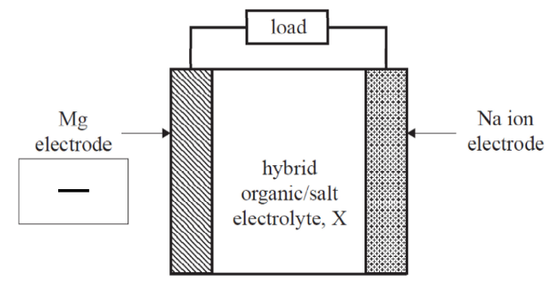
Question 2ai.
Marks | 0 | 1 | Average
% | 42 | 58 | 0.6

Question 2aii.
Marks | 0 | 1 | Average
% | 37 | 63 | 0.7
Mg → Mg²⁺ + 2e⁻
No states were required, but equilibrium arrows were not accepted.

Question 2b.
Marks | 0 | 1 | 2 | Average
% | 45 | 46 | 9 | 0.7
Students needed to provide any two logical responses that directly linked the Mg-Na hybrid cell posing potential health hazards.
Responses could have included:
- content of device/electrolyte is toxic/harmful/corrosive to the body if it leaks
- battery may overheat
- Mg is relatively reactive so may react in the body
- leakage would cause an imbalance in natural Mg²⁺/Na⁺ ion levels in the body.
General responses that didn’t link the specific issues to this Mg-Na hybrid cell were not accepted.

Question 2c.
Marks | 0 | 1 | 2 | 3 | Average
% | 56 | 24 | 13 | 7 | 0.7
The first mark was allocated for discussion of the need for molten MgCl₂/Mg²⁺ salt.
The second mark was allocated to the need for electrical energy to be supplied.
The third mark could be allocated through any of the following being provided:
- Chemical reaction at cathode.
- Cell design requiring the separation/isolation of products.
- Use of inert electrodes.
A possible response could have been presented as follows:
- Place MgCl₂ in a crucible and heat until molten.
- Apply a voltage (greater than 3.73 V) using inert electrodes.
- Keep the Mg metal and chlorine gas separated.
A number of students failed to recognise the need for a molten salt and incorrectly attempted to justify an explanation using the electrolysis of an aqueous solution. In this instance only partial marks could be awarded.

Question 3a.
Marks | 0 | 1 | Average
% | 34 | 66 | 0.7
An essential amino acid is one that that cannot be synthesised by the body and therefore must be included in the diet.
Both key points needed to be included in order to gain the mark.

Question 3bi.
Marks | 0 | 1 | Average
% | 23 | 77 | 0.8

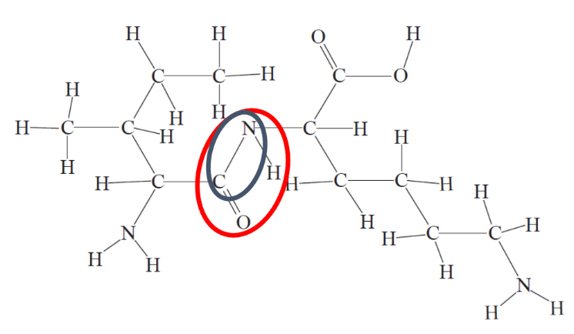
Either the four atoms, CONH, or the two CN atoms or the actual C-N bond could have been circled to receive full marks.
Students need to be cautious when approaching a question such as this; many circled other portions of the dipeptide as they attempted to identify the R-groups of the two amino acids.

Question 3bii.
Marks | 0 | 1 | Average
% | 40 | 60 | 0.6
Isoleucine

Question 3c.
Marks | 0 | 1 | 2 | Average
% | 34 | 41 | 25 | 0.9
The correct responses identified that:
- the papaya probably contained an enzyme/co-enzyme/co-factor that could have been involved in the digestion process of proteins.
- this enzyme/co-enzyme/co-factor facilitated the hydrolysis process.
No mention of specific enzymes was required to gain full marks.
The most common mistake made by students was to assume that acid was present, and this would cause denaturation to occur. While this may have been true, the key process in digestion is the breaking apart of primary structure in proteins.

Question 3di.
Marks | 0 | 1 | Average
% | 41 | 59 | 0.6
Any of these responses were correct:
- 6
- Omega-6
- Ω-6.

Question 3dii.
Marks | 0 | 1 | 2 | 3 | Average
% | 19 | 23 | 21 | 36 | 1.8
Linoleic acid*
Students were expected to include:
- a comparison of the relative number of C=C bonds in both molecules*
- a statement indicating a reason for weaker attraction between linoleic acid molecules (e.g. less effective packing of molecules or more extensive kinks in the chain).*
Most students seem to understand the theory behind this question but failed to deliver sufficient detail in their responses. Common mistakes were to:
- misread the data
- not directly compare oleic acid with linoleic acid
- state the answer as linolenic acid
- be too general in description of the relevant bonds. It was not sufficient to just state the ‘number of double bonds’, specific mention of the relative number of C=C was required.

Question 3e.
Marks | 0 | 1 | 2 | 3 | Average
% | 15 | 26 | 34 | 25 | 1.7
Any two of the following similarities were accepted:
- both have glycosidic links / ether links
- are polymers of glucose
- are straight chain / linear / unbranched polymers
- presence of same number of -OH groups.
Difference:
- Some reasoning identifying the difference in orientation of glucose monomers in the polymer chains.
Students did not always successfully express their understanding of the orientation of the glycosidic links between the glucose molecules in these two compounds; while α and β linkages were certainly not expected to be used in their explanations, it is possible that these have been taught as an easy way of explaining how these molecules are related.
The structures of both polymers were shown in the Data Book. Students are advised to ensure that they are familiar with the contents of the Data Book during their examination preparation.

Question 4a.
Marks | 0 | 1 | 2 | Average
% | 23 | 34 | 43 | 1.2
Two points were required:
- Fuel cells are a type of galvanic cell or a cell that converts chemical energy into electrical energy.
- Fuel cells require a constant supply of reactants to be added.

Question 4bi.
Marks | 0 | 1 | Average
% | 67 | 33 | 0.4
Accepted answers:
- hydrogen ions
- H⁺
- protons
- hydronium ions
- H₃O⁺.

Question 4bii.
Marks | 0 | 1 | Average
% | 35 | 65 | 0.7
The arrow must clearly be shown pointing to the righthand side and inside the box as directed.
It is important that students follow the instructions in the stem of the question very clearly. Marks could not be awarded for arrows that appeared elsewhere on the diagram.

Question 4c.
Marks | 0 | 1 | Average
% | 76 | 24 | 0.3
Either of the following equations were accepted:
- C₂H₆O(l) + 3H₂O(l) → 2CO₂(aq) + 12H⁺(aq) + 12e⁻
- CH₃CH₂OH(l) + 3H₂O(l) → 2CO₂(aq) + 12H⁺(aq) + 12e-
States were not required for this question.
Equilibrium arrows could not be accepted as the stem of the question clearly indicates a single direction process is occurring.
Students should be able to write appropriate half-equations for the oxidation of alkanol fuels in fuel cells and not just depend on the electrochemical series provided for the examination.

Question 4d.
Marks | 0 | 1 | Average
% | 60 | 40 | 0.4
Energy = 1.0 x 29.6 = 30 kJ (29.6 kJ)
Correct units were required. Many students gave the correct numerical response but incorrect units.

Question 4e.
Marks | 0 | 1 | 2 | Average
% | 49 | 37 | 14 | 0.7
Accepted responses:
- Highly porous electrodes or have a high surface area.*
- Electrodes could either be a catalyst or incorporate a catalyst.*
Students should be aware of properties of electrodes that enhance efficiency of fuel cells.

Question 4f.
Marks | 0 | 1 | Average
% | 53 | 47 | 0.5
Any of the following responses were accepted.
- Source the ethanol from a renewable/sustainable source, so the CO₂ released is balanced out.
- There is a net reduction in the greenhouse gas CO₂ emission when produced in a biologically sourced ethanol fuel cell operating at 100% efficiency.
- Obtain electrodes from renewable/sustainable source, reuse electrode materials.
- Manage end of life waste streams, in particular acidic electrolyte.
- Capturing CO₂ gas through CCS (carbon capture sequestration).

Question 5a.
Marks | 0 | 1 | Average
% | 39 | 61 | 0.6
2.0 x 17 + 3.0 x 37 + 18.7 x 16 = 4.4 x 10² kJ (444 kJ)
This question was very well done, and the only common mistake was that the students quoted incorrect units (e.g. 444 kJ g⁻¹ or 444 kJ mol⁻¹).

Question 5b.
Marks | 0 | 1 | 2 | 3 | Average
% | 62 | 22 | 11 | 6 | 0.6
This question, directly related to the key knowledge around ‘vitamins’ in the study design, was not answered well by students.
The following points were expected for full marks:
- Boiling sweet potato would be expected to have a minimal impact on the level of vitamin D present.
- This is because vitamin D is non-polar and therefore fat / lipid soluble.
- Therefore, vitamin D is not extracted out of the potato into the water because water is polar.
A common error was attempting to discuss the ‘denaturation’ of the vitamin. Since vitamin D has no secondary or tertiary structure, the term is not relevant in this situation.

Question 5c.
Marks | 0 | 1 | 2 | Average
% | 32 | 21 | 47 | 1.2
n(I₂) = 0.0500 x 21.81x10⁻³
= 1.09x10⁻³ mol
n(Vit C) = 1.09x10⁻³ mol*
m(C₆H₈O₆) = 1.09x10⁻³ mol x 176 g mol⁻¹
= 0.192 g / 192 mg*

Question 5d.
Marks | 0 | 1 | 2 | Average
% | 35 | 38 | 27 | 0.9
For one mark, either of the following responses was accepted:
- Coenzymes activate the enzyme by adjusting the active site to accept the substrate.
- Coenzymes bind to the active site of the enzyme and changes its 3D shape, therefore allowing the substrate to bind to the enzyme. (It was acceptable for a student to supply a well-labelled diagram here.)
For the second mark, the following response was required:
- Coenzymes act as electron and molecular species (atoms / groups of atoms) carriers.

Question 6a.
Marks | 0 | 1 | 2 | Average
% | 33 | 7 | 60 | 1.3
There were three viable options that a student could have chosen.
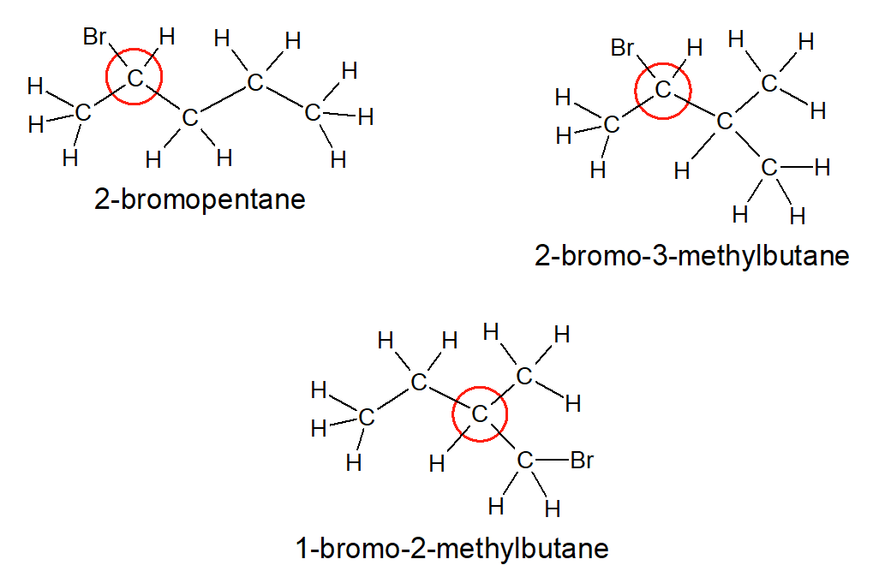
- The first mark was awarded for any one of the three valid structural diagrams.
- The second mark was awarded for the correct identification of a chiral centre.
Many students incorrectly supplied a structural diagram of 1-bromopentane.

Question 6bi.
Marks | 0 | 1 | 2 | Average
% | 22 | 27 | 51 | 1.3
Any one of the following three equations were accepted:
- CH₃(CH₂)₃CH₂Br + NaOH → CH₃(CH₂)₃CH₂OH + NaBr
- C₅H₁₁Br + NaOH → C₅H₁₁OH + NaBr
- C₅H₁₁Br + NaOH → C₅H₁₂O + NaBr
The first mark was awarded for the correct representation of both organic formulae being correctly quoted.
The second mark was awarded for an overall balanced equation with the two sodium salts being correctly included. The general nature of the term ‘sodium salt’ may have led to errors for some students; however, the reaction for the production of alcohols from a haloalkane and sodium hydroxide should have been well understood.

Question 6bii.
Marks | 0 | 1 | 2 | 3 | Average
% | 25 | 9 | 13 | 54 | 2.0
%atom economy = $\frac{mass of desired product}{total mass of reactants} ×100 or \frac{mass of desired product}{total mass of products} ×100$
= $\frac{88.0}{150.9 + 40} ×100 or \frac{88.0}{88.0 + 102.9} ×100$
= 46.1 %
One mark was awarded for students showing the correct mathematical relationship.
One mark was awarded for correct substitution of molar masses into this relationship.
One mark was awarded for correct calculation.
If an incorrect equation was presented in Part 6bi., consequential marks could be awarded. However, for this to happen the student needed to present full working.

Question 6c.
Marks | 0 | 1 | Average
% | 37 | 63 | 0.7
Pentanoic acid

Question 6d.
Marks | 0 | 1 | Average
% | 78 | 22 | 0.2

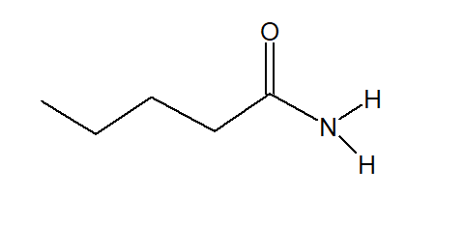
Students may have been challenged in identifying the amide group and/or representing the amide group in a skeletal structure.

Question 7a.
Marks | 0 | 1 | Average
% | 48 | 52 | 0.5
Compound T

Question 7b.
Marks | 0 | 1 | 2 | 3 | Average
% | 27 | 29 | 33 | 11 | 1.3
Compounds eliminated: P, Q and S.
Compound P has no -O-H group present, whereas the IR shows a clear -O-H alcohol with an absorbance at 3500 cm⁻¹.*
Compound Q has an -O-H group of an acid, whereas the IR shows a clear -O-H alcohol with an absorbance at 3500 cm⁻¹. There is no evidence of a large broad -O-H of an acid showing up between 2500 cm⁻¹ and 3500 cm⁻¹.*
Compound S has no -O-H group present, whereas the IR shows a clear -O-H alcohol with an absorbance at 3500 cm⁻¹.*
Most students picked up that either/both compounds P and S could be eliminated as they lacked any -O-H group. However, many did not specifically refer to the -O-H of an alcohol. Likewise, they frequently failed to recognise that Q, being a carboxylic acid, should have shown a strong, broad absorbance between 2500 cm⁻¹ and 3500 cm⁻¹.

Question 7ci.
Marks | 0 | 1 | Average
% | 51 | 49 | 0.5
Any of: [CH₃CO]⁺, [(CH₃)₂CH]⁺, [C₂H₃O]⁺ or [C₃H₇]⁺.
This question was generally handled well, except for the frequent lack of the essential positive charge.

Question 7cii.
Marks | 0 | 1 | Average
% | 69 | 31 | 0.3
Mass to charge ratio
The basic theory behind key instrumental techniques was a challenge for many students.

Question 7ciii.
Marks | 0 | 1 | 2 | Average
% | 35 | 52 | 13 | 0.8
One mark was awarded for the understanding that ions (cations) needed to be formed in order for any peak to appear on a mass spectrum.
One mark was awarded for the understanding that multiple ions form because of either:
- fragmentation pattern that occurs because of the initial parent ion being unstable
- molar masses of the different isotopes present in the parent ion.

Question 8a.
Marks | 0 | 1 | 2 | 3 | 4 | Average
% | 24 | 11 | 12 | 21 | 31 | 2.3
Multiple approaches were evident in students’ responses to this question. The following is representative of one common approach:
n(SO₃) at equilibrium = 20.0 / 80.1 = 0.25 mol*
 | n(SO₂) (mol) | n(O₂) (mol) | n(SO₃) (mol)
Initial | 1.00 | 1.00 | 0.00
Change | -2x | -x | +2x
Final* | 1.00-0.25 = 0.75 | 1.00-0.125 = 0.875 | 0.25
Therefore
[SO₂]_{eqm} = ${0.75}/{3.00}$ = 0.25 M, [O₂]_{eqm} = ${0.875}/{3.00}$ = 0.292 M, [SO₃]_{eqm} = ${0.25}/{3.00}$ = 0.083 M*
K = $\frac{[{SO}_{3}]^{2}}{{[SO}_{2}]^{2}[O_{2}]}$ = $\frac{{0.083}^{2}}{{0.25}^{2} ×0.292 }$ = 0.38 M⁻¹*
In order to gain full marks, students were required to submit the final calculated value with the correct units. Consequential marks were awarded when students were able to show clear calculations.

Question 8b.
Marks | 0 | 1 | 2 | Average
% | 42 | 21 | 37 | 1.0
Two key points were required to be shown:
- The new peak had to be shifted to the left of the original peak.
- The new peak had to be higher than the original peak.
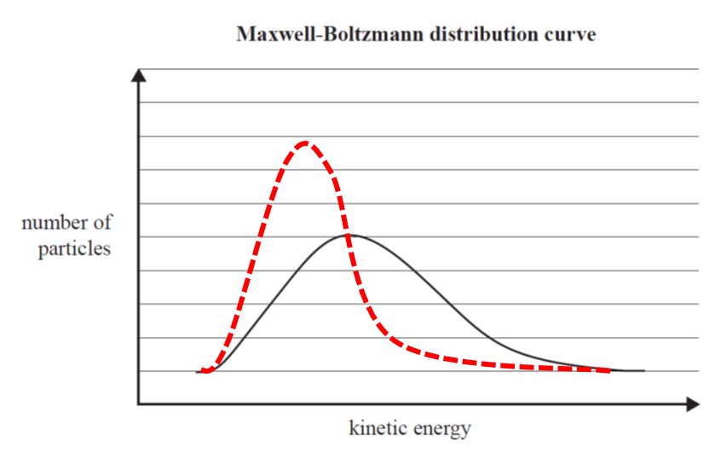
In order for both marks to be awarded, the new curve also had to be of roughly equivalent area.

Question 8c.
Marks | 0 | 1 | 2 | 3 | Average
% | 35 | 30 | 19 | 16 | 1.2
Responses had to be linked to the effect on the concentration of SO₂, as follows:
- As the volume doubles, the concentration of SO₂ halves.
- As the system moves to re-establish equilibrium, the concentration of SO₂ gradually increases.
- Once equilibrium is reached, the final concentration of SO₂ is still lower than the original concentration (before volume increase).
Although it was not explicitly required, some students included a concentration-time graph that assisted them to communicate their understanding.
The most common issue for students was a lack of clarity when explaining the effect. A lot of students discussed the cause that underpinned this change, which was not required by the question. This highlights the need for students to make sure that they clearly read the stem of each question and apply a response that is appropriate to what is required of them.

Question 9a.
Marks | 0 | 1 | 2 | Average
% | 35 | 17 | 49 | 1.2
The following two points were required
- Aspartame is sweeter than sugar.
- (Significantly) less aspartame is needed to achieve the same sweetness value and therefore less energy (calories) is provided.

Question 9bi.
Marks | 0 | 1 | Average
% | 30 | 70 | 0.7
Any of the following responses were accepted:
- rate of production of DKP
- change in concentration of DKP (over time)
- change in amount of DKP (over time).

Question 9bii.
Marks | 0 | 1 | 2 | 3 | Average
% | 73 | 13 | 7 | 6 | 0.5
The correct steps are:
- Calibrate the high-performance liquid chromatography (HPLC) under experimental conditions.
- Run a range of standard solutions for DKP.
- Use these standards to produce a calibration curve.
The DKP levels in the lemonade could then be analysed by comparison with this calibration curve at the various time intervals.
The use of a calibration curve produced under the same conditions that experimental data is collected is a fundamental aspect of instrumental analysis, which is explicitly stated in the study design.

Question 9ci.
Marks | 0 | 1 | Average
% | 89 | 11 | 0.1
Any one of the following responses were accepted:
- increasing the length of the column
- altering either the mobile or stationary phases
- altering the temperature of the column.
A common incorrect response was ‘repeat more trials’, which is not applicable when asked to state a change to the operating conditions of the instrument.

Question 9cii.
Marks | 0 | 1 | Average
% | 78 | 22 | 0.2
Measurement errors occur due to the overlap of the two peaks. If any of the stated factors in Part 9ci. are altered this can result in improved separation/resolution of peaks in a HPLC. Improved resolution of peaks leads to a more reliable analysis of peak areas and subsequently the concentrations of aspartame and DKP.

Question 9d.
Marks | 0 | 1 | Average
% | 33 | 67 | 0.7
A mark was awarded if any one of the following concepts was communicated by the student.
- As the temperature increases, the concentration of DKP shows a general increase.
- With the exception of the outlier at 25 °C, the trend is that as temperature increases the concentration of DKP increases.
- There is no consistent trend in DKP as the 15 ºC trial shows a decrease in DKP concentration compared to other temperatures, which show an average increase.

Question 9ei.
Marks | 0 | 1 | Average
% | 74 | 26 | 0.3
The following are examples of variables that have not been controlled in this experiment:
- the initial concentration DKP/aspartame was not known (i.e. no analysis of either DKP or aspartame was done at time = 0)
- the age of the cans of lemonade (i.e. were they produced from the same batch?)
- the brands/sources of lemonade that are used.

Question 9eii.
Marks | 0 | 1 | Average
% | 62 | 38 | 0.4
Students were required to relate the effect of the uncontrolled variable identified in Question 9ei. to the validity of the experiment. A response could have been as follows:
The lack of initial concentration values means it cannot be assumed that the starting concentrations of aspartame and DKP were the same in each can. Therefore, the final concentrations cannot be relied upon as a measure of the production of DKP, hence the validity of the experiment is compromised.

Question 10a.
Marks | 0 | 1 | 2 | 3 | Average
% | 32 | 24 | 26 | 19 | 1.3
The following points were required:
- A comparison statement of the relative GI of each component of starch or rate of hydrolysis of each component of starch.
- An understanding that respiration involves the consumption of glucose and produces energy. (An equation was acceptable to be used here to assist their explanation.)
- An understanding of the relationship between the timing of the physical activity and energy source. (Reference to the long-term benefits of amylose in this situation compared to the short-term benefits of amylopectin.)
Most students completed this question fairly well, showing a good understanding of the GI of the two materials found in starch. Quite a few students did not refer to cellular respiration despite the clear specification to incorporate it in the response. It was also common for students not to link their response back to the benefits of such a meal to the runner.

Question 10b.
Marks | 0 | 1 | 2 | 3 | 4 | 5 | Average
% | 53 | 11 | 9 | 12 | 10 | 5 | 1.3
The following points were required for full marks:
- Either an accurate equilibrium equation or accurate stated explanation of the equilibrium that exists between oxygen and haemoglobin, forming oxyhaemoglobin.
Equation 1
Haemoglobin + oxygen ⇋ oxyhaemoglobin
Hb4 + 4O2 ⇋ Hb4(O2)4
Hb + O2 ⇋ HbO₂
- Either an accurate equilibrium equation or accurate stated explanation of the equilibrium equation that exist between carbon monoxide and haemoglobin, forming carboxyhaemoglobin.
Equation 2
Haemoglobin + carbon monoxide ⇋ carboxyhaemoglobin
Hb₄ + 4CO ⇋ Hb₄(CO)₄
Hb + CO ⇋ HbCO
- A statement about the relative K values / extents of reaction / implied usage of competing equilibria.
- An understanding of the effect of carbon monoxide on equilibria in heavy traffic / reduction in oxygen carrying capacity, hence shortness of breath.
- An understanding of the effect of lack of carbon monoxide on equilibria in park / increase in oxygen carrying capacity, hence ease of breathing.
To obtain the final two marks, the student must refer to the reversibility of the two equations / chemical equilibria and explain the differences in breathing in the park area and in heavy traffic.
Given the prompts in the stem of the question, students should have used Le Chatelier’s principle and referred to competing equilibria when answering this question. Students should ensure they have a solid understanding of the study design, including the concept of carbon monoxide poisoning, as required by this question.

