2020 VCE Mathematical Methods 1 examination report

General comments
In 2020 the Victorian Curriculum and Assessment Authority produced an examination based on the VCE Mathematics Adjusted Study Design for 2020 only. Most of the content from the ‘Probability and statistics’ area of study was removed, and this was reflected in the examination content.
The examination consisted of eight short-answer questions. A range of well thought-out and presented responses were given.
Advice to students:
- Students who produced responses that were detailed with clear and legible methodology generally scored well. It was observed that students who attempted to do several manipulations in one line of working often confused themselves or made arithmetic errors. This was particularly evident in Question 4 (solving a logarithmic equation) and in Questions 6c. and 8c. (both involving the evaluation of definite integrals).
- Students are urged to regularly review and practise exponent and logarithmic laws and their application. (This is relevant to Questions 4, 5, 6c., 8a. and 8c.)
- Students need to practise algebraic manipulation, especially transposition of algebraic fractions (Questions 2 and 3) and take care with placement of brackets (Questions 1, 5 and 6c.) and notation when dealing with integrals or domains.
- Students need to be familiar with the required exact values for circular functions (see Question 3).
- Working through past papers (available on the VCAA website), consider alternative solutions that may be obtained using geometric methods. (See Questions 6c., 7c. and 8d.)
- ‘Show that …’ questions require a reasoned argument. Remember the answer is given and students are required to provide detailed progression to the answer given.

Specific information
This report provides sample answers or an indication of what answers may have included. Unless otherwise stated, these are not intended to be exemplary or complete responses.
The statistics in this report may be subject to rounding resulting in a total more or less than 100 per cent.

Question 1a.
Marks | 0 | 1 | Average
% | 14 | 86 | 0.9
This question was well answered. Most students competently and confidently applied the product rule.

Question 1b.
Marks | 0 | 1 | 2 | Average
% | 20 | 21 | 60 | 1.4
Students applied the chain rule; however, too often the lack of brackets resulted in an incorrect answer: for example,

Question 2a.
Marks | 0 | 1 | Average
% | 47 | 53 | 0.5
Students who scored the mark for this question generally used a Venn diagram or a table. The most common incorrect answer was , obtained by incorrectly assuming that the events F (air filter change) and $O^{'}$ (without an oil change) were independent, thus using $\operatorname{Pr}\left(F∩ O^{'}\right)=\operatorname{Pr}\left(F\right)×Pr⁡(O^{'})$.

Question 2b.
Marks | 0 | 1 | 2 | Average
% | 31 | 39 | 30 | 1.0
Students who obtained both marks typically used a Venn diagram or a table such as:
1

While many students saw the connection to part a. of the question, many did not set up the correct equation or did not correctly transpose their equation to make ‘m’ the subject. Students generally recognised the conditional probability. Many did not go further than stating a rule.

Question 3
Marks | 0 | 1 | 2 | 3 | Average
% | 27 | 22 | 28 | 23 | 1.5
Using $\left(1, 1\right)$ gives: $-1=\tan\left(-a+b\right)$ or $-\frac{π}{4}= -a+b$
and using $\left(1, \sqrt{3}\right)$ gives $\sqrt{3}=a+b$ or $\frac{π}{3}=a+b$
Solving simultaneously gives $a=\frac{7π}{24} and b= \frac{π}{24}$.
Most students were able to substitute from the points labelled on the graph, however, many did not proceed further. Many of those who did proceed further used incorrect angles. Students are expected to know exact values for the circular functions. A common error was to use $\frac{3π}{4}$ in the first equation or $\frac{π}{6}$ in the second equation.

Question 4
Marks | 0 | 1 | 2 | 3 | Average
% | 12 | 19 | 43 | 26 | 1.8
Students confidently attempted this question; however, many incorrect uses of the logarithmic laws were observed. Those who did end up with the appropriate quadratic equation and solved it correctly did not always check the validity of their answers; these students failed to reject the solution .

Question 5a.
Marks | 0 | 1 | 2 | Average
% | 33 | 38 | 29 | 1.0
Most students recognised use of the binomial distribution, clearly specifying the distribution with the parameters $n=4$and $p=\frac{3}{5}$.
Common errors included finding $\operatorname{Pr}\left(X=3\right)$ only, use of an incorrect formula, or arithmetic errors in evaluation.

Question 5b.
Marks | 0 | 1 | 2 | Average
% | 60 | 31 | 10 | 0.5
Students were generally able to identify that conditional probability was involved. However, they need to be aware that simply quoting a rule or formula is not sufficient; they are required to demonstrate how it is used within the context of the question (i.e. in this case, give evaluations of ). Many students did not present their answer in the required form.

Question 6a.
Marks | 0 | 1 | 2 | Average
% | 17 | 29 | 54 | 1.4
Students confidently attempted this question; however, some did not use notation well. Many students left their answer as $y=2x^{2}$, thus assuming $f\left(x\right)was the same as f^{-1}\left(x\right)$, in contradiction to their prior working. Some students did not state the required domain, or expressed it incorrectly

Question 6b.
Marks | 0 | 1 | 2 | Average
% | 19 | 12 | 69 | 1.5
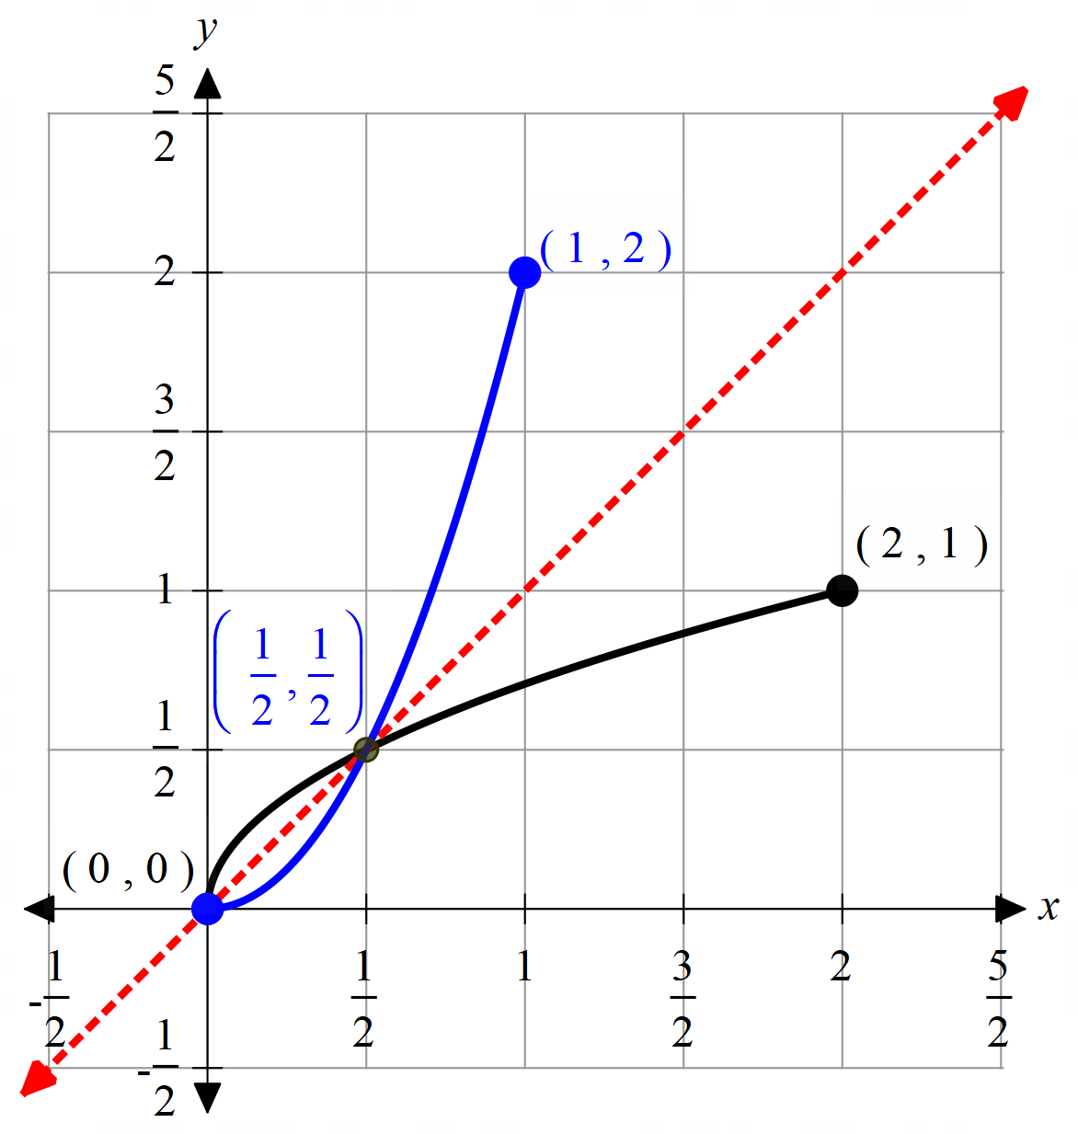
Most students correctly identified the endpoint at (1,2), but some students either plotted it in the incorrect position, or continued the graph beyond this end point. Some graphs lacked curvature and became vertical as x approached 1. The point of intersection was generally correctly obtained, but often not plotted in the correct position.

Question 6c.
Marks | 0 | 1 | 2 | 3 | 4 | Average
% | 28 | 22 | 23 | 18 | 10 | 1.6
Most students recognised at least one of the two required areas and generally obtained a correct anti-derivative, though often not all the correct anti-derivatives required. Errors in evaluating definite integrals and answering in the format specified by the question were common. Those students who took care with setting out their working and did not attempt to do several steps in one line of working generally scored well.

Question 7a.
Marks | 0 | 1 | Average
% | 15 | 85 | 0.9
There were several ways to complete this question. Most students chose to show that the point $\left(1, 0\right)$ was not on the graph through the use of substitution as indicated above. This was a ‘show that’ question, so those students who simply stated $f\left(1\right)=9$ without explaining the relevance of this were not awarded the mark. Some students found the discriminant of the quadratic to be negative or simply stated it was negative without evidence but did not relate this to the question.

Question 7bi.
Marks | 0 | 1 | Average
% | 48 | 52 | 0.5
Many students wrote down an expression for gradient but went no further. Some students made algebraic errors, in particular cancellations of ‘a’ or dealing with negative coefficients.

Question 7bii.
Marks | 0 | 1 | Average
% | 33 | 67 | 0.7
Most students recognised that an evaluation of the derivative was required. Some students incorrectly assumed the question required the equation of the tangent at x = a.

Question 7biii.
Marks | 0 | 1 | 2 | Average
% | 56 | 14 | 31 | 0.8
Alternatively find the equation of the tangent:

Students who equated gradients tended to score more highly. Many of those who used the ‘equation of the tangent’ method could not form the correct quadratic equation.

Question 7biv.
Marks | 0 | 1 | Average
% | 71 | 29 | 0.3
The most common error was students assuming that their value of ‘a’ was the gradient of the line instead of substituting into $f'(a)$.

Question 7c.
Marks | 0 | 1 | 2 | Average
% | 87 | 3 | 10 | 0.2
The turning point occurs at and is a minimum.
Translate f(x) 2.5 units in the positive x direction so that the turning point is directly above (1,0).
Thus $k=\frac{5}{2}$
Many students used the distance formula and then attempted to differentiate and equate to zero (often with limited success due to error in differentiation or algebra). Students who used a geometric approach tended to score more highly.

Question 8a.
Marks | 0 | 1 | 2 | Average
% | 24 | 17 | 59 | 1.3
The most common errors were incorrect differentiation of $f\left(x\right)=x log _{e}\left(x\right)$ or incorrect evaluation of $f\left(\frac{1}{e}\right)$.

Question 8b.
Marks | 0 | 1 | Average
% | 64 | 36 | 0.4
Given

Many students made-up their working as the answer was given, rather than clearly demonstrating progression to the answer.

Question 8c.
Marks | 0 | 1 | 2 | Average
% | 66 | 23 | 11 | 0.5
or equivalent.
Many students were unsure of which terminals to use for the definite integral, opting to use a generic ‘a’ and ‘b’. A common oversight was the fact that the required area was below the x-axis. Other errors occurred in evaluation.

Question 8di.
Marks | 0 | 1 | Average
% | 84 | 16 | 0.2
k = e
Many students did not attempt this question. Those who persisted recognised that the gradient was 2, though often gave the incorrect answer of x = e.

Question 8dii.
Marks | 0 | 1 | 2 | Average
% | 95 | 2 | 3 | 0.1
$$k>1$$
Some students tried to algebraically find the point of intersection of the graphs of function and its inverse function, with limited progress. This question could also be solved by consideration of the point where the gradient of g(x) was equal to the gradient of y = x.

