2020 VCE Mathematical Methods 2 examination report

General comments
In 2020 the Victorian Curriculum and Assessment Authority produced an examination based on the VCE Mathematics Adjusted Study Design for 2020 only.
- Students should carefully read questions and check to make sure they have answered all parts of the question. Question 1cii. required students to find the minimum value of the derivative, not just the x value of the turning point. Likewise, in Question 2c., students were required to find the minimum distance, not just the x value at which this minimum distance occurred. In Question 4dii., students were asked to find the coordinates of a point, not just the x value.
- If a rule is required, students need to write an appropriate equation. Rules were required in Questions 1ci., 4ei. and 4eii.
- Brackets must be used correctly. This was not done at times in Questions 1b., 1eii., 2d., 2f., 4c., 4eii., 4eiii. and 5a.
- Students should use their time effectively. There is no need to write out the entire expression for the functions. This occurred in Questions 1eii., 1f., 2e., 2f. and 4eiii.
- If exact answers are required, a decimal approximation is not acceptable. Exact answers were required in Questions 1cii., 1ei., 2b., 3f., 5b. and 5e. Likewise, if a decimal approximation is required, exact answers will not be accepted. This occurred in Question 1f.
Students should use technology efficiently and define functions at the start of the question. Question 1b. required students to expand a function, which can be done using technology. There is no need to expand it by hand as this is time consuming and often algebraic errors are made. Care should be taken that the correct equations are entered into technological devices. Errors occurred in Questions 2c. and 2e. Transcribing answers from technology should also be done carefully. In Question 4c., some students wrote instead of , and similar errors were noted in responses to Questions 4eii. and 4eiii.
- Do not round too early. Students could not be awarded marks in Questions 3 and 4 due to rounding too early.
- Provide appropriate steps in ‘Show that …’ questions. Questions 1a. and 5f. required substitutions. Question 5a. required algebraic steps.
- Do not cross your work out unless you are going to replace it with another solution. Do not write over your work if you have made a mistake; it is best to cross it out and write out the correct answer again, especially if you are changing a square bracket to a round bracket.
- Use the pronumerals that are given in the question. There is no need to redefine them as something else.

Specific information
This report provides sample answers or an indication of what answers may have included. Unless otherwise stated, these are not intended to be exemplary or complete responses.
The statistics in this report may be subject to rounding resulting in a total more or less than 100 per cent.

Section A
The table below indicates the percentage of students who chose each option. The correct answer is indicated by the shading.
Question | % A | % B | % C | % D | % E | % N/A | Comments
1 | 4 | 6 | 5 | 84 | 1 | 0
2 | 7 | 13 | 12 | 10 | 56 | 1
3 | 7 | 5 | 86 | 2 | 0 | 0
4 | 6 | 7 | 18 | 67 | 2 | 1
5 | 4 | 3 | 3 | 7 | 83 | 0
6 | 19 | 61 | 6 | 5 | 8 | 0
7 | 5 | 10 | 70 | 11 | 4 | 0
8 | 7 | 50 | 14 | 9 | 20 | 1
9 | 16 | 17 | 19 | 12 | 35 | 1 | Dilate by a factor of from the .  Translating 2 units to the left does not change the area.
10 | 11 | 62 | 12 | 10 | 5 | 0
11 | 7 | 13 | 60 | 15 | 4 | 1
12 | 20 | 9 | 11 | 15 | 45 | 1 | The maximum height is 25 cm at . Hence options D or E.  The period is 60 minutes. Hence option E.
13 | 26 | 20 | 38 | 11 | 5 | 0 | The graph of is mapped to the graph of.  There has been a dilation of a factor of from the y-axis and then a translation of 2 units to the left.
14 | 44 | 8 | 18 | 18 | 11 | 1 | Solve  correct to three decimal places
15 | 4 | 32 | 28 | 27 | 8 | 1 | The average value
16 | 6 | 16 | 17 | 53 | 6 | 1
17 | 10 | 21 | 42 | 17 | 9 | 1 | 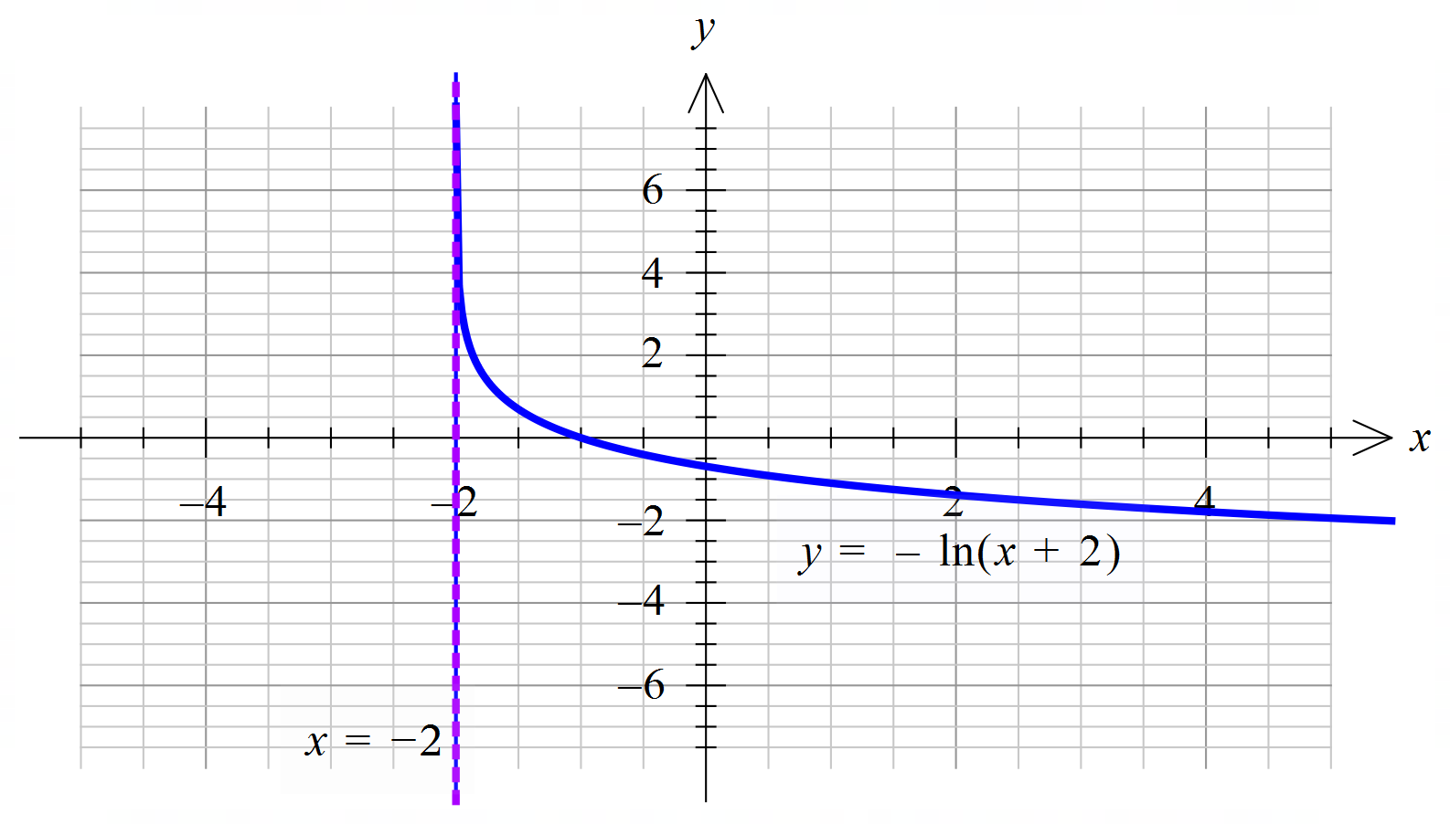  The maximum value of c occurs when the tangent to f is at .
18 | 13 | 8 | 29 | 43 | 6 | 1 | The coordinates of the endpoints are and .  The range is .  An example, using the graph of is shown below.  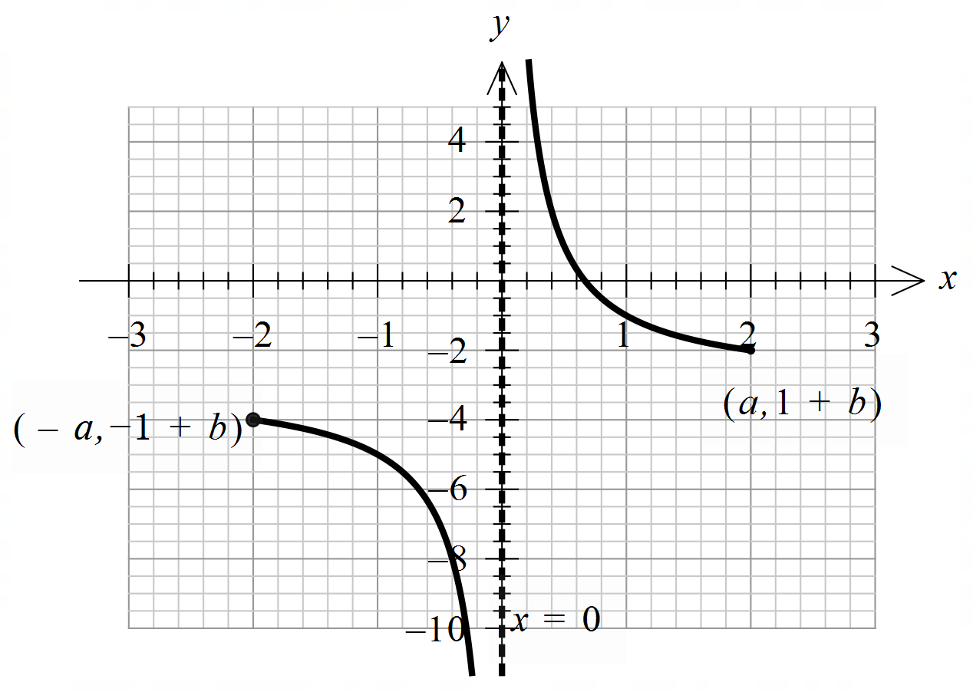
19 | 15 | 33 | 15 | 9 | 27 | 1 | ,  Examples  In general
20 | 21 | 18 | 24 | 21 | 16 | 1 | Checking each of the options for a suitable domain gives .  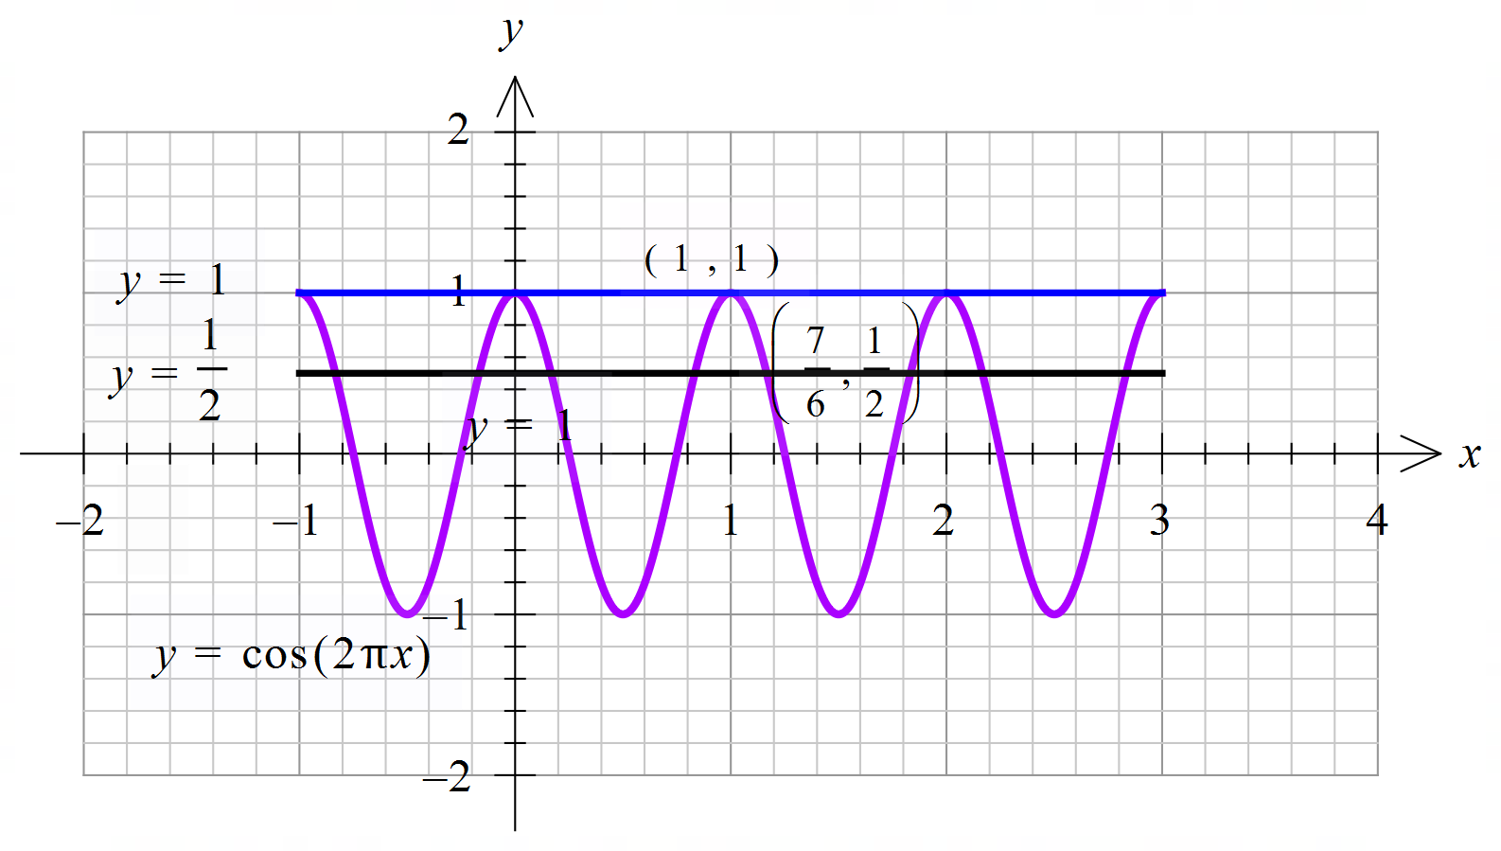

Section B

Question 1a.
Marks | 0 | 1 | Average
% | 17 | 83 | 0.8
, , ,
Some students assumed in their proof, rather than showing . Others did not substitute (0,4) into the equation. Some incorrectly substituted (2,0) or (–2,0).

Question 1b.
Marks | 0 | 1 | Average
% | 20 | 80 | 0.8
Some students tried to expand the function by hand and made algebraic errors. Others did not put the expression in the correct form. A common incorrect answer was

Question 1ci.
Marks | 0 | 1 | Average
% | 16 | 84 | 0.8
Some students did not write a rule. An equation was required. Others solved for x.

Question 1cii.
Marks | 0 | 1 | 2 | Average
% | 19 | 26 | 55 | 1.4
The derivative function has its minimum value at , . The minimum gradient is
An exact value was required. Some students found the x value but did not find the minimum gradient. Others wrote the coordinates of the turning point, without specifying which value was the minimum gradient.

Question 1d.
Marks | 0 | 1 | Average
% | 24 | 76 | 0.8
Either reflect in the x-axis, translate 2 units up, or translate 2 units down, reflect in the x-axis
Most students were able to describe the transformations. Some were not able to provide a suitable written description for the transformations or did not have them in the correct order. A common incorrect answer was reflected in the y-axis.

Question 1ei.
Marks | 0 | 1 | Average
% | 19 | 81 | 0.8
Solve for x,
Exact values were required.

Question 1eii.
Marks | 0 | 1 | Average
% | 24 | 76 | 0.8
OR
Some students used . Sometimes dx was missing or the functions were called by other names, such as g(x), without being defined.
There was some poor use of brackets, for example: .
There was no need to write out the full expressions for f(x) and h(x). This often led to transcription errors. Likewise, it was not necessary to substitute. This often led to algebraic errors.

Question 1eiii.
Marks | 0 | 1 | Average
% | 28 | 72 | 0.7
2.72 correct to two decimal places
Some students gave the response of 2.71. Some students forgot to multiply by 2, giving 1.36 as the answer.

Question 1f.
Marks | 0 | 1 | 2 | Average
% | 71 | 6 | 23 | 0.5
Solve for x,
Some students gave exact values for their answers:
.
Others had incorrect inequality signs. Some had extra solutions or only gave the values of x for when D = 2 units.

Question 2a.
Marks | 0 | 1 | Average
% | 11 | 89 | 0.9
40 – 30 = 10 m
Some students used the distance formula, which was not an efficient approach.

Question 2b.
Marks | 0 | 1 | 2 | Average
% | 21 | 27 | 52 | 1.3
Solve for , , distance east m or m
Some students subtracted 30 instead of 50, giving as their final answer. Others did not subtract, leaving their answer as . Exact answers were required; 16.7 was often seen.

Question 2c.
Marks | 0 | 1 | 2 | Average
% | 56 | 11 | 33 | 0.8
, solve for x, , m correct to one decimal place, or solving for x using perpendicular gradients, , , m correct to one decimal place.
Most students used the first method. Some found the x value but not the minimum distance. The distance formula was often set up correctly, but the incorrect x value was given. Students need to check that they have entered their formulas correctly into their technology.

Question 2d.
Marks | 0 | 1 | Average
% | 20 | 80 | 0.8
m2

Question 2e.
Marks | 0 | 1 | 2 | 3 | Average
% | 52 | 19 | 4 | 26 | 1.0
or
or , area is 837 m2 correct to the nearest square metre.
There were various approaches to this question. Appropriate working needed to be shown. was often seen. Some students incorrectly used triangles:

Question 2f.
Marks | 0 | 1 | 2 | Average
% | 78 | 15 | 7 | 0.3
, the maximum value occurs at either x = 0 or x = 200, , or
Some students were able to set up an appropriate inequality. There was no need to write out the expression for and as this often led to errors such as instead of . Some students did not substitute either x = 0 or x = 200 into the equation, leaving their answer as . A common incorrect approach was solving , giving .

Question 3a.
Marks | 0 | 1 | Average
% | 32 | 68 | 0.7
1 minute correct to the nearest minute
–1 or 2 minutes were seen occasionally.

Question 3b.
Marks | 0 | 1 | 2 | Average
% | 45 | 15 | 41 | 1.0
, , correct to three decimal places
Many students were able to recognise that this was a conditional probability question. Some were unable to write correctly. Others had 0.77 as the numerator and 0.5 as the denominator, creating an answer greater than 1. Some rounded too early, and 0.546 was seen occasionally.

Question 3c.
Marks | 0 | 1 | 2 | 3 | Average
% | 58 | 17 | 19 | 6 | 0.7
k can be found by a translation of 1.5 units in the direction of the negative t-axis, use symmetry to find second value for k or solve for k, or
Appropriate working must be shown. Drawing a diagram is a suitable method. Many students did not find .

Question 3d.
Marks | 0 | 1 | 2 | Average
% | 40 | 19 | 41 | 1.0
Let , correct to three decimal places.
Most students were able to recognise the binomial distribution, giving the correct n and p values. was seen occasionally. A common incorrect answer was .

Question 3ei.
Marks | 0 | 1 | Average
% | 76 | 24 | 0.2
Pr(at least one late) =
was a common incorrect answer.

Question 3eii.
Marks | 0 | 1 | Average
% | 77 | 23 | 0.2
, , n = 19
Some students left their answer as 18.43 or rounded down to 18. A common incorrect answer was 2, due to students solving .

Question 3f.
Marks | 0 | 1 | 2 | Average
% | 96 | 1 | 3 | 0.1
, , , minimum value for y is or and max value for y is or
Students who used a tree diagram were generally successful. Some gave approximate answers when exact answers were required.

Question 4a.
Marks | 0 | 1 | Average
% | 23 | 77 | 0.8
,
Some students wrote the equation of the tangent instead of its gradient.

Question 4b.
Marks | 0 | 1 | Average
% | 63 | 37 | 0.4
to the nearest degree
and were common incorrect answers.

Question 4c.
Marks | 0 | 1 | Average
% | 33 | 67 | 0.7
or
Some responses contained transcription errors.
Instead of writing , some wrote .
Brackets were not used well, and some students wrote the equation of the tangent instead of its gradient.

Question 4di.
Marks | 0 | 1 | 2 | Average
% | 38 | 8 | 54 | 1.2
Solve for p, correct to three decimal places
Some students solved . Others knew that but were unable to connect this information to their previous answers. was often seen.

Question 4dii.
Marks | 0 | 1 | 2 | 3 | Average
% | 46 | 11 | 17 | 26 | 1.2
or ,,
Many students successfully found that the point of intersection of the two tangents occurred at x = 0.80 but then substituted this into f(x), getting the value 2.29 instead of substituting it into one of the two tangent equations. Some students managed to find the equation of the tangent at x = 1 but did not know what to do with this equation. Others rounded too early.

Question 4ei.
Marks | 0 | 1 | Average
% | 56 | 44 | 0.4
Some students did not write a rule. Others left out x, giving the gradient as the final answer: .
A number of students wrote the rule in terms of f(n) and not n. Other common incorrect answers were: , and .

Question 4eii.
Marks | 0 | 1 | Average
% | 72 | 28 | 0.3
, (many forms)
A rule was required. Some students only wrote down the gradient. Others assumed .
There were a lot of transcription errors: was often written as .
The variable x sometimes looked like n and vice versa. Brackets were used poorly. Some students only wrote down part of the equation. Students need to make sure they scroll across the screen to ensure they identify a complete expression when using technology.

Question 4eiii.
Marks | 0 | 1 | 2 | 3 | Average
% | 60 | 7 | 22 | 11 | 0.8
Solve for n, n = 1.088 correct to three decimal places.
The majority of students who attempted this question were able to correctly set up the integrals. However, some were then unable to arrive at the final response. There was no need to write out entire expressions. This often led to transcription errors and misuse of brackets. Others used areas of triangles:
, which gave n = 1.087.
The area from to is a trapezium, not a triangle. So, the correct formulation is .

Question 5a.
Marks | 0 | 1 | 2 | 3 | Average
% | 36 | 7 | 9 | 49 | 1.7
, equation of the tangent, , substitute , , , ,
Most students were able to find the equation of the tangent. When finding the equation of the tangent, many students left out brackets when multiplying by the gradient , writing instead of . Some students did not show suitable steps.

Question 5b.
Marks | 0 | 1 | Average
% | 54 | 46 | 0.5
,
Some students wrote down only one solution, generally . Other incorrect answers were , and , . Some gave approximate answers.

Question 5c.
Marks | 0 | 1 | Average
% | 77 | 23 | 0.2
Horizontal line
The concept of the ‘nature of a tangent line’ was not obvious for many students. Common incorrect answers were undefined, asymptote, increasing, decreasing, inflection, maximum and minimum. Many described the curve of f and not the tangent.

Question 5di.
Marks | 0 | 1 | Average
% | 40 | 60 | 0.6
Solve for a, or or correct to four decimal places.
There were some decimal place errors such as , or .
Sometimes was written as .

Question 5dii.
Marks | 0 | 1 | Average
% | 87 | 13 | 0.1
Solve for a, correct to three decimal places.
Some students had the values within the interval in the wrong order. Others had incorrect brackets.

Question 5e.
Marks | 0 | 1 | 2 | 3 | Average
% | 82 | 3 | 8 | 7 | 0.4
, , , checking the condition using the formula gives .
Many students did not use .
Others did not eliminate the values where and included and 1.

Question 5f.
Marks | 0 | 1 | Average
% | 43 | 57 | 0.6
Some students did not expand the expression in brackets correctly. Others tried to show the required result by substitution.

Question 5g.
Marks | 0 | 1 | Average
% | 97 | 3 | 0.03
, , ,
This question was attempted by a small number of students. Some students found but were unable to write down the values of w.

Question 5h.
Marks | 0 | 1 | Average
% | 98 | 2 | 0.02
(odd function)
This question was attempted by only a small number of students. When the correct answer was given, it was sometimes accompanied with incorrect values of m and n: for example, . The key word in this part is restrictions. There were no restrictions on m, n or k.

