2021 VCE Mathematical Methods 1 external assessment report

General comments
The 2021 examination consisted of nine short-answer questions worth a total of 40 marks.
Most students found the examination accessible and there were some excellent responses observed. In particular, Questions 1, 2, 4a., 6a., 6c. and 8a. were well answered. Many students found Questions 5b. and 9a. to 9c. challenging.

Advice to students
- Scanned images are used for assessing and students should ensure their answers can be read clearly. Students are encouraged to practise writing within the spaces provided. Make sure all work is readable and clearly set out.
- Students need to ensure they answer the question being asked. Question 1b. asked for the function so it was important to write the complete function not just the value of c. Question 8a. required students to find the rule of the function. Again it was important to write the rule and not just the constant of integration as the final answer. Some students answered the question they thought (or hoped) was being asked. In Question 5a., students were required to solve not .
- Students need to pay attention to their use of brackets. If providing an interval, check that the relevant brackets are written; is not the same as . If setting up a transformed function, take care with the insertion of brackets. In Question 5b. was sometimes written instead of . When removing terms from brackets be careful to apply the relevant numeric operation; in Question 5b., .
- For questions worth more than one mark, appropriate working must be shown. If working is needed to support a conclusion or answer, make sure the solution process is clear and well presented. For Question 8b., students were asked to determine the nature of the stationary point. A key stage in the determination is to investigate the behaviour of either the curve or the derivative curve each side of the stationary point. For many students this determination was presented as a piece of muddled scribble at the bottom of the working space.
- Graphs must be drawn clearly, with key features labelled as requested. Coordinates are required for axial intercepts and equations are needed for asymptotes. Check that the graph displays the necessary features; curvature, asymptotic behaviour and position are essential details.
- Information from previous parts of a question may be utilised to assist with subsequent parts. The graph drawn as an answer for Question 4a. provided a clue as to the correct values required for the interval in part b. The intercepts found in Question 5a. could also have been transformed independently to give part of the answer to Question 5b. The domain of the function in part 9ci. served to remind students that, in part cii., the maximum occurred at an endpoint.
- Students must be mindful of notation. Use the names of functions as given in the question. If asked to define a function, consider whether the function exists over all real numbers or just a restricted domain. Ensure the variable used in the naming of a function is consistent with the rule. In Question 9ci., was needed, not . If introducing a new parameter, be sure to define the set of values for which the parameter exists. In Question 3c., a general solution to a trigonometric equation was sought and it was important to define k (or n) as an element of the set of integers; omission of this detail implies the set . The proper representation of an integral has a dx, for example .
- Transformation questions continue to be challenging. Ensure adequate practice of such questions, whether they are presented in matrix form (as in 2019, Question 2c.), presented using functional notation (as in 2019, Question 4b.) or as an ordered list of sequential transformations (as in Question 5b., this year).
- Knowing exact values for circular functions is an essential requirement for this subject. Students need to practise techniques for finding additional solutions within one revolution or period and also the set of general solutions.
- Using a diagram (tree diagram or Karnaugh map), even if not explicitly asked for, is a valuable way of tackling probability questions.
- A reminder that ‘show that’ questions require a reasoned argument. The answer is given and students are required to provide a detailed progression to the answer. Practise setting out working in a sequenced and legible manner. Ensure that each step is a clear and logical development and follows from correct mathematical reasoning.

Specific information
Note: This report provides sample answers or an indication of what answers may have included. Unless otherwise stated, these are not intended to be exemplary or complete responses.
The statistics in this report may be subject to rounding resulting in a total more or less than 100 per cent.

Question 1a.
Marks | 0 | 1 | Average
% | 13 | 87 | 0.9
This question was well answered. Most students accurately and confidently applied the chain rule and knew how to differentiate the exponential.

Question 1b.
Marks | 0 | 1 | 2 | Average
% | 30 | 28 | 43 | 1.2
,
Students generally handled this question well, applying the product rule to give the derivative. A common error was not differentiating the within the . The evaluation of the derived function involved evaluating square roots and this caused problems for some.

Question 2
Marks | 0 | 1 | 2 | Average
% | 9 | 20 | 72 | 1.7
This question was well answered; however, those who did not include the arbitrary constant could not complete the question. It is worth recognising that this question is not the usual ‘find an antiderivative’ question and that the constant of integration, c, was required to identify the correct antiderivative. Students need to take care with writing fractions; $1/4x^{4}+1/2x^{2}$ can be misinterpreted.

Question 3a.
Marks | 0 | 1 | Average
% | 22 | 78 | 0.8
This question was well answered. Common errors were writing the interval as , , or simply just writing 2.

Question 3b.
Marks | 0 | 1 | Average
% | 11 | 89 | 0.9
Students were mostly successful with this question.

Question 3c.
Marks | 0 | 1 | 2 | 3 | Average
% | 15 | 20 | 48 | 17 | 1.7
Most students attempted to find more than one solution. Those who could find the initial reference angle generally knew they needed to find multiple angles. Some gave only specific solutions within a period. The construction of a general solution, while attempted, was not done well.
Common errors include: , , , or lacked a correct number categorisation of .

Question 4a.
Marks | 0 | 1 | 2 | 3 | Average
% | 11 | 9 | 24 | 56 | 2.3

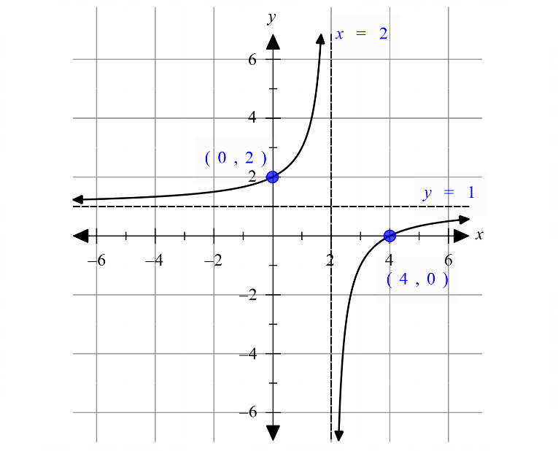
Most students recognised that the graph was a rectangular hyperbola and presented a neatly drawn curve with branches correctly positioned. Students generally paid attention to curvature and asymptotic behaviour. Asymptotes were sometimes correctly positioned but labelled inaccurately or not at all. The axial intercepts were generally given as coordinates with occasional errors seeing the x-intercept labelled (4,0) but positioned at (3,0) or the y-intercept given as (0,3).

Question 4b.
Marks | 0 | 1 | Average
% | 69 | 32 | 0.3
This question, while well attempted, was not done well. Most students attempted to solve algebraically instead of using the graph, and only obtained the lower bound of inequality. Other errors saw students write the interval as . Others had the values but incorrect brackets.

Question 5a.
Marks | 0 | 1 | 2 | Average
% | 23 | 14 | 63 | 1.4
Therefore, the other x-intercept is (0,0)
Most students were able to set and solve. Some students used the symmetry around the turning point to locate the x-intercept. Some erroneously tried to solve . A number of students chose to use the quadratic formula, introduced careless errors thereby making a simple solution process difficult.

Question 5b.
Marks | 0 | 1 | 2 | Average
% | 74 | 8 | 18 | 0.5
intercepts at
Correctly managing the transformations in this question proved challenging for many students. Some could not properly express the horizontal dilation, and, with the translation, many did not use brackets around the term leading to the incorrect rule of: .
Few students realised that the transformation of the x-intercepts could be formed independently of the rule, through simply transforming points. A significant number of students either could not, or did not realise they had to, find the x-intercepts.

Question 6a.
Marks | 0 | 1 | Average
% | 37 | 63 | 0.7
Generally, this question was well answered. A common incorrect answer was obtained by falsely assuming independence and calculating

Question 6b.
Marks | 0 | 1 | 2 | Average
% | 78 | 11 | 11 | 0.4

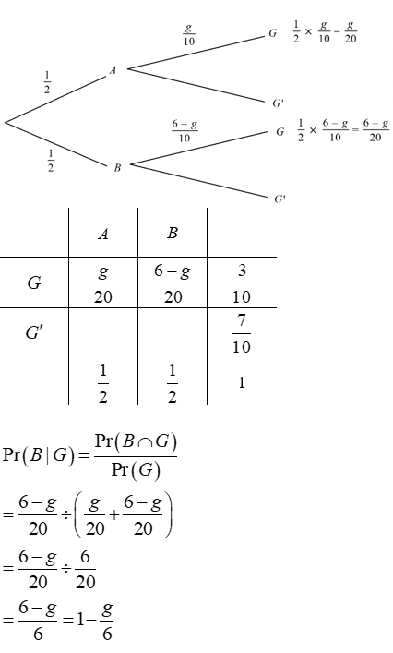
This question was not well answered. Many students did not use as stated in the question; few could find . Some used as a probability instead of and multiplied it by . Those who drew a probability diagram, either a tree diagram or Karnaugh table, tended to have better success.

Question 6c.
Marks | 0 | 1 | 2 | 3 | Average
% | 51 | 12 | 8 | 29 | 1.2
This question was well attempted. Students were generally able to identify the binomial distribution with parameters . Brackets, or lack thereof, caused a problem for some, but generally students were able to manipulate the fractions to obtain . Common errors involved incorrect identification of parameters as or .

Question 7a.
Marks | 0 | 1 | Average
% | 52 | 48 | 0.5
Most students could set up an integral, with correct terminals, equal to one. Occasionally the antiderivative was written as a logarithm, but generally students were able to correctly anti-differentiate the function. This was a ‘show that’ question and generally the solution process was clear, logical and well-explained. The was rarely missing.

Question 7b.
Marks | 0 | 1 | 2 | Average
% | 51 | 10 | 39 | 0.9
This was generally well answered, although some formed the integral of rather than . Common errors involved not recognising .

Question 8a.
Marks | 0 | 1 | 2 | 3 | Average
% | 26 | 16 | 38 | 21 | 1.6
Most students were able to anti-differentiate to get the correct powers, but often with incorrect coefficients. Some students lost the term and just had . Students who had included the constant of integration knew to substitute in to find . Solving to find caused problems; students encountered difficulties evaluating terms like .

Question 8b.
Marks | 0 | 1 | 2 | Average
% | 50 | 27 | 23 | 0.8

x | -2 | 3 | 10
 | + | 0 | -
 | / | __ | \
Alternative using second derivative
is a local maximum
Most students knew that they had to consider the slope of the curve on either side of . Appropriate values were chosen. The most common values used were −6, −2, 0, 2, 4 and 10. Most students had a valid approach, but not all provided convincing arguments that showed the working out of substituting suitable values. Those who tried a second derivative approach met with mixed success.

Question 9a.
Marks | 0 | 1 | 2 | Average
% | 78 | 9 | 13 | 0.4

It is important to remember that for ‘show that’ questions, the working needs to be clear and logically structured, with a well-defined progression from start to finish. This was not the case for many students. There were many different ways of approaching this question and those who could see the question as a right-angle triangle tended to fare better. It was clear that some students knew what they were doing; however, they did not show how they got to find the angle leading to the gradient of the tangent or how they found . Many differentiated the equation of the semi-circle, but then tried to evaluate the derivative at , a point that is not in the domain of the derivative. For most students, angles were not defined or labelled on diagrams, nor were side lengths indicated.

Question 9bi.
Marks | 0 | 1 | Average
% | 94 | 6 | 0.1
This question was poorly answered. Most students could not find , while some students gave , forgetting to exclude zero.

Question 9bii.
Marks | 0 | 1 | Average
% | 96 | 4 | 0.1
This question was poorly done. There were students who correctly identified the endpoints, but then wrote an incorrect interval. This question involves visualisation of the problem, and students are encouraged to practise this skill.

Question 9ci.
Marks | 0 | 1 | 2 | Average
% | 82 | 17 | 1 | 0.2
Students are reminded of the need to consider domains when defining functions. Many were able to write , but very few stated the domain of the function. Some wrote the function incorrectly as .

Question 9cii.
Marks | 0 | 1 | 2 | Average
% | 81 | 15 | 4 | 0.3
Because many students overlooked the domain in their definition of the function , they did not realise that the maximum occurs at an endpoint . Instead, many attempted this question by differentiation and then solved to get the incorrect maximum of .

