2021 VCE Mathematical Methods 2 external assessment report

General comments
There were some excellent responses to many questions. The following are helpful tips to remember when doing examinations.
- Students should be discerning in their technology use and have alternative approaches when their technology does not perform as desired.
- Students should use brackets correctly. Brackets were missing or incorrectly used in Questions 1a., 1d., 1fii., 3d. and 5ei.
- Students should practise finding the domain and range of functions. Students were asked to find the domain in Questions 1b. and 1fi. and both the domain and range in Question 3a. Particular attention should be given to whether round or square brackets are required.
- Exact values were required in Questions 1d., 2c., 2e., 4c., 5a., 5c. and 5g. In Question 1d. some students were giving their answers to the nearest integer. In Questions 2c. and 2e. was often written as 0.3.
- Some students rounded incorrectly or did not give the required number of decimal places. In Question 3f. the x-coordinate was required to three decimal places. Many students gave −0.75 as their answer. Likewise, in Question 5b., −1.72 was given instead of −1.722. In Question 4b. 10.67 was rounded to 10.6.
- In ‘Show that…’ questions, students should make sure adequate working is given and that it is clearly set out. In Question 1a. there was no need to expand the brackets and then factorise. The domain of the function needed to be considered in Question 1g.
- Appropriate working must be given for questions worth more than one mark. Often this is just the rule and then the answer. In Question 2c. the definite integral should have been given as well as the answer.
- In some questions more than one answer was required. In Question 1d. the maximum volume was required as well as the x-value at which it occurs. Some students only gave the x-value. In Question 3a. the domain and the range were required. Some students only gave the domain. In Question 3d. the x-coordinate and the bounded area were required.
- Students should use their technology efficiently. In Question 4, the hybrid function could easily be defined on the technology and then used for Questions 4f. to 4h. The equation of the tangent and perpendicular lines in Question 3b. can easily be found with the use of technology.
- Students need to practise questions that require explanations. In Question 3c. students were required to explain why a function was not one-to-one and in Question 5f. students were asked to explain why the function could not be greater than 2 or less than −2.
- Students should be careful when transcribing the equations from their technology. Transcription errors occurred in Questions 1c., 1d., 3d. and 5ei.
- Students should make sure the specific question is addressed. Equations were required in Questions 3bi. and 3bii., not just an expression. The gradient of the tangent, not the equation of the tangent, was required in Question 3d.

Specific information
This report provides sample answers or an indication of what answers may have included. Unless otherwise stated, these are not intended to be exemplary or complete responses.
The statistics in this report may be subject to rounding resulting in a total more or less than 100 per cent.

Section A
The table indicates the percentage of students who chose each option.
Question | Correct answer | % A | % B | % C | % D | % E | % N/A | Comments
1 | B | 3 | 67 | 22 | 6 | 2 | 0
2 | C | 3 | 11 | 81 | 4 | 1 | 0
3 | A | 72 | 7 | 6 | 8 | 5 | 1
4 | B | 10 | 58 | 9 | 18 | 4 | 0
5 | C | 7 | 12 | 73 | 7 | 2 | 0
6 | A | 88 | 4 | 2 | 3 | 2 | 0
7 | B | 4 | 56 | 20 | 16 | 3 | 1
8 | E | 19 | 9 | 3 | 29 | 40 | 0 | The gradient is decreasing and positive over the interval .
9 | E | 24 | 7 | 4 | 10 | 56 | 0
10 | D | 16 | 4 | 7 | 70 | 3 | 0
11 | A | 67 | 6 | 5 | 2 | 20 | 0
12 | D | 6 | 14 | 23 | 54 | 2 | 1
13 | B | 4 | 80 | 9 | 5 | 2 | 0
14 | E | 6 | 6 | 14 | 10 | 63 | 1
15 | D | 14 | 11 | 18 | 48 | 8 | 1
16 | A | 31 | 11 | 32 | 9 | 15 | 1 | ,  ,  ,
17 | C | 9 | 18 | 57 | 10 | 5 | 1
18 | D | 8 | 23 | 22 | 39 | 6 | 1 | and  will have a maximum of three solutions if the graph of f is translated to the left. The graph below shows three points of intersection for .  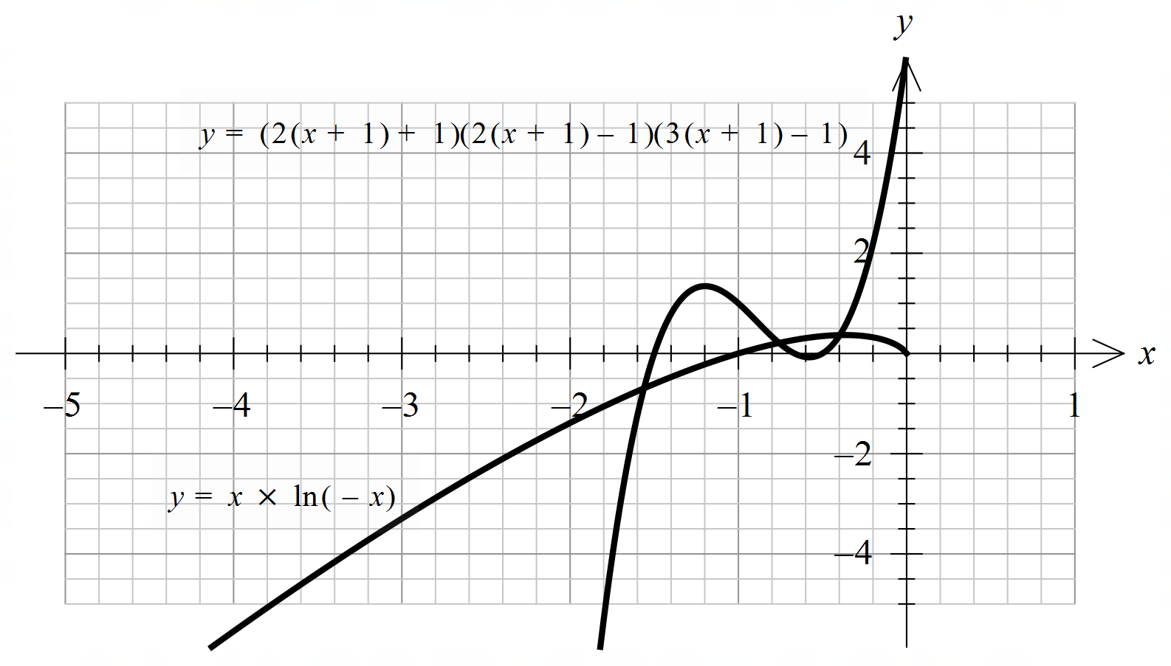
19 | E | 12 | 13 | 19 | 20 | 35 | 1 | The graph of f is continuous over the interval .  The graph of f is smooth at .  The function f where is differentiable for all real values of x.
20 | D | 20 | 17 | 11 | 39 | 12 | 1 | , and  since the events are independent

Section B

Question 1a.
Marks | 0 | 1 | Average
% | 29 | 71 | 0.7
This question was answered well.
Some students could not identify the dimensions correctly. Others used brackets incorrectly or omitted brackets, for example: .

Question 1b.
Marks | 0 | 1 | Average
% | 58 | 42 | 0.4
(0, 25) was often seen. Some students had incorrect brackets, for example, (0, 12.5].

Question 1c.
Marks | 0 | 1 | Average
% | 10 | 90 | 0.9
This question was well done. Some incorrectly wrote .

Question 1d.
Marks | 0 | 1 | 2 | 3 | Average
% | 17 | 13 | 21 | 49 | 2.0
Solve , , or
Exact values were required. Some students found the x-value but did not find the maximum volume. Others chose the incorrect x-value, , to find the volume.
There were some transcription errors: was often seen.

Question 1e.
Marks | 0 | 1 | 2 | Average
% | 35 | 19 | 46 | 1.1
Some students used volume and not area in the denominator. Many were able to work out that 100 cm² was cut out. Some were not able to convert their fraction to a percentage: 0.08% was often seen.

Question 1fi.
Marks | 0 | 1 | Average
% | 67 | 33 | 0.4
Some students gave the equation, , and not the domain. Others had incorrect brackets. (0, 25h) was sometimes seen.

Question 1fii.
Marks | 0 | 1 | 2 | 3 | Average
% | 42 | 13 | 12 | 33 | 1.4
, ,,
Many students were able to find the formula, . Some chose the incorrect x-value, and then gave a negative volume.

Question 1g.
Marks | 0 | 1 | 2 | Average
% | 55 | 10 | 35 | 0.8
, , or , as the domain is
Some students were able to find the correct formula, . Some did not show adequate working for a ‘show that’ question.

Question 2a.
Marks | 0 | 1 | Average
% | 4 | 96 | 1.0
This question was done very well.

Question 2b.
Marks | 0 | 1 | Average
% | 40 | 60 | 0.6
or
An exact answer was required. Some students rounded their answer to 0.47.

Question 2c.
Marks | 0 | 1 | 2 | Average
% | 14 | 6 | 80 | 1.7
The definite integral was required to obtain full marks. Some students rounded their answer to 0.3.

Question 2d.
Marks | 0 | 1 | Average
% | 84 | 16 | 0.2
A common incorrect answer was .

Question 2e.
Marks | 0 | 1 | Average
% | 12 | 88 | 0.9
An exact answer was required.

Question 2f.
Marks | 0 | 1 | 2 | 3 | 4 | Average
% | 48 | 42 | 3 | 5 | 2 | 0.7
, If :, , If :,
Many students were able to find or but not both. Others found but did not set up the definite integral properly. , was often seen.

Question 3a.
Marks | 0 | 1 | 2 | Average
% | 27 | 37 | 36 | 1.1
Domain , range R
Some students only gave the domain and not the range. Others gave the domain as or or .

Question 3bi.
Marks | 0 | 1 | Average
% | 26 | 74 | 0.8
An equation was required. Many students worked out the equation without using technology. This would have been time consuming.

Question 3bii.
Marks | 0 | 1 | Average
% | 35 | 65 | 0.7
Once again, an equation was required and it could be found easily using technology.

Question 3c.
Marks | 0 | 1 | Average
% | 34 | 66 | 0.7
‘Fails the horizontal line test’ or ‘many-to-one function’ or ‘there exist two x-values for some y-values’.
Some students wrote that there exists two x-values for every y-value, which is not the case, or p fails the vertical line test. Others gave the meaning of a one-to-one function without relating it to the question.

Question 3d.
Marks | 0 | 1 | Average
% | 33 | 67 | 0.7
Some students gave their answer in terms of x and not a. There were some transcription errors and brackets were used poorly. Others wrote the equation of the tangent.

Question 3e.
Marks | 0 | 1 | 2 | 3 | Average
% | 83 | 4 | 9 | 4 | 0.4
, , ,
This question was not answered well. Some students were able to find either or but not both.

Question 3f.
Marks | 0 | 1 | 2 | 3 | Average
% | 41 | 23 | 7 | 29 | 1.3
,
Many students were able to find . Some wrote their answer as , but three decimal places were required. Others were unable to set up the definite integrals correctly.

Question 4a.
Marks | 0 | 1 | Average
% | 22 | 78 | 0.8
This question was answered well. A common error was 0.228.

Question 4b.
Marks | 0 | 1 | Average
% | 36 | 64 | 0.7
Some students rounded their answer to 10.6.

Question 4c.
Marks | 0 | 1 | 2 | Average
% | 44 | 24 | 33 | 0.9
,
Exact answers were required. and were often seen.

Question 4d.
Marks | 0 | 1 | 2 | Average
% | 42 | 18 | 40 | 1.0
, ,
Some students gave the correct n and p values but not the final answer. Others wrote instead of .

Question 4e.
Marks | 0 | 1 | Average
% | 79 | 21 | 0.2
A common incorrect answer was 0.04.

Question 4f.
Marks | 0 | 1 | 2 | Average
% | 51 | 11 | 37 | 0.9
or or ,
Some students worked out the mean and not the median. Others set up the hybrid function incorrectly, for example, or . Students who used when writing out the definite integral were more successful with the method mark for this question. Students should define the hybrid function on their technology to save time.

Question 4g.
Marks | 0 | 1 | 2 | 3 | Average
% | 53 | 9 | 6 | 32 | 1.2
Some students worked out the variance instead of the standard deviation. Once again, students who used when writing out the definite integrals were more successful with this question.

Question 4h.
Marks | 0 | 1 | 2 | Average
% | 86 | 12 | 2 | 0.2
, , and or , , and
Many students were unable to set up the correct equations. The terminals were often incorrect.

Question 5a.
Marks | 0 | 1 | Average
% | 29 | 71 | 0.7
A common incorrect answer was .

Question 5b.
Marks | 0 | 1 | Average
% | 39 | 61 | 0.6
Some students gave the coordinates of the turning point and did not state the minimum value. Others gave their answer as or . Many evaluated , which equals correct to three decimal places.

Question 5c.
Marks | 0 | 1 | Average
% | 79 | 21 | 0.2
An exact answer was required. 6.28 was a common incorrect answer.

Question 5d.
Marks | 0 | 1 | Average
% | 32 | 68 | 0.7
This question was answered well by those who attempted it.

Question 5ei.
Marks | 0 | 1 | Average
% | 50 | 50 | 0.5
Some students found the derivative instead of the antiderivative. Others wrote .

Question 5eii.
Marks | 0 | 1 | 2 | 3 | Average
% | 52 | 20 | 16 | 12 | 0.9
for all a as a is a positive integer, the area must always be equally divided above and below the x-axis if the definite integral equals zero.
Some students were unable to interpret .

Question 5f.
Marks | 0 | 1 | Average
% | 87 | 13 | 0.2
has a maximum value of 1 and a minimum value of , has a maximum value of 1 and a minimum value of , in both cases for all , thus the sum of sine and cosine functions cannot exceed 2 nor be less than .
Some students considered the maximum value only and not the minimum value.

Question 5g.
Marks | 0 | 1 | Average
% | 98 | 2 | 0.0
An exact answer was required. was a common incorrect answer.

